

LEVEL 7 ASSESSMENT SPECIFICATION

Student name: | KEUNG Nga Yee Teresa | Student ID number: | 1922108
Programme: | MBA
Module: | Global Business Challenges
Module code: | BMMB7006 | Contribution to Overall Module Assessment (%): | 100%
Lecturer: | Dr. Che Cheong Poon | Internal Verifier: | Dr. Joe Leung
Assignment Title: | Analytical Report – Organisational Strategies in a COVID 19 World | Word count (or equivalent): | 5,000 words or equivalent
Submission deadline: | 22 February 2021 | Return date of provisional marks & written feedback: | Within 20 days after submission
Submission method: | All written assessments, where practical and possible, must be submitted via Turnitin unless otherwise instructed by the Lecturer. (Please DO NOT put this assessment specification into Turnitin or it will match many similarities with other students’ submissions.)  Late submission of the assessment will result in a late penalty mark. Penalties for late submission: Up to one week late, maximum mark of 50%. Over one week late, 0%. Only the Extenuating Circumstances Panel may approve a change to submission dates.
Academic honesty / referencing: | Academic honesty is required. In the main body of your submission you must give credit to authors on whose research and ideas your work is based. Append to your submission a reference list that indicates the books, articles, etc. that you have used, cited or quoted in order to complete this assessment.

UWTSD MBA (May/Nov 2020 intakes)
BMMB7009 Global Business Challenges

Assignment Title: Manning
Analytical Report – Organizational Strategies in a COVID 19 World

“I, KEUNG Nga Yee Teresa (Student number: 1922108), certify this work is the result of my own investigations, except where otherwise stated. All references have been duly cited”


Signed: _____________________

Date: 22 February 2021

Synopsis
The report is to evaluates the strategies for Mannings, which is one of the largest consumer goods company in Hong Kong, to ensure business continuity under the Covid-19 Epidemic Situation. By using the SWOT approach to analysis the information collected from the company’s annual reports, its half yearly results presentation, journals and related statistics published by Hong Kong Census and Statistics Department, the research findings suggested that Mannings performance is backed up by its important store layout, significant customer service experience, efficient loyalty programs, and a highly trained workforce, digital innovation, ensuring coordination of the company’s offline and online channels.

Table of Contents
Synopsis 3
1. Introduction 5
1.1 Research Motivation………………………………………………………………………..5
1.2 Research Framework……………………………………………………………………….6
2. Company Background 6
2.1 History in Hong Kong 6
2.2 Product Portfolio 8
2.3 Industry Competition 8
2.4 Company Revenue 9
3. Manning's business performance amid the economic disruption due to the COVID-19 outbreak 10
3.1 Macroeconomic Environment 10
3.2 Revenue Structure 14
3.3 SWOT Analysis Model & The Cost Structure 15
4. Analysis and Discussion 15
4.1 Challenges facing the Company 15
4.1.1 Costing Challenges 15
4.1.2 Pricing Challenges 16
4.1.3 Market Sharing Challenges 18
4.2 Strategies to Ensure Continuity of Manning's Business Amid COVID-19 Epidemic 19
4.2.1 The Business Continuity Plan 19
5. Conclusion and Recommendations 20
5.1 Conclusion 20
5.2 Recommendations 21
6. References 22

Introduction
There is a growing demand for wellness and cosmetics products in Hong Kong due to the increased population and their concern of health care. The growth of the health and beauty industry in Hong Kong has made it possible for large companies like Mannings to expand their operations on the e-commerce channel to drive sales growth under the Convid-19 epidemic situation.
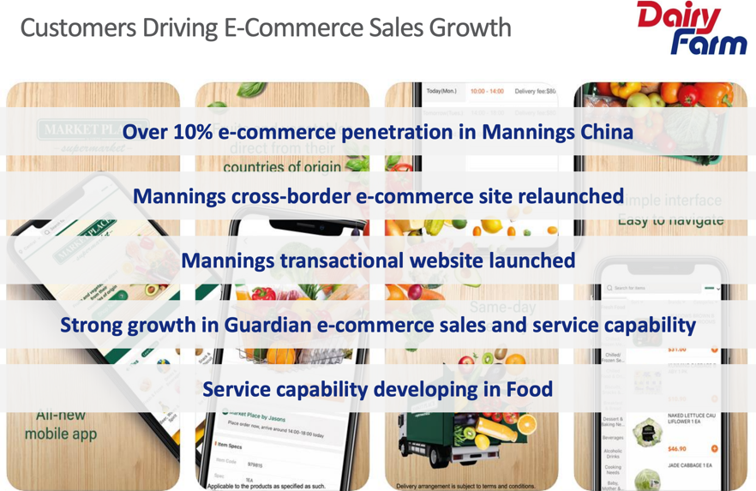
Source: 2020 Dairy Farm Half-yearly Results Presentation

1.1 Research motivation

The research motivation are to identify the potential challenges faced by Mannings, to recommend resolution measures to overcome the challenges, and to compile a workable business plan to maintain business continually under the Covid-19 pandemic situation. To do these, we first look at the company's background, including its ownership, history, products, and industry competitiveness; then a discussion of the company's business performance during the period of the coronavirus pandemic, which is characterized by economic disruption. Also, the paper analyses the challenges facing company and how they can be solved.

1.2 Research framework
The objectives of the report are to analyze the business performance of Mannings company, especially during the COVID-19 pandemic period, and comparing it its performance before the onset of the pandemic; to analyze the challenges faced by the company before and during the current period, which might affect the operations of the company, and to offer a remedy to the potential challenges faced by the organization. The other objective is to provide some recommendations that will assist the company's performance in mitigating challenges that affect the company.
Research findings are of great significance since it outlines its business performance in the coronavirus period, and the challenges that the company encounters before and during the pandemic period. Mannings is a wholly-owned subsidiary of Dairy Farm Group, which has maintained a significant performance in the period when the Hong Kong city is disrupted with coronavirus pandemic. The company is battling potential challenges such as consumers' sensibility due to changes in prices, the frequently changing retail landscape in Hong Kong, which needs technological advancement, staff turnover, talent shortage, and a low penetration rate for e-commerce. Some of the company's recommendations include that Mannings should better understand and analyze the as the most important Manning sales channels.
2. Company background

2.1 History in Hong Kong
Mannings’ history traces its origin to the year 1972 when it opened its first store in P & O Building. It was then integrated in 1975 by Dairy Farm Company Limited (Manning's, 2021). In the 1980s, the company had become successful, and it has positioned itself as the best beauty and health specialist. Then in 1996, Mannings opened its 100th store, and during the same year, it got its first Hong Kong Retail Management Association award (Ng and Banerjee, 2006). In the year 2002, six years later, it was the leading and largest store network in entire Hong Kong. It opened its first two Manning's plus banners in 2010 to be used as centers that offer health tests and free professional services (Jardine Matheson, 2013).
Mannings is the largest beauty and health product chain in Hong Kong. Over 350 outlets provide various quality healthcare, skincare, baby products, and personal care to a broad range of consumers (Manning's, 2021). The company has also been offering innovative services, and it is on top of the industry in serving the health and beauty needs of the general public. The company has been awarded six consecutive years as the best service retailer by the Hong Kong Retail Management Associations via the Mystery Shopper Program. Ipsos also has placed the company at position one in its survey of the Customer's Favourite Brand. The company focuses on promoting community healthcare education through a regular host of various promotional events that highlight common illnesses and healthcare issues. It is very enthusiastic about service efforts offered to the community it operates. It is very keen to provide free consultation services and enhance public healthcare.
Mannings is owned by Dairy Farm Group, which is a subsidiary of Jardine Matheson. Dairy Farm company is the largest retailer in Asia, and it has other brands such as 7-Eleven convenience stores, home furnishing retail chain Ikea, and Wellcome supermarkets (Ng and Banerjee, 2006). It is a publicly registered company with about 59,000 employees and operates in 2,200 outlets, including Mannings (Manning’s, 2021). The company is in the third level on its own as it is under Dairy Farm Company Limited as a brand. In contrast, the Dairy Farm Company Limited is a privately owned company under Dairy Farm International Holdings Limited, a listed public limited company (Jardine Matheson, 2013).

2.2 Product portfolio
Mannings offers a broad range of health and beauty products at a competitive price. The products are classified into four categories such as personal care, beauty care, baby care, and health care. The products include international brands such as L'Oréal, Dove, Ponds, Olay, Pantene, Gillette, Vidal Sassoon, and Neutrogena (Manning's, 2021). Other products are the Western medicine trusted brands such as Vaseline, Mentholatum, Panadol, Strepsils, and Tylenol, and other Chinese health brands such as Essence of Chicken and Brand's Bird Nest are all in the comprehensive health range of Mannings' company. Mannings also have their own brand, offers a wide variety of caring products, dermatologically tested and proven, such as bath & hand soap, toothpick, cotton, tissues etc.
Through its pharmacy dispensary services, Mannings adds value to customers and maintains patients' prescription records. More so, the company offers baby care products that mothers utilize all over the world, including Mead Johnson, Johnson and Johnson, Huggies, Pampers, and Wyeth products.
2.3 Industry competition
As a beauty and health company, Mannings operates under an industry with a competitive oligopoly structure. The market contains few participants, and all of them are aware of other competitors' actions. One firm's decision influence other firms' decision because of interdependence between such firms (Jardine Matheson, 2013). Mannings’ major competitor is Watson, which offers the same products and services to the same range of customers. Hence, there is fierce competition between the two beauty and health companies, and the price of one of them affects the demand for the other company's products because of substitute products and services. When the prices of manning's products increase, the demand for products sold by other competitors like Watson increases because their prices remain unchanged, and it will be below that of Mannings. Apart from Watson's company, there are other small pharmacies with the same products and services, making Mannings products elastic. A decrease in Mannings products' prices will lead to more gain than loss, leading to increased revenue.
Beauty & Health companies | Mannings | Watsons | Independent drug stores
No. of stores in Hong Kong | 350+ | 200+ | 1000+
Positioning Mass | Mass - Medium | Mass - Medium | Mass-Medium
Target customer | Local & Tourist | Local & Tourist | Local & Tourist
Source: Understanding beauty and health retailers in Hong Kong 2019

To stay ahead of industry competition in Hong Kong, Mannings continues periodically to enhance its shopping experience and store format through its 14-day policy on returning goods that cannot be matched by its industry rivals. It uses a promotion strategy to compete with its top competitors through offering a reward product to its customers who spend more than 80 dollars in their stores; such promotion increases the demand for Mannings’ products across its stores compared to its competitors, and in turn, its revenue will lead (Dairy Farm Group, 2019).

2.4 Company Revenue
Mannings revenue is obtained from its parent company Dairy Farm Group's yearly financial statements, which outlines all the revenues of different sectors of the conglomerate. Below are revenues of the health and beauty sector of Dairy Farm Group, which is under Mannings’ company in Hong Kong.
Table 1: Revenue from the health and beauty sector of Dairy Farm Group from 2016-2019
Years | Revenue in Million Dollars
2016 | 1,715
2017 | 1,744
2018 | 2,322
2019 | 2,402
Source: Dairy Farm Group statistics 2019
As indicated in Table 1, the revenue trend is increasing from 2016 to 2019, which indicates that the company performance improves yearly and continues to attract and retain more customers, which boosts its sales and reduces its costs (Dairy Farm Group statistics 2019).

3. Manning's business performance amid the economic disruption due to the COVID-19 outbreak

3.1 Macroeconomic environment

According to statistics compiled by the Hong Kong Tourism Board, within the total visitor expenditure of $328.2 billion in 2018, $167.1 billion was spent on shopping. This was equivalent to around one-third of the value of total retail sales. Therefore, the sharp fall in visitor arrivals in the second half of 2019 took a heavy toll on retail business.
(2019 ECONOMIC BACKGROUND AND 2020 PROSPECTS)
The local social incidents have also severely hurt consumer sentiment. The overall Hong Kong Consumer Confidence Index compiled by the City University of Hong Kong plummeted from 77.7 in the second quarter of 2019 to 52.8 in the third quarter of 2019, the lowest reading since the Index was available in 2008. It remained at a low level of 68.7 in the fourth quarter 2019. Private consumption expenditure, after growing moderately in the first half, turned to decline by 3.3% and 2.9% in real terms in the third and fourth quarter of 2019 respectively from a year earlier. Moreover, retail outlets and shopping malls in many areas were forced to close earlier from time to time. Many residents avoided going out in the fear of being hurt or having problems returning home. Latest surveys showed that both large and small-and-medium sized enterprises in the retail sector remained pessimistic about the business situation in the near term. More recently, the business environment of the retail sector has become even more difficult due to the threat of the novel coronavirus infection. The outlook for the retail business in 2020 is subject to high uncertainties, depending very much on whether the spread of the novel coronavirus infection can be kept under control and how the local social incidents unfold.

According to the results of the Census and Statistics Department (C&SD)’s Quarterly Business Tendency Survey (QBTS) conducted during 2 September to 15 October, business sentiment among large enterprises in Hong Kong turned less gloomy compared to three months ago (Chart 1). The proportion of large enterprises expecting business situation to worsen in the fourth quarter of 2020 over the third quarter exceeded the proportion of those expecting improvement by 8 percentage points (i.e. a net balance of -8), representing a modest pick-up from the net balance of -11 in the previous round. (Third Quarter Economic Report 2020)

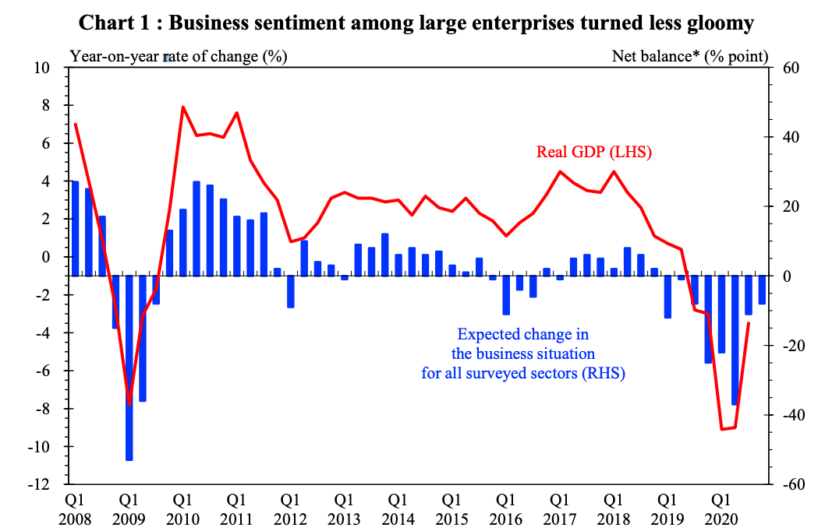

The company's performance in this COVID-19 period has resulted in several strategies being implemented to ensure the continuity of its operations. As a way of remaining loyal and committed to its customers, Manning's as a beauty and health retailer partnered with seven public hospitals in Hong Kong to enable various residence to collect their prescribed medicines in its pharmacies during the COVID-19 period. According to the company management, the move to partner with such hospitals is a COVID-19 initiative to offer peace of mind to its esteemed customers because such a move helps reduce the spread of COVID-19 through frequent hospital visits to many individuals at the same time. In the initiative, a patient takes a confirmed application and prescription from a specialist out-patient hospital to a registered pharmacist situated for collection of the prescribed medicine inside a Mannings’ store. According to Inside Retail Asia (2016), The medicine collection charges at Manning's store are KK$ 50, which includes a consultation service that involves reviewing the patient's medical history before collecting the medicine. Manning's seven hospitals have partnered with the Tuen Mun Hospital, Pamela Youde Nethersole Eastern Hospital, Princess Margaret Hospital, Queen Marry Hospital, Prince Wales Hospitals, United Christian Hospital, and Queen Elizabeth Hospital (Inside Retail Asia, 2016). The service offered in partnership excludes all medicines that need specialized handling and refrigerated drugs as it only involves offering medication to patients at specialist out-patient hospitals.
As a response to the effects of COVID-19, Mannings’ company collaborated with Hong Kongers, a DDB Group Hong Kong, to launch a campaign to ease widespread anxiety and build awareness concerning physical self-care and personal hygiene. The campaign features integrated elements across in-store, online, and social media channels.
The other campaign with the tagline 'strong beauty' was carried out by the company in salute of Hong Kong women to recognize women's strength as a defining factor of beauty at the time of pandemic when beauty is not more valued. The campaign is an appreciation of women customers for uplifting new spots and assistance they have provided to the company. The campaign was rolled out in the year 2020 after the onset of COVID-19, and its aim was to pay tribute to women in Hong Kong city who have remained strong and worked hard amid the pandemic challenges.

3.2 SWOT Analysis Model & The Cost Structure
The company's strengths include good quality control as most of them are dealer products; good reputation because of its well-known and good layout chain stores in Hong Kong; diversified products offered such as medicine, confectionary, skincare products, cosmetics, drinks, and medicine. Then many brands that their customers can choose from in its products; good management which has enabled the company to win its various awards.
The company's weaknesses include higher prices compared to its competitors such as small pharmacies, higher costs such as more expenses on quality control, higher labor costs, higher rent due to bigger shops located at good locations, and higher management costs. Its opportunities include the customers of the company are concerned more about health; thus, there is increasing market size due to increased demand for healthy and body products, which continuously increase. The other opportunity is increasing demand for good reputation shops and quality products due to an increased threat of China concerning fake products and quality food.
The threats of the company include the expansion of Watson company, which is its major competitor. Another threat is the increased number of pharmacies in entire Hong Kong, reducing the number of customers who could shop at its stores. The entry of new chain pharmacies is another threat to the company as they are increasingly entering the beauty and health market, which will reduce the company's share.

3.3 The revenue structure
Mannings’ sales have benefited from strong revenue due to improved customer offer and investment in its store fit-out. The company tried its best to find a solution to reduce the challenges brought by social unrest through reduced foot traffic in its store. The solution for such a challenge is the launch of a cross-border e-commerce platform offered via a WeChat mini program (Dairy Farm Group, 2019). The company's e-commerce development and adoption have changed customer behaviour and has driven the need for higher creativity, efficiency, and transparency from beauty and health retailers to meet online shoppers' changing needs.
Despite the coronavirus pandemic that disrupted the trading environment in Hong Kong, which caused a decline in the parent company Dairy Farm Group, its subsidiary Mannings tried its best to maintain its sales to counter the reduction in visitors from mainland China. The performance was boosted by new store formats, improved programs, and a good space-optimization plan, which has generated more efficiency and delivered tangible results. In addition, Mannings branded products have been introduced into almost 450 Yonghui stores in China. Sales for the group’s Health and Beauty Division benefitted from strong revenue and sales growth in their Guardian business in Southeast Asia. However, these positives were offset by the impact that the social unrest in Hong Kong has had on Mannings.
Annual results |  | 2015 | 2016 | 2017 | 2018 | 2019 | 2020
Sales (M $) | Released | 11,137 | 11,201 | 11,289 | 11,749 | 11,192 | 10,630
Source: Diary Farm’s annual publications 2020

4. Analysis and Discussion

4.1 Challenges facing the Company

4.1.1 Costing challenges
Mannings is unimproved consistency and high costs in the company stores. They suffer from a lack of consistency and higher costs in few areas such as business process re-engineering, category management, supply chain optimization, procurement, and store productivity. The company staff has been working on various store projects intended to remove unnecessary work duplication and improve team members' workflow. There is the continuing introduction of auto-replacement systems in the stores that aim to reduce manual labour needed for team members in re-ordering inventory (Sinha, 2013). The best solution for the problem is to fully implement new processes and new systems to enhance fresh food quality and implement lower waste. The systems are necessary for the stores as they are considered to be a cost-saving strategy.
Social unrest is another challenge that affects the operations of Manning's company in Hong Kong. The city has been experiencing various strikes and disruption by regulations that are formulated by mainland China. The strikes have disrupted several retail businesses, and the effect has been the major cause of a decline in the Dairy Farm Group sales and revenue. During the COVID-19 pandemic period, the unrest increased considerably due to a reduction in visitors from mainland China.
More so, there is a problem with maintaining the branding of the company products. A company like Mannings needs to maintain a more-than-premium branding in order to maintain its sales by retaining the current customers and enticing new ones. Mannings’ management struggles a lot to maintain such a brand, and sometimes it becomes a challenge to make it consistent in all its stores across the city. The solution to such a challenge is for the company to increase its value proposition by ensuring that the company brands resonate with the consumers' evolving tastes through massive marketing strategies to increase the company's awareness. A more-than-premium branding will enable the company to set reasonable and affordable prices for its products and services; thus, attracting more customers, which will eventually boost its overall sales leading to higher revenues.

4.1.2 Pricing challenges
The potential challenge that the company is facing is the sensibility of consumers due to changes in prices. Manning's consumers' demand is elastic because its competitors deal with identical products, meaning a small change in the company's prices leads to a higher shift in demand. Currently, the shoppers of health and beauty products in Hong Kong are more than ever sensitive to the good value and prices of beauty and health products and services. COVID-19 pandemic has impacted consumers' incomes to a greater extent; hence, such consumers want to spend less money to acquire maximum value in purchasing personal care products and services (Choi et al., 2020). Such consumers evaluate their choices concerning where they will purchase products and services based on the benefits or the utility they will obtain from the purchase (Leung et al., 2019). The changes in consumers' expectations in terms of value and prices are there to stay in the Hong Kong beauty and health industry. Hence, for Manning's company to stay relevant on consumers' faces and remain on top of the industry, it should capture new consumer behavior and expectations and respond fully to the market's evolution. The company should provide review its innovation and product portfolio to meet consumer demands; adapt proper communications to emphasize medical credentials and health benefits; construct its e-commerce offer by ensuring purchasing in the platform is easier and is fully supported by developed payment systems, infrastructure, and improved delivery; and establish a complementary and consistent offline-to-online experience which is aimed to maximize availability and exposure of the company's products and services.
The low penetration rate for e-commerce is another potential challenge for the company. Mannings has adopted an online e-commerce platform that involves selling its beauty and health products via the internet to its customers, mostly within Hong Kong. However, the move towards e-commerce has not performed well for the company because of the low penetration rate, which slows down the move towards online purchases. Hong Kong city remains tarnished in the development of e-commerce. The key reason for such notoriousness is the close proximity of stores in the city because of urbanization that has made more population reside. Urbanization has made many stores near each other; hence, there is convenience in physical shopping compared to online shopping. The solution to this challenge is for Mannings company to develop loyalty programs as they are the major defining factors for customer retention. E-commerce platforms across various competitors of Mannings are identical. Thus, Manning retains its customers and enables them to do online shopping by creating loyalty programs that act as deciding factors for the places where customers purchase an identical product sold by different retailers.
Mannings also has been struggling to meet its customer needs through a multi-channel strategy. In offering products and services in both in-stores and online platforms, the company struggles a lot to unite such two different channels because the operations or even the layout of the online channel differs from that of brick-and-mortar stores. The solution to such a challenge is adopting an omnichannel strategy, which is a key strategy in the retail industry to unlock value from its products and services. The benefit of omnichannel is its ability to offer an efficient, smooth, and seamless journey to consumers to interact with the best brands in online and bricks-and-mortar channels that complement each other.

4.1.3 Market sharing challenges
Changes in demand for beauty products is another challenge that affects Mannings company in Hong Kong. Few individuals can predict that personal beauty can remain a priority to several people even if they remain locked for several months during the coronavirus period. However, it has been seen that the desire to look beautiful is not apparent as it is thought. The maintenance of demand for beauty products by a company like Mannings, especially during the coronavirus crisis, is more of individuals' psychological and physical well-being in quarantine. Consumers are still keeping up with their facial and body care practices, and demands are ever-changing because maintaining a self-care routine apart from its health benefits also enables the consumers to hold on to a sense of regularity (Sinha, 2013). The best solution for such a challenge is proper to follow up and identify the changing needs and demands for customers to provide them with the needed products and services.
The emergence of experimental spending in the current generation is also a challenge to Mannings company. The current generation of consumers in Hong Kong has resulted in changes in both generation Z and millennial consumers' habits. It has added complexity to the company's operations through the shift of other operations to digital channels that have changed convenience and the value of products being sold. This challenge is an enhancement in the company's e-commerce platform to fit Generation Z and millennial customers' buying needs.
Staff turnover and talent shortage are other challenges affecting Manning's company as there is a reduced retail workforce in entire Hong Kong. The shortage of workforce is a challenge that affects Mannings company, but it is a challenge to the whole retail segment in Hong Kong. It is estimated that a top retailer in Hong Kong has a vacancy of about eight to nine percent across about an average of 200 stores (Choi et al. 2020). Manning's is not excluded from the shortage because it is on the top list of health and beauty retailers in Hong Kong. There is a need to introduce bold transformation in the company's talent retention and training and recruitment of young individuals because the aging employees are leaving the health and beauty industry in large numbers.
Tough circumstances are the coronavirus pandemic outcomes, and it has become a headache for the company management, who are trying to employ several strategies to maintain their customers and prevent any losses from occurring. The pandemic has caused a shock to the company. It has reduced its shopping traffic through a reduction in tourists to the city and limitation of free movement of the city's citizens. The solution to such a challenge is a strategy to re-structure and take measures like expansion into e-commerce channels to drive its sales.

4.2 Strategies to ensure continuity of Manning's business amid COVID-19 epidemic

4.2.1 The business continuity plan
The COVID-19 pandemic has disrupted Manning's daily operations as the pandemic has instilled uncertainty and fear in the company and has roiled financial markets. The pandemic has challenged the company leaders to respond to the crisis by allaying concerns and through understanding the issues presented by the pandemic. The challenges are mostly due to disruption in the company's operations through a reduction in foot traffic. The reduction is caused by the fear of COVID-19, which has caused social unrest where many mannings’ customers had reduced frequent visits to the company's stores. The company was forced to introduce extraordinary measures to maintain operations and protect its employees.
The company needs technological advancement due to changed experiences of health and beauty consumers who of late demands appropriate, engaging, and intuitive experiences that meet their beauty and health needs. The challenge calls for Mannings company to adopt appropriate technology to reduce its overdependence on the workforce. The retail landscape change is a technology problem that has forced several companies, including Manning's, to shift to an online platform to secure more customers for their products. The challenge arises from the fierce competition that Manning's experience from other top beauty and health retailers like Watson. The industry is being changed by the mobile-first customers who have disrupted the entire sector. Customers are becoming more demanding as they are empowered by instant access to the internet and all information concerning the company's goods. Hence, Manning's company should employ a technologically savvy workforce to meet customer demands.

5. Conclusion and recommendations

5.1 Conclusion
Mannings is a Hong Kong beauty and health retailer which was formed in 1972 and was integrated by Dairy Farm Group as its wholly-owned subsidiary in 1975. The company deals in both secondary and tertiary production. The secondary production involves the production of company brands like tissues and toothpicks. The tertiary production is the production of services such as beauty advice and retailing of various products such as L'Oréal, Dove, Ponds, Olay, Pantene, Gillette, Vidal Sassoon, and Neutrogena. Mannings operates in an oligopolistic type of market structure where few firms are in the beauty and health industry in Hong Kong with the major layers such as Watson and other small pharmacists. To be more competitive, Mannings enhances its store format and shopping experiences through promotion strategies. The company's performance is enhanced by creating one format across its entire stores and investing in an integrated information technology system. The company has developed loyalty programs that have made it won its parent company's trust and admiration. To remain operational in the market, the company partnered with seven hospitals in Hong Kong to ensure continuity of its operations. Manning has managed to win several consecutive awards from Hong Kong Retail Management Association's Service Category Leader through such performance. The company's potential challenges include consumers' sensibility due to changes in prices, the frequently changing retail landscape in Hong Kong, which needs technological advancement, staff turnover, and talent shortage, and the low penetration rate for e-commerce.

5.2 Recommendations
The recommendations include:
- The company should improve its image to avoid competition with other small pharmacies and to assist the company increase its revenue.
- Because of its product's elasticity, Mannings should decrease its prices slightly below that of its competitors as the benefits will be higher than costs leading to an increase in revenue.
- The company should attract more customers by opening more shops in Hong Kong and lengthening its opening hours in all its stores.
- Mannings should explore how technology can renovate front-line work in stores, labor-intensive, and free workforce to focus on more value-added tasks, challenging, and interesting where innovation, high levels of customer empathy, and passion are necessary for the delivery of enhancing customer service.

References
Choi, E.P.H., Hui, B.P.H. and Wan, E.Y.F., (2020) Depression and anxiety in Hong Kong during COVID-19. International journal of environmental research and public health, 1710, available at p.3740. https://www.mdpi.com/1660-4601/17/10/3740
Dairy Farm Group., (2019) Dairy Farm Annual Report 2019. Available at
https://ar2019.dairyfarmgroup.com/
Huang, I.Y., Manning, L., James, K.L., Grigoriadis, V., Millington, A., Wood, V., and Ward, S., (2020) Food waste management: a review of retailers' business practices and their implications for sustainable value. Journal of Cleaner Production, p.125484. Available at https://doi.org/10.1016/j.jclepro.2020.125484
Inside Retail Asia., (2016) Manning's Hong Kong resilient in retail drought. Available at https://insideretail.asia/2016/03/09/mannings-hong-kong-resilient-in-retail-drought/
Jardine Matheson.(2013) Dairy Farm health and beauty business: Going strong across the region. https://www.jardines.com/assets/files/NewsAndEvents/thistle/12_%20vol3.pdf
Understanding beauty and health retailers in Hong Kong. (2019) Available at

file:///Users/bb/Downloads/Hong%20Kong%20Beauty%20and%20Health%20Retailers%20Guide%20(1).pdf

Leung, P.P.L., Wu, C.H., Ip, W.H. and Ho, G.T. (2019) Enhancing online-to-offline specific customer loyalty in the beauty industry. Enterprise Information Systems, 13(3), pp.352-375. https://www.tandfonline.com/doi/abs/10.1080/17517575.2018.1527042
Manning's. (2021) About Us. https://www.mannings.com.hk/
Ng, E.M. and Banerjee, P. (2006) The dilemma of Dairy Farm Group between redesigning of business processes and rebuilding of management information systems. In Cases on Information Technology and Business Process Reengineering (pp. 221-240). IGI Global. https://www.igi-global.com/chapter/dilemma-dairy-farm-group-between/6290
Sinha, R.K. (2013) Supply Chain Management: A Case of Foodworld, Bangalore. Bangalore. https://papers.ssrn.com/sol3/papers.cfm?abstract_id=2291346

References
[Please follow the UWTSD’s Harvard referencing Handbook to format the reference list.]
2020 Dairy Farm Half-yearly Results Presentation

https://www.dairyfarmgroup.com/DairyFarm/media/Dairy-Farm/Investors/Analyst-Presentations/pre200729.pdf
Choi, E.P.H., Hui, B.P.H. and Wan, E.Y.F., 2020. Depression and anxiety in Hong Kong during COVID-19. International journal of environmental research and public health, 17(10), p.3740. https://www.mdpi.com/1660-4601/17/10/3740
2019 ECONOMIC BACKGROUND AND 2020 PROSPECTS
https://www.hkeconomy.gov.hk/en/pdf/er_19q4.pdf
Dairy Farm Group., 2019. Dairy Farm Annual Report 2019. https://ar2019.dairyfarmgroup.com/
Jardine Matheson., 2013. Dairy Farm health and beauty business: Going strong across the region. https://www.jardines.com/assets/files/NewsAndEvents/thistle/12_%20vol3.pdf
Mannings., 2021. About Us. https://www.mannings.com.hk/

