Dynamic Stress Strain Investigation
  - Physics ACDB4007
Tara Green | 2217777 | Due date; 22/05/2923

Contents

1.1 Introduction to Assignment and Review of the Brief..…………………………………………………… 2

1.2 Making the model…………………………………………………………………………………………………………. 2

1.3 Running and evaluation of the model……………………………….………………………………………….. 5

References

Introduction To The Assignment And Review Of The Brief.
From a review of the given brief, it can be seen that the final report will be structured through a set of four steps of which detail the process of researching, creating, executing and analyzing a ballistic model within the modelling software ABAQUS.
The aim of this assignment was that of ‘Contextualizing the syllabus content relating to computational modelling of ballistic impact’ alongside the requirements of creating a model of a ‘high speed ballistic impact of a projectile onto a target plate’. [1]

Making The Model
Requirements for the model as detailed in the assignment brief ;
- ‘Create two parts in the PART module: Projectile and target.
- In the PROPERTY module
  - Enter material properties for the various materials that you may want to assign.
  - Assign the properties to the corresponding components.
- In the ASSEMBLY module create an instance for each part and orientate them correctly.
- In the STEP module create a step with a maximum simulation time.
- In the LOAD module assign a velocity to the project as a predefined field.’ [1]

Illustrated below are some of the steps taken to create a model within the software ABAQUS;
- The first step to creating the model is to first sketch and assign the different materials to the projectile and the plate. For this instance the values for the steel plate were gathered from Overview of materials for Medium Alloy Steel (matweb.com) and the values for the aluminum projectile were gathered from Ferro Aluminum Oxide P890 (matweb.com).

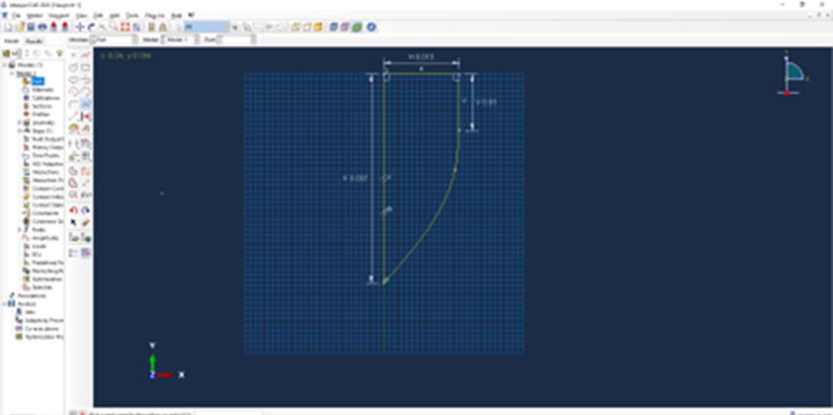
- The next thing to do is create both the bullet and the plate within the PART module, using the measuring tool values can be inputted to model specific scenarios.

- The next thing to do is proceed with creating an interaction with the projectile and the plate, this is done by putting the bullet just in front of the plate.

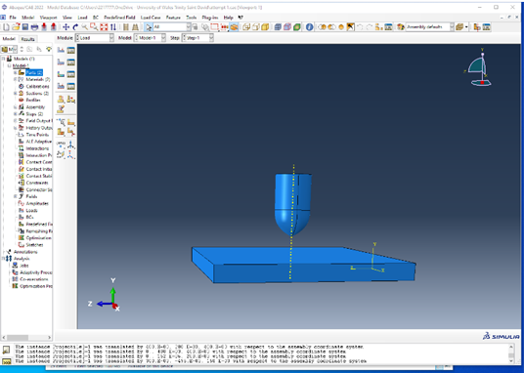
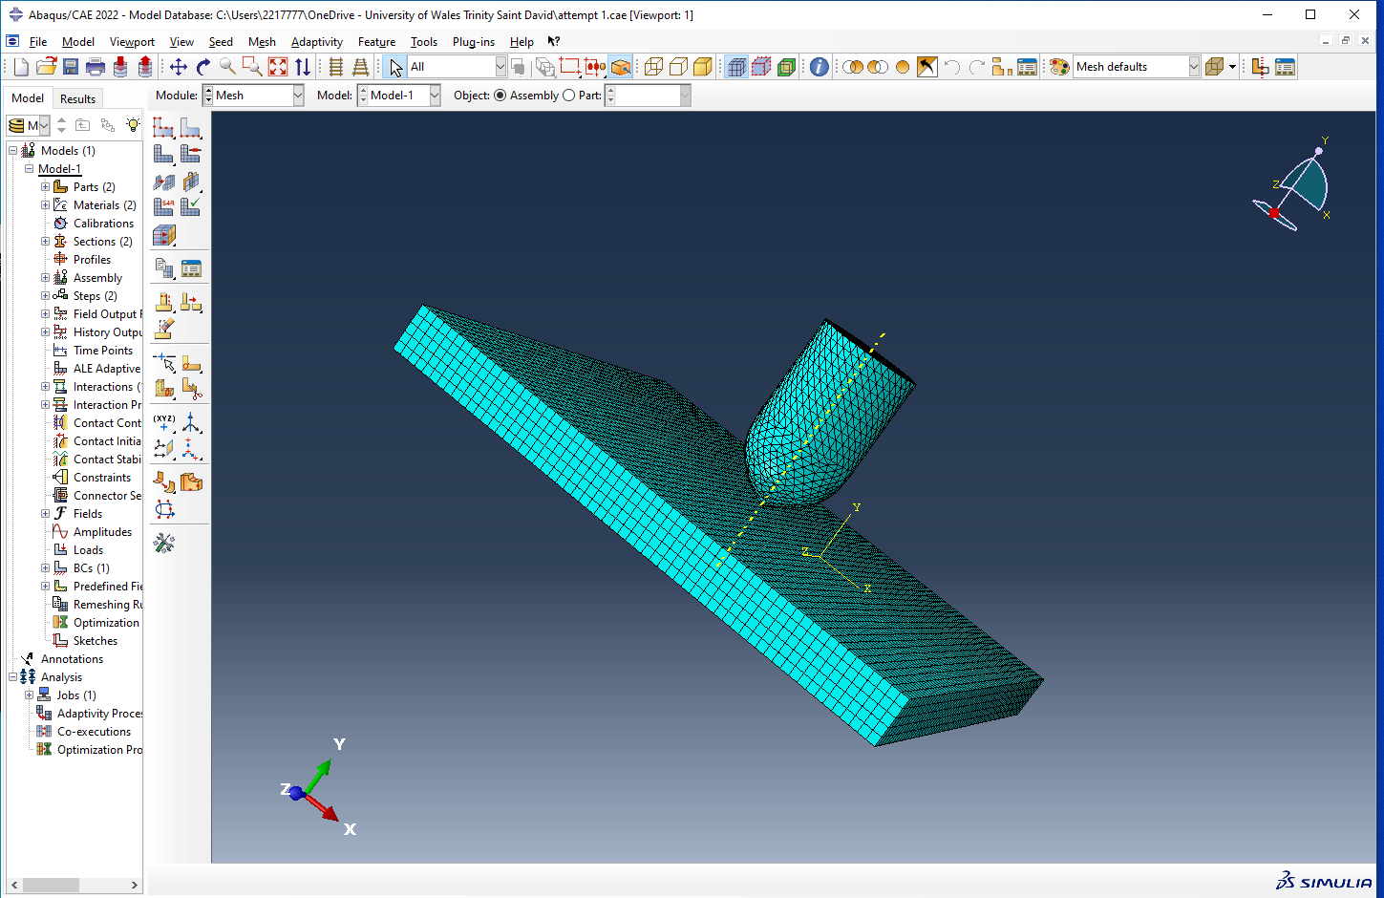
- The next thing to so is to mesh the parts so that it can be more easily seen how the materials will react under stress and shear forces.

- The next stage is that of inputting the velocity of the bullet, for the purpose of this assignment this value was changed (800, 1000, 1200 meters per second) but this will be discussed later in the report.

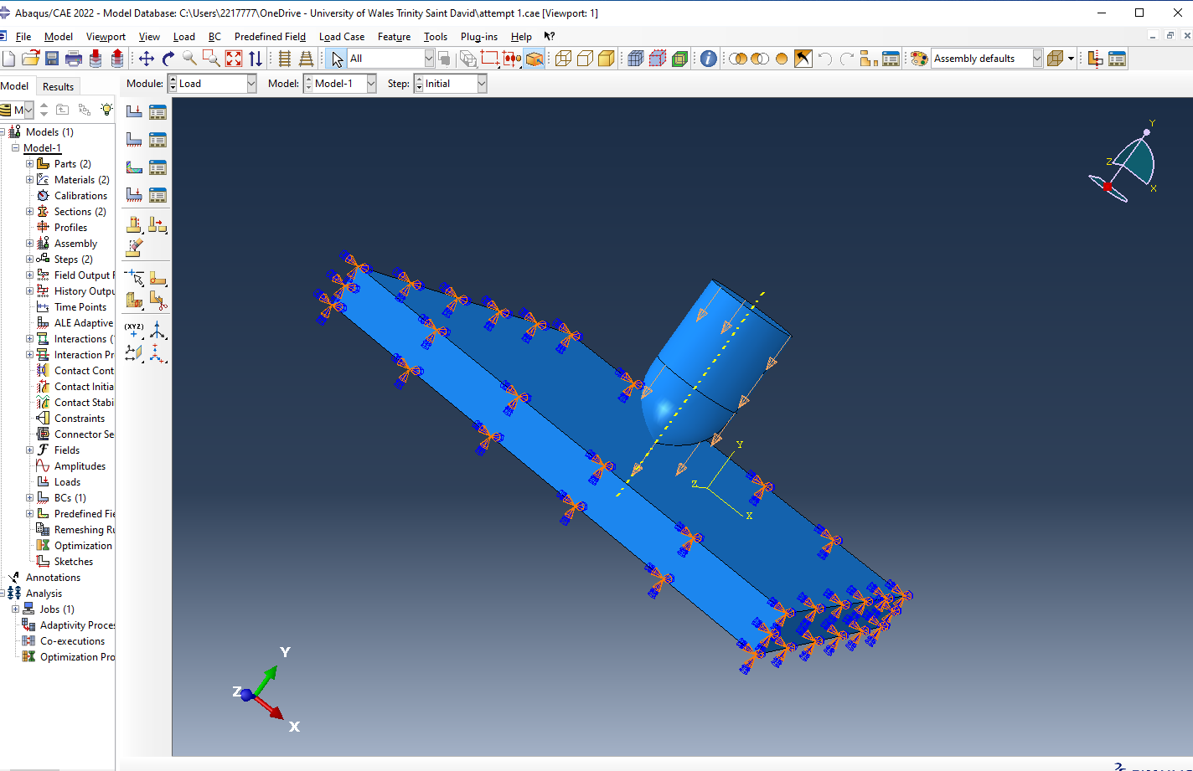
- It is also to be noted that the plate is now held in place so that when the simulation is run the plate part doesn’t move.

- The next step is to set an appropriate time step to the simulation so that an accurate interpretation can be made from the final model.
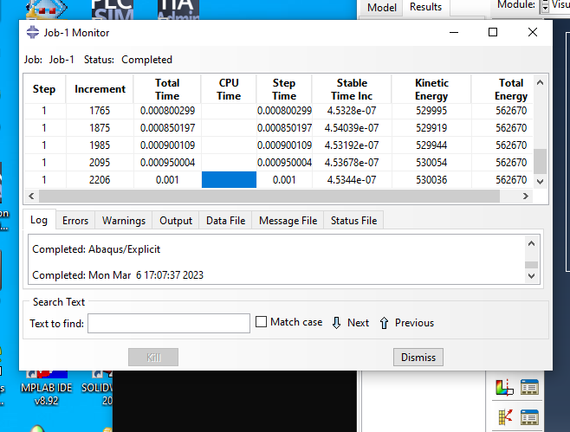

Running and evaluation of the model

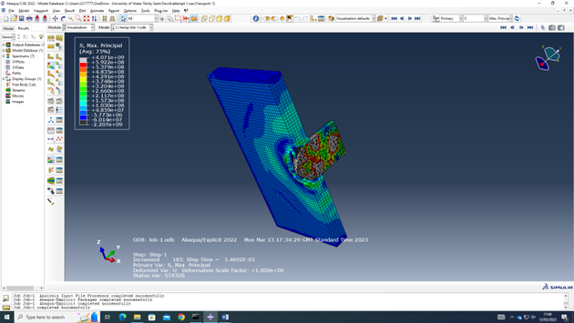
Running the model with the bullet at 800ms^-1

Seen above; Max principle values for 800ms^-1
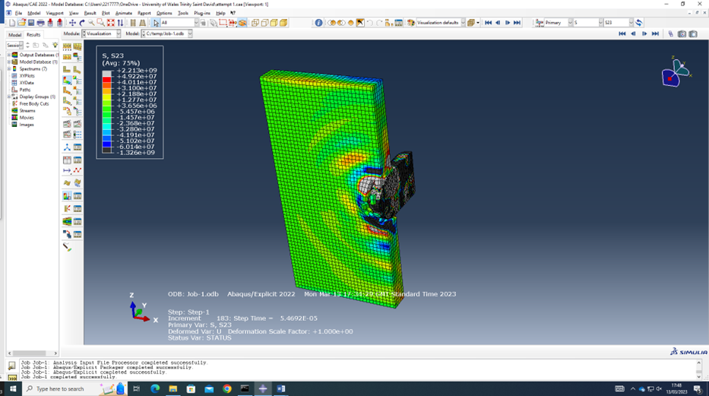
Seen above; Stress-Strain values for the bullet at 800ms^-1 in the S23 plane

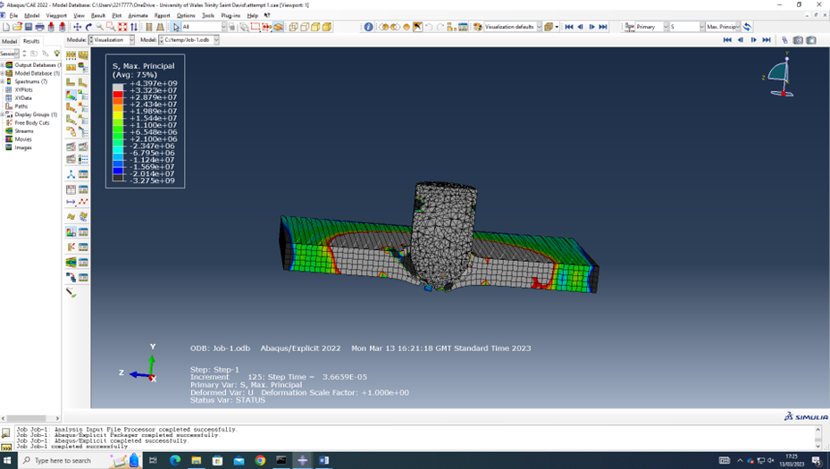
Running the model with the bullet at 1000ms^-1

Seen above; The max principle values for the bullet at 1000ms^-1
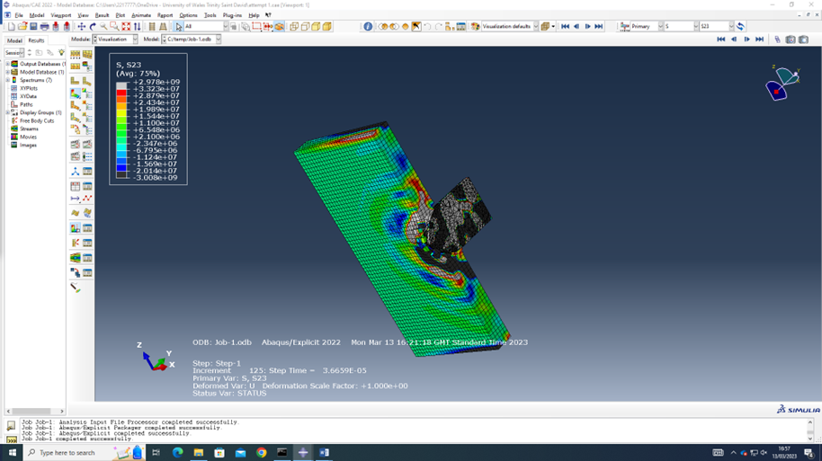
Seen above; the Stress-Strain values for the bullet at 1000ms^-1 in the S23 plane.

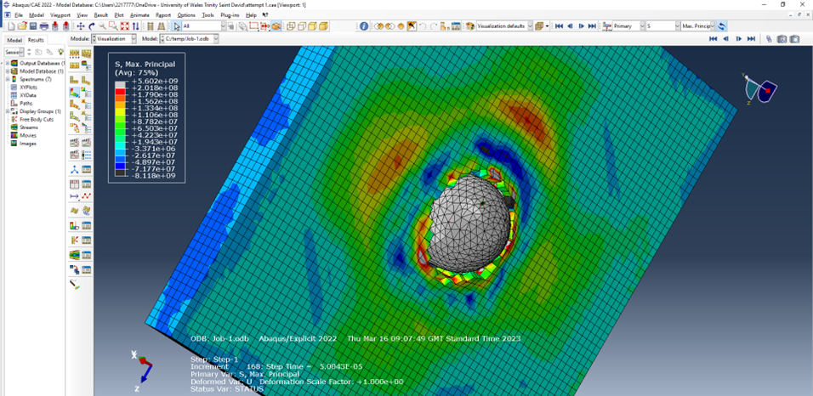
Running the model with the bullet at 1200ms^-1

Seen above; Max Principle values for the bullet at 1200ms^-1

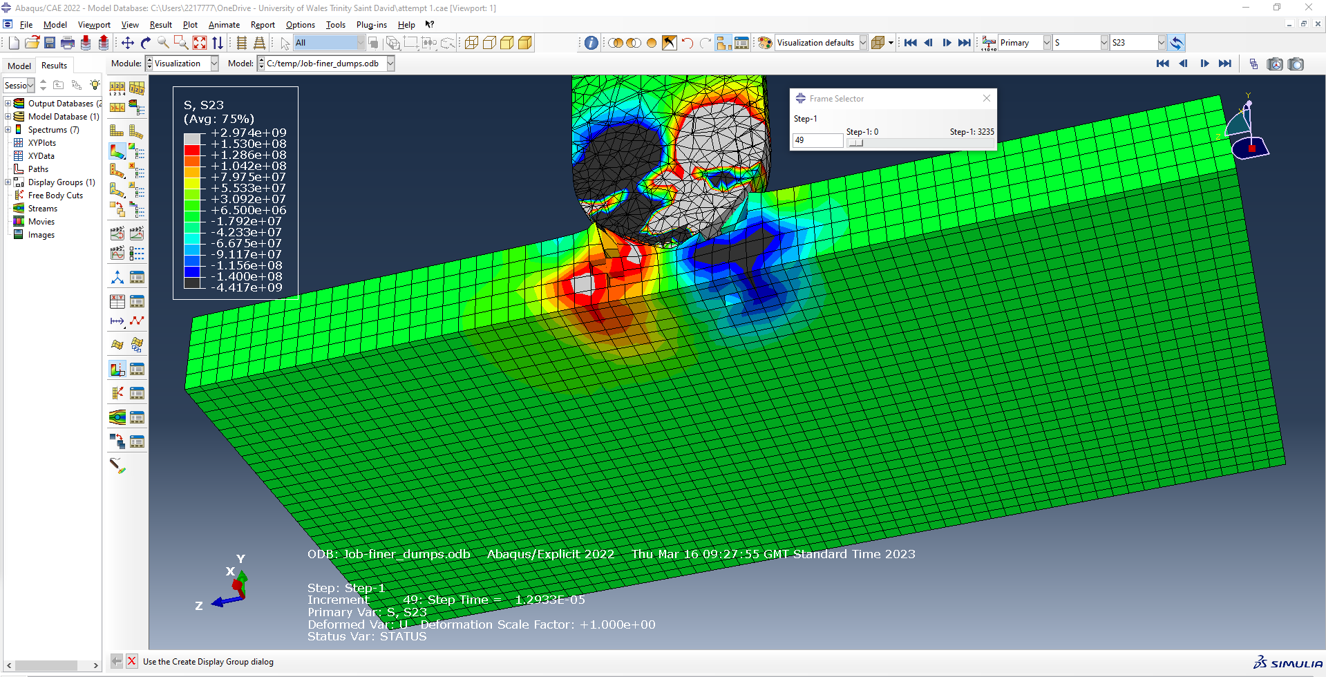
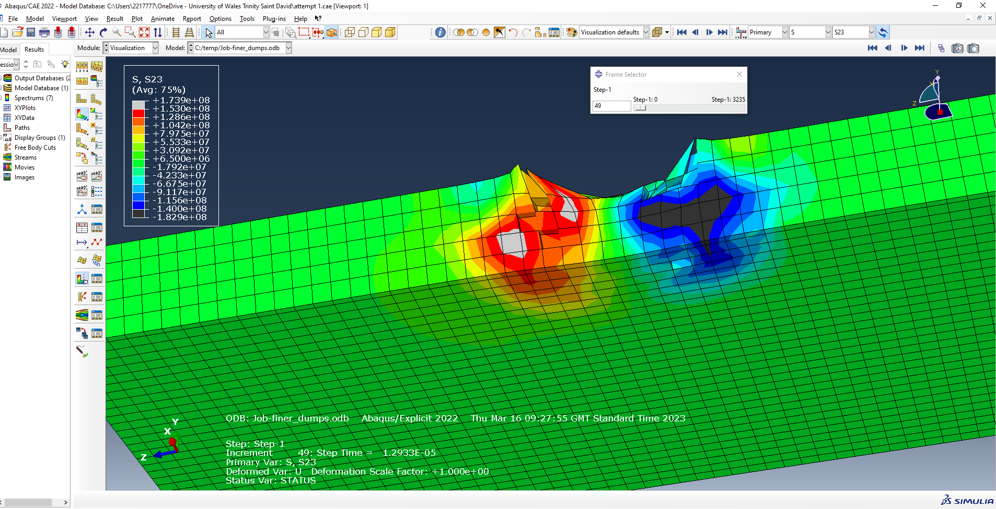

Seen above; the Stress-Strain Values for the bullet at 1200ms^-1 in the S23 plane.

From looking at the screen captures above from the S23 plane it can be seen that the plate section of the model breaks under the tension and not the shear forces present, this can be see in the above images when the tension value is very large whilst the bullet comes into contact with the plate. Also visualized with the colour differences.

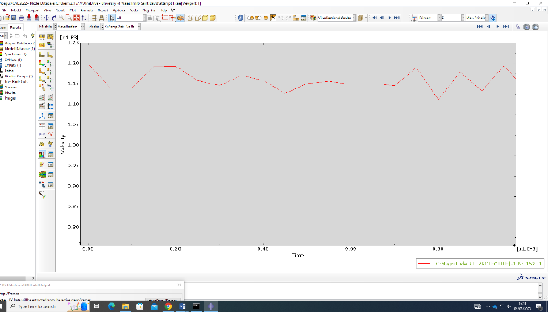

The graph above details the variation in velocity of the bullet when it is at a speed of 1200ms^-1, showing the initial impact of the bullet to the plate and the decrease in velocity after the fact. From this graph it can be seen that at 1200ms^-1 the projectile will pass through the plate with little to no resistance and very small yet visible decrease in velocity.
It should be noted that for the slower of the speeds the bullet would have an increase in change of velocity as the plate will provide greater resistive forces onto the projectile

References

[1] | UWTSD, Physics Lab Brief, Kelvin Donne .

