BA BUSINESS MANAGEMENT

Level 5 – Term 2 – Weekend

Assignment 1

WRITTEN REPORT ON ENTREPRENEURSHIP

Module: ENTREPRENEURSHIP

Code: LCBB5001

Lecturer: Amer Kareen

Student name: ROXANA BANEA

Student ID: 2124856

Submitted on: 19th August 2024

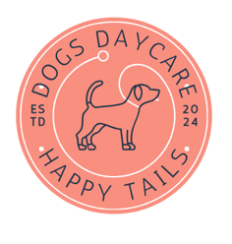

​​

Figure 1 Own created Happy Tails Dogs Daycare LOGO

Table of Contents
INTRODUCTION 3
MISSION STATEMENT 3
BUSINESS OVERVIEW 3
INDUSTRY ANALYSIS 4
PET INDUSTRY ON GLOBAL SCALE 4
PET INDUSTRY IN EUROPE 4
PET INDUSTRY IN THE UNITED KINGDOM 5
VRIO framework 6
PORTER FIVE FORCES 6
Buyer power 7
Supplier power 7
New entrants 7
Threat of substitutes 8
Competition 8
OPERATIONS AND MANAGEMENT TEAM 8
MARKETING PLAN AND BUSINESS STRATEGIES 9
The 4 Ps of Marketing 9
PRODUCT 10
PRICE 10
PLACE 10
PROMOTION 10
SUMMARY 12
Bibliography 12

INTRODUCTION

This report is focusing of the creation of Happy Tails Dogs Daycare business that is aiming to help the busy London dog owners feel at peace knowing that their favourite pets are cared for and safe at all times whilst life develops in the background. The first part of the report highlights the pet care industry around the world including United Kingdom. The second and third part of the report focuses on the business plan, the competitive landscape, the necessary marketing strategies to attract customers and the high emphasis placed on innovation and Ai technology.

MISSION STATEMENT

Happy Tails Dogs Day care is a business born out of love for dogs especially because of the sheer joy and happiness they bring to any dog owners. Within this, not so new century, the humankind has experienced a massive jump from a simple developing life to a fast developing one where we are all becoming increasingly busier, and we find less and less time for what we really love. This too affects our pets, people having long hours jobs or travelling might find it hard to care for a pet as they should. This is where Happy Tails comes into place to help those that want a tranquillity knowing that their pets are well looked after and sought after with love and dedication.

BUSINESS OVERVIEW

Our business offers not only a safe space for pets, but a place where the dogs can have fun, rest, and receive encouragement and training. Using the power of Ai (Artificial Intelligence) we provide for each dog a special collar which has a chip attached and which sends real time information related to health to a dedicated phone application 24/7. Moreover, the surveillance cameras within our dog day care are there to capture the whereabouts of the pets and allows owners to see real time footage of the dog. Furthermore, if health changes are detected, the information will be added to a health report with advice for the pet owners on what to do next for their pets. Such information can be accessed by any veterinarian within the country at any time for insides.

INDUSTRY ANALYSIS

PET INDUSTRY ON GLOBAL SCALE

The pet industry is ever so successful and constantly growing. It is expected to reach $300 billion dollars by 2033. This industry is over one hundred years old, and it is rapidly growing in developing countries with strong economies. It consists not only of buying and selling pets but also pet services such as grooming, clothing, food, pet sitting services, pet transportation, training, and veterinary services. (Zhang et. all, 2022).

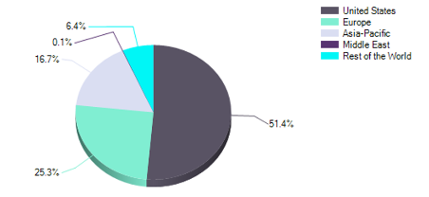
Figure 2 Global pet growth sustained by most developed economies. (Zhang et. all, 2022).

PET INDUSTRY IN EUROPE

In 2020 the European pet industry and healthcare market saw a growth of 3.5% and rose to almost $5.5 billion dollars. By 2025 this industry is expected to rapidly grow by 23.1% percent reaching $6.5 billion dollars. The growth is sustained by countries such as France, Italy, United Kingdom, Germany, Spain, and the smallest growth is represented by the rest of the European countries. (MarketLine, 2022).
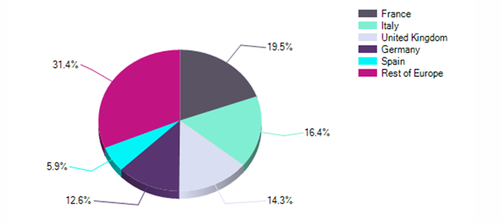
Figure 3 The European countries with the biggest pet industry growth. (MarketLine, 2022).

PET INDUSTRY IN THE UNITED KINGDOM
The United Kingdom currently hosts a dog population of 12 million, with the highest concentration found in the South-East, home to approximately 1,320,000 dogs. On average, British pet owners allocate about £178.00 per month, equating to £2,136.00 annually, for their pets' needs. Of this annual expenditure, £200.00 is specifically spent on pet clothing. Additionally, 66% of pet owners indulge in buying accessories and pampering items for their pets.
Despite the challenges posed by the COVID-19 pandemic, Brexit, and the rising cost of living, 80% of pet owners have adjusted their grocery budgets to maintain their pet-related spending. As of 2024, only 10% of pet owners have reduced their pet expenditures, with 42% continuing to splurge on their pets even with tighter budgets. The pet care industry is expanding rapidly, driven by increasing demand for services such as veterinary clinics, pet grooming, pet-sitting, dog-walking, dog training, and pet hotels. This sector is poised for further growth as pet owners continue to prioritize their pets' well-being. (Groomarts, 2022)
The United Kingdom pet industry sits at just over £8 billion pounds annually, out of which £760.1 million pounds are represented by the veterinary health care industry as per a MarketLine report from 2022. This forceful industry is expected to grow each year and add an extra £1 billion pounds to the economy. It is forecasted that in the next 3-5 years the pet industry will add to UK’s economy an extra £1 billion pounds per every year with an increase of 18.8% since 2020 with grooming and care services being the largest expenditure for pet owners. (MarketLine, 2022).

VRIO framework


COMPETITIVE PARITY

TEMPORARY COMPETITIVE ADVANTAGE

UNUSED COMPETITIVE ADVANTAGE

LONG-TERM COMPETITIVE ADVANTAGE


For a resource or capability to provide a sustainable competitive advantage, it must be valuable, rare, difficult to imitate (with no substitutes), and effectively utilized by the organization, even if replicating it is costly in terms of time, money, or both. The VRIO framework serves as a fundamental tool for conducting internal analysis. (Morris, J, 2020).
Happy Tails Dogs Daycare is valuable because it has the capability of attracting customer and offers premium memberships for its users. There are very few companies that can be called rare, and our business doesn’t meet such target. Moreover, the business model can be emulated but it will involve high costs and a very strong customer base. The business is well organised, but it is limited due to cash resources, space, and manpower.

PORTER FIVE FORCES
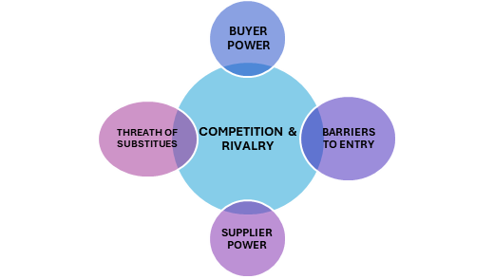

Figure 4 Porter's Five Forces

Buyer power

The overall pet industry buyer power it is represented by physical products for pets such as food and accessories and it is done largely through supermarkets and hypermarkets with a total market value of 19.6% in the year of 2020. For pet sitting, dog care and dog day care services, the buyer power is represented by those that have a higher income, a larger disposable income, families of 3 members, 4 members or more and ageing population. In the United Kingdom, the buyer power is concentrated in the Southeast of the country rather than the rest of it. (MarketLine, 2022).
Happy Tails Dog Daycare is in Chelsea in London where the need for dog care services, overnight boarding and dog sitting are more sought after. Because of the considerable number of dog owners, the business can have a constant flow of customers despite of the presence of competitors. Overall, the buyer power is strong,

Supplier power

The pet industry in the United Kingdom is not short of innovation and nowadays supplier tend to offer products and services that would meet pets’ basic needs, tailor made and even ones to support individual needs. Food products are now available based on age, weight, health limitations and requirements, etc. For care services, suppliers offer services to meet not only the pet needs but also the owners need with a few dog day cares offering long days boarding services, pick-up and drop-off services, weekend day care services, etc. Despite the high presence of dog day care businesses, the supply of space, trained staff, etc., are making the supplier power to be limited to moderate. (MarketLine, 2022).

New entrants

In Chelsea London, the main players are represented by City Paws Club, Pet Pals, and Borrow My Doggy whereas on a larger scale represented by the whole of London, Rover.com is the main player. Through this website, anyone can become a dog sitter, offer day care services for dog in their own personal home and other services. In this way the services can be much cheaper rather than an established dog day care, there is more flexibility for owners and the service providers and a larger coverage of the city of London and other part of the United Kingdom. Because of the moderate growth experienced during 2016 – 2020, the market is interesting to new entrants, but the threat remains moderate. (MarketLine, 2022).

Threat of substitutes

The threat of substitutes is relatively small as such dog care services require human input and help. There is the option of leaving a pet alone at home and having a friend/family member/relative feeding the pet daily but despite this option, some owners are not comfortable knowing that their pet is alone at home and not watched after. (MarketLine, 2022).

Competition

The UK pet industry is fairly fragmentated with a large part being represented by the healthcare industry, a part for food, one for grooming and another one for the rest of pet services. The competition for dog’s daycare can be intense based on areas such as London and less in other parts of the country. In London Chelsea, the biggest competitors of Happy Tails Dog Daycare are Club City Paws and Pet Pals whereas the biggest competitor at a national level is represented by Rover.com and independent dog sitters. Overall competition is not big but moderate leaving space for new entrants. (MarketLine, 2022).

OPERATIONS AND MANAGEMENT TEAM

Happy Tails Dog Daycare is a small business, and it is faced with a challenge that limits its development – this is related to space. Because of this limitation, the business cannot support more than 50 dogs on a daily basis and monthly which implicitly affect the manpower necessary for this business. This has led to having a small number of employees being hired as cluster and having to take on board tasks that would otherwise be covered by 2 people. Despite this setback, none of the tasks are deemed as exhausted nor can be impossible to complete.

The team is made of the CEO that will also be responsible for Marketing and Business strategy. The CEO is undertaking university courses for Business Management and has experience with marketing, social media engagement, etc.

The facility manager is responsible for inside daycare and as well as the outside, this ensures dogs are comfortable and safe while going on with their day. The manager will report directly to the CEO.

The IT director is not only responsible for keeping IT communications and applications running smoothly but as well he serves as the inventive mind of how the power of Ai (Artificial Intelligence) is being used for the business best interest and growth.

The professional dog trainers and behaviourist are there to support the dogs to make the most out of their day, offer ongoing support, care, and trainings.
Part of the funding required will be used to hire enough manpower to aid the ongoing development of the business.

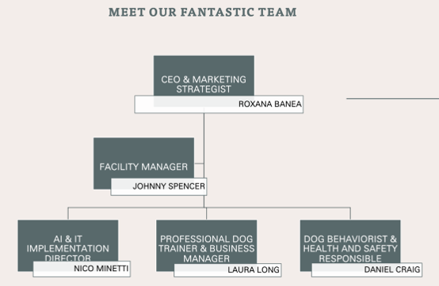

MARKETING PLAN AND BUSINESS STRATEGIES

The 4 Ps of Marketing

The four Ps of marketing – product, price, place, promotion – are the main marketing tools for any business which if well-established can lead to a successful growth within the business. This strategy was developed in the 1950s by Professor of Advertising at Harvard, Neil Bordon who sought to offer important business insights for any entrepreneurs looking for success. (Novak, 2024)

PRODUCT

The first P is represented by Product which can vary in forms; this could be a physical product, a service, an experience, or a digital service. (Novak, 2024)
In Happy Tails Dog Daycare’s case, the business offers a service rather than a physical product and a digital service. The Ai controlled dog collar allows pet owners to obtain real time information of their dog’s health. The algorithm is compacting the information into easy-to-read graphics to allow users to understand the health of their pets. Moreover, the dedicated phone application will send alarms if the pet is critically injured or unwell.
Another service provided is real time video footage of the dog. The Happy Tails Dogs Daycare cameras are specially designed to capture information of all dogs with special emphasis on some of the dogs.

PRICE

The 2nd P of the 4 Ps is price which allows business owners to obtain profitability and ensure constant flow of business. (Novak, 2024)
At Happy Tails Dogs Daycare, prices vary based on the number of days required for the dog to stay in. This price can be different if the customer decides to leave the dog overnight, for a longer period than the usual 5 days and if the dog requires training or special care.

PLACE

The 3rd P of the 4 Ps is place which is just as important and it refers to the place of where the products, services, etc. are being sold. (Novak, 2024)
The day care is conveniently located in Chelsea mainly because the targeted customers are busy families, people who travel abroad for work and people traveling to and from work. In Chelsea despite the space limitations and competitors, customers do require dog day care services.

PROMOTION

The 4th P of marketing is promotion which is the means through which businesses are advertising their product or services to attract their customers. (Novak, 2024)
For Happy Tails we are looking to use the means of social media and as well encourage our customers to recommend us to a friend.
Should any of our customers recommend us to their friends, both will be entitled to a 1 day of daycare free of charge.

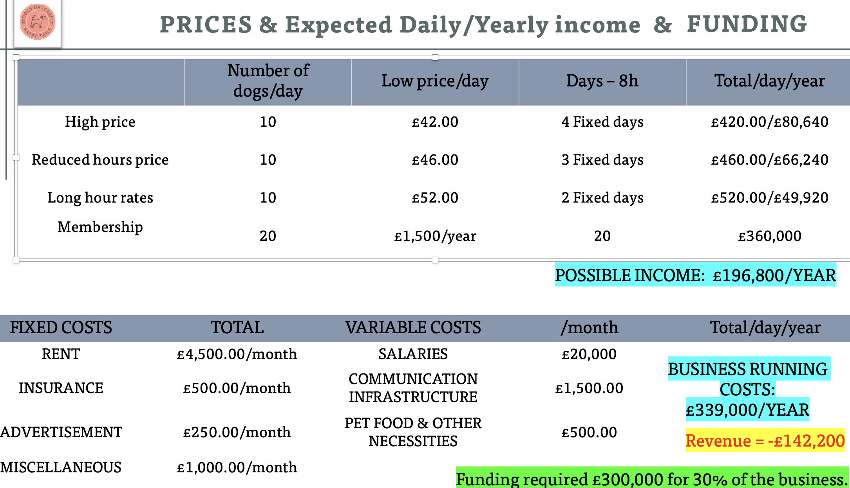
FINANCIAL PLAN
Figure 5 Image taken from my initial Power point presentation pitch of Happy Tails Dog Daycare.

The financial plan involves covering the business fixed costs such as: rent, insurance and advertisement which are required to be paid monthly. Rent is one of the largest fixed costs. The variable costs involve paying the salaries, covered the communication infrastructure such as internet, CCTV, AI based technologies, application development and maintenance etc. Further investment will be allocated for pet food, pet care services and other miscellaneous costs or unforeseen costs.

SUMMARY

Happy Tails Dogs Daycare is a premium pet care service in Chelsea, London, designed to meet the growing demand for reliable and innovative dog care. Founded from a deep love for dogs, our mission is to provide a safe, nurturing environment for pets while offering owners peace of mind through advanced technology. We integrate AI-powered health monitoring and real-time video surveillance to ensure the highest standards of care. This business plan outlines the expanding pet care industry, our competitive edge, and strategic initiatives, positioning Happy Tails as a trusted leader in the market.

Bibliography

- Morris, J. (2020). VRIO Analysis. Retrieved July 2024, from Oregon State University: https://open.oregonstate.education/strategicmanagement/chapter/4-vrio-analysis/
- Novak, J. (2024, June 18). FORBES. Retrieved from https://www.forbes.com/advisor/business/4-ps-marketing/
- ​​MarketLine. (2022). MarketLine Industry Profile - PET Healthcare in Europe. MarketLine Industry Profiles.
- ​MarketLine. (2022). Pet Healthcare in the United Kingdom. MarketLine Industry Profile. Retrieved from https://research-ebsco-com.ezproxy.uwtsd.ac.uk/c/onvpsy/viewer/pdf/jcfpexqzyn.
- ​Wangyi, Z., Ca, H., & L. L. (2022). Analysis of the Future Development Trend of the Pet. Proceedings of the 2022 7th International Conference on Financial Innovation and Economic Development (ICFIED 2022), 1682.

​​

