University of Wales Trinity Saint David
London Campus

Management Economics

Assessment 1:
Economic Analysis of British Airways plc

Lector: Samuel Ze -To

Galina Gancheva 2022711

Date: 05/09/2022 word count:2500

Contents
Introduction 3
About British Airways plc 3
Findings
Demand and Market Equilibrium 3
Factors that may affects demand 5
Cost management 5
Market structure 5
Regulation and Policies 6
Conclusion and Recommendation 7
Reference list 8
Appendices 10

Introduction
In this assessment, I will look at how economic data can be used as a guide for making policy at the international, national, and organisational levels. It will use several economic ideas, such as supply and demand, price elasticity, and cost analysis, to explain how managers make decisions in businesses. It will look at how government policy affects markets and how that affects the decisions that managers make. Economic analysis tries to figure out how markets work, how prices change, what can affect a company's costs and how it makes money. (Begg, and Ward 2013)
According to Sloman, J. (2019) All businesses are different, but they all produce goods and services in some way. They spend money on inputs to make outputs that make money. The firm's profit is the difference between how much money it made and how much it spent. Even though companies can have different goals, we assume that most of them want to make as much money as possible or at least keep their profits from going down. To reach these goals, managers will have to make good decisions about what to make, how much to make, and at what price; what production techniques to use; how many and what kind of workers to hire; and what suppliers to use for raw materials, equipment, etc. Business economists study these choices, and we will look at aviation services.

About British Airways plc
Investors today are really worried that their money should be put into a company that not only has a strong financial position for the near future but also has good social and environmental policies. All businesses try to be environmentally and economically sustainable in different ways. We'll talk about the pros and cons of putting out this kind of information and critically look at the social and environmental data that British Airways plc has put out, looking into specific issues related to the company and the aviation industry. This information would help you decide whether to recommend investing in the entity or not.
British Airways Plc is the largest airline in the United Kingdom in terms of the number of people who fly with it. British Airways was created in 1974 when four airline companies merged. It serves places all over the world and has code-sharing agreements with several companies, such as American Airlines and Qatar Airlines.

Demand and Market Equilibrium
During the coronavirus pandemic, the economy did well. The pandemic of coronavirus had a big effect on British Airways. The airline only made 3.9 billion British pounds worldwide in 2020, which was 70% less than the year before. Because of the coronavirus pandemic, British Airways lost 74% of its passengers, which means that only 11.66 million people will be able to fly with them in 2020. (Salas, E. 2022)
British Airways Plc is a public limited company based in England and Wales, which is also where it was founded. The London Stock Exchange is where the ordinary shares of the Company are traded. According to the CEO, British Airways had a mixed year last year. However, they are the only airline to have taken part in an emissions trading scheme, which is a big deal. Since 1990, they have cut emissions by 28%. In 2020, they set a new goal to cut CO2 emissions by another 25% by 2025. For the airline industry, the next few years will be very hard. (Annual Report 20/21).
British Airways plc is a group of about 30 companies whose headquarters are in Harmondsworth, UK (UK). British Airways has flights to both domestic and international locations, low prices, and both passenger and cargo flights. E. Salas did a study on it (2022) Between 2011 and 2021, British Airways plc's net profit changed each year. In 2012, the company made 114 million British pounds, which was the least. In 2015, the company made 2.5 billion British pounds, which was the most. In 2021, British Airways reported a net loss of almost 1.6 billion British pounds, which was better than the loss of 3.5 billion British pounds that the company reported in 2020.
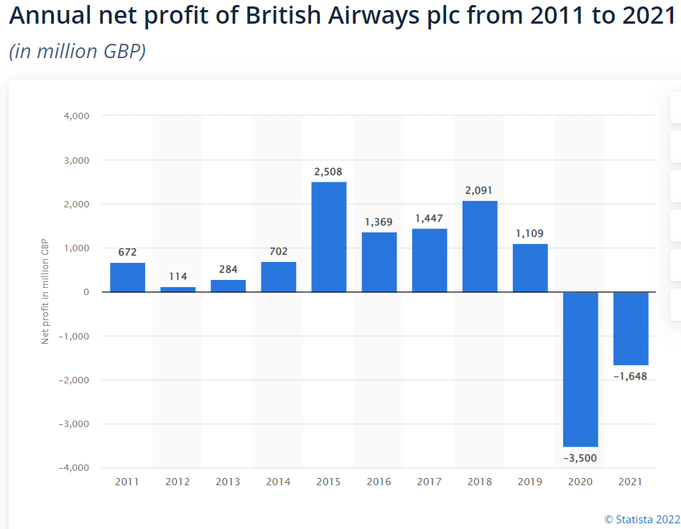
Airlines are having a hard time making money right now. Operations-wise, though, they are doing better than they ever have before, Mostly because of Heathrow Terminal 5. So, they continue to carefully plan for the future, balancing the need to take short-term actions to help us get through a very tough trading environment with our long-term goal: to build a high-performing, market-focused, global premium airline.
Since 2008, the number of passengers that British Airways plc picked up in the United Kingdom (UK) has been going up. However, when the coronavirus pandemic hit in 2020, the number of passengers dropped to 11.6 million. Even though its revenue and number of passengers have grown at a very fast rate, the UK-based airline is still a small player in the global aviation industry. With 274 planes in service, British Airways was the 13th largest airline in the world in 2019.
Number of passengers uplifted by British Airways plc from 2008 to 2020
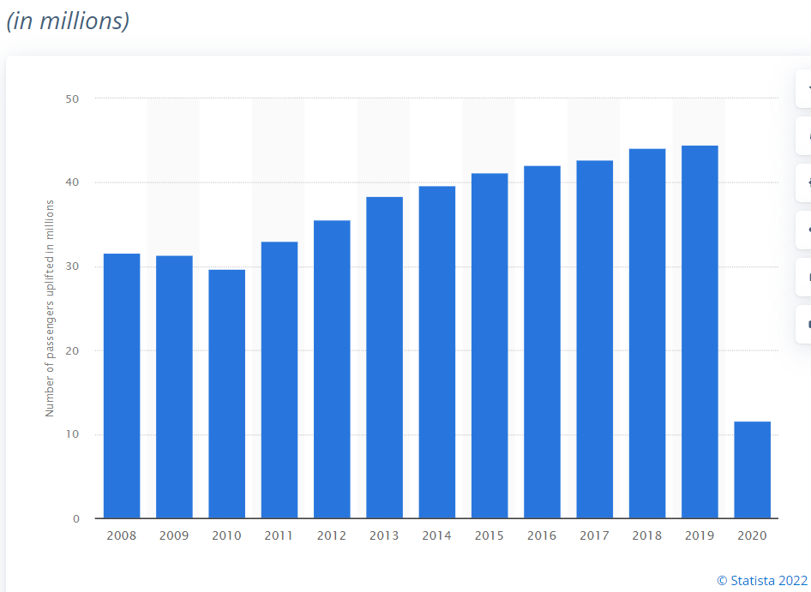

Factors that may affects demand
After so many flight cancellations and delays, British Airways, the national airline of the United Kingdom, has raised ticket prices by a lot. This decision was made because of the problems that happened last week. They were caused by a computer problem that was fixed, but it had a number of side effects that were made worse by a lack of staff and a new wave of covid-19 infections. (Avionews, 2022) Fuel prices are going up, which will have an effect on the price of the service. The number of people who fly could go down if flights got more expensive.
Consumers' tastes and preferences change depending on how much a product costs and how much people want it. The airline has more expensive business class tickets that are made to fit the tastes and needs of each customer. Most of the plane's costs would be paid for by the more expensive tickets. So, the company could offer cheaper tickets and get more people to use them.

Cost management and Market structure
Consistent with Sloman, J. (2019) The market determines what a business does. The more competitive a market is, the less power a company has to change it. In the worst case, the company may have no power at all to change the market. If it can't sell its product, its competitors will take all of its sales. They have to accept the price that the market sets. If they each try to sell for more than the market price, no one will buy.

In August 2008, they asked for anti-trust immunity so that they could run a business with American Airlines and Iberia across the Atlantic. The EU and US competition authorities are currently deciding if they should have the same rights on these routes as their main competitors, Star and Skyteam. British Airways and Iberia Airline said that they would join in 2010.
In the fall of 2008, the downturn in developed economies led to a recession around the world. With record oil and commodity prices, the collapse of the pound, and a global financial crisis, most businesses have lost money or even struggled to stay in business. Since fuel is still a big part of an airline's costs, this has caused British Airways to lose money. There is a lot of competition on the market. Low-cost airlines like EasyJet, RyanAir, WizzAir, and others have seen an increase in the number of people who fly with them.
The environment is also a very important factor in the airline business. As more people fly for business and pleasure, noise and air pollution are becoming bigger problems. Many analysts say that the damage the industry does to the environment is unsustainable. Airlines are getting more and more pressure to do more to protect the environment, such as make sure planes are running at full capacity, improve fuel efficiency and reduce emissions, invest in research and development, and think carefully about when flights start and end. (Sloman,2020)

Regulation and Policies
The Accounting for Sustainability project has made a Connected Reporting Framework to make information both inside and outside the organisation clearer, more consistent, and easier to compare. It shows how all parts of an organization's performance can be shown in a way that fits with its strategy and the way it is run. (Elliott, 2009). Since social pressure has grown, the Companies Act of 2006 says that the Directors' Report must include information about the company's employees, the environment, and social and community issues.
Fuel efficiency improvements take time and money. Even though regulations on emissions are getting stricter, the aviation industry only uses the newest engine models. Several studies have shown that corporations' environmental disclosure is still very low, even though they are getting more pressure from different stakeholder groups and government agencies to address environmental issues. Even though the US Superfund law has created a lot of financial risk for chemical and similar companies, disclosures of liabilities are a relatively new thing. (Milne and Patten, 2002). Some international organisations have made environmental initiatives to try to get companies to report on the environment and to help them do so. This study looks at a number of these initiatives, which have been proposed by different groups to help with the development of social and environmental disclosures. The study tries to answer the question of whether these programmes help companies get around the problems that keep them from making more detailed environmental reports. (Dixon et al, 2005).
Social and environmental reporting includes a wide range of things, such as employee reporting, social audit, silent social report, and ethical investment. The company might only tell the public about some of the information. Peer pressure groups like Greenpeace and Friends of the Earth want to find out more about the green funds and contingent liabilities that companies invest in.
The group's goal is to help people who care about how they fly get good service. In order to do this, British Airways knows it needs to work together with its shareholders. This has changed how it handles its social responsibility (CSR). Its approach has also been shaped by the fact that airlines bring big social and economic benefits, but also have big effects on the environment (like through noise and air quality) and on the communities near airports.
In the year 2000, international aviation was responsible for about 2.4% of the world's CO2 emissions. (Fuglestvedt et al., 2008). When the origin of each flight is taken into account, this already large global emissions burden can become an even larger and growing part of each country's emissions burden. (Jackson et al., 2007). The UK's Committee on Climate Change has recognised how important aviation is as a source of emissions. In response to the Climate Change Act of 2008, the Committee has recommended that international aviation emissions be included in the country's goal of cutting emissions by 80% by 2050 (CCC, 2008).
British Airways took part in CSR for more than one reason. The first reason is that creating growth opportunities near Heathrow Airport helps the company reach its long-term strategic goals. Second, waste and energy programmes helped businesses save money and become more efficient. This was a good argument for CSR. The company also thought that CSR could help them deal with risks by pointing out dangers to health, safety, and the environment that could make it harder to get investors and grow the business. Lastly, it knew it had to do something to improve the business's reputation and how customers felt about it.

Conclusion and Recommendation

From what has been said so far, we can draw the conclusion that the price of plane tickets is directly tied to the price of fuel. It is a very important part of pricing. The number of people on board is also very important. When everyone is on vacation, which is peak season, the price of tickets goes up. When it's not peak season, the price goes down. So, the elasticity of both supply and demand is different depending on a number of factors.
Energy efficiency has kept getting better because of things like better technology and better load management, among other things. Regional econometric modelling showed that the demand for aviation fuel is not affected by the price of aviation fuel, even though the two have opposite effects on the finances of individual airlines. The demand for fuel is very sensitive to the number of flights, which is mostly a result of economic growth. The fact that the energy intensity of the aviation sector is still going down in all parts of the world was confirmed by the elasticities of fuel demand and air traffic.
If I had to choose the best company to invest in, I would make sure it is honest and follows the rules. Since its start in 1974, British Airways plc has built a strong brand name. They are the biggest international scheduled airline and air cargo business with hubs at London Gatwick Airport and London Heathrow Airport. If you don't count their subsidiaries and franchisees, they fly to 148 places and own 245 planes. British Airways has made investments in subsidiaries that are wholly owned by them. These investments have helped them expand their activities to include airline marketing and operations, aircraft financing and maintenance, holding companies, insurance, investments, and package holidays.
Reference list:

- Sloman, John; Jones Elisabeth (2020) Essential economics for business; sixth edition; England; Harlow
- Sloman John; (2019) Economics for business [electronic resource]; eight edition; Harlow England; Pearson
- Sloman John; Garratt Dean; Guest Jon; John Elizabeth (2019) Economic for business; Eight edition; Pearson; Harlow England
- Samuelson; William E (2015) Managerial economics; Eighth edition; Wiley; Hoboken New Jersey (NJ)
- Aigner-Walder, B. (2015) Effects of the Demographic Changes on Private Consumption: An Almost Ideal Demand System Analysis for Austria. Journal of Economic and Social Studies
- Elliott, B., Elliott, J (2009) Financial accounting, reporting and analysis., 13ed Finanical Times/Prentice Hall, New York
- Andreyeva, T., Long, M. and Brownell, K. (2010) The Impact of Food Prices on Consumption: A Systematic
- Review of Research on the Price Elasticity of Demand for Food. American Journal of Public Health, 100,

- Griffith, G. (2003) The Impact of Supermarkets on Farm Suppliers. The Australian Economic Review, 37,

- OECD (2015) GENERAL ASSESSMENT OF THE MACROECONOMIC SITUATION. OECD Economic Outlook Volume 2015/1

- https://www.warc.com/ContentandPartners/EuromonitorInternational.info 04/09/2022 15:30

- https://fred.stlouisfed.org/ - data on macroeconomic indicators 04/09/2022 15:50

- https://www.ons.gov.uk/ - data on UK businesses 04/09/2022 16:00

- http://www.statista.com/ - data on various indicators for various countries 04/09/2022 16:15

- http://stats.oecd.org/ - data on social and economic indicators, OECD countries 04/09/2022 16:30

https://www.britishairways.com/en-gb/information/about-ba/ba-better-world/responsible-business accessed on 01/09/2022 17:35
https://www.britishairways.com/cms/global/pdfs/information/sustainability-report-2021.pdf 01/09/2022 17:30
https://www.britishairways.com/en-gb/information/about-ba

Salas, E. (2022) British Airways plc: annual net profit 2011-2021
Published Sep 1, 2022 https://www.statista.com/statistics/1007530/net-profit-british-airways-plc/#:~:text=In%202021%2C%20British%20Airways%20reported%20a%20net%20loss,2011%20to%202021%20%28in%20million%20GBP%29%20Additional%20Information
Salas, E. (2022) British Airways - statistics & facts Published Apr 19, 2022 https://www.statista.com/topics/5372/british-airways/

Passengers uplifted by British Airways plc 2008-2020
Published by Statista Research Department, Jul 12, 2022 https://www.statista.com/statistics/304108/number-of-passengers-on-united-kingdom-airlines/

Why British Airways ticket prices go up and down https://www.avionews.com/tv/item/1243539-why-british-airways-ticket-prices-go-up-and-down.html London, United Kingdom, 04/09/2022 11:09
AVIONEWS - World Aeronautical Press Agency

Appendices:

John Sloman ECONOMICS FOR BUSINESS
The Economics Network Pearson
Eighth edition University Of Bristol
Visiting Professor, University of the West of England
Dean Garratt
Aston Business School
Jon Guest
Aston Business School
Elizabeth Jones
University of Warwick
Page 66 fig. 5.3


