CIPD Level 5 Associate Diploma in People Management – Level 5
5CO01 Organisational performance and culture

- Evaluate the advantages and disadvantages of both a divisional structure and a matrix structure. Within the evaluation, you should include the reasons underpinning each structure. (AC 1.1)

Organisational structure defines how an organisation operates, on all levels. It must align with correlate to the operational its goals - to quote - “the aim of organisational structure is to manage a range of different activities that result in the provision of a product or service to a customer”. Its aim is to manage activities that deliver products or services to customers. Schein defines it as the organisation as a “planned coordination of the activities of a number of people for the achievement of some common, explicit purpose or goal, through a hierarchy of authority and responsibility” (Schein, 2010).

There are six main organisational structures – 1. Hierarchy, 2. Network, 3. Functional, 4. Flat, 5. Matrix, and 6. Divisional.

Below, I am going to I evaluate two potentially controversial structures, outlining their advantages and disadvantages and the reasons underpinning each structure with and supporting rationale.

Matrix structure

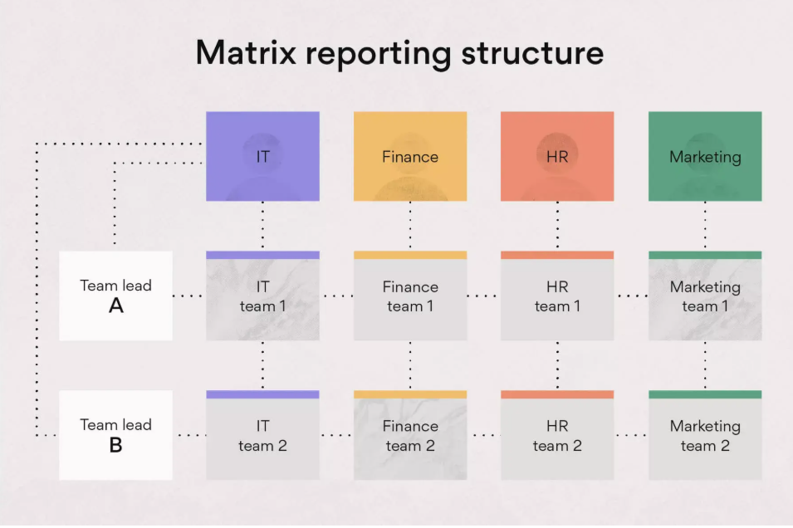

Fig. 1 - What Is a Matrix Organization and How Does It Work? (2025)

A matrix organisational structure as shown above in Fig. 1 Is one where a business has a goal or and brings together project teams are brought together to achieve the said goals. Each department has its own aims that contribute to overall success within the business to achieve the overall business goals – the way each department does this may differ; however, the essence is to achieve the business goal.

According to CIPD, “The structure encourages communication and collaboration between teams and improves decision-making” Disadvantages include, if poorly managed, can result in potential confusion, management conflict and a lack of clarity regarding priorities and organisational goals” (CIPD, 2022).

Working within Andrews Property Group in 2022/2023, there was a project called "make Andrews great again." This project was structured to the matrix structure above; each department had its own specific goals, and within those departments, individuals had their own tasks, and individuals within each department had more than one leader organised as a matrix, with departments setting goals and individuals reporting to multiple leaders. My task was to reduce turnover of staff to achieve this I must first identify why employees were leaving. I would then report to my managers the reason for the high staff turnover and how we could improve the employee life cycle to retain the talent and staff within the business. This, I feel, was a good example of a matrix organisational structure, where employees reported to multiple managers, often their own manager as well as other managers the business.
To achieve the data needed to implement changes to reduce turnover, data was collected by speaking To gather data I spoke to leavers to determine the reasons for leaving, why they left the company, as well as interviewing and interviewed employees that stayed in the business for over 3 years. To find out understand why they chose not to depart, to identify then use that data to gain insight into what was a positive reinforcers. I created a spreadsheet to collect the data and converted it into a chart with percentages that I would present to my HR director, the Finance Department, and Project Managers. Initially, the benefits for this structure, I found, were that it was conductive to positive change, shared accountability, and collaboration. Nevertheless, the negatives I found were that it incited confusion about my role, uncertainty about which orders to prioritise, and disagreements among managers who did not agree on the course of action once problems had been recognised. The structure encouraged positive change, shared accountability and collaboration. However, it created confusion about my role, uncertainty over priorities and managerial disagreements. The main issue here concerned Finance, as they perceived HR suggestions as financial burdens and saw them as disadvantages, short-sighted to the long-term benefits.
Each section of the project had its own aim, and although all were striving for the same goal ‘to make Andrews great again’, Department aims occasionally conflicted. An example being, Finance wanted to cut costs, while HR wanted to invest in training and rewards. Meetings were often contested, but decisions were impartial via departmental voting. occasionally team aims did not coincide. For example, Finance felt the need to cut spending, whilst HR wanted to invest more into employees. This meant investing in training and rewards which cost money. Suggestions from HR during project meetings would often be hotly contested, as Finance did not see the benefits of many of the proposals. This example was, to my mind, a balanced matrix structure, with each head of department voting on proposals, making it fair.

Divisional structure

A divisional structure is a popular organisational framework for categorising corporate activities according to products, services, geographical regions, or markets.

Divisional organisational structures present many advantages and disadvantages that can have a substantial impact on a company's operations. They offer advantages and disadvantages that strongly affect operations

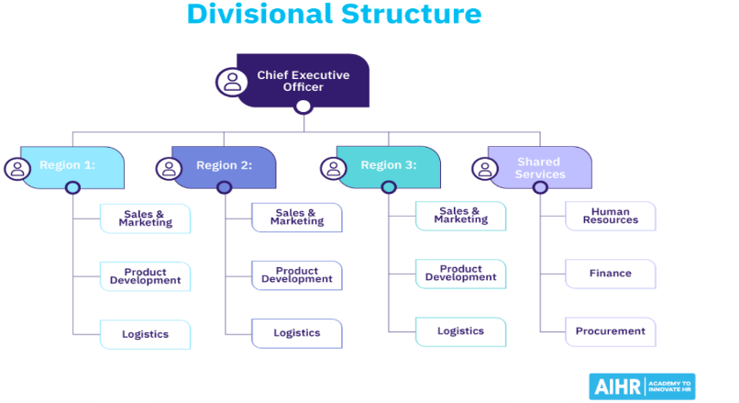

Divisional structure (2025) (Fig 2, above) outlines potential strategic decisions. One major benefit is that the opportunity for more greater concentration on certain products lines or markets, improving can lead to better divisional performance and responsibility. For this reason, this structure potentially gives giving divisions a greater degree of autonomy. Disengagement at work is an issue that firms must face in today's labour market. Autonomy in the workplace may be the key to overcoming employee disengagement and increasing their investment in their work can overcome the negative setbacks. However, including this type of structure can cause a lack of clear direction for those working autonomously.

Divisional organisational structures offer a number of advantages and disadvantages that can have a substantial impact on a company's operations and strategic decisions. One major advantage is the opportunity for increased concentration on certain product lines or markets, which can lead to better divisional performance and responsibility. This structure allows divisions to operate with more autonomy. Overall, divisional structures support autonomy and specialisation, but are risky if coordination is weak. Some professionals argue that There are many positives to divisional structures, however, as stated by Broadbent, M., Cullen, J. (1995). Divisional control. In: Berry, A.J., Broadbent, J., Otley, D. (eds) “an increase in an organisation’s size may lead to problems if a centralised and unitary control structure is maintained and how divisional structures were developed to balance the problems of allowing sufficient specialisation and yet providing an integration of the tasks carried out” (Broadbent, M., Cullen, J, 1995).

- Analyse the extent to which the organisational strategy in your organisation (or an organisation with which you are familiar) helps to ensure products or services meet customers’ needs. (AC 1.2)

Organisational strategy is what a company uses to accomplish their goals and objectives. ‘Each company has business develops a different organisational strategy which will be the best fit suited to reach the their goals’ According to Katuse, “the organisational strategy is founded on several aspects, including the resources, organisational goals, innovation, and employee learning and development” (Katuse, P., 2021).
An organisational strategy must be aligned with the organisational mission, vision and values. Each business must adapt to changes and set priorities and a clear path to achieve its goals. Customers’ needs must be met in every aspect for a business to stay profitable.
Andrews Property Group, being an estate agency, overall business goal of consistent profit, The business was owned by a charity, and a 3rd of profits went to the charity overall. Therefore, the business was essentially governed by the charity, in some respects. The founder E.C Coal also started that founder of Barnardos, one of its beneficiaries, had claimed – ‘Andrews must act ethically and fairly at all times, and if this was found not to be the case then it could risk damaging the reputation of the charity’.
To remain market leaders, the business must constantly adapt to changes in the market e.g. remaining competitive (its pricing of services must be attractive, and as charity is at the heart of this it must be heavily included in the business strategy and the customers must be also be at the heart ) One of Andrews strategy and approach to business was ‘to treat every customer as if it is its only customer’. Andrews is was, effectively, a one stop shop, as it provided customers with a network of services that allowed customers to get everything they needed from any office e.g. mortgage advisors, valuers, rent advice, so these services were constantly available. This allowed Andrews, with a range of different revenue streams at its disposal, to stay competitive and profitable. Each department of the business had to be exceptional - if one area of the service was failing, it would have a negative impact on the reputation of the whole business.
- Analyse the current impact of interest rates, inflation and one other external factor on your organisation (or one with which you are familiar). Identify organisational priorities arising from your analysis. (AC 1.3)

Organisations are affected by a range of external factors. For Andrews Property Group; interest rates, inflation and government policy/regulations.

Interest rates have risen sharply since 2021. ’The MPC’s raised rates from 0.1% in Dec 2021 to 5.25% in Aug 2023 in response to inflation’ (Daniel Harari 2025) Higher mortgage rates reduce buyers’ affordability which in turn has slows down the market. For Andrews a smaller pool of buyer may have impacted the number and speed of house sales. The implications of this are likely to impact Andrews commission-based revenue model. ‘Commission remains the core revenue stream’ (Frazer bond, London property experts). On the flip side the rise in mortgage costs and reduced potential buyers means there is an increased demand in the rental market “According to independent research for the National Residential Landlords Association (NRLA), 71% of landlords reported increased tenant demand in Q3 2023, a record high” (Sam Hunter 2023) This provides Andrews with an opportunity to prioritise increased revenue through management fees and tenet find services and upskilling staff in supporting potential buyers through affordability challenges.
Inflation has also raised operational costs. The implications for Andrews includes wage increases as staff seek pay rises to offset the cost of living. ‘Retention strategies have become critical with benefits such as increasing job satisfaction through flexible working becoming critical’ (Kelliher & Anderson, 2009). Priorities should be the implementation of retention beyond pay. This may include, training opportunities, flexible working and a clear career progression pathway.
Stricter compliance requirements for landlords such as the renters rights bill, which includes the abolition of section 21 “no fault” evictions giving more power to tenants. “41% of landlords said they plan to sell at least some rental properties, compared to just six per cent saying they would buy.” (Landlords today 2024) The reduced supply of rental properties could lead to significant rental prices increases. This provides Andrews with an opportunity to attract the business of independent landlords by offering complacence support effectively navigating the reforms. Priority opportunities include marketing as a compliance partner, expanding the letting portfolio and training of staff with the legal changes.

There are many factors to consider when analysing the current impact of interest rates and inflation all the while - there is a current boom in house prices. Below, I have created an analysis of strengths and weaknesses of external factors that could potentially have an impact on Andrews Property Group.

Strengths – Andrews Property Group operates in the housing sector, which can be a turbulent market. However, Since the Covid-19 pandemic, property sales and prices have soared and there is greater demand for property. Also, as the cost of buying a property and renting has increased, this has meant that Andrews can make more sales due to the increase, also affected by due to inflation the cost of house prices and add on services has increased. Andrews typically charges 2% on house sales, Which is competitive and as the cost of housing has increased alongside this, this means that Andrews has the potential to make more on rental agreements and sales.
Weaknesses – Inflation will result in higher staffing costs, which in turn reduces profitability. Without raising wages, this may mean that staff look elsewhere for work at different estate agents or different jobs completely. This in turn could lead to a loss of talent and knowledge within the company, to stay attractive to employees Andrews must look at different ways to attract and retain talent. One method Andrews could adapt without investing costly incentives would be to be more flexible – offer working from home and hybrid opportunities for staff – according to the CIPD factsheet named flexible working practices ‘ Flexible working can lead to direct and indirect business benefits, the direct business benefits include saving on office space’ The factsheet also includes evidence from a research article by sage concluding that ‘research shows that flexible workers have higher level of job satisfaction, commitment and are more likely to increase discretionary effort compared to those who do not work flexibly’ (Clare Kelliher, Deirdre Anderson 2009)

- In February 2024, Peter Cheese, current CEO of CIPD stated, “AI is transforming jobs, careers and workplaces. People professionals have a key role to play in encouraging safe experimentation and rapid learning, so that we can reap the benefits and mitigate the risks.” Assess the extent that AI is, or could be, used in your organisation (or an organisation with which you are familiar) and assess how AI impacts work. (AC 1.4)

Presently, AI is being used by my current employer, St. David’s Assemblies Limited. In my role there as HR advisor, overseeing employees at the local assembling factory, I have noticed various ways in which AI is being I have observed AI gradually implemented to streamlining processes. One example already in place is the use of mobile robots to that reduce the need factory floor workers. The use of robotic and Human, robot collaboration has been innovative in facilitating created a safer, smarter factory, and has produced producing various beneficial outcomes. The robotics installed on some of the new machinery has reduced repetitive tasks for workers resulted in fewer repetitive, mundane tasks having to be done by factory workers themselves. The average robot installation costs around £45,000 - this includes a contract for repairs. should anything malfunction. The robots work more efficiently in some areas and reduce the need for extra staff, ultimately saving the organisation money. After 2 years, the robot has saved the business on average around £10,000, compared to the cost of employing an individual to run similar processes. A major drawback to this is that it could be deemed as somewhat unethical - however, the current workforce at St. David’s Assemblies is an aging one and many employees are up for retirement in the next 5 years or so. Due to it’s remote location in Pembrokeshire, it is difficult to recruit new employees reliably, so the option to invest in robotics will help to ensure the business continues to operate.

- Potential for future AI implementation in the factory

Manufacturing and process optimising – AI has the potential to adjust variables taking place in the factory such as temperature, pressure of machines, etc. For example, AI could trigger a machine to turn off before it overheats, which is a common costly problem at the factory. and could result in costly repairs and waste product.

Quality control – AI has the potential to program machinery to inspect products before being sent to buyers. Currently, we have a Quality Control Manager, however, they cannot be responsible for the quality of every product being sent out. AI implementation in this regard could reduce potential defects which in turn, could result in greater customer satisfaction. Defects could be observed by AI immediately, therefore stopping any issues in their tracks before machines can make further mistakes. Using these methods, AI could save the business time and money. Nonetheless AI is not a totally positive solution. According to Gjepali, Ivan 2022/2023 an "An AI productivity paradox persists: many organisations fail to see significant performance gains from their AI strategies” (I. Gjepali, 2022/2023). However, the factory has seen the positives of introducing the robots.

- Explain Charles Handy’s model of organisational culture and explain David Rock’s SCARF theory. (AC 2.1)

Charles Handy was a philosopher and management expert who developed a an ideology model of organisational culture. Handy’s model identified 4 different types of organisational culture – each one represented by a god from Greek mythology, as follows:

Zeus – Power culture – A central power source, influencing the entire organisation. Advantages include quick decision-making from a centralised source. Negatives are that things can be potentially unstable and that the centralised figure may not have taken the appropriate time or consideration include instability and rushed to respond important decisions. Examples of this culture are usually Common in small, start-up businesses; as the business grows it’s likely the power of one centralised person will become limited.

Apollo – Role Culture – Roles and responsibilities are known to everyone working within the business. This allows employees working in this environment to feel secure, included and informed. It is often efficient and consistent – this culture works best in roles where working environments and processes do not change often.

Athena – Task Culture – This is based upon tasks and solving problems. Strong emphasis on results. This is a collaborative culture, experience is valued, innovation welcomed, although it still takes a good leader to implement effectively.

Dionysus – Person Culture – Focuses on the assets of each individual. An example of this culture would be a charity or cooperative that aims to care for the employees within it and champion some degree of autonomy for individuals. This culture can be effective as it helps to make individuals feel valued and increase the value they add to the organisation. Downfalls are that it can result in a lack of common purpose.

Applying Handy’s model to the organisation can have great benefits in understanding an organisational culture. The culture of a business can transform and move through any of Handy’s cultural examples at any one time, depending on where the organisation is within its life cycle. Most organisations have a blend of some or all of these cultures.

Each pillar can be applied to businesses; however, different pillars are more effective depending on the scale and climate of the business. Athena – Task culture encourages innovation, useful in creative industries such as media and advertising. Handy warned that ‘communication breakdowns are often the result of one culture clashing with another. Organisations “nearly always need a mix of cultures to carry out their different tasks” (C. Handy 1988). Handy’s model of organisational culture was very effective when it was introduced; however, there were some limitations, and whether his theory is still effective today, 40 years later, is a matter of debate. Despite this, Elon Musk, the leader of Tesla, is deeply involved in all aspects of the business, and his personality and direct impact align with the traits of Handy's power model, and Musk is still regarded as a transformative leader. According to VQ Solutions webpage, “Handy's model provides a framework for understanding the underlying values and beliefs that drive organisational behaviour. Organisations can better align their strategies, structures and management practices by identifying their dominant culture type”.

David Rock’s SCARF theory (AC 2.1) – SCARF is an acronym for STATUS, CERTAINTY, AUTONOMY, RELATEDNESS, FAIRNESS.

David Rocks theory is explained below:

- Status: Our perceived importance relative to others.
- Certainty: Our ability to predict future outcomes.
- Autonomy: Our sense of control over events.
- Relatedness: Our sense of safety with others.
- Fairness: Our perception of fair exchanges between people.

The theory draws upon neuroscience research and how our brains tend to respond to motivation and reward. This theory offers a perspective on how social experiences shape motivation. It heavily focuses on the feelings of individuals based on the role they are in. Unfortunately, while one person may perceive constructive advice or guidance as positive, another may feel threatened. It's important that leaders maintain a balance to support individuals and get to know their employees personally to develop a plan. One way David Rocks' theory can be applied would be before a decision is made, to consider how decisions and communications might impact the five domains bulleted above.

Overall, this theory is relevant to explain and consider practical workplace insight and leadership behaviour. However, it cannot be used as a standalone theory as it is too basic and does not consider external factors.

- Assess how employee selection or employee development impacts organisational culture and behaviour in your organisation (or one with which you are familiar). (AC 2.2)

In my current employment at St. David’s Assemblies we produce parts for automotive and NHS supplies there is a requirement for technical knowledge therefore selection of employees is seen as critical to success due to the niche specialism. The organisation recruitment from the Midlands, the talent pool is larger due to a large number of factories that produce similar components and parts.
Employee development plays a key role in organisation behaviour and culture. Training of employees to perform tasks that contractors previously completed has saved the organisation money while futureproofing it. Furthermore, the additional benefits include employees feeling more valued and invested in. This reflects J. Young (2019) argument “by promoting and investing in employee development, it is building an adaptive culture – creating a climate where innovation and self-improvement is expected and rewarded.” The reality is the initiative reinforced a culture of empowerment.
Supporting this, Chamorro-Premuzic (2018) in Harvard Business Review recommends “rewarding continuous learning and development.” St. David’s Assemblies reflects this through rewarding employees financially for upskilling. This is the incentivisation of positive behaviors such as continuous improvement, motivation and creating a culture of adaptability.
An organisation is planning a change relating to hybrid working. Many employees moved to home working during the Covid-19 pandemic. Whilst this approach worked well at the time, the organisation now wants all employees to work at least two days a week on site. Explain how Kotter’s approach to managing change could be used to successfully implement this change. (AC 2.3)

John Kotter a renowned havard business school professor, leader and author proposed an 8-step model for managing organisational change he created a structured approach that can be used to implement a change such as the hybrid working change
Step 1. Create a sense of urgency
The first step is to help employees realise why the return to working on site is necessary.
To achieve this evidence could be presented how there has been a reduction of collaboration and innovation since remote working became the norm. Moreover, there are long-term benefits, such as stronger relationships and better mentoring opportunities should be explained positively. Kotter (2012, p.130) emphasises that “a high urgency rate helps enormously in completing all the stages of a transformation process,” suggesting this process should be implemented promptly to succeed.
Step 2. Build a guiding coalition
Change is more successful when led by a coalition of influential leaders ‘According to Kotter (1996, p. 52), no one person is capable of single-handedly leading and managing the change process in an organization and putting together the right “guiding coalition” of people to lead a change initiative is critical to its success.’
When comparing this step with other change management models, for example, Lewin’s (1947) three-step model of change, Kotter’s is far more in-depth and potentially useful for businesses and employees, see below fig. 3. As you can see, the above step from Kotter’s model is not included.
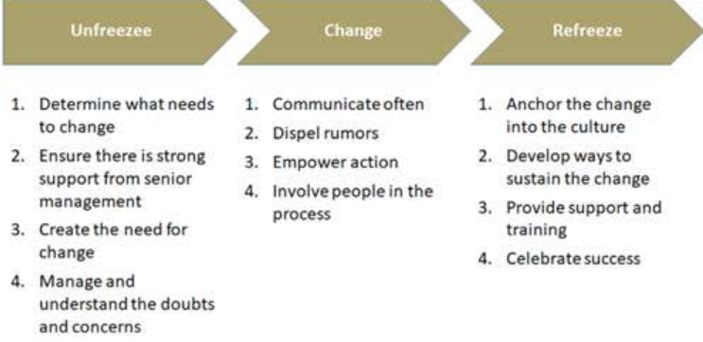
- Fig. 3. Lewin's three-step model for change management.

Step 3. Form a Strategic Vision and Initiatives
Create a clear vison for the hybrid working model. Employees are more likely to understand and act on a well-defined goal, even if the initial steps are difficult (Kotter, 1996, pp. 67-84). Present and implement a clearly defined hybrid working policy.
Step 4. Enlist a volunteer army
Having employees to act as advocates helps to generate some momentum. This can be achieved through the likes of pilot groups who could share a positive experience of hybrid working.
Step 5. Enable action by reducing barriers
For smoother transitions then employees need support reducing barriers. For this example lack of transport options, Solutions to this could be introducing a car sharing scheme or a cycle to work initiative.
Step 6. Generate short-term wins
Celebrating early successes can build team confidence. Communicating wins helps build trust and confidence in the new changes and helps mitigate against reverting to past patterns or employees leaving for fully remote jobs.
Step 7. Sustain acceleration
After a short term win then momentum should be maintained to drive further progress. This could include; addressing ongoing challenges, expanding hybrid policies across departments, refining the policy based on feedback.
Step 8. Institute changes
This is where a new hybrid working model should be embedded into the organisations culture by updating HR policies, job descriptions. The new policy should be reflected in the induction process for new employees and over time the policy will become the new norm.
Kotter’s 8-step change model, although well-regarded, does have limitations. A study by Nasamu (2023), “emphasised the need for managers to find acceptable problem-solving solutions and maintain open communication throughout the change model”. This points to a potential missing step in Kotter’s model, which could be to engage with employees before the change is implemented. Approximately 70% of organisations in the US fail to implement change due to low employee involvement. (EWF International, 2023)
- Using the Kubler-Ross change curve, discuss how change is experienced. (AC 2.4)
The Kübler-Ross Change Curve, which was originally designed to describe the stages of grief, has since been is widely utilised to understand how people emotionally reactions to organisational change. It emphasises that people feel change in phases, which can assist assisting managers in successfully supporting staff during transitions

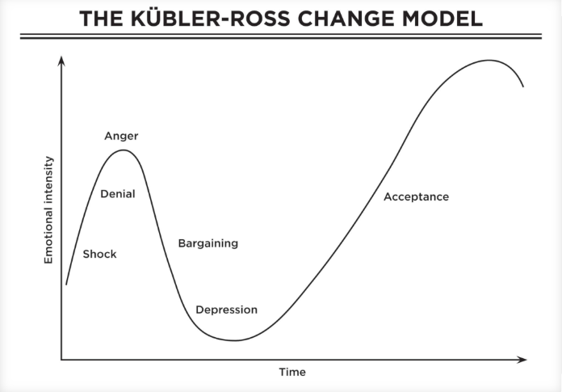
Fig. 4 – Kubler Ross Change Model

As you can see above shown in fig 4. Swiss psychiatrist Elisabeth Kübler-Ross change curve theory explains how a person people deal with grief. This theory can be especially important is valuable for HR and employers to relate to employees who are going through during organisational change “it is important to support staff during a workplace change or transition, which could include a redundancy / restructuring” (A. Roberts, CIPD Resource, 2024). I will outline all the points in the curve below The stages are:
- Shock - Leaders should anticipate this reaction by conveying the change clearly and gently and providing prompt emotional assistance (HR leaders should signpost employees to support if there’s an Employee Assistance Programme in place - this would be a good place to start.)
- Denial - Employees may resist the change, believing that "it won't happen to me" or that "things will go back to normal.
- Anger - Employees may feel angry or misled, particularly if the change appears unfair or badly handled.
- Bargaining - Employees may attempt to negotiate, a way out of the change, such as requesting request transfer, agreeing to different roles or adjust hours, some may or take voluntary redundancy if this is an option.
- Depression - Employee Morale may suffer, especially among employees expecting redundancy or watching colleagues depart.
- Acceptance - This is the last stage of the curve which is where employees accept the change. Understanding these stages and the necessity for individuals to come to grips with what is going on around them is critical given the volume and rate of change that businesses face today. Employees adjust and move forward. Leaders should help Helping individuals move through each step is vital in both making the change and maintaining it going forward. (A. Roberts, CIPD, 2024)
Potential limitations of this theory is that not everyone will experience change the same way, also and the theory came from Elizabeth Kubler-ross experience with people facing death and not a just a business change.
The CIPD’s Health and wellbeing at work survey 2023 found the percentage of organisations that have a standalone wellbeing strategy has risen from 40% in 2018 to 53% in 2023. Although the percentage has increased, this means that 47% of organisations do not have a standalone well-being strategy. Assess the importance of wellbeing at work and assess how good work could impact wellbeing. (AC 2.5)

A well-supported workforce is healthier, more resilient. and more capable of handling stress. Employee Engagement, contentment, and morale have also been noted to improve when organisations promote wellbeing. ‘One way to improve morale is to show employees that the company cares about their best interests.’ Ott, B. (2010). This in turn could help to create an environment with a wellbeing plan considerably reduced absences and employee turnover which could have a positive knock-on effect on profit margins and expenditure.

A wellbeing at work survey found an increase in sickness absence; at 7.8 days on average per employee per year, this is the highest level in a decade, up from the 5.8 recorded in 2019 (Simply Health 2023). It is important that organisations use statistics when looking at their own absence levels. Excessive absenteeism places increased increases workload on other employees who are present. When team members are absent, their colleagues pick up the slack, taking take on additional responsibilities and tasks. This Increased workloads could lead to stress and burnout among present employees, negatively impacting their performance and overall job satisfaction (K. BISHOP, 2024). Productivity is flatlining, employee wellbeing is at an all-time low and stress at an all-time high. Mental health issues are now the biggest single disability affecting the UK and are estimated to cost the economy £105bn each year. Traditional company design, structures and processes are making these issues worse and leading to unprecedented levels of staff burnout (Timms. Perry 2020).
wellbeing at work is no longer simply a sought-after benefit - it is a strategic process that impacts performance, culture, and retention of staff. Whilst it is encouraging that more organisations are taking on standalone wellbeing strategy.
A report on flexible working practices states that “80% of employees say that working flexibly has had a positive impact on their quality of life; just 4% say it has had a negative impact” (Report on flexible working practices, July 2023). This supports that flexible working could greatly enhance employee wellbeing. Ultimately, a proactive and well-thought-out approach to wellbeing could not only benefit employees individually but also contribute and contributes to the success of an organisation. towards the overall organisational success.
According to the CIPD survey, organisations with a well-being plan have lower absenteeism and higher retention rates. ‘3 in 10 people professionals said that their mental and physical wellbeing is negatively impacted by work’ However, 3 in 10 people professionals still report their wellbeing is negatively affected by work (People Professionals, 2022). Therefore it is important that employers adopt a wellbeing strategy to protect their employees and the business.

- Provide a brief overview of the employee lifecycle and discuss people practice roles at the recruitment, development and separation stages of the lifecycle. (AC 3.1)

The employee life cycle describes the key stages that a person progresses through when engaging with an organisation as an employee. (Sheldon Walker, 2023)

A typical employee life cycle model includes follows the steps below:

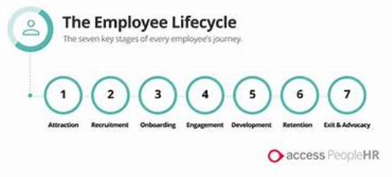
Fig 5. (Employee wellness, everything you need to know) (Munodiwa Zvemhara 2024)
1: Attraction - entails developing Building a strong employer brand and value proposition to attract potential applicants, good corporate social responsibility CSR, good brand image and perks help with attracting candidates.
2: Recruitment - is the act of Advertising roles and encouraging potential applicants to apply. People professionals must include innovative practices such as AI to recruit the best possible candidates one way people practices could do this is by including AI in recruiting. CIPD Resources state that “of those that use AI, 66% said it improved hiring efficiency and 62% said it increased the availability of useful information for resource planning” (CIPD’s Resourcing and talent planning report 2024).
3: Selection - involves Assessing and selecting the best qualified candidates for the position.
4: Onboarding - involves Introducing new employees to the organisation, its culture, and their responsibilities.
5: Development - includes encouraging Continual learning, performance, and professional development. “Organisations identify skills gaps and an inability to attract talent as the key barriers preventing industry transformation, with 60% of surveyed companies highlighting the difficulty in bridging skills gaps locally” (Future of jobs report, 2023). To combat this, Employers should adopt upskilling methods to bridge skills gaps while also investing in their and invest in employee development. This is backed up by J. Fahed-Sreih, who argues that “Employee satisfaction can be achieved by making a good career development system and giving an understanding of how important the system is that is designed by the company for managerial and professional employees” (J. Fahed-Sreih, 2020).
6: Retention - means Keeping employees engaged, satisfied, and driven to stay.
7: Separation - Managing an employee's departure in an organised and polite approach. The reasons employees leave an organisation could be down to many reasons It is important to that people professionals perform exit interviews. Employee turnover can have an adverse effect on success. Understanding why employees leave a company allows companies to develop measures that reduce turnover and boost employee retention (CIPD Employee turnover and retention Factsheet 2025). By conducting a leavers interview, employers can build a picture of why employees leave a business. There could be trends from exit interviews this that can be learnt from, creating opportunities to implement changes that could decrease employee turnover.
Analyse how people practice supports organisational strategy through vertical integration and how people practice supports wider people strategies through horizontal integration. (AC 3.2)

Vertical integration in HR strategies must support the operational and cultural goals of a business. For example, hospitality businesses should be focused on providing excellent customer service, it should be HR’s strategy to support this, this could be done by HR implementing training to promote good customer service. HR strategies must echo the ethos of the business they work within. Another example is workforce planning, HR must Forecast and shape the workforce to meet long-term organisational goals ‘HR professionals need to be able to reorganise talent swiftly and plan for future needs to enable the business to succeed.’ Gibson, A. (2021).

Horizontal integration in people practices is analysing HR operations to produce a cohesive and unified approach. This integration guarantees that all HR actions reinforce and support the organisation's overall people strategy.

HR departments should collaborate closely with other departments such as marketing, sales, and finance which can lead to improved integration of HR activities with specific departmental strategies. Sadly, however, research has suggested that achieving either horizontal or vertical integration is tricky. ‘it can be difficult and gaps can easily exist between what the strategy says will be achieved and what is actually achieved” (M. Armstrong, 2019).

- An organisation is planning to introduce a four-day working week. Discuss the processes the people function could use to consult and engage with managers and employees to understand their needs when moving from a five-day to four-day working week. (AC 3.3)

Introducing a four-day working week is hot topic in the HR world, and it presents a significant challenge for any organisation. However, “careful planning emanating from the HR department centrally is key to its success” (CIPD, 2022). Above all, The needs and concerns of all stakeholders must be considered to ensure everyone is in the loop and the best possible agreement can be reached. I have outlined some of the processes that might be considered for this below. Below are some of the processes that The People Department should use the following focus on during the planning stages. The 4 Day Week Global campaign group launched a four-day week trial involving 70 companies and more than 3,300 workers in the UK. A 4-day week report (2022) was created - see below Fig. 7,
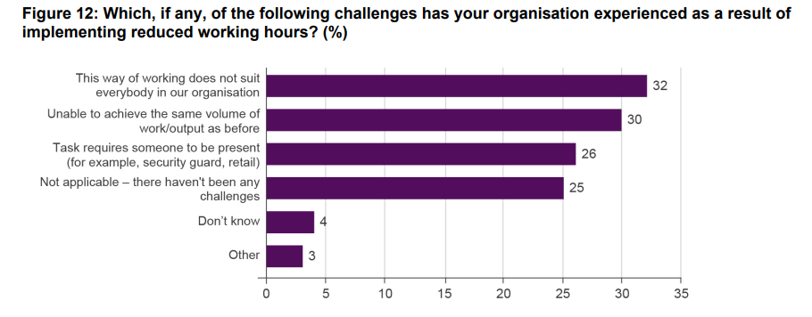
The above graph shows some negatives, it which could be used by people professionals to investigate how to alleviate risks the potential negative effects within their own organisation. According to another report, “There is a correlation between negative impacts on employees and higher commuting times” (Working lives Scotland report, 2025). See below Fig. 8 – this suggests that by reducing commuting times, this may can improve employees’ wellbeing and reduce burnout. and In turn improve retention rates giving employers adopting a 4-day working week a competitive gain and attracting better employee prospects.
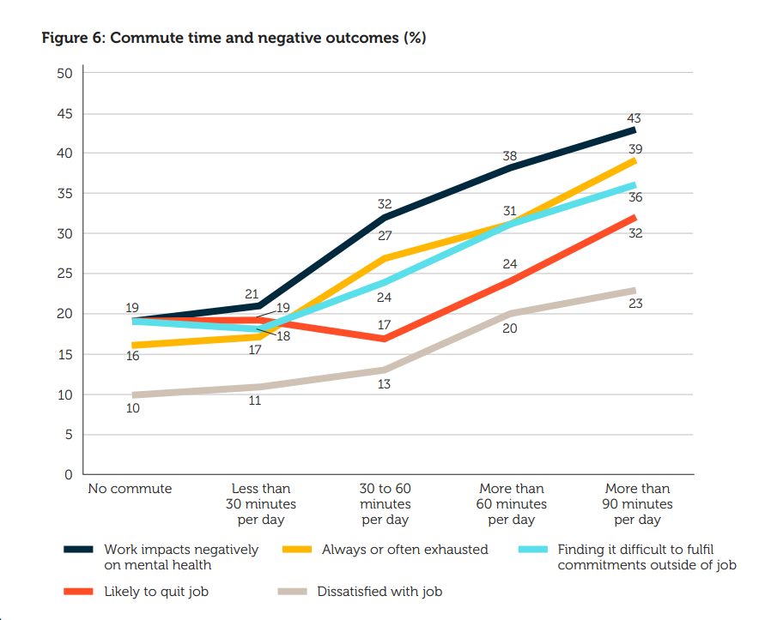
Fig. 8. (Working lives Scotland report 2025)
I will outline a few hypothetical points below that an organisation might consider.
- Check in with all key Stakeholders Before initiating consultation, HR should: Identify key stakeholders (e.g. team leaders, senior managers). Categorise stakeholders by role and teams and have 1-1 conversations to understand any concerns. Develop a communication plan to ensure consistent and transparent messaging between all involved.
Employee Surveys - Questions could focus specifically on productivity, workload, work-life balance, and personal views on a shorter working week. A case study by international SOS foundation found that “flexibility to choose one’s work location (or have a degree of choice) was the most important thing for employees surveyed and the strongest contributor to wellbeing outcomes” (International SOS CASE STUDY, 2023). This shows how Important surveys are in gaining insight into the feelings of employees within an organisation.
To conclude, effective and consistent consultation and engagement seem to be critical to the success of trialing a change such as this. By using a mixture of the above methods, the HR team can ensure that the transition aligns with business objectives while addressing the needs and concerns of both managers and employees.

References:

E. H. Schien, 2010, Organizational culture and leadership (4th ed.). Jossey-Bass.

Fig. 1, Asana Matrix Structure, https://asana.com/resources/matrix-organization (Accessed 25 May 2025)

Evaluate the Advantages and Disadvantages of two Types of Organisation Structures Including the Reasons Underpinning them, April 2023 https://cipdforum.co.uk/evaluate-the-advantages-and-disadvantages-of-two-types-of-organisation-structures-including-the-reasons-underpinning-them/ (Accessed 20 June 2025)

Fig. 2, https://www.aihr.com/hr-glossary/divisional-structure/

S Taylor, C. Woodhams, 2022, STUDYING HUMAN RESOURCE MANAGEMENT, a guide to the study, content and practice of hr. 3rd Edition

Divisional structure, 2025, AIHR, https://www.aihr.com/hr-glossary/divisional-structure/ (Accessed: 25 May 2025)

M. Broadbent, J. Cullen, 1995, Divisional control. In: Berry, A.J., Broadbent, J., Otley, D. (eds) Management Control. Palgrave, London. https://doi.org/10.1007/978-1-349-23912-2_7

P. Katuse, 2021, Employee Perceptions on Organisational Strategy Implementation in Covid 19 Era. Indian journal of economics and business

I. Gjepali, 2022/2023 Artificial Intelligence is ready for business, but are businesses ready for AI?

Strategic Human Resource Management: Back to the future? A literature review Michael Armstrong, Duncan Brown - (partnered with CIPD) 2019 https://www.employment-studies.co.uk/system/files/resources/files/517_Strategic-Human-Resource-Management-Back-to-the-future-IES-CIPD-2019.pdf

Doing more with less, flexible working practices and intensification of work. Clare Kelliher, Deirdre Anderson 2009 https://journals.sagepub.com/doi/abs/10.1177/0018726709349199

Charles Handy, 1988 Gods of management, the changing work of organisations https://books.google.co.uk/books?hl=en&lr=&id=cG6f-mxkJo0C&oi=fnd&pg=PR11&dq=charles+handy%27s+model+of+organisational+culture&ots=VDpa30QGFU&sig=nksyPa93uKHJdeVvBphzpai76tI#v=onepage&q=charles%20handy's%20model%20of%20organisational%20culture&f=false

VQSOLUTIONS https://hr.vqsolutions.co.uk/understanding-organisational-culture-charles-handys-model-and-david-rocks-scarf-theory/ (Accessed 17 August 2025)

J. Young, CIPD, (2019) Organisational climate and culture. Available at: https://www.cipd.org/uk/views-and-insights/thought-leadership/the-world-of-work/positive-organisational-culture-inclusion/ (Accessed 17 August 2025)

Thomas Charmorro-Premuzic, Josh Bersin, 2018, https://hbr.org/2018/07/4-ways-to-create-a-learning-culture-on-your-team (Accessed 18 August 2025)

Kotter, John P.. Leading Change, with a New Preface by the Author, Harvard Business Review Press, 2012.

Kotter, J.P. (1996), Leading Change, Harvard Business School Press

Fig 3. https://www.researchgate.net/figure/Lewins-three-step-model-for-change-management-36_fig3_342883322 (Accessed 17 August 2025)

Nasamu, I. (2023). Strategies for employees to effect change to improve performance fo public organisastions. Journal of Accounting, Business and Finance Research, 17(1), 1-9.

EWF International. (2023, March 15). Organisational Change Success. Retrieved July 2024, from ewfinternational.com: https://ewfinternational.com/organizationalchange-management-success-employee-buy-in/
Bouckenooghe, D., Schwarz, G. M., & Minbashian, A. (2015). Herscovitch and Meyer’s three-component model of commitment to change: Meta-analytic findings. European Journal of Work
Fig. 4 – Kubler Ross Change Model (Accessed 18 August 2025)

A Roberts, CIPD 11/12 2024 https://www.cipd.org/uk/knowledge/guides/change-management/#models-for-change (Accessed 19 August 2025)

Fig. 5 – VUCA World of work (Accessed 20 August 2025)

Simply health report, 2023
https://www.cipd.org/globalassets/media/knowledge/knowledge-hub/reports/2023-pdfs/8436-health-and-wellbeing-report-2023.pdf (Accessed 20 August 2025)

K. Bishop, 2024,
https://www.joincandor.com/blog/posts/the-impact-of-excessive-absenteeism-on-workplace-productivity#:~:text=It%20might%20seem%20harmless%20at%20first%2C%20but%20excessive,and%20delve%20into%20its%20direct%20and%20indirect%20consequences. (Accessed 20 August 2025)

Timms. Perry 2020, https://www-vlebooks-com.ezproxy.uwtsd.ac.uk/Product/Index/2055448?page=0&startBookmarkId=-1 (Accessed 20 August 2025)

Report on flexible and working practices July 2023 https://www.cipd.org/globalassets/media/knowledge/knowledge-hub/reports/2025-pdfs/8909-flexible-working-report-web.pdf (Accessed 18 August 2025)

(Sheldon Walker 2023) https://www.peoplehr.com/en-gb/resources/blog/what-is-the-employee-lifecycle/ (Accessed 19 August 2025)

Fig. 6 - (People professional map) (Accessed 20 August 2025) https://www.cipd.org/globalassets/media/comms/the-people-profession/profession-map-pdfs/profession-map-nov-2024.pdf, (Accessed 18 August 2025)

(CIPD’s Resourcing and talent planning report 2024) https://www.cipd.org/uk/knowledge/reports/resourcing-surveys/, (Accessed 20 August 2025)

(Future of jobs report 2023), https://www3.weforum.org/docs/WEF_Future_of_Jobs_2023.pdf, (Accessed 20 August 2025)

Josiane Fahed-Sreih, Career development and job satistfaction, 2020, https://www.intechopen.com/chapters/72489# (Accessed 19 August 2025)

CIPD Employee turnover and retention Factsheet, 2025 https://www.cipd.org/uk/knowledge/factsheets/turnover-retention-factsheet/ (Accessed 21 August 2025)

Michael Armstrong, Duncan Brown, Strategic Human Resource Management: Back to the future? (February 2019) - https://www.employment-studies.co.uk/system/files/resources/files/517_Strategic-Human-Resource-Management-Back-to-the-future-IES-CIPD-2019.pdf (Accessed 21 August 2025)

(Journal of European business and management research.) (Walid Abdullah Al-Suraihi, Siti Aida Samikon, Al-Hussain Abdullah Al-Suraihi,and Ishaq Ibrahim 2021)
https://www.ejbmr.org/index.php/ejbmr/article/view/893/488 (Accessed 21 August 2025)

Fig. 7 - (The 4 day week report 2022) THE FOUR-DAY WEEK Employer perspectives on moving to a shorter working week
https://www.cipd.org/globalassets/media/knowledge/knowledge-hub/reports/four-day-week-report-uk-oct22_tcm18-111257.pdf (Accessed 19 August 2025)

'Can we make a 4-day week work?’ Oct 2022
https://www.cipd.org/uk/knowledge/podcasts/four-day-week/ (Accessed 20 June 2025)

Fig. 8 - (Working lives Scotland report 2025) https://www.cipd.org/globalassets/media/knowledge/knowledge-hub/reports/2025-pdfs/8868-working-lives-scotland-2025-report-web.pdf (Accessed 19 August 2025)
(International SOS CASE STUDY 2023) https://www.cipd.org/uk/knowledge/case-studies/international-sos/#what-insights-did-the-evidence-provide (Accessed 19 August 2025)

‘Mental health and wellbeing plan: discussion paper and call for evidence’ Jul 2022
https://www.cipd.org/uk/about/public-policy/our-calls-for-action/mental-health-wellbeing-plan-discussion-paper-call-evidence/ (Accessed 20 June 2025)

‘Flexible working practices’ 2025 https://www.cipd.org/uk/knowledge/factsheets/flexible-working-factsheet/#title4 (Accessed 20 June 2025)

(Daniel Harari 2025) https://commonslibrary.parliament.uk/research-briefings/sn02802/ (Accessed 20 July 2025)

(Frazer bond, London property experts) https://fraserbond.com/blog/article/from-valuations-to-viewings-exploring-the-revenue-streams-of-estate-agents-in-the-uk-b7195 (Accessed 20 july 2025)

(Sam Hunter 2023) https://www.nrla.org.uk/news/press-release-rented-housing-demand-triples
(Accessed 19 August 2025)

(Landlords today 2024) https://www.landlordtoday.co.uk/breaking-news/2024/11/crisis-point-over-40-of-landlords-to-sell-property-in-coming-year/ (Accessed 19 august 2025)
According to Kotter (1996, p. 52), Kotter, J.P. (1996), Leading Change, Harvard Business School Press, Boston, MA.

FIG 5. (Employee wellness, everything you need to know) (Munodiwa Zvemhara 2024) https://www.thehumancapitalhub.com/articles/employee-wellness-everything-you-need-to-know (Accessed 19 August 2025)
Ott, B. (2010). The Real Way to Reform Healthcare; How to change employee behaviors and improve Americans’ wellness, one company at a time. Gallup Management Journal.

Gibson, A. (2021). Agile workforce planning : how to align people with organizational strategy for improved performance. Kogan Page.

