

OME HNC Apprenticeship
End Point Assessment Handbook

Table of Contents
OME HNC End Point Assessment Timeline at a Glance 3
Introduction and Overview 3
The OME End Point Assessment consists of 3 components: 4
Summary Table 4
End-point Assessment Gateway 5
Assessment Methods 6
Assessment Method 1: Practical demonstration with question and answer session 6
Assessment Method 2: Professional discussion supported by a portfolio of evidence 10
Assessment method 3: Knowledge Test 11
Assessment method 3 component 1: Knowledge Test 11
Reasonable Adjustments 13
Weighting of assessment methods 13
Apprenticeship Grading 14
Assessment method 1: Practical demonstration with question and answer session 14
Assessment method 2: Interview underpinned by a portfolio of evidence 15
Assessment method 3: Knowledge test 16
Overall EPA Level 4 Grading 16
End point assessment re-sit and re-take information 17
UWTSD – Internal Quality Assurance 17
Affordability 18
Professional body recognition 18
Mapping of knowledge, skills and behaviours (KSBs) 18
Assessment method 1: Practical demonstration with question and answer session 18
Assessment method 2: Interview underpinned by a portfolio of evidence 20
Assessment method 3: Knowledge Test 21

OME HNC End Point Assessment Timeline at a Glance

Figure 1: Level 4 EPA Timeline
Figure 1: Level 4 EPA Timeline 3

Table 1: Assessment Summary at a Glance 4
Table 2: Assessment method 1 grading 14
Table 3: Assessment method 2 grading 15
Table 4: Assessment method 3 grading 16
Table 5: Grading assessment boundaries 16
Table 6: Overall assessment gradings for EPA 16
Table 7: Knowledge mapping - Assessment method 1 18
Table 8: Skills mapping - Assessment method 1 19
Table 9: Behaviours mapping - Assessment method 1 19
Table 10: Knowledge, Skills and Behaviours mapping - Assessment method 2 20
Table 11: Knowledge mapping - Assessment method 3 21

Introduction and Overview
This document sets out the requirements for end-point assessment (EPA) for the Ordnance Munitions Explosives Technician apprenticeship standard. It will be of interest to Ordnance Munitions Explosives Technician apprentices, their employers and training providers.
Full time apprentices will typically spend 30 months on-programme (before the gateway) working towards the occupational standard, with a minimum of 20% off-the-job training. All apprentices must spend a minimum of 12 months on-programme.
The EPA period should only start, and the EPA be arranged, once the employer is satisfied that the apprentice is deemed to be consistently working at or above the level set out in the occupational standard, all of the pre-requisite gateway requirements for EPA have been met and can be evidenced to an EPAO.
The EPA must be completed within an EPA period lasting typically 6 months, after the EPA gateway. The EPA consists of 3 discrete assessment methods.

The OME End Point Assessment consists of 3 components:
- Practical demonstration with question and answer session.
- Interview underpinned by a portfolio of evidence
- Knowledge Test

Summary Table
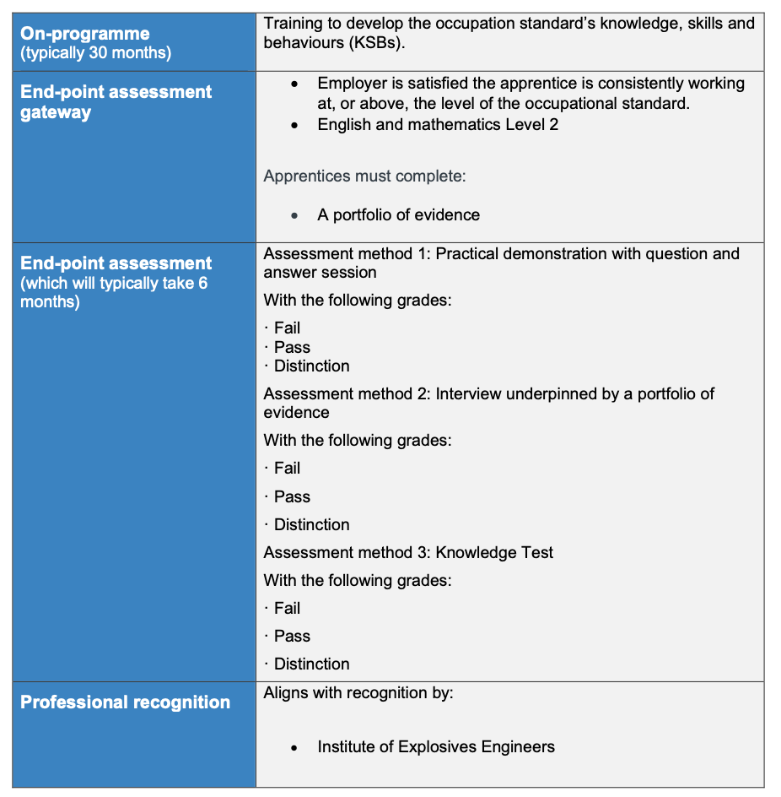
Table 1: Assessment Summary at a Glance

End-Point Assessment Gateway
The EPA period should only start once the employer is satisfied that the apprentice is consistently working at or above the level set out in the occupational standard, that is to say they are deemed to have achieved occupational competence. In making this decision, the employer may take advice from the apprentice’s training provider(s), but the decision must ultimately be made solely by the employer.
In addition to the employer’s confirmation that the apprentice is working at or above the level in the occupational standard, the apprentice must have completed the following gateway requirements prior to beginning EPA: English and mathematics at level 2.
For those with an education, health and care plan or a legacy statement the apprenticeships English and mathematics minimum requirement is Entry Level 3 and British Sign Language qualification are an alternative to English qualifications for whom this is their primary language.
For Practical demonstration with question and answer session: no specific requirements
For Interview underpinned by a portfolio of evidence, the apprentice will be required to submit: portfolio of evidence which is submitted to the EPAO at the Gateway.
The portfolio of evidence requirements are as follows:
- The apprentice will have prepared a portfolio of evidence during the on-programme phase to support the interview. The format and structure of the portfolio must be agreed between the employer and apprentice and will be presented electronically.
- The portfolio of evidence will be submitted to the EPAO at the gateway.
- The portfolio should contain written accounts of activities that have been completed and referenced against the knowledge, skills and behaviours, supported by appropriate evidence, such as video/audio extracts (these should be a maximum of 5 minutes in length); written statements; project plans; reports; minutes; observation reports; presentations; feedback from managers, supervisors or peers; papers or reports written by the apprentices; performance reviews. This is not a definitive list; other evidence sources are allowable.
- The content must be sufficient to evidence the apprentice can apply the knowledge, skills and behaviours required as mapped to assessment method 2 (Interview). There must be at least one piece of evidence relating to each knowledge, skill and behaviour mapped to assessment method 2. One piece of evidence can be referenced against more than one knowledge, skill or behavioural requirement. It is expected that there will be typically be a minimum of 12 pieces and a maximum of 15 pieces of evidence.
- The evidence provided must be valid and attributable to the apprentice; the portfolio of evidence must contain a statement from the employer confirming this.
The portfolio is not assessed, it informs the questioning for the interview and should be referred to by the apprentice to support their responses.
For Knowledge Test:
- no specific requirements

Assessment Methods

Assessment Method 1: Practical demonstration with question and answer session

Overview
Apprentices must be observed by an independent assessor completing 1 practical demonstration in which they will demonstrate the KSBs assigned to this assessment method. The end-point assessment organisation will arrange for the practical demonstration to take place, in consultation with the employer. The practical demonstration with question and answer session must be carried out over an assessment time of 2 hours 30 minutes. The demonstration has two discrete parts and the individual parts may not be split, other than to allow comfort breaks as necessary. The independent assessor has the discretion to increase the time of the practical demonstration by up to 10% to allow the apprentice to complete the last task that is part of this element of the EPA.
The independent assessor may conduct and observe only one apprentice during this assessment method. However due to Health and Safety operational requirements, some of the tasks may require two people to complete/support the task (this equates to the apprentice and one other person). The EPAO will arrange for a second person to be present for the assessment and can agree this with the employer. The apprentice must complete one task. The apprentice will instruct the person what to do throughout the task. The second person must follow the apprentice’s instructions and cannot ask for clarity on the instructions. If a second person is required, they must not be an apprentice and should be a work colleague that is independent of the apprentice undertaking the task and working at or above the level of the standard. All of the task must be attributable to the apprentice and the second person should provide a written statement to confirm this. The independent assessor should ensure that the second person does not influence the apprentice’s grade and is responsible for briefing the second person.
The rationale for this assessment method is:
- The OME occupational sector involves practical activity best assessed through practical demonstration; it will replicate the working environment in a valid way and employers would doubt the occupational competence of an individual not assessed in this way.
- This method will assess a core element of the role and is a critical part of this occupation and doing this in a simulated environment will enable the apprentice to conduct this covering the breadth and depth of KSBs, and ensures health, safety and security is maintained.

Delivery
Apprentices must be provided with both written and verbal instructions on the tasks they must complete, including the timescales they are working to.
The practical demonstration should be conducted in the following way to take account of the occupational context in which the apprentice operates:
The practical demonstration must provide coverage of the KSBs assigned to this assessment method and may be similar to the following examples:

Example 1: Mixing of explosives: -
Part 1. Select and prepare the workplace and equipment for an OME procedure (including demonstrating all protective arrangements and PPE)
Part 2. Undertake required mixing of explosives to required specifications, this would include obtaining explosive ingredients from stock, weighing measuring and dispensing the ingredients and using the appropriate equipment, ranging from hand sieves to complex mechanical mixers, to achieve the desired consistency and homogeneity. The individual must understand the requirements for handling, transporting and storing the prepared explosive and also the safe means for cleaning the process equipment afterwards. Including:
- Preparing and undertaking the process for quarantining or segregating OME in preparation for disposal, packaging and storage by an approved means.
- Carrying out explosive’s inspections, inventory updates in line with explosives regulatory procedures.
All parts must be successfully completed.

Example 2 Pressing of explosives: -
Part 1. Select and prepare the workplace and equipment for an OME procedure (including demonstrating all protective arrangements and PPE)
Part 2. The pressing of explosives will involve the conversion of an explosive powder into a compacted form which will:
- exhibit the correct chemical and physical behaviour and
- be robust enough to be handled safety in subsequent assembly or testing operations.
The operator will have to assemble the prescribed tooling, load the appropriate amount and type of explosive and ensure the pressing equipment delivers the appropriate load, at the appropriate rate for the prescribed time. The operator will then inspect the compacted sample to ensure specification requirements for dimensions and density have been met and also reject non- conforming or damaged work. Including:
- Preparing and undertaking the process for quarantining or segregating OME in preparation for disposal, packaging and storage by an approved means.
- Carrying out explosive’s inspections, inventory updates in line with explosives regulatory procedures.
All parts must be successfully completed.

Example 3 Initiation of charge for instrumented assessment or small-scale hazard testing: -
Part 1. Select and prepare the workplace and equipment for an OME procedure (including demonstrating all protective arrangements and PPE)
Part 2. Preparation and initiation of an experimental charge requires the operator to rig and set up the explosive train required in a safe and organised sequence. This will be clearly laid out within the trials specification though the operator should understand the rationale behind the preparatory sequence and the safety precautions required to keep themselves and others safe during the hazard testing. Including:
- Preparing and undertaking the process for quarantining or segregating OME in preparation for disposal, packaging and storage by an approved means.
- Carrying out explosive’s inspections, inventory updates in line with explosives regulatory procedures.
All parts must be successfully completed.
The practical demonstration should be conducted in the following way to take account of the occupational context in which the apprentice operates and should demonstrate all the KSB assigned to this assessment method:
The assessment will be split into two distinct parts:
Part 1 – 30 minutes total (If the apprentice completes this in less than 25 minutes, they can then move on to part 2)
- Apprentice will be provided with a task to read.
- The apprentice will review the task, if they want to the apprentice will be able to make notes on how they are going to undertake the task (these notes will not be assessed) and ensure that all equipment/resources are available – 15 minutes.
They will:
Set up the equipment required for the task and ensure that additional support (such as second person for Health and Safety or additional equipment) are aware of what their role will be – 15 minutes.
The apprentice will have a 15 minute break in an area where they cannot confer with other apprentices or individuals. During this time the independent assessor will check that the equipment has been set up correctly and additional support/resource (such as second person for Health and Safety or additional equipment) is available.
EPAOs must manage invigilation of apprentices during breaks in order to maintain security of the assessment in line with their malpractice policy.
Part 2 – 2 hours
The apprentice will undertake the practical demonstration that has been set – 1 hour and 30 minutes. If a second person is required for the correct completion of the task or for health and safety reasons, their role will be to follow instructions from the apprentice and not to carry on with the task without instructions from the apprentice. They will not be allowed to advise the apprentice on what they need to do. If it appears that the apprentice is not following safety procedures, the independent assessor must intervene at this stage and not the second person.
Once the practical demonstration has been completed, the independent assessor will ask questions – 30 minutes.
EPAOs will create and set open questions to assess related underpinning knowledge, skills and behaviours.
In the event of re-sits or re-takes the apprentice will be presented with a different task.
The questions must be asked after the practical demonstration is complete. The independent assessor must ask a minimum of 5 questions. Questioning must be completed within the total time allowed for the practical demonstration with question and answer session. The questioning can assess those KSBs that did not naturally occur during the practical demonstration although these must be kept to a minimum.
There may be breaks during the practical demonstration to allow the apprentice to move from one location to another.
KSBs observed and answers to questions must be documented by the independent assessor.
The independent assessor will make all grading decisions.

Questions and resources development
EPAOs will create and set open questions to assess related underpinning KSBs.
EPAOs will produce specifications to outline in detail how the practical demonstrations will operate, what it will cover and what should be looked for. It is recommended that this be done in consultation with employers. EPAOs should put measures and procedures in place to maintain the security and confidentiality of their specifications if employers are consulted. Specifications must be standardised by the EPAO.
EPAOs must develop ‘practical specification banks’ and ‘question banks’ of sufficient size to prevent predictability and review them regularly (and at least once a year) to ensure they, and the specifications they contain and the questions, are fit for purpose. The specifications, including questions relating to underpinning KSBs must be varied, yet allow assessment of the relevant KSBs.

Venue
Practical demonstrations must be conducted in one of the following locations:
- the employer’s premises
- a suitable venue selected by the EPAO (e.g. UWTSD’s premises or another employer’s premises)
If the venue is the apprentice’s workplace, the employer must provide all the necessary tools and equipment, if it takes place off-site, then the EPAO must provide all the necessary tools and equipment, although they may liaise with the employer to provide these.
The venue must hold the appropriate explosives license

Support material
EPAOs will produce the following material to support this assessment method:
- EPAO should create a bank of tasks for the demonstration of practice to assess the KSBs mapped to this method.
- Provide a specification of how the demonstration of practice will be set up, including the background material to be provided
- Provide the grading criteria for the independent assessors to use and record
- Develop a bank of questions for the independent assessor
- Provide a document for the apprentice and employer on how the assessment should be conducted

Assessment Method 2: Professional discussion supported by a portfolio of evidence

Overview
This assessment will take the form of an interview which must be appropriately structured to draw out the best of the apprentice’s competence and excellence and cover the KSBs assigned to this assessment method. It will involve the questions that will focus on the KSBs assigned to this assessment method and the apprentice can use evidence of their portfolio to support their responses.
The rationale for this assessment method is:
This method was judged to be the most appropriate for the KSBs being assessed. It allows a range of examples to be brought forward during the interview and ensures that excellence can be evidenced and acknowledged. Some KSBs cannot be reliably assessed in the practical demonstration and an interview is the most appropriate way to assess those KSBs that will not naturally occur during the practical demonstration, allowing the apprentice to draw on their experience to demonstrate competence. The purpose of the questioning is to assess the depth of understanding of the KSBs.

Delivery
The independent assessors will conduct and assess the interview.
The interview must last for 60 minutes. The independent assessor has the discretion to increase the time of the interview by up to 10% to allow the apprentice to complete their last answer.
During this method, the independent assessor must combine questions from the EPAO's question bank and those generated by themselves.
The interview will be conducted as set out here:
- This is a 1:1 interview in an appropriate environment (a quiet room free from distraction). Evidence must be captured using documentation produced by the EPAO. The independent assessor will ask a minimum of 12 open questions taken from an EPAO question bank and those generated by the independent assessor. Follow up questions can be used to draw out further evidence.
- The apprentice should be encouraged to refer to their portfolio of evidence during the interview to support their responses. The independent assessor should have a minimum of 10 days to review the contents of the portfolio in order to generate appropriate questions.
- Video conferencing can be used to conduct the interview, but the EPAO must have processes in place to verify the identity of the apprentice and ensure the apprentice is not being aided in any way e.g. use of a 360 degree camera to allow the independent assessor to look around the round the room during the interview.
The independent assessor must use the assessment tools and procedures that are set by the EPAO to record the interview.
The independent assessor will make all grading decisions.

Venue
The interview should take place in a quiet room, free from distractions and influence.
The interview can take place in any of the following:
- employer’s premises
- a suitable venue selected by the EPAO (for example a training provider's premises)
- Skype (or equivalent)

Other relevant information
A structured question bank must be developed by EPAOs. The ‘question bank’ must be of sufficient size to prevent predictability and the EPAO must review it regularly (at least once a year) to ensure that it’s content, are fit for purpose. The questions relating to the underpinning KSBs, must be varied yet allow assessment of the relevant KSBs.
EPAOs must ensure that apprentices have a different set of questions in the case of re-sits/re-takes.
Independent assessors must be developed and trained by the EPAO in the conduct of interview and reaching consistent judgement.
EPAOs will produce the following material to support this assessment method:
- Outline of the assessment method’s requirements
- Marking materials
- Data capture form for evidence and gaps
- Bank of questions to be maintained and meet current rules
- Guidance document for employers and apprentices on the process / timescales for the discussion as well as a description of the purpose of the discussion
- Guidance document for independent assessors on how to carry out the assessment

Assessment method 3: Knowledge Test

Assessment method 3 component 1: Knowledge Test

Overview
The rationale for this assessment method is:
This is a robust method to test some of the knowledge in the apprenticeship standard. It also complements the other methods as it tests aspects that can’t be tested elsewhere.

Test Format
The test can be computer based. It will consist of 40 questions closed response questions (multiple-choice questions) - 10 of which will based on 2 given scenarios.

Test administration
Apprentices must have 90 minutes to complete the test. The test is closed book, which means that the apprentice cannot refer to reference books or materials.
Apprentices must take the test in a suitably controlled environment that is a quiet space, free of distractions and influence, in the presence of an invigilator arranged by the EPAO. The invigilator may be the independent assessor, or another external person employed by the EPAO or specialised (proctor) software, if the test can be taken on-line. The EPAO is required to have an invigilation policy that will set out how the test is to be carried out. This will include specifying the most appropriate ratio of apprentices to invigilators to best take into account the setting and security required in administering the test.
The EPAO is responsible for ensuring the security of testing they administer to ensure the test remains valid and reliable (this includes any arrangements made using online tools). The EPAO is responsible for verifying the validity of the identity of the person taking the test.
This assessment method will be carried out as follows: The 40 multiple-choice questions will be made up of:
- 30 multiple-choice questions that should have 4 options of which 1 will be correct.
- 10 multiple-choice questions which will be based on two given scenarios, 5 questions will be asked per scenario which will still require the apprentice to select 1 option from a choice of 4. These questions ensure the apprentice can demonstrate that they can identify which knowledge or learning is appropriate for the given situation. The given scenario will be up to 150 words long based on a true to life OME scenario. For example, the scenario testing K15 might summarise a quality management system, with the 5 multiple-choice questions asking respondents to identify key activities required in these throughout the OME lifecycle. For K9 the scenario may describe the principles that underpin OME with the 5 multi-choice questions based on the concepts and components for a given explosive effect.
Multiple-choice tests should sample across the areas mapped to it to allow the test to determine the strength of the apprentice and avoid becoming too predictable.
The EPAO must source the venue for taking the test.

Marking
Tests must be marked by independent assessors or markers employed by the EPAO following a marking guide produced by the EPAO. Computer marking is also permissible, and is likely to be the preferred option, to improve marking reliability, speed of turnaround and cost efficiencies. The EPAO should notify the apprentice of the results in a timely manner.
Any incorrect or missing answers must be assigned 0 marks. Each correct answer will be assigned 1 mark.

Question and resources development
Questions must be written and standardised by the EPAO and must be relevant to the occupation and employer settings. It is recommended that this be done in consultation with employers of this occupation. EPAOs should also maintain the security and confidentiality of their questions when consulting employers. EPAOs must develop a ‘test specification’ and ‘question banks’ of sufficient size to prevent predictability and review them regularly (and at least once a year) to ensure they, and the questions they contain, are fit for purpose (to avoid apprentice familiarity with the questions and to ensure they are current e.g. in terms of OME legislation and regulation). Predictability of questions may also be reduced by multiple-choice tests and they should determine the apprentice’s depth of understanding.
EPAOs must ensure that apprentices have a different set of questions in the case of re-sits/re-takes.

Required supporting material
As a minimum EPAOs will produce the following material to support this method:
- a test specification
- sample test and mark scheme
- live test and mark scheme
- analysis reports which show areas of weakness for completed tests/exams and an invigilation policy.

Reasonable Adjustments
The EPAO must have in place clear and fair arrangements for making reasonable adjustments for this apprenticeship standard. This should include how an apprentice qualifies for reasonable adjustment and what reasonable adjustments will be made. The adjustments must maintain the validity, reliability and integrity of the assessment methods outlined in this assessment plan.

Weighting of assessment methods
All assessment methods are weighted equally in their contribution to the overall EPA grade.

Apprenticeship Grading

Performance in the EPA will determine the grade for your Apprenticeship - fail, pass, or distinction.
A fail is where you do not provide sufficient evidence to demonstrate that your performance meets the requirements of the pass criteria.
A pass will demonstrate that you have competently performed your role demonstrating application of all the knowledge, skills and behaviours in line with organisation and regulatory requirements. At a minimum you must meet all criteria.

Assessment method 1: Practical demonstration with question and answer session
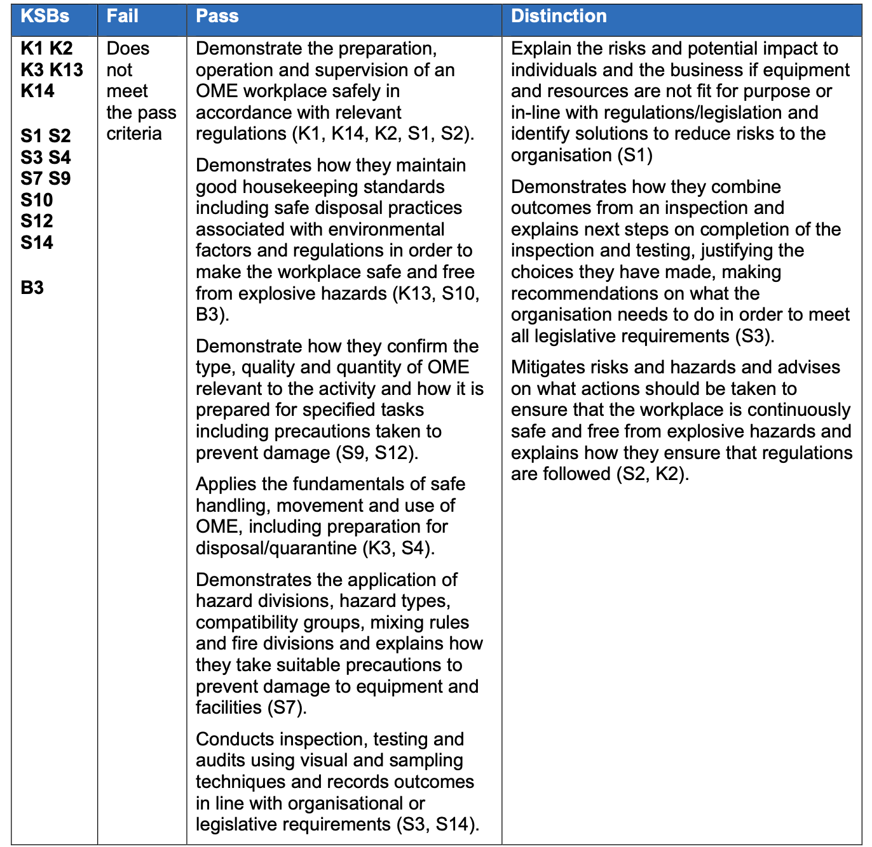
Table 2: Assessment method 1 grading

Assessment method 2: Interview underpinned by a portfolio of evidence
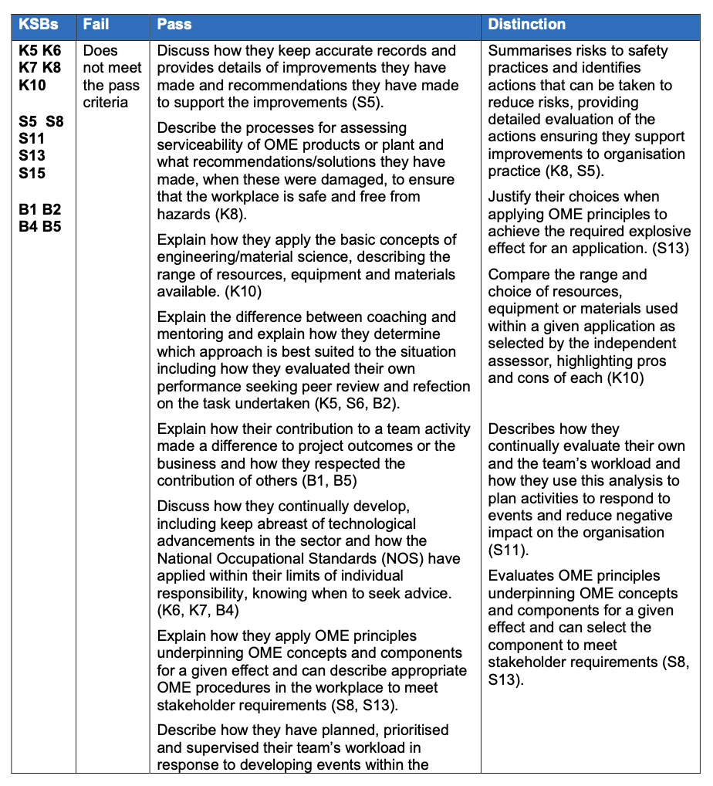
Table 3: Assessment method 2 grading

Assessment method 3: Knowledge test
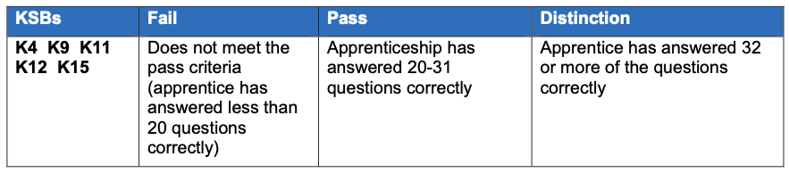
Table 4: Assessment method 3 grading
The following grade boundaries apply to the test:
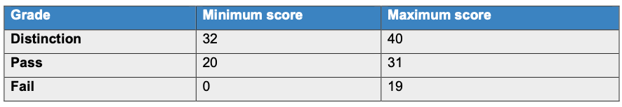
Table 5: Grading assessment boundaries

Overall EPA Level 4 Grading
All EPA methods must be passed for the EPA to be passed overall.
To achieve a pass, the apprentice must achieve a pass in both assessment methods by achieving all pass criteria.
To achieve a distinction, the apprentice must achieve a distinction in both assessment methods by achieving all pass criteria and all distinction criteria.
Grades from individual assessment methods should be combined in the following way to determine the grade of the EPA as a whole:
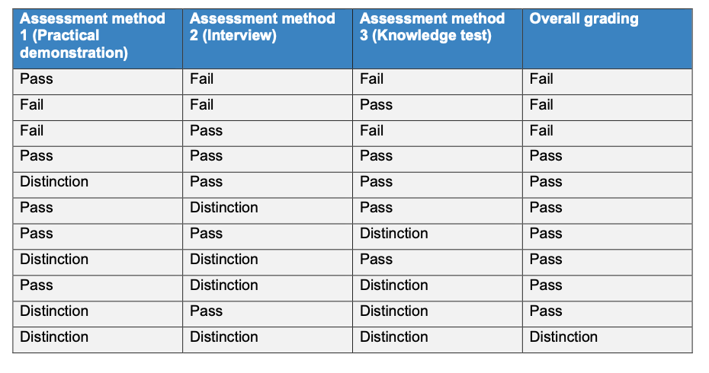
Table 6: Overall assessment gradings for EPA

End point assessment re-sit and re-take information
Apprentices who fail one or more assessment method will be offered the opportunity to take a re-sit or a re-take. A re-sit does not require further learning, whereas a re-take does.
Apprentices should have a supportive action plan to prepare for the re-sit or a re-take. The apprentice’s employer will need to agree that either a re-sit or re-take is an appropriate course of action.
An apprentice who fails an assessment method, and therefore the EPA in the first instance, will be required to re-sit or re-take any failed assessment methods only. If the apprentice fails the practical demonstration, they will need to complete a new practical demonstration. If the apprentice fails the interview, they will not have to resubmit a new portfolio of evidence.
If they fail the knowledge test, they will need to retake a new knowledge test.
The timescales for a resit/retake is agreed between the employer and EPAO. A resit is typically taken within 1 months of the EPA outcome notification. The timescale for a retake is dependent on how much re-training is required and is typically taken within 4 months of the EPA outcome notification. All assessment methods must be taken within a 6 month period, otherwise the entire EPA will need to be resat/retaken.
Re-sits and re-takes are not offered to apprentices wishing to move from pass to distinction.
Where any assessment method has to be re-sat or re-taken, the apprentice will be awarded a maximum EPA grade of pass, unless the EPAO determines there are exceptional circumstances requiring a re-sit or re-take.

UWTSD – Internal Quality Assurance
Internal quality assurance refers to the requirements that EPA organisations must have in place to ensure consistent (reliable) and accurate (valid) assessment decisions. EPA organisations for this EPA must:
- appoint independent assessors who have knowledge of the following occupational areas:
  - OME engineering/material science, manufacture, disposal and testing, including all safety and environmental aspects within the Apprenticeship Standard
- appoint independent assessors who have recent relevant experience of the occupation/sector at least one level above the apprentice gained in the last three years or significant experience of the occupation/sector.
- appoint independent assessors who are members of relevant professional bodies.
- appoint independent assessors who are competent to deliver the end-point assessment
- provide training for independent assessors in terms of good assessment practice, operating the assessment tools and grading
- have robust quality assurance systems and procedures that support fair, reliable and consistent assessment across the organisation and over time
- operate induction training and standardisation events for independent assessors when they begin working for the EPAO on this standard and before they deliver an updated assessment method for the first time
- ensure independent assessors attend standardisation events on an ongoing basisand at least once per year

Affordability
Affordability of the EPA will be aided by using at least some of the following practice:
- using an employer's premises
- a suitable venue selected by the EPAO (e.g. a training provider's premises or another employer’s premises)
- Skype (or equivalent)
- On-line assessment (knowledge test)

Professional body recognition
This apprenticeship is designed to prepare successful apprentices to meet the requirements for registration as an Ordnance Munitions Explosives Technician with Institute of Explosives Engineers.

Mapping of knowledge, skills and behaviours (KSBs)

Assessment method 1: Practical demonstration with question and answer session
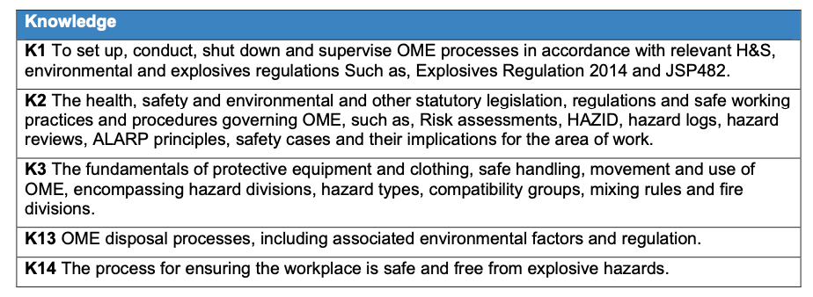
Table 7: Knowledge mapping - Assessment method 1
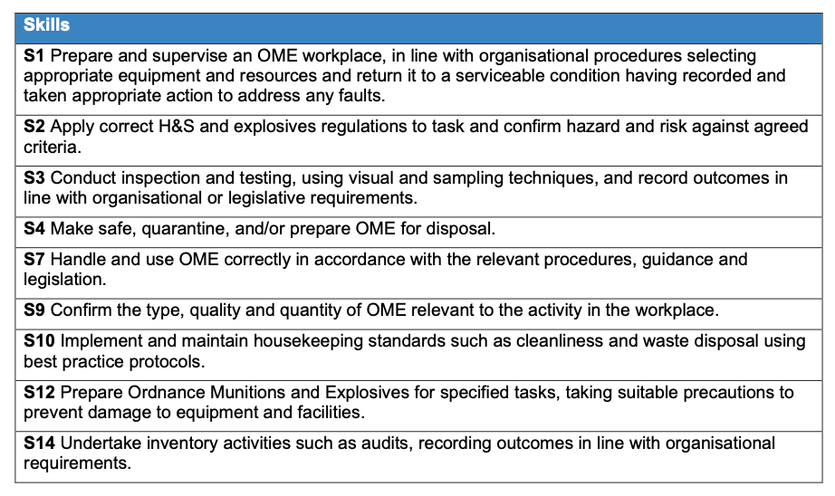
Table 8: Skills mapping - Assessment method 1
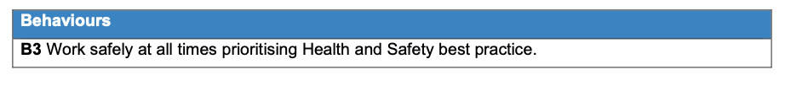
Table 9: Behaviours mapping - Assessment method 1

Assessment method 2: Interview underpinned by a portfolio of evidence
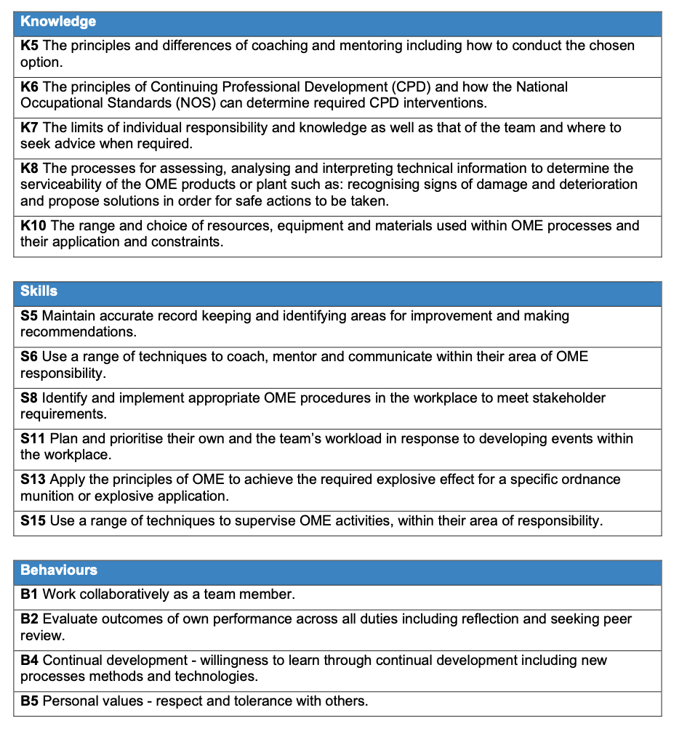
Table 10: Knowledge, Skills and Behaviours mapping - Assessment method 2

Assessment method 3: Knowledge Test
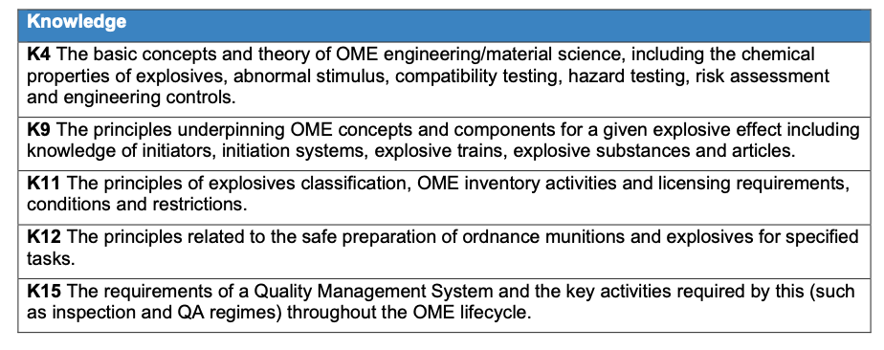
Table 11: Knowledge mapping - Assessment method 3

