Module name: The Global Business Environment
Module code: LCCB4005
Assignment Title: Assessment 2 Environmental Analysis of an industry
Lecturer name: Mushfiqur Rahman
Student ID: 2013037
Student name: Petru Vutcarau

Executive summary
In this raport I will critically analyze the changes that the company have made in the last few years to their business model to self-regulate and adapt to some of the concerns raised by the different stakeholders above. I will explain the factors which influence the company, their stakeholders and how all this changes regarding fashion pollution affect the industry.

Introduction
In various sovereign nations, the global business environment can be described as the environment. Outside, the societal, democratic, economic, administrative, fiscal, cultural, legal and technical contexts. In order for foreign businesses to work economically and successfully, they must consider the social climate of their host country. In several parts of the globe there are thousands of Multinational corporations. A company's ability to design and adapt the internal variables to take advantage of the external environment's opportunities would decide its performance. The study addressed developments in the current apparel market to achieve a strategic edge. The case study on the conservation of environmental issues has given rise to various stakeholders.

Company Overview (Marks & Spencer)
In 1894, Michael Marks and Thomas Spencer formed the company in Leeds. Owing to difficulties with its production chain, and disappointing product offerings, the firm had a tough financial situation in the early 2000s. However, the retailer continued to change its fortunes after the election of Sir Stuart Rose as CEO in 2004. M&S is historically known as the UK retail industry's bell weather, meaning that if M&S is in a difficult position, the entire business is in difficult times. The study of PESTEL seeks to classify the forces that affect the most on and success of the group. The below analysis examines how the business works and attempts to determine the macroenvironment. Marks & Spencer is one of the UK's top distributors (UK) Per week, the number of visitors to M&S stores is close to 21 million. 2,000 retailers are responsible for the satisfaction of consumers for outstanding quality goods.

Case Study
The fashion industry is the world's leading polluting market. The garment industries produce enormous emissions of pollution and pollute the oceans with micro-plastic. Washing clothes spill 500,000 tonnes, or 50 billion plastic bottles, per year into the ocean. The output of fast fashion accounts for 10 percent of the entire European Union world carbon emissions. In the rivers and lakes that pollute them, 85% of apparel manufacturing waste sinks. The atmosphere level is not being met by and employed in Bangladesh, Pakistan, China, Turkey, Botswana, Rwanda, Ethiopia and so forth. Over the last 12 years, company M&S emissions have fallen by 75%. They continue to explore new heating, transportation and cooling technologies. They also help some to act – to assist our suppliers in reducing carbon emissions. They say no business will flourish in an environment in which we strive to pillage wealth and dump CO2 into the atmosphere. From the broader supply chain M&S cut 13.3m tonnes of CO2e. The calculation of clean energy emissions on the market for 2019/20 was 195,000 tonnes. Further, we go further at M&S by offsetting the remaining emissions, known as carbon neutrality, to produce zero net emissions. We have become the world's first big store.
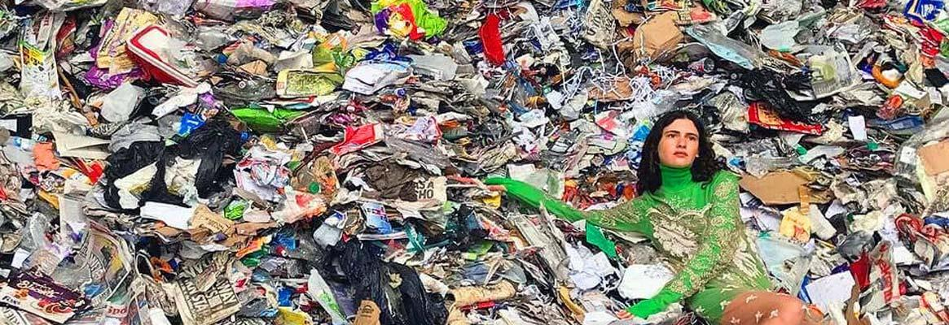

Change that Marks & Spencer Made Last Few Years

The manufacturers of Marks & Spencer propel waste for removal while all other healthy recycling opportunities are present. M&S does not burn solid waste because it emits hazardous air polluting gases. The company has supported an environmentally friendly waste disposal plant in Great Britain and Sri Lanka. In 2020, M&s is committed to reducing all hazardous waste releases during delivery. In order to affirm its contribution to the global social and environmental questions, Marks & Spencer also presented a study called "Plan A." M&S has set a deadline for the removal from manufacturing of all dangerous chemicals by 2020. The brand offers a wide variety of size, pregnant and small size audiences. The report would not specify concrete objectives for measures to reduce water. In the past, waste was handled directly by different parts of the corporation. M&S has constructed water treatment plants that aid 90% water recycling. In order to improve waste prevention, the company is committed to partnerships with the government in the UK. The corporation introduced a 'shopping' campaign that promotes the introduction of used clothing by consumers. Clothes were donated to the clothes shops of second hand Oxfam. A total of 11 million clothing donated.
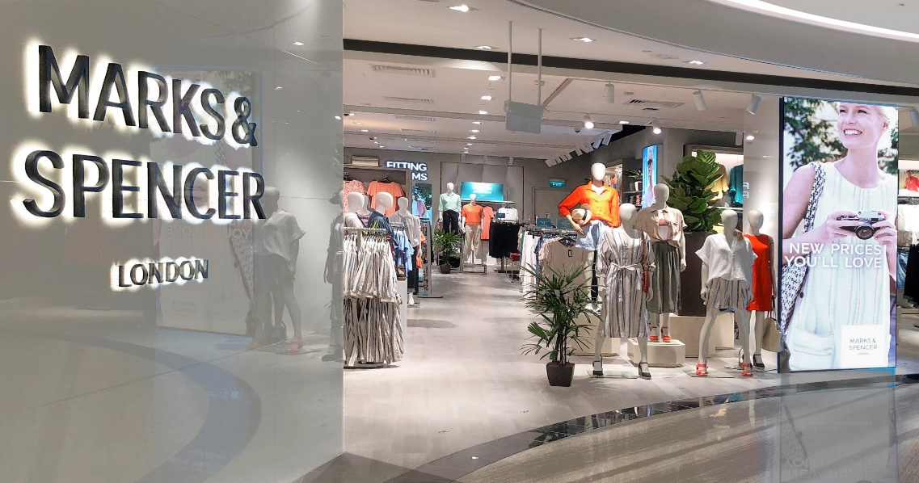
PESTLE Analysis of M&S
The research study PESTLE/PESTEL analyses in depth the core factors that affect Marks & Spencer's macro climate for the retail sector. Political and environmental considerations play a vital role in deciding a corporate plan, including fiscal, technical, legal and environmental factors. M&S complies with government and environmental laws to protect natural resources and the atmosphere by complying with proper waste processes.
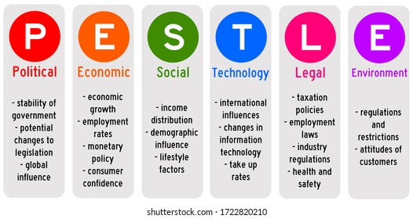
- Political factors: Marks & Spencer has more than 1300 stores worldwide and headquartered in the United Kingdom. The corporation has benefited from the trading arrangements of EC, leading to lower procurement costs. Political stability and taxation are the two major factors impacting the business. If the government raises taxes, the prices of Marks & Spencer goods which have a detrimental influence on the selling of its products rise more.
- Economic factors: The UK is one of the world's biggest economies and an open democracy. The corporation has an approach that is geared towards supplying its consumers with premium goods. Because of low disposable income, the financial crisis could reduce demand for high-quality goods for Marks & Spencer. The slump impaired the willingness of the company to sell reductions, as it discounted the original plan of providing a 20 percent discount on Christmas.
- Social factors: In terms of social status and demographics Asda and Marks & Spencer deal with various audiences. The cultural, social, personal and psychological developments in the market affect consumer procurement. Changing baby boomers from generation X to millennials allows companies to adapt tactics to meet the needs of today's generation. The sold clothing line and the room it has been allocated depend essentially on the town and the population. Trade grew by more than 10 percent in 2006 following the business entry of credit cards.
- Technological factors: Marks & Spencer also revealed the Transformation in Technology Program which will make the organisation a digital first company. It is intended to build a flexible, quicker and business technology feature. The group has concentrated on simplifying and strengthening the technological base of Marks & Spencer.
- Legal factors: Training workshops for areas such as wellbeing are carried out regularly and updated by Marks & Spencer every year. When it was reported that it did not protect its staff, the brand underwent open inspection.
For all crimes, they were charged with fines of 500,000 pounds. However, the organisation could not solve the whole issue, turning a blind eye.
- Environmental factors: Marks & Spencer has established its own green policy, now known as "Plan A." The corporation's initiative is beneficial about welfare, families and the earth. It is a company initiative They also engaged in a range of ways, such as the elimination of transfats, oil savings and fair trade.

Different Stakeholders
The key players in the M&S industry are clients, staff, vendors and investors (shareholders), but their influence is not as high a priority. The other stakeholders have influence. Customers are the focus of any industry and a company without customers will be unable and unsuccessful to make profits.
- Customers. M&S customers want and deserve to receive fair-priced merchandise as easily as possible. The workers must make it easier for consumers to transact. Owners must ensure that they have sufficient employees to ensure that they are sufficient. The production of your products by suppliers must be ethical, since otherwise consumers may boycott shops because they do not want to pay their money to help a supplier with which they disagree.
- Employee: M&S is a constant triumph for owners and staff alike. That is because it ensures that workers are safer in their work. Owners use as much money as possible to save the company in order to spend in other fields. Employees have a great impact on the business, since they won't make any attempt if they don't feel they are respected enough. This will have an effect on the company's clients and lose revenue.
- Suppliers: Sustainable goods may be used by suppliers and owners to the contrary. Somehow, both of the players, but more the client, work together. Both those involved, except consumers, collaborate to provide customers with support and goods. An concern of vendors, workers and owners is needed for all consumer interests. The clients are the market for M&S, so a company cannot succeed if there is no demand.
How These Changes Provide a Competitive Advantage
Going back to conventional manufacturing practises is more eco-friendly than wastes simply from the death of the materials alone. Designer labels use local handmade techniques most often, since this increases the longevity, elegance and appearance of the products. This works with conventional ways of using animals for items like fur, leather and silk. (The True Cost, 2015). Up-cycling/recycling is another way to contribute to sustainable materials. Old jeans, bottles and other castoffs can be made in natural garments, as well as the highway giant marcs and a suit-line all made of recycled materials is made by Spencer (Shen, 2014). The environmental contribution of Marks & Spencer is shown by its focus on high-quality and durable materials.
They are using eco-friendly materials such as recycled nylons, recycled polyesters and organic cotton, as do many other brands which lead sustainable use in the fashion industry.
They also provide shoppers with a recycling programme, which we can see on the popular “Greenpeace Detox Catwalk”.
The animal rating of Marks & Spencer in 'It's A Start' is unfortunately the lowest rating of brands. Without being open on its origins, the brand uses leather, down and cashmere. However, in their use of wool they conform to the Responsible Wool Standard. Moreover, M&S took the initiative of not using hair, angora and other animal exotic skin. Here's the hope that they can keep it. All M&S clothes will still produce 100% of cotton responsibly. We have also worked in partnership with Jeanologia to eliminate water in the finishing process. In comparison to industry standards, jeans are produced with 86% less water on average.
Customer staff fascinated by M&S to enhance the environment. This developments in the industry largely prompted M&s to encourage the reuse and recycling of customer loyalty programme. Award and sustainable industry leader was helped by environmental sustainability practises. M&S can achieve credibility and customer attention by implementing growth strategy.

Recommendations
There are some reforms M&S has to look at, so they can retrieve the missing market share and clients. The present approach M&S does not work very well. Come and gain customer loyalty by better service with latest quality items in clothes food and finance. Enhance shopping online, this helps not only to reduce expense, but also to increase revenue and to be competitive as well as to be able to promote online advertising. Improving the shopping experience for customers: M&S must improve in its stores in areas such as product accessibility and improved customer service which creates value for the customers and a specific equation. In order to reduce carbon waste, the Company will introduce new rules and legislation. In order to get consumer interest, M&S should concentrate on a competitive approach. It will increase the efficiency of the product and reduce fibre waste by better qualified employees.

Conclusion
In conclusion I can say that M&S should develop an emergency strategy that focuses not just on differenzation, but also on the increasing competition from other retail chains. Exclusivity must be examined if M&S approach is to be successful and to succeed in the long run, its key skills provide equal importance for consumers. Since consumers believe like they are not making profits, since the rival offers products at lower cost, their products are not uncommon and other rivals will copy them. The second most important polluting industry in the world is the fashion industry. The study looked at the improvements to M&S in order to improve the company's climate. It evaluated the improvements that contribute to emission reduction in the fashion industry. After doing this research I learned a lot of interesting facts about how the company fights with pollution.

References:
- Abeles, T. P., 2014. Fast Fashion and the Future. On The Horizon, 22(2), pp. 157-160.
- <http://www.marksandspencer.com/thecompany/> (n.d) [15 June 2011]
- <http://www.docshare.com/doc/103365/Exploring-Corporate-Strategy-in-Marks-and-Spe> (n.d) [16 June 2011]
- http://myacademicassist.com/pdfs/Critical%20Analysis%20of%20Marks%20and%20Spencer's%20SUstainability.pdf
- Cohen, E. (2011) 'Inside Marks & Spencer's Sustainability Report', Sustainable Business, 11 March.
- Big Society Awards (2013) Award Winner : Marks and Spencer - Shwopping, [Online], Available: http://www.bigsocietyawards.org/award-winners/marks-and-spencers-shwopping/ [18 June 2014].
- Johnson, M. (2004) 'Marks & Spencer implements an ethical sourcing program for its global supply chain', Journal of Organizational Excellence, vol. 33, no. 12, pp. 3-16.
- Spencer, M.a. (2014) We've won a welfare award, [Online], Available: http://producerexchange.marksandspencer.com/news/weve-won-welfare-award [18 June 2014].
- Taylor, G. (2012) 'M&S named Responsible Retailer of the Year', Retail Gazette, 21 September.
- https://www.theguardian.com/environment/2012/jun/07/marks-spencer-carbon-neutral-sustainability
- Nugent, H and Hawkes, S (2008). George follows Jeremy Paxman as M&S faces another brief challenge. 20 March 2008. www.timesonline.co.uk (Accessed 18/03/08).
- Marks and Spencer (2008). “Our History”. http://www.marksandspencer.com (Accessed 18/03/08).
- M&S (2007). M&S Annual report 2007. www.marksandspencer.com (Accessed 1803/08).

