Ransomware
  - Keeping your files safe
James T | Embedded Electronics | 01/11/2023

Contents
- Introduction
- Forms of Malware
  - Trojans
  - Virus
  - Ransomware
    - Should you pay?
- Cryptowall
  - What is it?
  - How does it work?
- How can this be prevented?
- Conclusion
- Bibliography

Introduction
This report will cover Forms of Malware, what ransomware is in more detail, its different forms, why and how people use it, and how you can prevent it in the first place. [1]REMEMBER – Prevention is always better than solutions. Finally, this report will deep dive into the CryptoWall variant and show how it was used, as an example of ransomware and why it was such a nasty form of ransomware.

Forms of malware

Trojans
[2, 3]Trojan (or Trojan Horse) is a Form of malware that, from the outside, seems like a legitimate piece of software, but is in fact malware. This is done by packing the malware into real software, to trick the victim into clicking in them. This means that the malware can only be installed through being physically installed.

Virus
[4]Viruses are different to Trojans since they self-replicate and spread from one victim to the next. Therefore, it can be thought of like the flu, since it cannot reproduce and spread without programming something such as a program or document. Similarly, the flu can’t spread without a host cell. For the Virus to get onto the computer, it requires the program its infected to be run on the computer, which will cause the virus code to be executed. This means a virus can be on a computer without showing any major signs. It can also infect other devices on the network that the computer is connected to. Some of the devastating things they do is steal passwords, data, spam email contacts, take over your machine and more.

Ransomware
[5, 6, 7]Ransomware is a form of Malware that locks your device, and encrypts the documents and pictures, as well as any other important files. The way it infects the devices is similar to that of viruses, since they disguise themselves as programs/software. Once infected, a demand to pay a sum of money is made to get back the files. It is always better to prepare for it than to repair damage caused by the attack. Therefore, here are some simple ways you can protect yourself and the data.
- Backup all your files – This could be done by storing data in different places such as; disk storage, Cloud storage and/or a storage device separate from the devices, for example: a memory stick
- Think – don’t just click the link or attachment from strangers
- Use a web adviser – A web adviser warns you if the link you’ve clicked on is or could me malicious
- Install security software – This protects devices by way of a firewalls and anti-spam filters
- Remember to keep the computer up to date and keep monitor of security

Should you pay?
[7]It is not encouraged or condoned to pay the ransom by the Law. Paying the ransom does not guarantee that you will get your data or computer access and the computer will still be infected – Only 19% of people who pay the ransom get their files back. Furthermore, you will be paying the criminal groups and are more likely to be targeted in the future as you have met their demands. Due to this, it further backs up reasoning to have recent online copies of your important data and files.

Cryptowall

What is it?
[8]Cryptowall is a program released at the end of April 2014, that is a file encrypting ransomware. It targets all versions of windows, with its 4 different versions (1.0 to 4.0), which contain additional changes over each other.

How does it work?
Once it has been loaded on the machine via a download of software that looks real (either distributed by app, Ads or email), it scans the computer and encrypts the files. Once this has happened, it will open a notepad window and in that contains all the instructions to pay that ransom. However, as stated above, it is unadvised to pay any ransom since there is not a guarantee you get those files back. These ransoms usually start at $500 and go up to $1000 after 7 days. The payment is wanted through Bitcoin. One example of what this looks like is shown in figure 1.
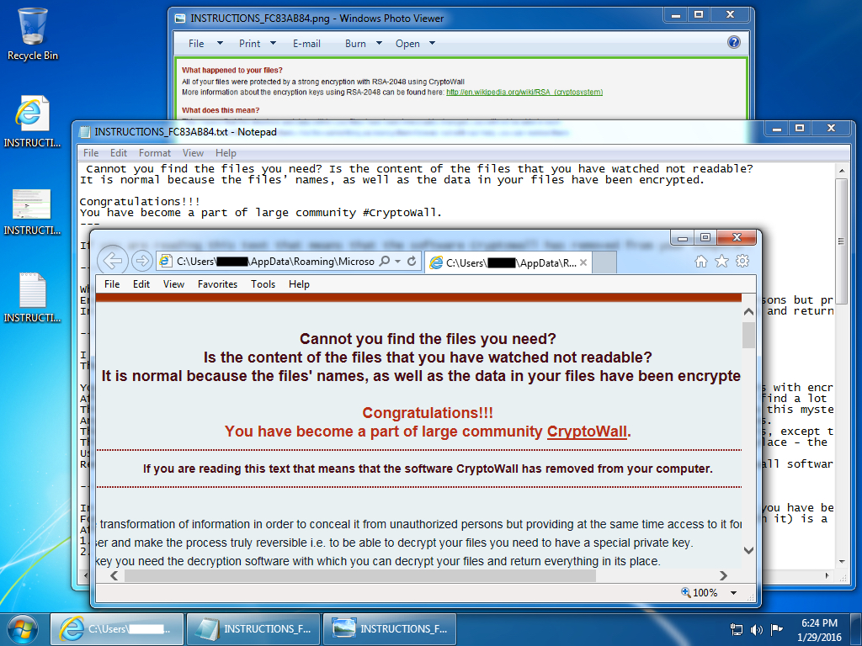
[9]Figure 1 (Example of Cryptowall message)

What files does it target?
[1]The files are Encrypted and only accessible again through an encryption key stated in the notepad. The files that are at risk to this are shown in figure 2
[1]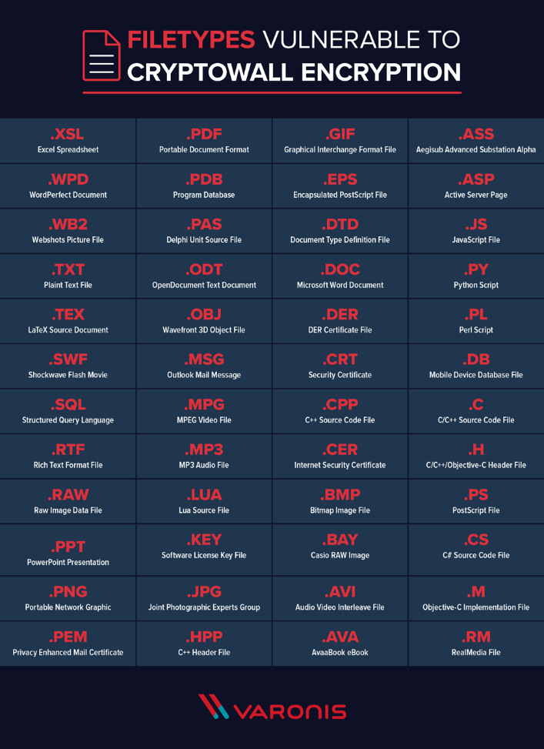
Figure 2 (Files Vulnerable to Cryptowall)

How can this be prevented?
[1]Protection on the devices is vital, so keeping the system up to date is ensuring that it is easier to avoid malware infections. Malware uses known vulnerabilities in software to more around machines. Keeping the system and apps to the most up-to-date versions makes it harder to encrypt.
Using anti-virus scanners and firewalls adds extra protection against several types of malware attacks. They do this by isolating known malware software and blocking them from being ran. The firewall protects you from some connections that malware uses, killing the attack by preventing the malware from making a connection.
Practicing safe browsing habits and not clicking links from people you don’t know or look suspicious. Keeping the browser up to date, turning off ads and JavaScript by default will help lower the risk of an attack.
Backing up the files is also important – keeping it stored in multiple places helps back up important files that could be lost due to a Cryptowall (or any malware) attack. Having a copy on the computer disk and the cloud is not enough for the most safety. An external drive, separate from the computer and network means that you will have a storage device that is safe from attacks.
These prevention methods aren’t just for the Cryptowall variant either. It is good practice to keep on top of all these points for any malware attack.

Conclusion
To conclude, ransomware is a form of malware that is similar to a virus, but its core purpose is to get money from the victim. Paying this ransom is making you more of a target since they know you will meet their demand, so don’t pay. Following the right protection method is an important step to lower the risks of an attack (any form of malware), especially backing up files since if an attack did happen and the files get encrypted, you have a safe store of those files so you can still access them. Remember – it is better to prevent an attack than to cure and attack.

Reference list

Bibliography

[1] | M. Buckbee, “The State of CryptoWall in 2018,” Varonis, [Online]. Available: https://www.varonis.com/blog/cryptowall. [Accessed 01 11 2023].
[2] | I. Belcic, “What Is Trojan Malware?,” Avast, [Online]. Available: https://www.avast.com/c-trojan. [Accessed 01 11 2023].
[3] | “Understanding Trojan Viruses and How to Get Rid of Them,” mcafee, [Online]. Available: https://www.mcafee.com/learn/understanding-trojan-viruses-and-how-to-get-rid-of-them/. [Accessed 01 11 2023].
[4] | “What Is A Computer Virus?,” Norton, [Online]. Available: https://uk.norton.com/blog/malware/what-is-a-computer-virus. [Accessed 01 11 2023].
[5] | “Differences between viruses, ransomware, worms, and trojans,” Mcafee, [Online]. Available: https://www.mcafee.com/support/?articleId=TS100872&page=shell&shell=article-view. [Accessed 01 11 2023].
[6] | “What is Ransomware?,” [Online]. Available: https://www.mcafee.com/learn/ransomware/.
[7] | “A guide to ransomware,” National Cyber Security Centre, [Online]. Available: https://www.ncsc.gov.uk/ransomware/home. [Accessed 2023 11 02].
[8] | “CryptoWall and HELP_DECRYPT Ransomware Information Guide and FAQ,” BleepingComputer, 10 07 2014. [Online]. Available: https://www.bleepingcomputer.com/virus-removal/cryptowall-ransomware-information. [Accessed 2023 11 02].
[9] | Malware-Traffic-Analysis.Net, 29 01 2016. [Online]. Available: https://www.malware-traffic-analysis.net/2016/01/29/index.html. [Accessed 03 11 2023].

