Leigh Sinclair 2313952
Contemporary Dialogues: Fine Art.
Confirmative Praxis
Word count: 5125

Layering, Folding, Revealing
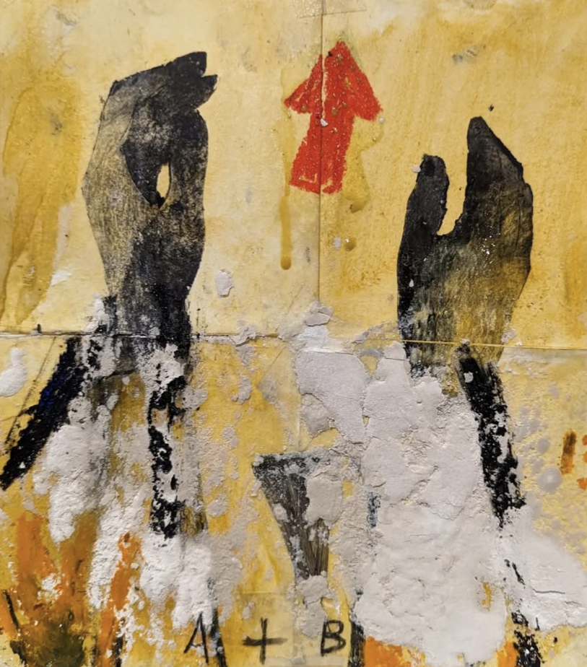
Figure 1. Sinclair, L. 2024‘Estyn’

Table of Contents

- Introduction
- Six Acres
- Autoethnography/Psychogeography
- Futures
- Past
- Temporal Latency-Duration
- Stratification
- Relationism
- Appropriation/ Assemblage
- Material as Memory and Time
- On Abstraction and Thresholds
- Dialectics
- Conclusion

Introduction

Aristotle stated, “Time is a measure of change.” (Rovelli, 2019, P86) As descriptions go this is reasonable, comprehensive, but within that change there is so much that occurs, “Think of the world as being made up of events. Of happenings. Of processes.” .”(Rovelli, 2019, P87)
There is a violence in time, an indifference a disregard, it speeds up, slows down, distorts, bends, time as a ‘changing’ entity seems altogether too passive a description to capture the force with which it exerts its energies.
This report communicates the conceptual and practical framework which has informed my praxis. My intention was to explore the relationship between mechanical time and the Bergsonian concept of real time and duration, ‘La Durée.’ ”Pure duration offers us a succession that is purely internal.” (Gilles Deleuze, 1988. P.37)
Through this research I explore the macro and micro features of time in relation to space and place, juxtaposing scientific ideas such as super positional theory with hauntology and psychogeography.
I achieved this through an intense scrutiny of materials and an autoethnographic investigation into the significance of the former family farm, and the landscape it inhabited. Examining the context, history and culture of the area where I grew up, I developed a broader understanding and perspective of the super-positions which have formed my understanding of the time and events that have shaped me in relation to this land.
Through this prism I visited further themes relating to ideas surrounding atemporality and contemporary artists such as Oscar Murillo and Ben Rivers, whilst taking on and challenging historical references from Abstract Expressionism and Arte Povera through artists such as Antoni Tapies and Mary Lloyd Jones.
Throughout the research I engaged with Post Structuralism through philosophers such as Derrida and Deleuze, whilst also exploring other thinkers such as and Yi- Fu Tun and Walter Benjamin
Painting, drawing and printmaking make up the core of my practice, combining these elements to illustrate and examine the temporal layers that mould our personal and collective histories.
Through the work It was my ambition to present the relationships between, time, memory, landscape and materiality, revealing the correlation between painting practice and the entropic processes witnessed in nature. I came to use a variety of materials to create a textured surface, layering, obscuring and revealing. Working intuitively, I allowed the surface to dictate the flow of paint and the varying curing qualities of the materials to dictate the outcome. What eventually revealed is an expression of activity and duration of time condensed, a temporal artefact.
“The experience of space and time is largely subconscious” (Tuan, 1977, P, 118)

Six Acres

Six Acres is what remains of the family farm in Brynamman, We know it as ‘Yr Ynys’ (The Island) In this place, memory and nostalgia have usurped my ability to perceive this place objectively. My Grandfathers farm, where my mother grew up and where I spent so much of my childhood is now an oasis of nature, situated between the Amman River and the old railway, it is now a dense scrubland of birch, oak, nettles, gorse and all manner of wildlife.
Visiting there as an adult what I see through my eyes, etched as they are with so many memories, is no longer chronologically accurate, the past and present oscillate. I see the landscape not only through my own experience, I see it through the stories passed on to me, through the prejudices, misconceptions and misinterpretations of my youth, through the previous history I was once ignorant of. What I now perceive is not what is there, what I see is a history beyond my own.
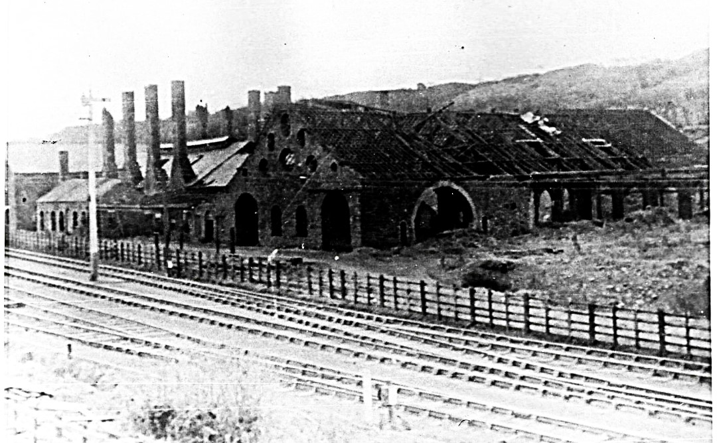
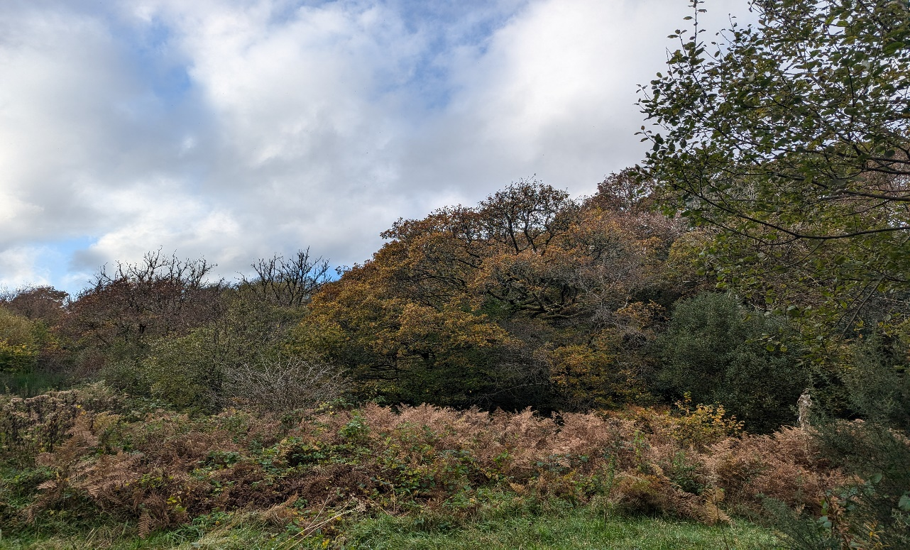
ATEMPORALITY
MODERNITY
ANTIQUITY

Fig 2. Sinclair, L. 2025. ‘Yr Ynys’

Autoethnography/Psychogeography

“In South Wales a lot of communities grew up around the industry and were left like boats on a muddy floor once the industry left, or as it died.” (King, 2022, P.390)
Growing up in 1980’s Brynaman, we were surrounded by the remnants of industry, our homes were decorated with miners’ lamps and brass pit ponies, reclaimed by nature our playgrounds were derelict collieries, slag tips and quarries.
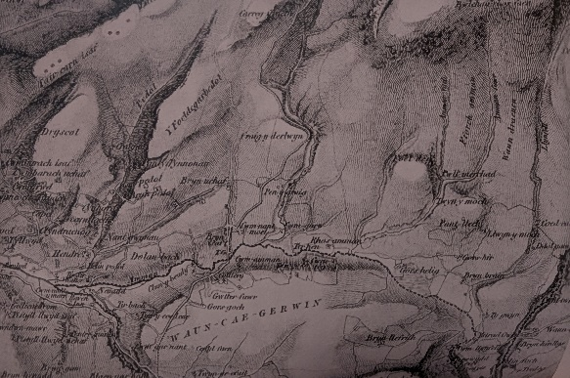
As a child I had no concept of my proximity in time to the collapse of industry, “A young childs experience of time differs from that of an adult. To the child time does not “flow”; he stands as it were outside it.” (Tuan, 1977, P.185) It seemed ancient, long in the past, I was, for a long time ignorant and unsympathetic towards the malaise caused by the socioeconomic climate and the aftermath I was growing up in.
Brynaman as I was familiar with bared no relation to the one that existed ten years before I was born and no comparison to the village that developed there over a hundred years prior.
Fig 3. Ordinance Survey map of Brynamman
Originally the village was a collection of farmsteads, mostly owned by private landowners occupied by tenant farmers, “There is evidence that people have lived in this area for centuries, as there are ruins of ancient stone dwellings, possibly prehistoric “ (Davies, 2019, P.15)
This came to change during the boom for coal during the 19th century. Mines sprung up all around the valley and what developed was a thriving village, that attracted workers and families from all over South Wales and Beyond.
Several generations benefitted from the investment of landowners such as John Jones and his son John Jones junior, roads were built, villages, farms and mines connected, workers also contributed to establishing local resources, chapels took care of the spiritual aspect of the community, schools and libraries fostered education and the entertainment were covered by billiard halls, theatre, public houses, workingmen’s hall and a lido.
My Family (on my mother’s side) have resided in the village for several generations, with my great grandfather and then my grandfather taking ownership of Glynbeudy Farm, which was situated on land that had previously been a tinwork, a colliery and the Brynaman railway station.
Not a great deal is documented about the land prior to industrialisation, its chrono history beginning with the dawn of the industrial revolution.
My experience of the village growing up bared no resemblance to what it had previously looked like, what this temporal disconnect has come to illustrate for me is a latency within our perception and of how we understand the world around us in relation to the past and present.

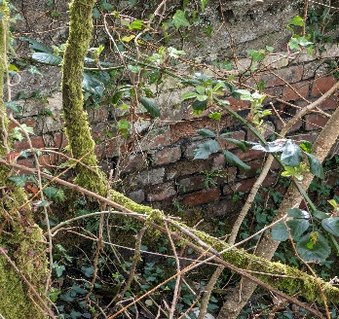
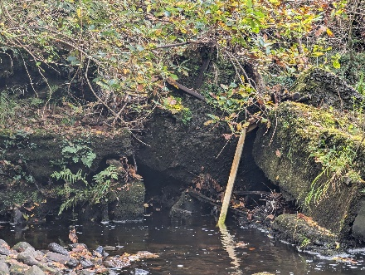
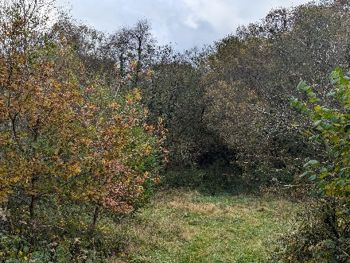
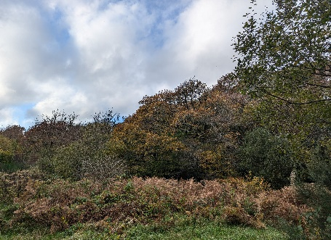
Fig 6. Sinclair, L. 2024 ‘Yr Ynys 3’
Fig 7. Sinclair, L. 2024 ‘Yr Ynys 4’
Fig 5. Sinclair, L. 2024 ‘Yr Ynys 2’
Fig 4. Sinclair, L. 2024 ‘Yr Ynys 1’

I begin taking walks, unearthing, stalking memories, it occurs to me I am a spectre, performing a haunting.

Future’s
Mark Fisher explored the relevance of the Future in his book ’Ghosts of My Life: Writings On Depression, Hauntology and Lost Futures.’ Fisher Posits that the failure to deliver the promises of a utopian future has created a disillusioned now. “This stasis has been buried, interred behind a superficial frenzy of ‘newness’, of perpetual movement ‘the jumbling of time’, montaging of earlier eras, has ceased to be worthy of comment; it is now so prevalent that it is no longer even noticed” (Fisher, 2014, P.17)
For Fisher this cultural revisionism is a symptom of something having gone wrong, Brynaman, along with so many communities across south Wales are examples of the failure of the future.
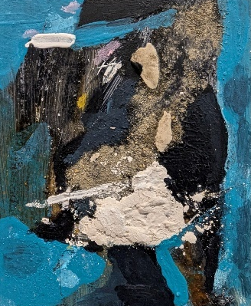
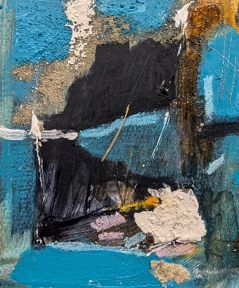
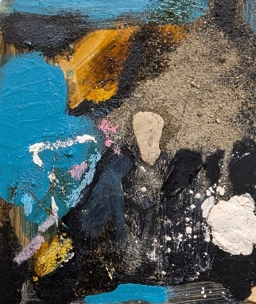
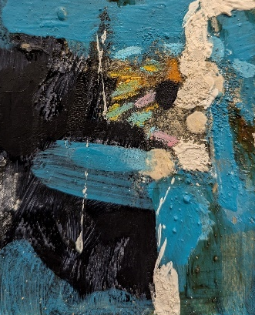
Fig 8. Sinclair, L. 2024, Study 1
Fig 11. Sinclair, L. 2024, Study 4
Fig 10. Sinclair, L. 2024, Study 3
Fig 9. Sinclair, L. 2024, Study 2
Fig 4. Sinclair, L. 2025 ‘Yr Ynys’
An excavation, beyond place, memories uncovered, exposed.

Past
‘All our experiences, in as much as they are ours, arrange themselves in terms of before and after.’ (Priest, 2002 p.119)
For the industrial communities of South Wales, any sense of the future ended abruptly in 1986, the demise of the coal industry, collapsed their economic security, leaving them cut off from an increasingly globalist world ushered in by Margaret Thatcher and neo liberal politics. Christine Powell, who famously egged Thatcher, said of the Tory leader’s intentions, “Thatcher was going to kill the coal industry whether is was by strike, or by stealth or privatisation: it was going.” (King, 2022. P,275)
At that precise moment, as below, the above communities became a petrified relic of a previous time, “The present slips and vanishes like sand between fingers, acquiring material weight only in its recollection.” (Tarkovsky,A 1986, P.58) the people became history, carbonised into memory.
The stratification of a culture was televised live, a localised story broadcast across the world. The competing forces of the conflict, the unions and the government dictated opposing narratives which have taken 40 years’ worth of unravelling to truly gain full perspective on the sequence and consequences of events. “Its not just a black and white story. You cant simply replace jobs in that sort of setting, because the old industrial patterns were not only about jobs, and that is something which people didn’t entirely grasp. They were about community patterns; they were about common culture.” (King, 2022. P,327) How we portray history is often defined through binaries, but as the mediums through which time and experience is measured, temporality is considerably more nuanced than our ability to document and communicate it.

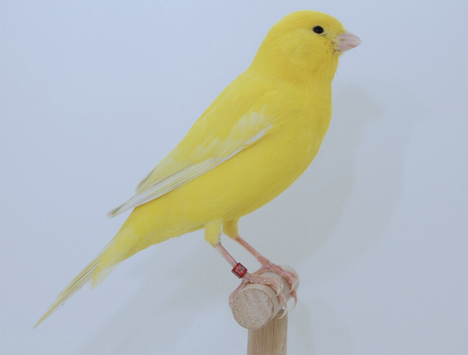
Silent canary
Uncertain future
Calcified past
Fig 12. Canary
Temporal Latency- Duration
Einstein recognised that gravity impacts the passing of time, as
illustrated by Carlo Rovellli,” a clock placed on the floor runs a little more slowly than one placed on a table.” (Rovelli, 2019, P9)
This impact of gravity on time proves the parallel existence of different times and therefore different perceptions of time and meaning. Gravity slows time down, as gravity diminishes at the edges of the atmosphere space and time dilates, speeds up and creates a temporal latency between the upper and lower atmospheres.
This is further evidenced through ‘Earandel,’ the star furthest away from Earth, 28 billion light years away, the light that we can see and photograph is 13 billion light years old and the star almost certainly perished about 12.9 billion light years ago. (Parks, 2022) What we can deduce here is that the further we investigate time and space the more abstract it becomes, as we observe Earandel, we are literally looking back, travelling back in time, with the knowledge that it is no longer there.

This latency can be applied externally to the subject as well as internally “Each force field (set in the chrono- time appropriate to it) oscillates between periods of relative arrest and periods of heightened imbalance and change, followed again by new stabilization.” (Coole and Frost, 2010, p.179) this imbalance and latency draws parallels with Henri Bergson’s notions concerning duration.
Duration according to Bergson is a condition of ‘real time. Deleuze expands this idea; ‘Duration is not merely lived experience; it is also experience enlarged or even gone beyond’ (Gilles Deleuze, 1988. P.37) From this interpretation we can distinguish ‘Duration’ from the standard quantitative definition of time, thus providing us with a qualitive measure of experience, and broadening our relationship with time as a subjective entity, of fluid time untethered from a fixed-point perspective.
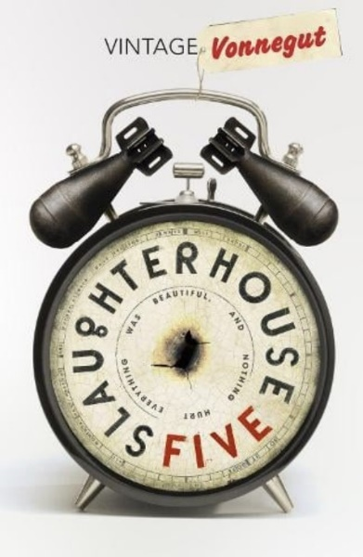
Kurt Vonneguts novel ‘Slaughter House 5’ begins with the line, ‘Listen, Billy Pilgrim has become unstuck in time.’ what follows is a narrative untethered from linear progression, chronicling the subjective experience of Vonneguts time as a soldier in World War 2, mechanical time becomes inadequate to deal with the emotional issues he experienced. For Vonnegut, an oscillating fluid account of past events prove to make more sense to him than the standard notion of time.
Fig 13. Vonnegut, K. 1969, Slaughterhouse 5
Deleuze expanded upon Bergson’s concepts of a more fluid dilation of time and multiplicity through his work ‘The Fold.’ The fold as he explains it ‘Goes out to infinity’ (Gilles Deleuze, 2006 p.139) For Deleuze the fold which he compares to the fashion and style of the baroque, obfuscates and distorts what is beneath the multiplicity of the fold ‘In the Thousand folds of garments that tend to become one with their respective wearers, to exceed their attitudes, to overcome their bodily contradictions, and to make their heads like those of swimmers bobbing in the waves.’ (Gilles Deleuze, 2006 p.139)
Deleuzian folds, represent the ‘infinite’ and the garbed body the ‘finite.’ Within this definition we can distinguish Bergsons ‘real time’ from ‘mechanical time.’
Duration and the latency experienced in time then can be perceived on these terms as an abstract experience, as the folds of reality continue to flow in and out of itself, time is constantly moving, evolving and ever changing.
Through this definition, Bergson distinguishes the past from the present through identifying the past as virtual, layers of events co existing alongside a present in perpetual motion, intuitively drawing on history as we move into an unpredictable future.
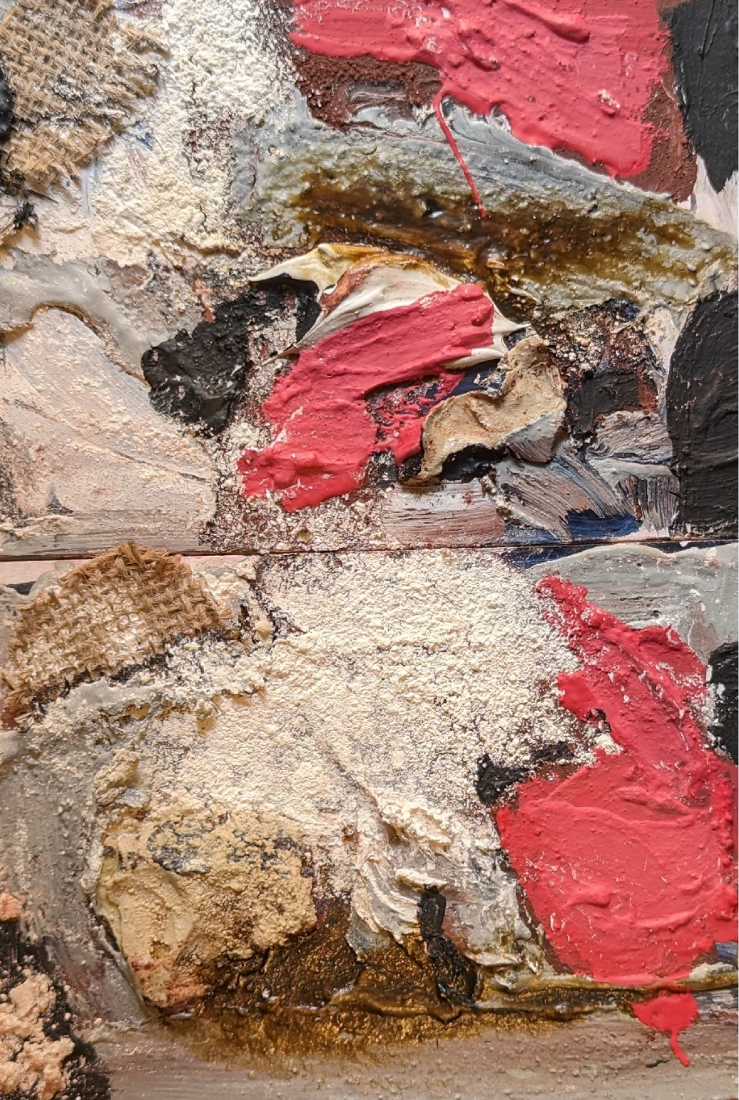
Mechanical time is therefore reduced to a mathematical system only and real time a subjective malleable amorphous form that Is interpreted and manifest through the subjective experience, continually constructing and collapsing meaning.

Fig 14. Sinclair, L. 2024. Study 5

Stratification
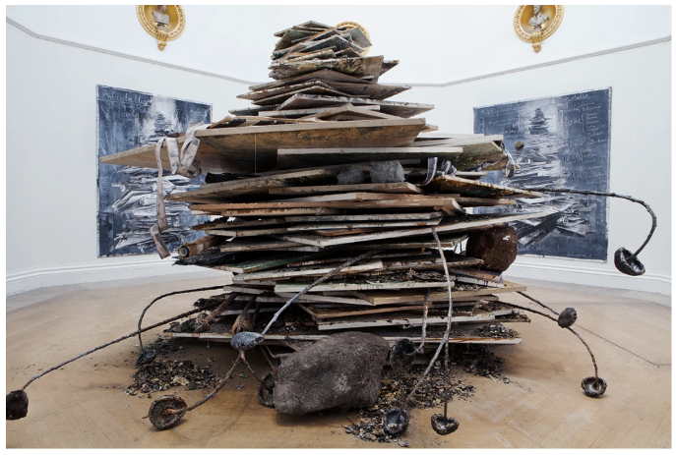
What Bergson and Deleuze allow us to indulge through this concept of unfolding and fluid time, is the freedom of epochs,
Anselm kiefer when discussing his work ‘Ages of the World’ describes it as being about the strata of time, specifically his time, a form of self-portrait, he describes as being ‘Me transported to the geological time. ’(imagine, remembering the future,2023)
Fig 15. Kiefer, A. Ages of the World (2014)
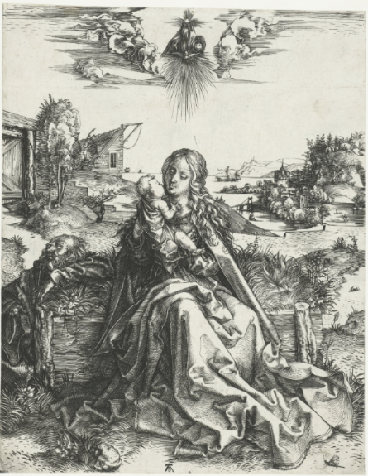
This concept of geological time proposes a different temporal connection. Are we separate from it? if so, is time different for all living things? Is human time different to that of a May Fly? We have already established that time moves faster the higher you are on the planet. This question brings us back to the meaning of Duration and the micro and macro aspect of time, particularly when considered as sedimentary layers over lapping, pressing and forming the stratification of all time. “Strata come in at least pairs, but in a different way each stratum is double (it itself has several layers). Each Stratum exhibits phenomena constitutive of double articulation.” (Deleuze and Guattari, 1987 P. 46-47) This view provides other perspectives upon how temporality can be experienced and valued but also the relational aspect of time.
Fig 16. Durer,A. ‘The Holy Family and the Mayfly.’(1465/1466)
In Ben Rivers 2019 film ‘Ghost Strata’ he takes on time and the juxtaposition of geological time and the layering of our human temporal experience. He presents a world tenanted by humans, recognizing in the geology of rocks the brevity of all thing’s material. ‘What one wants to get at is the real nature of things and the history of things, and the idea that even rocks are impermanent.” (Youtube, 2025)

Now what are space and time? Are they actual entities? Are they only determinations or also relations of things, but still such as would belong to them even if they were not intuited? Or are they such that they belong only to the form of intuition, and therefore to the subjective constitution of our mind, without which these predicates could not be ascribed to any things at all?
Emmanuel Kant
(Janiak, 2016)

Relationism
Yi-Fu Tuan states that our experience of time is always identified in relation to the space it occupies. A day for example, is the measurement of one full rotation of the earth through space. An arrow is often employed to mark the directional aspect, a pendulum illustrates the movements of a clock. however, these symbols only make sense through the context with which they are placed, without any relational aspect they cease to hold any meaning.
Super-Positional theory within quantum mechanics expands upon this relational aspect of time from an atomic perspective. An electron has no fixed position or determined pattern. “As if it were in a cloud of probability. In the jargon of physicists, we say that it is in a superposition of positions’ (Rovelli, 2019, P77)
Carlo Rovelli expands the example of superposition in relation to an electron to that of space time, the experiential existence of different times in space existing in parallel forms, fluctuating, oscillating, events occurring both before and after. Electrons Rovelli states can only be perceived in their relation to other forms, without this comparison, in space they cannot be perceived.
Our understanding of time is limited to our subjective experience of time, we witness the events of our lives thus giving them form, but this form is a subjective temporal interpretation of events, for in space time there is no absolute truth, because everything is a constant state of change and flux.

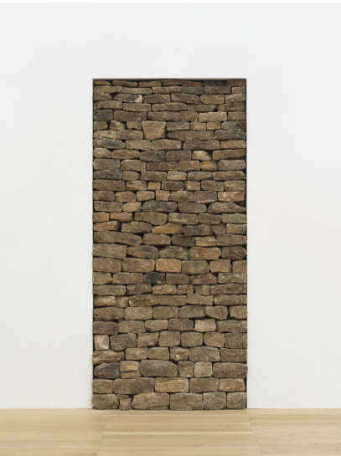
Appropriation/ Assemblage
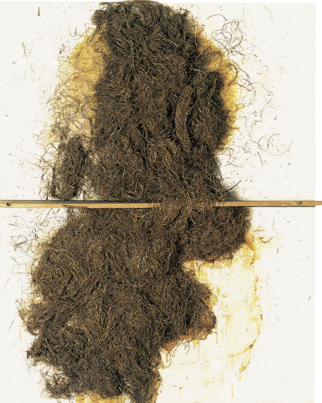
Art in the 20th century embraced this notion of flux and meaning, Following the collapse of old symbology associated with religion, a more secular philosophical position has dominated productivity. Technological innovation within fine art has become secondary to ‘concept’ and in terms of its use and innovation of materials and styles, become more circular regarding its experience of time. Arte Povera’s great legacy was the use of everyday items that already existed in the world to create new works, exemplified by artists such as Jannis Kounellis and Antoni Tapies.
Fig.17 Kounellis, J. Untitled 1969
Duchamps ‘Ready-Mades’ and the collages of the Dada group and later of pop artists like Robert Rauschenberg led to a democratisation of artistic resources and making art out of recognisable materials which were readily available to ordinary people.
Fig.18 Tapies. A. Straw and Wood, 1969
Appropriation of materials is now broadly accepted as a legitimate approach in the production of art, as Nicholas Bourriaud expanded upon in his book relational aesthetics, which talks about art as being “Being made of the same material as social exchanges.” (Bourriaud, 1998, P.521)
Bourriaud believes that a legitimate work of art is rooted in the here and now, that it presents an opportunity for people to engage with it. It should he states, “set its sights beyond its mere presence in space: it will be open to a dialogue, discussion, and that will form of inter-human negotiation that Marcel Duchamp called “the coefficient of art,” which is a temporal process.” (Bourriaud, 1998, P.521)
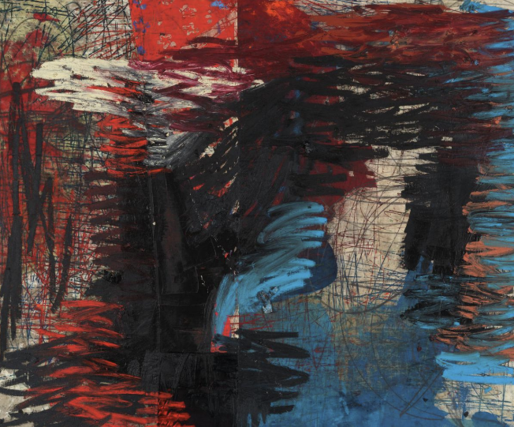
This universal sense of nowness, was the focus of a 2015 exhibition titled ‘Forever Now’ at Moma. The exhibition explored the notion of ‘atemporality.’ ”What characterises our cultural moment at the beginning of this new millennium Is the inability-or perhaps refusal- of a great many of our cultural artifacts to define the times in which we live in.” (Hoptman and New, 2014, P.13). Included in the exhibition was Oscar Murillo, his work borrows from across art history, his influences, Cy Twombly, Jean Michel Basquiat, Robert Rauschenberg are apparent, the work though doesn’t feel derivative, it refreshes a conversation with a previous point in time, previously abandoned by market driven fashion and trends.
Fig 19. Murillo, O. 2019-20. Manifestation
It is not only materials that can be appropriated and provided with new meanings, art can also be provided new concepts when juxtaposed with different relational parallels. A recent exhibition in Lisbon ‘An Atlantic Drift’ brings a unique configuration of art to re-examine the era that they occupied, “ An Atlantic Drift charts and unravels paths through the arts of the 20th century, specifically the period from 1909 to 1977, seeking to disrupt preconceived notions and established canons by bringing together references and artistic forms that are usually kept apart. The exhibition follows an erratic chronology, marked by digressions and temporal leaps” (Centro Cultural de Belém Foundation, 2025)
This approach collapses traditional archival methodologies and provides opportunities to reimagine history and create fresh narratives. A palimpsest approach challenges the familiar empirical and didactive presentation of history and view it as a fluid succession of events that represent time better than isolated and distinct events.

Material as Memory and Time

“An artist’s role is to behold and provide a new pair of eyes for those who care to look. A Painting can therefore accommodate paradox, demonstrating for example, the lands capacity for healing and regeneration whilst seemingly dealing with its destruction.”
(Mary Lloyd Jones, 2006. P.7)

Many of the former sites of industry were hollowed out, the terrain left behind strewn with rubble and debris, it is easy to misinterpret the lushness of the fauna that has reclaimed these areas. Spend any time scrutinizing the topsoil and you will quickly find the evidence.
Landscapes that appear fecund, pregnant with life are contradicted by the abrasive materials decaying, polluting and oxidising under and over the surface of the land. What these landscapes also reflect is the impact of rampant industrialisation on the land and on the people, Ponty stated “The nature in us must have some relation to Nature outside us; moreover, Nature outside us must be unveiled to us by the nature that we are.” (Coole and Frost, 2010, p.180)
Through my work I wanted to reflect the duality between a scarred landscape and people, coexisting in the aftermath of industry. I achieved this through appropriating materials that have more association with industry than of ‘fine art.’
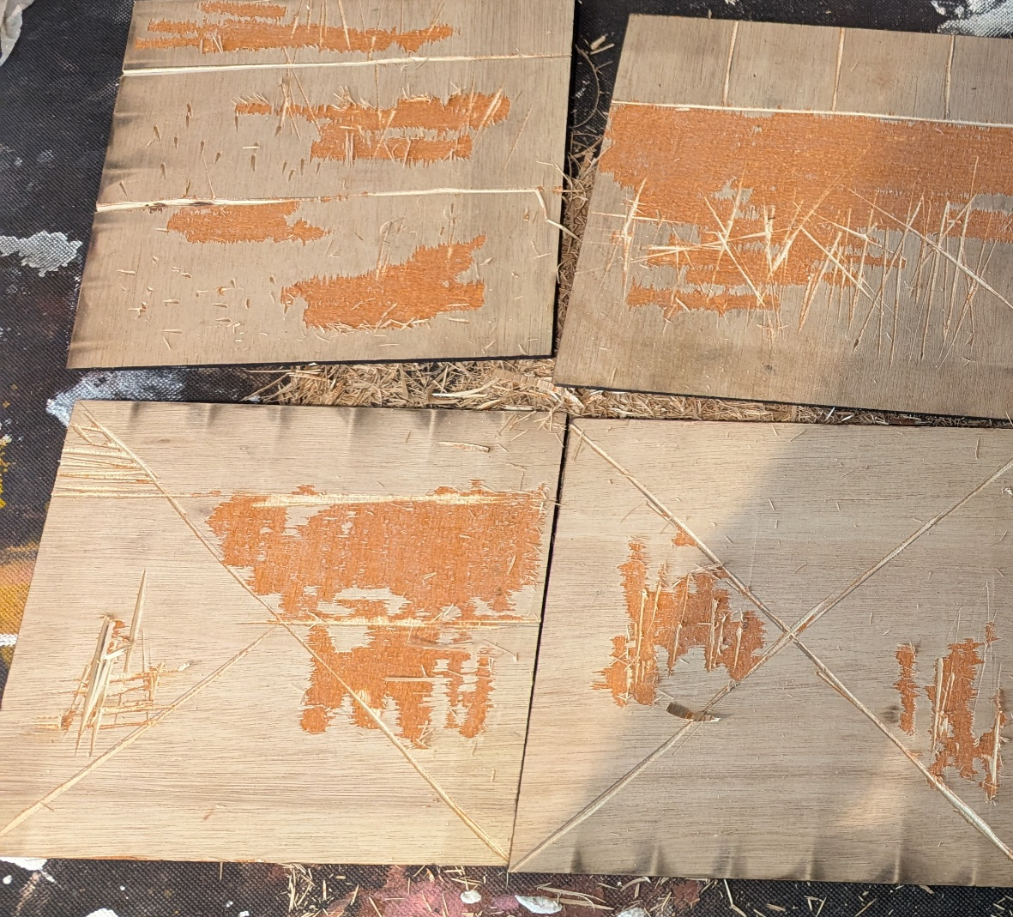
Beginning with a plywood surface, veneers of wood, fittingly glued together with a formaldehyde-based glue is distressed, abrasively sanded, scraped, hacked and gouged, manufacturing the
Fig 20. Sinclair, L. 2025 WIP 1

terrain from which to create an unsettling landscape, the conditions of which Deleuze would describe as the stage of an “asymmetrical nature” (Coole and Frost, 2010, p.181) which is periodically established to disintegrate old orders in the production of new systems.
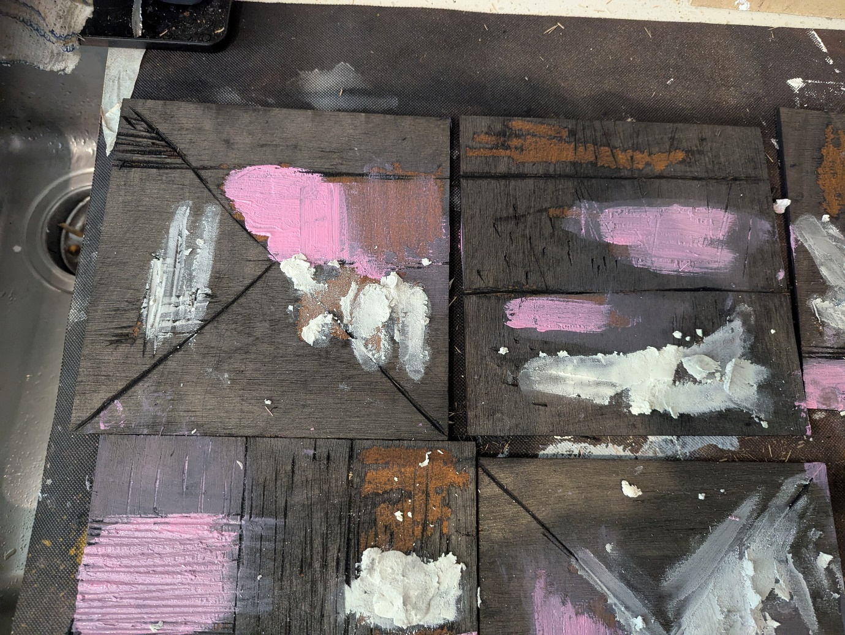
Fig 21. Sinclair, L. 2025 WIP 2

What this presents is a surface with no sense of planning or order, it is mindless, everything from this stage is reactionary to the topography of the substrate, causality guides the reordering of elements through the combinations of materials, dry powders, oxides, sand, coal, cement mix with oil and water based, stains, solvents and paint to create a conflicted top layer of materials reacting to each, drying, cracking and flaking in unpredictable ways.
What remains is a memory, evidence of activity, the details of which are established in the layers, an obituary of brushstrokes, scratches, drips and marks which reflects an intention to communicate and establish a dialogue with the past, present and future.
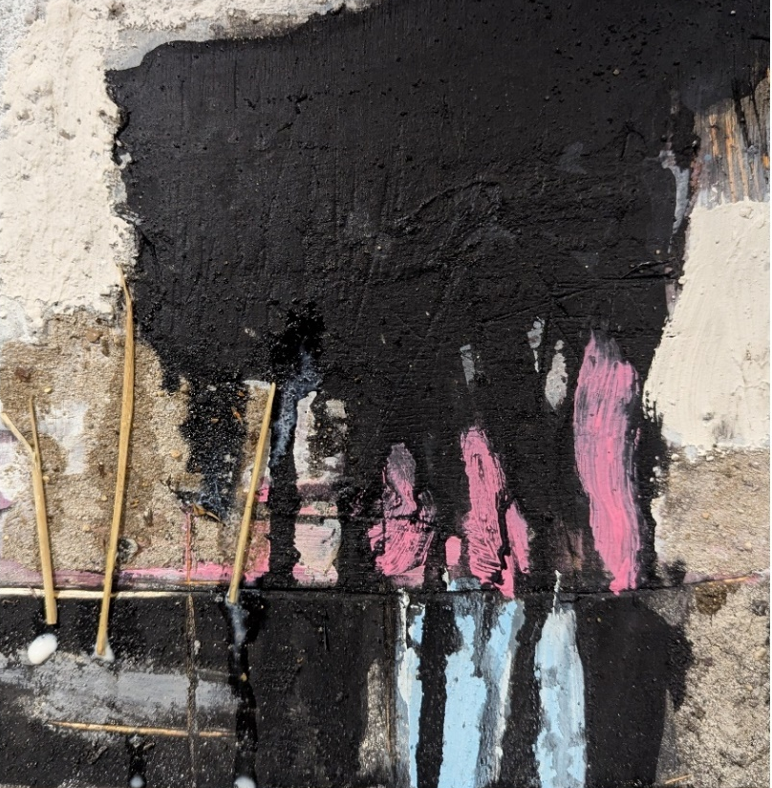
Fig. 22 . Untitled 1
Fig. 23. Untitled 2
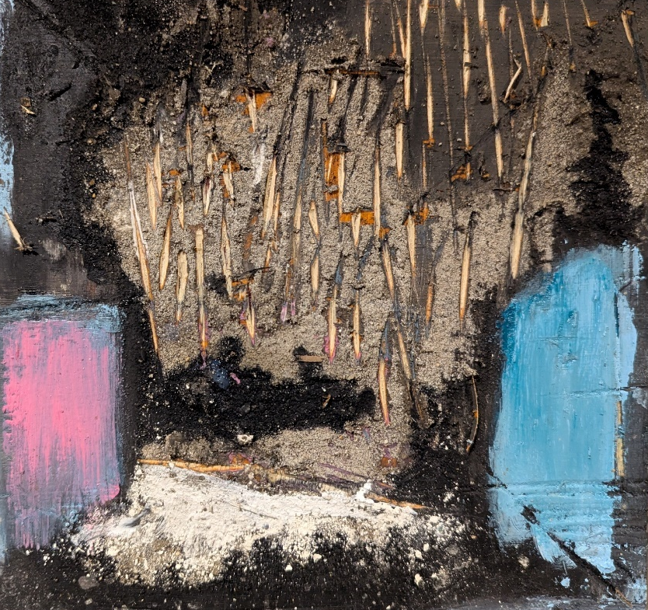

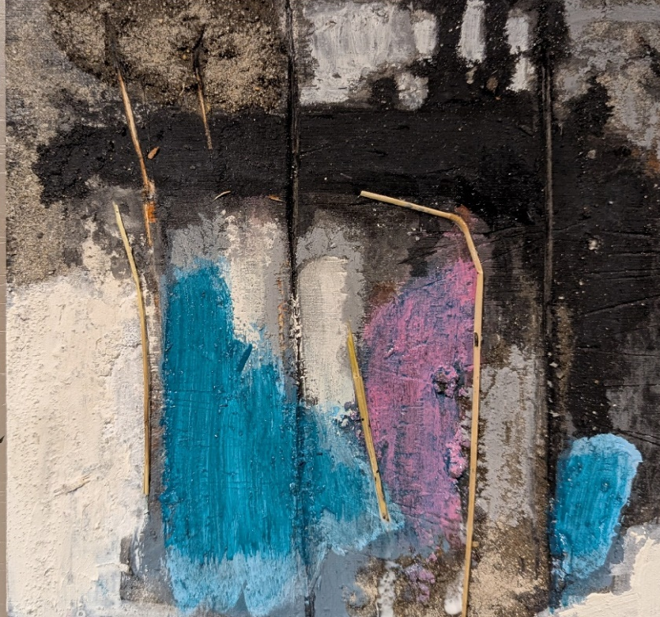
Fig. 24. Untitled 3

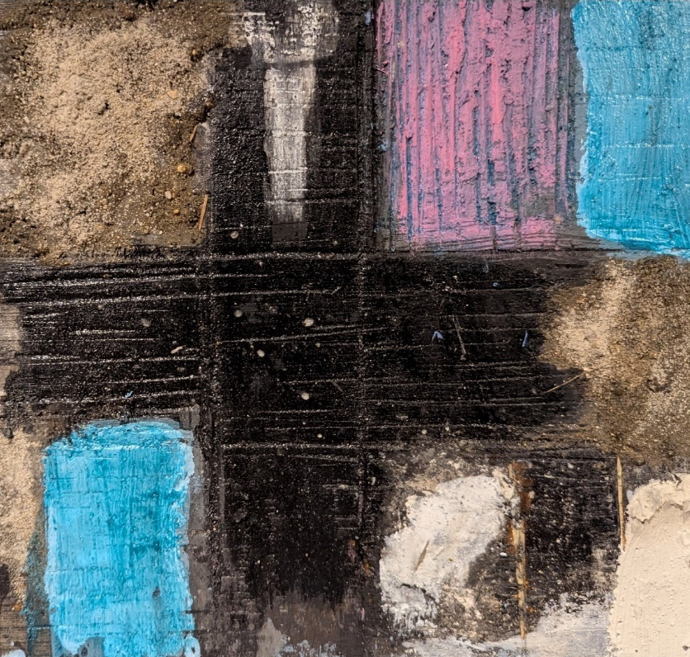
Fig. 25. Untitled 4

My Praxis developed its own ‘super position’ in relation to the past and present. It operated both simultaneously in the past and present, the factual and the speculative. Symbols of antiquity were appropriated as allegorical devices to illustrate a poetic connection with the past.
This grew out of an interest in Greek mythology and of the use of characters such as Mnemosyne and Hephaestus to embody characteristics that represented the human condition. Adopting these ancient symbols seemed appropriate to the process of connecting the past and present, layering and juxtaposing these with contemporary narratives and the human condition in relation to the 21st century.
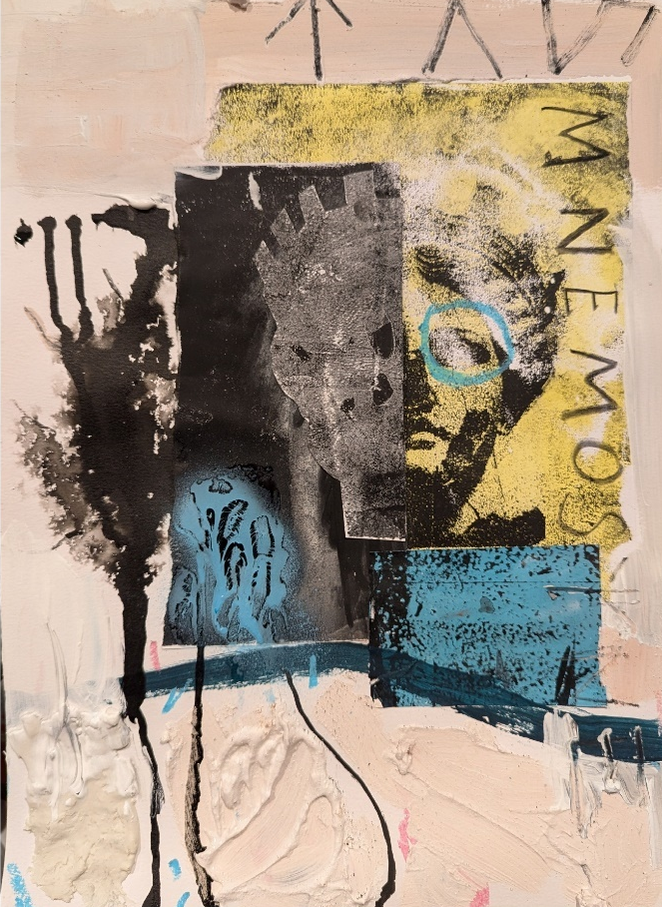
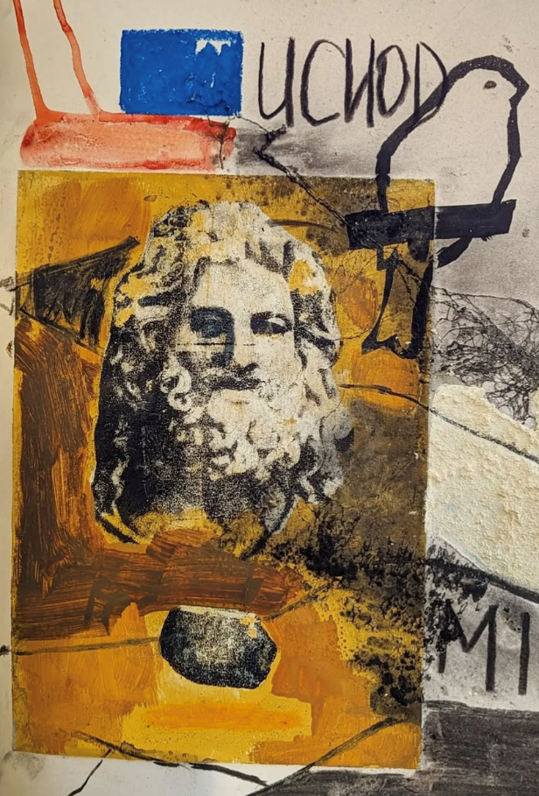
Fig. 27. Sinclair, L. Mnemosyne Appearing Above the Colliery

Fig. 26. Sinclair, L. 2024 Uchod

On Abstraction and Thresholds
“Mythic time and Historical time collide here and lie at the heart of experience as solidly as the Pentre Ifan cromlech.”
(Mary Lloyd Jones, 2006. P. 79)
Ideas throughout my praxis have been represented both figuratively and abstractly. These distinct modes of expression coalesce and maintain a dialogue with one another.
I Found an appropriate blend of opportunities to express these ideas where appropriate, engaging both approaches in ways that best expressed my thinking at the time.
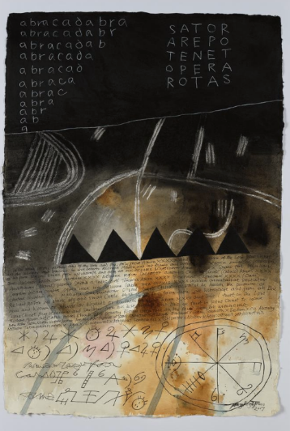
Through her work Mary Lloyd Jones similarly juxtaposes ancient signs with contemporary arts practice. Her loosely formed landscape layer meaning and symbols, Jones deals with runic motifs as well as contemporary Welsh language that jostle within her landscapes, evoking a synergy with tribal art and contemporary abstraction. “She too can rage against the lands wounds and the deforestation of our mountains, notwithstanding the toxins from the ore mines that blot the landscape.”
Fig. 28. Jones.M.L. Swyn 1

(Mary Lloyd Jones, 2006. P. 49) Sometimes the landscapes are void of symbols, at other times they dominate the composition. Her work evokes a history increasingly conflicting with the present and an uncertain future, her use of materials powerfully expressing a complex love of the land combined with a loathing of how it has been marred by industry. “Thickly- applied unmixed oils echo the accumulative seeping ore.
(Mary Lloyd Jones, 2006. P.49)

“For a painter art can have more than one purpose, there are so many dimensions, different perspectives, for me right from the beginning I saw the true meaning of a work of art was its power to transform the individual consciousness to carry us towards that state where for a moment we are in touch with a higher reality
Antoni Tapies (www.youtube.com, n.d.)
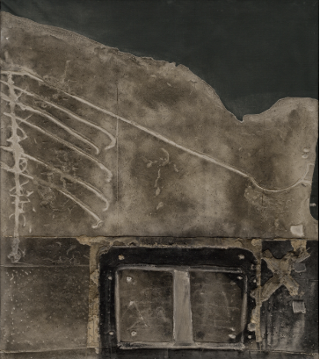
Antoni Tapies incorporated a variety of symbols and motifs that played with linguistics and semiotics, challenging the notion of what a painting is, expressing ideas closely related to theories expressed by Martin Heidegger. “Heidegger iterated that art is an art not because of its representation of reality but because it reveals and opens the contextual world of functional relations of a thing. He stated the need to transcend the literality of the thing-character of the artwork to understand the artwork's truth enclosed in the artist's intentions.” (Chen, 2019)
Through his work Tapies isolated the history captured in the weathered, ancient walls of Barcelona. Through elevating these banal spaces, he created an ontological connection to all of history, neither an expression of now or then, evoking and creating a synchronicity between pre-history and now.
Fig. 29. Tapies, A,. 1959. Grey Relief on Black

Allowing my work to oscillate between abstraction and figuration has allowed me to explore micro and macro aspects of time in relation to my own position dealing with issues surrounding my family and childhood whilst also being able to investigate a more universal notion of space and place.

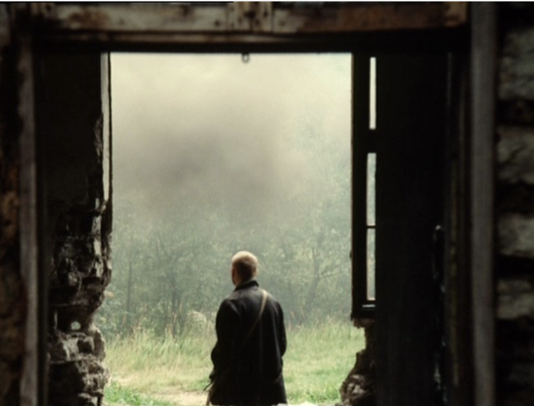
Dialectics
Fig. 30. Tarkovsky, A. 1979. Stalker

Paradoxically this investigation of an external space led to an internalisation of ideas and feelings. I began to consider the Ynys as combination of notions, ideas and feelings, it became less geographically identifiable and more psychological, an outside space rendered internal.
However, at an atomic level, there is no difference between outside and inside, and our senses of either are determined through our cognitive perceptions and preconditions. This binary distinction therefore becomes redundant when we consider our feelings towards a place. Jean Hyppolite spoke on this conflict between the definitions of inside and outside. “A first myth of outside and inside, You feel the full significance of this myth of outside and inside alienation, which is founded on these two terms. Beyond what is expressed in their formal opposition lie alienation and hostility between the two.” (Bachelard, 2014. P.212)
Dissolving boundaries between inside/outside dialectics led to a resolution between figurative and abstract oppositions. This has freed the work from a fixed notion expression, providing a fluid approach that reflects the passage of time and meaning.
Through his ontological search for the line between ‘being and beings,’ Heidegger found challenges in defining what this entity could be, settling on the term ‘Nothingness.’ “Nothingness here is not a vacuum, not a chaotic emptiness. Rather it is what is not.” (Silverman, 2004. P.159)
This sense of ambiguity between the nature of being suggests a parallel between time and the continuous process of ‘becoming,’ and the creation and collapse of states of being as time elapses, which we can see in the work of Deleuze and Guattari and their notions on ‘smooth and striated space.’ “smooth space is constantly being translated, traversed into a striated space, striated space is constantly being reversed, returned to a smooth space.” (Deleuze and Guattari, 1987. P.552)
Suggesting that our understanding of different spaces is altogether too binary, Deleuze and Guattari allow us to focus, not on the distinction which divides spaces but on the conditions that the change is occurring, which provides us the opportunity to analyse the forces at play.
Where abstraction and representation meet in painting, rather than being about distinctions, it simply represents a dialogue between, ‘more or less.’ Much like the concerns of scale, which was an area that I spent a great deal of time considering.
Initially working at a small scale, providing an opportunity to work quickly, It became apparent that I needed to engage with some large works and explore any possibilities that maybe available to me through simply scaling up.
What the process revealed was interesting on several fronts. Foremost, working on large works in a small studio space is a reductive process. My practice, which on a small scale had been hospitably accommodated within the space. Once I began painting on a larger scale the work began to compete with the space. Much like the conflict between outside and inside space, this conflict would eventually have detrimental effects on the production of the work.
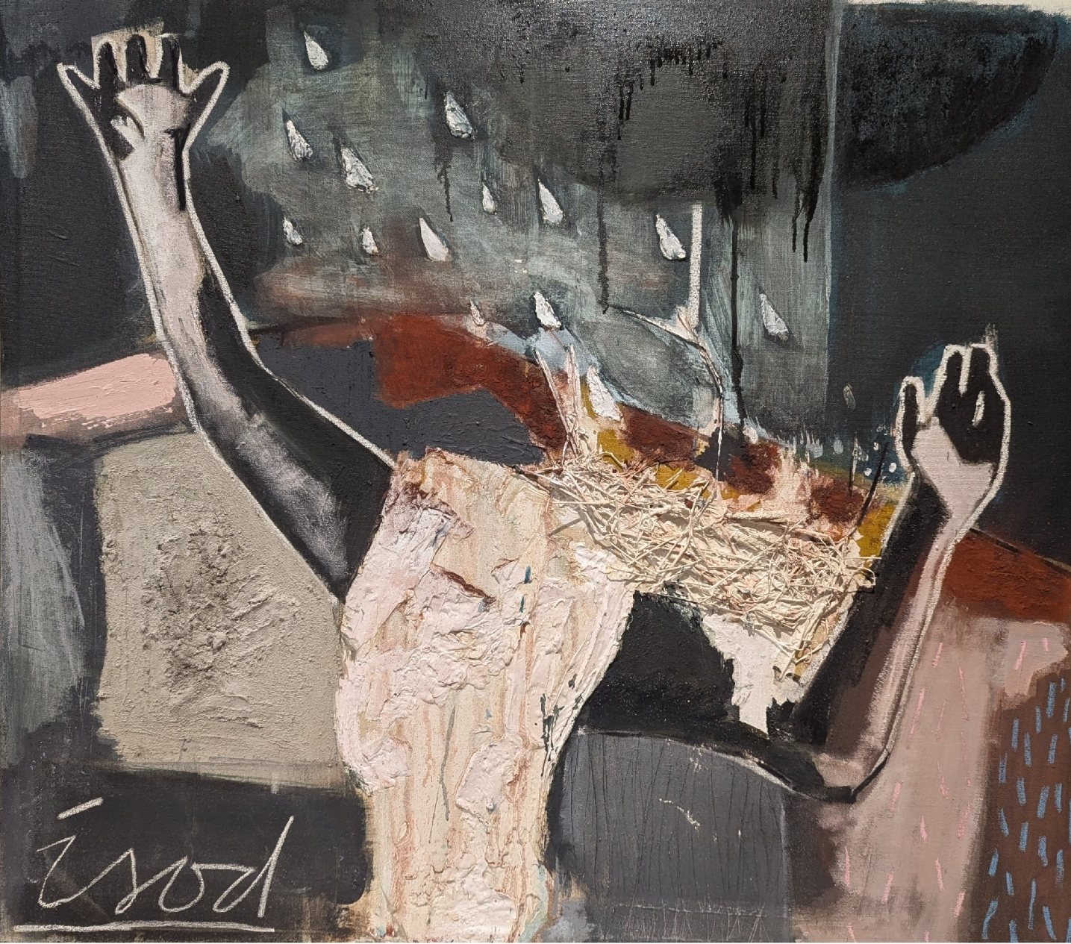
Fig 31. Sinclair, L. 2025 ‘Isod’

It brought social and political perspective to the work which I had previously not considered. Having space is often a condition of wealth, this led me consider the social limitations on creative practices for people from less privileged backgrounds.
Limited by my own financial situation, production of the work became focused on a scale could be recognised as a domestic scale, a scale associated with restriction rather than freedom, this once again becomes a dialectical issue, one associated with class and gender.
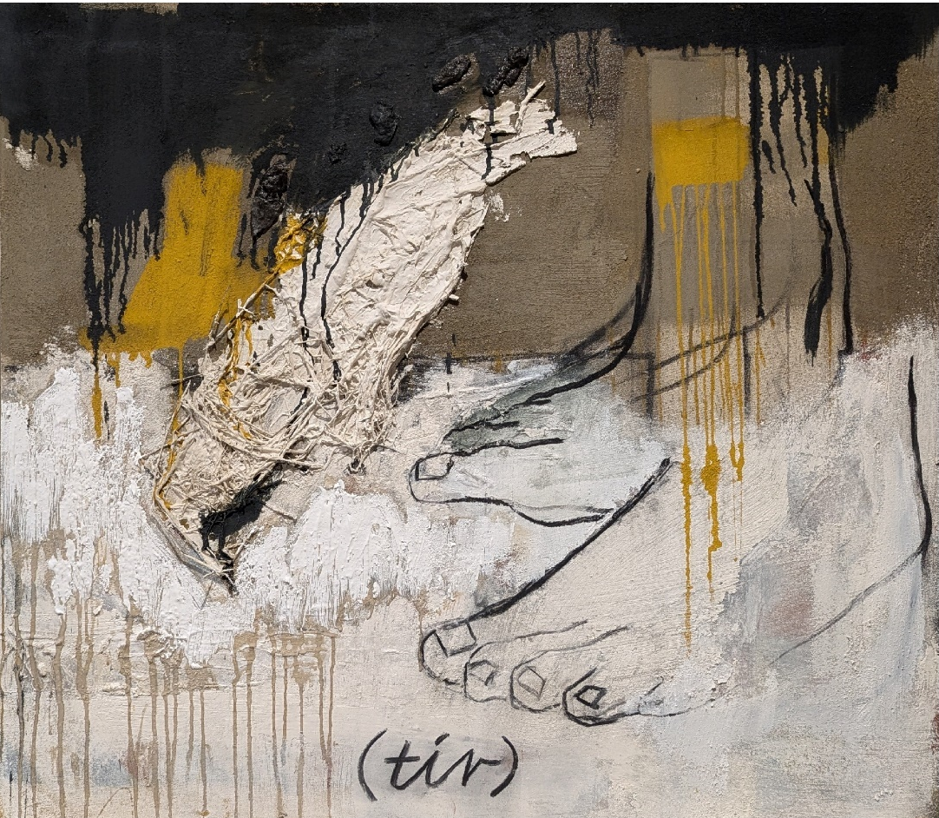
Despite these conditions, I was able to find a means through which to make the work at a scale that functioned well within the space and achieve my aims and targets for the work.

Fig 32. Sinclair, L. 2025 ‘Tir’

Conclusion

This body of work began with an autoethnographic investigation into the post-industrial legacy of industry in the village where I grew up. Following the passing of my grandfather, who, after 10 years succumbed to vascular dementia, it shifted to a deeper consideration of time, memory, erosion and thresholds.
Through the process of layering materials, cement, sand and plaster, I began to mirror the layering of history and forgetting, my practice evolving, becoming focused on balancing presence and absence, embracing ambiguity.
My paintings have come to represent palimpsests, with the ambition to engage the viewer in a slow contemplation, revealing and concealing any absolute meaning or interpretation.
From here I intend to challenge my process which can be described as an additive approach, with the intention of exploring reductive techniques, that evoke absence and silence, whilst expanding the thresholds between figuration and abstraction, developing a praxis which offers philosophical depth whilst remaining broadly engaging and accessible to a wide audience.

Reference List

Andrey Tarkovsky (1986). Sculpting in Time. London: Bodley Head.
Belsey, C. (2002). Poststructuralism: A Very Short Introduction. OUP Oxford.
Bourriaud, N. (1998). Relational Aesthetics. Paris: Les Presses Du Réel.
‌Chen, M.-H. (2019). Antoni Tàpies’ Hybrid Conception of Work of Art: Thingness, Playfulness, and Experience. Konsthistorisk tidskrift/Journal of Art History, 88(4), pp.161–172. doi:https://doi.org/10.1080/00233609.2019.1708456.
Coles, A. (1999). The Optic of Walter Benjamin.
Coole, D.H. and Frost, S. (2010). New materialisms : ontology, agency, and politics. Durham Nc ; London: Duke University Press
Davies, A.R. (2019). When Men Meet Mountain . Y Lolfa.
Deleuze, G. and Guattari, F. (1987). A thousand plateaus: Capitalism and schizophrenia. Bloomsbury.
Epicurus, Strodach, G.K. and Titus Lucretius Carus (2019). The philosophy of Epicurus. Mineola: Dover Publicatons, Inc.
Fisher, M. (2014). Ghosts of My Life: Writings on Depression, Hauntology and Lost Futures. Zero Books.
Gilles Deleuze (1988). Bergsonism. New York: Zone.
‌Gilles Deleuze (2006). The fold. London: Continuum.
‌Glendinning, S. (2011). Derrida : a very short introduction.
‌Hoptman, L.J. and New, A. (2014). The Forever now : contemporary painting in an atemporal world. New York: Museum Of Modern Art, New York, New York.
Janiak, A. (2016). Kant’s Views on Space and Time (Stanford Encyclopedia of Philosophy). [online] Stanford.edu. Available at: https://plato.stanford.edu/entries/kant-spacetime/. [Accessed 6th May 2025]
King, R. (2022). Brittle with Relics. Faber & Faber.
‌Mary Lloyd Jones (2006). Mary Lloyd Jones. Gomer Press.
Oxford: Oxford University Press.
Priest, S. (2002). Merleau-Ponty. Routledge.
Rovelli, C. (2019). The Order of Time. Penguin Books.
‌Tuan, Y.-F. (1977). Space and Place: the Perspective of Experience. Minneapolis: University of Minnesota Press.
‌‌ www.youtube.com. (n.d.). ‘Tàpies’ documentary (BBC 1990). [online] Available at: https://www.youtube.com/watch?v=9Z2GhLfCpDE.

‌

‌

‌

‌

‌

Websites List

Centro Cultural de Belém Foundation. (2025). An Atlantic Drift. The arts of the 20th century based on the Berardo Collection. [online] Available at: https://www.ccb.pt/en/evento/an-atlantic-drift-20th-century-art-from-the-berardo-collection/2025-05-04/ [Accessed 3 May 2025]. ‌
cmags27 (2016). The Desolation of Desire: The Cinematography of ‘Stalker’. [online] Scenes From An Imaginary Film. Available at: https://scenesfromanimaginaryfilm.wordpress.com/2016/03/20/the-desolation-of-desire-the-cinematography-of-stalker/.
Museu Tàpies. (2020). Selected works - Museu Tàpies. [online] Available at: https://museutapies.org/en/the-collection/selected-works/?pg=1 [Accessed 24 Apr. 2025].
Museum Wales. (2021). Swyn I - Collections Online. [online] Available at: https://museum.wales/collections/online/object/0c742ff1-e34f-36a8-be68-61324ee29907/Swyn-I/ [Accessed 6 May 2025].
Parks, J. (2022). Hubble spots the farthest star ever seen. [online] Astronomy Magazine. Available at: https://www.astronomy.com/science/hubble-spots-the-farthest-star-ever-seen/.
‌Tate (n.d.). Jannis Kounellis 1936–2017. [online] Tate. Available at: https://www.tate.org.uk/art/artists/jannis-kounellis-1438.
The Museum of Modern Art. (2025). Antoni Tàpies. Gray Relief on Black. 1959. [online] Available at: https://www.moma.org/collection/works/78435?artist_id=5809&page=1&sov_referrer=artist [Accessed 6 May 2025].
Youtube. (2025). Available at: https://youtu.be/8_ZC9_tLknc [Accessed 24 Apr. 2025].
Youtube (n.d.). ‘Tàpies’ documentary (BBC 1990). [online] Available at: https://www.youtube.com/watch?v=9Z2GhLfCpDE. [Accessed 5 May. 2025]
‌

‌

‌

Television/ Film
Anselm Kiefer: Remembering the Future - imagine..., 00:40 13/12/2023, BBC4, 65 mins. https://learningonscreen.ac.uk/ondemand/index.php/prog/3C1D61B0?bcast=140218512 (Accessed 24 Feb 2025)
Ghost Strata: Ben Rivers. (2019). [Movie].

‌

‌

Illustration List

Fig 1. Sinclair, L. (2024) ‘Estyn’
Fig 2. Sinclair, L. 2025 ‘Yr Ynys Digital collage’
Fig 3. Ordinance Survey map of Brynamman (Image) Davies, A.R. (2019). When Men Meet Mountain Y Lolfa.
Fig 4. Sinclair, L. 2025. Photograph of yr Ynys, 1.
Fig 5. Sinclair, L. 2025. Photograph of yr Ynys, 2.
Fig 6. Sinclair, L. 2025. Photograph of yr Ynys, 3.
Fig 7. Sinclair, L. 2025. Photograph of yr Ynys, 4.
Fig 8. Sinclair, L. 2025. Study, 1.
Fig 9. Sinclair, L. 2025. Study, 2.
Fig 10. Sinclair, L. 2025. Study, 3
Fig 11. Sinclair, L. 2025. Study, 4
Fig 12. Vonnegut, K. 1969, Slaughterhouse 5 Waterstones.com. (2025). Slaughterhouse 5 by Kurt Vonnegut | Waterstones. [online] Available at: https://www.waterstones.com/book/slaughterhouse-5/kurt-vonnegut/9780099800200 [Accessed 7 May 2025].
Fig 13. Sinclair, L. 2025. Canary. Wikipedia. (2020). Domestic canary. [online] Available at: https://en.wikipedia.org/wiki/Domestic_canary.
‌

Fig. 14. Sinclair, L. 2024. Study, 5.
Fig 15. Kiefer, A. (2014) ‘Ages of the World’ (Image) Available at: https://www.royalacademy.org.uk/exhibition/anselm-kiefer [Accessed on 24 November 2025]
Fig 16. Dürer, A. (1495). The Holy Family with the Mayfly,. [online] National Gallery of Art. Available at: https://www.nga.gov/collection/art-object-page.6571.html. [Accessed on 24 March 2025]
Fig 17. Kounellis, J (1969) ‘Untitled’ (image) Available at: ‌https://www.tate.org.uk/art/artists/jannis-kounellis-1438
{Accessed on 24 April 2025}
Fig 18. Tapies, A (1969) ‘Straw and Wood’ (image) Available at:
https://museutapies.org/en/the-collection/selected-works/?pg=
Fig 19. Tate (2023). Oscar Murillo born 1986 | Tate. [online] Tate. Available at: https://www.tate.org.uk/art/artists/oscar-murillo-31389
[Accessed 4 May 2025].
Fig. 20. Sinclair, L. 2024. WIP, 1
Fig. 21. Sinclair, L. 2024. WIP, 2
Fig. 22. Sinclair, L. 2024. Untitled, 1
Fig. 23. Sinclair, L. 2024. Untitled, 2
Fig. 24. Sinclair, L. 2024. Untitled, 3
Fig. 25. Sinclair, L. 2024. Untitled, 4
Fig. 26. Sinclair, L. 2024. Uchod
Fig. 27. Sinclair, L. 2024. Mnemosyne appearing above the colliery
Fig. 28. Jones, M,L. Swyn 1. Museum Wales. (2021). Swyn I - Collections Online. [online] Available at: https://museum.wales/collections/online/object/0c742ff1-e34f-36a8-be68-61324ee29907/Swyn-I/ [Accessed 6 May 2025].
Fig. 29. Tapies, A. 1959. Grey Relief on Black. The Museum of Modern Art. [online] Available at: https://www.moma.org/collection/works/78435?artist_id=5809&page=1&sov_referrer=artist [Accessed 6 May 2025].
Fig. 30. Tarkowsky, A. 1979. Stalker. cmags27 (2016). The Desolation of Desire: The Cinematography of ‘Stalker’. [online] Scenes From An Imaginary Film. Available at: https://scenesfromanimaginaryfilm.wordpress.com/2016/03/20/the-desolation-of-desire-the-cinematography-of-stalker/.
Fig. 31. Sinclair, L. 2025. Isod.
Fig. 32. Sinclair, L. 2025. Tir.

‌

‌

