Varun Chekuri
2424040
Finance For Business Managers
BMMB7005D

Table of Contents
Part 1 3
Introduction 3
Profitability analysis 3
Liquidity Analysis 6
Gearing Analysis 7
Investor Analysis 8
Conclusion 11
References 12
Appendices 14
Appendix 1 – Income statement 14
Appendix 2 – Balance Sheet 15
Appendix 3 – Cash flow statement 16
Part 2 17
Introduction 17
Net Present Value 17
Internal rate of return (IRR) 18
Investment appraisal techniques 19
Non-discounting methods of investment appraisal 20
Other factors in investment decision 20
Optimal investment policy 21
Sources of finance 22
Conclusion 25
References 27

Part 1

Introduction
The present report comprehensively assesses the company’s financial performance through four different avenues: profitability, liquidity, gearing, and investor ratios. Profitability measures considered consist of net profit margin, operating margin, ROCE, and asset turnover, with the primary concern being the efficiency with which sales and assets ultimately translate into earnings. Liquidity measures looked at are current ratio and a firm’s ability to meet short-term obligations without incurring distress. Gearing looks at the balance between debt and equity financing to underline solvency risk and funding risk. Investor ratios include EPS, dividend cover and yield, interest cover, ROE, and P/E, and show returns to shareholders and market views on future growth. By juxtaposing 2023 figures with 2024 numbers, we derive trends, expose root causes for the changes observed, and bring to light any exposed weaknesses. Therefore, the introduction paves the way for interpreting operating changes from one year to another, diagnosing imbalances and weaknesses stemming from operations and financials, and thereby framing the recommendations with the view to improving financial health and strategic positioning of a company.

Profitability analysis
Profitability ratios show how well a firm utilizes its resources or revenues into profit. They measure income generation capability, control over costs, operating effectiveness, pricing force, and a firm's ability to generate value for the shareholders for support to future growth or financing needs (Paramasivan and Subramanian, 2009).
Below is the calculation of profitability ratios of Llyod Plc:
Net Profit Margin
Formula = Net Profit / Sales x 100
 | 2023 | 2024
Net Profit | 5,518 | 4,477
Sales | 35,405 | 34,281
Net Profit Margin | 15.59% | 13.06%
Operating profit margin
Formula = Operating profit / Sales Revenue x 100
 | 2023 | 2024
Operating profit | 24,279 | 22,249
Sales Revenue | 35,405 | 34,281
Operating profit margin | 68.58% | 64.90%
Return on capital employed (ROCE)
Formula = Operating profit / (Total Assets - Current Liabilities) x 100
 | 2023 | 2024
Operating profit | 24,279 | 22,249
Total Assets | 881,453 | 906,697
Current Liabilities | 39 | 45
ROCE | 2.75% | 2.45%
% Asset Turnover
Formula = Profit before interest tax / (Total Assets - Current Liabilities) x 100
 | 2023 | 2024
Profit before interest tax | 24,279 | 22,249
Total assets | 881,453 | 906,697
Current liabilities | 39 | 45
Asset Turnover Margin | 2.75% | 2.45%

(Source: Appendix 1 and 2)
Interpretation
In 2024, all four profitability/efficiency metrics fell compared to 2023, showing modest but universal pressure on the firm's ability to convert revenue and assets to profit. A mixed picture emerges from the companies experiencing weakening revenue, testing cost control, and more significant below-the-line entries on an asset basket that is not yet bringing home capital returns in proportion.
Net Profit Margin - Net profit had dropped by 19%, while sales dipped by only 3%, so the bigger fall in actual profits leads to margin compression. Typically, or in the case of profits falling faster than revenue, there may be: (a) heightened finance costs (interest rate rises; increased borrowing), (b) a higher effective tax rate, (c) exceptional/restructuring charges, impairments or write-downs, or (d) dilution from minority interests or discontinued operations. Since operating margin declines, but less so, the greater divergence between operating and net results suggests that additional drag came from non-operating items rather than purely from core operations. Management should dissect the bridge from operating profit to net income to uncover recurring versus on-off causes.
Operating Profit Margin - Operating profit shrunk 8% while revenue fell 3%, indicating some pressure on the operating cost structure. Some potential explanations: input cost inflation (for materials, labour, and energy) not despite being fully passed through in pricing; an adverse movement in sales mix toward lower-margin products/geographies; heavier operating expenses (marketing to defend share, elevating R&D, regulatory compliance); or the rolling-off of one-offs from the previous year. Not that said and done; the reported level is still remarkably high compared to most industries; this could mean either: (i) legitimately advantaged, high-gross-margin business model (software, licensing, IP royalties) or (ii) a definitional issue - maybe 'operating profit' does not cover significant overhead categories. Make sure to clarify cost allocations before benchmarking peer or making strategic cost decisions.
ROCE - The decline in ROCE arose as the decrease in operating profit juxtaposed against an expansion of the capital base (Total Assets rose from 881,453 to 906,697; with negligible current liabilities, capital employed approximates to total assets). The fall in ROCE becomes concerning if the firm's WACC is materially higher; beneath-WACC returns destroy value.
% Asset Turnover - As calculated, this metric doubles ROCE because it uses the same numerator (profit) and denominator (net assets). Traditionally, asset turnover uses sales as the numerator (Sales ÷ Capital Employed). Using these numbers gives sharper insight; asset turnover had been recorded at 2.75% in 2023 while dropping to 2.45% in 2024. The fall, however slight, confirms that assets grew faster than revenue. Causes could include: steep capital investments still being ramped up, acquisitions awaiting synergy realization, buildup of inventory/receivables (working capital bloat), or elevated intangible balances (goodwill, capitalised development) inflating assets without an immediate bump in revenue.
Cross-ratio takeaways
Very high profitability in operating terms shall be combined with very low efficiency of the capital. This imbalance starts showing when at the very first cheaper increases in the cost projection, the ROCE begins to decline all. Yet another factor that compresses the net margins is the increase in non-operating charges. Sustained value creation will depend less on squeezing another point of operating margin and more on sweating the asset base and containing financing drag.
Recommendation to improve profitability
- Analyse the non-operating drag – Prepare an operating-to-net waterfall by interest, tax, and exceptional items. Where interest cost is dominant, pursue refinancing, interest-rate hedging, or debt reduction through surplus cash or disposal of non-core assets (Sooklal and Hosein, 2023). If taxes are volatile, look at jurisdictional mix and relief usage.
- Strengthen pricing and mix discipline – Track contribution margins by product/channel. When inflation eats away at margin, selectively reset prices or go for value-engineered offerings; exit chronically low-margin SKUs.
- Drive operating cost productivity – Benchmark procurement, SG&A, and overhead absorption. Shared services, process automation, and digital enablement can slow cost growth without harming strategic spend in R&D or brand (Thomson Reuters, 2024).
- Growth from leveraging existing assets – Push for the faster scaling revenue streams that are higher margin and asset-light (subscription, services, license). Incremental revenue on a largely fixed asset base will bolster asset turnover and ROCE (Rodriguez, 2024).

Liquidity Analysis
Liquidity ratios measure a company's ability to pay short-term debts with near-cash assets and provide insight into working-capital discipline, cash conversion period, and buffers available to absorb shocks without effecting operation disruptively or forced asset liquidation at a loss (Singh, 2022). Good liquidity ensures prompt payments to the suppliers, protects the credit rating, and stabilizes profitability by avoiding emergency financing costs. Said liquidity is important to key stakeholders: the management and the boards (operational planning), short-term lenders and trade creditors (repayment risk), banks offering credit lines, investors, and equity analysts (signal of solvency), as well as credit-rating agencies and employees and unions concerned about payroll continuity (Kapil, 2011). Regulators also keep an eye on liquidity as a front-line distress warning that might hamper compliance and reporting.
Calculation of liquidity ratio of Llyod:
Current Ratio
Formula = Current assets / Current Liabilities
 | 2023 | 2024
Current Assets | 1,183 | 526
Current Liabilities | 39 | 45
Current Ratio | 30.33 | 11.69
(Source: Appendix 2)
Interpretation
The current ratio sharply moves from 30.33x (2023) to 11.69x (2024), still extremely liquid but well above normal operating ranges (usually ~2x, industry-dependent). This movement occurs primarily due to a drop in current assets (1,183 → 526) and a slight rise in current liabilities (from ₤39 million to ₤45 million). Possible reasoning: cash spend on long-term projects or the pay-down of long-term debt, inventory run-off, tighter collection of receivables, or reclassification of assets. Too much liquidity in 2023 probably hampered returns, while the 2024 movement is indeed healthier from a directional perspective but might still hold idle funds.
Recommendation
It is further recommended that Llyod consider reducing its current ratio for better working capital management purposes. However, since in commercial banking and insurance instances current liabilities are usually minuscule, a 2024 current ratio may be deemed acceptable.

Gearing Analysis
Management currently compares gearing to the target leverage range. If gearing is low, one may add cheaper debt to exploit tax shields and to enhance the ROE (Pandey, 2021). If gearing is high, equity is preferably issued, retained earnings are used to reduce it, or assets are sold to de-risk covenants, save credit rating, reduce future financing costs, and enhance valuation (Peterson et al., 2004).
Calculation of gearing ratio:
Gearing
Formula = Long-term borrowings / (Long-term borrowings + Equity) x 100
 | 2023 | 2024
Long-term borrowings | 93,668 | 88,522
Equity | 47,365 | 45,888
Gearing | 66.42% | 65.86%
(Source: Appendix 2)
Interpretation
The gearing ratio has risen just a few points, from 66.4% in 2023 to 65.9% in 2024, implying that around two-thirds of the company's long-term funds still come from debt. This slight decrease came about because of some loan repayments (decreased by 5,146) and an equal effect from the shrinking of equity (decreased by £1,477 million) possibly due to dividends or losses. With borrowing at this level, companies could lose profits to interest charges while lenders could impose stricter terms. If short-term debt is also counted in or lease obligations are added, the actual debt level may be way higher.
Recommendation
The company can gear down by using some extra cash (say excess working capital) to diminish loans, suspending payouts of non-essential dividends, and either selling off unused assets or partnering for funding of new projects rather than borrowing outright.

Investor Analysis
The valuation and returns potential of a stock and its growth over time are measured using investor ratios like P/E, dividend yield, and EPS (Mathur & Rangarajan, 2015). Investor ratios allow for inter-firm or inter-sector comparisons and are considered while deciding whether to buy, hold, or sell and constructing a portfolio. These ratios show how well the firm has been performing, help with strategic planning, risk preparation, capital allocation, and setting up long-term goals (Brigham & Ehrhardt, 2024).
Calculation of Investor ratio:
Earnings per share (EPS)
Formula = Profit after interest and tax / No of ordinary shares issued
 | 2023 | 2024
Profit after interest and tax | 5,518 | 4,477
No of ordinary shares issued | 62,413 | 61,584
EPS | 0.09 | 0.07
Dividend Cover
Formula = Profit after interest and tax / Dividend paid
 | 2023 | 2024
Profit after interest and tax | 5,518 | 4,477
Dividend paid | 1,651 | 1,828
Dividend Cover | 3.34 | 2.45
Dividend Yield
Formula = Dividend per share / Market value per share x 100
 | 2023 | 2024
Dividend per share | 0.03 | 0.03
Market value per share | 47.71 | 54.78
Dividend Yield | 0.06% | 0.05%
Interest Cover
Formula = Operating profit / Interest on long-term borrowings
 | 2023 | 2024
Operating profit | 24,279 | 22,249
Interest on long-term borrowings | 880 | 846
Interest Cover | 27.59 | 26.30
Return on equity (ROE)
Formula = Profit after interest and tax / Equity x 100
 | 2023 | 2024
Profit after interest and tax | 324 | 452
Equity | 2,023 | 2,024
ROE | 16.02% | 22.33%
Price-to-earnings ratio
Formula = Market price / Earnings per share
 | 2023 | 2024
Market price of share | 47.71 | 54.78
EPS | 0.09 | 0.07
P/E Ratio | 539.64 | 753.53
(Source: Appendix 1, 2 and 3; Yahoo Finance, 2025)
Interpretation
Between 2023 and 2024 many investor‐focused ratios weakened with the sole exception of ROE. Earnings per share dropped from 0.09 to 0.07 as profit after tax declined while the share amount only marginally decreased. Low EPS is not only indicative of weak core earnings, but also a dilution of per-share returns. Dividend cover decreased from 3.34× to 2.45× because dividends rose while profits fell—management paid out an increasing share of earnings, thereby reducing the buffer in sustaining payouts should earnings wither further. Finally, dividend yield fell from 0.06% to 0.05%, as the per-share dividend held steady at 0.03, while in the meantime the share price had jumped from 47.71 to 54.78, thus weighing current income down against equity price appreciation. Interest cover, slightly down from 27.6× to 26.3×, marked a rough 8% drop in operating profit and a gentle decline in interest expense. But then, it's still a pretty strong buffer margin over financing costs. Contrary to this, return on equity (ROE) surged from 16.0% to 22.3%. This anomaly may be caused either by equity being reduced significantly or by one-off gains being favorably mixed to boost net profit against a relatively stable equity base. In this case, a high ROE may disguise underlying earnings weakness should it be caused by balance-sheet shrinkage rather than a genuine increase in profit.
Finally, the price-to-earnings (P/E) ratio soared, spiking from 540× to 754× on account of share price appreciation outpacing an EPS decline. Occasionally, these glaringly high multiples imply either the market is excessively optimistic about future growth or else that current earnings are so negligible that any alteration in price would create massive swings in P/E.
Recommendations to Improve Ratios
- Strengthening sustainable income and profitability by giving due attention to higher margin products/services while paring down operating costs are the essential strategies to raise dividend cover and interest cover EPS.
- Adjust the dividend policy to link payout to long-term earning power; dividends may grow modestly rather than remain flat when earnings decline to maintain dividend cover higher than 3×.
- Prudent management of equity base would keep away from unnecessary new issues and also further consider share buy-backs when EPS is depressed, hence supporting EPS and P/E stability (Arnold and Lewis 2019).
- Improving operating profitability through more efficient processes or select price increases would deepen interest cover and lessen dependence on financial levers.
- Growth strategy communication: If a high P/E is set on expectations of future earnings acceleration, provide milestone announcements with frequent updates establishing valuation; otherwise, set expectations below real earnings potential to avoid market disappointment (Bacon, 2010).

Conclusion
The year-over-year analysis reveals a mixed performance: profitability and liquidity ratios, notwithstanding their still strong in absolute terms, experienced a slight dip, reflecting cost pressures and inefficiencies concerning assets. Gearing continues to be high, indicating that reliance on debt still exists, albeit there was slight deleveraging. Investor ratios evidenced declines in EPS, dividend cover, and yield while ROE improved, a situation reflecting changes in the equity base and not operational gains. A sharp increase in P/E ratio bolsters market optimism but will bring its gargantuan sensitivity to any earnings shortfall. Taken together, therefore, it points out the need for stricter working-capital management, focused cost control, and civilized capital allocation. While improving asset productivity, curbing non-operational burdens, and enacting dividend policy in line with sustainable earnings will make for good liquidity and earn from leverage risk, and investor returns in the long run. These steps will heighten company resilience, thereby aiding value enhancement on the long run, while simultaneously revamping stakeholder confidence.

References
Arnold, G. and Lewis, D.S. (2019) Corporate Financial Management. Harlow, England: Pearson Education Limited.
Bacon, F. (2010) Corporate Financial Management. Acton, MA: Copley Custom Textbooks.
Brigham, E.F. and Ehrhardt, M.C. (2024) Financial management: Theory and practice. Boston, M.A: Cengage Learning.
Kapil, S. (2011) Financial management. Noida, India: Pearson.
Llyod (2024) 2024-LBG-annual-report.pdf. Available at: https://www.lloydsbankinggroup.com/assets/pdfs/investors/financial-performance/lloyds-banking-group-plc/2024/q4/2024-lbg-annual-report.pdf (Accessed: 17 July 2025).
Mathur, S.B. and Rangarajan, C. (2015) Financial management: Theory and practice. New Delhi: Trinity Press.
Pandey, I.M. (2021) Financial management. Uttar Pradesh, India: Pearson India Education Services Pvt. Ltd.
Paramasivan, C. and Subramanian, T. (2009) Financial management. New Delhi: New Age International (P) Ltd., Publishers.
Peterson, P.P., Fabozzi, F.J. and Habegger, W.D. (2004) Financial Management and analysis. workbook. Hoboken, N.J: Wiley.
Rodriguez, J.L.G. (2024) The five recommendations for increasing company profits, Forbes. Available at: https://www.forbes.com/councils/forbescoachescouncil/2021/03/30/the-five-recommendations-for-increasing-company-profits/ (Accessed: 17 July 2025).
Singh, M. (2022) Financial management. Delhi: University Science Press.
Sooklal, S. and Hosein, P. (2023) ‘Optimization of long-term profit when cross-selling insurance policies’, 2023 IEEE International Conference on Technology Management, Operations and Decisions (ICTMOD), pp. 1–6. doi:10.1109/ictmod59086.2023.10438158.
Thomson Reuters (2024) 8 ways accounting firms can increase profitability. Available at: https://tax.thomsonreuters.com/blog/8-strategies-to-increase-your-accounting-firms-profitability/ (Accessed: 17 July 2025).
Yahoo Finance (2025) Lloyds Banking Group plc (LLOY.L) . Available at: https://finance.yahoo.com/quote/LLOY.L/history/ (Accessed: 17 July 2025).

Appendices

Appendix 1 – Income statement
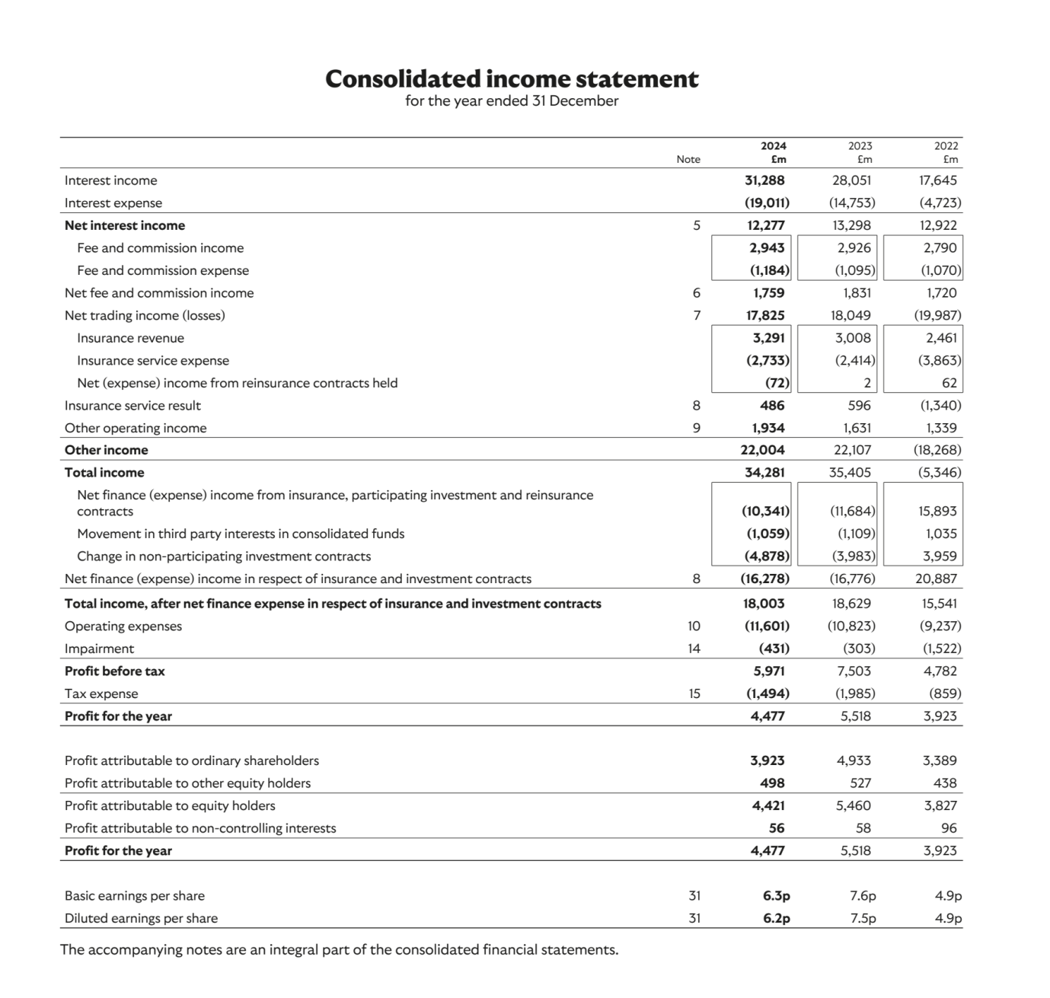
(Source: Llyod, 2024)

Appendix 2 – Balance Sheet
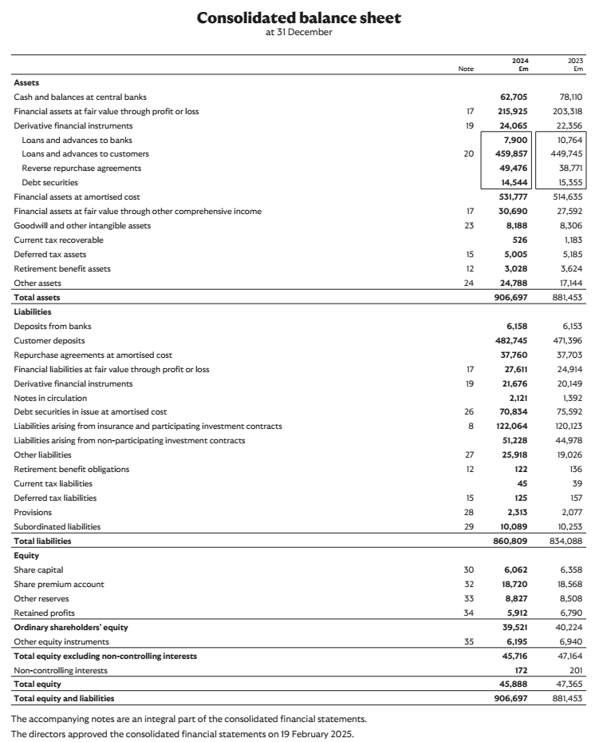
(Source: Llyod, 2024)

Appendix 3 – Cash flow statement
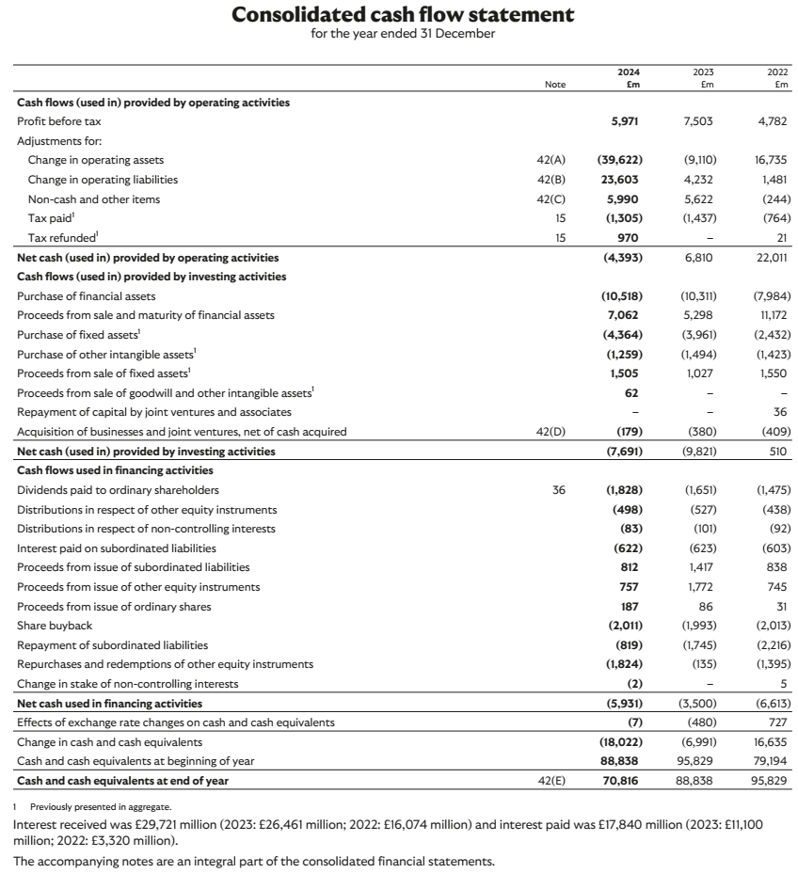
(Source: Llyod, 2024)

Part 2

Introduction
The report studies the expansion of internet sales at Jordons Plc (Option B) from a financial and strategic perspective. By means of net present value (NPV) and internal rate of return (IRR), the report assesses whether the project can create value beyond the company’s required rate of return. Five crucial qualitative factors—strategic fit, market dynamics, operational competence, regulatory environment, and managerial flexibility—are also evaluated to cement the basis for decision-making beyond mere numbers. Moreover, alternative financing sources (internal funding, bank debt, and scoped equity) are appraised to ensure that cost, time to market, and balance sheet health are given due consideration. These analyses collectively will form a holistic basis upon which a recommendation can be made for whether, and how, Jordons should pursue the e-commerce investment.

Net Present Value
Project A
 | Years
£’000 | 0 | 1 | 2 | 3 | 4
Cash flow | (600) | 200 | 300 | 400 | 500
Capital Allowance |  | (120) | (120) | (120) | (120)
Operating profit |  | 80 | 180 | 280 | 380
Corporation tax |  | (20) | (45) | (70) | (95)
Net profit |  | 60 | 135 | 210 | 285
Add: Capital allowance |  | 120 | 120 | 120 | 120
Adjusted Cash flow |  | 180 | 255 | 330 | 405
DF @ 6% | 1 | 0.943 | 0.890 | 0.840 | 0.792
DCF | (600) | 189 | 267 | 336 | 396
NPV (Σ of DCF) | 588
Project B
 | Years
£’000 | 0 | 1 | 2 | 3 | 4
Cash flow | (1,000) | 400 | 450 | 650 | 980
Capital Allowance |  | (200) | (200) | (200) | (200)
Operating profit |  | 200 | 250 | 450 | 780
Corporation tax |  | (50) | (63) | (113) | (195)
Net profit |  | 150 | 188 | 338 | 585
Add: Capital allowance |  | 200 | 200 | 200 | 200
Adjusted Cash flow |  | 350 | 388 | 538 | 785
DF @ 6% | 1 | 0.943 | 0.890 | 0.840 | 0.792
DCF | (1,000) | 377 | 401 | 546 | 776
NPV (Σ of DCF) | 1,100
Project C
 | Years
£’000 | 0 | 1 | 2 | 3 | 4
Cash flow | (1,600) | 400 | 700 | 850 | 1,100
Capital Allowance |  | (320) | (320) | (320) | (320)
Operating profit |  | 80 | 380 | 530 | 780
Corporation tax |  | (20) | (95) | (133) | (195)
Net profit |  | 60 | 285 | 398 | 585
Add: Capital allowance |  | 320 | 320 | 320 | 320
Adjusted Cash flow |  | 380 | 605 | 718 | 905
DF @ 6% | 1 | 0.943 | 0.890 | 0.840 | 0.792
DCF | (1,600) | 377 | 623 | 714 | 871
NPV (Σ of DCF) | 985

Option B (Develop online sales) has the greatest NPV (£747k), exceeding retail growth (A: £395k) and product diversification (C: £618k). It generates significant early cash flows that speed repayment, benefits from tax breaks through capital allowances, and maximizes wealth generation over four years. Internet sales growth is the most financially viable option since it requires less extra capex than C but has greater margins than A.

Internal rate of return (IRR)
Years | Adjusted Cash flow | DF @ 23% | DCF | DF @ 24% | DCF
0 | (1,000) | 1.000 | (1,000) | 1.000 | (1,000)
1 | 330 | 0.813 | 268.33 | 0.806 | 266.02
2 | 345 | 0.661 | 227.96 | 0.650 | 224.17
3 | 452 | 0.537 | 242.46 | 0.524 | 236.59
4 | 622 | 0.437 | 271.69 | 0.423 | 262.99
 |  |  | 10.44 |  | (10.24)
IRR = 23% + (10.44 / (10.44 + 10.24) x (23% - 24%) = |  |  |  | 23.50%

An IRR of about 23.5% indicates that the project's discounted cash inflows precisely offset its outlay when a 23.5% hurdle rate is used. The breakeven rate lies between the positive and negative NPV values of 23% (≈+10.44) and 24% (≈-10.24). If the organization's needed return (WACC) is less than 23.5%, the project provides value and should be approved. If its finance costs reach 23.5%, the project will lose value. Thus, the IRR benchmark assists managers in making decisions: decide to pursue this investment if the funding and opportunity costs are less than 23.5%.

Investment appraisal techniques
The Net Present Value (NPV) is considered as the best valuation method, because the NPV makes all cash flows expected to occur in the future measured in today's money-antithetical to an abstract positive or negative measure of the value that can be created (Arjunan, 2022). NPV takes into consideration the time value of money, since in discounting cash inflows and outflows expected in the future at a discount rate, which could be assumed to represent the opportunity cost to the investor, it acknowledges that a pound received in the future is worth less than a pound received today (Huang et al., 2022). But simpler methods such as payback or accounting rate of return do not consider timing or risk. In addition, NPV respects the value additivity principle that states that when a number of projects are independent, the value from all of them taken together should be equal to the sum of values for each project; this allows the manager to choose all positive-NPV projects to increase total shareholder wealth (Dai et al., 2022).
Another important advantage of NPV is that it assumes a realistic reinvestment rate. Unlike the IRR, which assumes that interim cash flows might be reinvested at the same return as the project, NPV assumes reinvestment at the cost of capital to the firm, which is the appropriate market-based benchmark aligned with the firm's financing policy (Drake and Fabozzi, 2002). Also, from a risk point of view, the higher the risk, the higher should be the cost of capital, which reduces the present value of the project and hence discourages undue investment in more risky projects (Kengatharan, 2016). Furthermore, NPV can tackle nonconventional cash flow patterns and mutually exclusive alternatives without being plagued by multiple-IRR issues (Bierman and Smidt, 2007). To summarize, given the way it theoretically treats issues of time, risk, and aggregation, NPV should be considered the cornerstone for capital budgeting decisions.

Non-discounting methods of investment appraisal
Theoretical limitations notwithstanding, payback and accounting methods of investment appraisal continue to see extensive use by practicing managers for their intuitive, quick, and easily communicable insights into investment proposals. Payback period simply measures the time taken to recover initial investment in nominal cash terms. Its simple appeal rests on the concept of liquidity risk: managers working under the threat of cash-flow shortfalls, economic downturns, or swift technological change are thus encouraged to resort to the shortest breakeven horizon (Röhrich, 2015). Likewise, the accounting rate of return attempts to put the profitability of projects into percentages that, from internal financial reporting, are familiar to individuals in the organization who have not been trained in finance and need to somehow interpret earnings against book values (Götze et al., 2015).
Since all these non-discounting and investment appraisal methods are just common spreadsheet exercises with easy access to accounting data, they require minimal systems support and explanation or none at all. In any case, they never even require agreeing on discount rates (Gordon et al., 2006). These are issues that cause delays to more sophisticated analyses in fast-moving environments. Particularly appreciated by middle managers is the very clear "snapshot" that these methods provide-through which multiple opportunities can be rapidly screened without engaging in detailed forecasting or arguments about an appropriate hurdle rate (Chen, 2008). Organizational inertia and incentive structures would serve to reinforce this use: targets and bonus plans could inter alia be linked to payback thresholds or accounting margin; hence rewarding managers for shorter payback periods or higher book-profit ratios (Paseda, 2016).
Non-discounting appraisal methods thus, rather than vie for supremacy against discounted-cash flow models, provide practical means of preliminary filtering: simple criteria by which to throw out projects with unacceptable liquidity or accounting returns before committing heavy resources to full-blown NPV or IRR studies.

Other factors in investment decision
- Strategic Alignment: Investing in an activity that fits perfectly into Jordons Plc's long-term vision and leverages its core competency in manufacturing superior quality wooden blinds will avoid distractions and yield a greater competitive advantage for the company. A project divergent to the strategic interests of the firm probably would result in underutilization of the set strengths of the firm and may lead to dilution of the brand (Bialowolski and Weziak-Bialowolska, 2014).
- Market Demand and Dynamics: Customer preferences, price elasticity, and competitor actions for the online window‐treatment sale need to be analyzed. Overestimation of demand and insufficiently attentiveness to shifts that may come by new entrants or change in platform fees can quickly destroy forecasted cash flows (Abdul kareem et al., 2023).
- Operational Capability: The company should analyze whether it would have such digital infrastructure or personnel or supply‐chain processes that it would take short time to develop for internet sale (Tseng and Yang, 2010). Foolishly driving under execution complexity can thus lead into huge delays, mishaps on quality grounds, or customer satisfaction issues.
- Regulatory and Legal Environment: To comply with e-commerce regulations, e.g., data protection, consumer rights, cross-border VAT rules, and evolving environmental standards, including sustainable sourcing, packaging directives, etc., can affect cost, cost-related time schedules, and at another level (Haidari, 2023). Earlier legal due diligence minimizes risk concerning unforeseen fines or changes to operations imposed on the company.

Optimal investment policy
Ranking of investment options
Projects | NPV | Rank
A | 395 | 3
B | 748 | 1
C | 616 | 2
Based on NPV’s three investment options, the option having highest NPV has been ranked first, while investment option having lowest NPV has been ranked third.
Projects | Initial Invest. | Revised Invest. | Proportion of Initial Invest. | NPV | Weighted NPV
A | 600 |  | 0% | 395 | -
B | 1,000 | 1,000 | 100% | 748 | 748
C | 1,600 | 1,000 | 63% | 616 | 385
 | Total | 2,000 |  |  | 1,133
The result shows that if £2,000,000 divided among two options – A and B based on their rank, then weighted or optimum NPV earned by the company will be £1,133,000.

Sources of finance
The primary financial sources for Option B (online sales) are evaluated below, with each being provided with its important characteristics, advantages, and downsides. Finally, a suggestion indicates the best option.
1. Retained Earnings (Internal Finance)
Description:
Using balance sheet earnings to support website development, digital marketing, and increased working capital (BBC, 2023).
Advantages:
- Zero direct cost: No interest or issuance fees, maximizing net project returns.
- Speed and simplicity: Avoids lender or investor approval processes, enabling rapid deployment.
- Control preserved: No dilution of ownership or external covenants(Besley and Brigham, 2015).
Disadvantages:
- Opportunity cost: Diverts funds from dividends or other growth projects, potentially displeasing shareholders.
- Capacity limits: May not fully cover a £1 million outlay if retained reserves are modest.
- Liquidity impact: Overuse could erode cash buffers, reducing flexibility to absorb unexpected expenses(Bodie et al., 2025).
2. Bank Term Loan
Description:
Kumar (2024) suggests obtaining a fixed-rate, amortizing loan from a commercial bank to cover start-up and platform expenditures for a period of 4-5 years.
Advantages:
- Predictable servicing: Regular payments allow precise cash‐flow planning.
- Tax deductibility: Interest expense reduces taxable income, lowering the effective cost of capital(Kumar, 2024).
- Tailored structure: Can include a grace period before repayments commence, matching the ramp-up of online revenues.
Disadvantages:
- Covenants and security: Lender may require financial covenants (e.g., minimum current ratio) and collateral (e.g., property or receivables).
- Rigid repayment: Missed payments risk default, penalties, or interest rate step-ups.
- Approval timeline: Credit underwriting and documentation can take several weeks(Chapeyama, 2014).
3. Equity Injection (Rights Issue or Private Placement)
Description:
The giving issue of new shares for raising money for online sales capital without any obligatory repayments (Gitman and Zutter, 2015) could be through a rights issue to existing shareholders or a targeted private placement.
Advantages:
- No fixed repayments: Frees up early cash flows for growth rather than servicing debt.
- Strengthens balance sheet: Lowers gearing, improving credit metrics(Gitman and Zutter, 2015).
- Market signal: A successful raise can demonstrate investor confidence in the digital strategy.
Disadvantages:
- Dilution risk: Reduces existing shareholders’ ownership percentage unless fully subscribed.
- Market dependence: Pricing and uptake hinge on investor sentiment; poorly timed issues may require heavy discounts.
- Longer lead time: Prospectus preparation, regulatory approvals, and offer period extend project start(Zutter and Smart, 2022).
4. Mezzanine Finance
Description:
Subordinated debt with attached equity warrants that bridges the senior bank debt and pure equity (Merbecks, 2023).
Advantages:
- Flexible terms: Often fewer covenants than senior loans, with repayment deferral options.
- Limited dilution: Warrants only convert if company outperforms, aligning interests(Zavyalova et al., 2021).
Disadvantages:
- High cost: Coupon rates plus equity dilution can make it one of the most expensive capital sources.
- Subordination risk: In default, mezzanine lenders rank below senior debt, limiting availability(Zavyalova et al., 2021).
Recommendation
For the £1 million internet rollout under Option B, Jordons should implement a capital structure that shares funds through internal accruals, debt, and some equity to balance cost, flexibility, and balance sheet health.
1.Retained Earnings (20–30%)
Using £200–300 k of retained earnings immediately accelerates the project launch without having to incur additional financing charges or dilution in ownership. This slice of internal funds should be applied towards initial website design and packaging along with pilot marketing campaigns. However, in order to protect liquidity, the use of retained earnings should be kept to about one-fourth of the entire outlay so as to retain sufficient cash buffers for working capital and unforeseen expenses.
2.Bank Term Loan (50–60%)
Borrow £500–600 k through a medium-term amortizing facility for 4–5 years with negotiation over a grace period of 6-12 months before principal repayments begin so as to match ramp-up in online sales. Interest is tax-deductible, thereby lowering effective capital cost, while fixed-payment schedules make forecasting cash flow exact. Covenants should be relaxed from current standard under the heavy gearing by tying financial covenants to adjusted EBITDA rather than straightforward debt-to-equity, while pledges should be limited to digital assets (e.g., domain portfolio, receivables) instead of core real estate.
3.Private Placement or Rights Issue to Raise Equity (10–20%)
Introduce £100–200 k equity to strategic investors or existing shareholders on a non-discounted basis. The trade-off of some dilution for increased capitalization in its first instance improves debt service coverage ratios and preserves headroom on bank covenants. Target specialized digital economy funds or high-net-worth individuals who comprehend the growth story in e-commerce. The private placement will expedite time to market, compared with a full rights issue, allowing for concurrent capital drawdown with project milestones.
4.Complementary Initiatives
– Leasing: For non-core infrastructure (warehouse racking, pick-and-pack equipment), consider operating leases to conserve cash.
– Grant Funding: Pursue government digitalisation grants or local enterprise support schemes to help with platform development costs.
This blended strategy seeks to balance speed (internal funds), cost (debt), and resilience (equity), thus enabling Jordons plc to roll out and grow its internet sales with minimum dilution, tightly controlled leverage, and strong stakeholder alignment.

Conclusion
Overall, the expansion of Jordons Plc into e-commerce is considered to have strong financial and strategic justification. The project shows a positive NPV given a cost of capital of 6%, and also presents an IRR of approximately 23.5%, which is much higher than the firm hurdle rate, thus proving the value methodological construct of the operation. In support of the qualitative argument, the project tightly correlates with the company’s digital development objectives, addresses changes in consumer behavior, leans upon the operational strengths of an existing setup, and has rewarded real-option flexibility in its design to minimize execution risk. Additionally, all regulatory and compliance aspects have been managed in advance to ensure that data protection regulation and e-commerce regulation will not stand in the project’s way. Given the financing needs of a £1 million rollout, a balanced mix consisting of retained earnings, a medium-term bank loan with a well-structured grace period, and a small private placement, all working together to optimize cost, maximize liquidity, and maintain manageable leverage, respectively, is advised. All of these analyses serve as the final support of a strong recommendation to proceed with Internet sales expansion, convinced that it will improve profitability, strengthen market positioning, and create sustainable shareholder value.

References
Abdul kareem, A.A. et al. (2023) ‘Factors influencing investment decisions in financial investment companies’, Systems, 11(3), p. 146. doi:10.3390/systems11030146.
Arjunan, K. (2022) ‘A new method to estimate NPV and IRR from the capital amortization schedule and the advantages of the new method’, Australasian Business, Accounting and Finance Journal, 16(6), pp. 23–44. doi:10.14453/aabfj.v16i6.03.
BBC (2023) Internal and external sources of finance - sources of finance - eduqas - GCSE business revision - eduqas - BBC bitesize, BBC News. Available at: https://www.bbc.co.uk/bitesize/guides/zj7yy9q/revision/1 (Accessed: 17 July 2025).
Besley, S. and Brigham, E.F. (2015) Principles of finance. Boston, MA: Cengage Learning.
Bialowolski, P. and Weziak-Bialowolska, D. (2014) ‘External factors affecting investment decisions of companies’, Economics, 8(1). doi:10.5018/economics-ejournal.ja.2014-11.
Bierman, H. and Smidt, S. (2007) The Capital Budgeting Decision: Economic Analysis of Investment Projects. New York: Routledge.
Bodie, Z., Merton, R.C. and Thakor, R.T. (2025) Principles of finance. Cambridge, United Kingdom: Cambridge University Press.
Chapeyama, M. (2014) Principles of Finance Essays. München: GRIN Verlag GmbH.
Chen, S. (2008) ‘DCF techniques and nonfinancial measures in capital budgeting: A contingency approach analysis’, Behavioral Research in Accounting, 20(1), pp. 13–29. doi:10.2308/bria.2008.20.1.13.
Dai, H. et al. (2022) ‘The analysis of Three Main Investment Criteria: NPV IRR and Payback Period’, Advances in Economics, Business and Management Research [Preprint]. doi:10.2991/aebmr.k.220307.028.
Drake, P.P. and Fabozzi, F.J. (2002) Capital budgeting theory and practice. West Sussex: John Wiley & Sons.
Gitman, L.J. and Zutter, C.J. (2015) Principles of Managerial Finance, brief. Harlow, Essex, England: Pearson.
Gordon, L.A., Loeb, M.P. and Tseng, C. (2006) ‘Capital budgeting and informational impediments: A management accounting perspective’, Contemporary Issues in Management Accounting, pp. 146–165. doi:10.1093/acprof:oso/9780199283361.003.0007.
Götze, U., Northcott, D. and Schuster, P. (2015) ‘Selected further applications of investment appraisal methods’, Springer Texts in Business and Economics, pp. 105–159. doi:10.1007/978-3-662-45851-8_5.
Haidari, M.N. (2023) ‘Impact of decision-making on Investment Performance: A comprehensive analysis’, Journal of Asian Development Studies, 12(4), pp. 980–990. doi:10.62345/jads.2023.12.4.78.
Huang, J. et al. (2022) ‘Application and comparison of NPV and IRR methods in the company investment decision’, Advances in Economics, Business and Management Research [Preprint]. doi:10.2991/aebmr.k.220307.012.
Kengatharan, L. (2016) ‘Capital budgeting theory and practice: A review and agenda for future research’, Applied Economics and Finance, 3(2). doi:10.11114/aef.v3i2.1261.
Kumar, S. (2024) Principles of finance. United States: Surjeet Kumar.
Merbecks, U. (2023) ‘Mezzanine finance’, Encyclopedia of Sustainable Management, pp. 1–7. doi:10.1007/978-3-030-02006-4_614-1.
Paseda, O.A. (2016) ‘Advanced Capital Budgeting Techniques: A review article’, SSRN Electronic Journal [Preprint]. doi:10.2139/ssrn.2901530.
Röhrich, M. (2015) Fundamentals of Investment Appraisal: An illustration based on a case study. Berlin: De Gruyter.
Tseng, S.-Y. and Yang, C. (2010) ‘The mediating role of information searches in risky investment preferences: Does more digital information search have a stronger effect?’, 2010 2nd IEEE International Conference on Information and Financial Engineering, pp. 228–232. doi:10.1109/icife.2010.5609288.
Zavyalova, L., Garanina, S. and Levochkina, N. (2021) ‘Mezzanine financing as a source of financing for business activities in Russia in a crisis’, Proceedings of the 1st International Scientific Forum on Sustainable Development of Socio-economic Systems, pp. 380–384. doi:10.5220/0010669000003223.
Zutter, C.J. and Smart, S.B. (2022) Principles of Managerial Finance. Harlow, Essex: Pearson Education Limited.

