Programming 1 Assignment

Name: Scott Mainwaring
Student Number: 1701633
Module: Programming 1
Lecturer: Mike/Tim

Table of Contents
Section 1: Understanding..………………………………………………………………...3
Section 2: Interpretation ....………………..………………………………………………4
Appendix ……..………….……………………………………………………………...….5

Section 1: Understanding
A variable in computer programming is used to store values that can be referred back to in a different section of a program. Variables provide a way of labelling values so programs can be understood more clearly for ourselves and other readers. Variables are given a unique identifier. Variables can be declared with using a ‘type’ such as a string, int, double or bool. This allows us to identify what type of information is stored in the variable and what we can do with this information. Variables are really important when it comes to programming simply because they allow programmers to write programs more flexibly.

A for-loop is a conditional iterative statement that checks for a certain condition using true or false and then repeatedly executes a block of code until the conditions are no longer met. For-loops usually tend to start at the value 0 and usually increments the value of one each time the statement loops.
for(count = 0; count < 5;count++) {
}
As seen above, the loop starts at the value 0 and will increment in values of 1 until the number of ‘count’ is no longer less than the value 5. From this, for-loops can also be seen as ‘counting’ loops because the statement counts until the condition is no longer met.
A basic example for using a for-loop/counting loop would be to display any times-tables of your choice. Instead of manually writing the code for each times table, you can write one line of code within the code block for the loop and allow the loop to display each times table every time the code block loops. Using a loop saves a lot of time writing the same code over and over again and also because less code has been written it makes it easier to read back over once created.

Arguments within a function are simply values that can be passed through the function to be used as some sort of input information. A good example of an argument being used within a function is information being passed through printf. Printf is short for print function and the information being passed through it is information you would like printed into the console.
printf(“%i”, number);
As seen above, the printf statement is passing an integer through statement and is being passed through the variable ‘number’.

Section 2: Interpretation
For this section of the assignment, code has been provided for the author to read through and explain how the code in the program has been implemented. The program is designed to allow the user to choose from any numbers of their choice and find the biggest and smallest values from the numbers provided.
The program is menu based with five options. The options in the menu are “1. Enter numbers”, “2. Find the smallest”, “3. Find the biggest”, “4. Display all numbers” and “5. Quit”. The program is set up so that if you enter anything other than one of the numbers in the list then it brings up a message saying “Unknown option value entered”. Example of this is in the screenshot below:
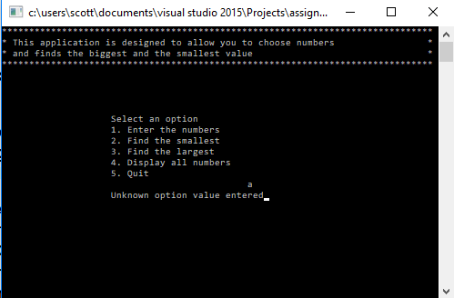
The menu has been created using a switch statement however; there are some problems with the selection menu. Both options four and five seem to give you the same outcome where it asks you quit the program even though option four is to display all the numbers you entered.
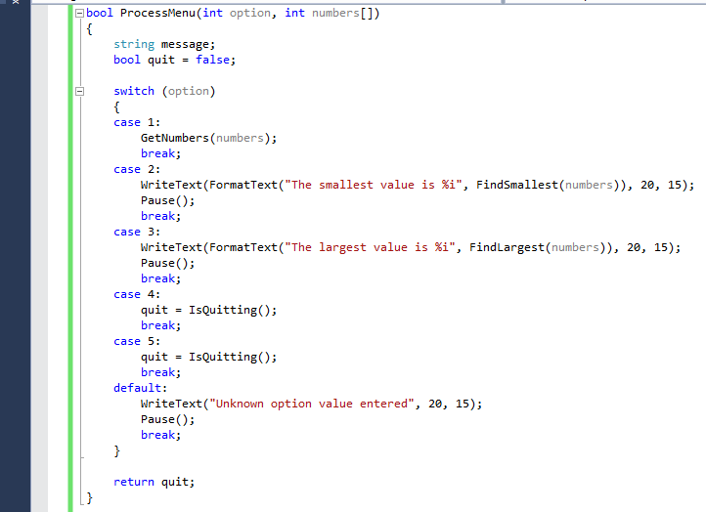
Case 4 and 5 in the switch statement are both using the same function called ‘IsQuitting’. Also another problem with the program is when the user requests to quit the program, the program doesn’t provide the user with the input options needed to type in order to quit the program. The input needed is “YES” but if the user inputs anything other than that then the program won’t close so there is two simply solutions for this. Either make it so the print statement says the options “YES/NO” so the user has some sort of indication as to what to type when exiting the program or simply add an extra part to the quit statement that is:
If(response == “YES” || response == “yes” || response == “y”)
This will then allow the user to type more than one option making sure the program does exit. This can also be expanded on by adding more options such as “Yes”.
Another problem with the program and that is when you go to enter the numbers you want to use. The program only allows the user to enter three numbers before removing the option to enter anymore. The user should be able to enter more than three numbers and this could be fixed with a while loop. The ‘while loop’ will continue to repeat the print statement asking for numbers and can be stopped if the statement turns false. For example, if the user was entering numbers and didn’t want to enter anymore, the user could type a certain character that isn’t a number to trigger the while loop to stop allowing the user to stop entering numbers.

Appendix
Exercise 1
Source.cpp
#define _CRT_SECURE_NO_WARNINGS
#include <string>

using namespace std;

int main(int argc, char**argv) {

string name = "Scott";
double length = 1.45;
int gameScore = 30;

char text[100];

printf("Hello, I am %s\r\n", name.c_str()); // Displays name
printf("Length = %0.2f\r\n", length); // Displays length
printf("You scored: %i", gameScore); // Displays score

return 0;
}

Exercise 2
Source.cpp
#define _CRT_SECURE_NO_WARNINGS
#include <string>
#include <stdlib.h>
#include <stdio.h>

using namespace std;

int main(int argc, char**argv) {

double circleRadius = 0;
double triangleBase = 0;
double triangleHeight = 0;

double areaOfCircle = 0;
double areaOfTriangle = 0;
double shapeArea = 0;

printf("Enter radius of circle: \r\n", circleRadius);
scanf("%lf", &circleRadius);

printf("Enter base of triangle: \r\n", triangleBase);
scanf("%lf", &triangleBase);

printf("Enter height of triangle: \r\n", triangleHeight);
scanf("%lf", &triangleHeight);

areaOfCircle = 3.14 * circleRadius * circleRadius; // calculates area of circle
areaOfTriangle = (triangleBase*triangleHeight) / 2; // calculates area of triangle

shapeArea = areaOfCircle - areaOfTriangle;

printf("Area of shape = %0.2f", shapeArea);

return 0;
}
Exercise 3
Source.cpp
#define _CRT_SECURE_NO_WARNINGS
#include <string>

using namespace std;

int main(int argc, char**argv) {

int gravelAmount = 0;
double costPerTonne = 0;
double total = 0;
double discount = 0;

printf("Enter amount of gravel purchased in tonnes: ", gravelAmount);
scanf("%i", &gravelAmount);

printf("Enter the cost per Tonne: ", costPerTonne);
scanf("%lf", &costPerTonne);

// Statement used if amount of gravel is more than 5 and less than 8
if (gravelAmount >= 5 && gravelAmount <= 8) {
discount = (gravelAmount * costPerTonne) * 0.02;
total = (gravelAmount * costPerTonne) - discount;

printf("Total price of gravel after discount: %0.2f", total);
}
else
// Statement used if amount of gravel is more than 9 and less than 40
if (gravelAmount >= 9 && gravelAmount <= 40) {
discount = (gravelAmount * costPerTonne) * 0.04;
total = (gravelAmount * costPerTonne) - discount;

printf("Total price of gravel after discount: %0.2f", total);
}
else
// Statement used if amount of gravel is above 40
if (gravelAmount > 40) {
discount = (gravelAmount * costPerTonne) * 0.06;
total = (gravelAmount * costPerTonne) - discount;

printf("Total price of gravel after discount: %0.2f", total);
}

return 0;
}

Exercise 4
Source.cpp
#define _CRT_SECURE_NO_WARNINGS
#include <string>

using namespace std;

int main(int argc, char**argv) {

int size = 0;
int rows = 0;
int cols = 0;

printf("Enter size: ", size);
scanf("%i", &size);

for (rows = 1; rows <= size; rows++) { // Loop for rows
for (cols = 1; cols <= size; cols++) { // Loop for cols
if (rows == cols || cols == (size + 1) - rows) {
printf("%s", "*");
}
else printf(" ");
}
// printf creates a new line
printf("\r\n");
}

return 0;
}

Exercise 5

Source.cpp
#define _CRT_SECURE_NO_WARNINGS
#include <string>
#include "PriceCalculator.h"
#include "TotalPrice.h"

using namespace std;

int main(int argc, char**argv) {

int count = 0;
TotalPrice *total = new TotalPrice(0);

// Loop for adding the products
for (count = 0; count < 5; count++) {
printf("Enter product price: ", total);
scanf("%0.2lf", &total[count]);
}

// Displays the total price of products
printf("Total is %f", total->GetTotal());

delete total;

return 0;
}

PriceCalculator.cpp
#include "PriceCalculator.h"

PriceCalculator::PriceCalculator(double initialCost)
{
this->_totalPrice = initialCost;
}
double PriceCalculator::GetTotalPrice()
{
return this->_totalPrice;
}

void PriceCalculator::AddItemCost(double price)
{
this->_totalPrice = this->_totalPrice + price;
}
double PriceCalculator::CalculateTax(double percent)
{
return this->_totalPrice * (percent / 100);
}

TotalPrice.cpp
#include "TotalPrice.h"

TotalPrice::TotalPrice(double initialPrice)
{
this->_total = initialPrice;
}
double TotalPrice::GetTotal()
{
return this->_total;
}

void TotalPrice::AddMoreProducts(double ProductPrice)
{
this->_total = this->_total + ProductPrice;
}

PriceCalculator.h
#pragma once
class PriceCalculator
{
// Attributes
private:
double _totalPrice;

//Constructor
public:
PriceCalculator(double initialCost);

// Properties
double GetTotalPrice();
// Methods
void AddItemCost(double price);
double CalculateTax(double percent);
};

TotalPrice.h
#pragma once
class TotalPrice
{
// Attributes
private:
double _total;
// Constructors
public:
TotalPrice(double initialPrice);
//Properties
double GetTotal();
//Methods
void AddMoreProducts(double ProductPrice);
};

Exercise 7

Source.cpp
#define _CRT_SECURE_NO_WARNINGS
#include <string>
#include <time.h>

using namespace std;

int main(int argc, char** argv) {

int tokens = 100;
int maxVal = 5;
string option = "Y";
time_t theTime;
srand((unsigned)time(&theTime));

while (option == "Y") {
int randomOne = rand() % maxVal + 1;
int randomTwo = rand() % maxVal + 1;
int randomThree = rand() % maxVal + 1;
printf("Would you like to spin? Y/N: ", option.c_str());
scanf("%s", &option);

printf("[ %i ] [ %i ] [ %i ] \r\n", randomOne, randomTwo, randomThree);
if (randomOne == maxVal && randomTwo == maxVal && randomThree == maxVal) {
tokens = tokens + 2000;
printf("You win 2000 tokens\r\n", tokens);
}
else
if ((randomOne == maxVal && randomTwo == maxVal) || (randomOne == maxVal && randomThree == maxVal) || (randomTwo == maxVal && randomThree == maxVal)) {
tokens = tokens + 20;
printf("You win 20 tokens\r\n", tokens);
}
else
if (randomOne == randomTwo || randomTwo == randomThree || randomOne == randomThree) {
tokens = tokens + 10;
printf("You win 10 tokens\r\n", tokens);
}
}

return 0;
}

