2x2 within-subjects design
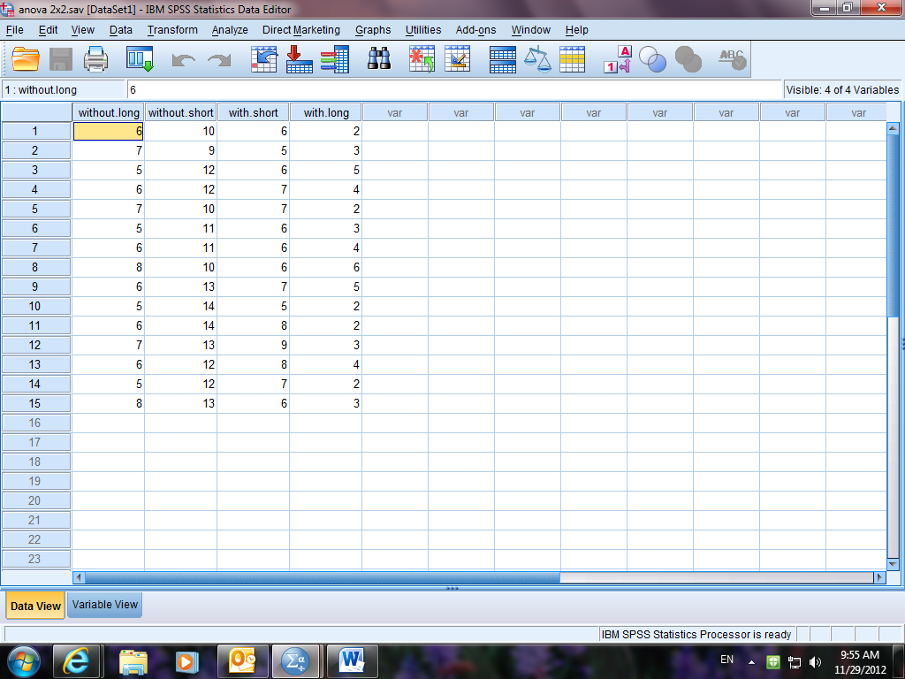
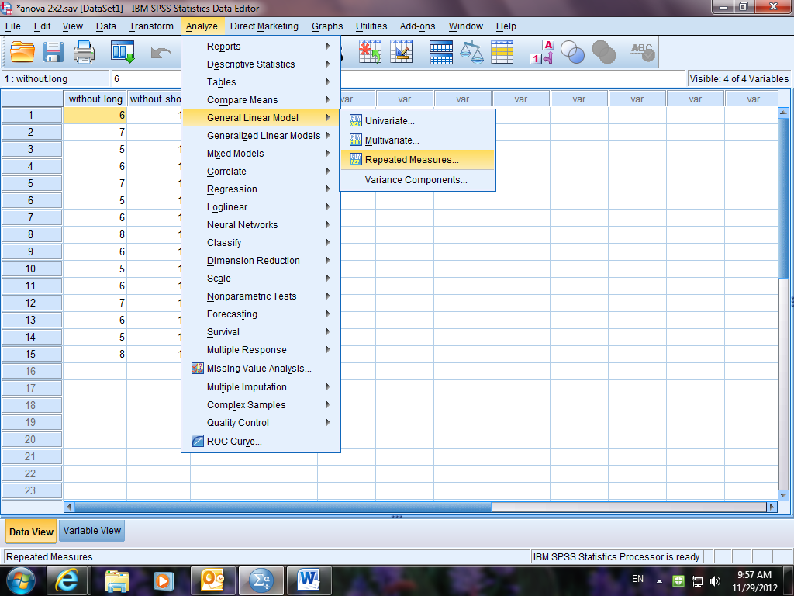
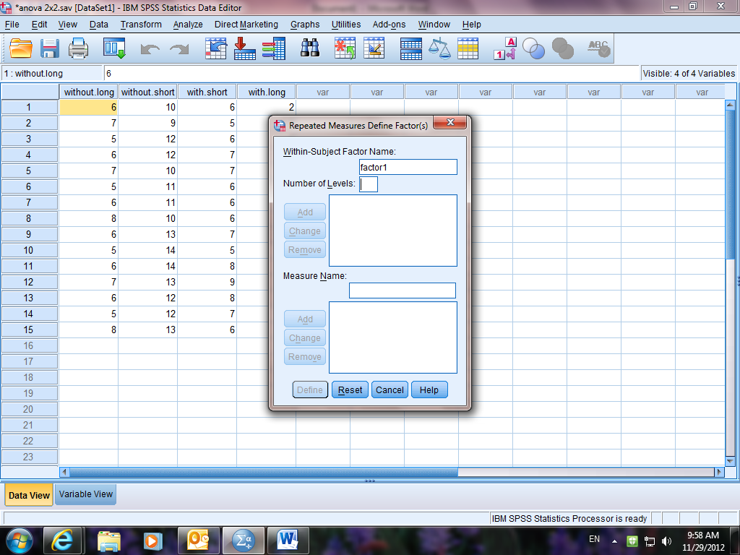
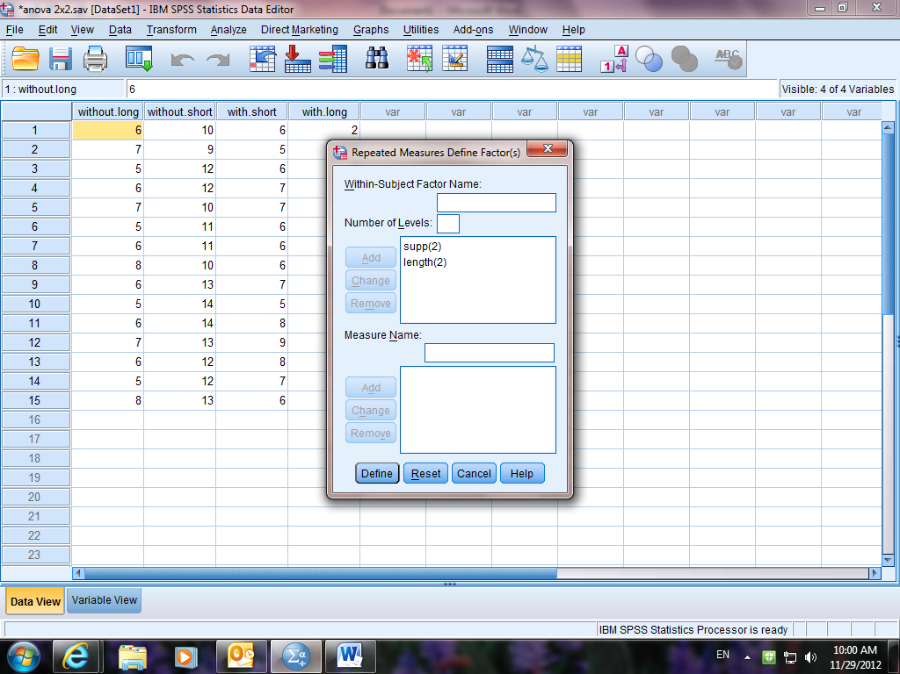
Insert supp in the factor box. Insert 2 in the levels box (you have 2 levels/conditions). Press add.
Insert length in the factor box. Insert 2 in the levels box (you have 2 levels/conditions). Press add.
Then press define.

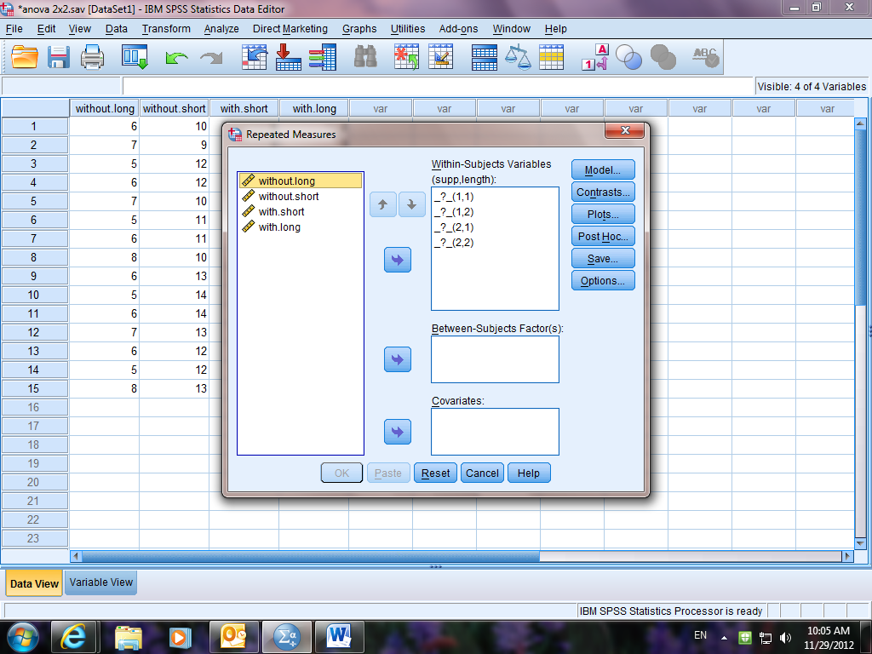
Move the conditions into the correct places in the right-hand box. Make sure that you match each condition to the appropriate number.
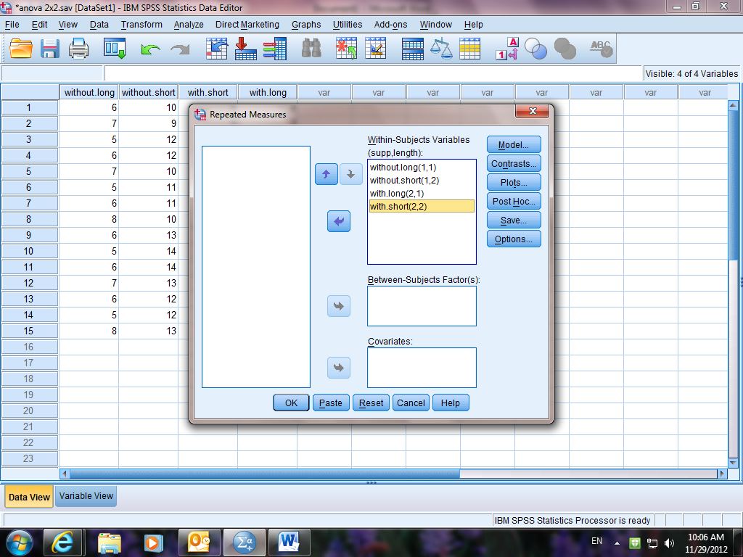
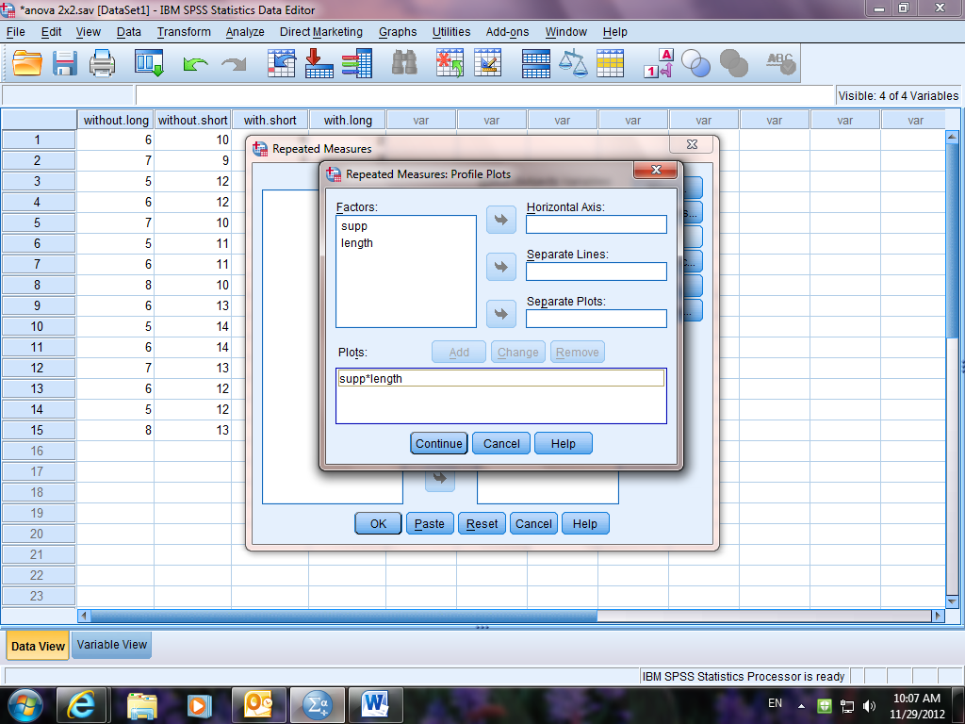
Press plots – move each variable to the horizontal and separate line (doesn’t matter which). Press ADD then CONTINUE.
Press options. Select compare main effects and descriptive stats and move all factors to the display means box on the right. Press CONTINUE. Then OK.


