

Programme: | MBA- Masters of Business Administration
Module: | Human Resource Management
Module code: | LCMB7000
Student Name: | Raval Maulik Rameshchandra
Student ID: | 2209391
Module  Coordinator/Lecturer: | Dr Gladius Kulothungan
Internal Verifier: | Dr John-Paul Okeke

Executive Summary
This assignment requires a report on the human resource management in the UK. This report is important for alerting job seekers intending to secure employment in the UK and improve their career opportunities. The present state of the labour market is discussed along with the emerging external changes in the business environment. This assignment follows the structure of a traditional report with introduction, main body and conclusion. Proper sub-headings were used to create distinctions between arguments and arrange information in an organised manner. The introduction consists of the main aim of the report. The first section creates an authentic picture of the labour market in the UK. The second section involves identification and analysis of emerging changes after Covid-19 and Brexit by including examples from the organisation Tesco. The conclusion provides an apt closure to the whole report.

Table of Contents
Introduction 3
Current Condition of the UK's Labour Market 3
Employment Rate 3
Economic Activity 4
Pay Growth 5
Necessary Skills 6
Human Resourcing Strategies: Emerging Changes 8
Changes due to Covid-19 8
Changes due to Brexit 10
Conclusion 12
Reference List 13

Introduction
This report analyses the human resource management prospects in the UK by highlighting the current labour market in the UK and emerging changes in human resourcing strategies. Future management aspirants need to understand the strengths and drawbacks of their intended field. A labour market allows labourers and industries to interact with one another. Workers aim to acquire the best job to display potential better, whereas employers seek the appropriate human resources for fulfilling strategies. A close study of a country’s labour market can reveal job trends, essential skills and more for the future career development of a job seeker. Moreover, a close analysis of human resourcing and the impact of external factors like Brexit and Covid 19 can better develop management competencies to survive and flourish in modern and volatile business environments. Hence, the report is for developing future workers.

Current Condition of the UK's Labour Market
The UK underwent massive changes due to Brexit, and the Covid-19 pandemic changed the job market drastically. EU workers could not enjoy the same facilities as before and had to seek other countries for better employment conditions. The Covid-19 pandemic overthrew certain traditional businesses by creating new start-ups that better understand and meet the needs of the new customers.

Employment Rate
The UK's employment rate is 75.6% from August to October 2022. There is a 0.2 increase in the percentage points, but it fails to equal the flourishing employment rate during the days before the Covid-19 pandemic. However, the number of employees in the UK increased in the last three months. However, the number of self-employed workers decreased causing a change in small-scale businesses in the UK. The total number of payrolled employees in the UK is 29.9 million, and the UK saw 107,000 workers added in October of 2022 (ons.gov.uk, 2022). In September 2022, market experts and recruitment businesses predicted that post-Covid 19 job booms would experience a slump shortly. Moreover, the labour shortage is the main cause behind job booms as EU workers went home before Covid-19 and have not returned since causing an immense loss to companies. This fact is evident from the massive shortage of warehouse operators and order-picking agents. UK citizens are not enough to fill the positions as they are not equally skilled for specialised positions (bbc.com, 2022).
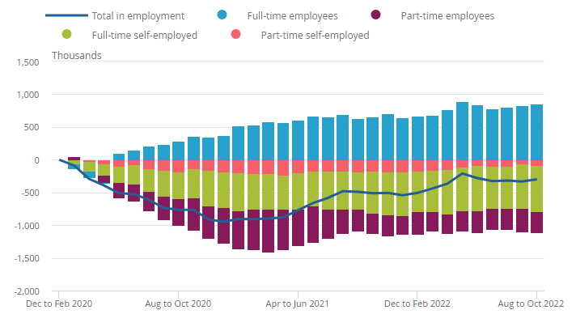
Figure 1: Employment Rate in the UK from 2020 to 2022
(Source: ons.gov.uk, 2022)
Ravalier (2022) observed stress and overwork cause negative employee experiences in the UK. Activities like peer support, bottom-up communication, top-down communication, psychoeducation and well-being are necessary for reducing employee attrition. The loss of EU workers would increase the burden of existing labourers leading to a high turnover rate. Hence, organisations should collaborate with the NHS or National Health Scheme of the UK to better support employees.

Economic Activity
Economic activity refers to the amalgamation of human resources, capital investments and production strategies to create particular goods and services that might cater to gaps in the market or meet customers' needs. The percentage of economic inactivity in the UK is 21.5% from August to October 2022. It experienced a reduction of 0.2 percentage points. The employees aged 50-64 underwent retirement as part of their natural life process. Citizens between 16 to 24 years of age are busy preparing for their future careers through studies and are engaged in economic inactivity for this reason (ons.gov.uk, 2022).
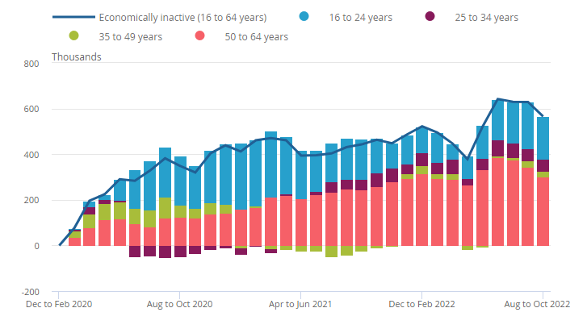
Figure 2: The Economic Inactivity Rate confined to students and old employees
(Source: ons.gov.uk, 2022)
The UK government is reportedly asking retired middle-aged workers to rejoin work to continue the workflow as there is a shortage of skilled labour as EU workers are absent. In December 2022, many UK workers took early retirement due to the Covid-19 pandemic to safeguard their health against the disease. However, this collective decision is another reason for the pressing labour shortages in the UK. The UK government created the mid-life MIT to encourage middle-aged workers to rejoin the workforce to ameliorate the issue. Long-term sickness is a pressing fear that overwhelms middle-aged employees from rejoining work as it would lead to permanent health complications. The threat of Covid-19 still looms large, and a reputed UK-based company like John Lewis witnessed 50 middle-aged employees leaving the workforce (bbc.com, 2022). Inactive economic groups might display apprehension to rejoin work due to their health, but this decision can instil mental health issues in such individuals. Volunteering is recommended as the ideal solution to increase economic activity and not put additional stress on middle-aged employees (Wang et al., 2022).

Pay Growth
The growth regarding total pay and regular pay of employees remained stagnant from August to September 2022 at 6.1%. The private sector witnessed a pay growth of 6.9%, and the public sector experienced 2.7%. This rate is favourable as it is more appropriate than the pay growth before the Covid-19 pandemic. Though the number of vacancies in the UK fell by 65,000 to finalise 1,187,000 in number, it is still at an all-time high concerning past experiences. Such vacancies in the UK labour force reveal the prospect of uncertainty in organisations (ons.gov.uk, 2022). However, the pay growth did not keep up with the inflation rate causing the people to undertake protest movements to bring justice to their deplorable economic situation. Real wages refer to wages adjusted based on inflation that considers the living standards of citizens. The real wages of UK citizens were reduced by 76 pounds a month in 2022, which irked many employees in the UK. This fact is detrimental to job prospects as employees are not earning enough for their work to sustain decent living conditions (theguardian.com, 2022).

Figure 3: Workers participating in Strikes in the UK for reduced Real Wages
(Source: theguardian.com, 2022)

Necessary Skills
It is evident from the above discussion that there is an absence of adequate employees in the UK labour market as the EU workers forfeited their jobs and returned to their countries. Moreover, high-quality workers are undergoing early retirements to protect their health, but the labour shortage forces them to join work again. Stofkova et al. (2022) asserted that the Covid-19 pandemic highlighted the inadequate digital skills among employees in their inability to cope with sudden changes. Digital skills are also called ICT or information and communication technology skills involving skilfully using Microsoft programmes, handling emails, using the internet and data processing skills for speeding up the workflow. The UK government urges the incorporation of ICT skills in its education policy to teach the younger generation the strengths of digital literacy. Moreover, companies should have training programmes to improve the skills of existing and middle-aged employees to make work pressure bearable for them.
The future of work survey identified digital skills as the most sought-after skill in the UK. The majority of respondents revealed a stark lack of confidence in handling digital technology due to inaccessible training due to high cost. Furthermore, routine-manual and cognitive-abstract skills are the soft skills that are effective for driving productivity and securing learning in organisations. Moreover, specialised digital skills are becoming indispensable for companies in the coming decade. Middle-aged employees can work from home if they acquire the necessary digital skills and helps to protect themselves against Covid-19. The new workers can learn new skills to withstand sudden external changes (forbes.com, 2022).
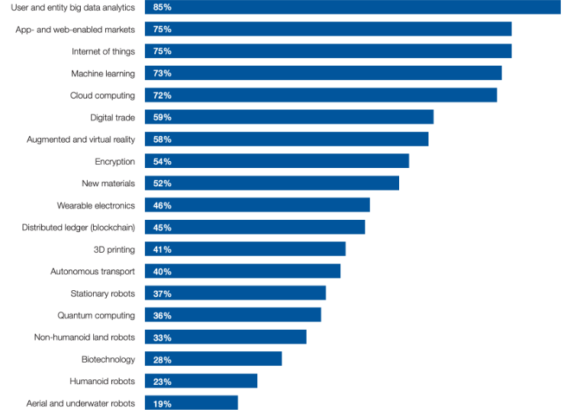
Figure 4: Few Emerging and Specialised Digital Skills in the Global Market
(Source: weforum.org, 2019)

Human Resourcing Strategies: Emerging Changes
Human resourcing strategies refer to recruiting the right employees, managing them and creating a positive and creative work culture. This section identifies and analyses emerging changes in the human resourcing strategies in the UK concerning the post-Covid and post-Brexit situation. The example of Tesco is used to further substantiate points.

Changes due to Covid-19
The introduction and perpetuation of flexible working is an important change in human resourcing in the post-Covid scenario. It is part of a company's working culture as it disrupts the traditional work culture and creates an alternate and more fruitful culture that meets the company's interests along with the employees. Flexibility, hitherto, was employer-based as it allowed organisations to control an employee’s working time, working location and working arrangements. Nowadays, it has shifted towards employee-oriented, causing working from home, work time flexibility and flexible working arrangements to enhance the mental health conditions of employees (Shiri et al., 2022). The UK lacks sufficient labour and the old employees are reluctant to rejoin work due to future Covid-19 infections. The promotion of flexible working can support middle-aged employees to not feel inadequate during their economic inactivity. However, organisations are expected to give adequate digital skills training to such employees to help them build confidence. A good example of this emerging change in human resourcing is the flexible working at Tesco.
Tesco is a UK-based grocery and supermarket chain that adopts changes in human resourcing. The flexibility allowed employees to continue work despite their travel restrictions through international remote working. A certain portion of Tesco's human resources is blended working from office locations with remote working to suit their convenience. A change in managerial policy involves compelling managers to agree to flexible working to properly manage employees' routines (tescoplc.com, 2022).

Figure 5: Two Emerging Changes in Human Resourcing due to Covid-19
(Source: Self)
Dedahanov et al. (2022) observed that paternalistic or modernised leadership is conducive to bringing out employee voice. The social exchange theory posits that trust is fundamental to the implementation of interpersonal exchange thereby affecting interpersonal relationships. Employees in a workplace prioritising an open exchange should have ample grounds to trust their superiors, leaders or managers. However, most employees deliberately withhold unflattering opinions regarding their competencies as they prevent themselves from appearing weak in the eyes of the leader they trust and respect. Thus, a paternalistic leader identifying the mannerisms of individual employees can draw out voices from employees to create a collaborative and innovative work culture. The Covid-19 pandemic disintegrated past autocratic leadership styles as flexibility, innovation and speed are considered important to survive and gradually gain competitive awareness. A humble leader can encourage employees to undertake work processes without approval to speed up the work processes to deliver goods and services on time.
For instance, the managers at Tesco are receptive to feedback from both customers and employees. Such leaders travel around the UK and Ireland to seek out the opinions of colleagues by arranging for meetings in the town hall. This process develops sustainability as managers are accountable for their actions and answer pressing questions regarding the company. Though it is questionable whether Tesco follows paternalistic leadership, Tesco's employees assert their opinions freely resulting in employee-centric leadership. Such managers are receptive towards employee support programmes regarding life coaching, mindfulness programmes and counselling to keep them motivated for work (tescoplc.com, 2022).

Changes due to Brexit
The post-Brexit external environment led to an increase in recruitment from non-EU countries and from within the UK. For instance in the healthcare sector like the NHS, 60% of medical professionals considered leaving the UK due to Brexit-related policy changes. The recruitment options of employers are limited due to changes regarding migration rules for workers. The labour and skill shortages are likely to get ameliorated due to the profile and number of employees. In January 2021, the UK created a points-based system that necessitates equal treatment regarding non-EU and EU citizens. This system was created as EU workers have no facilities to seek employment in the UK and settle there for a long time. Managers require innovative ways to attract immigrant or expatriate workers from countries that do not have the UK on their immediate radar for job search (Igwe, 2022). Tesco adopted an innovative and agile recruitment approach. Tesco succeeded in hiring 960 HGV drivers through recruitment, apprenticeships and conversion courses (tescoplc.com, 2022).

Figure 6: Emerging Changes in Human Resourcing Post Brexit
(Source: Self)
Tesco’s innovative recruitment campaign encouraged women employees to take up HGV lorry driver roles by diminishing the gender pay gap. The recruitment contract offered no evenings and weekends and the salary could extend up to 35k pounds in London. Tesco further included women in recruitment advertisements to garner the attention of women employees to participate in a male-centric job role. It is expected that Tesco’s advertisements would extend to non-EU workers via digital platforms in the same manner as attracting the marginalised women community in the UK. This innovation requires a change in the policies, processes and procedures of the HR strategy of Tesco to effectively blend into the post-Brexit environment. It is effective for all organisations in the UK to follow in the footsteps of Tesco to implement the emerging change of recruitment (bbc.com, 2021).
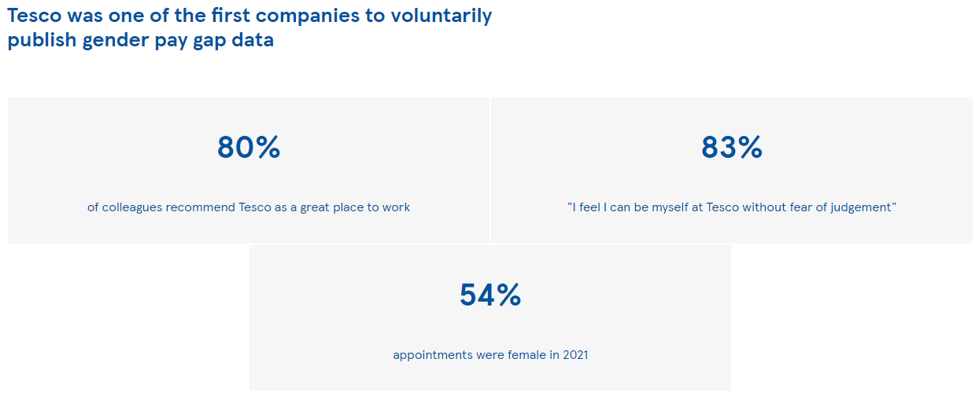
Figure 7: Gender Pay Gap Data of Tesco
(Source: tescoplc.com, 2022)
Migrant workers were considered slave labourers in large organisations due to poor working conditions, inequality, exploitation and non-unionisation. The post-Brexit business environment prompted managers to consider human rights and employee issues in formulating workforce planning. This change emerged as a way of fulfilling sustainable development goals to make foreign-based employees feel secure in their jobs in the UK. CSR or corporate sustainability report allows managers to include policies, procedures and processes that are tilted towards employees’ well-being. A popularisation of such a CSR strategy can create a positive impression in the minds of non-EU job seekers (Puygrenier, 2022). Moreover, the ESG or environmental, social and governance report highlights the growth opportunities and materials risks befalling an organisation. Managers can secure high non-EU investment which in turn can attract non-EU workers. Non-EU investors would get interested in the UK companies showing an avid interest in their human resources and culture, and allow such companies to not only receive their support but enter their territories also. It is analysed that a mixture of CSR and ESG strategies post-Brexit can reduce the ongoing issue of labour shortage in the UK (Redondo Alamillos and de Mariz, 2022).
Tesco follows CSR and ESG through its sustainability reporting to maintain diversity and inclusion at Tesco. The company publishes gender pay gap data for public viewing and it inadvertently leads to attracting more non-EU workers. Diverse talent committees help to motivate employees from diverse ethnic minorities and embed them into the workforce of Tesco. Moreover, the company has 35% representation regarding female employees and 14% representation concerning employees from diverse backgrounds. However, it still lacks a proper CSR report and the ESG regulatory obligations are not mentioned clearly. It is recommended that the company creates changes regarding such a lack of proper management and training (tescoplc.com, 2022).

Conclusion
It is concluded that the UK labour market suffers from a labour shortage due to a lack of EU workers concerning Brexit. Middle-aged employees are expected to revoke their retirement to make up for the labour shortage. In the post-Brexit scenario, recruitment and sustainability tools like ESG and CSR helps to create a positive impression for non-EU workers to attract them to the UK workforce. Regarding the post-Covid 19 scenarios, flexible working and modernised leadership styles are essential for improving management to cope with a sudden external change.

Reference List
bbc.com (2021). Tesco offers £1,000 joining bonus for HGV lorry drivers. Available at: https://www.bbc.com/news/business-57983698 [Accessed on 25 December 2022]
bbc.com (2022). Warning that post-lockdown jobs boom is ending. Available at: https://www.bbc.com/news/business-62877700 [Accessed on 25 December 2022]
bbc.com (2022). Workers over 50 encouraged to end early retirement. Available at: https://www.bbc.com/news/business-64083802 [Accessed on 25 December 2022]
Dedahanov, A.T., Fayzullaev, A.K.U., Abdurazzakov, O.S., Rakhmonov, D.A. and Zakirova, O., 2022. Paternalistic Leadership Styles and Employee Voice: The Roles of Trust in Supervisors and Self-Efficacy. Sustainability, 14(19), pp.128-135. https://doi.org/10.3390/su141912805
forbes.com (2022). Skills Development Needs Social Activities Attached To Succeed. Available at: https://www.forbes.com/sites/adigaskell/2022/12/15/skills-development-needs-social-activities-attached-to-succeed/?sh=213ded1c4079 [Accessed on 25 December 2022]
Igwe, P.A., 2022. The Paradox of Brexit and the Consequences of Taking Back Control. Societies, 12(2), pp.69-80. https://doi.org/10.3390/soc12020069
ons.gov.uk (2022). Employment in the UK: December 2022. Available at: https://www.ons.gov.uk/employmentandlabourmarket/peopleinwork/employmentandemployeetypes/bulletins/employmentintheuk/latest [Accessed on 25 December 2022]
ons.gov.uk (2022). Labour market overview, UK: December 2022. Available at: https://www.ons.gov.uk/employmentandlabourmarket/peopleinwork/employmentandemployeetypes/bulletins/uklabourmarket/december2022 [Accessed on 25 December 2022]
Puygrenier, L., 2022. Bureaucracy and the politics of time in state-business relations: Waiting to recruit migrant labour in Mauritius. Theory and Society, 12(2), pp.1-20. https://doi.org/ 10.1007/978-981-15-0874-5_10
Ravalier, J.M., 2022. Co-design, delivery, and evaluation of wellbeing initiatives for NHS staff: the HOW (Healthier Outcomes at Work) NHS project. International Journal of Environmental Research and Public Health, 19(8), pp.46-56. https://doi.org/10.3390/ijerph19084646
Redondo Alamillos, R. and de Mariz, F., 2022. How Can European Regulation on ESG Impact Business Globally?. Journal of Risk and Financial Management, 15(7), pp.79-91. https://doi.org/10.3390/jrfm15070291
Shiri, R., Turunen, J., Kausto, J., Leino-Arjas, P., Varje, P., Väänänen, A. and Ervasti, J., 2022. The effect of employee-oriented flexible work on mental health: a systematic review. In Healthcare. 10(5), pp. 883-895. https://doi.org/10.3390/healthcare10050883
Stofkova, J., Poliakova, A., Stofkova, K.R., Malega, P., Krejnus, M., Binasova, V. and Daneshjo, N., 2022. Digital Skills as a Significant Factor of Human Resources Development. Sustainability, 14(20), pp.117-131. https://doi.org/10.3390/su142013117
tescoplc.com (2022). Available at: https://www.tescoplc.com/media/759057/tesco-annual-report-2022.pdf [Accessed on 25 December 2022]
tescoplc.com (2022). PLC | Sustainability. Available at: https://www.tescoplc.com/sustainability/colleagues/diversity-and-inclusion-at-tesco/ [Accessed on 25 December 2022]
theguardian.com (2022). 2022 the UK’s worst year for real wage growth since 1977, TUC says. Available at: https://www.theguardian.com/uk-news/2022/dec/12/2022-the-uks-worst-year-for-real-wage-growth-since-1977-tuc-says [Accessed on 25 December 2022]
Wang, S., Ling, W., Lu, Z., Wei, Y., Li, M. and Gao, L., 2022. Can Volunteering Buffer the Negative Impacts of Unemployment and Economic Inactivity on Mental Health? Longitudinal Evidence from the United Kingdom. International Journal of Environmental Research and Public Health, 19(11), pp.68-79. https://doi.org/10.3390/ijerph19116809
weforum.org (2019). The digital skills gap is widening fast. Here’s how to bridge it. Available at: https://www.weforum.org/agenda/2019/03/the-digital-skills-gap-is-widening-fast-heres-how-to-bridge-it/ [Accessed on 25 December 2022]

