Global Corporate Social Responsibility

Merran Warbrick

P141914

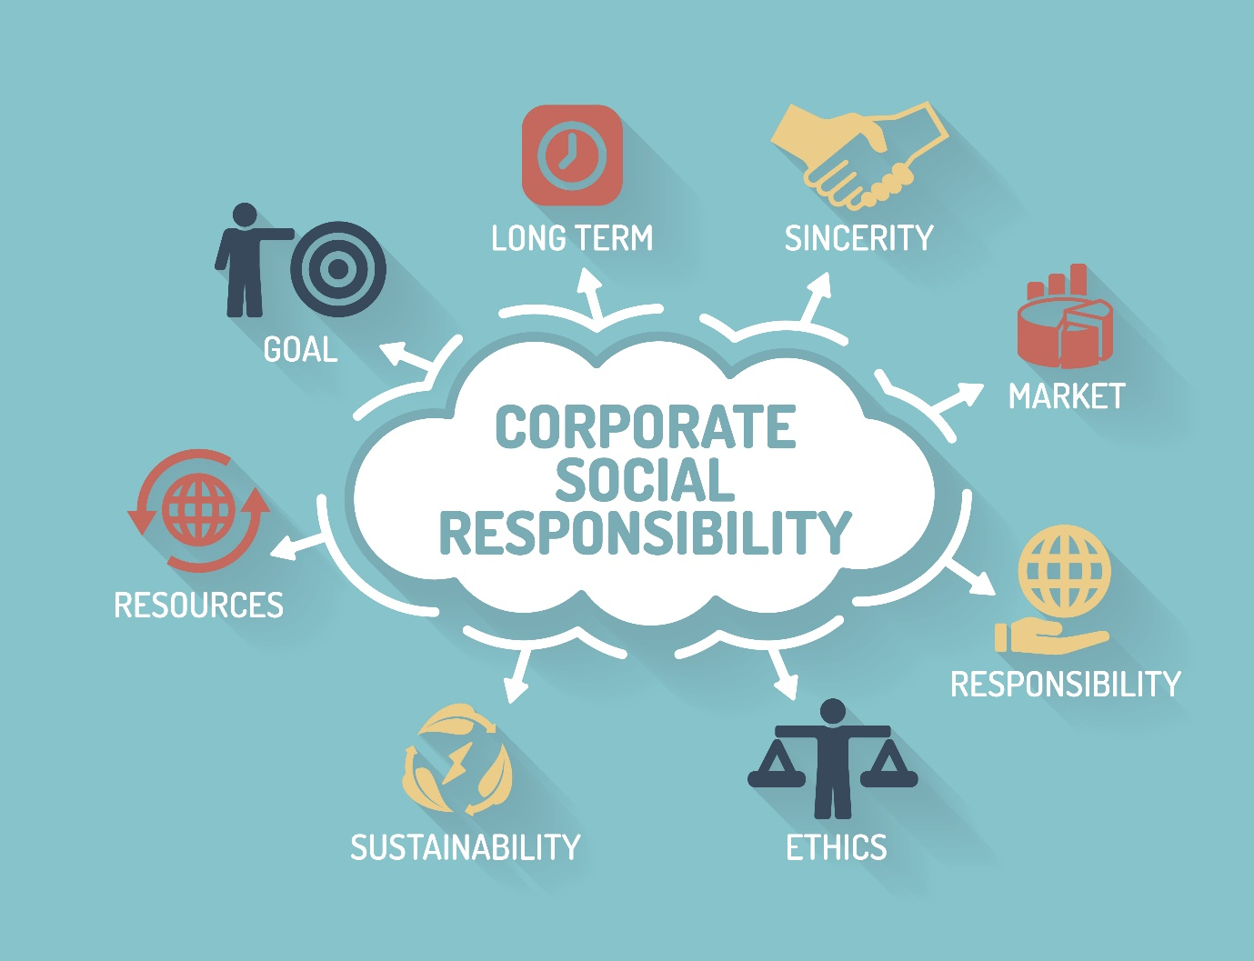

Executive Summary
This report has been written to examine Global CSR in the public sector and its importance, with particular reference to the UN Sustainable Development Goal ‘Decent Work and Economic Growth’. The report is focusing on this specific goal which is aiming to help one fifth of young people into education, employment and/or training.
This report contains details of a Global CSR initiative by McDonald’s and other partners which aims to help with getting young people into education, employment, and training through its ‘Youth Opportunity’. The initiative which started in 2018 and plans to end in 2025 has already seen encouraging results in various countries. However, not all outcomes are transparent and there are some recommendations that have been made as a result of this.

Table of Contents
Introduction | Page 4
Brief | Page 6
Results | Page 9
Discussion | Page 10
Conclusion | Page 11
Recommendations | Page 12
References | Page 13

Introduction
The Sustainable Development Goals created by the United Nations are 17 interconnected goals to creating a better and more sustainable future for everyone. They address the global challenges that we face in the 21st century, including those that are related to poverty, inequality, and climate change. The UN insist that it is vital we achieve each and every one of these goals by 2030 (UN, 2020).
This report will analyse Global Corporate Social Responsibility in the public sector. Using research undertaken on CSR initiatives and the United Nations Sustainable Development Goals, this report will systematically evaluate the importance of public sector involvement in Goal 8 - Decent Work and Economic Growth. Using the initiatives obtained during the initial research, this report will discuss how public sector organisations have worked together to tackle global development and implement CSR initiatives globally.
Whilst conducting research on CSR initiatives, it was discovered that Coca Cola is committed to giving back 1% of its profits to communities around the world every year. The beverage company founded the Coca-Cola Foundation in 1984. Since then, it has donated more than $820 million to causes within their priority areas which includes the development of disadvantaged youth (The Coca-Cola Company 2020).
This report will focus on Goal 8 – Decent Work and Economic Growth because research suggests that one fifth of young people are not in education, employment, or training (UN, No Date). Creating job opportunities for youth through Global Corporate Social Responsibility initiatives is fundamental to avoid any disadvantage and to achieve a better, sustained future for all by 2030 (United Nations, 2020).
According to International Labour Organization (2020) a global strategy for youth employment known as ‘The Global Initiative on Decent Jobs for Youth’ is the first United Nations attempt at the promotion of youth unemployment worldwide. Together, the UN and other global key partners are striving to maximise the effectiveness of youth employment investments to assist UN member countries in delivering on the 2030 Agenda for Sustainable Development.
One global CSR initiative from Decent Jobs for Youth is in partnership with the world’s leading fast food restaurant – McDonald’s, along with the International Youth Foundation (IYF). Their initiative is about removing barriers to employment for two million young people by the end of 2025 (Decent Jobs for Youth, 2018).
McDonald’s are known for their Global Corporate Social Responsibility initiatives. Since 2017, they have launched five commitments to help with achieving the Sustainable Development Goals: driving beef sustainability, improving packaging and reducing waste, reducing greenhouse gas emissions, offering more balanced choices for Happy Meals, and now youth opportunity has become the latest.

Brief
In 2020, approximately 50% of the world’s population shockingly still lives on the equivalent of 2 US Dollars a day. Current global unemployment rates are at 5.7% due to a lack of decent work opportunities, insufficient investments and under consumption. As labour productivity decreases and unemployment rates rise, standards of living begin to decline due to lower wages (United Nations, 2020).
According to the United Nations (No Date) ‘Decent work means opportunities for everyone to get work that is productive and delivers a fair income, security in the workplace and social protection for families, better prospects for personal development and social integration’. In order for economic growth to remain sustainable, societies will need to create the conditions that allow people to have quality jobs that stimulate the economy.
20% of young people are not in education, employment, or training (UN, No Date). Education is unfortunately not accessible to all children and young people around the world, only 40 – 50% of governments in some countries supply schools (Decent Jobs for Youth, 2017). Even in those countries where it exists – it is not always free, meaning that those from disadvantaged backgrounds are unable to attend. This leads to a large working age population who are not prepared for employment (The Guardian, 2014).
According to Decent Jobs for Youth (2017) providing youth with the best possible opportunity to transition into a decent job calls for investing in education and training of the highest possible standard and providing young people with skills that match labour market demands. All aspiring youth should attain productive employment regardless of their gender, income level or socio-economic background.
The organisation has eight priorities that present immediate and long-term opportunities to tackle the global youth employment issue. Transitions to the formal economy, for those who are working erratic hours for low pay. Digital skills for youth, for those who are not digitally competent in a world full of technology. Quality apprenticeships, for businesses to train young people and give them the skills they want their workforce to possess. Youth in fragile situations, for those impacted by conflict and complex emergencies. Youth in the rural economy, for those living in rural areas where a range of different jobs are less common. Youth entrepreneurship and self-employment, for those young people who want to run a business to overcome the barriers they face and realise their potential. Young workers in hazardous occupations, which is of particular concern to the United Nations who want to improve the quality of existing working conditions. Finally, green jobs for youth, which can also provide an opportunity to preserve the environment – something many young people today have a keen interest and concern about (Decent Jobs for Youth, 2017).
Decent Jobs for Youth are facing these worldwide priorities together with their partners in both the private and public sectors. Having such a large alliance means that they have access to a large network of resources and knowledge to achieve their goal of having a long lasting, positive impact on the lives of young people everywhere (Decent Jobs for Youth, 2017). Through this organisation, the United Nations have achieved their target of developing and operationalising a global strategy for youth employment by 2020. However, there is still a long way to go before youth unemployment is considerably reduced worldwide. If ‘Decent Work and Economic Growth’ as a Sustainable Development Goal is to be achieved by 2030, then significant results will need to be seen from this global scheme over the coming years.
One specific initiative involving Decent Jobs for Youth, McDonald’s and the International Youth Foundation is offering pre-employment job readiness training, employment opportunities and workplace development programs to two million young people all over the world by 2025 (Decent Jobs for Youth, 2018). The International Youth Foundation work with their partners and global network to provide young people with opportunities to transform their lives (International Youth Foundation, 2020).
The pilot for the ‘Youth Opportunity’ took place in 2018 in Chicago, USA. The pilot involved McDonald’s distributing $1 million in grants to four community-based organisations: After School Matters, Skills for Chicagoland’s Future, Phalanx Family Services and Central States SER (McDonald’s 2019). These organisations specialise in working with young people, and during the pilot program paired relevant skills training programs with a tailored version of the IYF’s Passport to Success curriculum that was developed in partnership with McDonald’s. The pilot program aimed to reach 4000 youth in the city (Decent Jobs for Youth, 2018).
According to McDonald’s (2019) Youth Opportunity expanded to Washington DC in July 2019. The Washington program aims to reach 1000 youth in total by 2025, although it is expected that target will be reached earlier. McDonald’s also rolled the program out to other US cities in 2019, before then taking it internationally (International Youth Foundation, 2018).
Globally, McDonald’s is partnered with locally relevant training programs who provide pre-employment training to young people. In European countries such as France, Germany, Italy and the UK, McDonald’s have pledged to offer 45,000 apprenticeships by 2025 as one of the career development opportunities that young people not in employment, education or training can access (McDonald’s 2019). These apprenticeships will combine workplace training with study, enabling young people to gain practical work experience and essential new skills whilst earning money (International Youth Foundation 2018). In the UK, McDonald’s offer apprenticeship opportunities to both new employees just starting their careers, as well as those already employed who are looking to develop their qualifications and professional skills further. Current UK apprentices range from 16 to 58 years old and 80% of these are already working for the company (McDonald’s 2020).

Results
The pilot in Chicago surpassed expectations and was incredibly successful, as it provided life skills training to over 4200 young people. Upon completion of the program, 87% of young people reported an increase in life skills and 71% were engaged in education or employment, with 150 working in McDonald’s franchises. Due to the rapid success of the initiative in the city, the program is continuing with a goal of aiding another 4000 young people by the end of 2025 (McDonald’s 2019).
No results from the Washington DC program have been published as of yet, so it is unclear whether they have or will meet their intended goal of reaching 1000 youth in the city and surrounding areas.
In Europe, McDonald’s is well on its way to achieving their goal of providing 45,000 young people with apprenticeships by 2025. Since announcing their commitment to do so in 2019, they have offered more than 13,000 apprenticeships across the 8,200 restaurants in the participating countries (McDonald’s 2020).
It appears this Global CSR initiative is seeing much success all over the world. McDonald’s have already made great strides in attaining their target in the two years since the initiative launched. However, if they are to achieve their target of helping 2 million people into employment or training by 2025, then even greater steps will need to be taken over the next 5 years.
However, a new global threat may have a significant impact on the ‘Youth Opportunity’ initiative and the outcome of the Sustainable Development Goals. Since the outbreak of Coronavirus in late 2019, progression of these initiatives has come to a halt, the global economy has been severely affected and currently there is no end to the disease in sight. Only time will tell what the long-term effects of it will be on Global CSR initiatives and in achieving the United Nations Sustainable Development Goals.

Discussion
McDonald’s are aware that many young people all over the world are out of work, usually down to no fault of their own and have established a way to help them whilst also helping themselves. The brand is proud of its commitments and are happy to report the successes of their Global CSR initiatives.
Results from the youth opportunity pilot scheme in Chicago were easy to come by on the McDonald’s Corporate website as well as on the International Youth Foundation website. The websites also contained a vast amount of information regarding who was involved in the initiative, how much money had been invested and what the results of the scheme were. On the same McDonald’s website, they also vaguely outlined how the program is being rolled out into other countries such as Australia, South America, and Canada without providing any specific details.
It was also simple to find some details and results of the initiative in the UK through their UK based careers website. However, locating specific information and the results of other schemes in the US – including Washington proved difficult. On the McDonald’s Corporate website, they were less specific about what organisations were involved, what they planned to do to help 1000 youth and the sum of money that was involved. Researching the initiative throughout other countries in Europe did bring up many successes with regards to education and employment, but no specific figures were visible.
No failures of this global initiative were found. However, it is ongoing and there are still 5 years to go before the end of this commitment - therefore I would not expect to find any at this stage. As previously mentioned, it will be interesting to see what the consequences of the Coronavirus pandemic will be on global initiatives and whether any failures as a direct result of it will be accurately reported in the years to come.

Conclusion
It is evident that achieving the Sustainable Development Goals is key to establishing a better future for everyone all over the world. Goal 8 – Decent Work and Economic Growth is an important and relevant goal that the UN have identified due to high global unemployment rates. Young people in particular are being affected, and a global strategy for youth employment that was aimed to be achieved by 2020 has already been established.
Decent Jobs for Youth, McDonald’s, and the International Youth Foundation are attempting to remove barriers to employment for two million young people by the end of 2025 - 5 years earlier than the deadline for the UN Sustainable Development Goals. They are implementing their ‘Youth Opportunity’ initiative worldwide - providing education, training and employment to youth who can access it. The pilot program helped over 4200 people in total. This was achieved in a short space of time and exceeded initial expectations. Even more so, the program is continuing with an even bigger goal aiming to be achieved. Since the pilot, the initiative has been rolled out internationally. Results from some countries have been published and are easily accessible, some are not. The results that can be found online are positive ones and the initiative has seen big successes very quickly. However, it is uncertain whether these will be maintained, especially due to new global circumstances that are beyond anyone’s control.
This report analysed Global Corporate Social Responsibility in the public sector. It systematically evaluated the importance of public sector involvement in Goal 8 using research undertaken on CSR initiatives and the UN Sustainable Development Goals. Using the initiatives obtained during initial research, this report discussed how public sector organisations have partnered to tackle global development and implement CSR initiatives globally. It is vital that global societies work together to help tackle the problems that as a world we face, or there is no hope of achieving a sustainable, healthier future for us all.

Recommendations
- Published clear initiative plan 2018 – 2025
A clear plan of the ‘Youth Opportunity’ initiative over the 7-year period outlining a proposed course of action and achievements would be valuable to compare with published results. This would allow tracking of the program over time and clarity as to what exactly is taking place, where it is taking place, who is involved and how long it is intended to take place.
- More transparency with regards to results
Results from the initiative throughout each country should be easily available and be clear as to whether they are under target, at target or above target and exactly what they mean for the initiative going forward.
- Published total worldwide figures and link to SDG
As well as results from each country being made clear and accessible to all, the total worldwide results should also be published. This will make it easier to assess how the initiative is assisting to decrease the figure of 20% of young people not in education, employment, or training according to the United Nations. They will also depict how the initiative is impacting world unemployment and contributing to the achievement of the Sustainable Development Goals.

References
Decent Jobs for Youth (2017) ‘About: The Challenge’ Available at: https://www.decentjobsforyouth.org/about (Accessed: 24th April 2020).
Decent Jobs for Youth (2017) Available at: https://www.decentjobsforyouth.org/ (Accessed: 24th April 2020).
Decent Jobs for Youth (2017) ‘Partners’ Available at: https://www.decentjobsforyouth.org/partners (Accessed: 24th April 2020).
Decent Jobs for Youth (2018) ‘Youth Opportunity: McDonald’s Global Initiative to Remove Barriers to Employment for Two Million People’ Available at: https://www.decentjobsforyouth.org/commitment/163 (Accessed: 25th April 2020).
International Labour Organization (2020) ‘The Global Initiative on Decent Jobs for Youth’ Available at: https://www.ilo.org/global/topics/youth-employment/databases-platforms/global-initiative-decent-jobs/lang--en/index.htm (Accessed: 24th April 2020).
International Youth Foundation (2018) ‘Partnership with McDonald’s Will Reach 2 Million Youth’ Available at: https://www.iyfnet.org/blog/partnership-mcdonalds-will-reach-2-million-youth (Accessed: 25th April 2020).
International Youth Foundation (2020) ‘What we do’ Available at: https://www.iyfnet.org/what-we-do (Accessed: 4th May 2020).
McDonald’s (2019) ‘Youth Opportunity’ Available at: https://corporate.mcdonalds.com/corpmcd/scale-for-good/youth-opportunity.html (Accessed: 25th April 2020).
McDonald’s (2020) ‘McDonald’s Expands European Pledge to Austria, Denmark & France’ Available at: https://news.mcdonalds.com/index.php/news-release/news-release-details/mcdonalds-expands-european-apprenticeship (Accessed: 26th April 2020).
The Coca-Cola Company (2020) ‘The Coca-Cola Foundation’ Available at: https://www.coca-colacompany.com/shared-future/communities/the-coca-cola-foundation (Accessed: 20th April 2020).
The Guardian (2014) ‘One in four young people in developing countries unable to read says UN’ Available at: https://www.theguardian.com/global-development/2014/jan/29/illiteracy-education-young-people-developing-countries (Accessed: 22nd April 2020).
United Nations (No Date) ‘Decent Work and Economic Growth: Why it matters’ Available at: https://www.un.org/sustainabledevelopment/wp-content/uploads/2016/08/8.pdf (Accessed: 22nd April 2020).
United Nations (2020) ‘About the Sustainable Development Goals’ Available at: https://www.un.org/sustainabledevelopment/sustainable-development-goals/ (Accessed: 20th April 2020).
United Nations (2020) ‘Promote inclusive and sustainable economic growth, employment and decent work for all’ Available at: https://www.un.org/sustainabledevelopment/economic-growth/ (Accessed: 21st April 2020).

