STUDENT NAME: DRAGOS NICOLAE BUCATARU
STUDENT NUMBER:1919242
MODULE TITLE: INTRODUCING THE MODERN WORKPLACE
ASSESSMENT TYPE: ASSIGNMENT 1
LECTURER NAME: GREGORY COWAN

Structure and Culture
Assessment 1

Contents

INTRODUCTION 1
MAIN BODY 1
CONCLUSION 6
REFRENCES 8

INTRODUCTION
Organisation is defined as a system that involve different structure and culture that help in conducting activities in a systematic manner. It is important for an entity to have an effective structure & culture as it assist in implementation of work systematically. Culture is defined as the values, norms, beliefs and opinions of employees prevailing in the organisation (Mansouri, Singh and Khan, 2018). It is important for an entity to ensure that positive working culture is provided to the staff members as it has direct impact on the performance and productivity of a company. Structure is basically a system by which a firm is develop an hierarchy level at the workplace. In the present report, Kellogg’s is taken into consideration. It is a food processing industry which was established in the year 1906 by Will Keith Kellogg. The products offered by company is crackers, cereals, frozen waffles, vegetarian foods, cereal bars, toaster pastries and many more. The report will describe relationship between organisation structure and culture with the performance of a company. In addition to this, there is discussion about various theories and models associated with the culture and structure of the respective organisation.

MAIN BODY
Kellogg’s is an American food production and manufacturing that is headquartered in Michigan, United States. The company was founded in the year 1906 by Will Keith Kellogg. Kellogg’s has a high market presence as it offers product and service in more than 180 countries globally. There are various range of products offered by company that is frozen waffles, cereals, toasted pastries, cereals bars, vegetarian food and so on. In addition to this, Kellogg’s offer its products by diverse brands such as Sunshine biscuits, pringles, Eggo and Grarden burger etc. The subsidiaries of Kellogg’s are Rxbar, kashi, Keebler company, Bear Naked Inc and so on. Kellogg’s conduct analysis for identifying relationship between organisation structure and culture with its performance and people as well.
Organisation structure is termed as a system that is adopted by an entity to outline the overall process that will assist implementing activities as well as operations which in turn leads to achievement of desired goals in an effective manner (Miller, 2020). Organisation structure consist of various roles as well as responsibilities that is performed by members of company according to their hierarchy and designation level. It is determine that an effective organisational structure helps companies to effectively implement all activities and attain competitive advantage at marketplace. It basically shows the stages by which an information as well as communication take place within the organisation. Organisation structure is of different types that is adopted by organisations in order to perform all the operations and activities in a proper manner. For instance, hierarchical structure is where every group of employees are instructed by one single head or employer. Herein, the group is created on the basis of various factors such as products, functions, services and so on. It is analysed that hierarchal structure is mainly adopt by large organisations that involve different level of authority,

power, and management as well. In addition to this, another form of structure is flat structure that is usually adopt by small entities. In this structure, all the stages and departments are undertaken at similar level and adopting such organisation help an entity to decline several middle level management. Further, there are also other forms of structure that is adopted by higher authorities of a company as per their operations as well as size and these are divisional, matrix, line, network, team base and so on (Long, 2018). With reference to the respective organisation that is Kellogg’s, its managers adopted matrix structure in which some employees report to more than one leader or supervisor as well. In this, the reporting relationship are set up as a grid instead of the traditional hierarchy. In addition to this, staff members have dual reporting relationship as they are reported to both functional manager and product manager in a proper manner. With the help of this model, Kellogg’s is able to exchange information as well as message in an appropriate manner. Along with this, it also promotes democratic leadership style wherein all the employees are fairly and equally treated. It also helps company to enhance the motivation level of all the staff members that has positive impact on the sales and profitability level of the respective organisation.
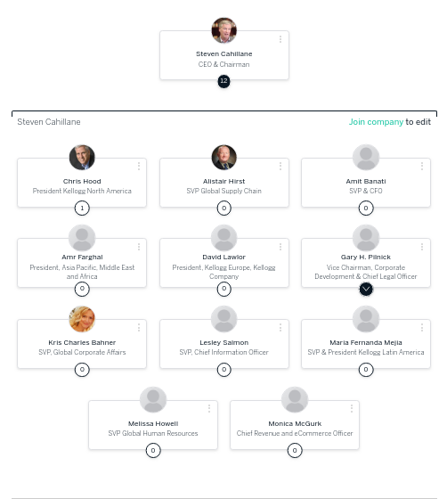Illustration 1: Org chart
(Source: Org chart, 2019)

By analysing the above chart, it is sated that Kellogg’s staff members and employers are required to report to both functional as well as production manager. In addition to this, the higher authority or senior manager of organisation require to report to SVP, presidents, CFO and they need to report chairman and chief executive officer of respective company who is Steven Cahillane. Further, it is determine that the organisation structure of Kellogg’s is associated to the culture, performance and people as due to effective structure, employees are able to implement activities effectively and also follow structure in an appropriate manner (Tanwar and Kumar, 2019). Moreover, it will also assist respective company to implement all operations as well as activities systematically which has a positive impact on the performance and profitability level of an organisation.
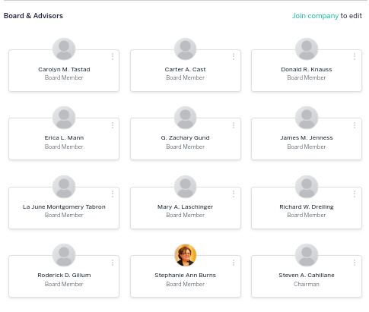Illustration 2: Org chart
(Source: Org chart. 2019)
Organisation Culture is defined as set of values, ethics norms, opinions, ideas as well as assumptions that is developed and acquired by an entity for maintaining positive and effective working environment. In context to Kellogg’s, it is determined that company has adopt Hofstede culture dimension theory so that they can gain insight about culture in an effective way. Hofstede model involves five dimension that shows various forms of culture at workplace. The foremost and first dimension is power distance that involve powerful members of Kelloggs’s. in this type of culture, power is equally proportionate between the staff members. It is determined that kellogg’s perform its work via matrix structure and due to this, it have power index of high level. The second dimension of such theory is Individualism and collectivism that means collective culture within a company will assist respective company to attain objectives timely and effective. Adoption of individualism dimension develop a negative mind set of staff members and demotivate them that impact on the quality and performance of respective company in a negative manner.
The third dimension of Hofstede theory is uncertainty avoidance index that means respect organisation should give training to its employees as it help them to deal with the risk situation which can arise at any time and at any palace (Kwarteng and Aveh, 2018). In addition to this, it reduces the negative mind set of employees and make them feel encouraged and influence towards their working. Femininity and Masculinity is the fourth dimension, femininity is basically a type of culture where a company prefer more female staff members. On the other side. Masculinity is where an organisation prefers male staff members to work. It is determined that the higher authorities of Kellogg’s adopt both dimension as it will assist in developing positive brand image in market and maintain positive working culture at workplace. The last and the important dimension of Hofstede theory is Short-term and long-term dimension. It states that a company can develop short-term culture and in this they can form strategies for short time basis. On the other hand, long-term culture define as a situation wherein higher authorities develop every decision for long-term. With reference to chosen organisation, it is required to adopt both form of culture that will be depend on the situations and the ability to handle such situations.
In a company, people are defined as an employees or the staff members who implement all the activities and operations according to the guidelines so that organisational objectives is achieved within stipulated time period. In addition to this, they assist company to enhance the level of market performance and attain competitive advantage at marketplace. In addition to this, it also consists of stakeholders who invest their time as well as money in an entity with an aim to attain higher profits. With reference to Kellogg’s, it has more than 34,000 skilled and effective employees which is the main reason of its success at marketplace. All this staff members are expert an experience in manufacturing convenience and in cereal food like frosted flakes, corn flakes, pop tarts and so on. In addition to this, people also consist of shareholders that invest money on business activities with an aim to earn higher profits (Chen, Thompson and Pan, 2019). The shareholders of Kellogg’s are BlackRock Fund advisor, Vanguard group, Templeton Global advisor, Mellon trust and so on. all this are the top owners and shareholders of Kellogg’s organisation due to which it is able to expand operations at global level.
Organisation Performance is defined as an actual outcome that is gain by an entity by performing operations and activities in an effective manner. In addition to this, it is also earned by company by targeting the right people at right place in an appropriate way. The organisation performance is basically involved three man areas that shareholders return, financial performance and product performance as well. In relation to respective organisation, its higher authorities conduct an analysis for gaining insight about organisational performance as it helps them to make improvements and attain objectives within stipulated time period. For this, the managers adopt SWOT analysis tool that aid in identifying strength, weakness, opportunities & threats as well. From this analysis, it is analysing that one of the major strength of Kellogg’s is its market presence as it offer product and service in more than 180 countries. Another strength is ,it offers healthy products that attract people to consume it which has positive impact on its sales and profitability level. In addition to this, it has several weaknesses also that is required to be overcome by company in order to gain higher growth and competitive advantage at marketplace. It is analysed that Kellogg’s bring innovation in a slower rate as compare to requirement in market that has negative influence on its customer base level. Along with this, the company is also facing issues at the time of conducting marketing campaign as it is not matched with the message given with the product. This impact negatively on the overall brand image and market performance of Kellogg’s.
In context to the opportunities of Kellogg’s, the company can expand its market globally due to which its sales and profit margin is increased (Agarwal, Chhugani and Wanchoo, 2018). In addition to this, Kellogg’s can make tie ups with hotels, colleges as it will help in increasing customer base and market presence as well. If it is talking about the threats of Kellogg’s is its competitors such as Quaker oats, Nestle, generally mills decline its profitability and market share.
By conducting the study, it is stated that Kellogg’s is required to adopt effective structure as it helps in maintaining positive working culture at workplace. It is important for the company to focus on systematic implementation and execution of activities as it helps in enhancing performance and profitability level in an appropriate manner.

CONCLUSION
From the above study, it has been analysed that an effective working culture, structure and people are required in order to enhance performance level and market share as well. In addition to this, employees are the asset of an organisation which help an entity to meet with their targets and achieve competitive advantage at marketplace. It is significant for the higher authorities and management team of company to adopt effective structure so that all the activities are carried out in a systematic and effective way that has positive impact on the overall performance and profits of an organisation. Providing positive working culture to the staff members enhance the motivation level and develop morale of employees due to which they work with full potential towards attainment of desired goals and objectives in a timely manner. Further, it is essential to evaluate the performance level and for this, many theories and methods were used such as SWOT analysis and so on.

REFRENCES
Books and Journals
Agarwal, P., Chhugani, R. and Wanchoo, V., 2018. Analysis of brand valuation techniques for cereal brand: Kellogg. International Journal of Education and Management Studies, 8(1), pp.31-34.
Chen, H., Wooten, H., Thompson, L. and Pan, K., 2019. * Department of Animal and Food Sciences, Texas Tech University, Lubbock, TX, United States,† WK Kellogg Institute for Food and Nutrition Research, Kellogg Company, Battle Creek, MI, United States. Biopolymer Nanostructures for Food Encapsulation Purposes: Volume 1 in the Nanoencapsulation in the Food Industry series, 1, p.39.
Kwarteng, A. and Aveh, F., 2018. Empirical examination of organizational culture on accounting information system and corporate performance. Meditari Accountancy Research.
Long, S., 2018. The perverse organisation and its deadly sins. Routledge.
Maldonado, T., Vera, D. and Ramos, N., 2018. How humble is your company culture? And, why does it matter?. Business Horizons, 61(5), pp.745-753.
Mansouri, A.A.A., Singh, S.K. and Khan, M., 2018. Role of organisational culture, leadership and organisational citizenship behaviour on knowledge management. International Journal of Knowledge Management Studies, 9(2), pp.129-143.
Miller, V., 2020. Understanding digital culture. SAGE Publications Limited.
Stemn, E., Bofinger, C., Cliff, D. and Hassall, M.E., 2019. Examining the relationship between safety culture maturity and safety performance of the mining industry. Safety science, 113, pp.345-355.
Tanwar, K. and Kumar, A., 2019. Employer brand, person-organisation fit and employer of choice. Personnel Review.

