EFFECTIVE TEAM WORKING AND COMMUNICATION
BMSW4002_LON

Assignment Title:
Understanding of the models of communication and communication skills

Student: Mariya Delieva – 2007927
Tutor: Anita Nan
2021/UWTSD

Contents

Introduction………………………………………………………………………………….….2
- Models of communication…………………………………………………………....2
1.1. Shannon and Weaver Model……………………………….……………….….3
1.2. Schramm’s Model ………………………….……………………………………4
1.3. Berlo's communication model (SMCR) ……………………………………….5
2. Communication Skills ………………………………………………………………….6
2.1. Verbal communication…………………………………………………………...6
2.1.1. Written communication……………………………………….……....7
2.2. Non – verbal communication…………………………………………………….8
3. Communication on the workplace………………………………………………………8
4. How to improve communication…………………………………………………………9
Conclusion………………………………………………………………...…………………....11
Reference list…………………………………………………………………………………...12

Introduction
Historically, the word communication comes from the Latin word "communicate," which means to convey, to participate, to share. Communication is any act of transmitting thoughts, ideas, and emotions between people, using a system of symbols that can be written, spoken through body language, as well as pictures, graphics, tables. Human relationships are based entirely on communication. Knowledge and improvement of communication skills meliorate the ability to make connections and perform tasks in the workplace. The general communication model is the transfer of a message from sender to recipient. The main elements of the communication model are the participants: the sender and the recipient; message; communication channel (means of transmitting information); means of communication; target audience of communication, which seems both local and more general goals and interests of the participants (Yakupov, 2016). When the recipient in turn communicates, understands the meaning of the message through words or actions, this is called feedback and completes the communication process.

1. Models of communication
The communication models analyzed in the report follow the 6 main steps in which it is applied.
The Communication Cycle model is a linear model of communication that provides a schematic representation of the relation between sender, message, medium/media, and recipient (Mulder, 2016).
Figure 1
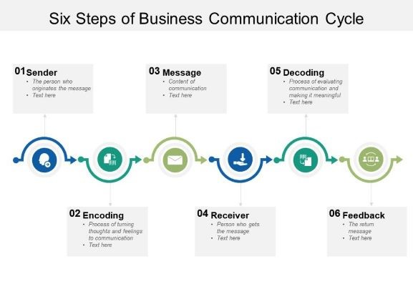
The sender originates the message. Can be individual or group. sends something that can be words, gestures, song, dance, etc. Encoding is still with the sender, the process of turning of thoughts and feelings into communication. The message is the content of the communication, can be verbal or non-verbal. The receiver is a person or group, who gets the message and decides what the sender wanted to say. The feedback is when the receiver return message.

1.1. Shannon and Weaver Model
In 1948, the linear model was created by American scientist, mathematician Claude Elwood Shannon and electronic engineer Warren Weaver. It is designed to improve technical communication between sender and receiver via telephone. But they find factors that affect the communication process called "Noise".
Figure 2
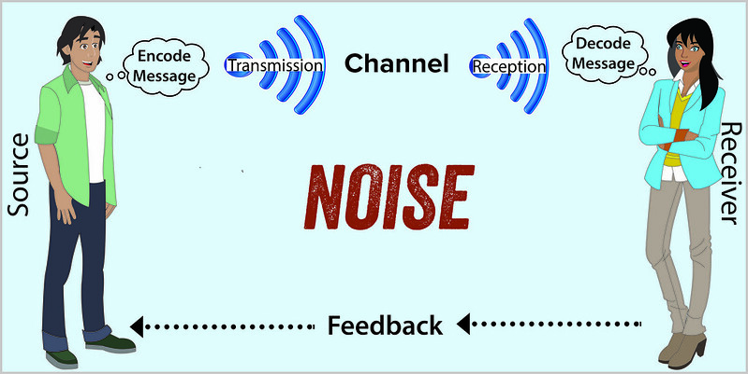
(Social Sci Libre Texts, 2020)
As figure 2 shows the details of the model include:
The sender of the message. Encoder is transmitter that converts the message into signals.
Decoder is the point of signal reception that converts signals into a message. The receiver converts this binary data or waves into a message that is convenient and understandable to the receiver. Based on the decoded message, the recipient returns their feedback to the sender. If the message is distracted by noise, it will affect the communication flow between sender and receiver. During the process of transmitting of messages may be distracted or
affected by physical noise such as home sounds, thunder and crowds, or coded signals may distract from the channel during the transmission process, so the receiver may not receive the correct message.
The model only deals with external noise that affects messages or signals from external sources. For example: the case study Maria and Pedro examined in class assess how the noise directly affect mobile phone communication or distract messages.
it describes:
The noise of the construction site prevents Pedro from hearing Maria's message. But Pedro's confusion could have been avoided if he had asked Maria if he understood her message correctly (feedback).

1.2. Schramm’s Model

Schramm’s model from 1954 determine communication as a process between an encoder and a decoder. What sets it apart from other models of communication is that this model considers the way people interpret the message. According to Shram, human experience, knowledge and origin are factors that influence interpretation. Shram believes that messages are transmitted on a medium. The decoder will be able to send feedback on the message to indicate that the message has been received. Schramm's model stressed, encoding and decoding are vital for effective communication. Any communication that does not decode or does not provide feedback is not effective or complete.
Figure 3
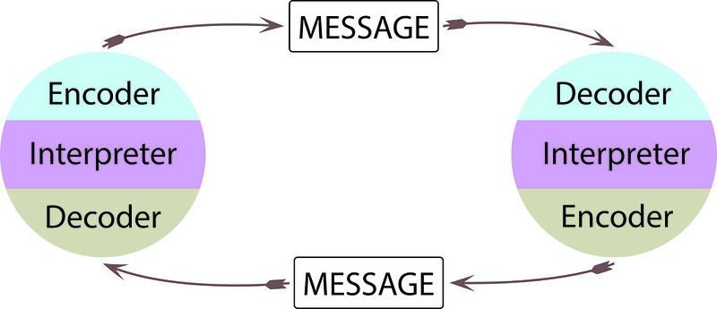
(Social Sci Libre Texts, 2020)

1.3. Berlo's communication model (SMCR)

Built by David Berlo in 1960, the model is an advanced version of Shannon and Weaver model, which in addition to sender, message, channel, and receiver, includes elements that affect each of the components of the model.

Figure 4
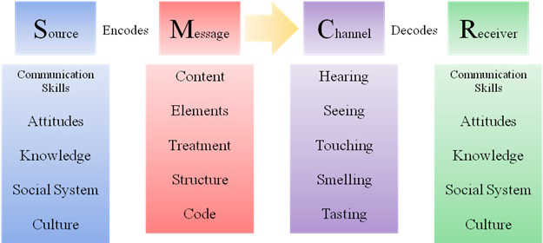
(jayaseelansr.blogspot.com. (n.d.)

Berlo argue receiver and speaker must be on the same platform for better understanding of the message and possess good communication skills to understand what the speaker is trying to convey. The knowledge of the speaker and the recipient must be equal. They must be of the same social and cultural background to have effective communication. Understanding the receiver depends on how the message is transmitted. For example, “The professor in the village" case study, discussed in class, shows how communication between a professor and largely uneducated villagers fails when his house catches fire and he go to the village to ask for help. The villagers do not understand the complicated academic language of the professor, which he uses to explain that his house is on fire. As a result, the villagers ignored him, and his house was destroyed.
Conclusion: If the professor had explained in simple and clear language to the villagers that he was in trouble, they would have helped him and saved the house.
The main disadvantages of this model of communication are that there is no feedback, also the sender and recipient must be at the same level, which in practice in life it rarely happens.

2. Communication Skills
Communication is a process of exchanging information, transmitting ideas, and achieving equality in the thinking and opinions of participants in teamwork. The communication methods are verbal and non-verbal.
- When people interact through use of words or messages in language form, and conversational use refers to speech (oral communication), especially face-to-face communication is verbal communication. It includes written communication.
- When people communicate without words and use body language is non-verbal communication, which also involves appearance, silence, time.

2.1 Verbal communication.
We spend much of our everyday life talking, maybe that is why we take talking
for granted and open our mouths before engaging the brain. (Stanton, 2009) Business communication is strongly linked to verbal skills, rhetorical techniques, the application of persuasion skills, the various logical and emotional means of influencing and forming a certain opinion. Several rhetorical skills can be derived that relate to the ability of businesspeople to persuade by word of mouth:
- Clarity. Use simple and organized language without long syllables to clearly express ideas and thoughts.
- Empathy. Trying to put yourself in the other person's shoes helps to establish empathy for the other person and it helps to be patient and understand his point of view.
- Sincerity. Be yourself. Natural behaviour in conversation creates trust.
- Relaxation. Experiencing anxiety and tension during a conversation makes it difficult to express ourselves correctly.
- Eye contact. Signifying wish to be friendly.
- Appearance. Appearance creates a certain impression in people and forms an opinion. Personal cleanliness and order, as well as appropriate clothing for the situation are key to the message we send.
- Posture.
- Tone of voice. Speaking loud and fast means aggression, while speaking calmly and articulately means confident.
2.1.1. Written communication.
Well-written communication helps define goals, identify problems, and arrive at
solutions in every aspect of business. Executives must clearly write so that staff understands the directives without confusion. To be effective, the written communication should use the correct tone, inoffensive language, and appropriate grammar.
The tone, the choice of words and the way the words are put together vary
between the two styles. Formal language is less personal than informal language. It is used when writing for professional or academic purposes like university assignments. Informal language is more casual and spontaneous.
Informal: I don’t believe that the results are accurate.
Formal: The results are not believed to be accurate.
Comparison Chart
BASIS FOR COMPARISON | FORMAL WRITING | INFORMAL WRITING
Meaning | It is used for business, legal, or professional purposes. | It is used when writing for some personal or casual reason.
Sentences | Long and complex Sentences | Short and simple Sentences
Language | Formulaic | Direct
Voice | Passive Voice | Active Voice
Interjections | Not used | Used
Personal pronoun | Third person | First and second person
Tone | Professional and official | Personal and friendly
(Key Differences, 2019)
2.2. Non – verbal communication
Non-verbal communication can contradict verbal communication. For example:
if the question "How are you?" she says "okay” but has a sad tone in her voice or narrowed eyes. Research shows that when verbal and nonverbal communication contradict each other, receivers often attach more value to nonverbal communication than more accurate communication. But nonverbal communication can also repeat, regulate, or substitute verbal.
Management professionals need to know non-verbal cues to make their
work forces feel safe, comfortable, and calm. The eye contacts a person can confidently judge other people's emotions just by looking him in the eye. Can understand how someone feels based on their facial expression. The pose someone's body is positioned also communicates certain messages.

3. Communication in the workplace.
I had to go on a business trip, but I got the flu at the last minute and the
manager sent my teammate. After some time in the office, my colleague accused me of pretending to be ill to avoid a business trip that was not pleasant. I was disappointed because that was not true.
Regardless of the method (internal, external, formal, informal, verbal,
nonverbal) or channel (written, oral, external) used in the workplace, communication can be improved by applying some techniques:
- Be friendly. - Be attention.
- Be open to ideas. - Be relaxed.
- Be expressive. - Be an animation.
- Avoid making quick assumptions.
- Establishing trust at all levels of communication.
The styles of communication we use in the workplace are Analytical, Personal, Intuitive or Functional. In professional communication I prefer to use an Analytical style because it is based on statistics, figures, and accurate facts through which I manage my decisions. The positive side of analytical communicators is that they can intersect emotions and get to the heart of the matter for them, the details are important.
In each of the styles there are strengths and weaknesses and is more suitable for some tasks than others.

4. How to improve communication.
Listening
One morning we received instructions from the manager for the
implementation of a large client advertising project. A colleague who was new to the company constantly interrupted the manager with questions, some of which were not related to the task and related to sick leave, vacations, bonuses. As a result, the instruct lasted longer than planned. After the instruction, the colleague asked me exactly what his tasks were.
The example from my workplace in Bulgaria shows how failing to focus and
listening actively leads to loss of concentration, misunderstanding of tasks, poor performance, loss of time. This can be avoided through listening development techniques: pay attention, shut upping, look body language, listen for the deeper meaning. Being a good listener is as important as being a good speaker, and it will improve the quality of verbal interactions. Five stages of active listening in mind:
- Receiving - Responding
- Understanding - Evaluating
- Remembering

Speaking
Clear, confident, and balanced speech is especially important in business
interactions, because is more likely to inspire respect for others and build relationships. Several techniques can improve communication skills:
- Think before you speak - Be clear and concise
- Speak with confidence - Vary vocal tone
- Be an active listener - Be aware of non-verbal communication cues
- Think about the perspective of your audience.

Barriers
Understanding barriers is a factor for effective communication. Although the barriers to communication may be different in different situations in the classroom, some basic ones were mentioned:
1. Physical barriers. 2. Attitude barriers. 3. Language barriers.
4. Physiological barriers. 5.Cultural noise. 6. Lack of communication experience.
7. Ambiguity. 8.Information overload. 9. Jumping to conclusions
10. Problem with structure design.

Conclusion
Human communication is a process of understanding our experience and the
experience of others using verbal and nonverbal messages. But this process involves a few elements such as the sender who encodes the message and the recipient who decodes it, the channel through which the message flows and the noise that can interfere with the correct interpretation. Another element is Feedback, it sent by recipient to sender is often a key element in workplace communication. Professional success largely depends on the skills of a good communicator. Becoming a role model in the workplace requires continuous self-improvement, knowledge of the audience, reading the context, adapting to the environment and finally the ability to know yourself. It is a process of discovering our strengths and weaknesses and continuously improving our communication skills in different situations and audiences (Quintanilla and Wahl, n.d.).

Reference list:

1. Communication Theory (2014). Shannon and Weaver Model of Communication. [Online] Communication Theory. Available at: https://www.communicationtheory.org/shannon-and-weaver-model-of-communication/.[Accessed: 10 March 2021].
2. jayaseelansr.blogspot.com. (n.d.). David Berlo’s Model of Communication. [Online] Available at: http://jayaseelansr.blogspot.com/2017/07/david-berlos-model-of-communication.html [Accessed 9 Apr. 2021].
3. Key Differences. (2019). Difference Between Formal and Informal Writing (With Comparison Chart). [Online] Available at: https://keydifferences.com/difference-between-formal-and-informal-writing.html. [Accessed: 10 March 2021].
4. Mulder, P. (2016). Communication Cycle model by Shannon and Weaver. [Online] Available at: https://www.toolshero.com/communication-skills/communication-cycle-shannon-weaver/ [Accessed: 3 March 2021].
5. Quintanilla, K. and Wahl, S., n.d. Business and professional communication, p.15.
6. Roubler, UK. (2017). Managing Body Language in the Workplace | Roubler UK Blog. [Online] Available at: https://roubler.com/uk/resources/blog/nonverbal-communication-workplace/. [Accessed 5 March 2021].
7. Smarp.com. (2019). Top 5 Communication Skills and How to Improve Them. [Online] Available at: https://blog.smarp.com/top-5-communication-skills-and-how-to-improve-them. [Accessed 5 March 2021].
8. Social Sci Libre Texts. (2020). 2.4: Models of Interpersonal Communication. [Online] Available at https://socialsci.libretexts.org/Bookshelves/Communication/Book%3A_Interpersonal_Communication__A_Mindful_Approach_to_Relationships_(Wrench_et_al.)/02%3A_Overview_of_Interpersonal_Communication/2.04%3A_Models_of_Interpersonal_Communication. [Accessed: 3 March 2021].
9. Stanton, N. (2009). Mastering Communication. Basingstoke; Palgrave MacMillan.
10. Yakupov P. (2016). Communication: definition, types of communication and barriers of communication. Vestnik Universiteta. ;(10):261-266. (In Russ.)

