A study on Labor market in UK and changes in HRM post COVID and post Brexit
Table of Contents
1. Introduction 3
2. Discussion 3
2.1 Labor market in UK 3
2.2 Human Resourcing Strategies in the post Covid, post Brexit 7
3. Conclusion 11
References 12

1. Introduction
In accordance with the most recent Labour Force Survey (LFS) estimations for the period of February to April 2022, worldwide employment rate has increased while the rates of joblessness and socioeconomic inactivity declined. The employment rate in the UK grew by 0.2 percent over the course of the quarterly to 75.6%, but it is still smaller compared to prior to the COVID-19 epidemic. Over through the quarter, the company employed more full-time employees than it has ever been, however this was largely offset by a drop in the number among part-timers (Keaney, 2018). Despite an uptick well over past quarter, the number of independently employed people has remained relatively stable since the coronavirus outbreak. The most up-to-date assessment of payrolled personnel for May 2022 predicts an ubiquitously expressed of 90,000 above the modified April 2022 projection to a historic 29.6 million. In the three months from February through April 2022, real monthly hours worked rose by 12.2 overtime opportunities to 1.04 billion hours. This is nevertheless 7.6 million fewer people than before the coronavirus outbreak (Keaney, 2018).

2. Discussion

2.1 Labor market in UK
The unemployment rate during quarter period February through April 2022 dropped from 3.8 percent from 3.8 percent. The most massive increase throughout late 2020 occurred during the most recent three-month timeframe among those without a job for at least six months. The percentage of individuals who had been unemployed for more beyond six months reduced to counteract this, and the number among individuals who had not worked for between six and twelve months reached a new low. Furthermore, the number of individuals who had been unemployed for more than a year fell (Keaney, 2018). From February to April 2022, the rate of business inactivity dropped by 0.1 % points to 21.3 percent. Due in large measure to the fact because they were students, individuals who were permanently unemployed decreased in comparison to the preceding three months. Nonetheless, they are all now juxtaposing the most recent event with just a time because certain businesses saw a growth in the number of workers on furlough as a result of something like the closure in the winters of 2020–2021. As a result, these areas will undergo a minimal base effect. This won't approach to the same extent as what researchers observed were comparing timeframes during the beginning of said coronavirus outbreak (Keaney, 2018).

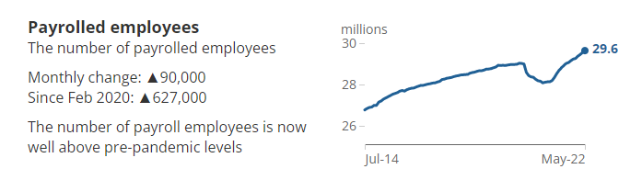
Figure : Payrolled Employees (Source – HMRC PAYE RTI)

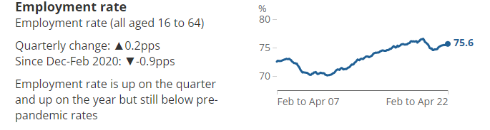
Figure : Employment (Source – ONS LFS)

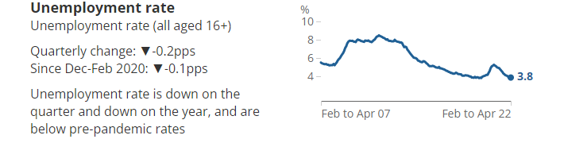
Figure : Unemployment rate (Source - ONS LFS)

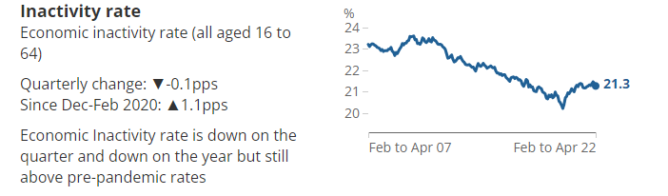
Figure : Inactivity rate (Source - ONS LFS)

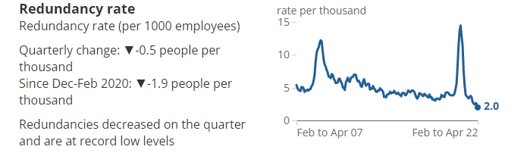
Figure : Redundancy rate (Source – ONS LFS)

Weekly wages on average
The quantity that British businesses pay to their workers every week and without taxes and some other deductions is defined as both the average weekly wage. Given that they also are taken into account other developments in the workforce's basic structure, the projections are more than merely a gauge of pay increases. The business would experience an increase there in wages growth rate when there were more high-paying occupations available (Malik and Sanders, 2021).

Economic sluggishness
If individuals haven't looked for work during the last 4 weeks and/or are not going to begin employment with in coming two weeks, individuals who are not currently in the labour market, also referred as unemployed, are not employed yet do not fall within the outstanding global concept of unemployed (Malik and Sanders, 2021).

Vacancies
Vacancies that organizations are actively looking to hire from outside one‘s commercial entity are referred to as vacancies. The figures are based upon that Vacancy Survey, a company survey intended to provide predictions of the inventory of openings all throughout economy, excluding some in agricultural, forestry, including fisheries (Malik and Sanders, 2021).

Real-Time Pay As You Earn (PAYE) Information (RTI)
Those numbers originate first from Pay As You Earn (PAYE) Real - time data Information (RTI) system of HM Revenue and Customs (HMRC). These provide for more accurate population projections because they encompass the overall population instead of simply a selection of individuals or corporations (Malik and Sanders, 2021).

Employment
The number of individuals contributing to society or who seemed to have a job but were able to stay away from it is defined by unemployment. Because some individuals have many occupations, this seems to be different from the total number of occupations. The percentage of individuals employed here between ages of 16 through 64 is known as the rate of employment (Prouska et al., 2020).

Unemployment
The number of individuals who are unemployed who have spent actively looking for employment and over previous four week and therefore are capable of starting working within the coming two weeks are counted as unemployed. The percentage of the population that is unemployed does not reflect the unemployment rate. This refers to the percentage of said employed population who've been working and individuals who are looking for work—that is unemployed (Prouska et al., 2020).

Data measurement
In the paper, "Assessment of Labour Market Sources Of data," comparison of data sources and to go through a number of key distinctions.

Coronavirus
On the specialized coronavirus web page, one can get the most recent information and analysis that have on how the virus affects the UK's people and economy. This is the main location for all unique coronavirus releases, utilising all available knowledge. Researchers are striving to make ensuring that they maintain the publication of growth forecasts in the face of the rising coronavirus crisis. Please refer to COVID-19 and thus the preparation of statistics for some more details (Prouska et al., 2020).

Reweighting of the Labour Force Survey
Using revised Pay As You Earn (PAYE) Real Time Information (RTI) data, the Labour Force Surveys estimates released on June 14th, 2022 have already been reweighted covering periods between January to March 2020. This applies rate of growth with PAYE RTI statistics in the same approach that was put into place in July 2021. The non-response biased modification, that have historically been used for data across England, Wales, as well as Scotland, is now additionally used for data from Northern Ireland. This report upon that impact for reweighting on critical indicators from the Labour Force Survey in 2022 discusses the implications and provides a more complete reweighting schedule (Prouska et al., 2020).

2.2 Human Resourcing Strategies in the post COVID, post Brexit

Requirement of fresh HR strategy
The Committee is presently confronted with a range of critical and new concerns, along with the global catastrophe, creating an organizational, and also the rapid growth of technology. The workplace seems evolving, and indeed the COVID pandemic only has sped up tendencies favoring workplace flexibility and digitization. On the other hand time, the Committee must demonstrate by reflecting EU principles and playing its share in delivering the effective interventions it urges Member States to enact. For instance, the "Greening the Commission" Declaration commits to being environmentally neutral by 2030 (Bienkowska et al., 2022).

Becoming fit for such digital age entails utilising the most up-to-date cooperation IT tools available to ensure a coordinated European response to issues and challenges that are getting more sophisticated all the time, as well as a require a substantial IT platform to facilitate greater HR service quality in assistance of the complete gamut of Commission actions. Furthermore, a more multicultural and diverse Commissioner will ensuring that its personnel accurately represents the European population it serves, with only a wide range of abilities and capabilities being fully utilised (Bienkowska et al., 2022).

Important goals

Topic related (attractiveness, recruiting, and career) are really the main focus of the Strategy, which is supported by a forth, bridge priority (processes).

The Commission should improve the diversification of said European society it represents and increase its competitiveness as an employment to attract and keep top talent from across all Member States. The approach will support ongoing efforts to foster a diverse, positive workforce that supports single parents and offers everyone enticing opportunities to advance their careers. They will seek to aggressively promote equal workplace culture that is devoid of prejudice, accommodating of personnel from either a wide variety of backgrounds, and completely approachable for people who are handicapped by new activities (CIPD, 2021).

For instance:
Achieving complete equality between the sexes by 2024 at all levels within Commission management.
Diversity-related initiatives will be assessed and modified.
The both physical and digital environments of the Commission being made more accessible.
A foundation for preventative as well as stronger anti-harassment regulations will be implemented, and initiatives will be undertaken that will further enhance the appeal of particular Commission sites (CIPD, 2021).
The Committee will adjust to flexible work arrangements by offering assistance to employees and supervisors who telework through both workplaces and their homes.
By updating its procedures for housing, employee international flights, outside expert travel, transportation, and IT, it will minimize its carbon emissions. Any leftover pollutants will be made up for by increasing carbon recoveries (CIPD, 2021).

To keep pace with some other both public and private businesses, the Commission will develop contemporary, quicker, and also more flexible selection and employment procedures for internally and external applicants in close collaboration only with European Personnel Selection Office (EPSO). The Commission employs upwards of 32,000 people in much more than 200 locations, and annually hires 500 officials including 1,800 temporary business contract workers (CIPD, 2021). The Commission necessitates a more flexible as well as balanced workforce, thus the present assessment and recruitment strategy needs to be quicker and improve. For instance, an implementation strategy that incorporates country-specific analysis to comprehend the causes of some nations' start to decline as well as suggested ways to address this issue would indeed be prepared together Member States (ons.gov.uk, 2022).

All coworkers will receive specialist assistance and education to help them have flexibility and fulfilling jobs. This would encourage the Commissioners to adopt an increased and autonomous culture wherever individual knowledge and expertise are applied using the most efficient manner to meet priorities. Increasing employee mobility as well as smarter, more productive organisational structures, including cross-cutting project members, will result in enhanced career flexibility (ons.gov.uk, 2022). These have already been shown to be effective, in addition to being a source of pride and inspiration for coworkers using these new managerial styles. These play a significant role in the Commission's ability to deal with brief spikes in demand and to test employees who are ready to undertake new tasks. Supervisors will receive the help and resources required to raise the motivation and effectiveness of the staff (ons.gov.uk, 2022).

The fields of career counselling, mentoring, training, and executive search will be enhanced and organized. The importance of an open attitude, trust-based leadership, and accountable will be emphasised.

The fourth overriding priority—the examination and modernization of human resources methods the other three. These fundamental precepts will be the starting point for this:
The once-only approach for knowledge application; minimising procedure whenever possible; accessibility; and uncomplicated, approachable, accessible, and open processes (Van Aerssen et al., 2022). The HR produces output will indeed be improved to provide the Commissioners the most potential for increased. It will be accomplished by efficient HR technologies that is appropriate for the role in order to comply with expectations of the employees and organisational needs.

Connection to outside world

The Strategies takes into account the Committee's requirement to act at peak efficiency for something like the benefit of all Europeans. It outlines a modern, adaptable, and value systems institution with staff who are greater committed than ever prior to delivering excellent results all EU people on the matters that matter very much to them. a group typically sets an example and thus is recognized as contributing toward the implementation of the policy shifts it requests Membership States to make (Van Aerssen et al., 2022). More particularly, a number of something like the new HR Strategy's elements have obvious applications to numerous diverse stakeholders. For instance, steps to simplify the employment process and increase the Committee's appeal as an employment will be of considerable interest to by both viable applicants. The Commission must assume a significant role if it is to be a legitimate actor, and it is determined to taking the lead in the transformation to a society that is environmental neutral. As both a result, it is carrying out its part help protect the environment, moving toward corporate decarbonisation by 2030. To ensuring that it mirrors the very same gender equality and diversity imbalance of the community it serves, it is acting in this manner. Due to this, it is working through its own digital transformation, bringing in new HR IT platforms and also more effective HR services (Orazulike, 2017).
Last but not least, Commissioner activities are ingrained in rural residents, each of which has its own requirements and issues.

Traffic as well as pollution will be addressed through less commuting and the adoption of cleaner, environmentally sustainable modes of transport. Every building inventory and surrounding environs will additionally be touched by a dedication towards the preservation of wildlife and the natural world.

Geographical and racial diversity of the Commission's employment adequate

No population should, in theory, fall beyond 80% of its guideline rate. But how many already do, so the dilemma needs to be resolved. Additionally, researchers are well on the approach to achieving full female representation at all top management by both the conclusion of the term in 2024, as committed by President von der Leyen. Inside this area, scientists already had made significant advancements (Orazulike, 2017). By the middle of March 2022, 45 % of the management at the Commission will be female, representing the first time in its history that this has happened. The Commissioner will refresh the diversification improvement plan starting early 2022 in order to assure that Commission staff appropriately resemble the society that serve.

Change in Hiring practises

The existing selection as well as recruitment policy has to be speedier and grow to reflect the Commission's demand for an more integrated and change proposal in order to deal only with difficulties in drawing and hiring highly qualified, bilingual, and internationally mobile individuals. In order to represent a quicker, more contemporary selection process EPSO is currently designing international competitions (Brown et al., 2019). To particularly valued and perhaps even greater appeal in all Member States, competition will gradually transition to a 24-language framework. Examinations that evaluate more essential skill sets, particularly - as a principled factor - pertinent EU knowledge, will also be given a greater weighting. Verbal, quantitative, and abstract thinking examinations will perform a smaller role there in elimination process (Brown et al., 2019).

3. Conclusion
The amount of actual number of hours on a frequent basis has now risen to values akin toward those preceding the coronavirus outbreak, including part-time professionals averaging 0.6 hours more per week than typically did even before coronavirus epidemic. As a result, the decrease in unemployment is to blame for the total reduction in hours when compared to pre-coronavirus. The importance of the European public servants lies through its rich multicultural and linguistic diversity; hence the Commissioner somehow doesn't implement nationality-based quotas but this does pay special attention to geographically balance as one of its workforce. In in order to accomplish this, it requires use of "guiding rates," or perhaps the fraction of staff that appropriately matches the populace of a Member State.

References
Keaney, A., 2018. An Investigation into Generation Y: Job Expectations and Career Anchors in Post-Brexit Ireland (Doctoral dissertation, Dublin, National College of Ireland).
Malik, A. and Sanders, K., 2021. Managing human resources during a global crisis: A multilevel perspective. British Journal of Management, 10, pp.1467-8551.
Prouska, R., Ayudhya, U.C.N., Beauregard, A., Psychogios, A. and Nyfoudi, M., SPECIAL ISSUE CALL FOR PAPERS.
Bieńkowska, A., Koszela, A., Sałamacha, A. and Tworek, K. (2022). COVID-19 oriented HRM strategies influence on job and organizational performance through job-related attitudes. PLOS ONE, [online] 17(4), p.e0266364. doi:10.1371/journal.pone.0266364.
CIPD (2021). Understanding Economy & Labour Market | Factsheets | CIPD. [online] CIPD. Available at: https://www.cipd.co.uk/knowledge/work/trends/economy-labour-market-factsheet.
Labour Market Outlook | Surveys | CIPD (2021). Labour Market Outlook | Surveys | CIPD. [online] CIPD. Available at: https://www.cipd.co.uk/knowledge/work/trends/labour-market-outlook.
ons.gov.uk (2022). Labour market overview, UK - Office for National Statistics. [online] www.ons.gov.uk. Available at: https://www.ons.gov.uk/employmentandlabourmarket/peopleinwork/employmentandemployeetypes/bulletins/uklabourmarket/june2022.
van Aerssen, K.F., Gomez-Salvador, R., Soudan, M. and Spital, T. (2022). The US and UK labour markets in the post-pandemic recovery. www.ecb.europa.eu. [online] Available at: https://www.ecb.europa.eu/pub/economic-bulletin/focus/2022/html/ecb.ebbox202108_02~0b5bde72b4.en.html.
Orazulike, U., 2017. Post-Brexit threats to work safety and health standards and good working conditions in the UK. Orazulike, Ugochukwu (2018).“Post-Brexit Threats to Work Safety and Health Standards and Good Working Conditions in the UK,” Psychosociological Issues in Human Resource Management, 6(1), pp.63-95.
Brown, R., Liñares-Zegarra, J. and Wilson, J.O., 2019. The (potential) impact of Brexit on UK SMEs: regional evidence and public policy implications. Regional Studies, 53(5), pp.761-770.

