

When in Rome are Bejiing

Elysia Williams | International Communication | 20/11/18

Contents
Introduction
Considerations of importance to remember
Culture Custom
Culture Confusion
China
Cultural Differences
Individualist vs Collectivist culture
Masculine vs Feministic culture
Power Distance
Long / short term orientation
Business Code of Conduct
Introductions
First Impressions
Negotiation and Communication
Dubai
Culture Differences
Individualist vs Collectivist culture
Masculine vs Feministic culture
Power distance
Long / Short term orientation
Business Code of Conduct
Introduction
First Impressions
Negotiations and Communication
Conclusion

Introduction
This report is to advice the head of TGB tours LTD on how best to prepare for the intercultural meetings during their forth coming business development trips to China and Dubai.

Considerations of the Importance to Remember
Culture Custom-
Before attending any business meetings or trips to either China or Dubai, it is of importance that the American TBG tours gains an understanding with familiarity of both cultures to know what is acceptable and what is expected. To understand how to communicate within the countries, what behavioral characteristics is acceptable within the different societies. The Head of the TBG tours will have to make sure that they are openminded whilst attending meetings and being patience for the duration of the meetings as each culture has a different way of doing things.
Cultural Confusion-
Being abroad and travelling to different countries where there are a number of different cultures, there may be culture confusion. Timm(2011) explains the term by ‘ mixed feelings’, this is confusion can lead to overwhelming and sudden changes within cultures and different routines. This is applied especially when it comes to China and Dubai as they are such different cultures compared to America.

China
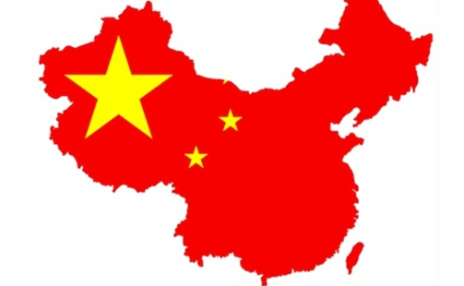

Cultural Differences
Individualist vs Collectivist culture-
Unlike America, China is a highly collectivist culture this means that relationships come first for example people act in the interest of the group rather than themselves. As a collective culture people belong within the ‘in groups’ that take care of each other in exchange for the groups loyalty. As shown Hofstede in figure 1 China is a score of 20 highlighting it’s a collectivist country. However, compared two the other two countries it is compared with in figure 1 China is very different as there is a difference of 56 with Italy as Italy score 76 and 71 difference with the United States scoring 91, proving how much of an individualistic society the other countries are compared to places like China. This is also meaning that the US and Italy is more focused on encouraging its citizens to make personal choices and to stand up for themselves more than others, for examples the task comes before anything else e.g within businesses the money is more important than the relationship.

Masculine vs Feministic Culture-
Out of China, Italy and the United states, China has the second masculinity score of 66. Masculinity and femininity are two sexes that have had different qualities attributed into them. By China being a high score of masculinity it suggests that the society is driven by competitiveness, toughness, perseverance and more which has been associated to men. the society’s success is being defined by the best in the field of the winner, these types of systems are set in place in school and is continued throughout their organizational life. This states that the Chinese will sacrifice family and leisure priorities for their work. The big issue with being a masculine or feminine society is that it depends on what motivates cultures more wanting to be the best (masculine) or choosing to do what you like (feminine).
All three of the country’s masculinity are high on masculinity meaning that they have a low score of femininity. Having a femininity culture means that a society is more creative, compassion, harmoniousness and there the dominant vales with in a society are caring for other and the quality of life.

Power Distance-
Within less powerful member of difference organisations and institutions within different countries they accept and expect that the power will be distribute unequally. This dimension helps sort out that all the individuals with different societies are not treated as equals. As shown in figure 1 China is significantly more higher than the US, with China scoring 80 and the US have a scoring of 40 meaning that China Is twice as power distance than US meaning that the society believes in inequalities amongst there cultures are acceptable. This also means that the Chinese believe that people should not have any aspirations to reach beyond their current ranks.
As a result of this big different between the countries it can lead to issues within intercultural meetings for example someone from China meeting with someone below their rank creating china to believe that they are superior within the meeting. This could also happen the opposite way and leave China feeling belittled and out of place within the meeting. Both then creating a bad relationship with the Chinese. With the US believing that everyone is unique and that everyone is unequal but can work for their power and position. This is a place in which the Chinese and US need to communicate to find common grounds and build trust.

Long / Short Term Orientation-
When it comes to the long term orientation of a society is to maintain some of the links with its own past while dealing with all the different challenges of the present and what difficulties that may occur in the future.
China has scored 87 as shown in figure in 1, which means that this is a very pragmatic culture. This shows that china has the ability to adapt their traditions easily to changed conditions, a strong propensity to save and invest within their business and to also have perseverance in achieving results.
The long term orientation of china is very high compared to the Italians and the Americans as shown in figure 1. This means that the Chinese are opened mined as being a long term orientation their traditions can change what is good and bad depends on a situations and they are willing to learn from others, this also proves that the Chinese are perseverant in achieving results.

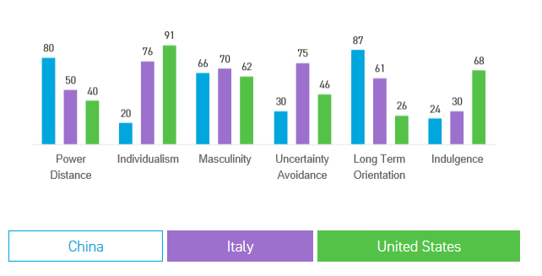
Figure 1 Hofstede insights

Business Code of Conduct

Introduction-
Similar to many other countries China’s meetings are often scheduled and the punctuality of these meetings are important to the Chinese as they see time as something very valuable. The Chinese attitude to time can be very easily noticed as they often apologies for taking up people’s time. The Chinese also thank at the end of each meeting to show the participants of the meeting, that they are grateful for them contributing their valuable time.
Before a meeting is started it is best that all parties attend with the same expectations for the meeting and the outcome, it is also best that there is some sort of relationship before the meeting or at the start of the meeting is agree as countries like Dubai and China choose to meet and plan future business with their friends.
One thing of importance to remember when attending a meeting with the Chinese is that they rarely like touching so instead of shaking hands which is a common way of greeting it is more acceptable to bow.
First Impressions-
First impressions of business is very important you need to be groomed and smart for example men are expected to wear shirts with collar and a tie. Then women smart dress or suit outfit. This is implied by Moran et al (2014) formal business wear is also expected to create a good first impression.

Negotiations and Communications-
The Chinese are very skilled negotiators, they put strong emphasis on the relationships they have created or creating. Their negotiations are also very well and powerful due to their communication skills. The Chinese are a low contact culture also like the United States. By being low contact it means that they are task centered and rule oriented. This means that these countries values individualism. However Hall argues ‘most of the information must be in the transmitted message in order to make up for what is missing in the context’

Dubai


Cultural Differences
Individualist vs Collectivist Culture-
When looking into whether a society is individualistic, or collectivists Hofstede’s data has releveled that there are four associations with in this particular dimension, these being wealth, geography, birth rates and history. With all there taking into consideration when Hofstede scored Dubai’s (
United Arab Emirates). The individualism score that they received was 25. This score was the lowest out of all three country, Norway scored 69 and the US score 91, meaning Dubai is less than half of the others.
This means among the members of the Arab society it is more collective then individualism. This means that within these societies people are belonging to ‘in groups’ these groups take care of each other in exchange for one another’s loyalty. Loyalty within a collective culture like Dubai is paramount and determines relationships and the responsibilities of members within a group.
Within a collectivist culture they value the greater good and many of the member of a sociality like Dubai have their future prescribed by the government, family and even their church.
Dubai is similar to China in the aspect that they are both collectivism cultures they both want to focus on the relationships they are creating, and they have a slower pace of life. When it comes to a meeting with Dubai and China, America need to take into consideration that both countries choose to priorities the relationship they will be building within the cultures and harmony in their society is the ultimate goal.
Masculine vs Feministic Culture-
Masculine culture of the dimension represents the preference in societies for heroism, salaries take priority, tough and material rewards for success. In cultures that have more masculinity they seem to have a more rigid between the different roles of gender.
Femininity culture is stands for more of a preference for cooperation, modesty, equality, emotional and relationship care. Hofstede’s has revealed two of the associations with masculinity and femininity the first being geography, is it predicted that the more feminine cultures are more likely to be in colder climates. And the other being in feminine cultures women have a stronger say in the number of children.
Dubai score 50 meaning they are they powered by masculinity and femininity, the culture seems to have balance, they seek reward and look for success whilst also focusing on their relationships, cooperation and being modest.

Power Distance-
Out of the 3 countries being compared (Figure 2) Dubai scored an outstanding 90 which means that people within the United Arab Emirates accept a hierarchical order, in which people within the difference societies has a place within the culture. The hierarchy with in Dubai’s organisations is seen reflecting inherent inequalities, also subordinates expect to be told what to do and the ideal boss benevolent autocrat.
With there being such a big difference between America and Dubai’s power distance. America will have to be careful when setting up meetings with the Arabs as well as the Chinese, as both can feel unequal within meetings and like they are being undermined, they will want to meet with someone who shows openness and makes sure the conversation flows with respect for all parties participating.

Long/ Short Term Orientation-
For this dimension of the Hofstede theory the United Arab Emirates (Dubai) doesn’t have a score which could imply that they are a short term orientation which according to Hofstede is cultures that prefer to maintain time-honored traditions and norms while viewing societal change with suspicion. This is meaning that these types of societies focus on getting quick results that their traditions are sacrosanct.
As a result of no conformation of long term, it is better that the US is to prepare that Dubai are a short term orientation, that they like to keep with traditions and the importance of resolving problems is fundamentalism.
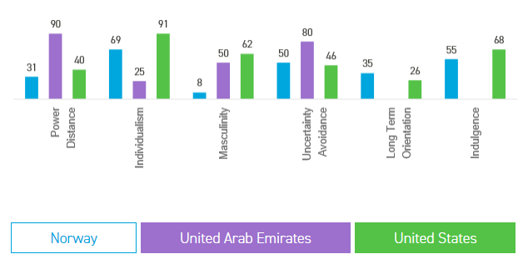
Figure 2 Hofstede Insight

Business Code of Conduct
Introductions-
When meeting with Arabs if is usual that they often arrive late, causing poor time management within the meetings and can leave schedules off time. When Arabs attend meetings they can also be interrupted throughout the meetings by phone calls and different visitors e.g other business partners, friends and family.
Similar to the Chinese, the Arabs like to be addressed by a title and family name for example Dr Sara or Mr Adaileh. Another thing which is of much importance when meeting with the Dubai society you must greet Salan alaikum on arrival and Alaikum salam on departure. When asking for something within and out of a meeting the polite way of saying please in Arabic Min Fadlak. When meeting a person from Dubai offers your hand for a hand shake.
First Impressions-
When meeting with the Arabs much like meeting with the Chinese and if meeting with America, you must always be smart and presentable, however Lubna Hamdan (2018) says that when creating an image for clothing with an Arab meeting ‘overdressing is better than underdressing’.
Negotiations and Communication-
When negotiating the Arabs do though friendship but also stating what they want. Dubai high contact culture as this they value group sense, they use more feeling in expression when communicating and emphasizes spiral logic.

Conclusion
When looking at both China and Dubai it is imperative that people understand the different dimensions of their cultures. Although they certainly have their similarities and differences, they both differ from the American culture. Having the knowledge of these differences highlights the struggles that are caused when regarding business deals. Therefore, it is important to be open to different cultural views and undergo preparation before meeting e.g. good communication and an understanding of the cultural differences and how to adapt to them if necessary.

Reference
Hofstede, G. and Hofstede, G. J. (2005) Cultures and Organisations – software of the mind. 2nd Ed. New York: Mc Graw, Hill
Timm, A. (2011). Intercultural problems in the tourism industry. Norderstedt: Grin
https://www.hofstede-insights.com/country-comparison/norway,the-united-arab-emirates,the-usa/
https://www.hofstede-insights.com/country-comparison/china,italy,the-usa/

