Introduction

This report will examine research on the “World Risk Report “that is released by the World Economic Forum on a yearly basis. The World Economic Forum are a group of over 150 countries that aim to work together to improve the state of the world, they engage the worlds political, business and other leaders in a quest to shape global, regional and industry agendas (World Economic Forum, 2023).
The “World Risk Report” identifies the current risk crises for the present year and explores the impact that these risks could have on the global efforts on sustainable development (Einhorn, 2024).

The main multinational body to monitor and address environmental challenges and sustainable development ideas is ‘The United Nations Environment Programme”(UNEP) (UNEP, 2024).

This paper will examine the researchers assessment of the risks and the possible ways forward in attempting to address them. The ‘Global Risks’ report (Figure 1) states that the main risks for 2024 is “extreme weather events”, “biodiversity loss and ecosystems” and “changes to earth systems.” The later has not been highlighted on this list in previous years and so this is the threat that this report will examine in further detail (Einhorn, 2024).

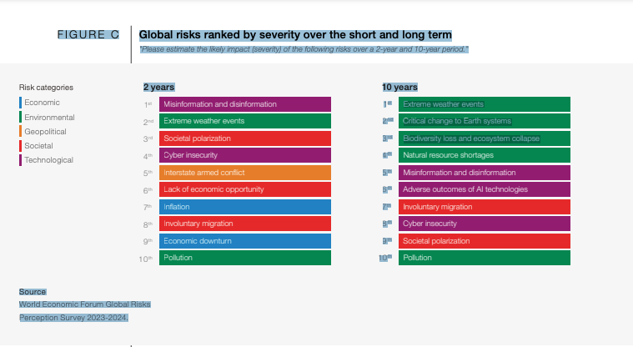
Figure 1

The continual changing of Earth’s systems hold intense implications for the global sustainable development efforts.
As climate patterns shift, ecosystems are transformed and natural resources alter, this drives a need to adapt and innovate within sustainable frameworks (Cheng, 2020).
One such framework is the ‘green economy’ which promotes sustainable development by reducing risks and ecological scarcities while providing social and economic benefits.

Understanding these impacts are crucial for safeguarding biodiversity, fostering resilient communities, and advancing development globally (Cheng, 2020).

Risk - Climate Change

Climate change can be described as changes in the Earth’s climate, at local, regional or global level, it can also refer to the effects that these changes have on the world, such as melting glaciers, extreme weather patterns or global warming (Pachauri et al, 2014).
Global warming is one of the symptoms of climate change and refers to the Earth’s rising temperature. This rise in temperature has increased by about 1 degree Celsius since the Industrial revolution. Between 1880 and 1980 it rose on average 0.7 degrees every 10 years.
Since 1981 this rate has shown an increase, and the last 40 years has shown a further increase of 0.18 degrees per decade. This shows that the rate has doubled compared to previous years records (Global Warming 101, 2019)
Figure 2
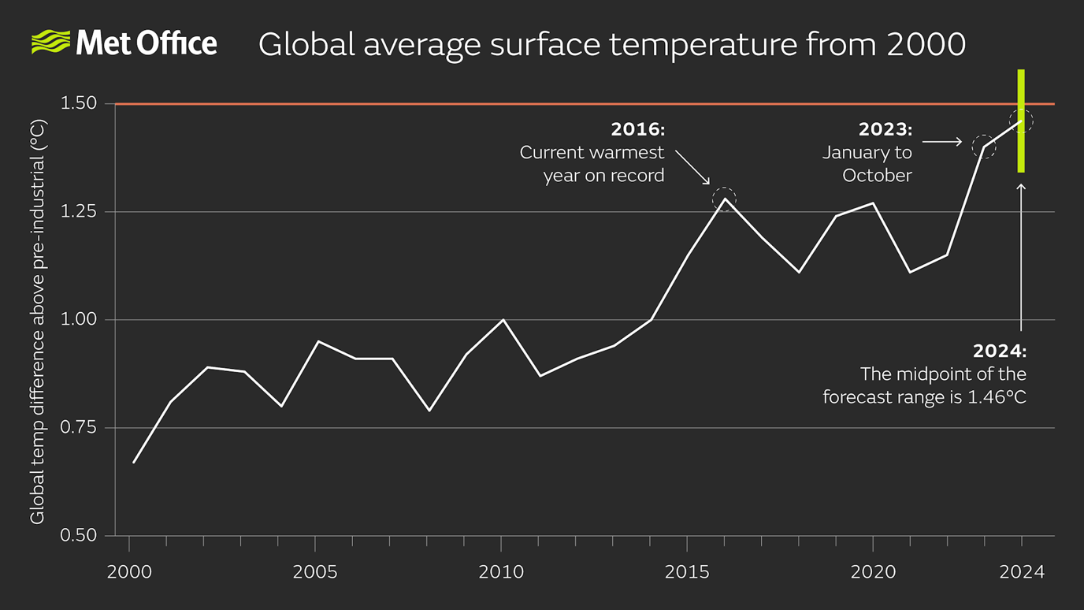

Climate scientists have warned that this increase cannot continue and there is a need to limit global warming to 1.5 degrees Celsius by 2040 or the impact on the Earth could be catastrophic. This could include heat waves, droughts and floods and could lead to the deaths of more than 250,000 people around the world every year. It could also add to the poverty crises and force 100 million people globally into poverty by 2030 (IPCC, 2018).
Climate change is linked to biodiversity loss as rising temperatures and changes in weather systems disrupt the ecosystems of the world, leading to species extinction, habitat destruction and ecological imbalance (Chetan-Welsh & Hendry, 2022).

Risk - Biodiversity Loss

Research suggests that Biodiversity loss is showing the highest figures than ever recorded in history. It suggests that this biodiversity loss is not well known and its impact on health and ecological cycles that we rely on to keep us healthy are even more unclear to us. More than one million species are facing extinction, and the Amazon, which is home to over one third of the planet’s species, is being destroyed by record levels of deforestation. This causes a closer exposure of humans to animals (Igini, 2022).

This affects humans by exposing them to “zoonotic spill over” which occurs when bacteria or viruses that cause disease jump from animals to humans. Research suggests that 75% of emerging infectious diseases are caused by pathogens that originally circulated in animals.
The disruption of this delicate ecological balance affects our oxygen, water and nutrient cycles. This imbalance will also affect the many different species in our world, all of which play an important role in this system. They pollinate, nourish and all the plants and animals in our food chain (Marie & Gordon, 2023).

The continual use of the natural world to discover new medicines and treatments for human health is another factor that can be disrupted by the ecological balance.
Farms, forests and fisheries could be affected by pests, weather events could cause flooding which could destroy agriculture and fisheries., and the disruption of coral reefs could drive many plants and species to extinction (Lindwall, 2022).

Natural Resource Management

Natural resource management looks at the process of using, conserving and managing natural resources to protect the environment and minimise negative impacts. It includes strategies that balance the use of resources with the awareness of preserving them for future generations.

There is a need to focus on the energy sector, to change to sustainable ways of producing energy. At present the cost of renewable energy is falling. Solar, wind and hydroelectric power reduces the reliance on carbon emissions and the reliance on fossil fuels so due to this decrease in cost research suggests that the change from fossil fuels should be easier. The International Renewable Energy Agency (IRENA) states that 90% of the worlds electricity should be from renewable sources by 2050 (United Nations, 2022).

The Agriculture sector needs to adapt by implementing sustainable processes such as crop rotation, organic farming and precision agriculture to ensure the preservation of soil fertility and the reduction of water usage.
This sector also adds to greenhouse gases with livestock emissions, animal waste and fertilisers being the main sources. Through the use of new technologies farmers can help reduce their emissions and so help the environment . They can also help by changing how manure is stored and spread as research suggests this can have a considerable effect on the amount of methane, ammonia and nitrous oxide it produces. The suggestion is to store the manure on an impermeable base and cover with sheeting (Strut & Parker, 2021).

The Transport sector accounts for 25% of the European Union’s greenhouse gases, and research suggests that it is the only sector that has increased its emissions since 1990.The transportation sector needs to invest in electric vehicles and encourage the use of public transportation to reduce the emissions from cars. (Transport & Mobility, 2024)

The Manufacturing sector needs to adjust to using eco-friendly processes, implement water reduction measures and recycling initiatives to assist in the preservation of the environment and minimisation of waste.

The construction sector needs to adapt by using “green” building practices, such as using sustainable materials and incorporating renewable energy sources into building designs.
The technology sector needs to use energy efficient appliances and clean technologies to promote sustainability.

Social Equity and Environmental Justice

The environmental changes have a disastrous effects on vulnerable populations, which makes social inequalities worse.
Research stresses the importance of integrating the principles of equity justice and inclusivity into any sustainable development policies.
The way in which this sector approach sustainable development is that they ensure quality of life for everyone, that is the access to food, water and shelter. The access to education, health and housing means that there are less inequalities and less poverty.
Lu, 2022, suggests that this climate crisis is the main cause of hunger and the World Food Program concurs stating that the worsening climate changes threaten to put more people in the category of food insecurity. They further suggest that global hunger has risen to 282.7 million people across 80 countries and this accounts for an increase of 110% compared to the 2019 figures. The increase is possibly due to the pandemic and increased unrest and conflicts in various countries around the world (WFP, 2021).
Thomas Malthus suggests in his Malthusian theory that climate change exacerbates existing resource constraints, particularly in regions where productivity is heavily reliant on predictable climate patterns. Extreme weather events during climate change such as floods and droughts could lead to food shortage, displacement of populations and heightened competition for resources potentially resulting in social unrest and conflicts. He further suggests that
“population will always outrun the growth of production”
This he suggests is that the population will always grow but the production of food is not infinite. He states that the only way this can be controlled was for the numbers of people to decline due to wars or famine or abstinence (Britanica, 2024).

The United Nation Sustainable Development Goals of 2015 features the need to end hunger. The number of hungry and malnourished people had started to decline but in 2015 due to conflicts of war and weather associated to climate change these figures have once again risen (National Geographic, 2022).

Economic Sustainability

The promotion of a sustainable economy seeks to meet the need of the present without compromising the ability of future generations to be able to meet their own needs. This economy involves integrating environmental, economic and social factors into every decision to safeguard long term sustainability (United Nations, 1987).

There is a need to balance economic growth with environmental protection and social wellbeing, this emphasise the importance of preserving natural resources, reducing carbon emissions , promoting renewable energy and fostering social equity. It also explores the ethical supply chain and waste reduction (Vivien, 2023).

There are many benefits of economic sustainability in that it invests in renewable energy and a green infrastructure.
There is a desire to create employment and this stimulates economic growth (Safdie, 2022).

Economic sustainability helps businesses by reducing operating costs, it improves the efficiency of the operation and so profits inevitably show an increase.
It encourages social equity which allows the people from lower socio- economic areas to have the basic needs to live. The long term benefits of this concept is that this renewable energy such as solar or wind energy, can be replenished over time (Mollenkamp, 2023)
.
Marsh, 2022, disagrees and suggests that there is a high cost to installing these new infrastructures for renewable energy or “green” infrastructures.
Another disadvantage to this economic sustainability is that there is limited available resources where these structures can be positioned, e.g. solar has to be in a good position to be efficient or wind sources need to be at the coast or in a high position to gain the best wind flow.
It can also be difficult to implement these strategies in some traditional areas who are culturally opposed to such changes. Finally another problem could be the slow progress of implementing these structures.

Resilience and Adaptation

Research suggests that even though we as a human race are uniting to try and combat climate change, inevitably there are some areas where reversal is not possible. So there is a definite need to build resilience in communities to cope with the extreme changes and adapt to the new ways of living by recognising the problems and working together to overcome them (Adger et al., 2007).

To accomplish this there is a need to gain access to better knowledge and hopefully find breakthroughs in scientific challenges in technology
Research suggests the need to experiment on

Drought resilient crops - Maize trialled in Zimbabwe (Mafundikwa, 2023).
Technologies for saving water – gravity fed wateraid (Climate Change Adaptation: Water Technology | WaterAid UK, n.d.).
Utilising satellites for environmental observation - (Guo et al., 2015).

There is a need for these strategies to be adaptive and be prepared for disaster limitations and resilience to climate development.

Conclusion

This paper examined the effects of the Earth’s changing systems and global sustainable development efforts. It showed the urgent need for action at local, national and international levels.
The “Global Risks” report highlighted the most urgent risks for the next two years and its results were ‘Extreme weather”, “Biodiversity loss and eco systems” and “Changes to the Earths systems”. These sectors were all examined and the different approaches to remedy the problems were explored.
Environmental changes pose problems for ecosystems, communities and economies but they also present opportunities for innovation, resilience and change.
Stakeholders can work together by addressing these problems together and foster sustainable development pathways that prioritise both human well-being and the environment.
The effective solutions require approaches that include environmental, social and economic consideration.

Recommendations

In moving forward it is essential to prioritise sustainable development agendas that are guided by science and driven collectively by governments, businesses, society and individuals worldwide. This is the only way to strive towards a more sustainable and resilient future.

Researchers Comments

The researcher has explored the problems and the suggested solutions to aid this global problem, and it has shown that there is a great deal of work to be done to alleviate the impact that has been done already to the environment.
The pessimistic views of many theorists do not hold true to the researcher who believes that this world has a way of repairing itself and although there are scientific evidence to report the damage that has already been done and the need for everyone to play their part in rectifying this. It is not felt that it is too late,
The need to replant trees and stop the irresponsible way of living is in the opinion of the researcher the correct way to move forward. The recent Covid 19 Pandemic was devastating for many people and no one would want to see it return, however the lessons learnt at that time were valuable and showed that as a society it is possible to do more to stop abusing our world.
Rasmussen, 2021, agrees and states that the decrease in air pollution and greenhouse gas emissions during the pandemic when there were restrictions on travel and other economic sectors was drastic.
This shows that there are more restrictions that can be put in place if needed to ensure that every person is realising it is a problem that every person in the world needs to address in whatever small way they can.

Words - 2337

