Cover Page

Student Name: Anita Bano

Student ID: 2406936

Module Code: BMHP5015

Module Title: Changemakers: Building your Personal Brand for Sustainable Employment

Assessment: Component 2

Word count:2000

Submission Date: 19th July 2026

Job Title
Mental health support workers

Link Here

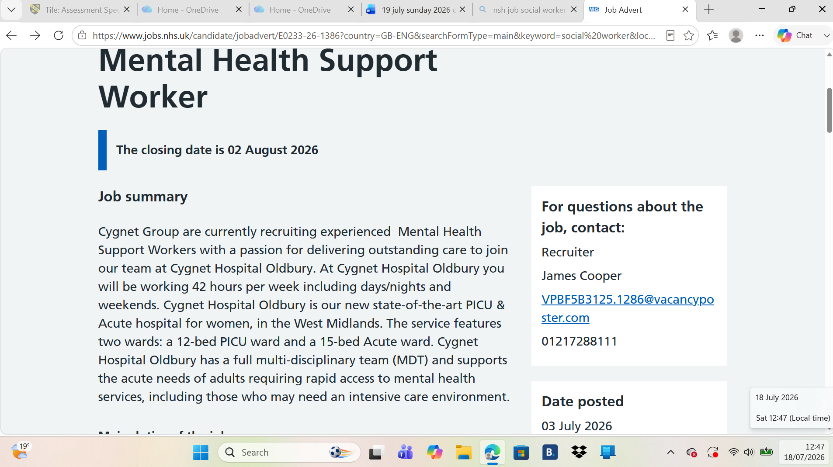

Introduction

This report focuses on the role of a
Mental Health Support Worker at Cygnet Health Care
based on a current vacancy advertised through NHS Jobs (NHS Jobs, 2026). I have chosen this role because I am interested in supporting people experiencing mental health difficulties and helping them improve their wellbeing, confidence and independence. As a Level 5 BSc Health and Social Care student, I aim to develop the knowledge, practical skills and experience needed to work effectively within mental health services in the future.

The report will examine the job description and person specification and critically analyse the employability skills needed for the position. It will also evaluate my current skills, qualifications and experience against the employer’s requirements. In addition, the report will consider how I can build a suitable personal brand and professional identity, find the value I could bring to the role, and create a realistic action plan and timeline for achieving my career goal.

Job Role Employability Skills

The Mental Health Support Worker role at Cygnet Health Care requires a range of employability skills to provide safe, effective and person-centred care. One of the most important skills is communication. Support workers must communicate clearly with service users, their families and members of the multidisciplinary team (MDT). Effective communication helps build trusting relationships, understand individual needs and report changes in a person’s condition accurately (NHS England, 2023).

Teamwork is another essential skill because Mental Health Support Workers work closely with nurses, doctors, psychologists and other healthcare professionals. Working collaboratively ensures that service users receive coordinated, person-centred care that supports their recovery and wellbeing (Skills for Care, 2024).

The job advertisement also highlights the importance of compassion, empathy and resilience. Supporting people with mental health conditions, particularly in acute and Psychiatric Intensive Care Unit (PICU) settings, can be demanding. Staff must remain calm, respectful and supportive while promoting dignity, independence and recovery.

In addition, problem-solving and decision-making skills are required to respond appropriately to changing situations and provide the most suitable support for each individual. The role also requires accurate observation and record-keeping skills to recognise changes in a person’s mental or physical health and communicate these changes to the wider healthcare team.

Finally, safeguarding, time management and professionalism are essential. Mental Health Support Workers handle protecting vulnerable adults, keeping confidentiality and following organisational policies and procedures. These employability skills enable staff to deliver high-quality care while meeting the standards expected by Cygnet Health Care and supporting positive outcomes for service users (Cygnet Health Care, 2026).

Evaluation of My Skills

To become a successful Mental Health Support Worker, it is important to evaluate my current skills and find the areas I need to improve. After reviewing the Cygnet Health Care job advertisement, I believe I already have several strengths that match the role, while recognising that I still need to develop some knowledge and practical experience to meet all the employer’s expectations.

One of my main strengths is communication. Through my Level 5 BSc Health and Social Care studies and my current role as a kitchen chef in a school, I communicate with colleagues, managers and children from a variety of backgrounds every day. This experience has improved my confidence, active listening skills and ability to communicate respectfully and professionally. I believe these skills will help me build positive relationships with service users and work effectively within a multidisciplinary team.

Another important strength is teamwork. My current job requires me to work closely with colleagues to complete tasks efficiently while keeping exacting standards of safety and hygiene. This has taught me the importance of cooperation, reliability and supporting others to achieve shared goals. These transferable skills are directly relevant to the Mental Health Support Worker role, where effective teamwork is essential for providing safe and person-centred care.

I also believe that I am compassionate, patient and dependable. I enjoy supporting others and understand the importance of treating every individual with dignity, empathy and respect. These personal qualities reflect the values highlighted in the Cygnet job advertisement and are essential when working with people experiencing mental health difficulties.

However, I recognise that I need to develop my practical experience in mental health care. The job advertisement says that earlier experience in a mental health setting is desirable, and I understand that gaining experience through volunteering, placements or entry-level support roles would strengthen my confidence and practical skills. I also want to improve my understanding of mental health legislation, safeguarding procedures and professional record-keeping through my university studies, added training and learning from experienced professionals.

Overall, I believe I have a solid foundation of transferable skills, but I understand that continuous learning and practical experience are essential to become a competent and effective Mental Health Support Worker.

Action Plan and Timeline

To prepare for a career as a Mental Health Support Worker, I have developed an action plan to strengthen my knowledge, practical skills and professional confidence. This plan is based on the requirements of the Cygnet Health Care job advertisement and the areas for development identified in my self-evaluation. Setting realistic goals with clear timeframes will help me monitor my progress and improve my employability.

Goal | Action | Timeline | Expected  Outcome
Increase my knowledge of mental health care | my Level 5 BSc Health and Social Care studies and actively engage in lectures, seminars and independent reading. | During my degree | Gain a stronger understanding of mental health, safeguarding, legislation and person-centred care.
Gain practical experience | Apply for volunteering opportunities or work placements in mental health or community support services. | Within the next 6–12 months | Build confidence and develop practical skills when supporting people with mental health needs.
Improve my professional knowledge | Complete added training courses in safeguarding, mental health awareness, communication and de-escalation techniques. | Within 12 months | Develop specialist knowledge and improve my ability to respond safely and effectively in different situations.
Build my professional profile | Update my CV, create a LinkedIn profile and attend university careers events and workshops. | Within the next 6 months | Present myself professionally and improve my chances of securing interviews and employment.
Begin my career | Apply for Mental Health Support Worker positions and continue learning through workplace supervision, training and Continuing Professional Development (CPD). | Within 1–2 years | Secure employment and continue developing the knowledge and skills needed for career progression.

Following this action plan will help me develop the skills and experience expected of a Mental Health Support Worker. I understand that professional development is a continuous process that requires commitment, reflection and a willingness to learn. I will regularly seek feedback from my lecturers, managers and experienced colleagues to find areas for improvement and continue developing my confidence and competence. By following this plan, I will be better prepared to provide safe, compassionate and person-centred care while making a positive contribution to the people I support and the wider healthcare team.

Building My Personal Brand

Personal branding is the way an individual presents their skills, values and professional qualities to employers and colleagues. As an aspiring Mental Health Support Worker, I want my personal brand to reflect compassion, professionalism, reliability and a genuine commitment to supporting people with mental health needs. Developing a positive personal brand is important because it helps employers recognise my strengths and demonstrates that I share the values expected within health and social care.

To build my personal brand, I will continue developing my knowledge and practical skills through my BSc Health and Social Care degree, additional training and relevant work experience. I will maintain an up-to-date CV and LinkedIn profile to showcase my education, transferable skills and achievements. I will also seek regular feedback from lecturers, managers and colleagues to identify areas for improvement and support my continuous professional development.

In addition, I will prove professionalism by communicating respectfully, keeping confidentiality, being punctual and treating everyone with dignity and empathy. By consistently proving these behaviours, I will build trust with employers, colleagues and service users. Developing a strong personal brand will improve my employability and support my long-term goal of becoming a successful Mental Health Support Worker.

Promoting My Professional Identity

Professional identity is developed through knowledge, skills,
values and professional behaviour. As a future Mental Health Support Worker, I understand the importance of acting ethically, respecting confidentiality and providing person-centred care that promotes the dignity, wellbeing and recovery of every service user. Developing a strong professional identity will help me work effectively within a multidisciplinary team and provide safe, high-quality care.

To promote my professional identity, I will continue developing my knowledge through my BSc Health and Social Care degree, additional training and Continuing Professional Development (CPD). I will keep up to date with current legislation, evidence-based practice and organisational policies to ensure my practice remains safe, effective and relevant. I will also attend relevant training opportunities and use feedback from lecturers, managers and experienced colleagues to improve my skills and confidence.

In my professional practice, I will communicate respectfully, work collaboratively with colleagues and always keep professional boundaries. I will treat every service user with dignity, respect and compassion while promoting equality, diversity and inclusion. Reflecting on my experiences and learning from feedback will help me continue improving my practice. By consistently proving these professional values and behaviours, I will strengthen my professional identity and become a trustworthy and competent Mental Health Support Worker.

Building a Network for Successful Employment

Building a professional network is crucial to securing employment as a Mental Health Support Worker. Networking enables individuals to learn from experienced professionals, gain career advice, and become aware of job vacancies, training opportunities, and current developments within the health and social care sectors. Developing strong professional relationships can also improve confidence, support career progression, and create opportunities for continuous learning.

During my studies, I will build my professional network by developing positive relationships with lecturers, classmates, and placement supervisors. Their knowledge, guidance and feedback will help me improve my skills and prepare for future employment. I will also use the university careers service to receive advice on writing a professional CV, improving my interview skills, and finding suitable job opportunities.

In addition, I plan to attend career fairs, workshops, and professional training events to meet healthcare professionals and expand my understanding of mental health services. Creating and claiming a professional LinkedIn profile will also enable me to connect with employers, organizations, and professionals working within health and social care. By actively building and keeping these professional relationships, I will strengthen my employability, increase my confidence, and create more opportunities to achieve my long-term career goal of becoming a Mental Health Support Worker.

Conclusion

This report has explored the role of a Mental Health Support Worker at Cygnet Health Care and examined the employability skills, knowledge and personal qualities needed to succeed in the position. By analyzing the job advertisement, I have developed a better understanding of the responsibilities involved and the importance of communication, teamwork, compassion, resilience, and professionalism when supporting individuals with mental health needs.

Completing this report has also allowed me to evaluate my own strengths and find areas where I need further development. Although I have gained valuable transferable skills through my BSc Health and Social Care studies and my current employment, I recognize the importance of gaining practical experience in mental health care, continuing my professional development and expanding my knowledge through further training and learning opportunities.

The action plan developed in this report provides a realistic pathway towards achieving my career goal. Building my personal brand, strengthening my professional identity, and developing a strong professional network will further improve my employability. Overall, I am committed to continuous learning and self-improvement, and I am confident that these steps will help me become a compassionate, competent and effective Mental Health Support Worker who can make a positive contribution to the lives of service users.

Reference List

1. Cygnet Health Care (2026) Mental Health Support Worker – Cygnet Hospital Oldbury. Available at: Cygnet Careers⁠￼ (Accessed: 18 July 2026).
2. Department of Health and Social Care (2022) Health and social care integration: Joining up care for people, places and populations.
3. Foster, K., Roche, M., Delgado, C., Cuzzillo, C., Giandinoto, J. and Furness, T. (2021) ‘Resilience and mental health nursing: An integrative review’, International Journal of Mental Health Nursing, 30(2), pp. 356–371.
4. NHS England (2023) NHS Long Term Workforce Plan.
5. Skills for Care (2024) Core Skills Framework.
6. Social Care Institute for Excellence (2023) Person-centred care.
7. Thompson, N. (2023) People Skills. 5th edn. London: Bloomsbury.
8. World Health Organization (2022) World Mental Health Report: Transforming Mental Health for All.
9. Department of Health and Social Care (2015) The Care Certificate Standards.
10. Social Work England (2024) Professional standards. (Useful as a professional standards source, even though the role is not a registered social worker.)
NHS jobs (2026) Mental Health support Worker – Cygnet Health Care. Available at: https://www.jobs.nhs.uk/candidate/jobadvert/E0233-26-1386?country=GB-ENG&searchFormType=main&keyword=social%20worker&location=Birmingham&language=en

