MBA INTERNATIONAL BUSINESS
Name: Atishaya Kadam
Student id: 2318625
Subject Name: Dissertation
Subject code: LCMB7035
Professor/ Supervisor: Amare Desta

Title: AI-Driven Trade Policies and the Transformation of India’s Automobile Industry: Overcoming Challenges for Sustainable Development
1. Introduction
The automotive sector serves as a primary economic growth engine for India because it creates strong impacts on both GDP and employment figures (Saberi, 2018). In FY23 India manufactured 25.9 million automobiles throughout a yearly timespan. The Indian market displays solid performance through home business needs as well as international export activity (IBEF, 2024). The automobile industry confronts various obstacles including insufficient supply chain management and high manufacturing expenses together with environmental issues and the EV market transition (Dhairiyasamy et al., 2024). The absence of charging stations prevents consumers from buying electric vehicles even though investors show no interest in building charging networks because of limited EV adoption. The research investigates how AI-based trade strategies address current industry obstacles by supporting sustainable development goals through SDG 9 and SDG 13.
2. Research Aim and Objectives
- To examine the key challenges faced by the Indian automobile industry.
- To analyse the role of AI-driven trade policies in addressing these challenges.
- To assess the impact of AI adoption on sustainability and economic growth.
- To explore the implications of AI-driven trade policies on India’s trade relations.
3. Research Questions
- What are the major challenges facing the Indian automobile industry?
- How do AI-driven trade policies address these challenges?
- What is the impact of AI adoption on sustainability and economic growth in the automobile sector?
- How do AI-driven trade policies influence India’s trade relations?
4. Literature Review
Existing research highlights several issues within India’s automobile industry, including supply chain disruptions, pollution, and inefficiencies in production and logistics. Studies suggest that AI can optimise manufacturing, predict maintenance, and streamline supply chains (Riad, Naimi and Okar, 2024). Artificial Intelligence (AI)-driven trade policies are emerging as a transformative force, enhancing efficiency, reducing emissions, and fostering innovation (Alanazi, 2023). Additionally, research on AI-driven trade policies suggests they enhance regulatory compliance, improve market predictions, and promote sustainable trade practices. However, limited studies focus on the intersection of AI, trade policies, and sustainable development in the Indian automobile sector.
5. Research Methodology This study adopts a secondary qualitative research approach, relying on existing academic literature, industry reports, policy documents, and expert analyses. The methodology includes:
- Data Collection: Reviewing scholarly articles, government policies, trade reports, and case studies.
- Data Analysis: Thematic analysis of qualitative data to identify trends, patterns, and policy implications.
- Comparative Analysis: Examining global best practices and their applicability to India’s automobile industry.
6. Expected Contributions This research will contribute to:
- A deeper understanding of AI’s role in addressing industry challenges.
- Policy recommendations for AI-driven trade enhancements.
- Insights into sustainable industrial development through AI.
7. Time Plan
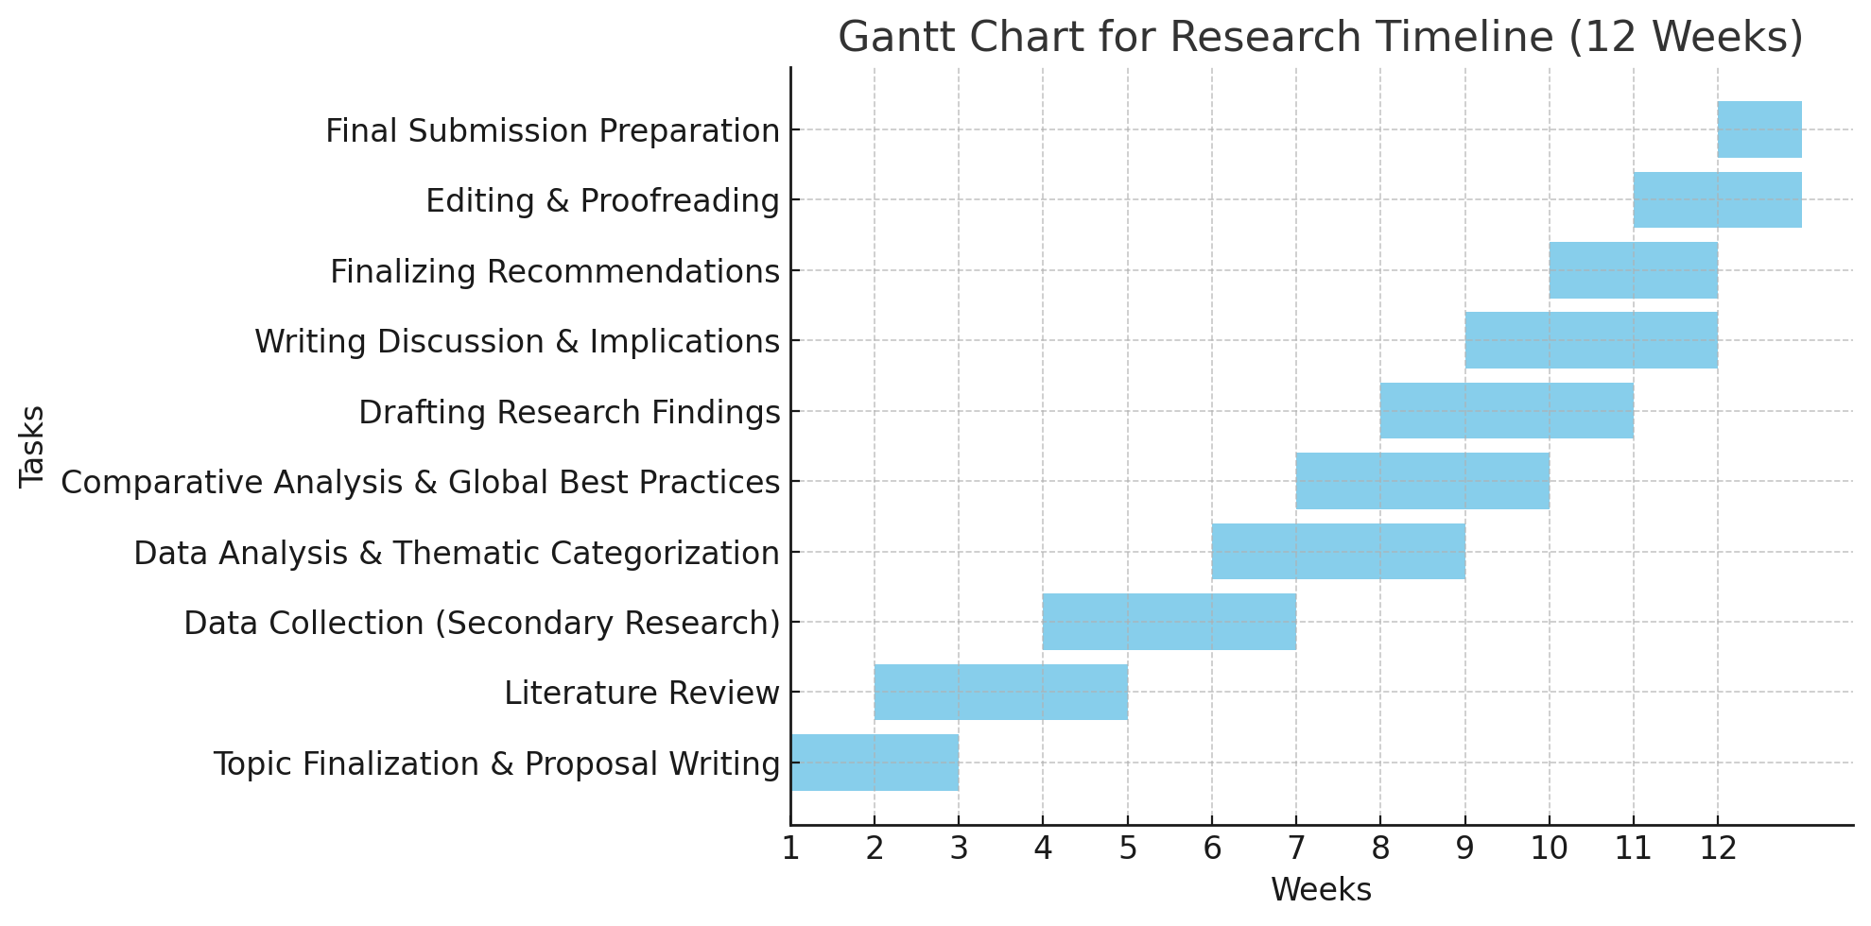
8. Conclusion By analysing the intersection of AI, trade policies, and sustainable development, this study will provide valuable insights into how India’s automobile industry can overcome its challenges and align with global sustainability goals. The findings will benefit policymakers, industry stakeholders, and researchers interested in AI-driven economic transformations.

Reference list
Alanazi, F. (2023) ‘Electric Vehicles: Benefits, Challenges, and Potential Solutions for Widespread Adaptation’, Applied Sciences, 13(10), p. 6016. Available at: https://doi.org/10.3390/app13106016.
Dhairiyasamy, R., Gabiriel, D., Bunpheng, W. and Kit, C.C. (2024) ‘A comprehensive analysis of India’s electric vehicle battery supply chain: barriers and solutions’, Discover Sustainability, 5(1). Available at: https://doi.org/10.1007/s43621-024-00595-7.
IBEF (2024) Automobile Industry in India, Indian Automobile Industry, Sector, Trends, Statistics, www.ibef.org. Available at: https://www.ibef.org/industry/india-automobiles.
Riad, M., Naimi, M. and Okar, C. (2024) ‘Enhancing Supply Chain Resilience Through Artificial Intelligence: Developing a Comprehensive Conceptual Framework for AI Implementation and Supply Chain Optimization’, Logistics, 8(4), p. 111. Available at: https://doi.org/10.3390/logistics8040111.
Saberi, B. (2018) The role of the automobile industry in the economy of developed countries, ResearchGate. unknown. Available at: https://www.researchgate.net/publication/326274056_The_role_of_the_automobile_industry_in_the_economy_of_developed_countries.

