
Design & Analysis of Extended Surfaces
Gabriel Phillips

April 12, 2026
University of Wales Trinity Saint David
ACMA6011

Table of Contents
List of Figures 2
Task A 3
Emergence of the Automotive Industry and the Introduction of Heat Transfer Applications (Early 1900s) 3
Refinement of Design (Mid – Late 20th Century) 4
Modern Day Design 5
Modern Day Manufacturing 7
Microprocessors and Extended Surfaces 8
Task B 11
Task C 12
Part 1 12
Part 2 13
Part 3 13
Part 4 14
Part 5 15
Copper 16
2024 Aluminium Alloy 16
Brass 17
304 Stainless Steel 17
References 19
WORD COUNT: 2524

List of Figures
Figure 1 - Morgan Runabout at the Olympia Show, November 1910 (Mooney, 2024) 4
Figure 2 - Thermal imaging of water cooled vs air cooled generator (Mitsubishi Heavy Industries, 2026) 5
Figure 3 - Typical gasoline engine cooling system (Britannica, 2026) 6
Figure 4 - CFD analysis of air passing through radiator with temperature and velocity gradients (Araiz, 2021). 7
Figure 5 - CFD analysis of water travelling through radiator with temperature and velocity gradients (Araiz, 2021). 7
Figure 6 - PWR Tube and Fin Heat Exchanger (PWR Corporate, 2024). 8
Figure 7 - Microtube Radiator (Kelly, 2020) 9
Figure 8 - Microprocessor with aluminium heat sink (Trick, 2022). 9
Figure 9 - My home computer using a large heat sink directly attached to the processor, along with intake and exhaust fans to promote airflow. 10
Figure 10 - Gyroid TPMS structure with a water inlet velocity of 0.2 m/s and a heat flux of 1 kW/m² applied from the bottom surface. 11
Figure 11 - Heat Transfer Ratio as a function of fin parameter (mL) 12
Figure 12 - Temperature of materials at free end of 200mm handle. 13
Figure 13 - Temperature distribution of materials across 200mm handles. 14
Figure 14 - Rate of heat loss of 200mm handles. 14
Figure 15 - Optimal length handle and rate of heat loss at optimal length. 15
Figure 16 - Rate of heat loss for 200mm handle vs optimal length handle. 15
Figure 17 - Temperature distribution along handles of optimal length for heat loss. 16
Figure 18 - Copper temperature at 200mm end of adiabatic tip handle. 17
Figure 19 - Copper temperature at 200mm from base of optimal length handle for heat loss. 17
Figure 20 - Copper safe temperature distance from base. 17
Figure 21 - 2024 Aluminium alloy safe temperature distance from base. 18
Figure 22 - Brass (70 Cu/30 Zn) safe temperature distance from base. 18
Figure 23 - 304 Stainless steel safe temperature distance from base. 19

Task A
The application of fins as extended surfaces to enhance heat transfer has been fundamental to automotive thermal management since the early development of internal combustion engines (Motor Equipment News, 2020). In heat transfer engineering, fins are used to increase the rate of heat dissipation from a surface by expanding the available surface area, thereby promoting more effective convective heat transfer (Massachusetts Institute of Technology, 2007).

Emergence of the Automotive Industry and the Introduction of Heat Transfer Applications (Early 1900s)
Fins have been incorporated as heat transfer surfaces in automotive engineering since the earliest stages of the industry, primarily to regulate the thermal loads generated by internal combustion engines. A significant milestone occurred when Wilhelm Maybach patented one of the first closed-circuit water-cooling systems incorporating a radiator in September 1900 (Motor Equipment News, 2020; Autoradiators, n.d.). Subsequently, early vehicle manufacturers continued to refine thermal management strategies; for example, the British company Morgan introduced the Morgan Runabout in 1910, which employed finned heat sinks surrounding its twin-cylinder engine to enhance heat dissipation from the cylinder heads (Mooney, 2024). This design relied on convective heat transfer, allowing ambient air to remove heat directly from the engine surfaces and thereby improving cooling efficiency.
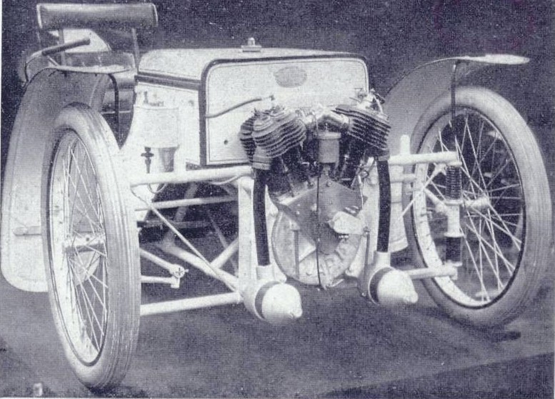
Figure 1 - Morgan Runabout at the Olympia Show, November 1910 (Mooney, 2024)
The design philosophy of the finned systems developed by both Maybach and Morgan was based on the fundamental principle of increasing the surface area available for heat transfer; however, each applied this concept through distinct cooling strategies. Morgan employed direct air cooling, whereby fins surrounding the cylinder facilitated convective heat transfer from the engine surfaces directly to the ambient air. In contrast, Maybach utilised an indirect cooling approach, in which air passed over finned radiator surfaces to remove heat from circulating coolant water, which was then recirculated throughout the engine to regulate operating temperature. These two configurations—air-cooled and liquid-cooled systems—represent the primary cooling methods employed in automotive engineering, both of which rely on finned surfaces to improve convective heat transfer. (Demon Tweeks, 2019).

Refinement of Design (Mid – Late 20th Century)
As the twentieth century progressed and manufacturers began producing higher-power, more efficient engines, it became increasingly evident that water-cooled systems provided superior thermal regulation compared with conventional air-cooled designs as shown in figure 2.
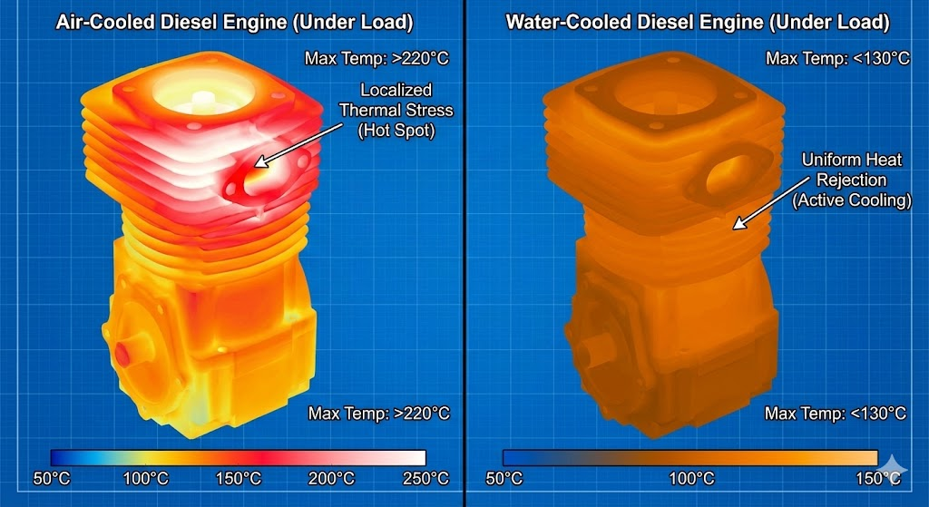
Figure 2 - Thermal imaging of water cooled vs air cooled generator (Mitsubishi Heavy Industries, 2026)
Although some vehicles achieved notable success with air-cooled engines, such as early Porsche 911 models (Dick Lovett, 2020) and the original Volkswagen Beetle (Uttarakhand, 2023), these applications remained relatively limited in comparison with the widespread adoption of liquid-cooled systems. For example, companies such as Chrysler attempted to develop an air-cooled flat-six engine during the 1930s; however, persistent cooling efficiency challenges ultimately led to the adoption of water-cooled configurations (Holley, 2025).
Concurrent advances in thermodynamics and manufacturing techniques towards the late 20th century enabled the development of more sophisticated fin geometries. Engineers began to optimise fin spacing, thickness, and orientation and employing louvered designs to enhance heat transfer performance and improve overall cooling efficiency (Holley, 2025). During this period, new materials such as aluminium and plastics were gradually introduced into radiator construction. Although these materials possess lower thermal conductivity than traditional copper and brass, their use resulted in lighter, more durable, and more cost-effective cooling systems (FTH Industries, 2025).
Furthermore, mechanical water pumps and engine-driven fans became standard components within automotive cooling systems, as illustrated in Figure 2, enabling increased airflow through fin arrays and supporting the development of more compact and efficient radiator designs.
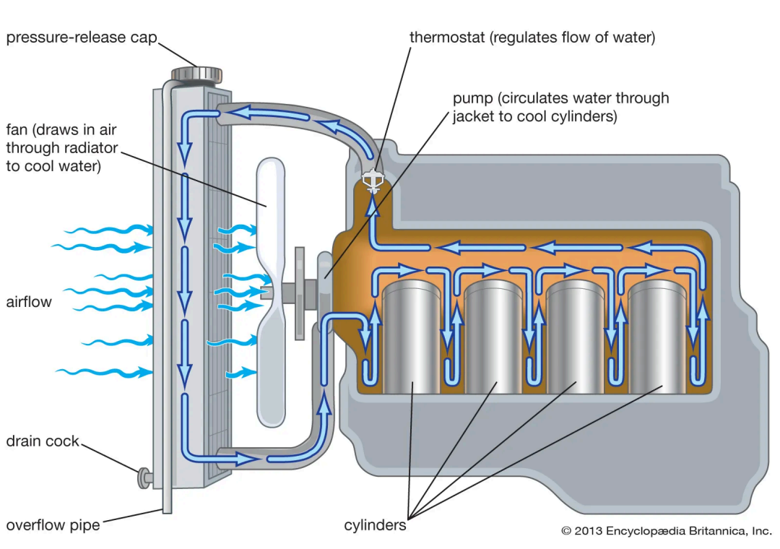
Figure 3 - Typical gasoline engine cooling system (Britannica, 2026)

Modern Day Design
The advancement of computer technologies has significantly influenced the design and optimisation of automotive cooling systems, particularly through the development of computational tools such as Computational Fluid Dynamics (CFD). These tools enable engineers to simulate and analyse thermal and fluid flow behaviour under a wide range of operating conditions without the need for physical prototypes. Parameters such as airflow velocity, temperature gradients, turbulence characteristics, and material properties can be systematically evaluated within a virtual environment, allowing designers to predict heat transfer performance with a high degree of accuracy as illustrated in Figures 4 and 5.
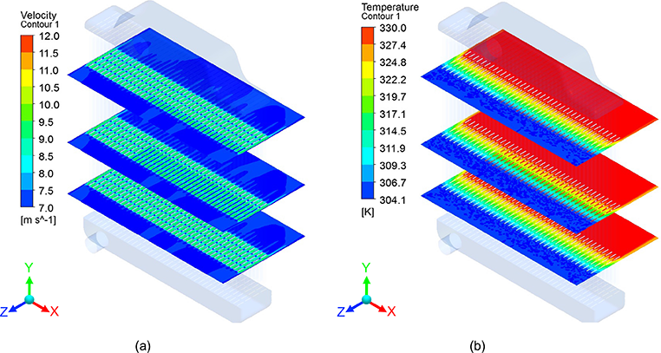
Figure 4 - CFD analysis of air passing through radiator with temperature and velocity gradients (Araiz, 2021).
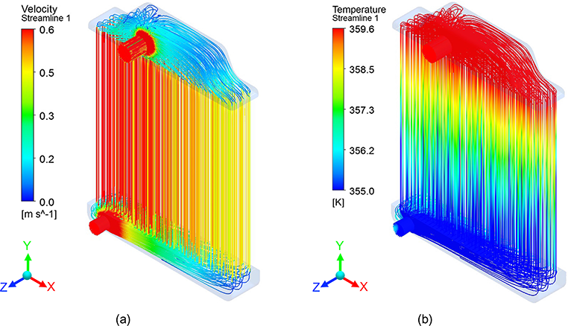
Figure 5 - CFD analysis of water travelling through radiator with temperature and velocity gradients (Araiz, 2021).
Consequently, radiator geometries, fin configurations, and material selections can be optimised to meet specific performance requirements prior to manufacturing, reducing development time and cost while improving thermal efficiency and reliability. This approach also supports iterative design processes, where multiple design variations can be assessed rapidly to identify the most effective configuration. The application of CFD in radiator development therefore enables manufacturers to maximise cooling efficiency and ensure system performance before production.

Modern Day Manufacturing
Modern manufacturing processes have advanced significantly in recent decades, enabling the production of automotive radiators with greater precision, efficiency, and performance. Radiator components are now commonly fabricated using computer numerical control (CNC) machining and automated production systems (Abreu, 2026), which allow for consistent dimensional accuracy and high-quality surface finishes. In addition, bespoke or performance-oriented radiator units can be produced using additive manufacturing techniques, enabling the creation of asymmetrical and highly complex geometries that would be difficult or impossible to achieve through traditional manufacturing methods.
These technologies allow for the incorporation of tightly spaced fin structures and optimised internal flow channels, improving heat transfer efficiency while maintaining structural integrity. As a result, modern manufacturing methods support the development of compact, lightweight, and high-performance radiator systems tailored to specific operating requirements, ultimately enhancing thermal management and overall vehicle performance, as illustrated in Figure 6.
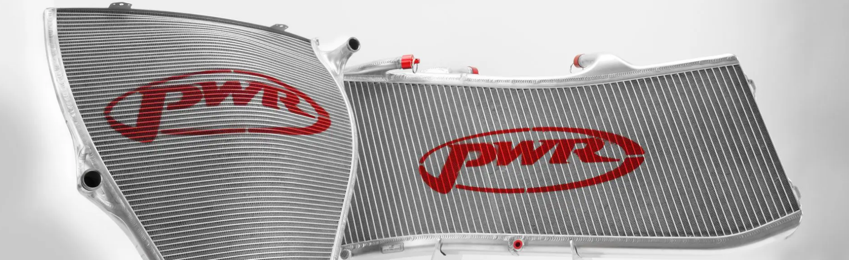
Figure 6 - PWR Tube and Fin Heat Exchanger (PWR Corporate, 2024).
Furthermore, advancements in manufacturing technologies have enabled the production of microtube radiators, also referred to as micro-matrix heat exchangers. These systems incorporate hundreds of small-diameter tubes arranged within a compact matrix configuration, often reducing or eliminating the need for traditional fin structures. The design typically utilises hollow tubes with diameters ranging from approximately 0.3 mm to 1 mm, positioned in a closely spaced grid pattern that allows airflow to pass between the channels. This configuration provides a substantially increased surface area relative to conventional designs, making microtube radiators particularly effective for maximising heat transfer efficiency and improving overall thermal performance (PWR Corporate, 2024; B Sport, 2020).
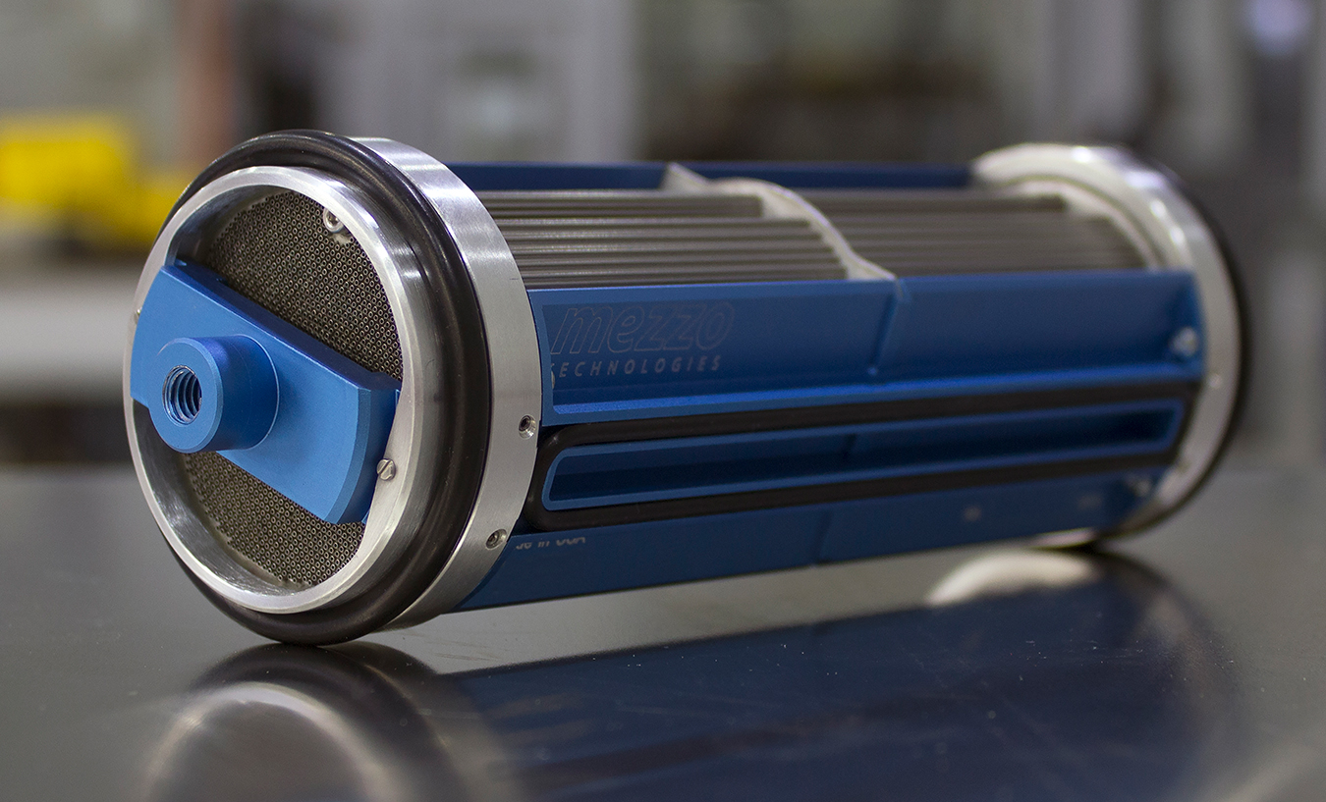
Figure 7 - Microtube Radiator (Kelly, 2020)

Microprocessors and Extended Surfaces

Extended surfaces (fins) are widely incorporated into the design and operation of microprocessors to enhance heat dissipation from high-power electronic components (Trick, 2022). As microprocessor performance has increased, heat generation has risen significantly, making efficient thermal management vital for maintaining reliability, preventing overheating, and sustaining processing speed. Extended surfaces increase the effective surface area available for heat transfer, thereby enhancing convection to the surrounding air or liquid. An example of a basic heat sink is shown in Figure 8; however, for high-power processors, additional cooling methods are often required. These systems frequently incorporate forced convection using fans or liquid cooling systems to maintain safe operating temperatures during periods of high computational demand, as illustrated in Figure 9.
Figure 8 - Microprocessor with aluminium heat sink (Trick, 2022).

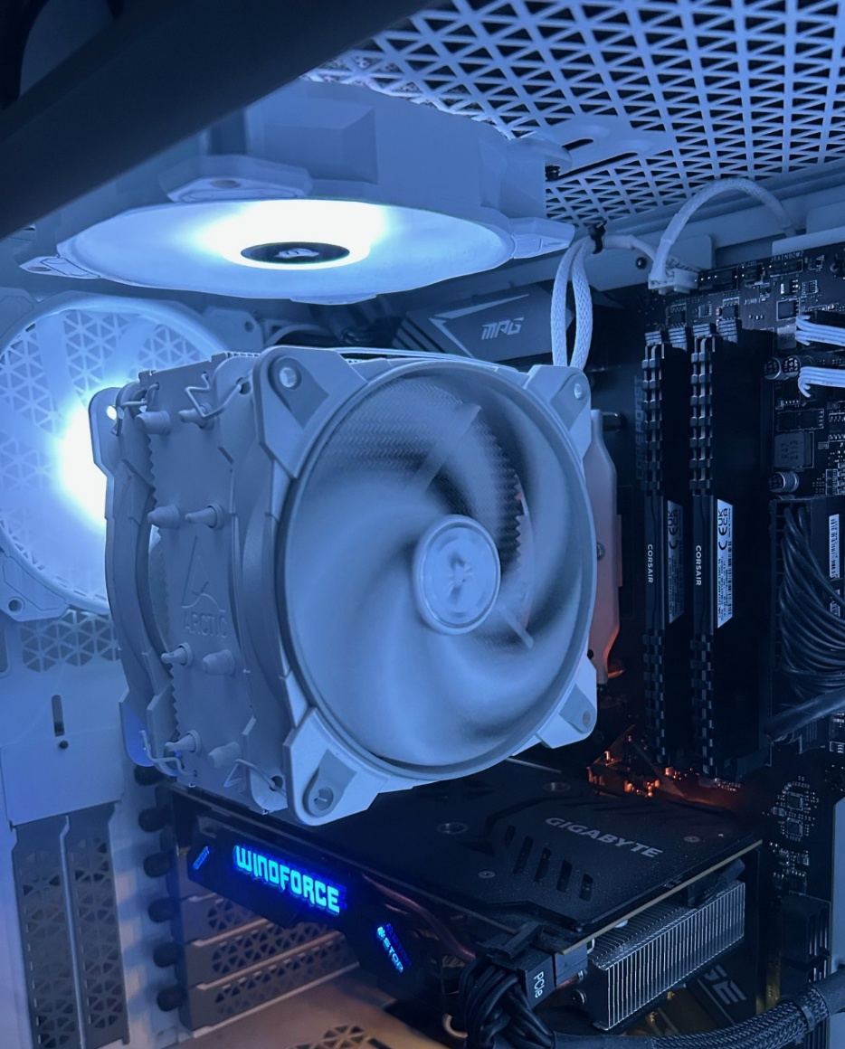
Figure 9 - My home computer using a large heat sink directly attached to the processor, along with intake and exhaust fans to promote airflow.
Microprocessors have increasingly benefited from the integration of CNC machining, machine learning, and additive manufacturing in collaborative design processes, enabling the production of highly complex and optimised thermal management components (3D Printing Industry, 2019). One example of this is the use of additive manufacturing to produce triply periodic minimal surface (TPMS) structures, as illustrated in Figure 10. These advanced geometries offer exceptionally high surface-area-to-volume ratios, which significantly enhance heat transfer performance compared with conventional fin designs while maintaining structural strength. Such intricate shapes are generally not feasible to manufacture using traditional CNC methods; however, laser sintering and other additive manufacturing techniques allow the creation of a wide range of complex geometries that were previously impractical to produce.
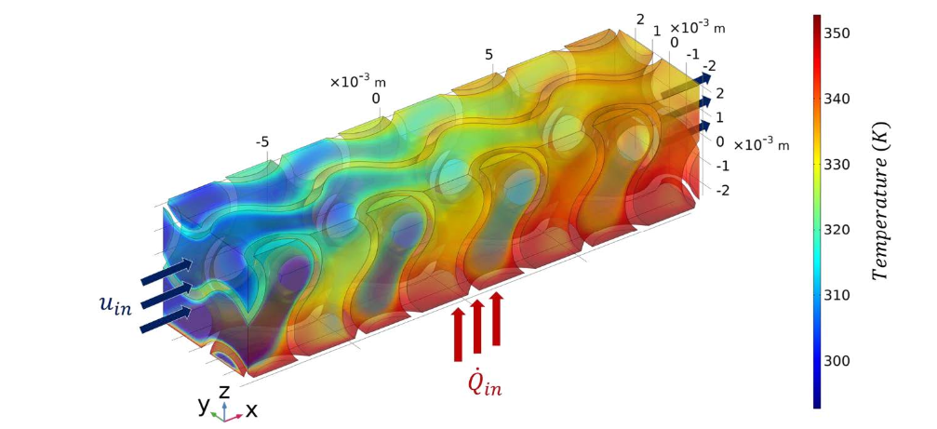
Figure 10 - Gyroid TPMS structure with a water inlet velocity of 0.2 m/s and a heat flux of 1 kW/m² applied from the bottom surface.
In summary, extended surfaces are essential for managing heat in modern microprocessors by increasing surface area and improving heat dissipation. As processor power increases, advanced cooling methods and innovative designs, including additive-manufactured TPMS structures may become increasingly important. These technologies enhance thermal performance, reliability, and efficiency, supporting the continued development of high-performance computing systems.

Task B
Figure 11 illustrates the heat transfer ratio of a finite-length fin to that of an infinitely long fin as a function of the fin parameter mL. The equations used are given below.
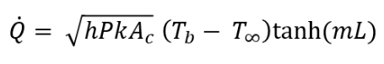
Finite length fin:
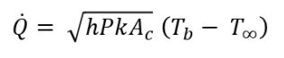
Infinite length fin:

When the heat transfer equations are divided (${\dot{Q}}_{finite}/{\dot{Q}}_{∞}$) and simplified, the resulting ratio simplifies to tanh(mL).

Figure 11 - Heat Transfer Ratio as a function of fin parameter (mL)
From the data, it can be observed that when the fin parameter is 2.65 illustrated by the red line in Figure 11, the fin reaches approximately 99% of the heat transfer of an infinitely long fin, further increases in fin length result in negligible additional heat transfer. Beyond mL≈2.65, only about 1% additional heat transfer can be achieved as the fin length approaches infinity.

Task C

Part 1
Figure 12 presents the calculated temperature at the free end of the pan handles, determined using the following equations:
Fin Parameter: $m= \sqrt{\frac{hP}{kA_{c}}}$
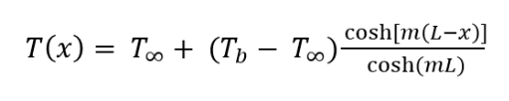
Adiabatic Tip Boundary Condition:

Figure 12 - Temperature of materials at free end of 200mm handle.
From the results it can be concluded that with the current handle configuration Copper, 2024 Aluminium alloy and Brass (70 Cu/30 Zn) would be unsuitable as above 60°C can cause 3rd degree burns in 5 seconds (Antiscald Inc., n.d.). The only suitable material with this handle configuration is 304 stainless steel.

Part 2
The temperature distribution along the length of the 200 mm pan handle was calculated for each material, as illustrated in Figure 13. The results confirm that, with this handle configuration, the three materials identified in Part 1 remain within the red shaded region, indicating temperatures capable of causing 2nd & 3rd degree burns (Zaydon, 2024).
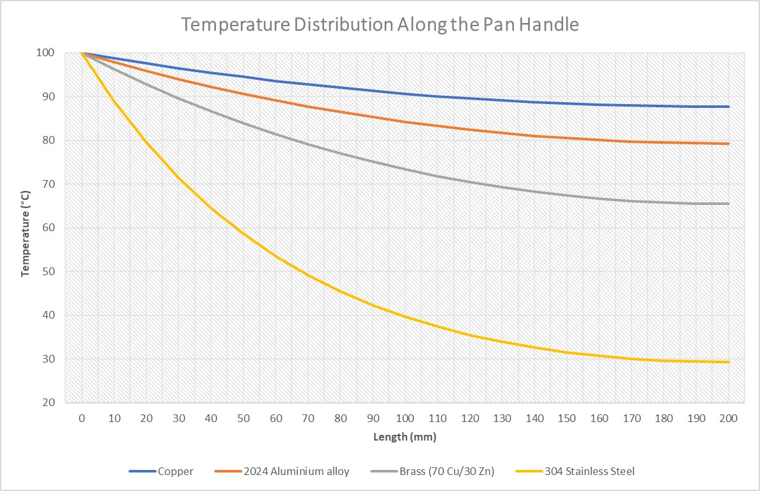
Figure 13 - Temperature distribution of materials across 200mm handles.

Part 3
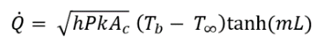
Figure 14 illustrates the corresponding heat loss for the four handle materials analysed in Part 2. The equation used to determine the heat loss is given below.
Rate of heat transfer from adiabatic tip fin:
Figure 14 - Rate of heat loss of 200mm handles.

Part 4
The assumed optimum length when is when mL ≈ 2.65, results shows in Figure 15 with their respective heat loss.
Figure 15 - Optimal length handle and rate of heat loss at optimal length.
Figure 16 shows the actual heat loss from the handles compared with the heat loss at the nominal fin length, indicating the proportion of heat dissipated along the fin relative to the nominal length determined from mL≈2.65. The results demonstrate that copper achieves only 54.5% of its nominal heat loss rate at a length of 200 mm. However, because heat loss from a fin is not a linear function of length, achieving the remaining 44.5% of the nominal heat loss would require a length of approximately 879 mm, rather than the additional ~180 mm that would be expected if the relationship were linear. The same principle applies to aluminium and brass, with heat loss values of 68.5% and 83.9% of their respective nominal heat losses. However, to achieve the nominal heat loss, fin lengths of approximately 641 mm and 446 mm would be required, respectively. As the value for 304 stainless steel exceeds 100%, this indicates that mL>2.65, meaning the fin length has surpassed its nominal length. This is consistent with Figure 15, which shows the nominal length to be approximately 173 mm. Consequently, the remaining 27 mm of the 200 mm pan handle contributes only a marginal increase in heat loss, of approximately 0.5%.
Figure 16 - Rate of heat loss for 200mm handle vs optimal length handle.

Part 5
Figure 17 shows the temperature distribution along the four handles when they are at their optimum lengths for maximum heat loss.

Figure 17 - Temperature distribution along handles of optimal length for heat loss.
From the results, it can be observed that the temperature at which the fins fall below the safe handling threshold of 50 °C occurs at a shorter distance along the fin compared with the previously analysed 200 mm fins. This difference arises because the tip of the 200 mm fin was modelled as adiabatic, meaning the end of the fin was perfectly insulated and therefore lost heat only through the lateral surface area rather than through the tip itself. An example of this effect can be demonstrated by recalculating a specific point along the optimal-length shafts. Taking copper as an example, the temperature at the end of the 200 mm handle can be compared with the temperature at a position 200 mm from the base of the 879 mm handle. The results of this comparison are presented below in Figures 18 & 19.
Figure 18 - Copper temperature at 200mm end of adiabatic tip handle.
Figure 19 - Copper temperature at 200mm from base of optimal length handle for heat loss.
From the results, a significant variation in temperature can be observed, with the 200 mm fin reaching 87.7 °C at its tip, compared with 65.2 °C at the corresponding 200 mm position on the optimal-length fin. This difference provides further evidence of the increased rate of heat loss along the longer fin, as illustrated in Figure X.
The following section will analyse each fin individually to assess its suitability for use as a pan handle.

Copper
Copper has an optimal fin length of 879 mm, at which the tip temperature is approximately 32 °C. However, the temperature does not fall below the safe handling threshold until approximately 360 mm from the base, as shown in Figure 20. This location represents the point at which the surface temperature becomes safe to handle. To ensure safe and comfortable use, an additional allowance equivalent to the average width of a human hand, approximately 90 mm, must be considered (Zelman, 2019). This results in a required nominal handle length of approximately 450 mm for copper. Such a length is impractical for a typical pan handle; therefore, the use of copper is not recommended for this application.
Figure 20 - Copper safe temperature distance from base.

2024 Aluminium Alloy
Aluminium has an optimal fin length of 641 mm, at which the tip temperature is approximately 32 °C. However, the temperature does not fall below the safe handling threshold until approximately 263 mm from the base, as illustrated in Figure 21. This point represents the location at which the surface temperature becomes safe to handle. As with the previous case, an additional allowance of 90 mm, representing the average width of a human hand, must be included to ensure safe and practical handling. This results in a required nominal handle length of approximately 353 mm. While this length remains relatively large for a typical handle, it is more manageable than the equivalent length required for copper.
Figure 21 - 2024 Aluminium alloy safe temperature distance from base.

Brass
Brass has an optimal fin length of 446 mm, with the tip temperature again reaching approximately 32 °C. The temperature falls below the safe handling threshold at approximately 183 mm from the base, as shown in Figure 22. This observation is notable because, in Figure Y, the shorter 200 mm handle remained unsafe to handle at this same distance. The difference in temperature arises because the original 200 mm fin was modelled with an adiabatic tip located at that position, meaning the temperature gradient was forced to approach zero at the end of the fin. In contrast, the longer fin has its adiabatic tip located further from the base, allowing heat to continue to be conducted and dissipated beyond the same position, resulting in a lower temperature. Allowing an additional 90 mm to accommodate the average width of a human hand results in a required nominal handle length of approximately 273 mm. This length is considered relatively suitable for use as a pan handle.
Figure 22 - Brass (70 Cu/30 Zn) safe temperature distance from base.

304 Stainless Steel
Stainless steel has an optimal fin length of 173 mm, with the temperature falling below the safe handling threshold at approximately 71 mm from the base, as shown in Figure 23. Allowing an additional 90 mm to account for the average width of a human hand results in a required nominal handle length of approximately 161 mm. This length would be suitable for use as a pan handle; however, increasing the handle length to 200 mm would provide greater flexibility in hand positioning and an additional margin of safety.
Figure 23 - 304 Stainless steel safe temperature distance from base.
Overall, stainless steel provides the most practical solution for a pan handle, as it achieves safe handling temperatures at a significantly shorter length than the other materials. In contrast, copper, aluminium, and brass require substantially longer handles to reach safe temperatures, making them less suitable for this application due to reduced practicality and ergonomics.

References
Abreu, R. (2026) Factory tour of how my custom radiators are made! YouTube. Available at: https://www.youtube.com/watch?v=BlL39Iz9nKc (Accessed: 18 April 2026).
Antiscald Inc. (n.d.) Burn exposure chart. Available at: https://antiscald.com/index.php?route=information/information&information_id=15 (Accessed: 12 April 2026).
Araiz, M. (2021) Introductory chapter: Heat transfer. In: Araiz, M. (ed.) Heat Transfer – Design, Experimentation and Applications. London: IntechOpen. Available at: https://www.intechopen.com/chapters/53025 (Accessed: 10 April 2026).
Autoradiators (n.d.) Analysis of the historical development of automobile radiator. Available at: https://www.autoradiators.com/analysis-of-the-historical-development-of-automobile-radiator.html (Accessed: 9 April 2026).
B Sport (2020) The MicroTube radiator in Formula 1 and LMP1 explained. YouTube. Available at: https://www.youtube.com/watch?v=9rs5QMk40IQ (Accessed: 20 April 2026).
Britannica (2026) Automobile: Cooling system. Available at: https://www.britannica.com/technology/automobile/Cooling-system (Accessed: 17 April 2026).
Dick Lovett (2020) Origins of the air-cooled Porsche engine. Available at: https://www.dicklovett.co.uk/porsche/news/origins-of-the-air-cooled-porsche-engine (Accessed: 8 April 2026).
FTH Industries (2025) Evolution of car radiator technology. Available at: https://www.fthindustries.in/evolution-of-car-radiator-technology/ (Accessed: 15 April 2026).
Holley, C. (2025) Gallery: Tracing the evolution of the modern radiator. Available at: https://moparconnectionmagazine.com/gallery-tracing-the-evolution-of-the-modern-radiator/ (Accessed: 14 April 2026).
Kelly, K. (2020) Micro’s scope. Racecar Engineering. Available at: https://www.racecar-engineering.com/news/micros-scope/ (Accessed: 20 April 2026).
Massachusetts Institute of Technology (MIT) (2007) Thermodynamics lecture notes. Available at: https://web.mit.edu/16.unified/www/FALL/thermodynamics/notes/node128.html (Accessed: 7 April 2026).
Mitsubishi Heavy Industries (2026) Why water-cooled diesel generators are the only choice for heavy-duty applications. Available at: https://www.mhi.com/group/mvde/blog/why-water-cooled-diesel-generators-are-the-only-choice-for-heavy-duty-applications (Accessed: 16 April 2026).
Mooney, J. (2024) Famous Firsts – The Morgan Runabout. Car & Classic Magazine, 26 July. Available at: https://www.carandclassic.com/magazine/famous-firsts-the-morgan-runabout/ (Accessed: 13 April 2026).
Motor Equipment News (2020) High-performance radiators for high-performance engines: The honeycomb radiator 120 years ago. October. Available at: https://motorequipmentnews.co.nz/article/high-performance-radiators-high-performance-engines-honeycomb-radiator-120-years-ago (Accessed: 11 April 2026).
PWR Corporate (2024) Tube and fin heat exchangers. Available at: https://www.pwr.com.au/products/tube-fin-heat-exchangers/ (Accessed: 19 April 2026).
Trick, C. (2022) What is a heat sink, and how does it work? Trenton Systems. Available at: https://www.trentonsystems.com/en-gb/blog/what-is-a-heat-sink (Accessed: 20 April 2026).
Uttarakhand, F. (2023) Beetle’s heart: The science behind air-cooled VW engines. Available at: https://medium.com/@fursat/beetles-heart-the-science-behind-air-cooled-vw-engines-f56b33914f5d (Accessed: 6 April 2026).
Zaydon, T.J. (2024) Scald burns: How temperature and exposure time impact burn severity. Available at: https://drzaydon.com/scald-burns-how-temperature-and-exposure-time-impact-burn-severity/ (Accessed: 5 April 2026).
Zelman, K. (2019) Average hand size: For adults, children, athletes, and more. Available at: https://www.healthline.com/health/average-hand-size (Accessed: 4 April 2026).
3D Printing Industry (2019) 3D printed heat sinks display higher efficiency. Available at: https://www.3dprinting.lighting/3d-printed-heat-sinks-display-higher-efficiency/ (Accessed: 20 April 2026).

