DS 1 Template

My Screenshots/Photos
- Please add 4–6 screenshots or photos of your digital life.
- You can use your phone or laptop.
- For each screenshot, write one or two sentences explaining what it shows.

Screenshot/Photo 1
Apple pay – Is something I use on a day to day basis quick easy and reliable


Screenshot/Photo 2
Snapchat – This is another app I use to send family, friends’ pictures and videos and also to send messages and keep location on my son.
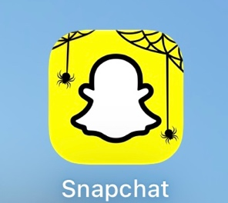

Screenshot/Photo 3
 what’s app – I use this app day to day to communicate with family and friends abroad

Screenshot/Photo 4
Microsoft teams – I have used this app quite a lot to communicate with my son’s school and for job interviews very hand and easy to use app

Screenshot/Photo 5
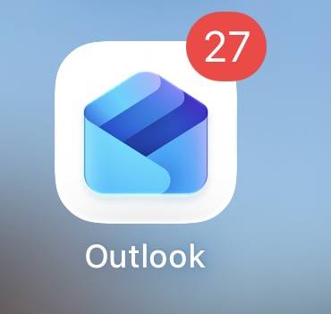 Outlook- this app helps me keep up to date with all kinds of thing like sending receiving emails

[Write what this shows of your digital life]

Screenshot/Photo 6
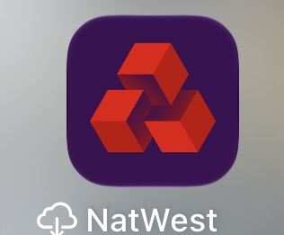
NatWest- this app helps keep track of all my payment bills direct debts and many other things easy to use.
My reflection
The six tools I use on a regular basis help with day to my day-to-day life for example what’s app helps me communicate with my family and friends that live abroad this app is super reliable, apple pay is another one easy and sufficient also Microsoft teams having online meetings and job interviews. I feel confident when I am using these apps, but I know there are many other apps and digital skills that I need to learn and understand them more to help life day to day life in the digital side. I’m hoping that this module with help me gain all the skills needed and progress they are important as without learning and having the knowledge to focus and have the time to learn and improve.

