ECAD7004
Researching the Learning

An Explanatory Case Study of Reception Teacher’ Perceived Barriers and Challanges to Implementing Outdoor Learning in a Primary School in South Wales

Jessica Burgess - 2004467

Introduction
This research project aimed to develop better understanding of the different attributes that practitioners perceive to act as a barrier to outdoor learning within their educational environment. From further reading, common themes will be identified alongside potential factors that can contribute to develop finer implementation. The rationale for this research focus was due to the prevalence of outdoor learning currently within Wales and throughout the Welsh Curriculum (2022). As a student teacher, it is essential to have a comprehensive understanding of what outdoor learning looks like withing educational settings in Wales to provide adequate practice and align with national missions such as the Well-being of Future Generations Act (2015). Being able to effectively implement outdoor learning within practice is a powerful tool to acquire and is essential within education today.
The research conducted for the study was taken from an urban setting within South Wales. The research took place within an English medium primary school for children ages three to eleven years old, however research was taken from practitioners currently working in nursery up to year two. Throughout the piece, the aim is to understand from practitioners' perspectives what factors may prevent or interrupt outdoor learning.

Literature Overview
Play within the early years is a pertinent element of a child’s education (Irvin, 2017). It contributes to the holistic development of the child and research supports its active role in brain development (Siviy, 2016). Both directed and undirected play is advantageous to learners however undirected play specifically is proven to activate the whole neocortex of the brain where learners develop their complex problem-solving skills, decision making skills and their emotional intelligence (Siviy, 2016). The Curriculum for Wales (2022) recognises the significance of play-based pedagogy’s and therefore is embedded throughout the guidance. However, it is crucial to acknowledge that there are other contributing factors to the success of play-based learning such as careful planning and preparation (Rumbold, 1990). It is clear that play is advantageous within early years, and when combining play with the outdoors, the advantages extend (The Welsh Government, 2008). The outdoors enhances play and experiential learning experiences due to the uniqueness of the environment and providing authentic and engaging experiences (Welsh Government, 2023).
Other advocates for the effectiveness of outdoor learning include a range of theoretical perspectives. Piaget’s constructivism theory (1973) promotes hands on learning experience and environmental interactions (Triantafyllou, 2022). Through outdoor learning, learners are supplied with chance for exploration and observation through direct experience, therefore enhancing skills such as critical thinking and problem solving, developing their overall cognitive abilities through active construction (Fosnot, 2013). Furthermore, Kolb’s experiential learning theory (1984) highlights the importance of active engagement in concrete experience and experimentation. The theory suggests that outdoor learning is a powerful approach to form abstract concepts and apply their knowledge fostering holistic development (Kolb et al., 1999). There is also the Bronfenbrenner's Ecological system theory (1979) which emphasise the importance of the environment and the connection, and influence between the environment and the individual which is promoted through outdoor learning. This allows for a deeper understanding of their ecological surroundings and fostering connections and responsibility within the natural world (Guy-Evans, 2024).
While there are great benefits from outdoor exposure to academic outcomes, there are also significant benefits to mental and physical health (Twohig-Bennett and Jones, 2018). Outdoor learning has been proven to develop social skills, confidence in learners, resilience and independence, all leading to an increase in mental health (Gustafsson et al., 2012). Freedom within the environment also allows for development of physical health along with balance, co-ordination and agility (Nidirect, 2018). These both are crucial areas for development according to the NHS (n.d.) who recorded that due to the Covid-19 pandemic, children’s emotional well-being has declined along with reduced physical activity.
The Curriculum for Wales (2022) promotes free flow within early years environments to accentuate learning experiences. However, Estyn (2023) notes that the most common barrier to outdoor learning is the absence of opportunities presented to learners. It has been recorded that practitioners are hesitant to transform pedagogy and fully implement outdoor learning for various reasons, one of which is education around and confidence in own practice (Maynard, Waters and Clement, 2011 and Natural England, 2016). Teachers have expressed concerns about meeting the curriculum via the outdoors environment and completing assessments (Patchen et al., 2022). It has been recorded that more than eight of ten practitioners would prefer to take learning outdoors however do not due to the curriculum pressure (Edwards, 2022). While being outdoors is naturally valuable; to reap full benefit, practitioners need adequate training to utilise and effectively supply outdoor experiences (Barrable, Touloumakos and Lapere, 2020). In 2011, Estyn reported that most settings are not developing reading, writing, ICT, creative skills and cultural diversity through adequate outdoor use. However, it is important to note that the evidence from Estyn is not up-to current date and is not accurate to education within 2023. By providing professional development opportunities, practitioners can be educated and supplied with confidence to lead, effectively manage and overcome barriers to outdoor learning (Welsh Government, 2023). However, due to the current funding crisis within education in Wales and the increase of living, this can result in inconsistency across educational settings and therefore impacting the opportunities presented to teachers and learners (National Education Union, 2023).
Other barriers were noticed to come into play as a concern within outdoor learning. From limited access to safety concerns, practitioners express their concerns around urban settings with limited outdoor access and resources, and the welfare of the children when exposed to the outdoor setting (Waite, n.d.). Physical barriers also included access to appropriate resources to account for weather conditions. Due to financial constraints both within educational settings as well as at the learner's home’s, some learners are not dressed appropriately for changing weather conditions, and the school is unable to fund resources as an alternative, therefore meaning it isn't always able to go outdoors (Kings College London, 2010). Financial constraints come largely into play within supplying schools with adequate resources to supply practitioners with the ability to effectively implement outdoor learning. However, the Welsh Government (2009) suggests that regardless of available resources, practitioners are able to adapt to overcome barriers with increased motivation (Guerra, Villa and Glăveanu, 2020). There were also social barriers such as cultural attitudes and lack of support from parents/carers and staff in the education setting as well as psychological barriers in terms of risk taking and the perception of academic value within outdoor settings (Van Dijk-Wesselius et al., 2020).

Explanation of the Case Study
Case study research is a qualitative method involving in-depth exploration and analysis of specific subjects (Denzin and Lincoln, 2011). It includes collecting data through different methods to give a comprehensive understanding of the specific subject case (Priya, 2020). The main aim of a case study is to gain a greater in-depth understanding of the subject, allowing researchers to explore real-life contexts, examine phenomena and generate rich, detailed insights (Gerring, 2004). Case study research is an advantageous approach to take as it allows you to explore specific and unique cases, to give a detailed analysis and contribute to existing knowledge within the subject field (Crowe et al., 2019). There is also a limitation to the ability to broaden use of the findings due to the specific focus (Sage, 2011). This can also be the case where researchers can potentially be biased within their data interpretation and therefore affect the objectivity of the study (Mendez-Sanchez, 2022). More specifically, within education, case studies are often a suitable approach to explore and measure impact to inform future practice and plan next steps (Cain, 2019). However, it is important to note that in order to gage this level of understanding and knowledge around the subject, it can be a time-consuming task (Herfors, 2016). Case study research often requires a significant amount of time to both collect and then analyse the collected data. It is crucial that data collection is ethical and thorough to ensure that the data gathered is accurate, rich, detailed and informative (Resnik, 2020). It is also important to consider the variables within the research to identify cause-and-effect relationships, however usually within case studies, the variables are difficult to manage and therefore these relationships cannot always be identified (Sage, 2011).
Specifically in relation to this case study, the participants have been selected from a primary school setting within South Wales, United Kingdom and all qualified teachers within the setting have been given the opportunity to voluntarily participate. This target audience was developed from the primary target of the research. There is a requirement for qualified and professional teachers who have understanding and experience within the subject area. The exclusion criteria for the case study included anyone that did not want to participate in the study. In gathering the participants, a non-probability sampling technique based on convenience was used. Convenience sampling consists of selecting participants that best fit the criteria of the researcher who is available to participate (Golzar and Tajik, 2022). This was suitable for the research study as participants were easily and conveniently accessed and was used to gather views and opinions of a small group of members as opposed to a greater population (Vehovar et al, 2016 and Jager, 2017).

Research Methods
This study required a qualitative design to investigate a range of perspectives, opinions and knowledge from contributors for greater understanding of the perceived barriers. Qualitative data is specifically useful to gather thoughts and feelings from participants to develop an understanding of perspectives and experiences (Sutton and Austin, 2015). This type of data can supply researchers with greater depth and explanation as it is not numeric and is language based (National Library of Medicine, n.d.). A qualitative design was appropriate to the study as its aim was to explore the viewpoints of participants at a local level, identify any common themes throughout the data as well as in comparison to current literature. The instruments adopted for qualitative data collection within this study included questionnaires and interviews.
Questionnaires were used to gather data from respondents based on their personal views on the specific theme (Sapsford, 1999). The questionnaire is designed around the chosen topic, including a range of both open and closed questions (Lavrakas, 2011). This allows for deeper exploration of the practitioner's experiences and opinions of the barriers that they come face-to-face with in their own practice. There is a clear focus within the questions to ensure that the aim of exploring the topic and reaching the research aim (NHS England, 2018). This case study contained an online questionnaire for practitioners within the primary setting, aimed to allow practitioners to complete anonymously giving their true experiences with comfortability. By using an online platform to create and share the questionnaires, it can easily be distributed to the respondents who fit the inclusion criteria (Regmi et al., 2016). All questions within the questionnaire were created through a thematic analysis of the literature to create a thorough knowledge, due to this, a qualitative method is the primary employed strategy.
Using questionnaires as an instrument for data collection can be advantageous for several reasons. One of which includes the pace of responses from participants. Questionnaires are a cost-effective way to gather data whilst retaining respondents' anonymity (Boynton and Greenhalgh, 2004). Questionnaires are also beneficial to upholding the validity of the data gathered. By providing opportunities to complete anonymous questionnaires, participant pressure is eliminated and therefore responses can be more honest and not influenced by what respondents feel is the desired answer or feel a victim of judgement (Rowley, 2014). During this study, participants include practitioners from a primary school setting, however data responses will not be identifiable. Research has shown that dishonest responses and bias are inclined when researchers are present at the time of completion (Heal & Sigelman, 1995). As the questionnaires are presented online, distribution is convenient and allows for straightforward data analysis, data presentation and visualisation (Sage, 2011). There is also the option to use both closed and open questioning throughout, in this specific study, a mix of both has been used to allow for elaboration without restriction to give context where needed, as well as retrieving desired and more specific answers with closed questions (Hyman & Sierra, 2016).
The second method used to collect data was interviews. Interviews were conducted within this study to allow for open dialogue and free guidance in discussion with practitioners (Jamshed, 2014). This approach is another that allows for exploration and insight into people's perceptions, understandings and experiences (Frances, Coughlan and Patricia, 2009). More specifically, semi-structured interviews were chosen to give flexibility in data collection for adaptation where required (DeJonckheere & Vaughn, 2019). One disadvantage of questionnaires is that responses cannot be followed for further exploration, whereas with interviews, responses can allow for re-direction and greater depth of understanding (Artino et al., 2014). There is also the possibility to probe and clarify responses with this tailored effect (Robinson, 2023). There is also the ability to build a professional rapport with the respondents by taking this approach, which can lead to trust and develop responses. However, on the other hand, this can also result in a dip in validity due to the pressure and influence from the present researcher (Coleman, 2021). When conducting interviews, it is important to understand that for effective data collection, the researcher requires skill and knowledge (Frances, Coughlan and Patricia, 2009). This is also a more time-consuming process to carry out depending on the sample size being used. Within this specific case study, due to a small sample size, it was manageable and insightful to carry out. When conducting and transcribing interviews, a considerable amount of time is taken in addition to preparing and carrying them out.
Despite the disadvantages of both methods to gather data, both instruments are able to provide valuable data and give adequate insight to the practitioner's experiences and opinions of the barriers that they come up against within day-to-day practice in their setting when carefully considered and used appropriately. Both methods of data collection are suitable for the case study by allowing respondents to be open in sharing whilst giving them opportunity to comfortably and anonymously respond. The reliability of the data is dependent on each individual participating however different feelings and opportunities have been considered in planning, such as confidence, validity, open and closed questions and probing opportunities for concrete understanding and interpretation. In planning and carrying out both questionnaires and interviews, the aim to achieve greater insight within the local community setting, involving a range of aged and experienced practitioners, from newly qualified to over ten years of teaching, chosen through convenient selection, plays into the quality of the data. Both the questionnaire and interview schedule can be referred to within appendices B and C.
This data gathered for this case study is dependent on the social context of the setting, including the access to outdoors, resources and personal circumstances of the setting such as the curriculum followed in accordance with the Curriculum for Wales (2022) guidance. This study aligns with the interpretivism paradigm, meaning that the data is influenced by its surrounding factors. This paradigm approach seeks to comprehend rather than establish the total truth, considering social context while producing and influencing results (Ryan, 2018). The basis of interpretivism is that it is socially constructed, and knowledge is developed via comprehension and experience, therefore each will be unique. This approach depends on comprehending and investigating the subject matter to generate and compile data to obtain high-quality knowledge (Kivunja and Kuyini, 2017).

Analysis and Data
As the data gathered for the study was qualitative, the analytic approach used was thematic analysis. Thematic analysis is a method used to discover patterns within data, often used within relation to qualitative data (Nowell et al, 2017). This is done after the qualitative data collection has occurred, it is then carefully read through to identify key themes that emerge and patterns between that occur throughout (Dawadi, 2020). This will be done through open coding to summarise. This approach offers a methodical technique for evaluating qualitative data, guaranteeing accuracy and transparency (Dawadi, 2020).
Thematic analysis is a flexible approach which allows the researcher to explore a wide scope in both small and large-scale studies. It is a suitable method to use when analysing rich and detailed data as it allows the researcher to gain a deep and comprehensive understanding of participants' experiences and perspectives before categorising into relevant themes and then recognising and trends throughout (Vaismoradi, Turunen and Bondas, 2013). Within this case study's context, overarching themes will be recorded throughout the data analysis process and due to the participants having similar setting context, trends may occur. When conducting thematic analysis, it is important to carefully categorise themes from reading to avoid bias in interpretation (Roberts, Dowell and Nie, 2019). Using interviews as a research method participates in overcoming biases to gather true meaning of practitioner's responses through dialogue and probing. This analysis can be time consuming, however due to the small sample size, it is manageable.
During analysis of the case study, when open coding to summarise, common themes were distinguished and then all was reviewed to ensure none were missed. These themes were given headings to easily categorise and identify for further analysis to avoid any bias or misinterpretation. These categories can then be applied to the topic to understand their relationship and importance in what barriers practitioners are facing within the setting and maybe within the wider community (Maguire & Delahunt, 2017).

Ethical Considerations
This study was granted ethical approval by the University of Wales Trinity Saint David’s Ethics Board on the twenty-fourth of April 2024. Within the application form the four principles were considered and addressed, these included harm, anonymity, deception and informed consent. It was assured throughout that participants and respondents were at no personal or professional risk and all data will be kept anonymous during collection to avoid any risk of personal data exposure. All participants are within their right to access any personal information and contact the researcher with any queries they may have. They are also able to withdraw from collection, object to and erase or restrict the use of their data being processed at any time. All data handled will be managed in accordance with the GDPR Law (2018). Data will be stored on a password protected university laptop until the degree award is confirmed and then it will be disposed of indefinitely. All data gathered will be processed and included within the final document with all sensitive data anonymized, the final document will be available to participants upon completion at request of the designated person.

Results and Analysis
In analysing the collected data, the researcher identified key themes within the responses. Several practitioners identified common key factors that act as barriers within implementing outdoor learning. The themes identified from the data collected are as follows: weather conditions, limited timing, and lack of resources and support.

Weather Conditions
Data collected from the questionnaires sent out by the researcher show that practitioners recognise and value the importance of outdoor play and learning throughout the setting and do have access to outdoor learning environments available within the setting. All respondents stated that there is no free flow between the indoor and outdoor classroom, however all give regular access conditionally. This of which is planned for each week alongside free-time access. During interviews, these safety concerns were discussed further to uncover a deeper meaning. In the dialogue, nearly all participants commented on the weather affecting access, especially during winter months. However, within the Welsh Assembly Government Outdoor Learning Handbook (2009), weather conditions are referred to as ‘special stimuli’ which enhances learners experiences in authentic contexts and being outdoors in weather conditions such as rain can create robust learner (Bento and Dias, 2017). One practitioner during interviews elaborated expressing how they did not have the resources to use the outdoor environment within poor weather conditions and that ‘parents would be unhappy if their children were sat soaking wet and cold all day in our care’ due to inappropriate clothing, and explained that to request this from parents within a cost of living crisis would be ‘unfair’. Estyn (2023) explains that outdoor play should be encouraged regardless of weather and encourages practitioners to supply children with appropriate clothing to allow for play within inclement weather conditions. However, where funding is not available to retrieve resources within the school, suggestions from the Outdoor Learning handbook suggest’s requesting for donations within the local community and parents (Welsh Government, 2009). The data collected suggests that this is the most common barrier that they experience and yet it is an uncontrollable variable. Relevant literature suggests that this is a widespread issue experienced by practitioners and settings across the United Kingdom.

Limited Timing
Limited timing was an element recorded from just over half of the respondents however not all recorded this. Under half of the participants recorded that they felt pressure from the curriculum to ensure the learners were transitioning throughout their education with adequate knowledge and therefore would primarily focus on subject coverage within the classroom. During interviews, practitioners A and D explained how there were some topics that they found difficult to cover outside and would be more suitable in other environments, giving one example of learning about money in shops would be a greater benefit than outdoors. Maynard et al (2013) expresses that ‘real work’ is classroom based however the data suggests that this is not the belief within this setting. The practitioners see beyond the classroom, however, are experiencing difficulty in integrating the pedagogy with curriculum aims and outcomes. In addressing time constraints within day-to-day activities in classrooms, it is important to set realistic opportunities for outdoor play and learning. Factoring in time from play and lunch and building upon this throughout the day where they may have reward times with free-flow option, or taking the learning to the outdoors by planning carefully will benefit learners holistically. Spending twenty minutes outdoors is proven to impact learners stress levels (Harman, 2024). Practitioners and planning are key elements to success in both indoor and outdoor learning and this is important to factor into preparation as opposed to learners only being exposed to the outdoors during playtime and lunch (NASUWT, 2023).

Lack of resources and support
In analysing data, every practitioner recorded different barriers that involved resource and support in the implementation of outdoor learning. Problems within relation to outdoor access, materials and training were noted. Practitioners included that they saw certain resources as an asset to outdoor learning however did not have easy access to them. In interviews, practitioners explained that some classes shared outdoor areas and scheduling for use was a common problem within the setting and that adequate training wasn’t available for practitioners. When conducting interviews, a common theme arose where newly trained practitioners in the setting expressed their confidence in leading outdoor learning. In 2005 it was recorded that teacher training (ITE) did not supply new teachers with the confidence to lead outdoor learning, however this is not reflected within the case study (House of Commons, 2005). This implies that since 2005, the ITE has developed this area of teaching and learning, however this is not supported by evidence. This information was also taken from England however this case study is based within South Wales and is important to recognise. Within the literature review, reductions in funding across schools within Wales were discussed and could potentially impact the training available to practitioners. In 2021, it was found in England that school's professional development opportunities had decreased by over forty percent since 2018 (Hannay, 2022).
There was also discussion around lack of access to materials and equipment and lack of funding for these to be put into place. Due to them being within an urban setting, data records that more than one practitioner referred to their outdoors as a ‘concrete jungle’ with a nature deprived environment for students to explore. Literature around these barriers suggests the need to be creative in order to demolish these barriers (Mackenzie and Carolan, 2019). However, tarmac is recorded to have a wealth of opportunities for learners and should be embraced, from sensory experiences to developing writing skills there is opportunity to utilize the environment using free and basic resources from the classroom (Welsh Government, 2009). Within Wales, there is also a large focus on developing partnerships with the local community to develop teaching and learning. Reaching out to the school's community links can improve outdoor provision through collaboration. Community engagement is proven to strengthen teaching and learning experiences and provide greater opportunities (Welsh Government, 2023a). A small percentage of the respondents included that they repurpose and share materials and ideas throughout their phases in order to try and overcome these barriers, however felt it wasn’t enough and hindered planning. Theorists such as Montessori support using natural materials such as wood, acorns and other natural materials to develop learners' senses and provide open ended activities (Kuemerle , 2019). These resources can be gathered from local areas and used within the settings outdoor area.
During the analysis, it was discovered that outdoor learning and the benefits are recognised throughout the setting and Welsh policy is adhered to within the setting. However, there are several barriers that they face day-to-day within their current environment. Practitioners stated these barriers above to be the most prevalent within their practice and barriers that they found re-occurred. The main finding throughout the data was that several barriers that practitioners experienced could potentially be removed with additional funding to support and resource outdoor learning within the setting. Another contributing factor that literature suggests could help to break down barriers is careful planning and collaboration within the school and wider community. Literature has suggestions to attempt to tackle the barriers in place. However, surrounding literature has made it apparent that these barriers are experienced in the wider country as opposed to just within South Wales.

Conclusion
Although the study is based on a small sample and therefore has limitations, the data produced provided an accurate insight to the settings barriers to outdoor learning. It is important to recognise the current prevalence of outdoor learning within Wales and throughout the Curriculum for Wales (2022). Therefore, it is possible that settings would avoid negative discussion around their provision or setting to avoid any negative association or damage to their reputation. Alongside this, practitioners may also be mindful of protecting their professional reputation by disclosing any negative relations. Although themes discussed disclosed barriers within the setting, it is possible that others were not disclosed purposefully, and the researcher was aware of this throughout the case study. To avoid this, questionnaires were kept anonymous to protect respondents and aid them in giving accurate data. Going forwards, to improve the study limitations have been recongised. The participant sample could have been extended to include teaching assistants, which would have given a broader understanding. As stated above, practitioner engagement is crucial to successful outdoor learning and by involving teaching assistants within the questionnaire process, the practitioners who are also alongside learners day-to-day could have provided more of an in-depth understanding.
Overall, the findings support that practitioners follow current policy within Wales and hold adequate knowledge to implementation within their setting, trying to overcome barriers that they face each day. While there is clear evidence that outdoor learning is valued within the setting, there is also lack of confidence in practitioners leading it. Going forwards, it is important to recognise the elements that create a quality outdoor learning environment and how to utilise current resources to do this. This can be achieved throughout professional development; a suggestion would be to share expertise around the setting via adds sessions and invest time in developing the outdoor areas in partnership with the community. Teaching assistants were not included within the study but due to the importance of the practitioner in outdoor learning, it would also be beneficial to support their professional development alongside teachers (Welsh Assembly Government, 2008). Patchen et al (2022) states that lack of education around outdoor learning can create a barrier to outdoor learning itself and therefore it is crucial that practitioners are made aware of the significance of outdoor learning for both themselves and learners. To further support outdoor provision and its significance of frequent outdoor exposure through planning and creativity to tackle barriers.
In Wales, the professional teaching standards place great emphasis on providing a curriculum that develops learners to be ambitious and capable learners, enterprising and creative contributors, ethical and informed citizens, and healthy and confident individuals. This includes promoting holistic development, developing curiosity and increasing learners' engagement within the natural world around them. Learning within Wales is all about engaging in real-life authentic contexts for best outcomes and therefore incorporating outdoor learning is an essential skill to develop as a student teacher to integrate into planning, teaching and assessment (Welsh Government, 2022). This will contribute to ensuring that outdoor learning is an integral part of the curriculum within Wales.

Appendices:

Appendix A: Ethics Form
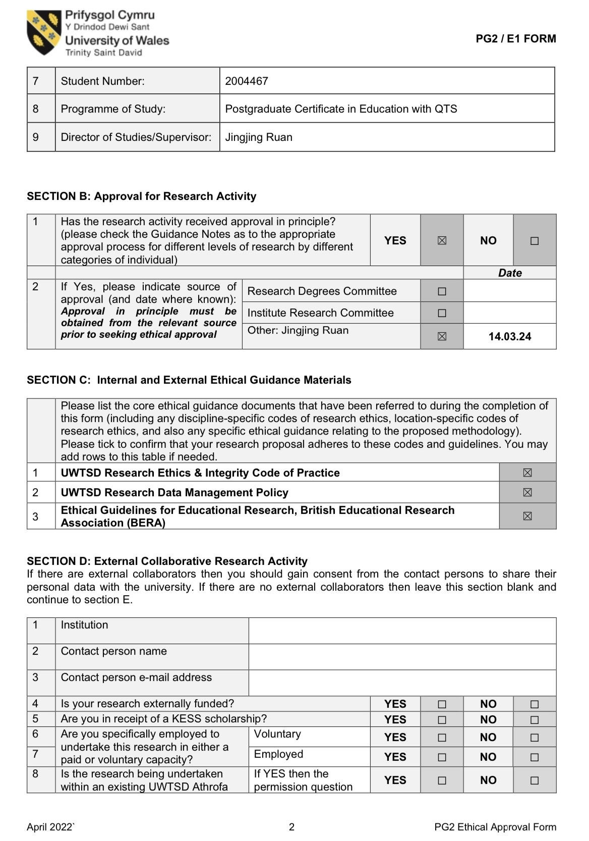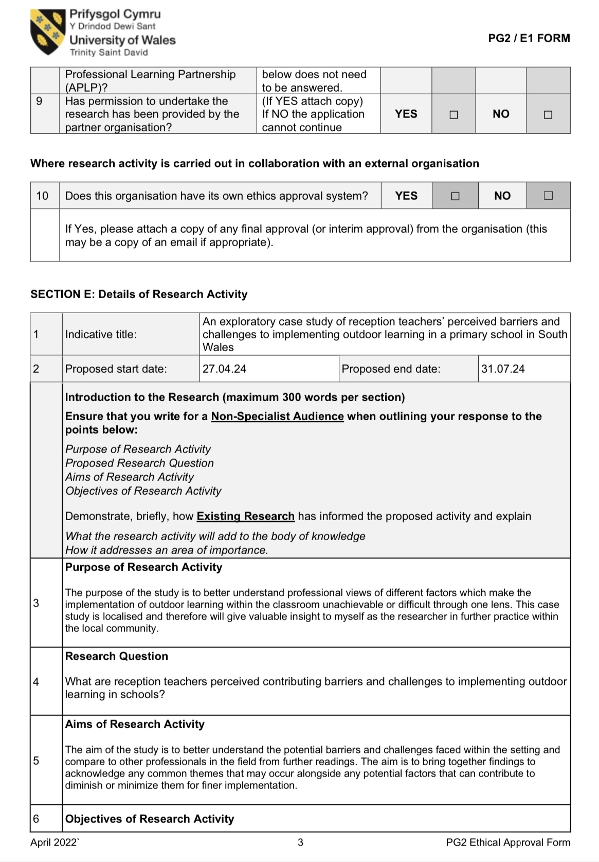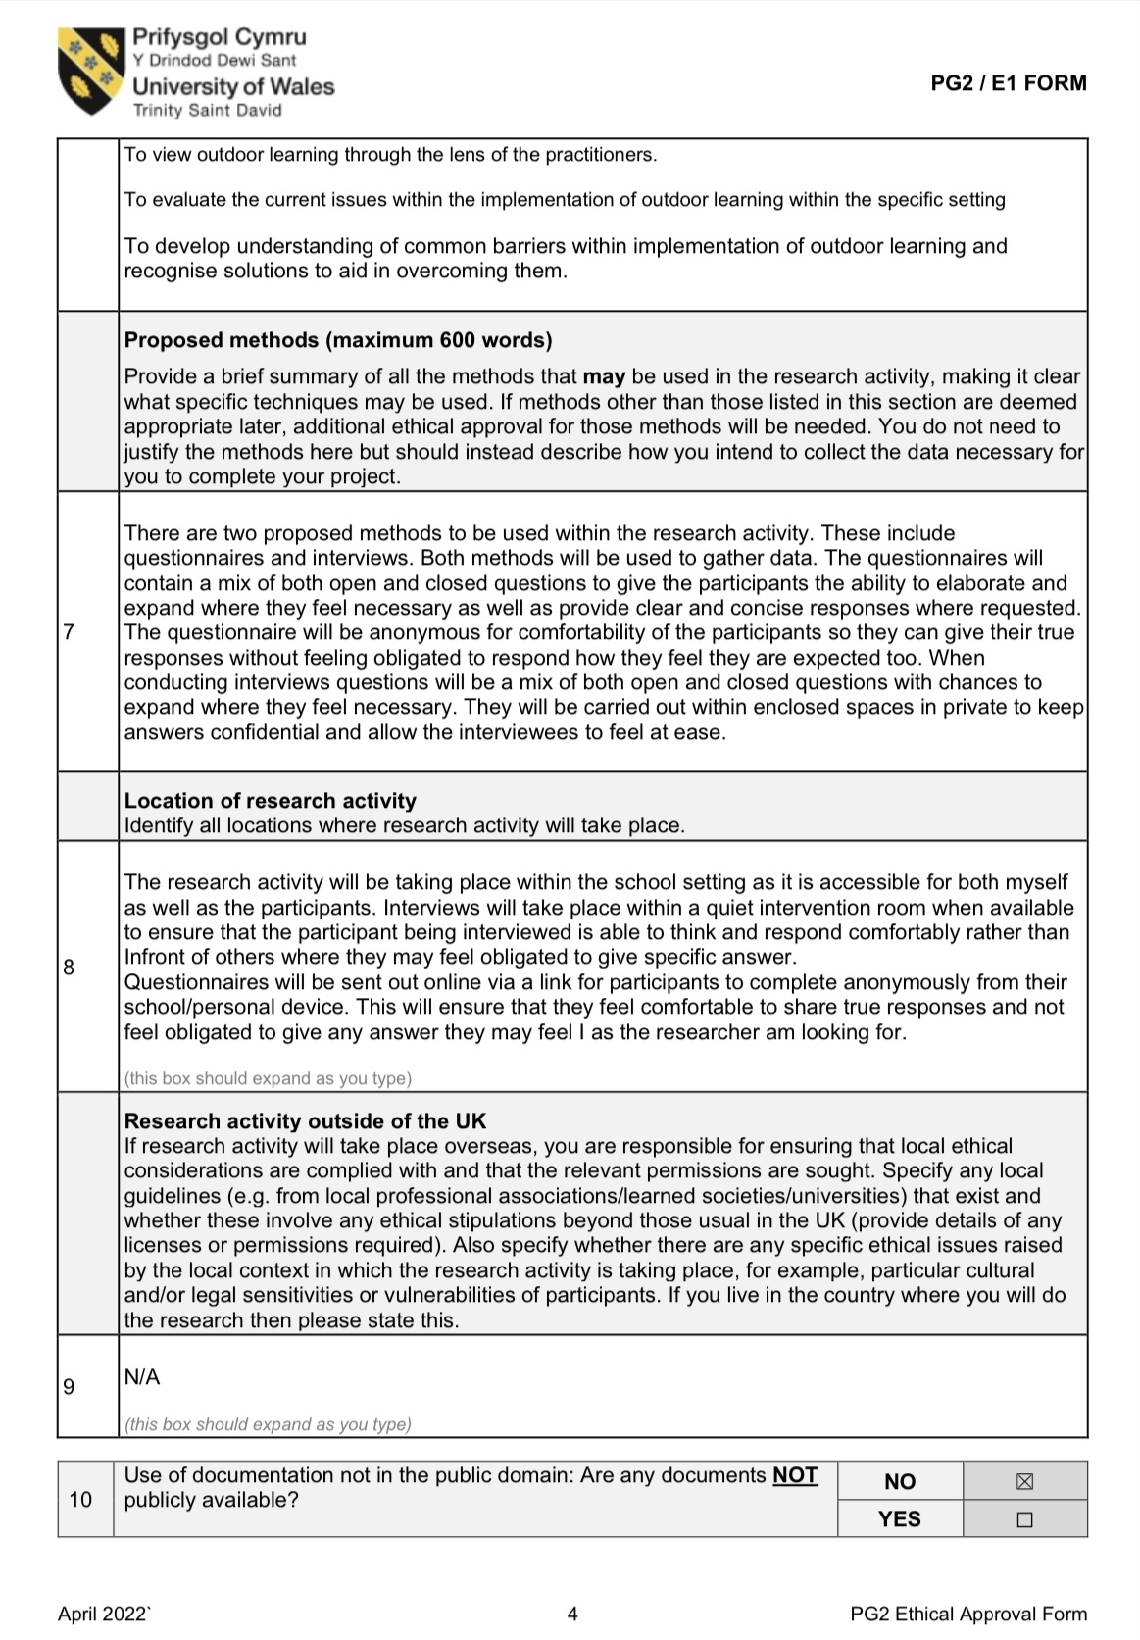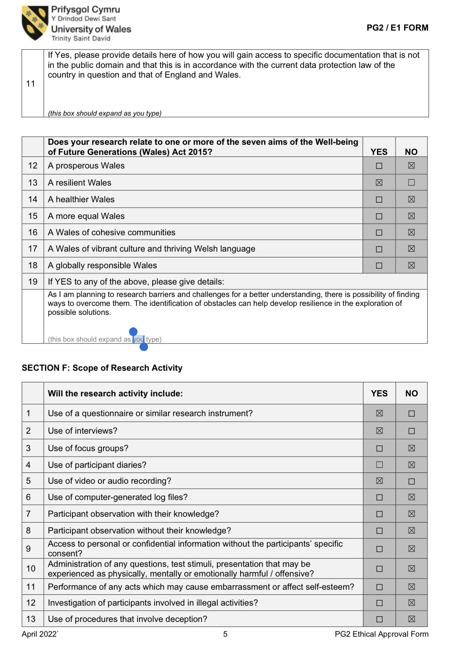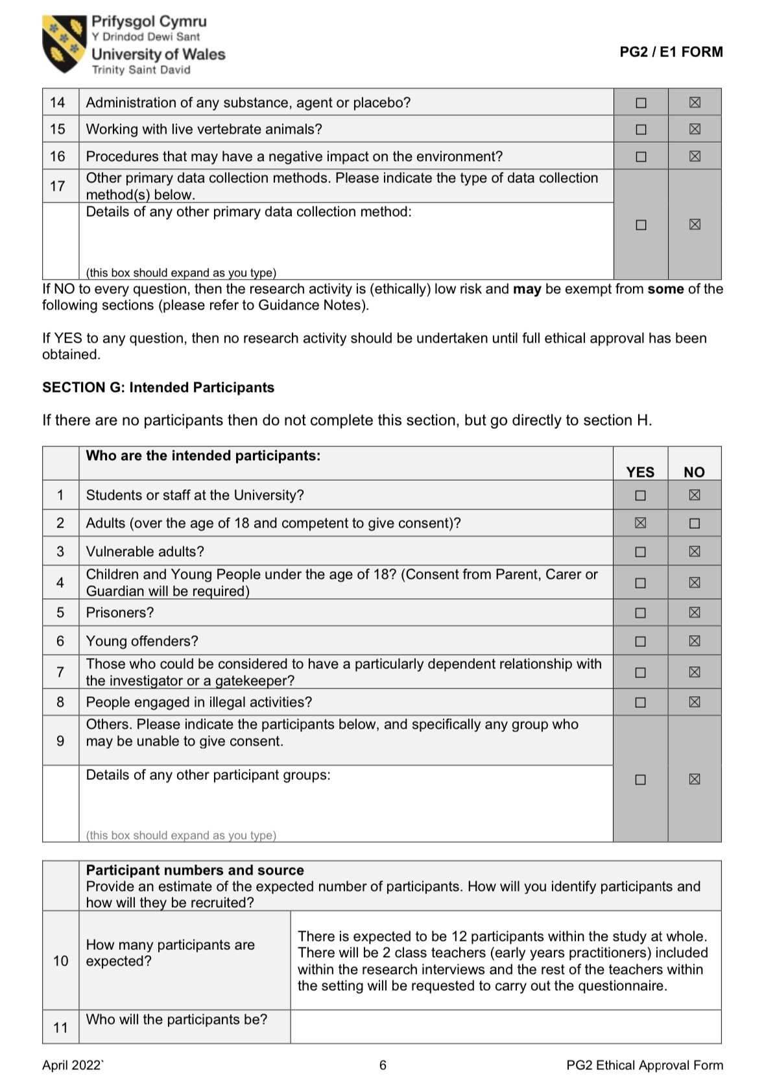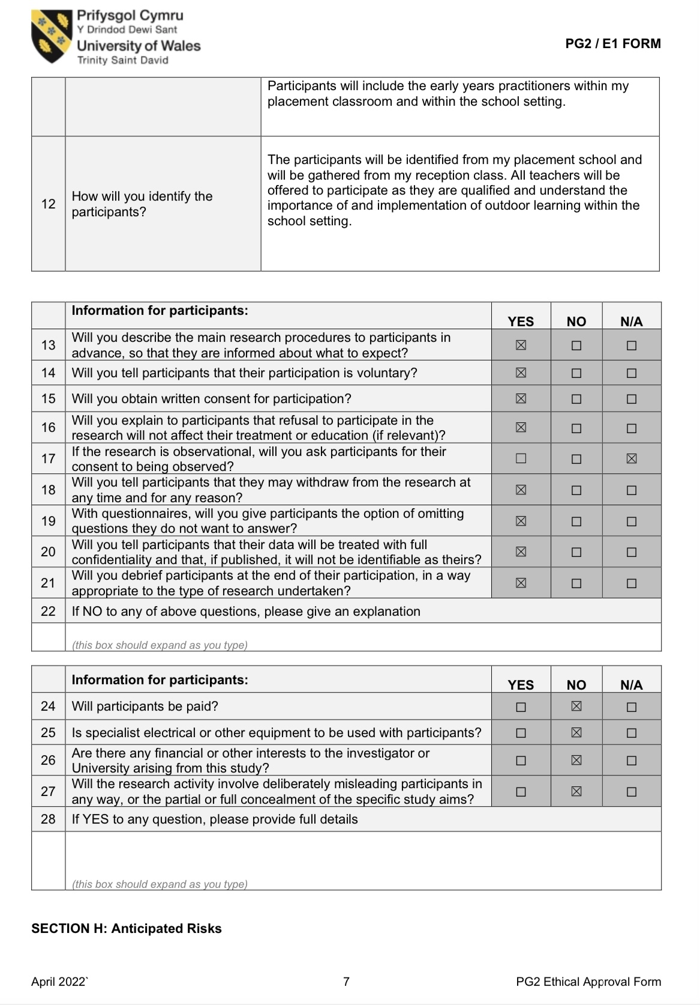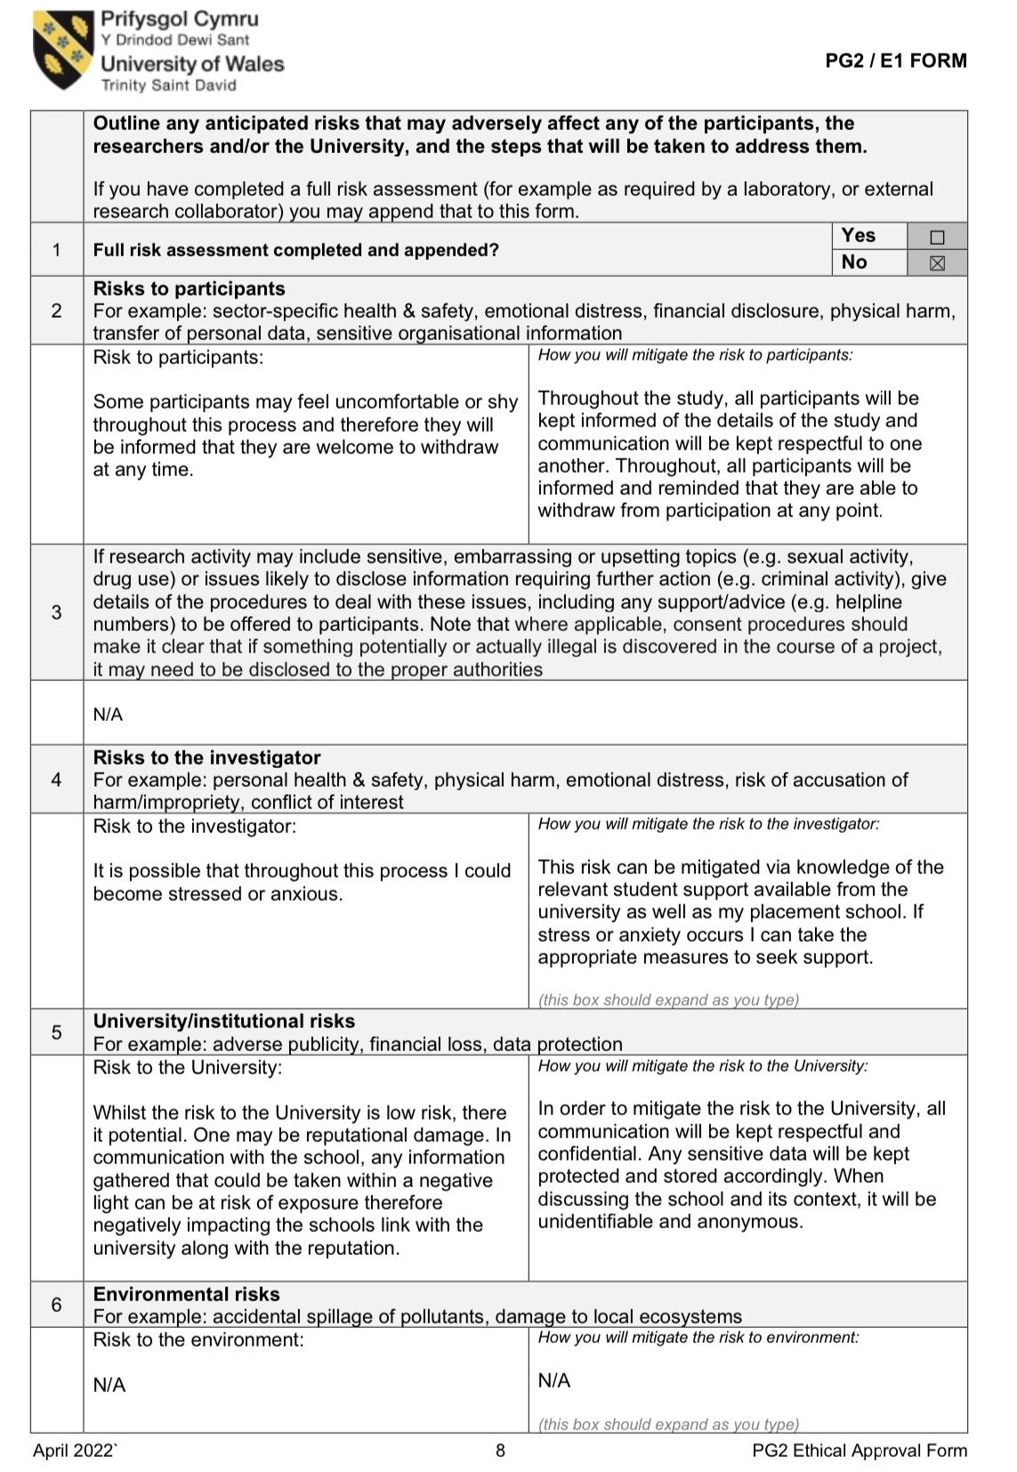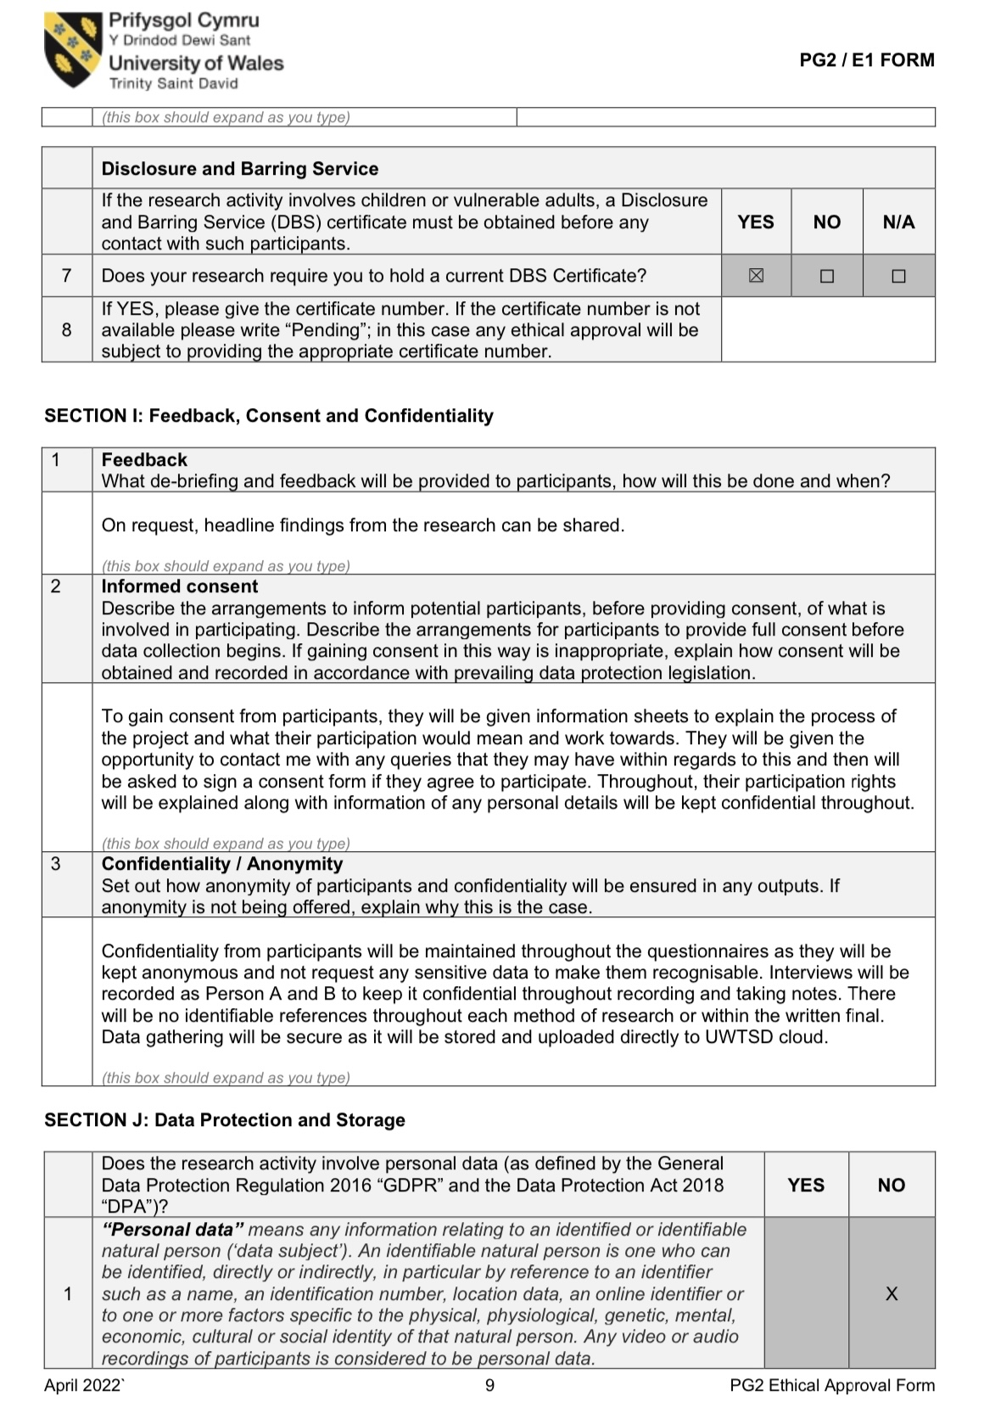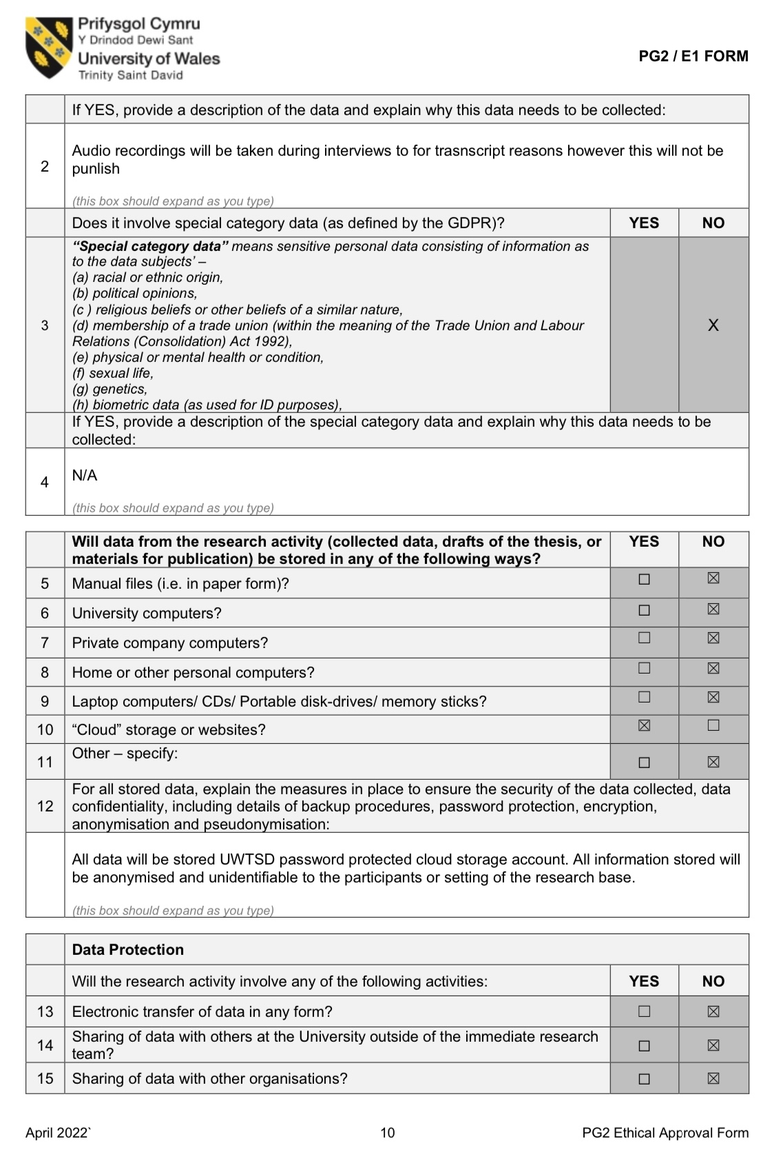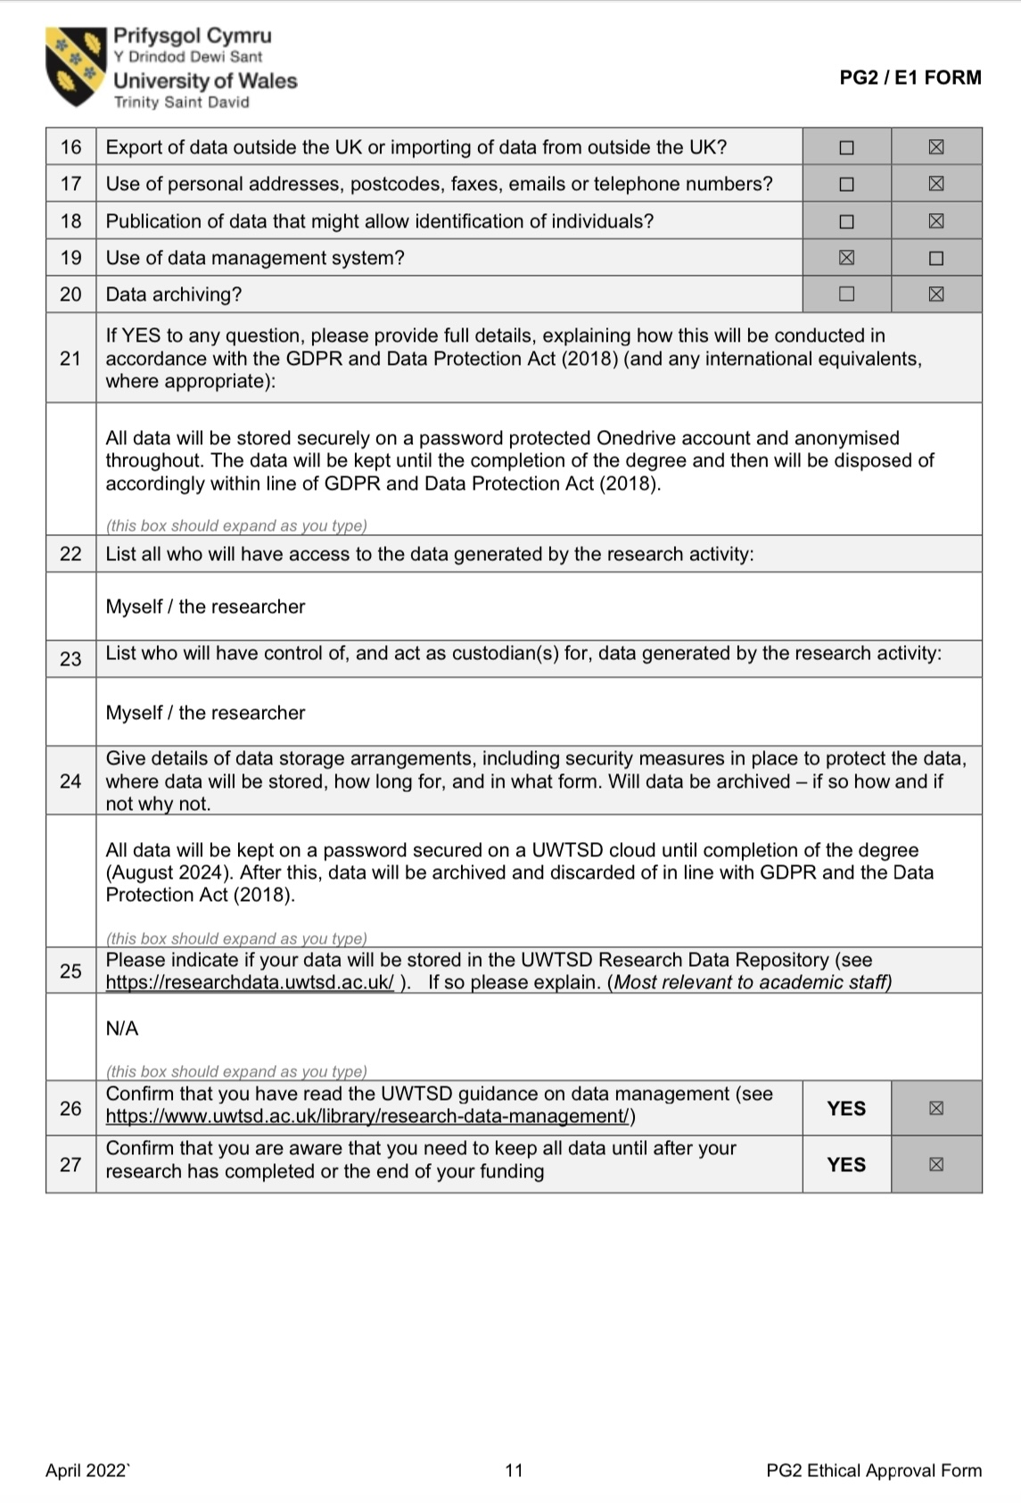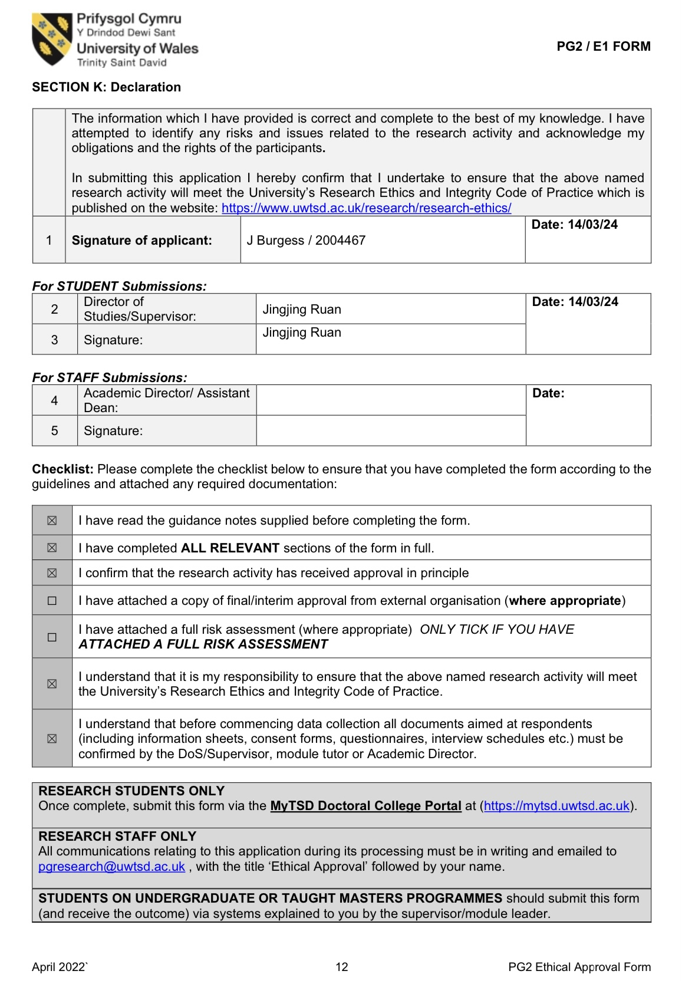
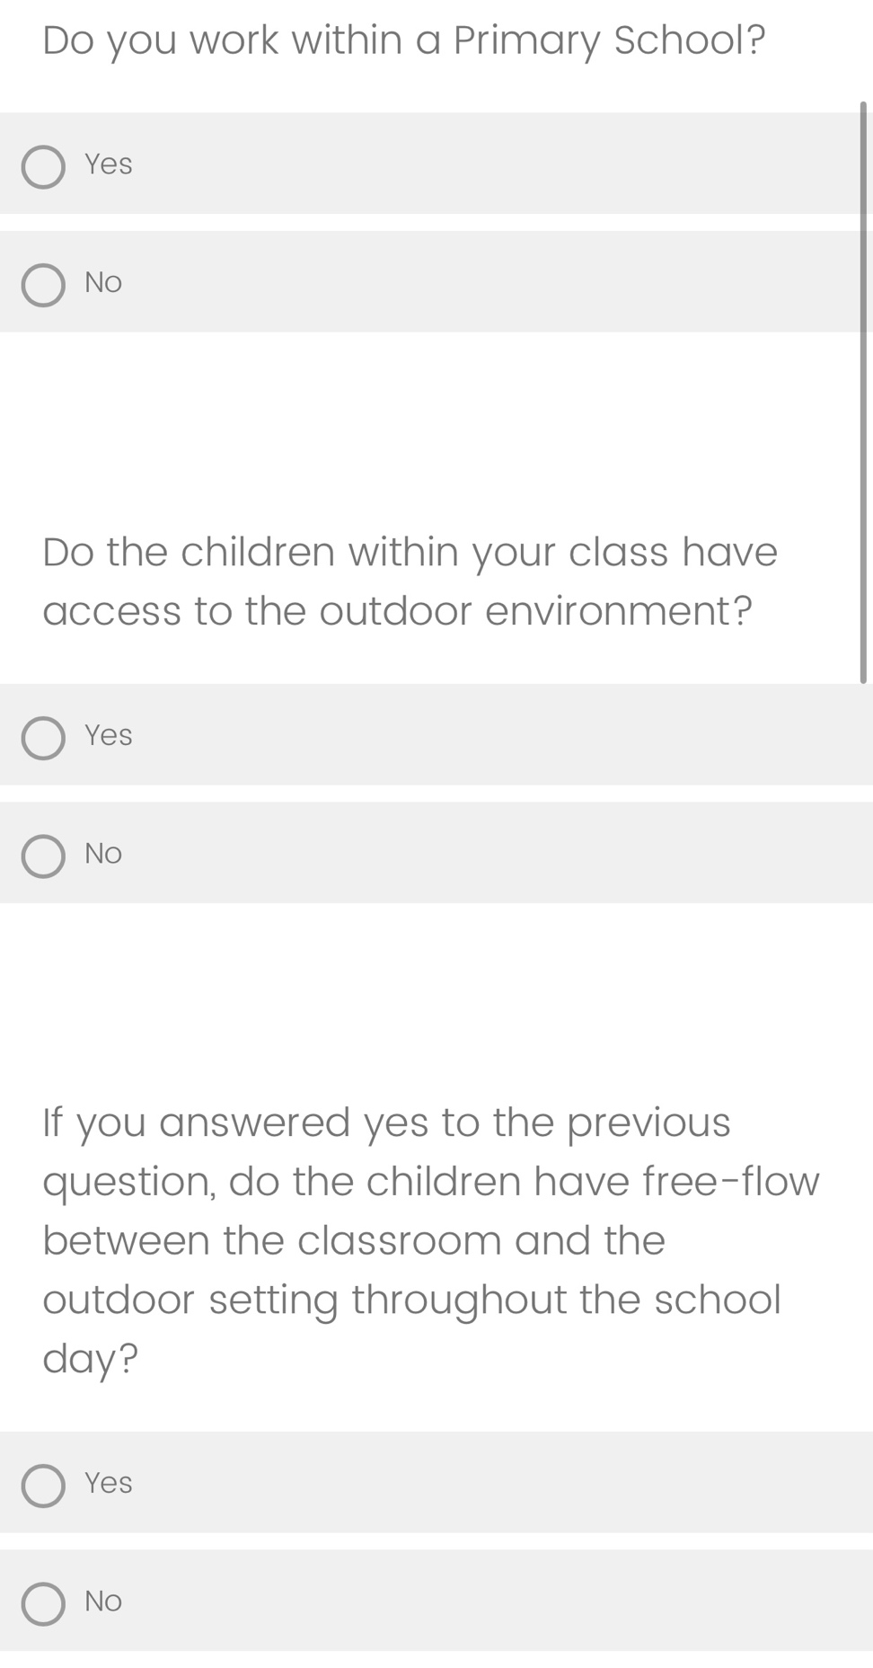
Appendix B: Questionnaire Schedule
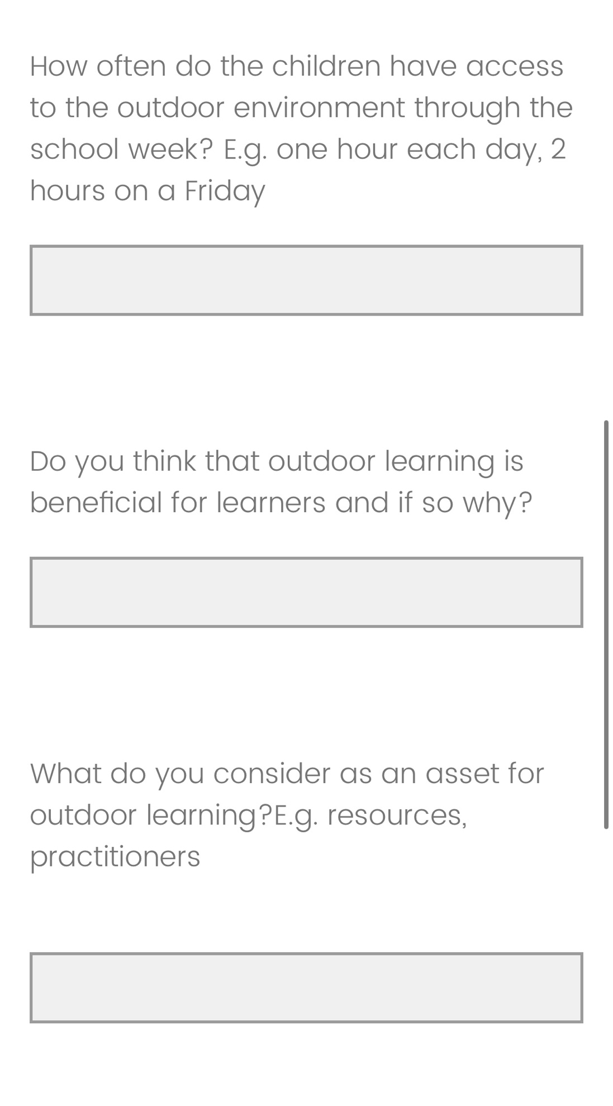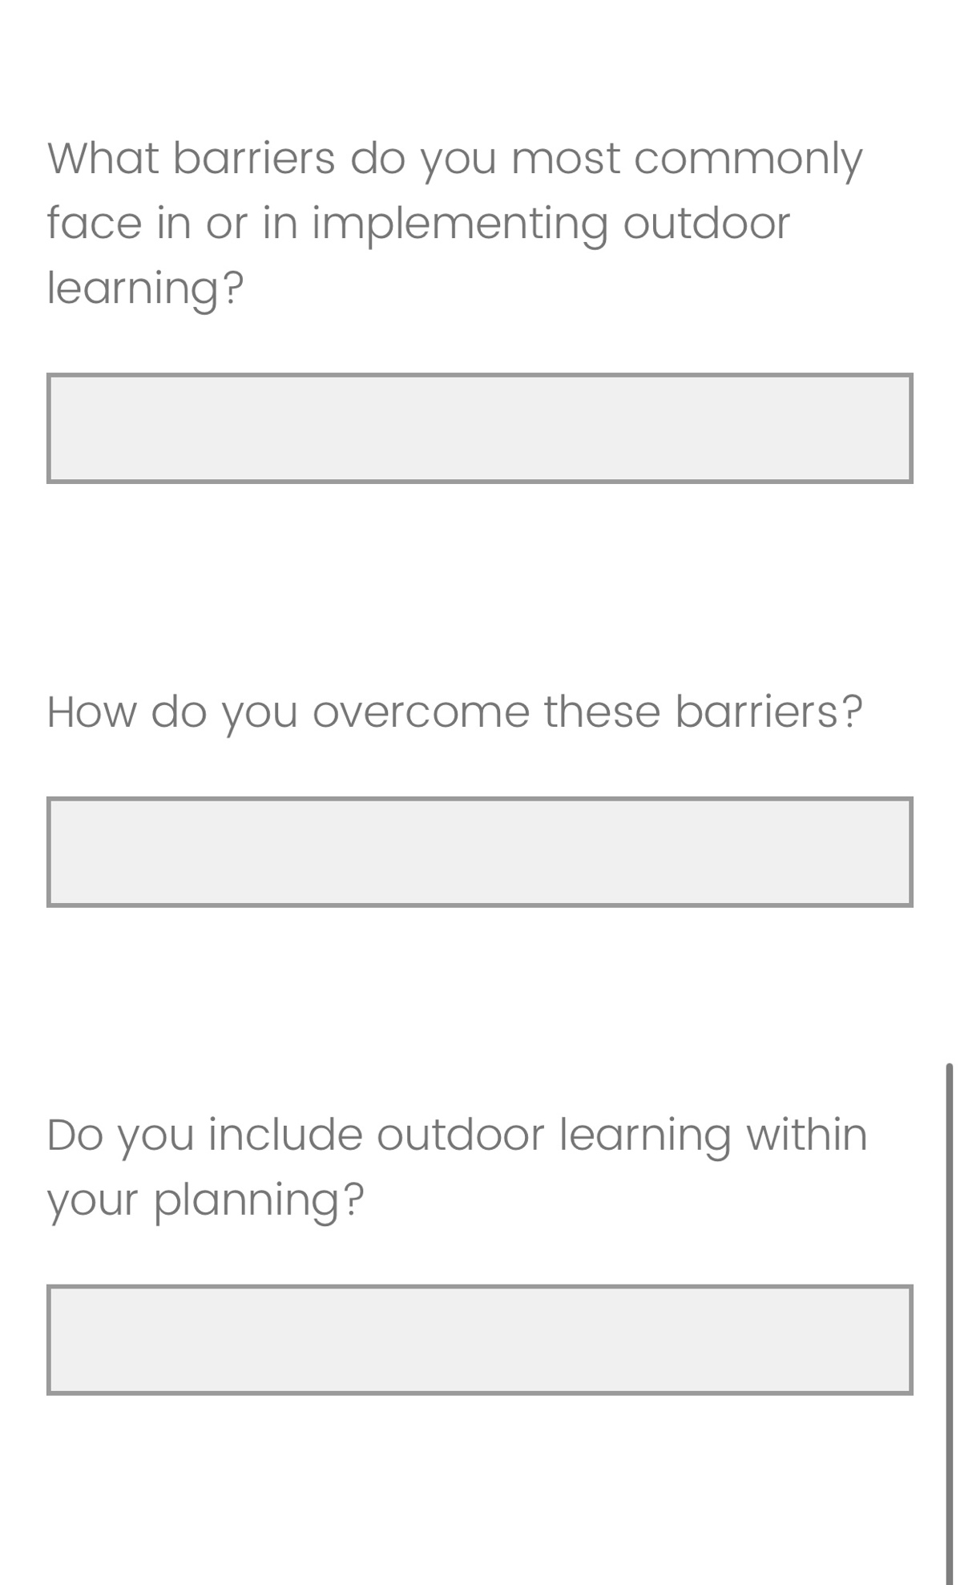
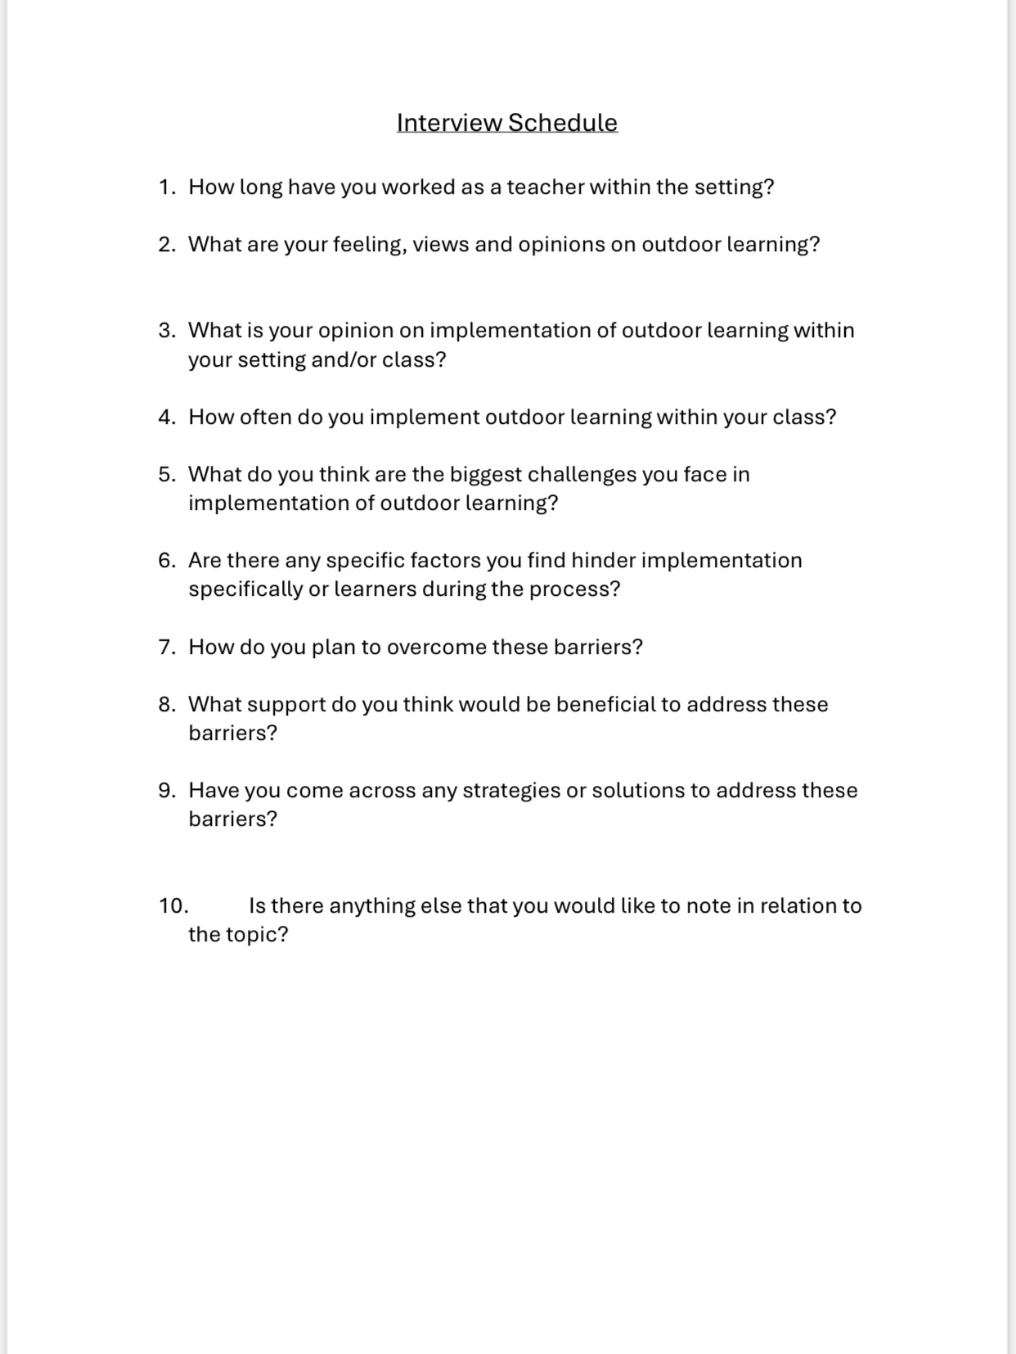
Appendix C: Interview Schedule
References:

Artino, A.R., La Rochelle, J.S., Dezee, K.J. and Gehlbach, H. (2014). Developing questionnaires for educational research: AMEE Guide No. 87. Medical Teacher, [online] 36(6), pp.463–474. doi:https://doi.org/10.3109/0142159x.2014.889814.

Barrable, A., Touloumakos, A. and Lapere, L. (2020). Exploring student teachers’ motivations and sources of confidence: the case of outdoor learning. European Journal of Teacher Education, 45(3), pp.1–17. doi:https://doi.org/10.1080/02619768.2020.1827386
Bento, G. and Dias, G. (2017). The Importance of Outdoor Play for Young Childrenʼs Healthy Development. Porto Biomedical Journal, [online] 2(5), pp.157–160. doi:https://doi.org/10.1016/j.pbj.2017.03.003.
Boynton, P.M. and Greenhalgh, T. (2004). Selecting, designing, and Developing Your Questionnaire. BMJ, [online] 328(7451), pp.1312–1315. doi:https://doi.org/10.1136/bmj.328.7451.1312.
Bronfenbrenner, U. (1979). Ecology of human development. Harvard University Press.
Cain, T. (2019). How research can inform teachers and teaching in schools. [online] www.bera.ac.uk. Available at: https://www.bera.ac.uk/blog/how-research-can-inform-teachers-and-teaching-in-schools.
Coleman, P. (2021). Special article validity and reliability within qualitative research in the caring sciences. International Journal of Caring Sciences, [online] 14(3), pp.3–2041. Available at: https://www.internationaljournalofcaringsciences.org/docs/54_goleman_special_14_3.pdf.
Crowe, S., Cresswell, K., Robertson, A., Huby, G., Avery, A. and Sheikh, A. (2019). The case study approach. BMC Medical Research Methodology, [online] 11(1). doi:https://doi.org/10.1186/1471-2288-11-100.
Dawadi, S. (2020). Thematic Analysis approach: a Step by Step Guide for ELT Research Practitioners. Journal of NELTA, [online] 25(1-2), pp.62–71. Available at: https://files.eric.ed.gov/fulltext/ED612353.pdf.
Dejonckheere, M., & Vaughn, L.M. (2019). Semi structured interviewing in primary care research: a balance of relationship and rigour. Family Medicine and Community Health, 7(2). https://www.ncbi.nlm.nih.gov/pmc/articles/PMC6910737/

Denzin, N.K. and Lincoln, Y.S. (2011). The SAGE Handbook of Qualitative Research. [online] Google Books. SAGE. Available at: https://books.google.co.uk/books?hl=en&lr=&id=AIRpMHgBYqIC&oi=fnd&pg=PA301&dq=what+is+a+case+study&ots=kqAPwLlvld&sig=7nKrPfIogQRtnzhWclPETy-8oJI&redir_esc=y#v=onepage&q=what%20is%20a%20case%20study&f=false
Edwards, M. (2022). Teacher confidence: Why it’s integral to outdoor learning. [online] Learning through Landscapes. Available at: https://ltl.org.uk/news/teacher-confidence-why-integral-outdoor-learning/.
Estyn (2011). Outdoor Learning an evaluation of learning in the outdoors for children under five in the Foundation Phase. [online] Available at: https://www.estyn.gov.wales/system/files/2020-07/Outdoor%2520learning%253A%2520%2520an%2520evaluation%2520of%2520learning%2520in%2520the%2520outdoors%2520for%2520children%2520under%2520five%2520in%2520the%2520Foundation%2520Phase%2520-%2520September%25202011.pdf.
Estyn (2023). Ymateb i Ymgynghoriad / Consultation Response Background information about Estyn. [online] Available at: https://www.estyn.gov.wales/system/files/2023-06/Consultation%20on%20the%20Outdoor%20Education%20%28Wales%29%20Bill_0.pdf [Accessed 12 Feb. 2024].
Fosnot, C.T. (2013). Constructivism: Theory, Perspectives, and Practice, Second Edition. [online] Google Books. Teachers College Press. Available at: https://books.google.co.uk/books?hl=en&lr=&id=-pIbAgAAQBAJ&oi=fnd&pg=PT9&dq=piaget+constructivism&ots=tzJdOVitCA&sig=NiXiWRFiqIZ9CRzFtHvcc-wuEj8#v=onepage&q=piaget%20constructivism&f=false [Accessed 7 May 2024].
Frances, R., Coughlan, M. and Patricia, C. (2009). Interviewing in Qualitative Research. [online] ResearchGate. Available at: https://www.researchgate.net/publication/261471599_Interviewing_in_qualitative_research.
Gerring, J. (2004). What Is a Case Study and What Is It Good for? American Political Science Review, 98(2), pp.341–354. doi:https://doi.org/10.1017/S0003055404001182.
Golzar, J. and Tajik, O. (2022). Convenience Sampling. [online] Available at: https://www.researchgate.net/publication/366390016_Convenience_Sampling.
Guerra, M., Villa, F. and Glăveanu, V.P. (2020). The teacher’s role in the relationship between creativity and outdoor education: a review of the literature. [online] Available at: https://www.researchgate.net/publication/351049069_The_teacher's_role_in_the_relationship_between_creativity_and_outdoor_education_a_review_of_the_literature.
Gustafsson, P.E., Szczepanski, A., Nelson, N. and Gustafsson, P.A. (2012). Effects of an outdoor education intervention on the mental health of schoolchildren. Journal of Adventure Education & Outdoor Learning, 12(1), pp.63–79. doi:https://doi.org/10.1080/14729679.2010.532994.
Guy-Evans, O. (2024) Bronfenbrenner’s ecological systems theory, Simply Psychology. Available at: https://www.simplypsychology.org/Bronfenbrenner.html.
Hannay, T. (2022). Economics lessons: How painful will things get? [online] SchoolDash. Available at: https://www.schooldash.com/blog-2210.html#20221021 [Accessed 6 May 2024].
Harman, N. (2024). Outdoor learning is vital for children’s mental health. [online] UK Youth. Available at: https://www.ukyouth.org/2024/02/outdoor-learning-is-vital-for-childrens-mental-health/.
Heal, L.W., & Sigelman, C.K. (1995). Response biases in interviews of individuals with limited mental ability. Journal of Intellect Disability Research. 10.1111/j.1365-2788.1995.tb00525.x

Herfors, D. (2016). The time and process used to write a case study. [online] Available at: https://www.diva-portal.org/smash/get/diva2:1052966/FULLTEXT01.pdf.
House of Commons (2005). Education Outside the Classroom Second Report of Session 2004-05 Report, together with formal minutes, oral and written evidence. [online] Available at: https://publications.parliament.uk/pa/cm200405/cmselect/cmeduski/120/120.pdf.
Irvin, M. (2017). The Importance of Play in Early Childhood Education. [online] Available at: https://nwcommons.nwciowa.edu/cgi/viewcontent.cgi?article=1067&context=education_masters.
Jamshed, S. (2014). Qualitative Research Method-Interviewing and Observation. Journal of Basic and Clinical Pharmacy, [online] 5(4), pp.87–88. doi:https://doi.org/10.4103/0976-0105.141942.
Kings College London (2010). Beyond Barriers to Learning Outside the Classroom in Natural Environments .
Kivunja, C. and Kuyini, A.B. (2017). Understanding and applying research paradigms in educational contexts. International Journal of Higher Education, [online] 6(5), pp.26–41. doi:https://doi.org/10.5430/ijhe.v6n5p26.
Kolb, D., Boyatzis, R., Mainemelis, C., Sternberg, R. and Zhang, L. (1999). Experiential Learning Theory: Previous Research and New Directions. [online] Available at: https://learningfromexperience.com/downloads/research-library/experiential-learning-theory.pdf.
Kuemerle , J. (2019). Exploring the World Around You: A Guide to Learning About the Natural World . [online] Available at: https://scholarworks.bgsu.edu/cgi/viewcontent.cgi?article=1608&context=honorsprojects.
Lavrakas, P. (2008). Encyclopedia of Survey Research Methods. Encyclopedia of Survey Research Methods, 1(1). doi:https://doi.org/10.4135/9781412963947.
Mackenzie, M. and Carolan, M. (2019). oals) (prosperity Childhood, Unplugged: Overcoming Barriers to Outdoor Learning and Hands-On Play. [online] Available at: https://www.instituteforchildsuccess.org/wp-content/uploads/2019/02/Childhood-Unplugged-Outdoor-Learning.pdf.
Maguire, M., & Delahunt, B. (2017). Doing a Thematic Analysis: A Practical, Step-by-Step Guide for Learning and Teaching Scholars. Journal of Teaching and Learning in Higher Education, 9(3). https://ojs.aishe.org/index.php/aishe-j/article/view/335

Maynard, T., Waters, J. and Clement, J. (2013). Moving outdoors: further explorations of ‘child-initiated’ learning in the outdoor environment. Education 3-13, 41(3), pp.282–299. doi:https://doi.org/10.1080/03004279.2011.578750.
Mcleod, S. (2007). [Simply Psychology]. www.simplypsychology.org. [online] Available at: https://www.simplypsychology.org/Bronfenbrenner.html..
Mendez-Sanchez, N. (2022). Interpretive bias on research evidence: Striving to meet the trustworthiness criteria | Annals of Hepatology. [online] www.elsevier.es. Available at: https://www.elsevier.es/en-revista-annals-hepatology-16-avance-resumen-interpretive-bias-on-research-evidence-S1665268122002265#:~:text=The%20interpretation%20of%20data%20can.
NASUWT (2023). Lesson planning. [online] www.nasuwt.org.uk. Available at: https://www.nasuwt.org.uk/advice/in-the-classroom/lesson-planning.html.
National Education Union (2023). The Crisis in Funding for Schools and Colleges in Wales. [online] National Education Union. Available at: https://neu.org.uk/latest/press-releases/crisis-funding-schools-and-colleges-wales-motion-22.
Natural England (2016). England’s largest outdoor learning project reveals children more motivated to learn when outside. [online] GOV.uk. Available at: https://www.gov.uk/government/news/englands-largest-outdoor-learning-project-reveals-children-more-motivated-to-learn-when-outside#:~:text=It%20was%20launched%20following%20evidence%20that%20the%20challenges%20to%20learning%20outside%20the%20classroom%20in%20the%20natural%20environment%20in%20schools%20were%20local%20and%20revolved%20around%20a%20lack%20of%20teacher%20confidence%20in%20teaching%20outside.
National Library of Medicine. (n.d.). Qualitative Data. https://www.nnlm.gov/guides/data-glossary/qualitative-data
NHS England. (2018). Writing an Effective Questionnaire. https://www.england.nhs.uk/wp-content/uploads/2018/01/bitesize-guide-writing-an-effective-questionnaire.pdf

NHS (n.d.). Research brief. [online] Available at: https://phw.nhs.wales/publications/publications1/children-and-young-peoples-mental-well-being-during-the-covid-19-pandemic-research-brief/#:~:text=The%20emotional%20well%2Dbeing%20of.
nidirect (2018). Playing outdoors | nidirect. [online] www.nidirect.gov.uk. Available at: https://www.nidirect.gov.uk/articles/playing-outdoors#:~:text=children.
Nowell, L.S., Norris, J.M., White, D.E., & Moules, N.J. (2017). Thematic Analysis: Striving to Meet the Trustworthiness Criteria. International Journal of Qualitative Methods. https://doi.org/10.1177/1609406917733847

Patchen, A.K., Rakow, D.A., Wells, N.M., Hillson, S. and Meredith, G.R. (2022). Barriers to children’s outdoor time: teachers’ and principals’ experiences in elementary schools. Environmental Education Research, 30(1), pp.1–21. doi:https://doi.org/10.1080/13504622.2022.2099530.
Priya, A. (2020). Case study methodology of qualitative research: Key attributes and navigating the conundrums in its application. Sociological Bulletin, [online] 70(1), pp.94–110. doi:https://doi.org/10.1177/0038022920970318.
Regmi, P.R., Waithaka, E., Paudyal, A., Simkhada, P. and Van Teijlingen, E. (2016). Guide to the design and application of online questionnaire surveys. Nepal Journal of Epidemiology, [online] 6(4), pp.640–644. Available at: https://www.ncbi.nlm.nih.gov/pmc/articles/PMC5506389/.
Resnik, D. (2020). What Is Ethics in Research & Why Is It Important? [online] National Institute of Environmental Health Sciences. Available at: https://www.niehs.nih.gov/research/resources/bioethics/whatis#:~:text=There%20are%20several%20reasons%20why.
Roberts, K., Dowell, A. and Nie, J.-B. (2019). Attempting Rigour and Replicability in Thematic Analysis of Qualitative Research data; a Case Study of Codebook Development. BMC Medical Research Methodology, [online] 19(1), pp.1–8. Available at: https://bmcmedresmethodol.biomedcentral.com/articles/10.1186/s12874-019-0707-y.
Robinson, O. (2023). Probing in qualitative research interviews: Theory and practice. Qualitative Research in Psychology, [online] 20(3), pp.382–397. doi:https://doi.org/10.1080/14780887.2023.2238625.
Rowley, J. (2014). Designing and Using Research Questionnaires. Management Research Review, [online] 37(3), pp.308–330. Available at: https://e-space.mmu.ac.uk/579515/1/Designing%20and%20using%20Research%20QuestionnairesREV18042013.pdf.
Rumbold, A. (1990). Rumbold Report (1990). [online] www.education-uk.org. Available at: https://www.education-uk.org/documents/rumbold/rumbold1990.html [Accessed 4 May 2024].
Ryan, G. (2018). Introduction to positivism, Interpretivism and Critical Theory. Nurse Researcher, [online] 25(4), pp.41–49. Available at: https://oro.open.ac.uk/49591/17/49591ORO.pdf.
Sage (2011). Chapter 12: Qualitative Data, Analysis, and Design. [online] Available at: https://www.sagepub.com/sites/default/files/upm-binaries/43144_12.pdf.
Sapsford, R. (1999). Survey Reserach. London: Sage.
Siviy, Stephen M. (2016). A brain motivated to play: insights into the neurobiology of playfulness. Behaviour, 153(6-7), pp.819–844. doi:https://doi.org/10.1163/1568539x-00003349.
Sutton, J. and Austin, Z. (2015). Qualitative Research: Data Collection, Analysis, and Management. The Canadian Journal of Hospital Pharmacy, [online] 68(3), pp.226–231. Available at: https://www.ncbi.nlm.nih.gov/pmc/articles/PMC4485510/#:~:text=CONCLUSIONS-.
Triantafyllou, S. (2022). Constructivist Learning Environments. [online] Available at: https://www.dpublication.com/wp-content/uploads/2022/04/2-4042.pdf.
Twohig-Bennett, C. and Jones, A. (2018). The Health Benefits of the Great outdoors: a Systematic Review and meta-analysis of Greenspace Exposure and Health Outcomes. Environmental Research, [online] 166, pp.628–637. doi:https://doi.org/10.1016/j.envres.2018.06.030.
Vaismoradi, M., Turunen, H. and Bondas, T. (2013). Content analysis and thematic analysis: Implications for conducting a qualitative descriptive study. Nursing & Health Sciences, [online] 15(3), pp.398–405. doi:https://doi.org/10.1111/nhs.12048.
van Dijk-Wesselius, J.E., van den Berg, A.E., Maas, J. and Hovinga, D. (2020). Green Schoolyards as Outdoor Learning Environments: Barriers and Solutions as Experienced by Primary School Teachers. Frontiers in Psychology, [online] 10. doi:https://doi.org/10.3389/fpsyg.2019.02919.
Waite, S. (n.d.). Outdoor learning for children aged 2-11: perceived barriers, potential solutions. [online] Available at: https://www.researchgate.net/profile/Sue-Waite/publication/242494391_Outdoor_learning_for_children_aged_2-11_perceived_barriers_potential_solutions/links/0deec5300881a079f8000000/Outdoor-learning-for-children-aged-2-11-perceived-barriers-potential-solutions.pdf.
Welsh Assembly Government (2008a). Yr Adran Plant, Addysg, Dysgu Gydol Oes a Sgiliau Department for Children, Education, Lifelong Learning and Skills Learning and Teaching Pedagogy. [online] Available at: https://hwb.gov.wales/storage/8f0b360f-f1f6-4bec-b11a-df88168007f9/learning-and-teaching-pedagogy.pdf.
Welsh Assembly Government (2008b). Yr Adran Plant, Addysg, Dysgu Gydol Oes a Sgiliau Department for Children, Education, Lifelong Learning and Skills Play/Active Learning Overview for 3 to 7-year-olds. [online] Available at: https://hwb.gov.wales/storage/52aae98d-65ed-4065-9222-1a7876e150de/play-active-learning-overview-for-3-to-7-year-olds.pdf.
Welsh Government (2009). Foundation Phase Outdoor Learning Handbook. [online] Available at: https://hwb.gov.wales/storage/fcb8539c-9be7-4883-8542-35d7b54b56f2/foundation-phase-outdoor-learning-handbook.pdf.
Welsh Government (2015). Well-being of Future Generations (Wales) Act 2015: the essentials [HTML]. [online] GOV.WALES. Available at: https://www.gov.wales/well-being-future-generations-act-essentials-html#60668.
Welsh Government (2022). Curriculum for Wales - Hwb. [online] hwb.gov.wales. Available at: https://hwb.gov.wales/curriculum-for-wales.
Welsh Government (2023a). Annex 4: Developing Community Engagement in Community Focused Schools [HTML] | GOV.WALES. [online] www.gov.wales. Available at: https://www.gov.wales/annex-4-developing-community-engagement-community-focused-schools-html.
Welsh Government (2023b). Teaching and learning in the outdoors: the current state of outdoor learning in schools in Wales. [online] Available at: https://hwb.gov.wales/api/storage/177a33a6-7c70-4843-bb63-903e70a04154/teaching-and-learning-in-the-outdoors-the-current-state-of-outdoor-learning-in-schools-in-wales.pdf.

