Certificate of Higher Education Skills for the Workplace (Health & Social Care)
PORTFOLIO-TWO TASKS
Module: Introduction to Health and Social Care
Module code: LCHS4003
Fahtima Iyaiz
Student number: 2319515

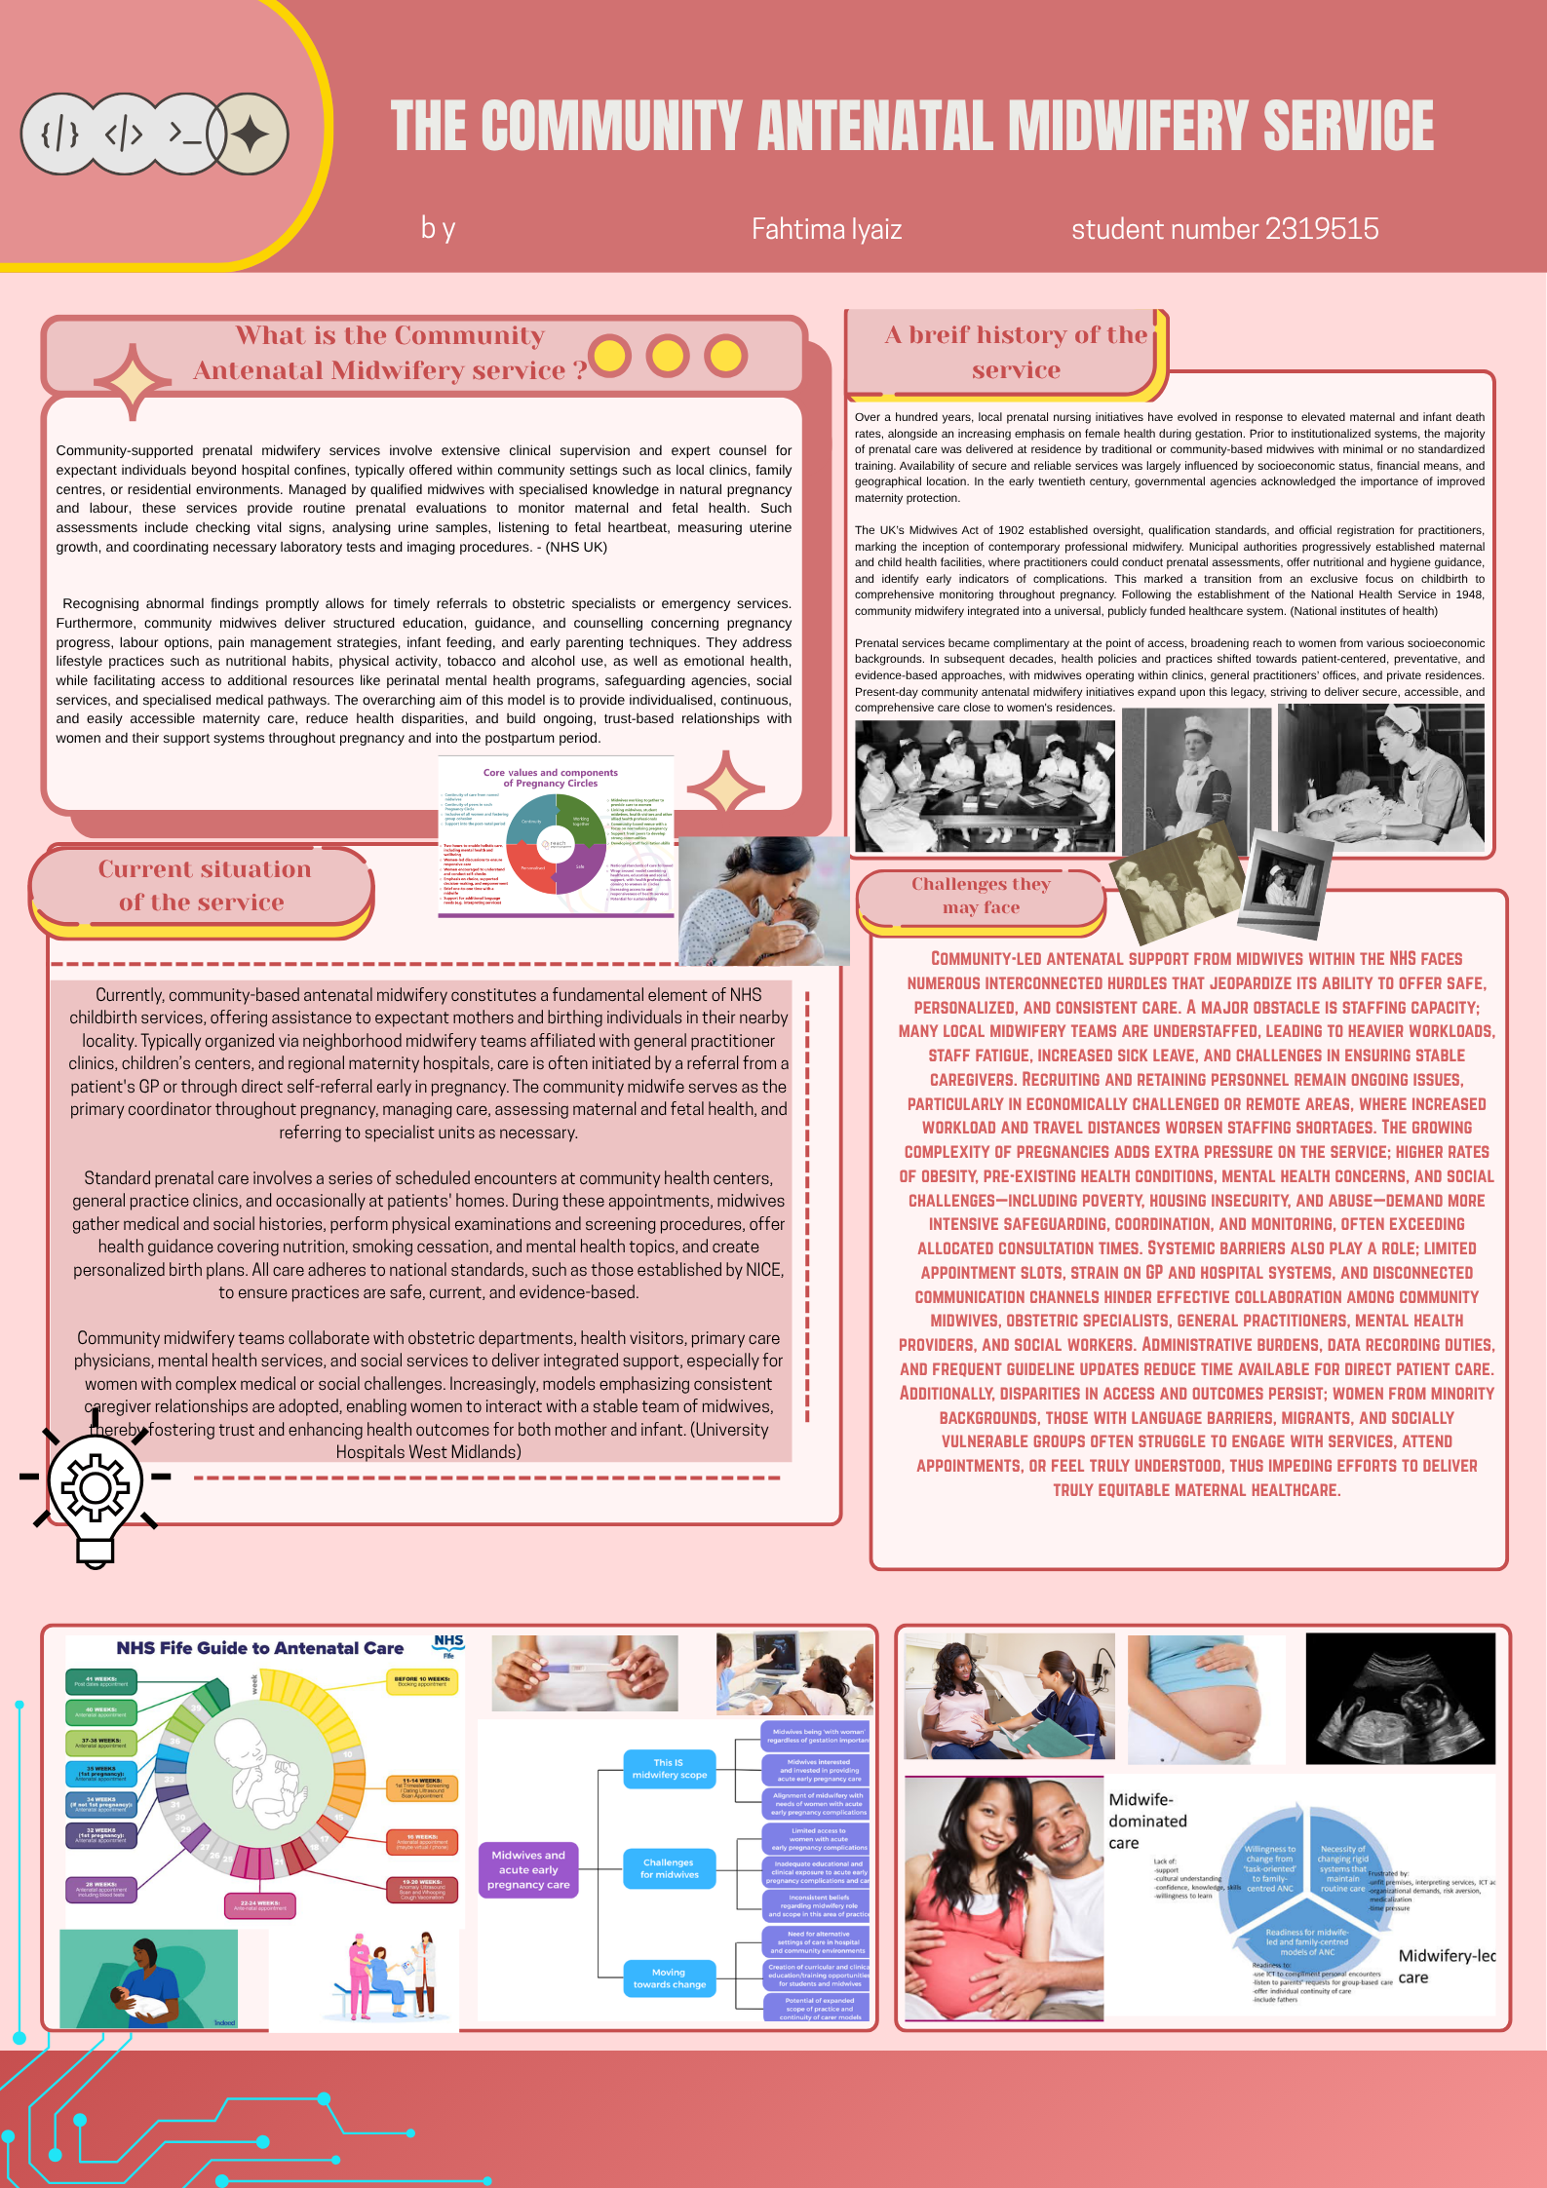Task 02

Established in 1948, the NHS has roots in earlier UK societal, political, and economic shifts. Before its creation, healthcare was fragmented, based on personal finances, voluntary efforts, and small government programs. Early 20th-century concerns grew over public health, especially among workers, impacting industry, military, and society. (Gorsky, 2008; Baggott, 2019)

The 1911 National Insurance Act mandated health coverage for certain workers, funded by employees, employers, and government. However, it covered only a segment of the population and predominantly addressed primary medical services, excluding hospital care and various demographics such as dependents and the unemployed. During the inter-war period, disparities persisted, shown by high infant mortality, poverty, and unequal access to hospitals. (Baggott, 2019; Gorsky, 2008)
The conflict universally influenced global history, reshaping political boundaries, economic systems, and cultural practices worldwide, marking a significant turning point. Its profound consequences prompted nations to reevaluate their policies, fostering new alliances and challenging traditional structures. The war's aftermath saw extensive reconstruction efforts and the emergence of international organisations aimed at ensuring peace and stability, reflecting its pivotal role in shaping modern society.
Aneurin Bevan, as Minister of Health in the post-war Labour government, was key in turning ideas into policy. The 1946 National Health Service Act created the NHS, based on three main principles: universality (access for all residents), comprehensiveness (including various services), and gratuity at entry (funded by taxes, not fees). These reflected broader commitments to social citizenship, equality, and shared responsibility, honoring wartime sacrifices. (Gorsky, 2008; Baggott, 2019; NHS England, 2023)

The National Health Service initially merged formerly autonomous charitable and municipal medical centres under government control, while primary care physicians (GPs) continued operating as independent agents of the state. Over subsequent years, the organisation evolved into a national emblem representing social unity. Nonetheless, disagreements soon arose due to increasing patient volumes, technological innovations, and resource constraints, fuelling an ongoing discussion concerning expenditure, effectiveness, and fairness. (The King’s Fund, 2022; NHS England, 2022)
The NHS remains rooted in its original principles, but its structure and operations have changed through reforms. In England, it's divided into tiers like the Department of Health and Social Care, NHS England, ICPs, hospital trusts, and primary care. Scotland, Wales, and Northern Ireland have unique NHS frameworks with separate policies and admin structures. (The King’s Fund, 2022; NHS England, 2023; Pollock and Roderick, 2019)
The NHS faces ongoing challenges due to demographic shifts, like an aging population and rising chronic illnesses, and increasing demand. Limited funds and personnel shortages cause longer wait times, stress emergency services, and hinder quality. Since the 1990s, reforms introduced market mechanisms separating purchasers and providers, fostering competition, and involving the private sector to improve efficiency and patient options.
Proponents say reforms boost innovation, responsiveness, and resource use. Critics argue they cause care fragmentation, higher admin costs, and weaken NHS collaboration. Concerns also exist about privatisation, fearing that outsourcing and private investment may threaten equitable care based on need, not ability to pay.
Recently, there has been a policy shift towards greater integration and cooperation, mainly through Integrated Care Systems designed to unify health and social services, emphasise preventative measures, and address disparities in health outcomes. However, social care remains means-tested and operates separately from the NHS, leading to service gaps for elderly and disabled individuals and putting extra pressure on healthcare facilities.
The NHS maintains universality and point-of-service care but faces balancing government funding, administrative shifts, and market influences. Its future depends on resolving conflicts between fairness and efficiency, control and autonomy, and urgent versus preventive care. It must also tackle financial sustainability and staffing issues, which will shape how well it can serve as healthcare demands evolve.

References

1. Book on health policy and NHS principles Baggott, R. (2019) Understanding Health Policy. 3rd edn. Bristol: Policy Press. Available at: https://policy.bristoluniversitypress.co.uk/understanding-health-policy (Accessed: 1 April 2026).
2. Historiography and development of the NHS Gorsky, M. (2008) ‘The British National Health Service 1948–2008: A review of the historiography’, Social History of Medicine, 21(3), pp. 437–460. Available at: https://doi.org/10.1093/shm/hkn064 (Accessed: 1 April 2026).
3. Official NHS principles and evolution (policy) NHS England (2023) The NHS Long Term Plan: About the NHS. Available at: https://www.longtermplan.nhs.uk/online-version/chapter-1-a-new-service-model-for-the-21st-century/the-nhs-long-term-plan/ (Accessed: 1 April 2026).
4. Current NHS structure explained The King’s Fund (2022) The NHS in England: The structure and how it works. Available at: https://www.kingsfund.org.uk/publications/nhs-structure-explained (Accessed: 1 April 2026).
5. Integrated Care Systems and current reforms NHS England (2022) What are integrated care systems? Available at: https://www.england.nhs.uk/integratedcare/what-is-integrated-care/ (Accessed: 1 April 2026).
6. Market mechanisms and privatisation concerns Pollock, A.M. and Roderick, P. (2019) ‘Why we should be concerned about Accountable Care Organisations in England’s NHS’, BMJ, 360, k343. Available at: https://www.bmj.com/content/360/bmj.k343 (Accessed: 1 April 2026).

