Developing Relationships and Workplace Achievement

Student id Liliana Calin

Table of contents
Introduction
Overview of founding relationship alongside workplace
Case study Capco
1 Critical valuation according the strongest benefits from the organization and his function
2 Development parts that can be affordable for individual established essentials needs
3 A strategy to help solve particular needs and all the desired goals
Conclusion
References

Introduction
An important feature of improving performance in a business is create a great workplace background that can offer chances of diverse situations. Also an important factor to improve individual performance that’s help achieve success . The great workplace can clearly perform a association with stakeholders and employees which brings job satisfaction towards workplace . In this work is focus on improvement and creating relationship between staff , that helps them to bring positive ethics to the company . Also an individual assessment will be also discuss Wipro Capco case study where important aspects will appropriately showed for improve relationships. A positive relationship is crucial for facing upcoming situations. Other aspect the particular organization employees must be able to improve a relationship with all and show best examples towards management boards . Therefore the operation management must create few steps to change the ethics and policies that can bring satisfaction and interest to the employees at the workplace . The operation management can review that’s facts to get high performance and cut the risks .
Overview of founding relationship alongside workplace
Requirement alongside expectation should exist unacceptable form in any organization . This fact can clearly produce morals and values of workers . There are some solutions below .
- Harmonic workplace . This is one aspect that employees take In consideration . Having this environment is better for employees so they can build a good relationship between and provide best results. As 85% of capco `s workers realise that they are contents in terms of personal development . This factor help company `s commitment to support all workers and discover their skills , their industry knowledge, at any time of their future career .
- Company’s heads . Normally , every organizations superiors are the important piece to organize the workers into a good way also offer better solutions to achieve the target of the company . Senior manager have a crucial responsibility to manage their best employees and create a strong connection . Middle managers also help employees to get a good understanding of their task and provide them training . Capco management transformational leadership communicates regularly with the employees to give the best motivation and enhance their productivity and efficiency .
- Freedom . Normally all employees have expectations from an organization to have the free expression and feel free to share new ideas and create a good relationship between work and personal experiences . Employees which benefits of this fact they can offer a better service and performance in their task .
- No separation . Usually , employees are not concentrating on no group separation which create conflicts. Therefore they stay focuses on achieving business targets in that time. A team work can communicate , brainstorm, collaborate , share , decide and solve all the upcoming hard situation or unknown that can be meted in workplace . Astrong team is a key towards the success of a organization .

Case study Capco Wipro
Case background : Basically , Capco has been an important player in leading global provider in terms of tech- companies providing it services including business process outsourcing services globally . This organization was science 15 years ago regarding Technology and services . This case are observing his employees in terms of growth creativity and provide tailored solutions . Capco is a top organization in terms of offering technology solutions , and consulting for financial part . The detailed concept of organizational behaviour permit us o understand the attitudes and the behaviour oh the people working of the organizations in the most efficient way . This concept is the most important task to understand the workplace culture and build a easy way through the success of the organization . This organization is a strong company and is situated in a good position top of 100 technologies company . The principal factor of this success are their employees , the company has build his value of respect, integrity, knowledge which say the way of how the company interact with his clients and reflect the behaviours from its employees. Also they have a large scale clients with 75 % of the world global financial services organizations .

Fishbone analysis
This analysis is useful to develop a better decision making methods and problem solving. After this analysis this particular case may want to rise some of the biggest dares that can simply change organizations . Moreover This examination shows oncoming problems at the market when competitors can also expect the chance to present specific service which can be exclusive and new from opponents . The client is a leading manufacturer and supplier of printing and imaging solutions. Headquartered in us offers services that the clients request such us print services, managed software , professional services globally across industries like banking, education, government, healthcare manufacturing . The purpose is matter and used for showing the bottleneck state wakeup Ing any interest. Whoever this examination contribute to transform issues and is an principal aspect in terms of decision making methods .

Capco redesigned and re-architected the clients data extraction and transformation applications to increase the reliability of critical business apps . There are some improvements and scopes .
- Putting in place a mixture of best practices and performance tuning exercises to handle the load on the applications used , inhibiting productions delays and frequent high severity incidents
- Connecting knowledge gaps within the team and improving motivation team
- Leading pareto analysis to allow effective problem management which ran to important reduction in high severity incidents .
- Improving operational excellence through value stream mapping and automation.
- Identifying cost and efficiency gains in business processes
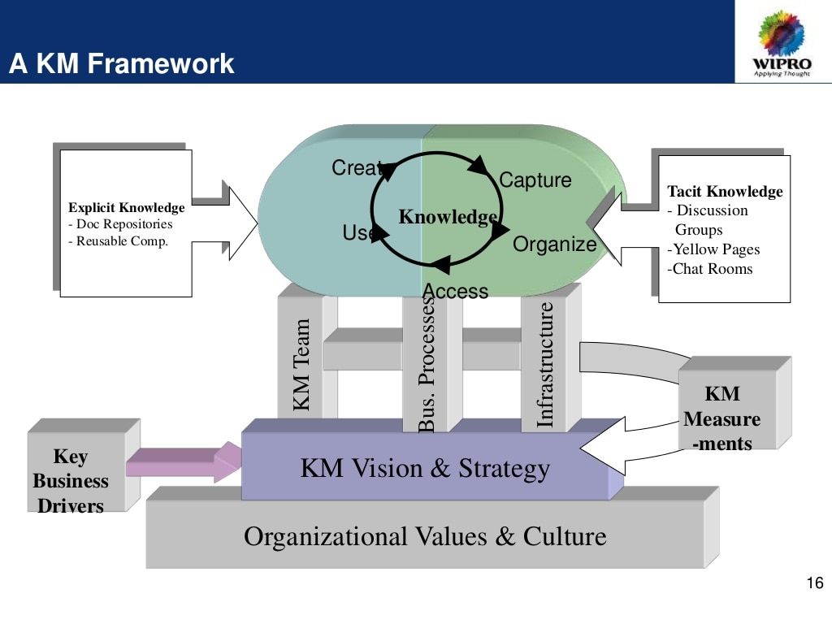

Also Capco must offer suport at organizational matrix , and that must be rise for companies improvements counting organizations activities. Therefore companies can create unique business design and present advance technology .

1 Critical valuation according the strongest benefits from the organization and his function

After evaluating the capco file , has been offered many components that can bring many benefits towards the organization also considering the individual personality growth . Also few strongest benefits can develop professional improvement among employees and personal development by offer training sessions at workplace .

Name | Assessment
The absence regarding complex bureaucracy | The organizational increase the scale of bureaucracy next to the keeping power . This type of bureaucracy offer a big input for changing the workplace and try to help to develop decision-making methods. Capco is free from the bureaucracy issue .
Idea creation hub | A review on that founding has been applied from workers ideas in an organization. A individual concept normally exist in an organization that which could easily provide equal opportunity towards individual workers .
Training courses | An important element applied by this organization official training has been offered mentioned by capco
Service diversification | Different products describe news ideas lunching can be more interesting to new customers . Also many improvements can be applied in name of the organizational work which could help to achieve strategic plans of the company .
Big customers base | Capco create a enormous client base that prove is an important element regarding loyal customers. Capco is complementary good brand image in terms of client across world .

After reviewing all the factors that capco organization provide us , employees should dispose a lot of services and supplies to search and improve trust that can helps to measure relationship . While the level of performance can be easily improved an example improve job vacancies as soon as the firm took a good position in the market. In addition such factor can make a difference comparing the necessities and skills for each employee. The part management has indicated to make use of KPI for create work performance . Among this method used approximately for a better functionality and improvement . In fact the organizational management takes in consideration and having a view of the employees weaknesses and strengths . Applying this can be monetarized individual performance daily or monthly and also the organization can determine strategic goals and having idea to develop duration-making method and employees influence can be considered during operation . In other hand compare and improve performance in the next days? The board management think in implement KPI for developing individual performance . Trought this technique can be applied for a better organizational and the overall function . Using this the strengths and wekneass of the employees can be easily to recognize . Apart of that the company can visualize and analyse this points and start train employees for a better performance and for the goal that the organization want to achieve .

2 Development parts that can be affordable for individual established essentials needs

Looking at the above scenario has established suitable points for the factor of connecting precise points looking at the needs of the development. Personal development is a lifelong process. It is a mode for persons to asses their skills and qualities consider the aims and goals in terms of realise and maximise the potential . Holding support structure within an organization or a personal structure of the personal development skills to be more versatile in changing must be established a framework with all the key statements and improvements in order to know what can be performed . Capco innovation process meets the needs of its clients by certain steps

Task | Definition
Personal learning and different skills | This factor explain important parts into a company and offer best support to all the workers for create a strong association . The company must design one way that can be easier to develop product demands . However employers can improve work experience by getting involved into business operation . Individual employee can easily learn important aspects in terms of project management style from superiors.
Driving Potential Market via effective Brand Positioning | building big thoughts can clearly produce products design and quality towards consumers and bring an apport to the organization . And follow what can be offered towards a strong market . Consumers expectations can stay changed according to the time while competitors can introduce the information of the products . Therefore innovations well although can impress customers and stay focused on productive service and proper behaviour .
Working Culture | This element is an important and effective aspect that can help improvement for the individual. Also the workplace atmosphere makes sure that workers can offer a better service and improve their knowledge and express their opinions and show efficiency accurately .(Shell,2003 ).
In addition , this organization create some variables which can be useful to improve the individuals assets .
- Management of the individuals career progression : A order of a good planning builds will surely conduce persons career way . A numerous plans are ready to get the success of a technical vocation ,
- Achieve the objective /strategy : Is the next step of the organization vocation management setting . The guideline planner drive his processes in touch with the timeline .
- Establish a horary : This is an important aspect in times to build a management strategy . All the question that can be created can be solved . The conclusion is know and discover the feelings that an employer can have about that job , and try to converse and find a way to create a nice workplace environment and refuse misunderstandings .

A strategy to help solve particular essentials and the future goals
The business starts with a idea to define the necessities and hopes of an individual. Wipro also have a growth strategy which I explain below. steps they follow is considering the principal factors and strategies to get the aim of the company . All is based on the customers expectation and the improvement on the industry . They have a structured strategy towards the market research ,domain and technology .
- Work with clients to discover and define the vision and growth aim as a north star for the strategy effort .
- Define the critical points and get focused such us geographical ,client , line of business, product/services , thinking in the demands , competition, and the objective core competencies .
- Define the best differentiation strategies that permit customers to get a new market share by competing on innovation product, customer experience , or new business model , all are the above to create a unique value.
- Define the operating model and skills required to implement the strategy that can drive to identify risks and opportunities and permit to customers to move forward with confidence .
Developing a winning strategy is not easy . Succes appear when is clearly defined some core statements like have a clear vision and understanding of costumers , competition and core competencies . The revolution process offer capco and its customer t the trust that the plan is going to be successfully worth a long time investment and try meting all the clients necessities .

Conclusion
Managing these relationships between organization and employee is crucial to business success, a strong relationship can lead to grater employee happiness and increase productivity . In this case Capco focuses on organizational behaviour . Employees of Capco feels appreciated , happy , creative, knowledge, problem solving, commitment , integrity and respect. This organization is situated on 27th position among 100 best companies list. This company has a clearly defined values that all follows which is Integrity, respect, commitment, excellence, knowledge . Capco is an integrated corporation that offers a diversity list of products, solutions and services in systems software costumer needs, and infrastructure technology . With a constant innovation the company try to create a trust a vision and passion with all customers by offering their best solutions and services . Capco`s culture means its workers stay empowered and motivated . This encourages them to positively add to generating important ideas and operational team working in this innovative working environment .

References
Amstrong , M.(2010). Armstrong’s essentials human resources management practice. London : Kogan Page .
Scales , P. (2011). Continuing professional development in the lifelong learning sector . Maidenhead : Open university Press / Mc Graw -Hill Education .
Koopman , P.L and Wierdsma, A (1998) “ Participative management , “ Personnel Psychology : Handbook of work and Organizational Psychology , Hove , UK : Psychology Press , 1998, vol.3, pp 297-324 .
Symes , C., McIntyre , J. and Barnett , R . ( 2016). Working Knowledge . Milton Keynes : Open University Press .
Boone , L.E ., & Bowden , D.D. (1987) . Great writings in management and organizational behaviour (2nd ed.). New York : Mcgraw -Hill, Inc. p.47.
Shell, R. (2003). Management of professionals . New York : Marcel Dekker.

