  Component One:  What are the key skills required when working in the housekeeping team? 750 words (+/- 10%)  Contribution to Overall Module Assessment: 25% | Student No: | 2128179
 | Module Title: | Operating Hotel Facilities
 | Module Code: | BMIH4006
 | Lecturer: | Laurence Blake
Housekeeping is a critical department in the international hotel industry, responsible for maintaining the cleanliness and overall appearance of guest rooms, public areas, and back-of-house spaces. The housekeeping department plays a significant role in shaping the guest experience and ensuring that guests feel comfortable and satisfied during their stay (Hinkin, 2006).
To work in the housekeeping team, there are certain key skills that are required. Here are some of them with examples and applicable experiences:
- Attention to detail: Housekeeping involves ensuring that every nook and cranny is cleaned, from the floors to the ceilings. Having an eye for detail is essential in this role. For example, you should be able to spot a missed spot while cleaning a room, or notice when the linens on a bed are not properly aligned.
- Time management: In housekeeping, you may be given a set number of rooms to clean within a certain time frame. It is important to manage your time effectively to ensure that you can complete your tasks within the given time (Huffington, 2017). For example, you could be given a certain number of minutes to clean a hotel room, and you should be able to work within this timeframe.
- Communication skills: You may need to interact with guests, colleagues, and supervisors in a professional and friendly manner. Good communication skills are important in ensuring that the job is done well and to the satisfaction of all parties involved. For example, you may need to communicate with guests to ensure that their requests are met (Crystler & Farace, 1987).
- Physical stamina: Housekeeping can be physically demanding, especially if you are required to clean multiple rooms or work in a large facility. You need to be physically fit and have the stamina to carry out tasks that require standing, bending, and lifting. For example, you may need to lift heavy items or push a cleaning cart around a large hotel.
- Organizational skills: Housekeeping involves managing cleaning supplies, linens, and equipment. You need to have good organizational skills to ensure that everything is in order and that you can find what you need quickly and efficiently. For example, you may need to organize cleaning supplies and ensure that they are stored properly to avoid accidents.
- Adaptability: Housekeeping can be a dynamic environment, and you may be required to adapt to changing circumstances, such as changes in room assignments or unexpected cleaning needs (Ninemeier & Kavanaugh, 2013). You need to be flexible and able to adjust your plans and strategies as necessary. For example, you may need to switch from cleaning a bathroom to a bedroom if a guest arrives earlier than expected.

Housekeeping is a critical department in the hotel industry, with a key role in ensuring guest satisfaction and maintaining the reputation of the hotel. Here are some of the reasons why housekeeping is important in the hotel industry:

- Guest satisfaction: Cleanliness and hygiene are among the top factors that guests consider when choosing a hotel. A clean and well-maintained guest room can enhance the guest's overall experience, while a poorly maintained room can lead to negative reviews and lost business.
- Health and safety: Housekeeping plays a critical role in maintaining the health and safety of guests and staff. Proper cleaning and disinfection can help prevent the spread of infectious diseases, while regular maintenance can prevent accidents and injuries.
- Brand reputation: The cleanliness and appearance of a hotel can impact its brand reputation and image. A well-maintained hotel can generate positive reviews and repeat business, while a poorly maintained hotel can damage the brand's reputation and lead to negative reviews.
- Operational efficiency: Housekeeping is a key component of the hotel's operations, with responsibilities ranging from cleaning and maintenance to inventory management and staff scheduling. An efficient housekeeping department can help reduce costs and improve the overall efficiency of the hotel.
- Compliance: The hotel industry is subject to various regulations and standards related to cleanliness, safety, and hygiene. Housekeeping staff must be knowledgeable about these regulations and ensure that the hotel complies with them to avoid legal and reputational issues.

Theoretical knowledge plays an important role in preparing individuals for a career in the hotel industry, but it is equally important to be able to apply this knowledge effectively in practical settings. some examples of how theoretical knowledge can be applied whilst working in the hotel industry include operations management, marketing, financial management, human resources management, and quality management.
In summary, housekeeping is a crucial department in the hotel industry, with responsibilities ranging from maintaining cleanliness and hygiene to ensuring guest satisfaction and maintaining the hotel's reputation. Working in housekeeping requires a range of skills, including attention to detail, time management, communication, physical stamina, organizational skills, and adaptability (G., 2007). Developing these skills and demonstrating them in previous work experiences can help you succeed in this role. A well-managed housekeeping department can enhance the guest experience, improve operational efficiency, and contribute to the success of the hotel.

Word Count | 824

Component Two:
Contribution to Overall Module Assessment: 25%
In this scenario – You have just been promoted to team leader for a floor within the hotel. A guest complains that on their arrival, their room had not been properly cleaned. Create an action plan and answer the following questions.

Problem | Why did it happen? | What are you going to do? | How will you prevent this from happening in the future? | What measures would you introduce to improve team effectiveness?
Miscommunication | Communication breakdown between housekeeping and front desk staff can lead to rooms being missed for cleaning. This can happen if the front desk staff does not accurately update the housekeeping department on which rooms are vacant or occupied, resulting in confusion and missed cleanings  (Schaefer et al., 2017). | Miscommunication between the front desk and housekeeping staff, hotel management can implement regular meetings or daily huddles to ensure that everyone is on the same page. A communication log or system can also be put in place to update housekeeping on room status changes. | Hotel staff should be trained on the importance of proper communication and the procedures for updating room status. This can help prevent miscommunication and ensure that all rooms are cleaned. | Hotel management can encourage a culture of open communication among the housekeeping team, front desk staff, and management. Regular team meetings can be held to discuss issues and share ideas for improvement.
Staff shortages | The housekeeping department is understaffed, there may not be enough staff to clean all the rooms in a timely manner. This can lead to some rooms being missed, especially during peak periods when the hotel is fully booked. | Hotel management can address staffing shortages by hiring additional housekeeping staff, implementing more efficient cleaning procedures, or outsourcing cleaning services during peak periods (Poonia, 2018). Staff retention programs, such as offering competitive salaries and benefits, can also help to retain existing staff. | Hotel management should regularly assess staffing needs and adjust staffing levels accordingly. This can help prevent understaffing and ensure that all rooms are cleaned in a timely manner. | Hotel staff should be provided with training and development opportunities to improve their skills and knowledge. This can help to ensure that they are equipped to handle any challenges that may arise and improve their effectiveness in performing their job duties.
Technical problems | Technical problems with cleaning equipment or supplies, such as a malfunctioning vacuum or shortage of cleaning products, can cause delays in cleaning and result in some rooms being missed. | Regular maintenance checks can be conducted to ensure that cleaning equipment is functioning properly. A sufficient inventory of cleaning supplies should be maintained to prevent shortages. | Regular audits of cleaning equipment and supplies can help prevent technical problems and ensure that housekeeping staff have the necessary tools to perform their job effectively (Jackson, 2018). | Each member of the housekeeping team should be assigned clear roles and responsibilities to ensure that tasks are completed efficiently and effectively. This can help to prevent confusion and misunderstandings.
Time constraints | The housekeeping staff has a limited amount of time to clean rooms before check-in or after check-out, they may prioritize certain rooms over others (Petersen & Petersen, 2008). This can result in some rooms being missed or not receiving a thorough cleaning. | hotel management can implement more efficient cleaning procedures, such as prioritizing certain tasks or using automation tools. Hotel staff can also be trained to work more efficiently and effectively to complete cleaning tasks within the allotted time. | Hotel management should regularly review and improve cleaning procedures to ensure that they are efficient and effective. This can help prevent time constraints and ensure that all rooms are cleaned thoroughly. | Teamwork and collaboration should be encouraged among housekeeping team members to ensure that tasks are completed efficiently and effectively. This can help to improve communication, increase productivity, and enhance overall team effectiveness.
Privacy requests | Some guests may request privacy and opt out of housekeeping services during their stay. If the housekeeping staff is not aware of these requests, they may skip these rooms during cleaning (Suryani, 2012). | Hotel staff should maintain accurate records of guest privacy requests and communicate these requests to the housekeeping staff to prevent missed cleanings. | A system to record privacy requests can help prevent missed cleanings and ensure that guest preferences are respected. | Hotel management can provide incentives and recognition for housekeeping team members who consistently perform at a high level. This can help to motivate team members and improve overall team effectiveness.

Component Three:
Contribution to Overall Module Assessment: 50%
Your task is to create and prepare a presentation following the detailed scenario provided below.

As the floor housekeeping manager and given the recent guest complaints you need to put together a basic training presentation for your colleagues within the housekeeping team to get the best out of them, ensure that brand standard is being achieved and that Health and Safety procedures are also being followed.

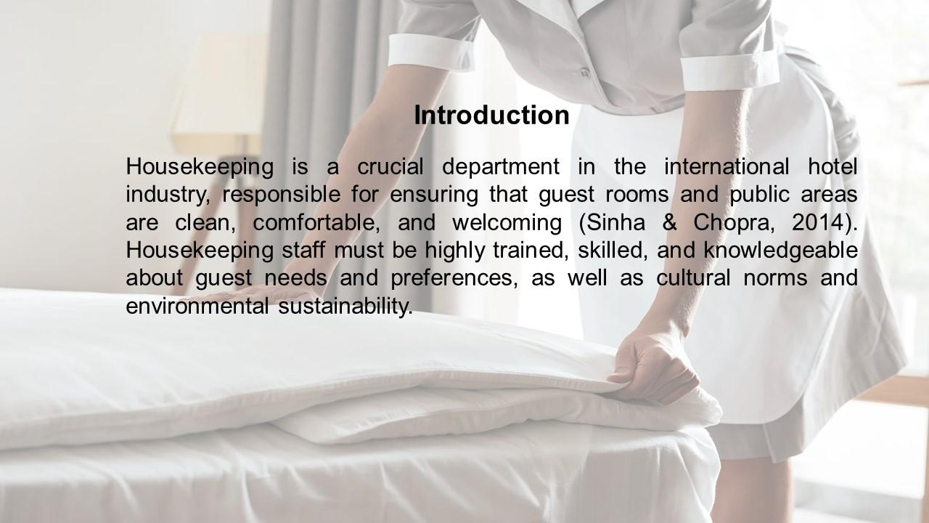
Training Notes:
Housekeeping is a crucial department in the international hotel industry, responsible for ensuring that guest rooms and public areas are clean, comfortable, and welcoming (Sinha & Chopra, 2014). Housekeeping staff must be highly trained, skilled, and knowledgeable about guest needs and preferences, as well as cultural norms and environmental sustainability. This training session on the importance of housekeeping in the international hotel industry is designed to provide attendees with a comprehensive understanding of the critical role that housekeeping plays in maintaining guest satisfaction and the reputation of the hotel. Attendees will learn about the essential skills required to work in housekeeping, such as attention to detail, time management, communication, physical stamina, organizational skills, and adaptability. They will also gain insight into the reasons why housekeeping is essential in the hotel industry, including the impact on guest satisfaction, health and safety, brand reputation, operational efficiency, and compliance.
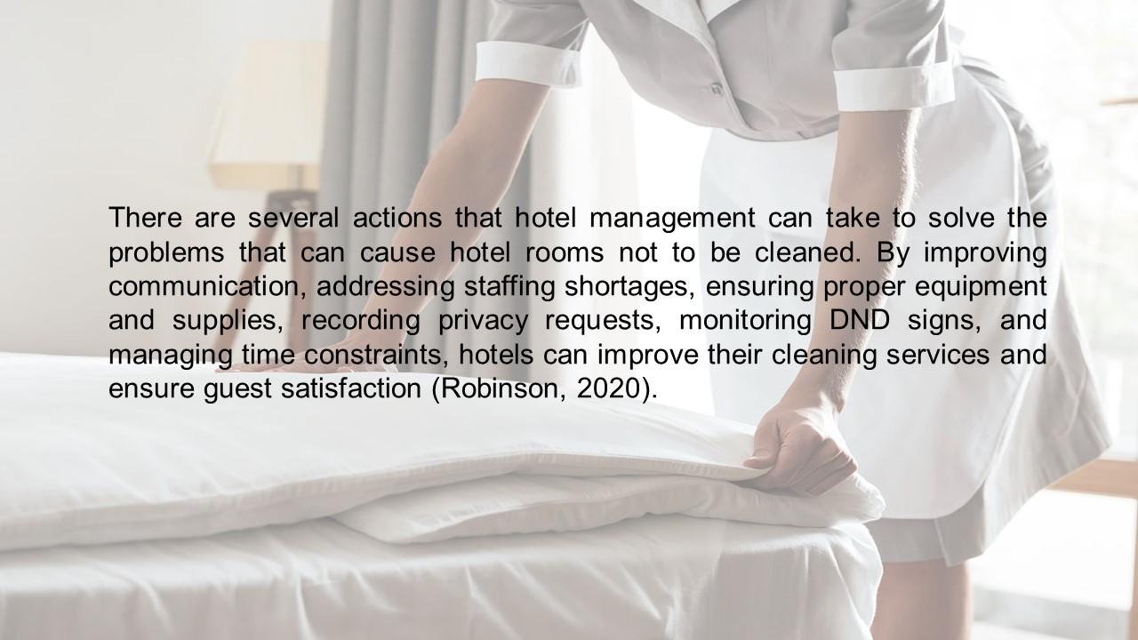
Training Notes:
There are several actions that hotel management can take to solve the problems that can cause hotel rooms not to be cleaned. By improving communication, addressing staffing shortages, ensuring proper equipment and supplies, recording privacy requests, monitoring DND signs, and managing time constraints, hotels can improve their cleaning services and ensure guest satisfaction (Robinson, 2020). To maximize the effectiveness of this training session, attendees should actively participate in discussions and engage with the presented material. They should also take notes and ask questions to clarify any points that are unclear. Upon completion of this training, attendees are encouraged to apply their newfound knowledge to their work in the hotel industry and continually improve their skills to succeed in the housekeeping department.
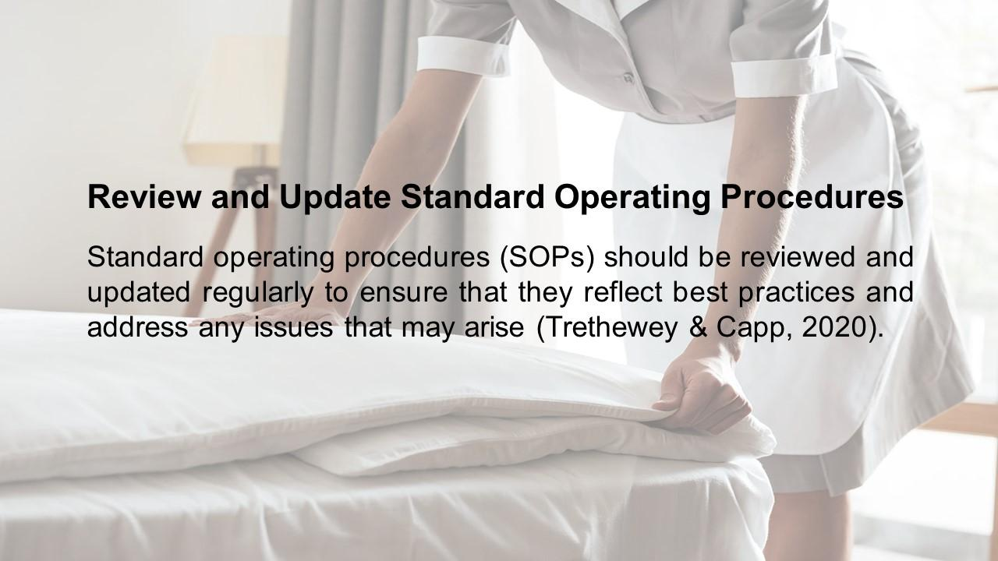
Training Notes:
Standard operating procedures (SOPs) should be reviewed and updated regularly to ensure that they reflect best practices and address any issues that may arise (Trethewey & Capp, 2020). A review of the housekeeping department's operations and standard operating procedures (SOPs) is essential to ensure that the department is functioning efficiently and effectively. Regular reviews of the SOPs can identify areas where improvements can be made, such as optimizing the use of cleaning supplies, reducing the time required to clean a room, or improving communication between team members.
During the review, it is important to ensure that the SOPs are up-to-date and reflect any changes to the hotel's policies or regulations. The review can also help identify any new trends or emerging technologies that can be integrated into the department's operations, such as new cleaning products or equipment.
Recommendations for improving the housekeeping department's SOPs could include conducting regular training sessions for team members, encouraging feedback and suggestions from staff members, and implementing a system for monitoring and measuring the effectiveness of the SOPs. These steps can help ensure that the housekeeping department is operating efficiently and effectively, contributing to the overall success of the hotel.

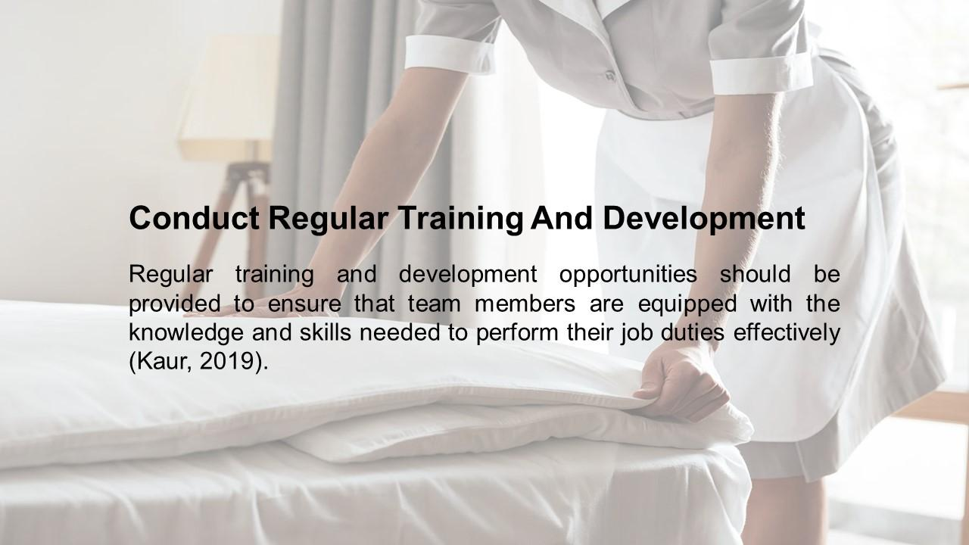
Training Notes:
Regular training and development opportunities should be provided to ensure that team members are equipped with the knowledge and skills needed to perform their job duties effectively (Kaur, 2019). Regular training and development is essential for the growth and success of any organization. This is especially important in the hotel industry, where employees need to constantly update their skills to keep up with changing customer demands and industry trends. Conducting regular training and development sessions can help employees improve their job performance, increase their confidence, and enhance their career prospects. To ensure effective training and development, it is important to identify the specific needs of employees and design training programs that meet those needs. Training can take many forms, including on-the-job coaching, classroom training, e-learning modules, and workshops. Regular performance assessments can help identify areas where employees need additional training and development. In addition, it is important to involve employees in the training and development process by seeking their feedback and ideas. This can help ensure that training programs are relevant, engaging, and effective. Regular training and development can lead to improved employee retention, higher job satisfaction, and increased productivity, all of which can contribute to the success of the hotel.

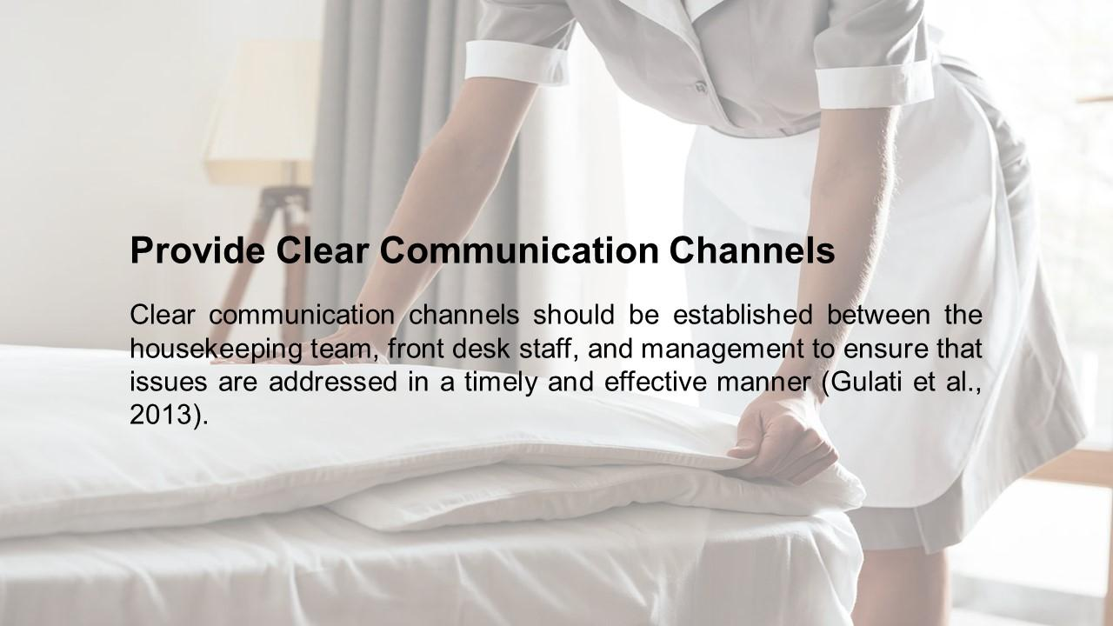
Training Notes:
Clear communication channels should be established between the housekeeping team, front desk staff, and management to ensure that issues are addressed in a timely and effective manner (Gulati et al., 2013). Clear communication channels are essential in any organization as they enable effective communication between employees, teams, and departments. In the hotel industry, clear communication channels are particularly important because they ensure that guests' needs and concerns are addressed promptly and efficiently. Effective communication channels in the hotel industry include face-to-face communication, telephone communication, email, messaging apps, and other digital platforms. It is essential to establish clear communication channels in the hotel industry to avoid misunderstandings and ensure that everyone is on the same page. This includes providing clear instructions, giving and receiving feedback, and being transparent about expectations and goals. Additionally, it is crucial to train employees on how to communicate effectively, including how to listen actively and express themselves clearly and concisely.
Regular training and development programs can help improve communication skills, promote collaboration, and foster a culture of open communication. Effective communication channels can improve guest satisfaction, enhance team performance, and contribute to the overall success of the hotel.

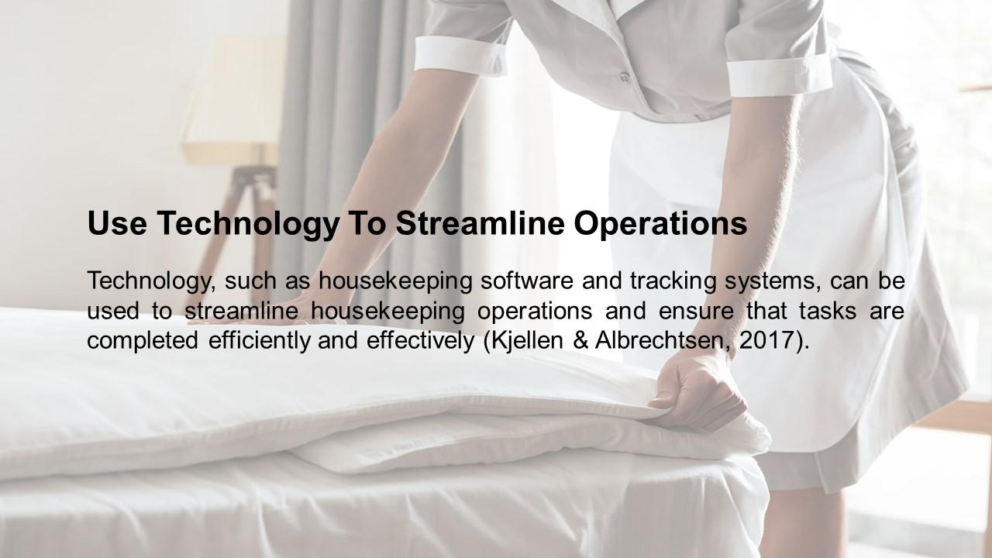
Training Notes:
Technology, such as housekeeping software and tracking systems, can be used to streamline housekeeping operations and ensure that tasks are completed efficiently and effectively (Kjellen & Albrechtsen, 2017). Technology can be a powerful tool in streamlining hotel operations and improving efficiency. There are various types of technology that can be utilized, including property management systems, automated room controls, mobile apps, and online booking systems. These tools can help automate and streamline various tasks, such as inventory management, housekeeping scheduling, and guest check-ins. Additionally, using technology can help hotels to better understand and analyse guest behaviour and preferences, allowing them to provide a more personalized and satisfying experience. By incorporating technology into their operations, hotels can improve their efficiency, reduce costs, and enhance the overall guest experience. However, it is important to ensure that the technology is user-friendly and that staff members are adequately trained in how to use it effectively.
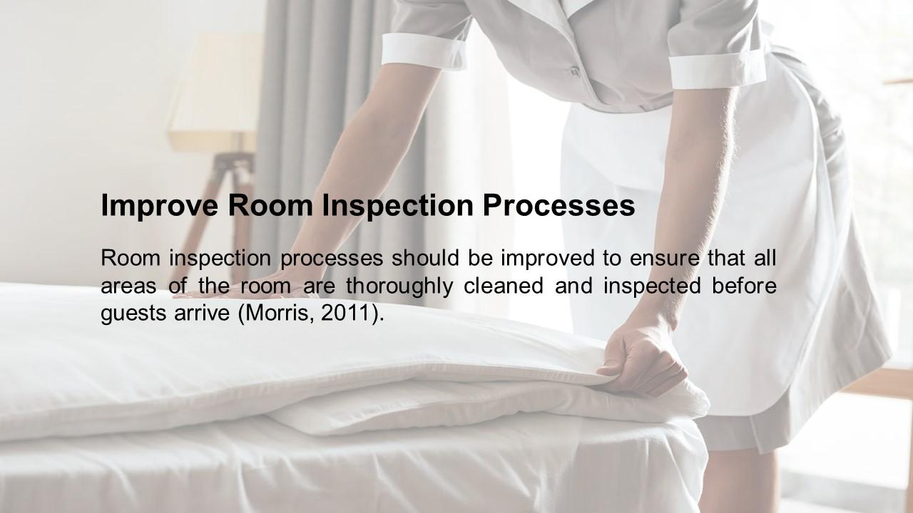
Training Notes:
Room inspection processes should be improved to ensure that all areas of the room are thoroughly cleaned and inspected before guests arrive (Morris, 2011). Improving the room inspection process is crucial in maintaining high standards of cleanliness and guest satisfaction. One way to enhance the inspection process is by using technology such as mobile devices or tablets to conduct inspections efficiently and accurately. Implementing a standardized checklist for inspections can also help ensure that all areas of the room are thoroughly inspected. Providing regular training to housekeeping staff on the importance of the inspection process and how to identify and address any issues can also improve the overall effectiveness of the inspection process. Regular communication between the housekeeping department and management can also help identify areas for improvement and ensure that corrective actions are taken promptly.
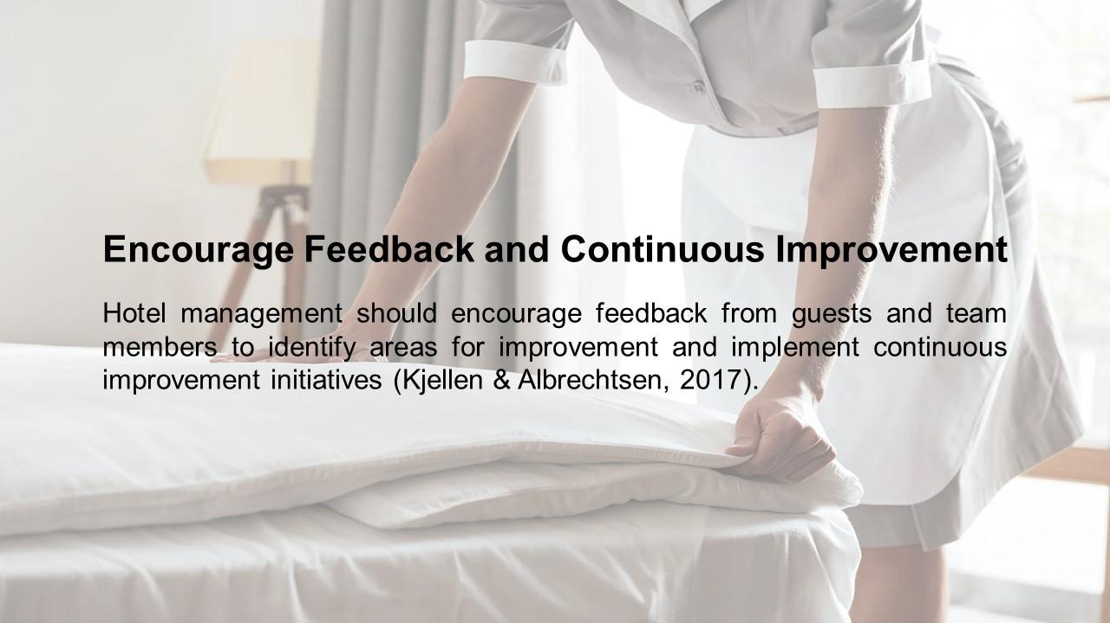
Training Notes: Hotel management should encourage feedback from guests and team members to identify areas for improvement and implement continuous improvement initiatives (Kjellen & Albrechtsen, 2017). Encouraging feedback and continuous improvement is essential for any successful business, and the hospitality industry is no exception. By actively seeking feedback from guests and employees, hotels can identify areas for improvement and make necessary changes to enhance guest experiences. It is important to create a culture that encourages feedback and fosters a sense of collaboration between staff and management. Regular meetings and surveys can be used to gather feedback, and action plans can be developed to address any issues or concerns that arise. By continuously striving for improvement, hotels can stay competitive in the industry and provide guests with an exceptional experience.
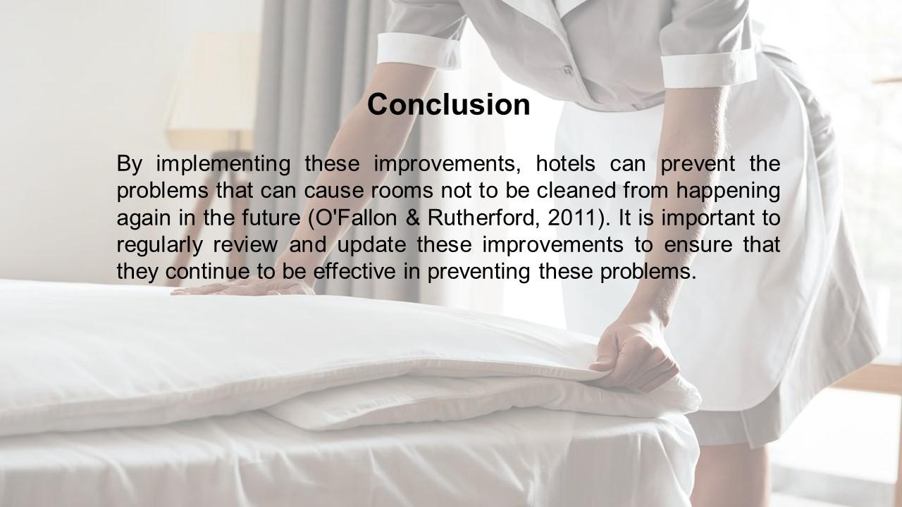
Training Notes:
By implementing these improvements, hotels can prevent the problems that can cause rooms not to be cleaned from happening again in the future (O'Fallon & Rutherford, 2011). It is important to regularly review and update these improvements to ensure that they continue to be effective in preventing these problems.

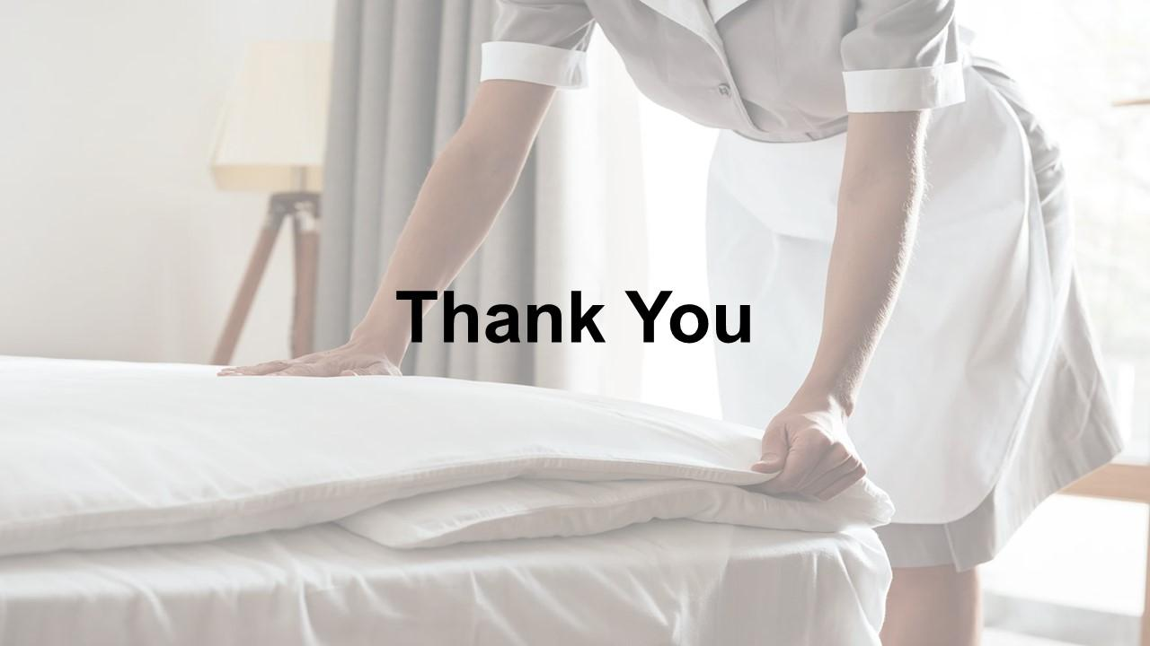
Training Notes:
Thank You.

References

Crystler, J.G. and Farace, R.V. (1987) Effective communication in hotel sales and marketing: A workbook. Washington, D.C.: Foundation of the Hotel Sales and Marketing Association International.
G., L.T.L. (2007) The International Hotel Industry: Sustainable Management. New York: Haworth Hospitality &amp; Tourism Press.
Gulati, R., Mayo, A.J. and Nohria, N. (2013) Management. Mason, OH: South-Western Pub.
Hinkin, T.R. (2006) Cases in hospitality management: A critical incident approach. Hoboken, NJ: John Wiley &amp; Sons.
Huffington, A.S. (2017) The sleep revolution: Transforming your life, one night at a time. New York: Harmony Books.
Jackson, E. (2018) Hotel Management. New York, NY: Larsen et Keller.
Kaur, P. (2019) Training and development. New Delhi, India: New Century Publications.
Kjellen, U. and Albrechtsen, E. (2017) Prevention of accidents and unwanted occurrences theory, methods, and tools in safety management, Second Edition. Boca Raton: CRC Press.
Morris, M.J. (2011) Starting a successful business: Choose a business, plan your business, manage operations. London: Kogan Page.
Ninemeier, J.D. and Kavanaugh, R.R. (2013) Supervision in the hospitality industry. Lansing, MI: American Hotel &amp; Lodging Education Institute.
O'Fallon, M.J. and Rutherford, D.G. (2011) Hotel Management and Operations. Hoboken, NJ: John Wiley &amp; Sons, Inc.
Petersen, C.J. and Petersen, C.J. (2008) Good housekeeping clutter rescue!: Just minutes a day to get organized--forever! New York: Hearst Books.
Poonia, V.S. (2018) Hotel Management. New Delhi: Aggarwal Book House.
Robinson, M. (2020) Housekeeping. New York: Picador Farrar, Straus and Giroux.
Schaefer, R.F. et al. (2017) Information theoretic security and privacy of Information Systems. Cambridge, United Kingdom: Cambridge University Press.
Sinha, P. and Chopra, B. (2014) Housekeeping. New Delhi: Crescent Publishing.
Trethewey, N.D. and Capp, L. (2020) Housekeeping. Ashland, NE: Pentameter Press Studio.

