

Methods and Search Strategy Academic Poster

Student name:Elisabeta-Roxana Pasareanu
Student ID:

Module name:
Module code:

The Importance of Early Childhood Education in the United Kingdom: A Study of Children Aged 3 to 5 Years

01 Introduction and Research Aim  The project focuses on the significance of early childhood education for children aged 3–5 in the UK. It investigates the way early learning helps to develop a child’s cognitive, social-emotional as well as physical skills. The study considers the challenges of quality and access to education. Research indicates that quality preschool experiences can enhance children’s learning in later life (Sylva et al., 2010). | 02 Search Strategy  A systematic review of the existing literature will detect appropriate publications. We will primarily conduct our research topic through various electronic databases. Reports from the Department for Education, the OECD, and Ofsted will also be considered. Identifying what is already known and what is still unknown requires a clear search strategy.
03 Searching for Information  Early Childhood Education, Education for the Early Years, Development of Young Children, School Readiness, Cognitive Development, Inequalities Educational, United Kingdom. An example of a Boolean search would be: (early childhood education OR preschool education) AND (school readiness OR child development) AND (UK OR United Kingdom). We will prioritise research published between 2016 and 2026 and make exceptions for influential studies before 2016. Screening of titles and abstracts will be done. | 04 Picture / Graph / Visual Aid / Statistics  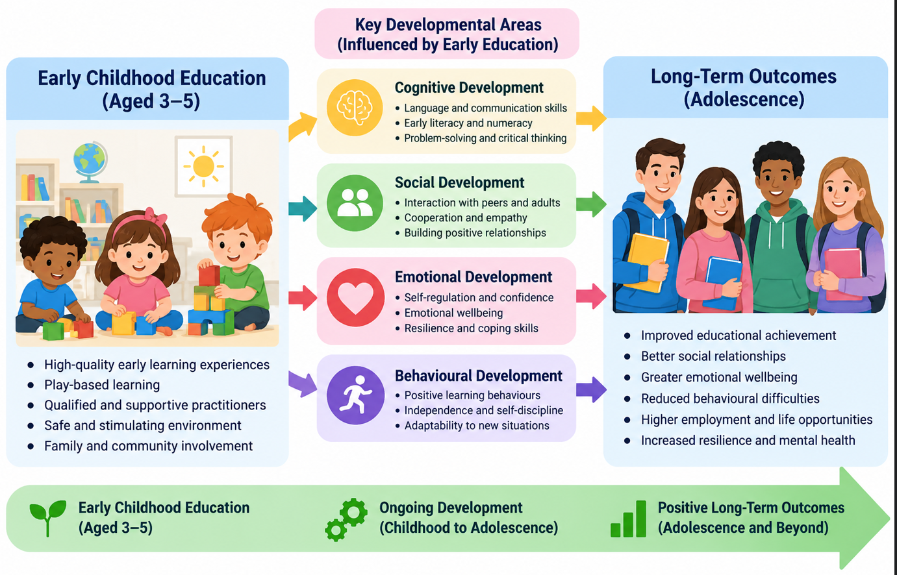
05 Research Validation and Analysis
The CRAAP Test will evaluate the Currency, Relevance, Authority, Accuracy and Purpose (Blakeslee, 2004) The characteristics of samples studied as well as their limitations. According to Braun and Clarke (2006), thematic analysis will use familiarisation, coding, theme development and interpretation. The topics may include education and developmental outcomes, school readiness, educational inequalities and quality of provision; family and socioeconomic.
06 Inclusion Criteria  Studies on early childhood education (3-5 years), child development, school readiness or educational quality; evidence based in the UK and useful international comparisons; peer-reviewed articles, academic books and credible government reports; publications mainly in English, mainly since 2016 but with some key earlier studies where relevant. | 07 Exclusion Criteria  Studies which do not relate to early childhood education or the relevant age group will be excluded. Studies that are not mostly relevant to the UK will be excluded too. Unsupported claims, blogs and unverified websites will also be excluded. Publications not available in English will be excluded too. Studies which are older and do not present any theoretical or methodological significance will also be excluded on the basis of publication date.
08 Ethical Considerations
Since the project uses secondary data already published, participants will not be recruited. A journalist’s ethical responsibilities are ensuring accuracy in reporting, avoidance of plagiarism, appropriate acknowledgment of authors using Harvard referencing and refraining from the collection of identifiable personal data. Findings should not exaggerate the causal relationship or disregard children’s context. Educational research ought to show integrity and transparency (BERA, 2018; Creswell, and Creswell, 2018).

References
Blakeslee, S. (2004) ‘The CRAAP test’, LOEX Quarterly, 31(3), article 4.
Braun, V. and Clarke, V. (2006) ‘Using thematic analysis in psychology’, Qualitative Research in Psychology, 3(2), pp. 77–101. https://doi.org/10.1191/1478088706qp063oa.
British Educational Research Association (BERA) (2018) Ethical Guidelines for Educational Research. 4th edn. London: BERA.
Creswell, J.W. and Creswell, J.D. (2018) Research Design: Qualitative, Quantitative, and Mixed Methods Approaches. 5th edn. Thousand Oaks, CA: SAGE Publications.
Snyder, H. (2019) ‘Literature review as a research methodology: An overview and guidelines’, Journal of Business Research, 104, pp. 333–339. https://doi.org/10.1016/j.jbusres.2019.07.039.
Sylva, K., Melhuish, E., Sammons, P., Siraj-Blatchford, I. and Taggart, B. (2010) Early Childhood Matters: Evidence from the Effective Pre-school and Primary Education Project. London: Routledge.

