Scott Jones – P1803767
1803767@student.uwtsd.ac.uk
Lecturer – Sue Maw

Project management and research methods
Project Initiation Document

Table of Contents

Table of Contents 1
Introduction 2
Objectives 2
Scope 2
Constraints 3
Authorities 3
Power Interest Graph 3
Resources 4
Scott Jones (The Writer) – Project Manager 4
Lowri Jones – Mobile Developer 4
Habzz Merlyn – Web Developer 4
Rosie Aktar – Marketing 4
Lloyd Johnson – Business Developer 4
Shaun Holborow – Business and Usability Analyst 4
Gantt Chart 5
Network Diagram 6
References 7

Introduction
In this document, the writer will be presenting the ideas and plan for a group project. The project is based on a fitness application for mobile devices which allows the users to compete with their friends and family in real time. The application will have multiple different and unique features throughout, which will be discussed within this document. Each member of the group will be given a specific task to do, so communication will be vital for this project to be a success. The name of the project will be J&J Fitness.

Objectives
The main objectives of the application are to allow the users to compete with their friends and family without physically being in the same place. Whilst there are multiple different features within the application, this main focus is to get this real-time competing feature working since this is what sets it aside from any competitors.

Scope
- “scope is the set of boundaries that define the extent of a project.” [1]
Like previously mentioned, the application will need multiple different features to operate correctly. One of these features would be a step-count. This will count the number of steps the user has achieved within a specific time period, and the user will gain points based on how many steps they have done. These points will then be used to compete with friends who are also using the application.
There will be a free version of the application which anybody can use to allow a wider range of potential users, there will also be an option for a paid membership which would be £X per month. All users will be able to compete to one another despite being a member or not.
The applications would need a log in / register form, online secure databases to store user information, a time / date system to allow the daily challenges and real-time competing features. The user would need to be automatically logged in upon opening the application.
One important factor that would be excluded from the project on the development side, is that we are not creating the fitness plans for the users to follow. This will be left to any instructors or personal trainers that may use the application.

Constraints
A big constraint for this project is the timescale and a lack of application developers. If there was no time scale, there would be able to be a handful amount extra features that we are currently unable to fit in. An online shop for sportswear and supplements would be some of these features. Also, there is no application developer within the group which would make it very difficult to create the app exactly how it was envisioned.
One big problem is finance. Right now, the group hasn’t got the funds to create project fully.

Authorities
The stakeholders are anyone that would be affected by the project.
The project manager is Scott Jones. The role of Project Manager will include ensuring the project short term (and eventually) long term goals are being met.
The sponsors will be the group members (see ‘Resources’) not one person has a higher authority within the project.
Gyms, Personal Trainers, Gym Members, Clothing brands which specify in gym-wear. These are just some of the people that would be affected with the creation of this application.

Power Interest Graph
- “a simple tool that helps you categorize project stakeholders with increasing power and interest in the project.” [2]
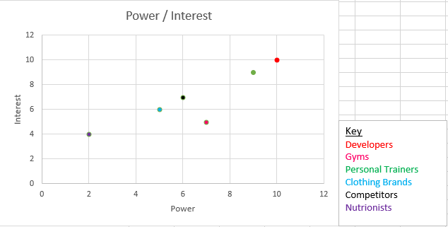

Resources
Within the group, there is multiple roles for the project:

Scott Jones (The Writer) – Project Manager
This position oversees the project. The project manager needs to ensure that goals are being met and needs to maintain the teamwork.

Lowri Jones – Mobile Developer
This position must develop the mobile architecture for both IOS and Android devices.

Habzz Merlyn – Web Developer
This position must be able to create the Web Application for the project, designing the front and back end architecture.

Rosie Aktar – Marketing
This position will need to research the target audience and potential clients/users for the application.

Lloyd Johnson – Business Developer
This position must design a business model and manage any finances within the project.

Shaun Holborow – Business and Usability Analyst
This position must design the Graphic User Interface and assess project requirements and team progress.

Gantt Chart
- “A Gantt Chart is a timeline that is used as a project management tool to illustrate how the project will run.” [3]

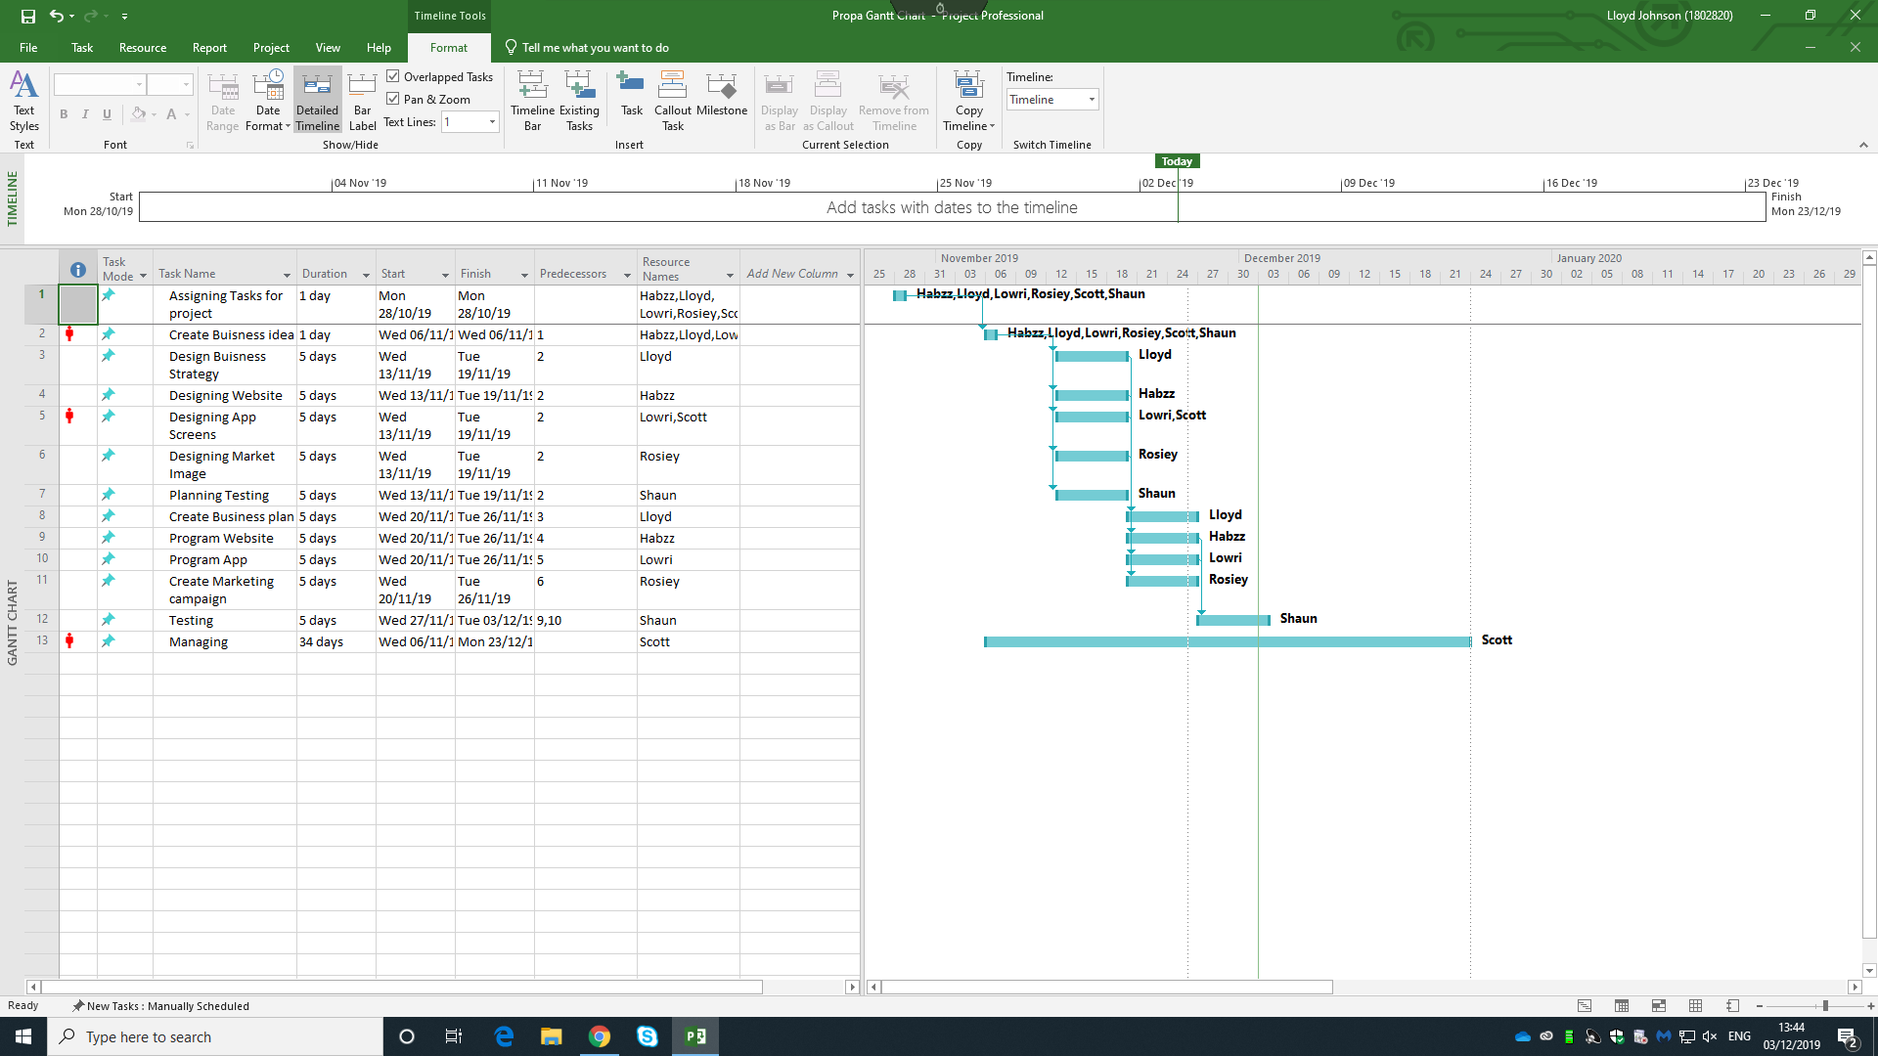
The group used ‘Microsoft Projects’ to create a Gantt Chart. This help the group with planning on keeping on track with their tasks.

Network Diagram

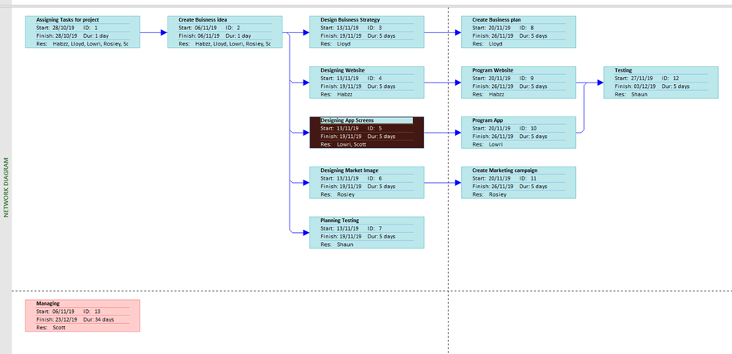

References

[1] | K. Stricker, “Scope, Risk, and Assumption in Project Management,” 16 6 2019. [Online]. Available: https://www.thebalancecareers.com/three-critical-project-management-terms-to-know-2276111.
[2] | R. Sharma, “Power/Interest Grid (Matrix) for Stakeholder Prioritization,” Bright Hub Project Management, [Online]. Available: https://www.brighthubpm.com/resource-management/80523-what-is-the-powerinterest-grid/.
[3] | B. Anderson, “What is the Purpose of a Gantt Chart,” Successful Projects, 28 6 2016. [Online]. Available: https://successfulprojects.com.au/purpose-of-a-gantt-chart/.

