Bradley Jones
Student Number 2219978

Learning in the Digital Era
Learning in the Digital Era – BMPL4007

Table of Contents

Task 1 – Written summary 3
Task 2 – Mind map 4
Task 3 – Presentation 5
Task 4 – Reflection 6
Reference list 7

Task 1 – Written summary
The topic “Preparing for Higher Education” is one that provides valuable information to students on what can and cannot be used in preparation for moving forward into higher education. Some of the key take aways from the topic include the helpful advice which includes tips to be able to comfortably study at home (Smith, 2022). Included in the article it is suggested that you can study at your own pace, as well as the fact that you can be left alone leading to less of a likelihood of distractions from peers. As well as this, there are also topics included which suggest how plagiarism happens and how to prevent committing plagiarism (UWTSD, 2022) which includes an article on multi-Plagiarism lawsuit which puts it into perspective how much of a major deal plagiarism can be (Flood, 2019). It is suggested in the article that in this case of plagiarism it is considered quite an uncommon level as there was allegedly many books and authors that had been replicated. Another beneficial topic included to help people prepare for higher education would be the step-by-step assistance on how to create and order Microsoft Word and PowerPoint documents (Microsoft 365, 2021). To follow on from this, there are also various things to look out for on the internet which a newer user may not be completely aware of, frauds. According to (Munbodh, 2022) there has been billions of pounds lost to fraud in the last twelve months and for this reason they have given several frauds to look out for, the likelihood of someone who is used to being on the internet regularly falling for one of these frauds is not extremely high but including it as additional information alongside the learning process of the digital era seems quite essential moving forward. These frauds come in a range of ways and can be relative to what an individual may be expecting for example, an online delivery or random phone calls which require your personal information for one reason or other.

Task 2 – Mind map
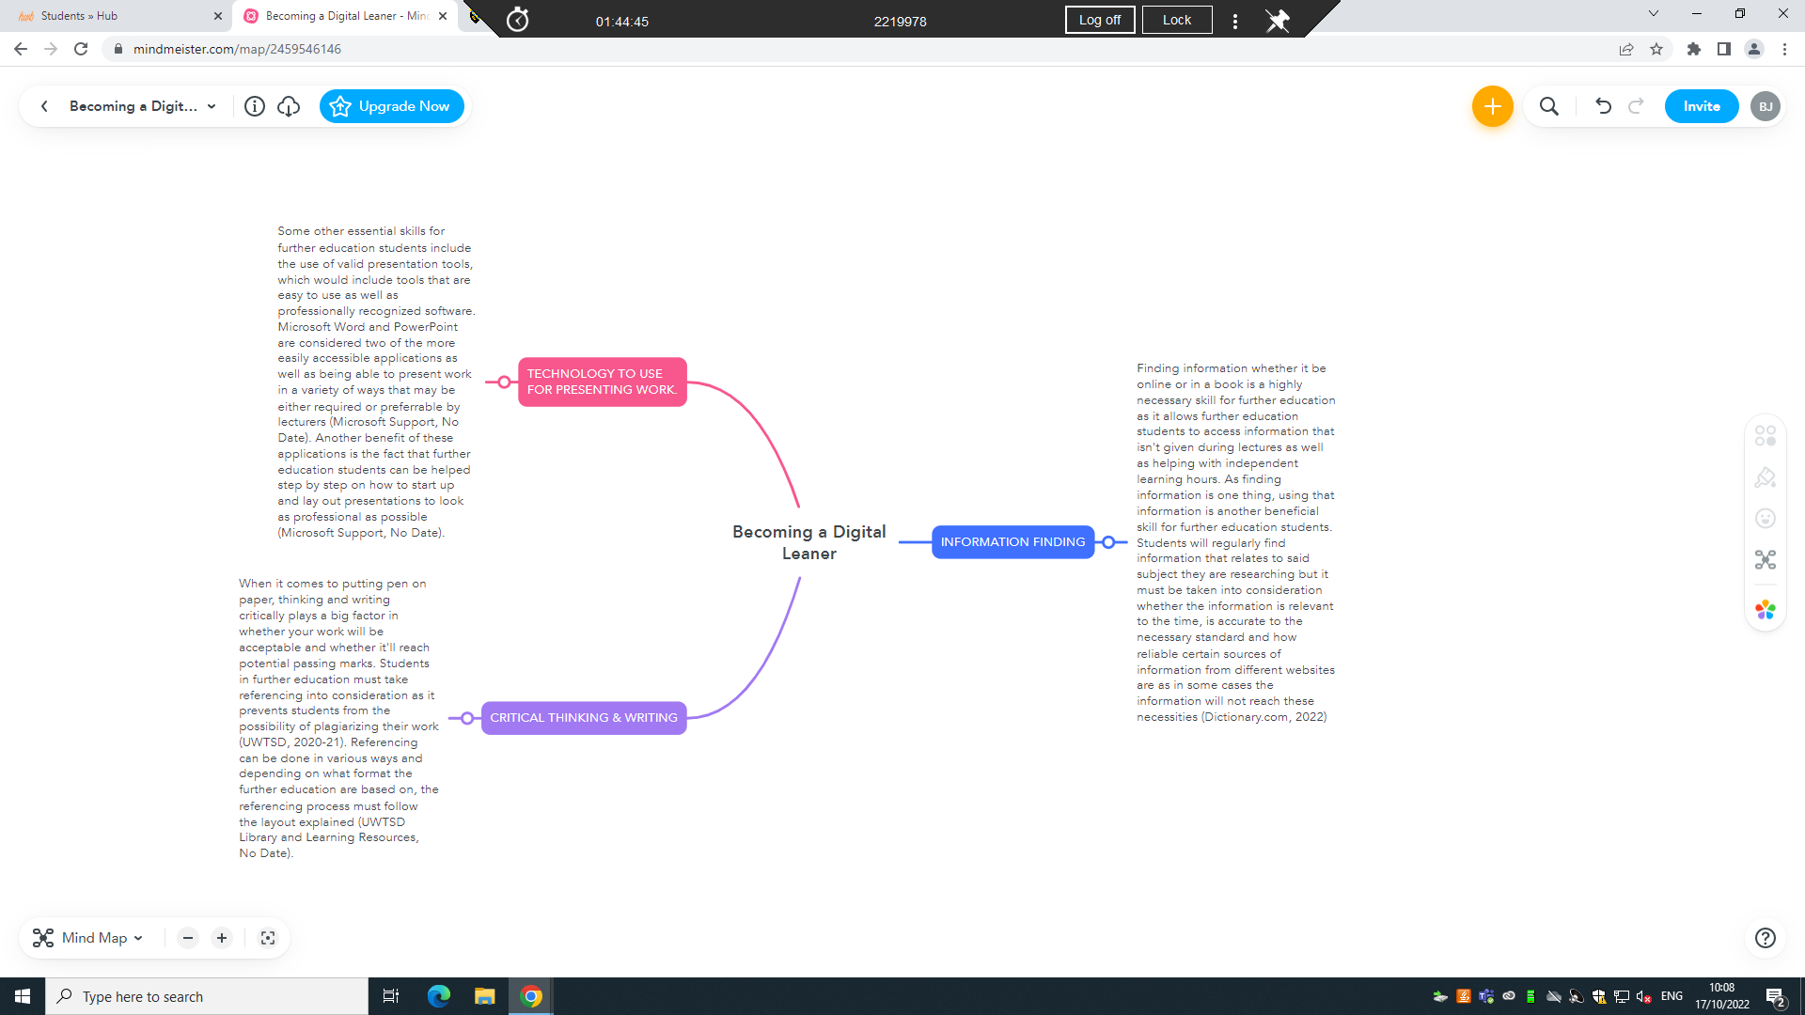
https://uowtsd-my.sharepoint.com/:p:/r/personal/2219978_student_uwtsd_ac_uk/_layouts/15/Doc.aspx?sourcedoc=%7B0D6CDE54-E8E3-4045-8378-B7998566EFF5%7D&file=Becoming%20a%20Digital%20Learner.pptx&action=edit&mobileredirect=true

Task 3 – Presentation
Please follow this link to view my presentation:

Task 4 – Reflection
Starting university has benefitted me with my value to my future career as I have learnt a variety of key digital skills which are essential going forward due to the increased amount of online and computer work that is required within the police force today. While learning about the essentials of the digital era I have come across various tools which are more commonly used such as Microsoft Word and PowerPoint to layout work as well as new tools which I have never used before such as MindMeister which has also given me a wider perspective on tools to use depending on the type of work required of me in university and future work life. Before beginning university, I was feeling stressed about the possible workload to juggle as well as work life, etc, but now with a further knowledge for digital learning, including the likes of Harvard Referencing and how to accurately cite information to use for future assignments, I am currently a lot more comfortable, stress free and capable of taking on various amounts of work (UWTSD, 2022). Additionally, I would say that I am a lot more comfortable in the classroom, asking questions, giving answers and helping peers with tasks they may be struggling with which I might currently not. Due to these points, I believe I have completed my assignment to the best of my current ability and moving forward I believe this ability can increase with further understanding through the use of the UWTSD library resources available to me (UWTSD, 2022).

Reference list

Dictionary.com (2022) ‘Definition of ‘post-truth’. Available at: https://www.dictionary.com/browse/post-truth (Accessed 12 October 2022)
Flood, A. (2019) ‘Nora Roberts files ‘multi-plagiarism’ lawsuit alleging writer copied more than 40 authors’, Available at: https://www.theguardian.com/books/2019/apr/25/nora-roberts-files-multi-plagiarism-lawsuit-alleging-writer-copied-more-than-40-authors (Accessed 05 October 2022)
Microsoft Support (No Date) Apply styles [video]. Available at: https://support.microsoft.com/en-us/office/apply-styles-f8b96097-4d25-4fac-8200-6139c8093109 (Accessed 12 October 2022)
Microsoft Support (No Date) Create a presentation [video]. Available at: https://support.microsoft.com/en-us/office/understand-the-difference-between-powerpoint-templates-and-themes-e2408e10-e015-43b3-8b29-b99d128ae448 (Accessed 12 October 2022)
Microsoft 365 (2021) ‘Outlook Training’, Available at: https://support.microsoft.com/en-us/office/outlook-training-8a5b816d-9052-4190-a5eb-494512343cca (Accessed 05 October 2022)
Munbodh, E. (2022) ‘Twelve scams to watch out for right now’, Available at: https://www.thetimes.co.uk/money-mentor/article/financial-scams/ (Accessed 05 October 2022)
Smith, J. (2022) “5 tips for studying at home”, Available at: https://www.prospects.ac.uk/applying-for-university/university-life/5-tips-for-studying-at-home (Accessed 05 October 2022)
Study Hub (No Date) ‘Team Roles’, Available at: https://studyhub.fxplus.ac.uk/study-guides/teams-groupwork/activities/team-roles (Accessed 07 November 2022)
UWTSD (2020-21) Academic Misconduct Policy. Available at: https://www.uwtsd.ac.uk/media/uwtsd-website/content-assets/documents/academic-office/misc-forms/Academic_Misconduct_Policy_2021-22.pdf (Accessed 12 October 2022)
UWTSD Library and Learning Resources (2022) ‘Referencing handbook: Harvard’. Available at: https://uwtsd.ac.uk/media/uwtsd-website/content-assets/documents/library-and-learning-resources/infoskills/Harvard-eng_v1.2.pdf (Accessed 05 October 2022, 1)
UWTSD Library and Learning Resources (2022) ‘Referencing handbook: Harvard’. Available at: https://uwtsd.ac.uk/media/uwtsd-website/content-assets/documents/library-and-learning-resources/infoskills/Harvard-eng_v.1.2.pdf (Accessed 12 October 2022, 2)
UWTSD Library and Learning Resources (2022) ‘Referencing handbook: Harvard’. Available at: https://uwtsd.ac.uk/media/uwtsd-website/content-assets/documents/library-and-learning-resources/infoskills/Harvard-eng_v.1.2.pdf (Accessed 25 October 2022, 3)
UWTSD Library (2022) ‘Student Essentials’. Available at: https://uwtsd.ac.uk/library/student-essentials/ (Accessed 25 October 2022)

