
Postgraduate Dissertation coversheet & feedback form:

THIS SHEET MUST BE THE FIRST PAGE OF THE ASSIGNMENT YOU ARE SUBMITTING (DO NOT SEND AS A SEPARATE FILE)
For completion by student:
Student Name: John Booker

Student University Email: 1002438@student.tsd.ac.uk
Module code: AHAN7025 | Student ID number: 1002438 |  |  |  | Educational support needs:  Yes/No
Dissertation title: To what extent were astronomy and astrology significant features in the medical texts of Hippocrates and Galen?
Supervisor: Dr Dorian Gieseler Greenbaum |  |  | Word count: 20047
I confirm that this is my original work and that I have adhered to the University policy on plagiarism.
Signed John Booker
For completion by the first marker:
Comments:
This is an absolutely excellent piece of work. You have covered the subject very clearly, arguing your case throughout in a balanced way with excellent use of reference to primary sources, and also to other commentators, concerning whom you maintain a clearly-articulated critical perspective. Your style is direct and strikes an admirable balance – neither too conversational, nor too formal and stilted.
In terms of the explication of your material, there is only one issue where I wished for a little more clarity. That is the question of whether Galen actually used either natal or conception charts, particularly in his practice. This issue surfaces at pp. 63 – 66. It may well be that the evidence is ambiguous and it is simply not possible to be sure; that is the impression you give. If so, it would have been good to state this more directly, since it is quite a major issue as regards the extent, and manner, of Galen’s use (or not) of astrology.
The big picture, though, is that this was the only point where I found myself wishing for a little more clarity, and given the scope of your work that counts as quite an achievement. This is a really worthwhile contribution to our knowledge of the field; well done!

First Marker’s Mark: 71  Signature: 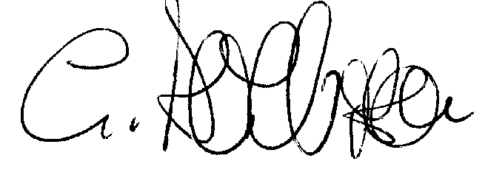 |  |  |  | Date:  3rd March 2015
For completion by the second marker:

Comments:

Second Marker’s Mark:  Signature: |  | Date:
NB. All marks are provisional until confirmed by the final examination board.

For completion by the External Examiner:

Comments:

Proposed Mark:

Signature of External Examiner:

Final Agreed Mark:

