

Application Development

ACCA5012

Assignment on:

Application Development

Submitted to:

Dr Kemi Ademoye

Submitted by:

Anthony Smith

1704559

Year 2 semester 1

Contents
1 Abstract Introduction 3
2 Application Development Concepts 3
2.1 Chatbots 3-4
3 Requirements 4
3.1 Website objective 5
3.1.1 Purpose / Subject matter 5
3.1.2 Target audience 5
3.1.3 Relevance 5
4 Design and Implementation 5
4.1 Design features 5
4.2 Mobile first Strategy 6
4.3 Media Queries adopted 6
4.4 Content display strategy 7
4.5 Implemented Functionality 7
4.5.1 JavaScript functions used 7-8
4.5.2 Web API 8
4.6 Major browsers 8
4.7 Main scripts / methods / classes 9-13
5 Evaluation 13
6 References 14
Appendix
Appendix A Test cases 16-19
Appendix B JavaScript Code 20-23

1 Introduction
The aim of this assignment was to create a functional website that could be operated easily by an end user. The subject matter for the site was exclusively the creator’s preference, as long as certain criteria was met.
The report would cover key stages of the process and describe in detail the reasons certain approaches were made in the designing of the site, along with motives behind the selection of topic. Due to advances in web-based technology and the speed in which they are tailored to assist online consumers, the most popular trends utilised currently in web development were highlighted, with specific attention directed at AI Chatbots.

2 Application Development Concepts
With more and more consumers and business organisations using the internet to fulfil certain acquirements, whether its for purchasing goods or offering an online service, web builders are applying new techniques that will revolutionise the actions that applications can perform.
These advances can be identified by their popularity, as smart developers try to stay ahead in the everchanging world of web [reference(s)]:
- Progressive web
- Single page application
- Mobile friendly Websites
- AI chatbots
- Blockchain technology
- Motion UI
- JavaScript
- Cybersecurity
- Low code development
For the purpose of this report, the main focus has been applied to AI Chatbots. This field has already become popular and used in many online sites and will continue to emerge as one of ‘must have’ applications to attach to organisational web pages. [1]

2.1AI Chatbots
“The Turing test is a test of a machine’s ability to exhibit intelligent behaviour equivalent to, or indistinguishable from, that of a human” [2]
AI chatbot technology is becoming widely established amongst many areas of digital systems and is required mainly to fill the void between business and customer interaction. Currently, there are two forms of chatbot utilised in online services, the first being a rule-based system. This technique uses a text interface and operates to a certain set of rules enabling it to respond to the end user who has activated the communication. But as this method is rule-based, the chatbot can only respond if key words or phrases are triggered by the user, if this does not occur the chatbot attached to the website would pass the conversation to its human counterpart. This bot is only as intelligent as it is programmed to be and due to the lack of this efficiency, AI chatbots have been chosen to develop a more realistic customer service and enhance the customers’ experience. [3]
The growth in technology has encumbered the service sector by encouraging higher customer expectations leading to the need for 24-hour customer support and instant response times, which requires major manpower and knowledge. AI chatbots are the solution to bypass these inadequacies and are designed to personalise the interactions from user to user, making them perform like a real human-being and are accessible whenever they are required. [4]
Artificial intelligent chat robots (shortened to ‘bots’) come in many guises and appear in many homes across the world. Two of the most sophisticated AI chatbots currently available are Apple’s Siri and Amazon’s Alexa, who through speech recognition use machine learning to adapt. These new-generation bots are self-learning agents whose behaviour is driven by data, powered by artificial intelligence, and personalized through natural-language conversations with users. Natural language processing (NLP) is a division of AI that studies how computers can be used to analyse, interpret, understand and manipulate natural text or speech in order to complete certain tasks [5]. Once you request a service from Siri or Alexa the microphone built into your device records that request and sends the recording over the internet to connect to the cloud. The recording will then be analysed in the cloud and the correct response will then be sent back. This technology is available for online sources, but although organisations use AI chatbots its very rare they use speech recognition, instead they rely on the typed message format.
Over 85% of leading organisations believe that AI chatbots will give them a strategic edge over companies that do not use such technology. [6]
The success of introducing AI into a website interface isn’t just about how clever the technology is, but how easy it is to interact with such innovation. A good UI (user interface) is an integral part of who and how often a user will interact with that webpage and the overall control they feel they have. By having a good design, the results of a positive experience will be abundant.

3 Requirements
Before creating a project, we need to specify what elements are to be included in its development and make sure that the final product will be easy to use and have all the important information required to make the website a success. Avoiding non-essential data will speed up the deliverables and increase the efficiency of the software programmers.

3.1 Website Objectives / Purpose
The main objectives of the website were to create a fully interactive webpage that was user friendly and enhanced their online experience. The web application included six pages that were relevant to the issue.
3.1.2 Subject matter
Originating from a musical background, the project idea focused on a band that the creator of this report has been a member of for the past 25 years. The site would contain pages that were relevant and indicative to the band. The application had to be current and comparable to many of the other sites available online, many of the music sites generally follow the same layout and contain similar facts and information.
3.1.3 Target Audience
Although popular in the local town and surrounding areas their national reach has been limited and the decision was made to make the band have an online presence and become accessible to a wider audience. By its diversity in the rock genre the band increased their relatability to all types of listeners young and old.
3.1.4 Relevance
One of the biggest tools a brand or organisation can benefit from is advertisement to promote their goods or services. This trend will be continuous as the internet becomes more and more popular with the consumer. To connect with new customers or supporters, the best way to achieve popularity is to create a website or enter social media. For musicians and bands there is no better platform as access to all information is in one place and available via an easy to use interface.
4 Design / Implementation
The ideals behind web design is to make the application simple to use and understandable for the user to designate around. These are the principles that were adapted to the design and implementation of the music website.
4.1 Design features
Choosing the pages that were going to be included in the website had to cover every angle of the band’s journey, these comprised of gallery, discography, about, merchandise and gig guide. Once this process was complete, configuration of the layout and colour schemes had to be underway.
The layout had to be simplistic and easy to navigate through, making it less confusing for potential users. Navbar design was easily defined, while the pages were not cluttered with needless functions and information. A working website became president over gadgets and gizmos that may have looked great, but hit and miss in their functionality.
As like many other rock / heavy metal sites, the decision was made to go for a black background , this was the preferred palette as it allows the content to stand out and makes all the initiated interactivity visible.
4.2 Mobile first strategy
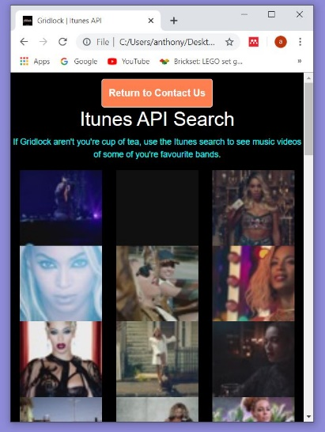
Whenever a website is created, it is wise to set the page to fit the dimensions of a mobile phone first. The design should accommodate the smallest screen first and then scaling up to the largest, this will provide the right experience for all users.( fig 1.1)
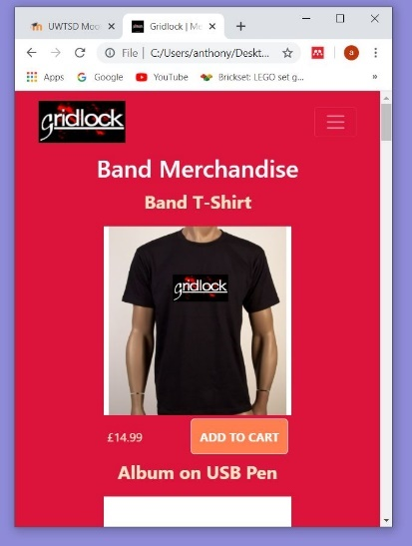


Fig 1.1 – Examples of mobile first design

4.3 Media queries
To highlight responsiveness of the website, @media queries can be implemented to show changes made to the website. These changes can be written into the CSS of the website and sets parameters or conditions that are only set when the conditions are true. This can be changing the colour of a background when the size of the screen increases and decreases or setting resolutions of images. All these modifications are used to enhance the users enjoyment and to make sure that screen size will not be an issue for full interactivity.
Pixel size of most small devices such as smartphones have a screen size of 600px, this was the final choice for the responsiveness of the media query.(fig 1.2)

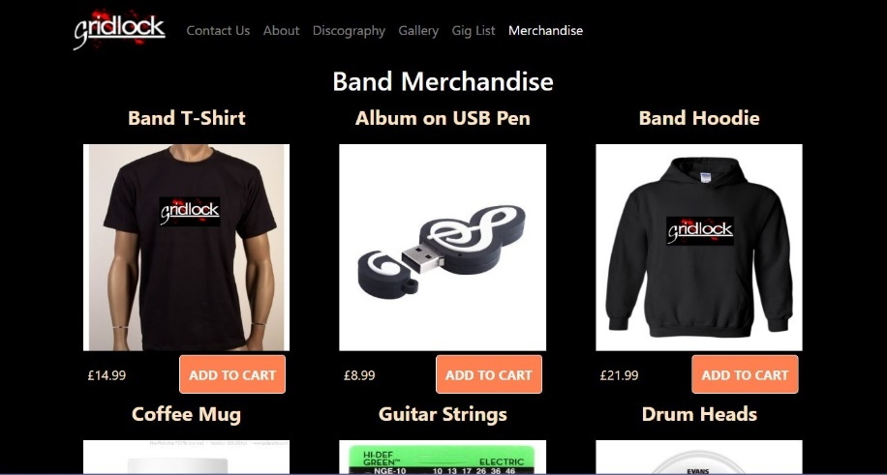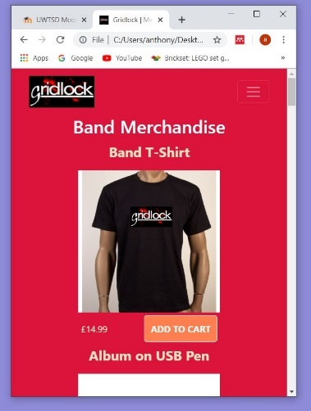
Fig 1.2 – shows that the background goes from black to red when the viewing size is changed to 600px.
4.4 Content display strategy
To keep the formation of the images, the use of lightbox was implemented. Using lightbox for images also helped with the responsiveness of the page, as it is based around flexbox. [7]
Setting a class for columns, that when the size of the screen was altered the images and text would also move position in sync with the change. Other CSS functions were used to improve the functionality of the website such as wrap around.
All headings were displayed in a clear and defined way, while navigation around the site was also simplistic.
4.5 Implemented functionality
Whenever a user connects to a webpage, there has to be a certain amount of functionality and control that gives them a satisfying experience and entice them to use it again and again.
These Functions can be implemented in CSS and HTML but have limiting factors.
More and more web applications need to be more dynamic to keep up with trends and user expectations, so the best way to have a better performing website is to use a client-side programming language like JavaScript.
4.5.1 JavaScript functions used
The implementation of JavaScript was present several times throughout the website and added needed functionality to a site based on a music band. The following is a list of the functions that were used to help a user navigate around the application.

- Shopping cart
Most bands allow merchandise to be bought from their website and can include several items, which needs to be totalled and added to the shopping basket once the customer is ready to purchase. [8] This function was a must for the website and was in keeping with the traditional format of band pages.
- Playing Audio Tracks
In the discography page, the option to sample each and every track that was created by the band was available. Both albums were displayed with a list of tracks that can be selected by using the audio player built into the page. Although this function can be used without the use of JavaScript, the premise behind the use of JavaScript was to prevent a new page opening every time a track was selected. [9]

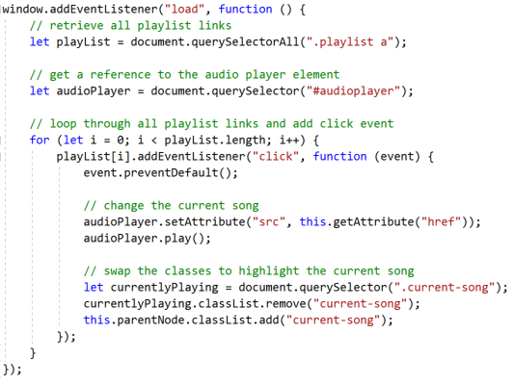
- Alerts
Alerts can be used to display a warning or explain a process that has occurred within the website [10]. This is the exact purpose several alerts were used. With browsers allowing different permissions, some functions that were required to function may not, as in auto-play, Google Chrome does not allow audio auto-play when a page is opened [11]. A warning message appears on the enter website page to highlight the fact that is may happen.
To display a purchase that has been made on the merchandise page, an alert was used to show the user that their order was successful.
(please see Appendix for JavaScript implemented code)

4.5.2 Web API
With so many API’s available, choosing the right one that would enhance the users experience of the website was fairly difficult. The API had to integrate with the content of the site, there would be no point in displaying a weather API in a bands website.
Having a merchandise page gave the ideal location to contain an API allowing the user to interact with it:
- Adding merchandise to a basket and then totalling up the amount of products the user has bought.
Although the shopping cart function is known as an API, it does not have server to server functionality. No other website is accessed to gain information that is then displayed on the designated page.

- iTunes API
This allows a search for different keywords that the user decides to input and once the selection has been made, a list of music videos will appear on the page. Each video thumbnail will give a 30 second excerpt of the chosen video. [12]

4.6 Major Browsers
All the major browsers have been considered when creating the website, but not all functions will have the capabilities to work. The reasons for these imperfections will change from browser to browser, but the main reasons are their permissions. To function across the board of online browsers the use of webkits may need to be incorporated into the CSS of the website.
The most popular browsers currently used are:
- Edge
- Explorer
- Chrome
- Firefox
- Safari

4.7 Main scripts, methods and classes
The design of the website contains many classes that are embedded in div’s. Within the main script of each page there are several column divs that were used to keep the formation of the page. As there are many sections of the site that required independent design, the use of classes and id’s to change certain sections without compromising the whole page were widely used. Html and CSS contain the biggest chunk of the programming as that’s where the most experience lies.
To make the website a visual tour of the band ,the use of iframes where implemented for viewing videos from other pages and due to the amount of pictures required to explain the bands hard work the <img> tag was applied throughout.
Within JavaScript , eventListeners and getElement code where used inside functions that would allow users to interact with the pages more.
A culmination of all the methods used in producing the application came together to produce a working website, as can be seen from the following images.

Fig 1.3 – This page allows entry into the hub of the site.

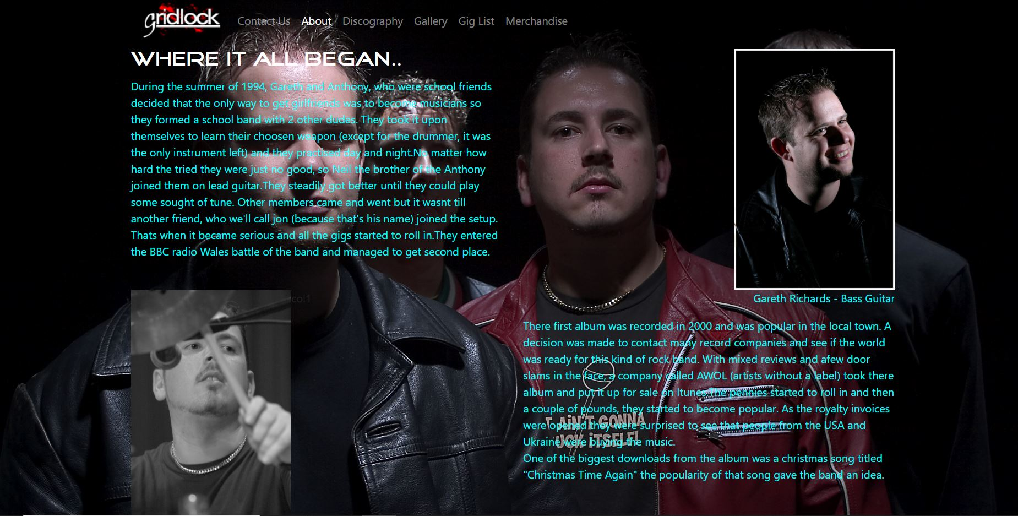
Fig 1.4 – About the band page that is accessed once the ‘Enter Website’ button is pressed on the web entry page.

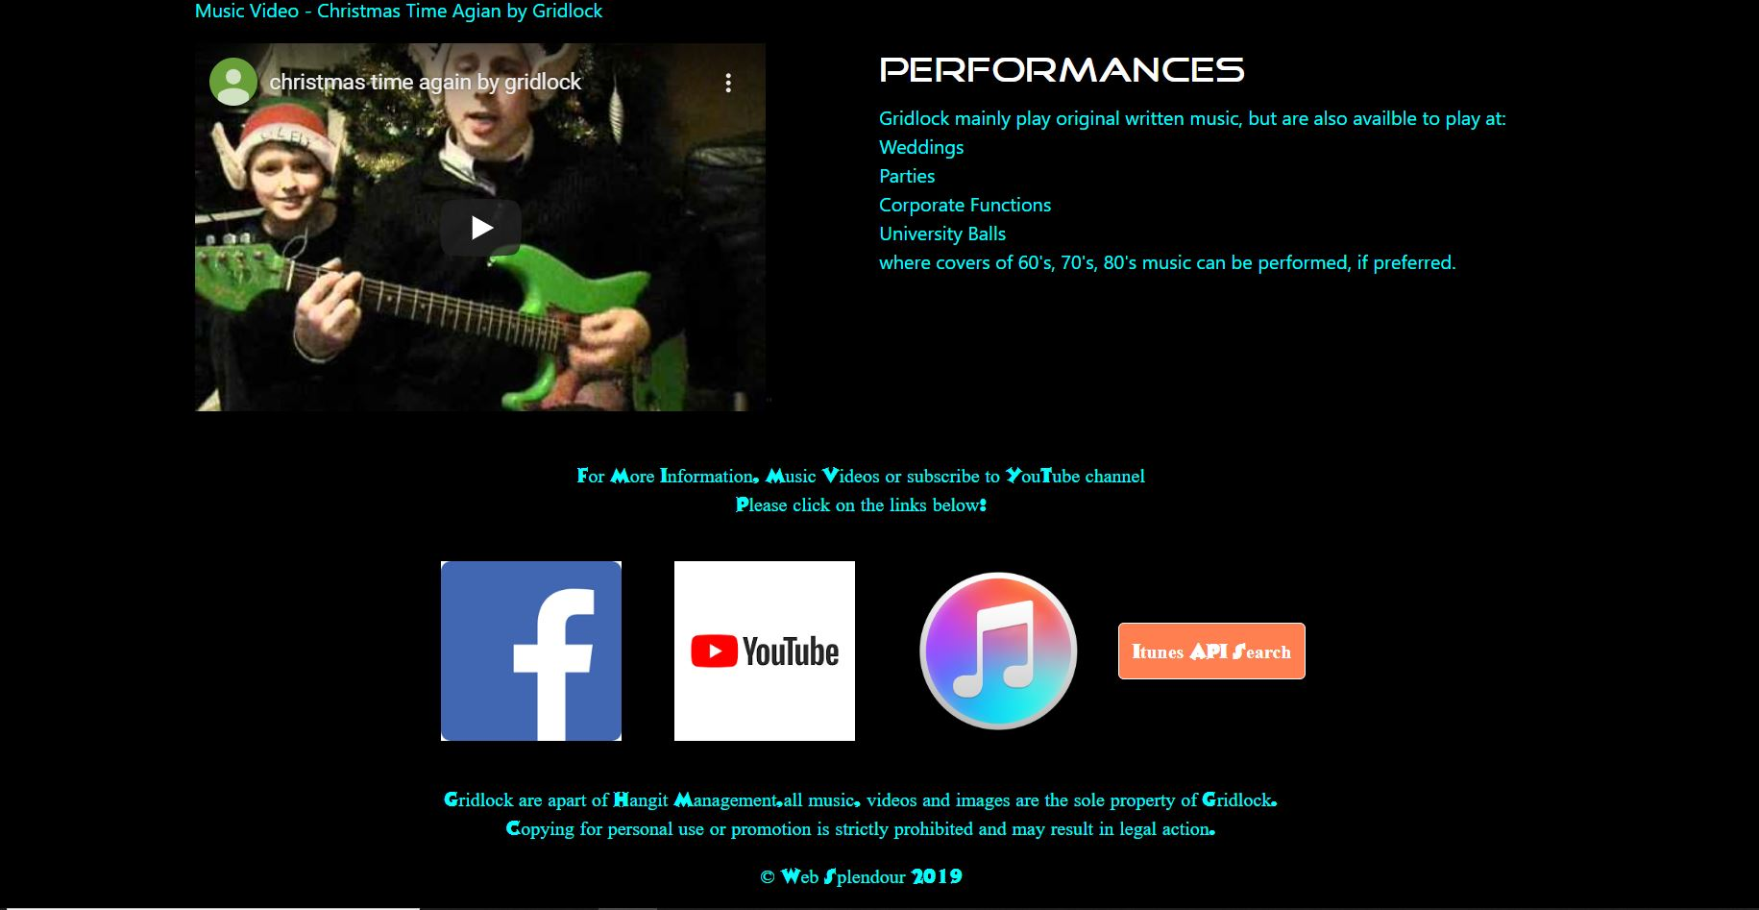
Fig 1.5 – The contact page, access to the API is made from here. Also displays music videos .

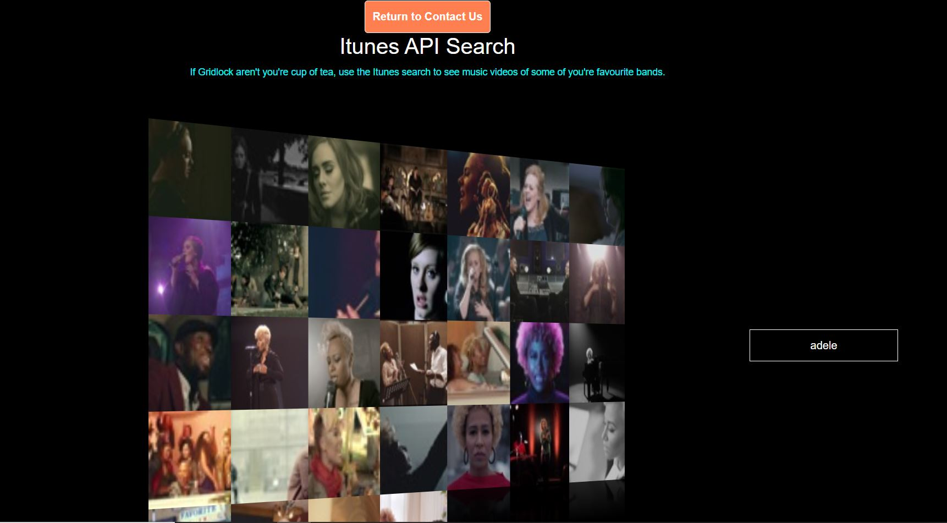
Fig 1.6 – The iTunes API.

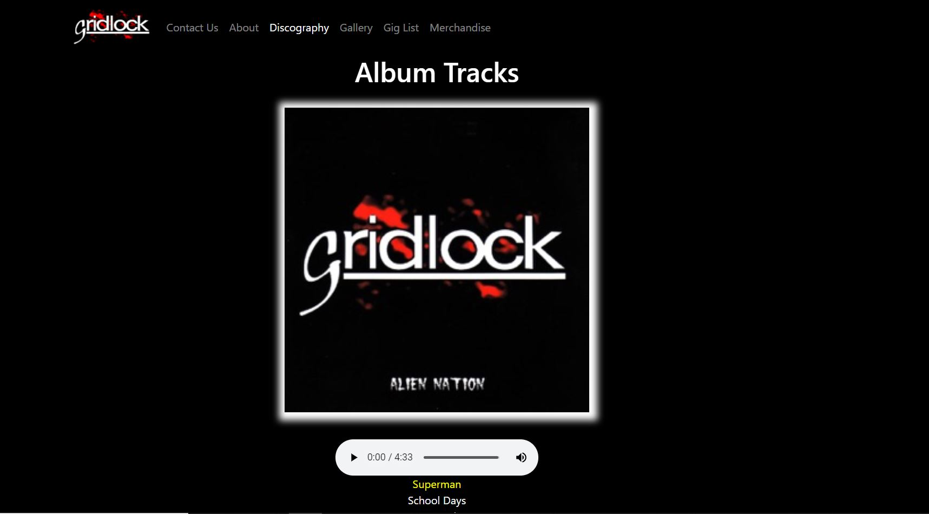
Fig 1.7 – The Discography page.


Fig 1.8 – Photo Gallery Page.


Fig 1.9 – The Gig list page.

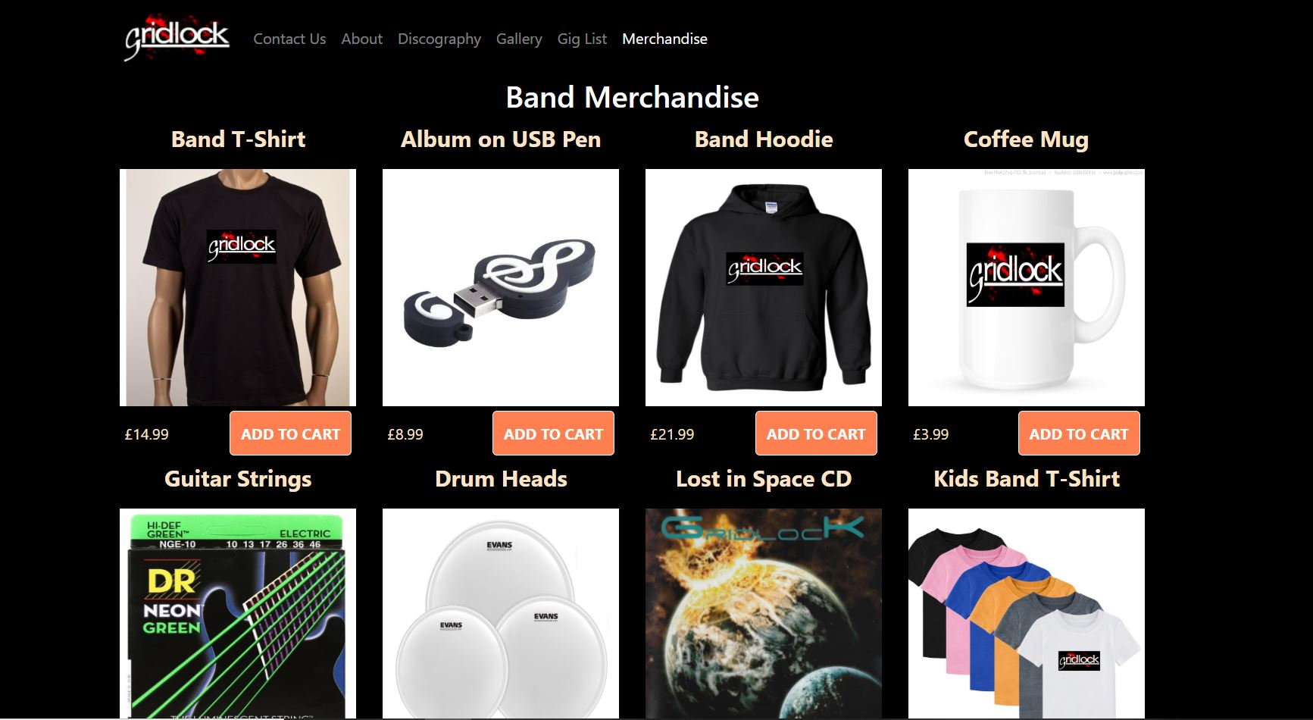
Fig 2.0 – Band merchandise page.

Fig 1.3 – Fig 2.0 are cropped images of the pages, as they are to large to display adequately.

5 Evaluation
Overall, the website performs how it was envisioned, but not without minor imperfections that could be rectified if more knowledge and understanding was obtained.
The site is very easy to operate and can be utilised by users of all ages, which was how it was set out to be. The wording is simple, and the layout is perfect for navigating around and not at all confusing. The site is not cluttered with functionalities that would detract from the overall look of the application and contains what most websites of a similar kind of genre have.
More knowledge of JavaScript is needed, as that is where some of the problems occurred in the implementation of some of the functionality. One of the issues was getting the audio player on the discography page to play all the selected tracks without opening a new page every time a track was chosen. The prevent default command was implemented but to no avail. This probably could be fixed with simple alterations to the code. The Merchandise page should allow the basket to empty once the ok button on the purchase alert was pressed but this failed to happen. Once again, minor changes to the code, but the author of this report was unable to see them.
Due to time restraints, not every element of the web design could be executed, and some improvements could be defiantly made. The ‘buy tickets’ on the gig list page could allow virtual purchases to be made and take the user to a different page that shows the tickets and order code. A sound analyser bar could be placed on any page that contains an audio file to show the EQ of the track.
6 References

References

[1] | N. Balog, "Coding DoJo," 23 jan 2019. [Online]. Available: https://www.codingdojo.com/blog/web-development-trends-of-2019. [Accessed 2 Dec 2019].
[2] | M. French, "How Artificial Intelligence is advancing engagement with Defined Contribution pensions," 25 Mar 2019. [Online]. Available: https://www.willistowerswatson.com/en-GB/Insights/2019/03/how-artificial-intelligence-is-advancing-engagement-with-defined-contribution-pensions. [Accessed 29 Nov 2019].
[3] | K. N. K. N. Sorna Shanthi.D, "Hexabot: A Text-Based Assistive Chatbot To," International Journal of Engineering and Advanced Technology (IJEAT), vol. 8, no. 3s, 2019.
[4] | T. Adams, "AI-Powered Social Bots," arXiv:1706.05143, vol. 1, p. 1, 16 June 2017.
[5] | b. Marr, "Bernard Marr and Co," [Online]. Available: https://bernardmarr.com/default.asp?contentID=1830. [Accessed 20 Nov 2019].
[6] | S. A. Nguyen Quynh N, "Understanding User Interactions with a Chatbot: A Self-determination Theory Approach," in Twenty-fourth Americas Conference on Information Systems, New orleans, 2018.
[7] | Clever Techie, "How To Create Image Gallery Using HTML, CSS and Javascript | Lightbox Gallery," 16 Sept 2018. [Online]. Available: https://www.youtube.com/watch?v=TSRtBISvsh4. [Accessed 18 Nov 2019].
[8] | Web Dev Simplified, "JavaScript Shopping Cart Tutorial for Beginners," 4 Oct 2018. [Online]. Available: https://www.youtube.com/watch?v=YeFzkC2awTM. [Accessed 1 Dec 2019].
[9] | MicroTech Tutorials, "HTML - Audio Playlist," 8 Feb 2016. [Online]. Available: https://www.youtube.com/watch?v=vtZCMTtP-0Y. [Accessed 25 Nov 2019].
[10] | M. Mark, A Smarter Way to Learn JavaScript, Amazon, 2015.
[11] | Stack Overflow, "How to make audio autoplay on chrome," [Online]. Available: https://stackoverflow.com/questions/50490304/how-to-make-audio-autoplay-on-chrome. [Accessed 21 Nov 2019].
[12] | Junior Developer Central, "iTunes API tutorial," 17 Oct 2018. [Online]. Available: https://www.youtube.com/watch?v=e0e6m2mxJlU. [Accessed 9 Dec 2019].

Appendix

Appendix 1 – Test Cases

Appendix 2 – JavaScript Code

Appendix A – Test Cases
The following Images show that the Web pages have been checked and have returned no errors in the code.
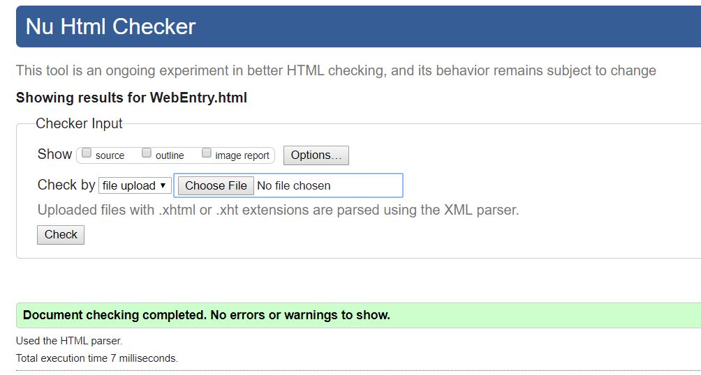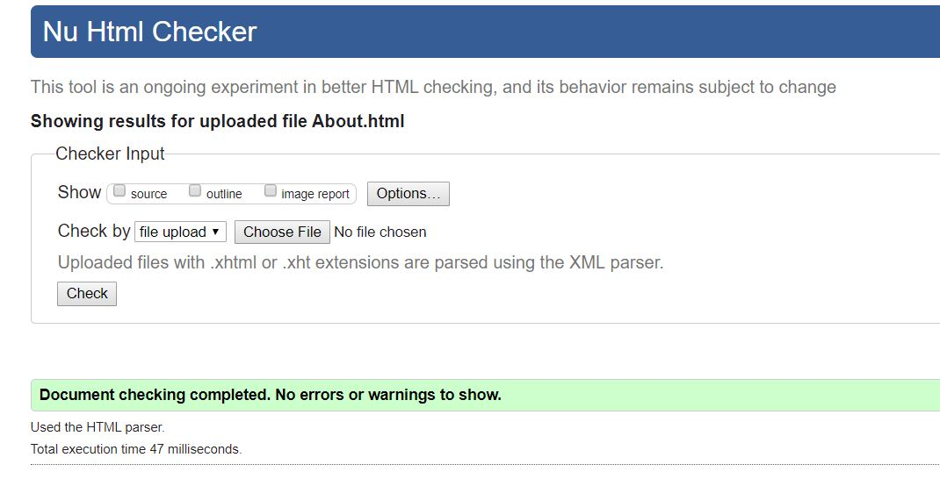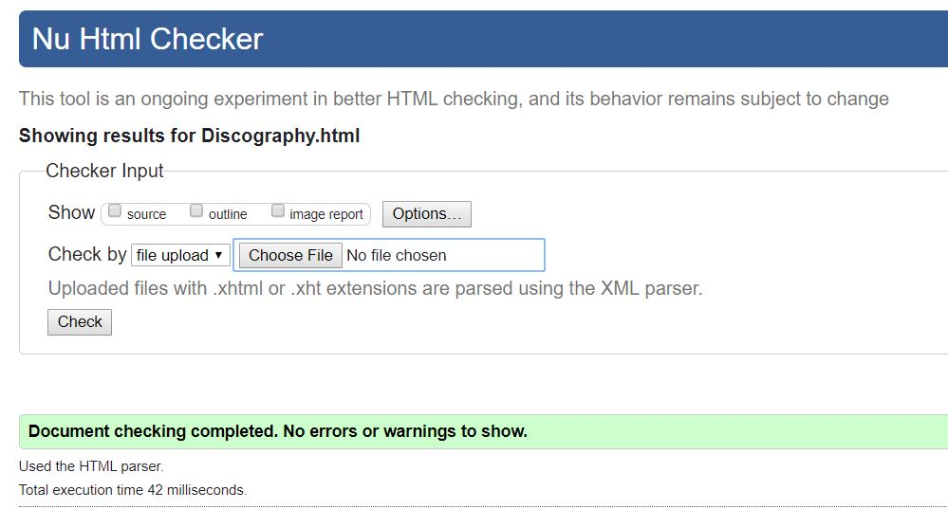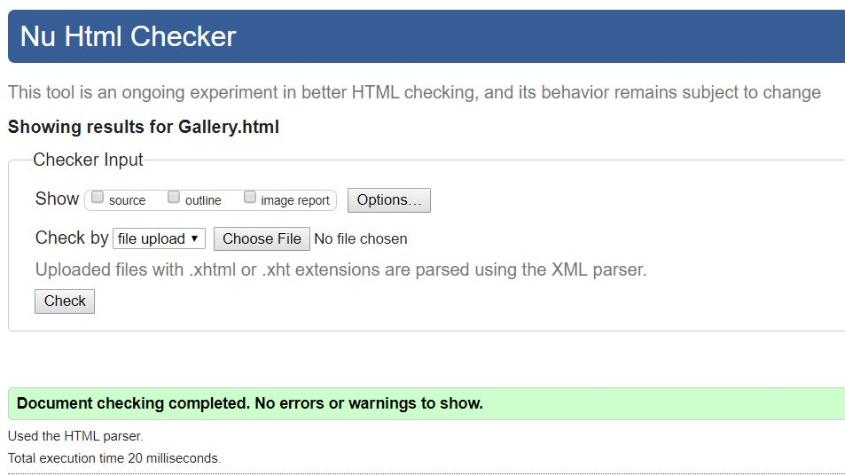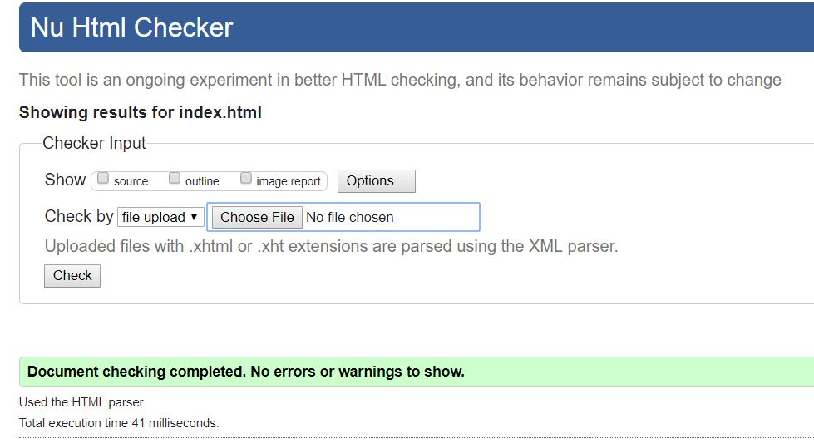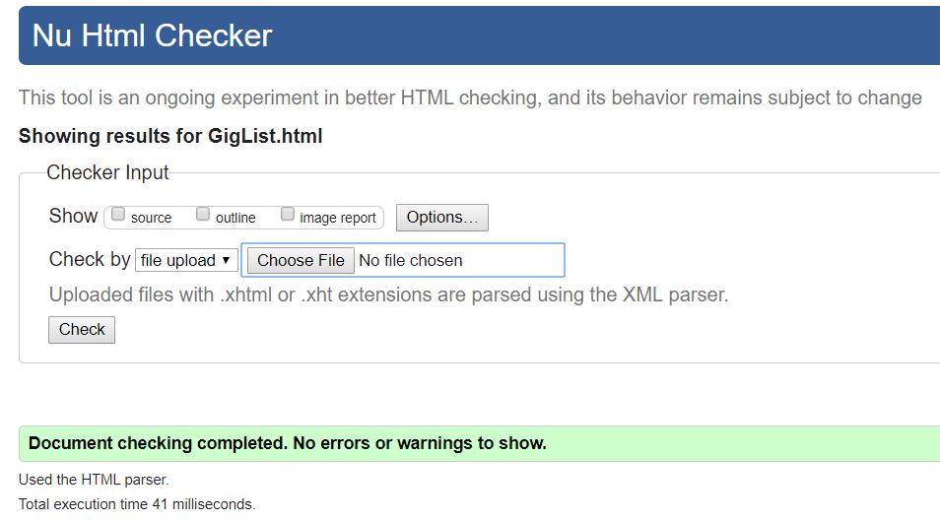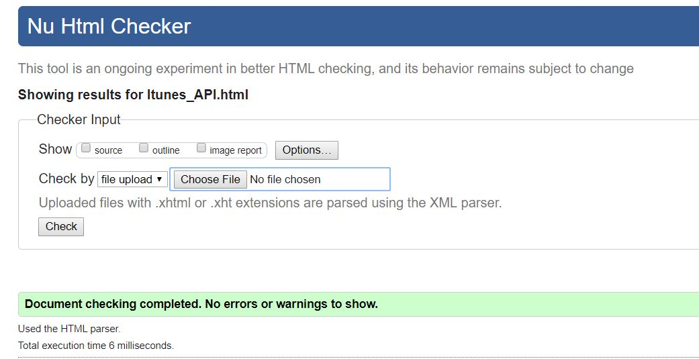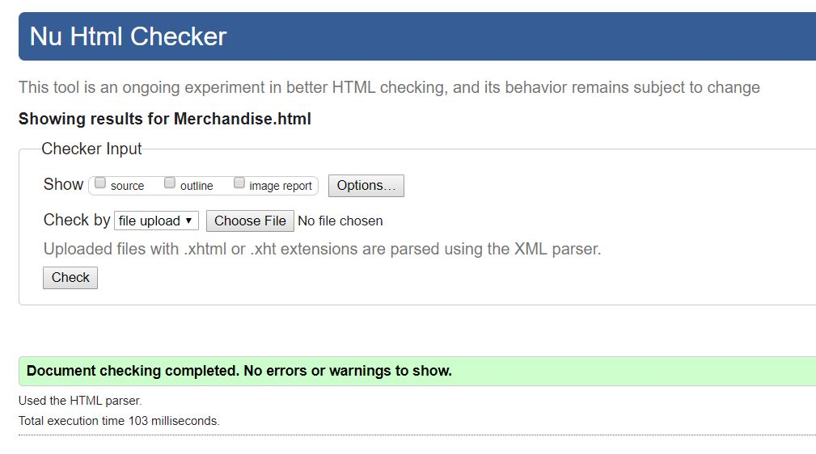

The following are 2 examples of test cases carried out on the website to see if it is functioning as it should.
A) Test Case 1 – Audio player on Discography page
This test is on the operation of the audioplayer to see if it fully controllable and that a user can choose whichever track they want to listen to using the same audio player.
Test steps
Select each track in the list
Test Data
Nothing to enter

Expected Result
Each track to be played through the same audio player
Actual Result
Only the first track on each album uses the players, all other tracks open a new web page.
All the tracks do play but not in the way they should.
Status
Fail
B) Test Case 2 – iTunes API
A user can access music videos from the apple iTunes API by typing an artist in the search bar.
Test Steps
Check that an artist selected returns a result
Test Data
Enter Duran Duran in the Search bar.
Expected Result
Once ‘Enter’ is hit, a list of music videos of Duran Duran or any artist associated with that group appear on screen and then they can be selected to play a short clip of their music video.
Actual Result
Artist selected returned music videos and was successful.
Status
Pass

Appendix B – JavaScript Code

Shopping Cart

if (document.readyState == 'loading') {
document.addEventListener('DOMContentLoaded', ready)
}
else {
ready()
}

function ready() {
var removeItemButton = document.getElementsByClassName('btn-danger')
for (var i = 0; i < removeItemButton.length; i++)
{
var button = removeItemButton[i]
button.addEventListener('click', removeCartItem)

}
var quantityInputs = document.getElementsByClassName('cart-quantity-input')
for (var i = 0; i < quantityInputs.length; i++)
{
var input = quantityInputs[i]
input.addEventListener('change', quantityChanged)
}

var addToCartButtons = document.getElementsByClassName('shop-item-btn')
for (var i = 0; i < addToCartButtons.length; i++)
{
var button = addToCartButtons[i]
button.addEventListener('click', addToCartClicked)
}

document.getElementsByClassName('btn-purchase')[0].addEventListener('click', purchaseClicked)

}

function purchaseClicked()
{

alert('Thanks for your purchase')
var cartItems = document.getElementsByClassName('cart-row')[0]
while (cartItems.hasChildNodes())
{
cart-Items.removeChild(cartItems.firstChild)
}
updateCartTotal()
}

function removeCartItem(event) {
var buttonClicked = event.target
buttonClicked.parentElement.parentElement.remove()
updateCartTotal()
}

function quantityChanged(event) {
var input = event.target
if (isNaN(input.value) || input.value <= 0) //isNAN is not a number
{
input.value = 1
}
updateCartTotal()
}

function addToCartClicked(event) {
var button = event.target
var shopItem = button.parentElement.parentElement
var title = shopItem.getElementsByClassName('shop-item-title')[0].innerText
var price = shopItem.getElementsByClassName('shop-item-price')[0].innerText
var imageSrc = shopItem.getElementsByClassName('shop-item-image')[0].src
addItemToCart(title, price, imageSrc)
updateCartTotal()
}

function addItemToCart(title, price, imageSrc) {
var cartRow = document.createElement('div')
cartRow.classList.add('cart-row')
var cartItems = document.getElementsByClassName('cart-items')[0]
var cartItemNames = cartItems.getElementsByClassName('cart-item-title')

for (var i = 0; i < cartItemNames.length; i++) {
if (cartItemNames[i].innerText == title) {
alert('This item is already added to the cart, adjust quantity if more is required')
return
}
}
var cartRowContents =
`<div class ="cart-item cart-column">
<img class ="cart-item-image" src="${imageSrc}" width="100" />
<span class ="cart-item-title">${title}</span>
</div>
<span class ="cart-price cart-column">${price}</span>
<div class ="cart-quantity cart-column">
<input class ="cart-quantity-input" type="number" value="1" />
<button class ="btn btn-danger" type="button">REMOVE</button>
</div>`
cartRow.innerHTML = cartRowContents;

// cartItems.innerHTML += "<div class='cart-row'>" + cartRowContents + "</div>";
cartItems.append(cartRow)
cartRow.getElementsByClassName('btn-danger')[0].addEventListener('click', removeCartItem)
cartRow.getElementsByClassName('cart-quantity-input')[0].addEventListener('change', quantityChanged)
}

function updateCartTotal() {
var cartItemContainer = document.getElementsByClassName('cart-items')[0]
var cartRows = cartItemContainer.getElementsByClassName('cart-row')
var total = 0
for (var i = 0; i < cartRows.length; i++) {
var cartRow = cartRows[i]
var priceElement = cartRow.getElementsByClassName('cart-price')[0]
var quantityElement = cartRow.getElementsByClassName('cart-quantity-input')[0]
var price = parseFloat(priceElement.innerText.replace('£', ''))
var quantity = quantityElement.value
total = total + (price * quantity)
}
total = Math.round(total * 100) / 100
document.getElementsByClassName('cart-total-price')[0].innerText = '£' + total
}

Audio Player
function audioplayer()
{
var currentsong = 0; // will track the current song we are on.
$("#audioplayer")[0].src = $("#playlist li a")[0];//grabs the first element in the list which is 0-10 (0 will be superman).playlist li a grabs all the list .
$("#audioplayer")[0].play();//plays automatically the first in the list
$("#playlist li a").click(function (e)// so we can click on a track to select it (e) being the event.
{
e.preventDefault();// stops the link or track from opening up a new page
$("#audioplayer")[0].src = this; //puts the selected track into the audioplayer
$("#audioplayer")[0].play();//plays automatically with every track selected
$("#playlist li").removeClass("current-song");//should remove yellow highlight from superman when something else is choosen.
currentSong = $(this).parent().index();// makes the song choosen the current track playing, and index will make the selection from the list of tracks
$(this).parent().addClass("current-song");// turns the track selected yellow to indentify current song.
});

$("#audioplayer")[0].addEventListener("ended", function () // autmatically playes a track after the current track finishes. should play them in list order
{
currentSong++;// increments the song by 1.
if (currentSong == $("#playlist li a").length)
currentSong = 0;//restarts the playlist agin
$("#playlist li").removeClass("current-song");//removes the yellow highlight when track has finished.
$("#playlist li:eq ("+currentSong+")").addClass("current-song");//turns the next current song to yellow
$("#audioplayer")[0].src = $("#playlist li a")[currentSong].href; //setting up the track we want to grab
$("#audioplayer")[0].play();//song will auto play when one ends.
});
} // $ replaces the getElementbyId

Alert Message and Entry Audio Player

//********alert message about autoplay**********
function alertUser(msg)
{
alert(msg);
}

////****************************WEB ENTRY PAGE*****************************
//create audio for web entry page and allow some properties to be altered.
var audio = new Audio();
audio.src = 'assets/audio/01SuperMan.m4a';
audio.controls = true;
audio.loop = false;
audio.autoplay = true;

// mp3 player last to load on page
window.addEventListener("load", initmp3Player, false);
function initmp3Player()
{

document.getElementById('audio_box').appendChild(audio);
Context = new webkitAudioContext();//audioContext object instnce using the web kit for chrome, if all browsers work the webkit can be removed
analyser = context.createAnalyser();//analyserNode method
canvas = document.getElementById('analyser render');
ctx = canvas.getContext('2d');
//re-route audio playback into the processing graph of the audioContext
source = context.createmediaElementSource(audio);
source.connect(analyser);
analyser.connect(context.destination);
frameLooper();

}

marking criteria and Student FEEDBACK

This section details the extent to which the assessment criteria are demonstrated by you, which in turn determines your mark. The marks available for each category of skill are shown. Lecturers will use the space provided to comment on the achievement of the task(s), including those areas in which you have performed well and areas that would benefit from development/improvement.

Common Assessment Criteria Applied (Assignment 1) | Marks available | Marks  awarded
1. Engagement with Literature Skills

A very good introduction of the chosen web application trend. The required background from a relevant peer-reviewed study is, however, missing. (Grade mark: 68.00%) | 25 | 17
2. Knowledge and Understanding Skills

3. Cognitive and Intellectual Skills

A detailed set of test cases has been developed for the different set of JavaScript functionality added to the website. A very good, reflective evaluation of the implemented website has also been provided. (Grade mark: 85.00%) | 20 | 17
4. Practical Application Skills

An excellent attempt featuring an entertaining website with well-thought-out content and a good range of interactive functionality. There are a few things to note. Be careful with your variable names and ensure you are consistent and using the variable names that you have declared. Consider adding your script references before the closing </body> tag as JS can be a render blocking resource. Refactor repeated blocks of code into reusable functions with parameters for what varies. Although there were some issues with one/two of the JS functions, you have demonstrated a good range of relevant functionality. Some suggestions on some of the challenges you had with some of your JavaScript functionality have been provided in your report. See your report for other comments. (Grade mark: 82.00%) | 50 | 41
5. Transferable Skills for Life and Professional Practice

The report is well-written and presented. See your report for some suggested improvements. (Grade mark: 80.00%) | 5 | 4

Assignment Mark (Assessment marks are subject to ratification at the Exam Board. These comments and marks are to give feedback on module work and are for guidance only until they are confirmed. ) | Late Submission Penalties (tick if appropriate) |  | 79%
 | Up to 1 week late (40% Max) |  | 79%
 | Over 1 week late (0%) |  | 79%

