Provide to: Dr. Jonh – Paul Okeke
Provide by: Reneta Ivanova
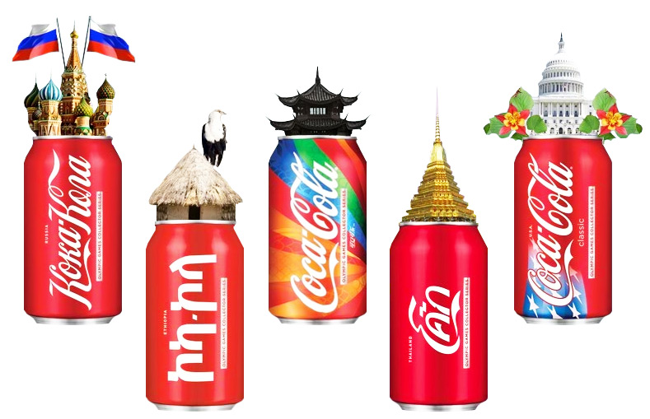

REPORT
Design organization structure and culture
of Coca Cola company
Assessment 1
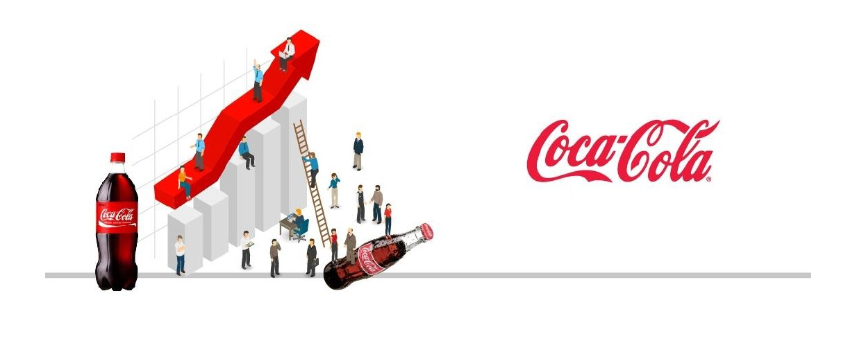
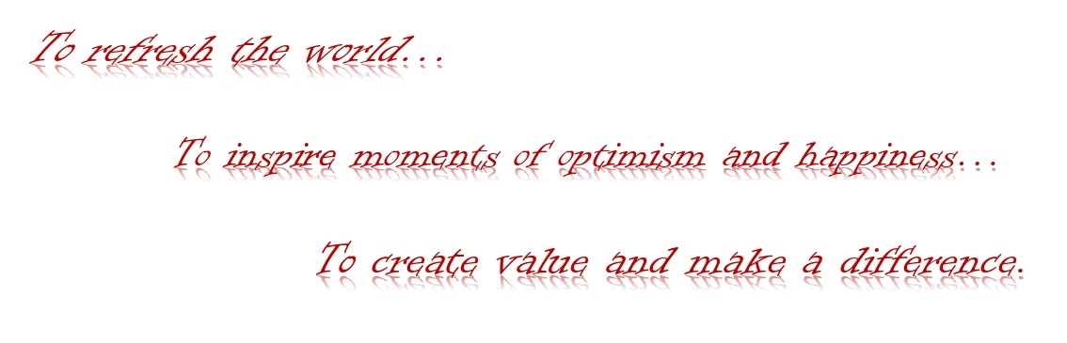
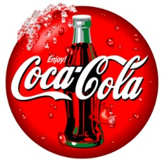


TABLE OF CONTENT
- Introduction......................................................................................3
- Coca Cola company……………………………………………….4
- History of Coca Cola………………………………………………4
- Vision, Mission and Values……………………………………….6
- Organization design and effectiveness………………………….....8
- Organization structure……………………………………………10
- The influence of dynamic global environment…………………..14
- Organization culture…………………………………………..….15
- Organization technology…………………...…………………….18
- Organization evaluation………………………………………….19
- Conclusion……………………………………………………….20
- References……………...………………………………………...21

- Introduction
‘’Organisation behaviour is concerned with the study of behaviour of people within an organization setting. It involves to understand, prediction and control of human behaviour. Common definition of organization behaviour are generally along the lines of: the study and understanding of individual and group behaviour and patterns of structure in order to help improve organization performance and effectiveness.’’ says Laure J. Mullins, Organization behaviour, 11th edition, Pearson, 2016.
The global Coca-Cola Company has a strong market focus both locally and internationally with the support of its bottling partners. The organizational behavior of the company provides a good organizational structure and culture by making the best decisions for planning, organizing, controlling, and managing.
Coca-Cola is a leader in global beverage production, distributor and retailer of soft drinks. The leading product of the company with which it became world-famous is Coca-Cola, the creator of the drink was the pharmacist John Pemberton in 1886. In 1889 the brand and the formula were bought from Asa Candler.
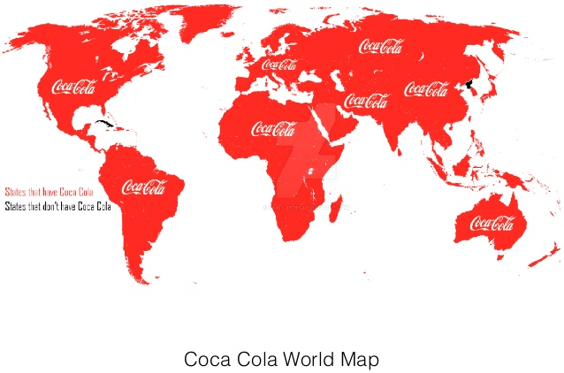
In addition to the Coca-Cola drink, the company offers more than 500 brands in more than 200 countries. The management of the franchise is aided by a distribution system, with the company producing syrup concentrate, which is then sold in various bottles around the world. Coca-Cola is headquartered in Atlanta, Georgia.
Fig.1

- Coca Cola company

- History of Coca Cola

The Coca-Cola brand was first introduced in 1886 by a pharmacist named Dr. John C. Pemberton. Pemberton's original recipe was altered by removing alcohol under the law in Atlanta, Georgia. The prescription was initially introduced as a patented drug in stores, claiming to be a cure for diseases.
In 1888, Pemberton sold the company to various parties and most of Asa G. Candler. Candler acquired the rights to the Coca-Cola brand and the formula, and in 1892 expanded the company's operations and the production of Coca-Cola syrup concentrate.
The marketing strategies applied through the intriguing Coca Cola promotions led to the company's success, and in 1894 businessman Joseph Bidenharn began bottling the drink. Candler sold bottling rights to the beverage in 1899 to two lawyers named Joseph Whitehead and Benjamin Thomas.
In 1916 was an important moment for the Coca-Cola Company, as they introduced a new design of the brand and the advantage that their product could differ from the imitations with the introduction and production of contour bottles.
The Coca-Cola Company was sold in 1919 to a group of investors led by Ernest Woodruff, and in 1923 his successor, Robert Woodruff, was elected president of the company, contributing to its expansion. In 1928, Coca-Cola became a sponsor of the Olympic Games.
Demand for Coca-Cola during World War II was increased by American soldiers serving abroad. In response to increased demand, Woodruff began building bottling plants abroad.
Coca-Cola began producing larger bottles in 1955 and introduced metal cans in 1960.
Advertising is a very important part that builds the brand and image of Coca-Cola, for example with one of their slogans "I would like to buy the world of Coca" in 1971.

The company's CEO in 1981 was Roberto K. Goizueta, who organized and controlled the various bottling operations in the United States, committed to innovation, and launched Diet Coke, marking the first expansion of the Coca-Cola brand. Following the worldwide success with Diet Coke's low-calorie soft drink, Goizueta is focusing on changing and improving Coca-Cola to create a new flavor.
Coca-Cola relies on innovation in the organization and its culture is dynamic according to external influences. For example, the company developed a diet soft drink, replacing sugar with saccharin. Coca-Cola is a producer of differentiated soft drinks, including Fanta and Sprite, so through the variety that the market offers, it can satisfy every customer, even the most demanding according to his wishes and taste.
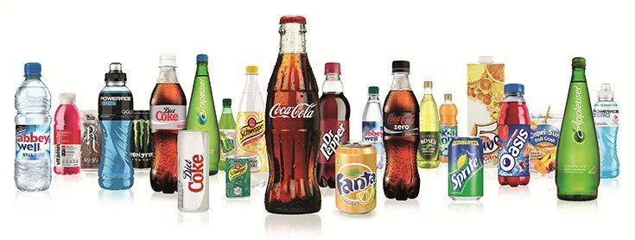
Fig. 2
The company focuses on the production of healthy drinks after the growing interest of consumers. These include Nestea flavored tea, Fruitopia fruit drink and Dasani water, orange juice. Top secret is the recipe for the drink Coca-Cola, the company has never been threatened.
The company is a world leader as a producer and trader of soft drinks Coca-Cola, Diet Coke, Fanta, and Sprite. The success of the recognized brand is due to the high quality of the products it offers to consumers, marketing based on creativity and innovation, global accessibility, as the company produces large quantities that are bottled and distributed worldwide and last but not least constant innovation in its products.

- Vision, Mission and Values
The dynamics of the world are crucial for a global company like Coca Cola. For their future development, they must innovatively forecast and implement long-term strategies to ensure their future success. All this guarantees the company's vision in 2020, setting long-term goals and prospects for their business.
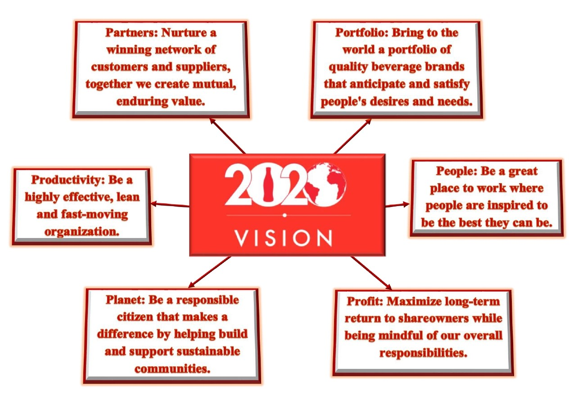
Fig. 3

The company's mission is sustainability, which aims to create the best standards with their actions and decisions.
Their vision is to create brands and drinks that people love, to refresh them in body and spirit. The company with this approach is a step towards a more sustainable business and a better-shared future that changes the lives of people and our planet.
The company's strategy is to preserve the values ​​of Coca Cola, based on its culture by taking the lead in the first place, giving them the right direction to work and shape a better future for the planet. In second place is the cooperation that motivates the performance and cooperation of the team to improve the world. The system of the organization is also based on integrity and accountability to be real and responsible. In the penultimate place is the passion for the brand with heart and mind. Last but not least, the values ​​of the products and the variety offered are important values.
The company clearly expresses through its values, vision, and mission that Coca Cola creates everything for people and the planet for a better life. Everything he achieves and continues to do is based on their beliefs to change the world for the better and no doubt impresses their partners.

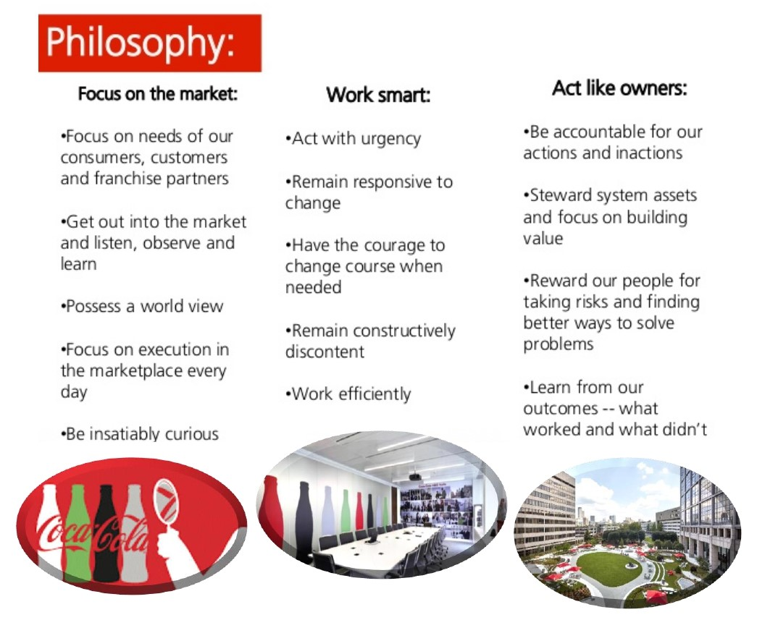

Fig.6.
Fig. 4
Fig.7.
- Organization design and effectiveness
Today, Coca-Cola is an icon of many cultures, all achieved thanks to the ability to adapt to find new opportunities and markets. Founded in 1885, it has focused on growth and marketing. The company's campaigns with gifts from numerous promotional materials depicting the Coca-Cola brand logo, so many more people would like to try the product.
Coca-Cola creates a concentrate for the beverage and then sends it to the distributor, who adds carbonated water and other ingredients needed for the final product. The process and ingredients are secret, so the value of the company cannot be replaced because it is unique. The process of creating the drinks is mechanized, regulates the amount of ingredients and their mixing and there is a guarantee for efficient production. The organization operates large-scale production, which confronts them with many challenges that it must meet. The global market has different trends and requirements, such as consumers want dietary and low-calorie drinks.
Social, ecological and political factors reflect on the company, with each country having different rules and laws where they trade.
The company trades in over 200+ countries and territories and therefore face a variety of recycling challenges and therefore seek to find local decision partners. Coca-Cola is investing in North America with a purpose increase participation in recycling in communities with existing recycling available infrastructure.
Coca-Cola company in 2018 launches a new program "Zero Waste Cities" - which is aimed at zero waste. Planning for the waste prevention program focuses on countries and cities in Europe, the Middle East, and Africa.
There are also problems with a water supply and drinking water use, for example in India, the company has a conflict with local communities with the use of their water resource.
The organizational culture of the company is based on respect for human rights to employees, bottling partners, consumers, suppliers and the communities they serve. Their policies are approaching yes meet the expectations of stakeholders.
The corporate culture of the company can be influenced by the decisions and attitudes of the organization. Stakeholders are shareholders, companies, customers, employees and others.
The advantage of the organization is the competencies of the established brand and the network of distribution and bottling companies. The opportunities offered by the company on the market with the diversification of the product portfolio, duplication opportunities are minimized and almost impossible.
The competitive advantage of the organization is based on the relationships and contracts with its distributors, avoiding the possibility of imitation. The symbiotic relationship between company and distributors is achieved through rules, attitude, and trust, with Coca-Cola agreeing to sell directly from the company's authorized retailers to the bottling company.
Consumers are strongly committed to the brand because the company's strategy focuses on marketing development innovatively, as their brands are constantly promoted and this creates good protection against their competitors.
Structure of organization work properly in the marketing and innovation department, which provides the organization with secure control over production, marketing and development. The expansion of local offices creates a better precondition for local market research and innovative approaches to serve new potential customers. The advantage of complex integration mechanisms is that the company has good coordination between levels and divisions.

Fig.13.

- Organization structure
‘The structure of an organisation is the total of the ways in which it divides its labour into distinct tasks and then achieves co-ordination among them’ (Mintzberg, 1979). Organisation structure describes how managers divide, supervise and co-ordinate work. It gives someone accepting a job a reasonably clear idea of what they should do – the marketing assistant should deal with marketing, not finance.’’ said David Bobby, Management an introduction, fifth edition, 2011.
The structure of the organization is determined by the nature of the activity and its size. Coca Cola spans a global scale, and in 2005 was named one of the most recognized brands.
- Autority, power and responsibility
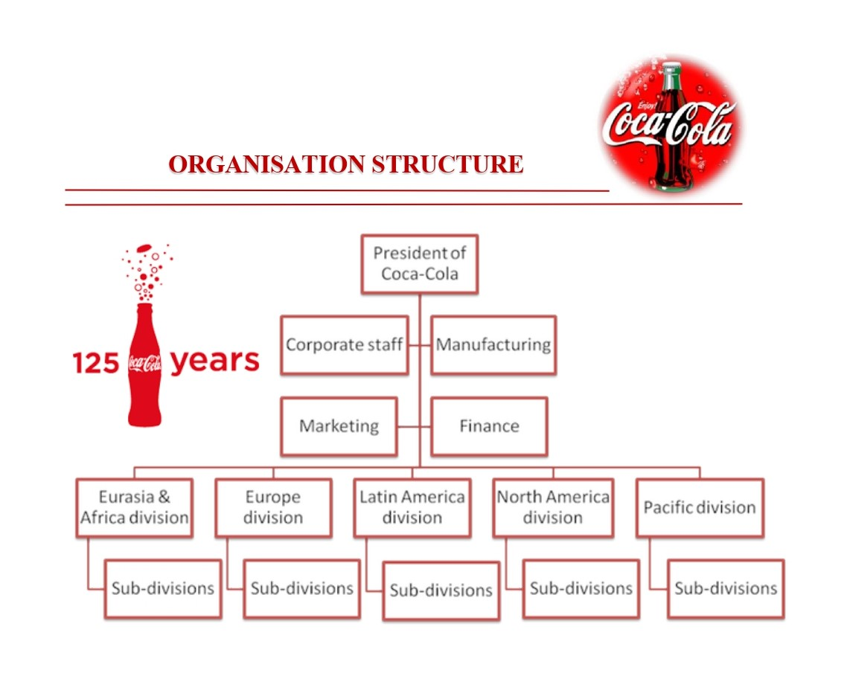
The company currently employs about 94,800 people. The organization chart for hierarchical levels are over 5. https://www.coursehero.com/file/p5ckmck/Designing-organizational-structure-Authority-Control-The-coca-cola-company/

Fig. 5

Strategy and tactics determine the development and growth of any company, as the division of labor is a key function for a balanced work process. The company Coca Cola has a high hierarchy of on-site and subordinate, divided into regions. In order for the global organization to cope with the activities, it applies the organizational structure with the design of the division of labor in places, as each area has a certain amount of subordination, the number of which depends on the production capacity. This strategy used by the opportunity is the team, understood by regions, which can be close to the local market and connect with advertising campaigns, using taste qualities from this region. Each region has a subdivision e.g. Europe is divided into Southeast, Northwest, North and Baltic.
The company relies on the marketing department as the most highly developed and powerful share. Another important role is human resource management, which must be able to change and adapt to the uncertain side of the company, while at the same time must be able to deal with conflicts in the organization.
The power of marketing has made the Coca-Cola brand one of the most recognized in the world today. The conducted market researches provide the company with minimization of the expenses, as the data of the consumers are an indicator for the production of the drink to stop or to increase the quantity.
The disadvantages of high hierarchies, such as that of the company, are related to the communication and motivation of the staff. The use of the intranet significantly increases the communication between the levels in the hierarchy and there is a better efficiency of the top management to communicate with the employees.
The strategic changes that the organization has undergone, such as using a hybrid structure, are in order to minimize the shortcomings, thus having a positive efficiency and the advantage of both mechanistic and organic structures. The result is increased sales and satisfied employees. The company's efforts are linked to decentralization to create a more innovative culture.
- Specialization and control
The best choice that the company makes is by applying the divisional structure, which predisposes the organization to the possibility of full security and stability due to changes in its uncertain environment.

The multi-division structure has the advantages for the company, which has a positive effect for good development in the work process. The company's strategy is to focus on the individual market, giving the divisions of different geographical regions in specialized aspects, as the global market is different and one market will like or approach the advertising campaign or slogan, but for another it may have the opposite effect. The multi-division structures have the advantage that the operations in the activity are performed narrowly specialized, as the day-to-day operations are the responsibility of the division managers, and the commitment to long-term planning is the responsibility of the corporate managers.
Strategy and tactics determine the development and growth of any company, as the division of labor is a key function for a balanced work process. The company Coca Cola has a high hierarchy of on-site and subordinate, divided into regions. In order for the global organization to cope with the activities, it applies the organizational structure with the design of the division of labor in places, as each area has a certain amount of subordination, the number of which depends on the production capacity. This strategy used by the opportunity is the team, understood by regions, which can be close to the local market and connect with advertising campaigns, using taste qualities from this region. Each region has a subdivision e.g. Europe is divided into Southeast, Northwest, North and Baltic.
- Recommended changes can be implemented in the tall organization structure
The company has power with a clear hierarchical structure, which has a large layer, managing offices in over 200 countries.
With power comes responsibility, the problems in the organizational structure which are on several levels is difficult to manage. The company may lose or reduce the focus on employees and they are demotivated, this can lead to organizational problems, resulting in reduced business efficiency. According to data in 2010 the company lost labor of 185,608 days.
The recommendation to Coca-Cola to find a solution for a more stringent management structure in its regional and local divisions. This approach would have the potential to motivate employees.

The company is managed using centralization and decentralization (The Times, 2005). The disadvantage of decentralized power is limited to the advertising and marketing activities of the business. On the other hand, the company has a centralized government that operates in Atlanta, there is one that focuses on the company's larger solutions.
The problem of the company, when centralization has a positive effect more than limiting its effect on regional divisions. A number of authors analyze and propose solutions for the existing organizational structure, for example, Campbell analyzes a study of the division and demotivation of regional workers. Centralization can lead to a lack of innovation, as other authors claim.
There is a proposal for decentralization in particular in the organizational structure, which could lead to such an organization of efficiency. This can be recommended to respond to faster decisions and change employees and geographical location.

- The influence of the dynamics global environment
Globalisation refers to the increasing integration of internationally dispersed economic activities.
The global market provides great opportunities for the company to grow and grow, but also threats, such as an uncertain environment as an external factor, can negatively affect the organization. The huge global competition creates the company's efforts for the most important resource on the customer's market and supply of material resources, because clean water cannot be found anywhere in the world.
The global nature of the company predisposes it to dynamic solutions and therefore complicates the global nature of operations. In the event of sudden large-scale changes in the world market, the company is threatened by a number of unpleasant consequences, such as reduced production and distribution problems.
Company are increasingly finding information on how global companies are facing with the environmental problem. Many companies are already focusing on investing in preventive measures and environmental protection, with Coca-Cola in this direction regarding the environment. There have been criticisms of the company for its operations in India, alleging that they caused heavy pollution and damaged local water supplies.
Coca-Cola's governance is based on techniques that include diversification to strengthen leadership and competitiveness through strategic alliances. The company applies exclusive contracts with bottling partners and other customers. To consolidate its leadership position, the organization formed a strategic alliance with Burger King, becoming the only beverage supplier in the restaurant.
Nowadays, the organization has a strategic alliance with many global organizations, such as McDonald's, KFS, etc., a large percentage of the share of production and revenues of the company are from the unions. We have all the brands located worldwide, mounted on people are huge and valued as a drink that promises and spontaneously shows interest, families, cultures that send messages that advertise with the concept to mention the moment.
- Оrganisation culture
Organization culture is a common perception held by the organization’s members that distinguishes the organization from other organization, i.e. ‘’personality’’.
Because organization culture represent common perceptions shared by the organization’s members, though individuals may have different backgrounds or levels in the organization, they will tend to describe in similar terms the organization’s dominant culture shared by the majority of the orgaznisation’s members.
In 1886 – Atlanta, pharmacist John Pemberton searching for quick cure for headaches creates a caramel -colored liquid formula mixes it with carbonated water at Jocob’s Pharmacy and invents Coca Cola.
The company's messages with the concept of culture to make a change, inspiration, optimism and refreshment gathers countless users and employees to share a story, culture, drink. Coca-Cola company does not mean an ordinary drink for its users and employees, it gives them much more, they become part of something huge and they are proud that it means so much to billions of people.
Culture trip of World of Coca-Cola is museum in Antlanta, when we can visited fans around the world of the brand can learn a lot about the history of the company. Visits to the unique museum leave a pleasant experience, knowledge of the history of Coca Cola.
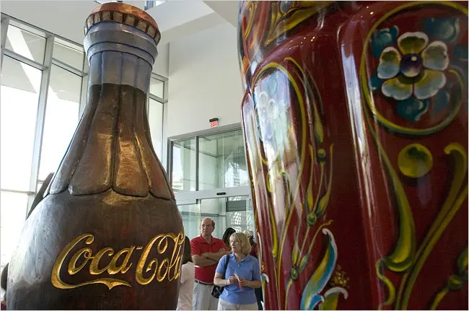
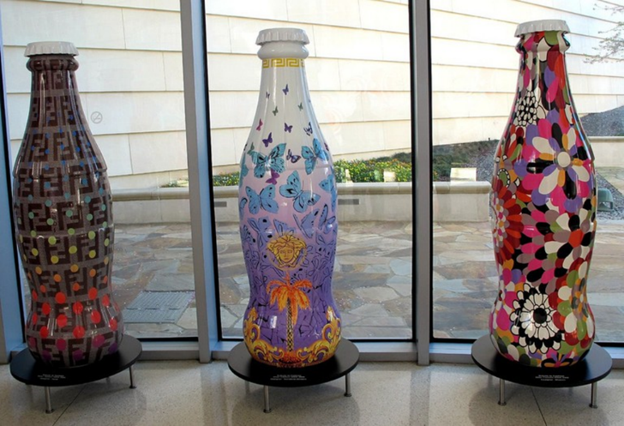

Fig.6.
Fig.7.

The company has a World of Coca-Cola Museum in Atlanta, which provides incredible experiences and cultural travel from around the world to its customers.
There are countless attractions that are definitely worth visiting the museum, such as the 7-foot polar bear Coca-Cola from the famous "Always Coca-Cola" campaign.
The visit will bring you a lot of interesting facts and knowledge, you can enjoy watching the 4-D movie for a secret formula.
The cultural trip around the world in the tasting area provides visitors with 100 different fragrance of Coca.
The company strives to change innovatively according to the dynamics of the global market, it encourages its employees by giving them the opportunity to participate in the goals of the Coca Cola company.
When looking for solutions to a problem, the organization makes drastic changes in the company's culture, such as when the company began to shrink, they reflected on how to reward employees and efforts to attract more employees.
Each level in the organization's hierarchy has different responsibilities, for example, the board of directors makes vital decisions for the company that management does not trust. The board of directors has an interest in minimizing the risk to the company, as it can be detrimental to board members who have invested in shares.
The organizational culture of the brand has an emotional impact on consumers. Branding has a connection between customers and brand values ​​through a sensitive level of their senses. The message of the brand creates harmony, reflected by communication media, corresponding to the basic human values ​​and giving the customer a sense of personalization. The company's corporate culture expresses emotional values ​​by engaging customers with the brand for long-term desire and lifestyle. Coca Cola promotional campaigns have simple and clear messages such as "Share Coca", "Taste the feeling", etc., and the brand has an emotional impact individually.
Eight different groups of cultures were developed and published in the Harvard Business Review in 2018 to understand the details of the culture and the optimal approach to coping. There are two concepts that give us an overview of the different cultural types located on the two-dimensional axis
An open system has two groups: purpose and caring of organizational culture to employees to maintain sustainability and loyalty in the global market.
The rational goal is responsible for two goals: in the organizational culture, such as employees to have security and safety and to be united through cooperation.
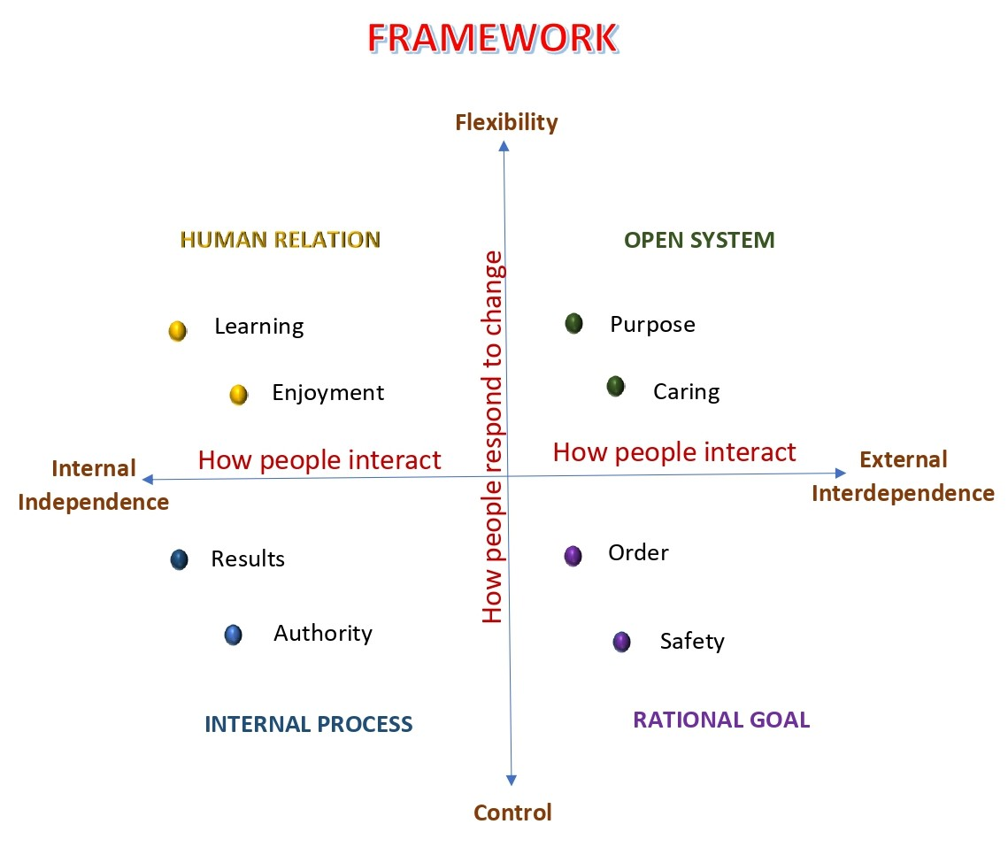
A internal process is responsible for two goals: in organisational culture results for employees and authority. The human resource has two goals: motivation of employees to learning and enjoyment of the work.
Fig. 8
The 8 Different Types of Company Culture that Exist today, OCTOBER 16, 2018, <https://hired.com/blog/candidates/the-8-different-types-of-company-culture-that-exist-today/>
- Оrganisation tecnology
The most uncertain source of the organization is related to production processes, as Coca-Cola does not produce the final product and does not have control. Bottling is done by the distributors they work with, who have the task after mixing the syrups and concentrates to mix them with other ingredients mainly carbonated water and then place the products on the market. To maintain high-quality products, the company applies maximum control and pressure so that there are no negative consequences. The fact that they are not part of the final process of the products, but the brand is in the final product, they must be very careful and cautious.
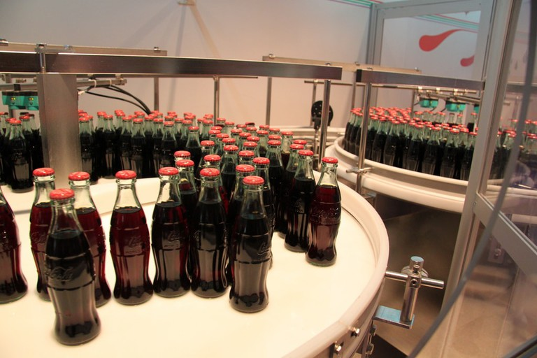
Fig. 9
The large-scale production of the company, which is extremely mechanized for each product, leads to an increased level of technical complexity.
The production has a continuous process and with a mechanical structure, ensures the efficiency of the desired end product. The hierarchy in the company has the characteristics of an organic structure, thanks to the focus on marketing and local landmark.

- Оrganisation evolution
Any company can go through the life cycle of birth, growth, decline, death, but now Coca-Cola after 120 years, remains in the development stage, thanks to good marketing strategies, ideas for innovative development, Coca-Cola is today a highly valued brand.
The company with its global scale has many external problem factors, as I have already mentioned the uncertainty with the suppliers it works with, the distributors, the political and public pressure. As the company continues to grow, the best managers expect responsibility for decision-making from local levels. In this way, corporate managers focus on strategic planning and improve concentration better in each market individually.
The company strives to simplify the structure and reduce bureaucracy so that decisions can be made more timely and efficiently. Lower-level managers can improve and participate in the company's growth efforts. The idea of ​​this structure is to achieve harmony and balance with the goals of the company and the managers.

- Conclusion
Management provides an opportunity to plan, organize, and control and answer questions about what to do, how to do it, and where to do it, combining work and management to create value.
Coca Cola, through its organizational culture, focuses on the problems and difficulties faced by the operating structure and finds a solution for more innovative and effective methods. The company restored its functional management and connected regional business units with its headquarters. The company optimizes a number of important internal processes, removing all obstacles and barriers that stopped them from being effective.
The portfolio includes more than 400 brands, including carbonated drinks, juices, coffee, tea, sports drinks, water, value-added dairy products, energy, and improved hydration drinks. Among these brands, there are several that generate more than a billion dollars in annual retail sales.
Emotional branding is a long-term tool that integrates the bond and deeply touches customers who can see the brand's values ​​as a person. The complex of tangible information that customers receive, the reflection of emotions through the brand, and the quality of the product influence the awareness and the choice to make their purchase. The Coca Cola brand is more than a drink, it provides the consumer with pleasure, emotion, and happiness.

- Reference

- Bobby D, Management an introduction, 5th edition, 2011.
- Armstrong M., Taylor, Armstrong’s handbook of human resources management practice, 13th edition, 2013.
- Mullins L, Organisation behaviour, 11th edition, Pearson, 2016.
- World of Coca-Cola, https://www.worldofcoca-cola.com/ /, (Accessed: July 6, 2020).
- 15 Facts You Need to Know About the World of Coca-Cola in Atlanta, Jacy Topps 5 February 2018, <https://theculturetrip.com/north-america/usa/georgia/articles/15-facts-need-know-world-coca-cola-atlanta/, (Accessed: 8 July 2020).
- Practice of management of coca cola, September 24, 2020, <https://www.slideshare.net/markedme/practice-of-management-of-coca-cola>, (Accessed: July 9, 2020).
- https://slideplayer.com/slide/2918853/>, (Accessed: July 11 2020).
- COCA-COLA AND POP CULTURE, Published with reusable license by Erin Kim, November 1, 2016, <https://prezi.com/ljc0y-w1hfnv/coca-cola-and-pop-culture/>, (Accessed: July 10 2020).
- <https://sites.google.com/site/muhammadkaroliav3/Coca-Cola>, (Accessed: July 11, 2020).
- Organisation Behaviour, <https://www.locusassignments.com/solution/unit-3-organisation-behaviour-assignment-sony-coca-cola>, (Accessed: July 13, 2020).
- The Coca-Cola Company, 19 April 2017, <https://plus.credit-suisse.com/rpc4/ravDocView?docid=_XAr32AL-YxKG>, (Accessed: July 13, 2020).
- Why Work at The Coca-Cola Company, 2020, <https://www.coca-colacompany.com/careers/why-work-at-the-coca-cola-company>, (Accessed: July 14, 2020).
- Coca-Cola HBC 2018_IAR_Strategic Report_15Mar2019.pdf, https://coca-colahellenic.com/Campaigns/AnnualReport2018/assets/pdf/Coca-Cola%20HBC%202018_IAR_Strategic%20Report_15Mar2019.pdf, (Accessed: July 15, 2020).
- Company and industry analysis Coca Cola company, <https://juliegilhuly.wordpress.com/2014/03/01/coca-cola-organizational-complexity/>, (Accessed: July 16 2020).
- What strategy will help Coca Cola and McDonald’s continue to Grow?, Posted on January 21, 2015 by arjkay, <https://strategyinsight.wordpress.com/2015/01/21/what-strategy-will-help-coca-cola-and-mcdonalds-continue-to-grow/>, (Accessed: July 16 2020).
- <https://en.wikipedia.org/wiki/Coca-Cola>, (Accessed: July 17 2020).
- coca-cola-business-and-sustainability-report-2018.pdf, <https://www.coca-colacompany.com/content/dam/journey/us/en/policies/pdf/safety-health/coca-cola-business-and-sustainability-report-2018.pdf>, (Accessed: July 17 2020).
- Creating an effective organizational structure at Coca-Cola, 25 September 2019, <https://businesscasestudies.co.uk/creating-an-effective-organisational-structure-a-coca-cola/>, (Accessed: July 17, 2020).
- Organisational Structure: Case on The Coca Cola Company, January 14, 2013, <https://danuzice.wordpress.com/2013/01/14/organisational-structure-case-on-the-coca-cola-company/>, (Accessed: July 18 2020).
- The Coca-Cola Company, <https://www.britannica.com/topic/The-Coca-Cola-Company>(Accessed: July 18, 2020).
- The Coca Cola company, <https://www.coca-colacompany.com/company>(Accessed: July 19, 2020).
- History of Coca-Cola, <https://www.interexchange.org/articles/career-training-usa/2016/03/08/history-coca-cola/>, (Accessed: July 19, 2020).

1944

