MA Graphic Design (Contemporary Dialogues)
Coexistent Perspectives (ADAA7000)
Jessica Pritchard – 2109765

Does the work of David McCandless prove or disprove that text is the most vital aspect of information design?

Submission Date: 10.01.2025
Word Count:

Abstract:
“Every day, every hour, maybe even every minute, we’re seeing and absorbing information”
(McCandless 2012)

Every moment of the day someone is trying to share a message with someone else. Individuals
Introduction:
“Every day, every hour, maybe even every minute, we’re seeing and absorbing information”
(McCandless 2012)

Every moment of the day someone is trying to share a message with someone else. Individuals having a conversation with each other, a shop making customers aware of a sale, road signs warning people their usual route is closed and charities trying to get people to donate to their cause. The world is full of information which needs to be displayed and understood (Holland 2002).

One of the largest volumes of information that is around is data, which is nothing new. Humans have been recording and analysing data for centuries, but with the development of the internet we now have access to unlimited information. Collecting and storing data has become more accessible, which has given more clarity in decision making, how we communicate ideas and who we communicate them to, the issues that are faced by people which leads to more chances to help solve these issues (Yau 2011).

We have access to so much data and information, however, there is no guarantee this means that everyone can understand what they are looking at. We need human insight into this data to make sure that is accessible and readable, which is where information design comes into play. The role of the information designer is to produce designs that will allow people to visualise the data to gain a further understanding of what it is they’re seeing (Spence 2007).

One method which is used to do this is through infographics, which exist to present complex information quickly and clearly. They use a variety of visual components such as colours, signs, images and text to make these large chunks of information in a visually appealing way to make people want to read it (Siricharoen 2015).
Knowing this then raises the question, in a piece of information design, what is the most important aspect? The information needs to be there, but simply writing this information out as text, on a white sheet of paper, in a simple font just would not work. There would be a loss of interest and people would not take the information in.

One information designer David McCandless set out to test this out, after being swamped by information, wanted to find a better way to view this information. They have written the book “Information is Beautiful”, which is full of information design and infographics. McCandless states that we need colour, charts, maps and diagrams in order to make the information meaningful, approachable and beautiful (McCandless 2012).

The aim of this essay is to show, through McCandless work, that even though words are needed in designs there are three more vital aspects. The first being semiotics, relating to signs and symbols and how they are interpreted. The second being colour and the meaning behind the choices of colour used. Finally, typography, as words are needed in infographics this chapter will focus on how we present the words and the way they look on the page.
Semiotics:

“Seeing comes before words”
(Berger 1972)

Signs are all around us, there is no escaping them. From road signs stopping us from driving down a one-way road all the way to body language the messages we unconsciously send. These signs, in relation to semiotics, stand for something or represent something else. It can be argued that everything has the potential to be interpreted but nothing has only one meaning. Semiotics is focussed on how meaning is made from these signs, and some would argue that as humans we are meaning makers, above all else, and we decide how reality is represented (Chandler 2002).

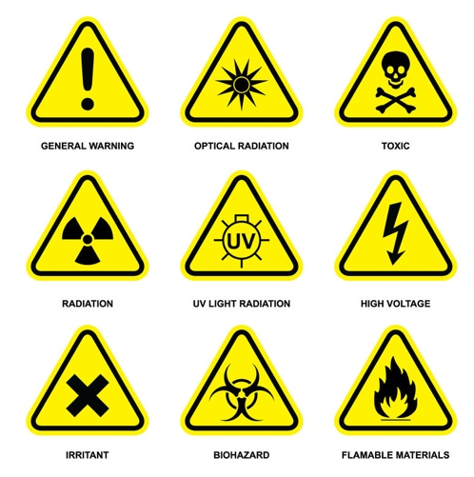
When creating a piece of information design, it is important to consider the use of signs symbols and images as these have the potential to change the meaning of the words used, or to emphasize the point the words are trying to make (Hall 2012).

Consider the word “danger”, on its own it is not clear what the severity is or how a person should respond to the danger. However, one of the signs in Fig 1 is added to the word it gives much more information. It allows the person viewing to know exactly what the danger is and how they can specifically avoid this danger and remain safe.
Fig 1 – Danger signs

This is a very simple example of the power of semiotics, as these signs used well known ISOTYPE,
which is a system created to use icons to convey meaning. The simplicity and obvious nature of the image means there is no question is what the message is they are conveying. The clarity of these symbols allows the signs to transcend language to create almost a universal language that all can understand. The idea of changing the scale or quantity of these symbols to dictate the importance or a numerical amount is another well used method of sharing information through ISOTYPES (Kosara 2013).

From birth we recognise visuals before we understand words, and this pattern is present throughout our entire lives. We can explain what we see in the world using words, but this will never truly represent what we see (Berger 1972). For example, you could read this description of a sunset: “A clear line divides the deep blue waters and the orange sunlight. The sky is lighter and the light from the sun is reflected in every wave.” But this does not fully represent the beauty that comes from seeing it in person, like in Fig 2.


Fig 2 – Aberystwyth Sunset

The description of a scene also cannot fully draw out the emotions that the scene could evoke when viewed in person. But even these aren’t universal experiences, as the way a person takes in the world around them is determined and differentiated by their experiences and beliefs. To one this sunset would be a sight of calm and peace, to another the water might be a fear which would mean this could potentially be a stressful scene. When we look at something we never just “look” we make a connection between what is seen and how it can personally relate to our lives (Berger 1972).
The use of well-known symbols to increase understanding, and the importance of creating an emotion connection, can be seen in this piece by David McCandless, in Fig 3, to illustrate the effects of a rising sea level. Being told that the sea level will rise 6 meters can be difficult to visualise, which can lead to this information having a low impact on how our lives. However, by showing that by the water levels rising 6m then the London Eye, a well known symbol thatrepresents London would be underwater, it gives a sense of comparison and scale which the information can be compared to.
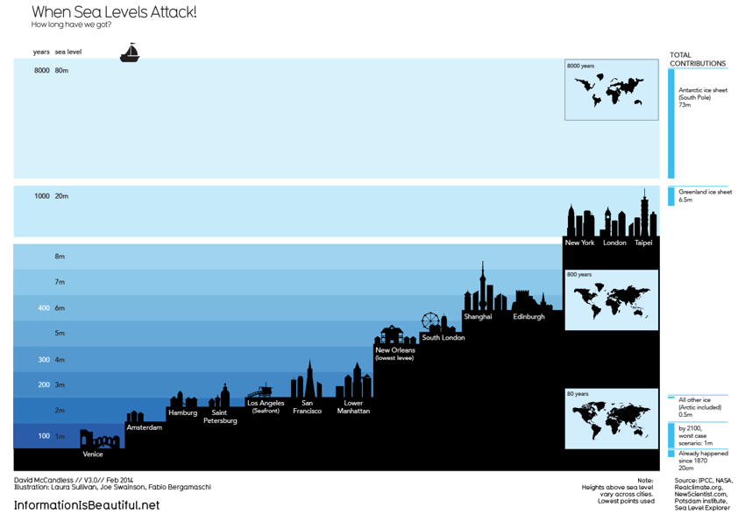

Fig 3 – Sea Levels, David McCandless

Crow would argue that visual artists have power over a viewer when conveying a message, they have a knowledge of how meaning is formed and therefor can use images and visual language to convey a meaning to those viewing it (Crow 2010).

It is clear to see how McCandless used this power mentioned by crow in Fig X. The idea of all these famous cities being underwater is something from a sci-fi film and something a person simply could not imagine living through. If this fear is instilled in a person through this image, then taking action as a result is more likely in order to prevent their home from ending up underwater in the future.

Another example of McCandless’ work is his piece ‘A Lack of Conviction’ which shows rape conviction statistics, but in this instance the visuals that he uses are much simpler but have the potential for a huge impact.
In fig 4 we can see that the only visual imagery used was circles, and they were used to show larger and smaller figures. The use of the half circle disappearing off the page as the number is too large, representing the amount of estimated attacks, compared with the smallest circle at the bottom of the page representing convictions. This clearly shows an injustice in this area and how much change needs to happen to match these two figures together.
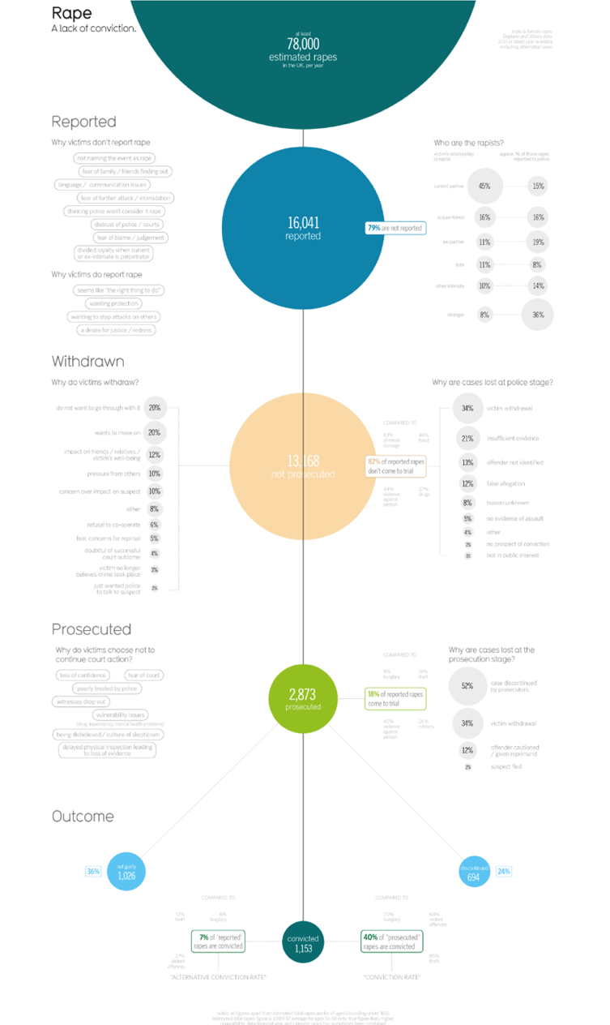

Fig 4 – A Lack of Conviction, David McCandless

To conclude this chapter I would say that the work of McCandless clearly puts an emphasis on the use of semiotics as well as words. Words will still be needed in a piece of information design, however on their own they cannot have the same power when paired with signs and symbols to ensure the intended meaning is conveyed.
Colour:

“Colour is fundamental to our experience of the world”
(St Clair 2018)

Language is the first thing you think of when it is time to communicate, but colour can communicate just as clearly without the use of any written or verbal language. Not only does it communicate but it has the power to evoke an emotional response. We have assigned each colour a feeling and the responses are hardwired into us. The term “feeling blue” has been equated to sadness, “seeing red” when we are feeling angry or “green with envy” are commonly used terms that show how we associate a colour with each emotion, and it could be argued that we are saying those colours become a part of who we are (Whelan 1994).

However, it is possible for one colour to evoke a number of different feelings, as each person will view colour differently from the last. When we look at colours what we are actually seeing is light being reflected off a surface and into our eyes. What is visible to us is only a small percentage of the entire electromagnetic spectrum, as seen in Fig 5, but even what is seen can be interpreted differently depending on each individual. 4.5% of the population is colour blind, and faulty cells can change how our eyes absorb the light (St Clair 2018).
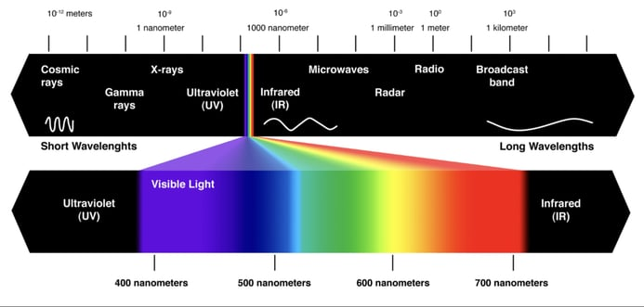

Fig 5 – Visible light spectrum

Finlay states one theory, that this means that colours don’t exist, it is simply just light we are seeing with certain wavelengths missing. It is just our minds that have made up these colours and decided what each ones means. However, Finlay also states this does not change the beauty or the power that they have, the colour red still comes to our minds when we think of power or love (Finlay 2009).

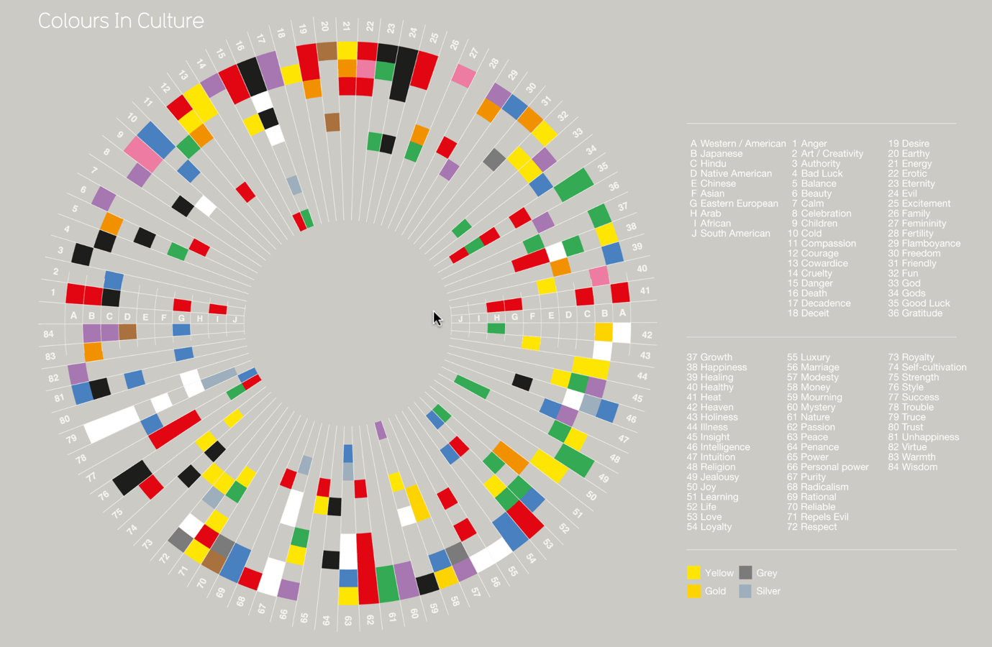
However, colours can have different meaning dependant on where in the world we are, which McCandless has illustrated in Fig 6. Different cultures will have different emotional responses to each colour and this needs to be considered in information design. Researching the cultural association to colours is vital depending on where you are designing (Pianov 2024). Taking an example from Fig X, row 35 shows good luck, which is Western areas is usually green, but for China this is red, which is usually used for bad luck in Western countries. The difference this could make to a piece of work if used in a different culture could mean the wrong message is put across and the design would not be effective.
Fig 6 – Colours in Culture, David McCandless

From this information it is clear to see why colour can be such a powerful tool within information design and how colour can have more power than if words were used. David McCandless piece “based on a true story” in Fig 7 uses colour very well to illustrate the difference between what is true and false in films that are based off a true story. The use of colours in this work are successful in many ways, immediately they have done their job as there is a clear contrast between the blue and the dark pink to show the clear contrast between moments of truth and what was made up for films. Other than the words in the key at the top of the poster you do not need any information to see how much of a film is true to reality.
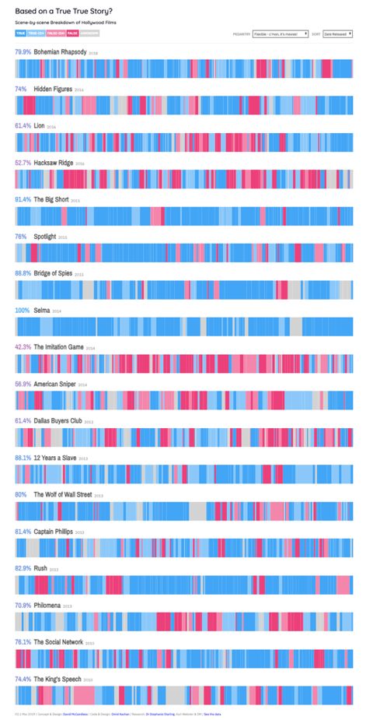

Fig 7 – Based on a true story, David McCandless

The colours chosen and what they represent are a great choice for this work as well. Blue is a colour used to represent calmness and peace, but also to emit truthfulness. Using this as the colour for the “honest” portions of the film is a clever colour choice. In contrast, red is a colour of power, one that demands attention. Using it to portray the parts of the film that are not true to the actual story, it gives the impression that the film is “dishonest” (Whelan 1994). This may seem like too harsh a term as the films were created for entertainment rather than to deceive the audience, but for this piece of information design it works perfectly.
Another example of McCandless’ work where these colours are used is in his piece “Left vs Right” which shows the views of different political parties, seen in Fig 8. Even though this has a lot of text on the piece it can be argued the colours say a lot more than the words do. The text is there for a factual purpose, but the colours tell a different story. If we used the same theory as stated by Whelan about the colours red and blue, we can easily see which side is deemed as the honest and trustworthy side and which is not. Practically the difference in colour between these two parties was originally used to make news coverage clearer, and to have a united image across all news channels.
Some would argue that the use of colour could sway votes, however research conducted by Furrer et al shows that the colour did not necessarily make a difference. When the colours were changed to orange and green the votes did not change. The colours did not influence a decision but the clarity in information allowed people to see how the votes were going in each state, and this helped each voter to decide if their vote could make a difference or not (Furrerr et al 2023).
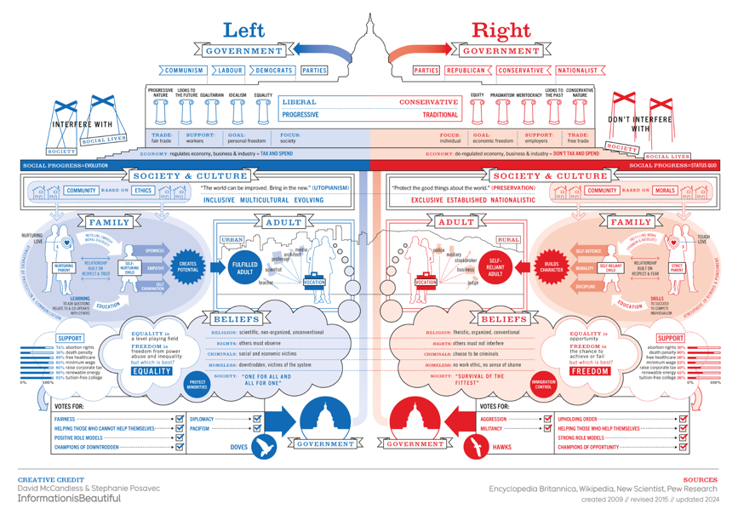

Fig 8 – Left vs Right, David McCandless

To conclude this chapter it is clear to see the power that colours can have over information design. They can dictate what emotions we feel when looking at a piece of design and help to understand the motivation of the piece. Colours are unique to each person based on their biological make up, but there is something beautiful about how we can all feel a connection through them as well.
Typography:

“Typography is the voice of the written word”
(Williams 2012)

Even though the last two chapters have been focussed on aspects of information design that are there to enhance words, but there are very little scenarios where words can be completely replaced and not used at all. This is where typography comes into play. In a world where there were no words, we would all be lost. Imagine yourself in another country and all signs and packaging are in a different language, how lost would you feel? Words are required, and typography is what gives them the impact they need. The use of typefaces and layouts are usually classed as “invisible work” in the sense that when this is done effectively it is not something that is usually noticed (Spiekermann 2019).

See fig 9, in this advertisement for Coco Chanel, the wrong typeface was used and the message that should read “I love Coco” could easily be seen as “I love Cow” which is probably not the message they were trying to put across.
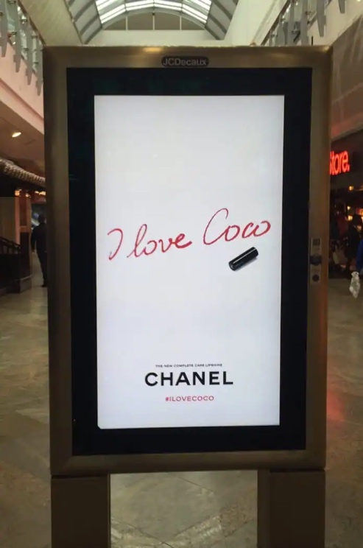
Fig 9 – Coco Chanel advert

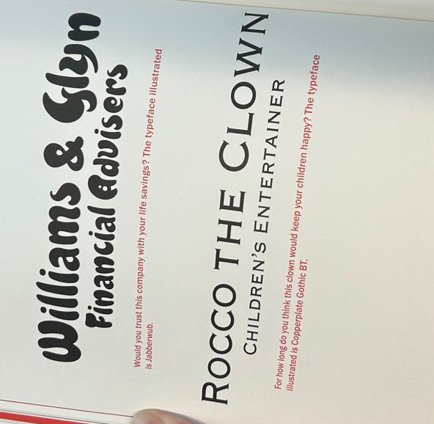
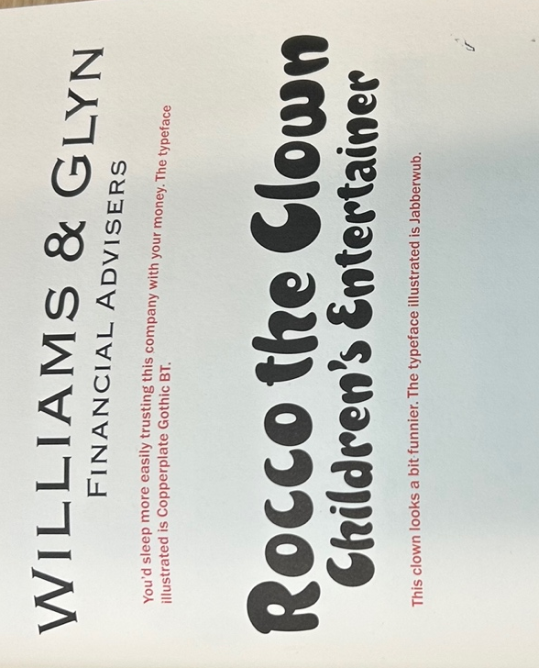
The choice of typeface can make or break a project and add a completely different voice. Williams states that “typefaces are clothes for words and like a finely tailored suit, it’s the detail in their composition that adds interest”. The typeface adds personality and voice to the words that are used in a piece of work. This can be seen in fig 10 & 11, for a serious company that deals with people’s finances you do not want to give a playful impression, the company wants to gain trust from its customers. In contrast a company that deals with children’s events want to give a playful impression to be seen by potential customers (Williams 2012).
Fig 11 – Type matters 2

Fig 10 – Type matters 1

As mentioned above, typography should be an invisible work which is rarely noticed, as it is doing its job so well. But that means that bad typography is much more noticeable and pointed out a lot more often. This results in a lot of pressure to make the right decision when choosing a typeface as it has the power to distract from what is being said (Walters 2013).

It is also important to remember that just because a typeface is successful in one example of work, it does not mean it will be for another. Futura is one of the most iconic typefaces of the twentieth century, it has rightly developed this reputation over the use of many successful projects and is widely used by designers, but it should not be relied upon to make a project work. A designer needs to decide what voice their project has and find a typeface to help make it louder (Thomas 2017).

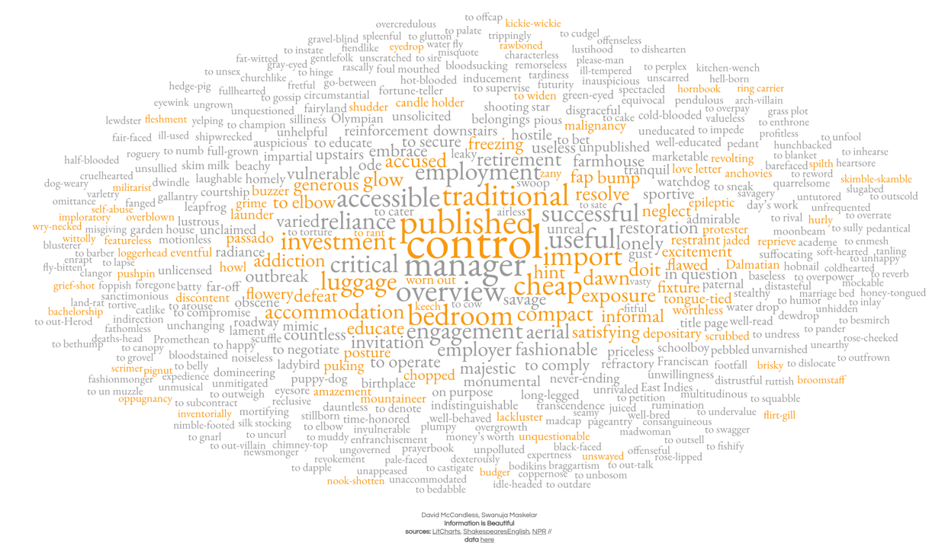
David McCandless work follows this principle well throughout his work, but in Fig 12, a piece illustrating words coined by Shakespeare. The typeface used for this project has the feel that it has been written by a typewriter, more vintage and less modern feel. Even though Shakespeare did not use a typewriter, this choice is more suited to the topic than Futura, with its modernist style, would be.
Fig 12 – Words coined by Shakespeare – David McCandless

Typeface is not the only choice that has to be made within typography. In every effective piece of design work there are four principles that should be considered. Contrast is used to distinguish elements in a design, which can help to draw the viewers’ attention and clarify the hierarchy on the page. Repetition of visual elements will create groups within a design and help with the organisation of a piece. The repetition of typefaces, fonts and colours helps to create categories within the piece which again can strengthen the hierarchy of information. The alignment of page is also crucial, nothing should just be placed on a page, thought needs to go into it to ensure each element has a visual connection with another. Finally, proximity needs to be considered to group elements together to create visual units to help create a clear structure for the reader. When all these principles are brought together into a piece of information design then this would result in a visually interesting yet informative piece (Williams 2015).

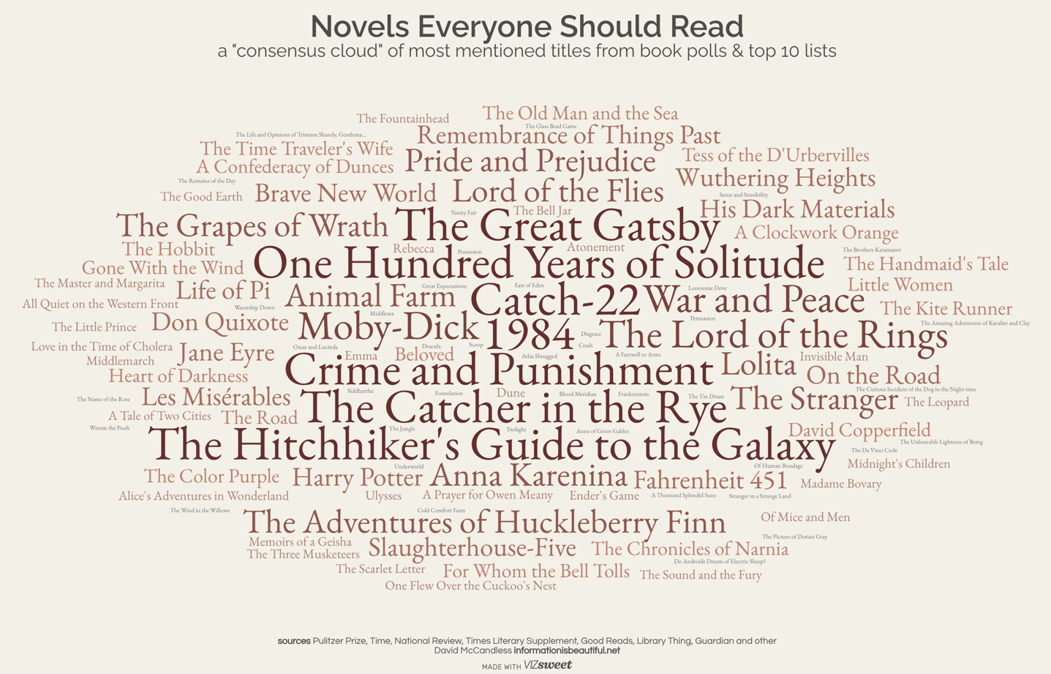
In Fig 13 we see McCandless’ piece ‘Novels Everyone Should Read’ which shows how many times novels are mentioned in polls or top ten lists. The most common books are the largest on the image, in the darkest colour and placed in the centre of the page. In contrast, as the books are mentioned less and less the colours get lighter and the font becomes smaller. They are still noticeable and readable, but it is clear which are the most popular.

Fig 13 – Novels everyone should read, David McCandless

This next example of McCandless work might seem like a strange example to show for use of typography, as there is not much type used, however, what has been used is used effectively.
Fig 14 shows the gender pay gap in different roles in the US, and within it the only text is on the side, with the list of occupations. The use of the bolder font to distinguish the categories and the lighter font to show the job titles makes it very clear what you are looking at. The spacing between the words as well, even though there are many in the list, it is not overwhelming or bunched too close together to make it unreadable.
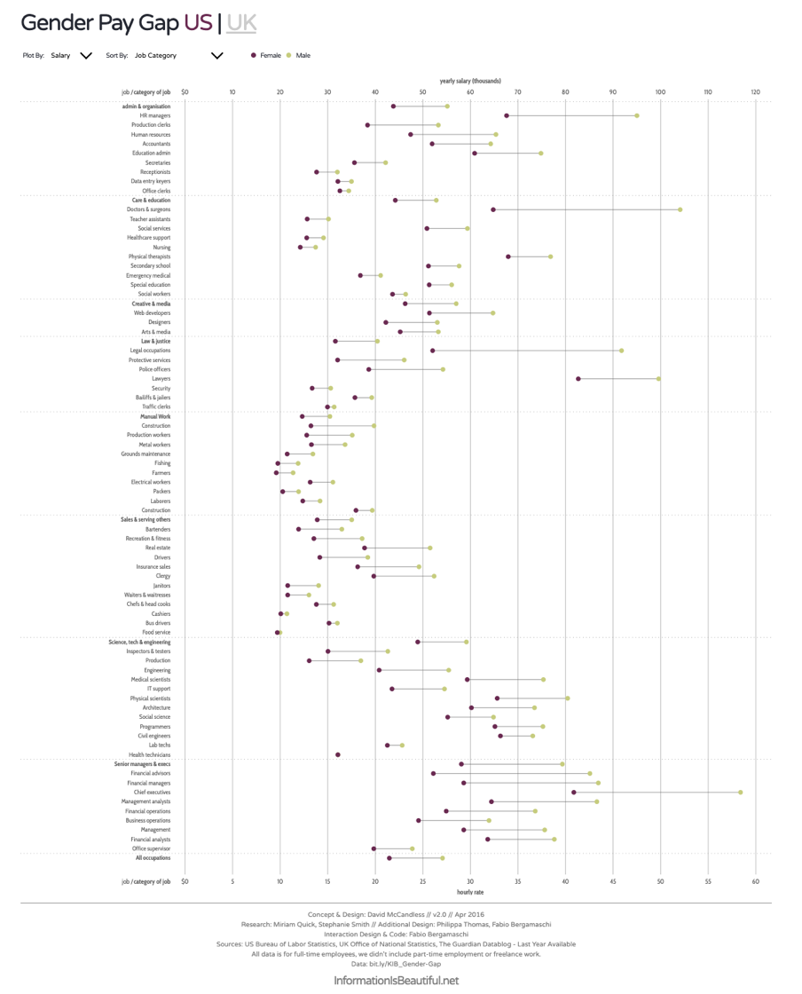

Fig 14 – Gender Pay Gap, David McCandless

Type is needed in almost every piece of information design, but what good is it if the information is not clear. What we can conclude from this chapter is that typography is used to enhance the words that are used in a design. Without typography the words would not have the right “voice” and would take away from what the designer is trying to portray.

Conclusion:
“Can a book with the minimum of text, crammed with diagrams, maps and charts still be exciting and readable? Can it still be fun? Can you make jokes in graphs? Are you even allowed?”
(McCandless 2012)

In conclusion we can see from the above examples that wee need to understand data in order to function and improve in society. This means that data visualisation is vital. If people are not drawn to read the data, then it cannot be used. Data has so many purposes in our day to day lives, it needs to be accessible to as many people as possible. The examples of the work shown by McCandless is there to stir people to action and is covering some important topics, such as climate change, unreported crimes and providing people with information they need to vote.

We can also see from this essay that successful visualisation of data needs to appear effortless, and when it is done well it is almost unnoticeable. If information is presented badly then this will attract the viewers’ attention for all the wrong reasons. They will spend much more time looking at the negative parts of the design and how it does not work and will not take in any of the data, thus making the piece of information design irrelevant.

All the examples of McCandless work used in this essay clearly make use of all three elements very well and the information is easily understandable, but specifically let’s look at fig 4 again with all three elements in mind. As mentioned previously the use of circles to denote amounts immediately gives a clear view and helps viewers understand what they are reading. The use of colours here are clever as they are vibrant and contrasting enough to make the information clear, and to show that each circle denotes a different value. However, they are not so vibrant and bright that they make light of the serious subject they are trying to denote. Similarly, the typographic choices made for this piece are sensitive yet clear. The typeface is simple and clear, with no frills, to ensure that the information is clear and readable and it gives the piece the serious voice it deserves. There is also a lot of information on this piece, but the way it is arranged in sections means it is not overwhelming, and the viewer knows exactly where to look to find the information they are looking for in the design.

Fig 4 – A Lack of Conviction, David McCandless

In conclusion McCandless work shows that even though there is text present in each of his designs, and this text is needed to understand the data, the design of the infographic and the way the text is designed is much more important. These three elements of semiotics, colour and typography need to be considered in every piece of information design in order for it to be clear and to catch the eye of the viewer and have the impact the designer desired.
Figures

1 – A set of danger signs used in an industrial field –
https://www.freevector.com/danger-symbol-icons-vector-19820 . Accessed 06.01.2025

2 – Sunset over the sea in Aberystwyth – Photograph by Jess Pritchard, August 2023

3 – When Sea Levels Rise, David McCandless - https://informationisbeautiful.net/visualizations/when-sea-levels-attack-2/ Accessed 06.01.2025

4 – A Lack of Conviction, David McCandless - https://informationisbeautiful.net/visualizations/rape-a-lack-of-conviction/ Accessed 06.01.2025

5 – Visible light spectrum –
https://www.once.lighting/en/news/the-visible-light-spectrum Accessed – 07.01.2025

6 – Colours in Culture, David McCandless –
https://informationisbeautiful.net/visualizations/colours-in-cultures/ Accessed 07.01.2025

7 – Based on a true story, David McCandless - https://informationisbeautiful.net/visualizations/based-on-a-true-true-story/ Accessed 07.01.2025

8 – Left vs Right, David McCandless –
https://informationisbeautiful.net/visualizations/left-vs-right-us/ Accessed 07.01.2025

9 – I love Coco – Chanel
https://creativemarket.com/blog/design-fails-10-times-typography-ruined-the-day Accessed 08.01.2025

10 – Type Matters, Jim Williams Page 34

11 – Type Matters, Jim Williams Page 35

12 – Words invented or coined by Shakespeare
https://informationisbeautiful.net/visualizations/words-shakespeare-invented/ Accessed 08.01.2025

13 – Novels everyone should read, David McCandless
https://informationisbeautiful.net/visualizations/novels-everyone-should-read-interactive/ Accessed 08.01.2025

14 – Gender Pay Gap, David McCandless
https://informationisbeautiful.net/visualizations/gender-pay-gap/ Accessed 08.01.2025

Bibliography:

Albers, J. (2013). Interaction of Color. 4th ed. New Haven, Conn.: Yale Univ. Press.

Arthur Asa Berger (1998). Seeing is believing : an introduction to visual communication. 2nd ed. Mountain View, Calif.: Mayfield Pub. Co.

Berger, J. (1972). Ways of seeing. London: British Broadcasting Corp. And Penguin Books.

Bride M Whelan (1994). Colour harmony 2. Uk: Thames & Hudson.

Chandler, D. (2002). Semiotics : the basics. Abingdon ; New York, Ny: Routledge.

Crow, D. (2010). Visible signs : an introduction to semiotics in the visual arts. London ; New York: Bloomsbury.

Finlay, V. (2009). Colour : travels through the paintbox. London: Folio Society.

Furrer, R.A., Schloss, K., Lupyan, G., Niedenthal, P.M. and Wood, A. (2023). Red and blue states: dichotomized maps mislead and reduce perceived voting influence. Cognitive Research: Principles and Implications, 8(1). doi:https://doi.org/10.1186/s41235-023-00465-2.

Hall, S. (2012). This means this, this means that : a user’s guide to semiotics. 2nd ed. London: Laurence King Publishing.

Holland, D.K. (2002). Design issues : how graphic design informs society. New York: Allworth ; Garsington.

Kosara, R. (2013). The ISOTYPE. [online] eagereyes.org. Available at: https://eagereyes.org/blog/2013/isotype.

Mccandless, D. (2012). Information is beautiful. London: William Collins.

Siricharoen, W.V. and Siricharoen, N. (2015). How Infographic should be evaluated? The 7th International Conference on Information Technology. doi:https://doi.org/10.15849/icit.2015.0100.

Spence, R. (2007). Information Visualization. Prentice Hall.

Spiekermann, E. (2019). Stop stealing sheep & find out how type works. Peachpit Press.

St Clair, K. (2018). The Secret Lives of Colour. Hodder.

Thomas, D. and Lupton, E. (2017). Never use Futura. New York Princeton Architectural Press.

Vladyslav Pianov (2024). Do different cultures perceive colors differently? How does this affect design decisions? [online] Cieden. Available at: https://cieden.com/book/sub-atomic/color/color-symbolism-and-meanings.

Walters, J.L. (2013). Fifty Typefaces That Changed the World. Conran.

Williams, J. (2012). Type matters! London ; New York: Merrell.

Williams, R. (2015). Non-designer’s design book : Design and typographic principles for the visual novice. Berkeley: Peachpit Press.

Yau, N. (2011). Visualize This. Chichester: John Wiley And Sons.

