

Restaurant Concept: Flavours Unleashed

Student: Sefora Hoszu
Student ID no: 2246571

Food & Beverage Operations
BMIH4002
Lecturer: Antoinette Milne
Word Count: 408 words

PART 1:
Welcome to "Flavors Unleashed" where culinary boundaries dissolve, and global tastes collide in a symphony of vibrant sensations. This modern fusion restaurant, introduced to the esteemed Hotel Trinity Chain, seeks to redefine the dining experience by celebrating the diversity of flavors from around the world.
At "Flavors Unleashed" we believe that food is a universal language that transcends borders. Our concept is a culinary journey that explores the rich tapestry of global cuisine, fusing together ingredients and techniques from various culinary traditions to create a unique and unforgettable dining experience. The ambiance is a harmonious blend of modern elegance and cultural influences, reflecting the eclectic nature of our menu.
Our target audience is the modern epicurean, someone who craves more than just a meal—they seek an adventure on their plate. "Flavors Unleashed" caters to individuals who appreciate the artistry of food, value diverse and bold flavors, and are open to exploring new culinary horizons. Whether you're a seasoned traveler or an adventurous local diner, our restaurant is designed to tantalize the taste buds of those who yearn for a gastronomic escapade.
Each item on our menu is carefully crafted to showcase the unique flavors and techniques from different corners of the world. The "Global Bites Platter" is a perfect introduction—a medley of small bites that takes you on a journey from Asia to South America in a single bite. The "Miso Maple Glazed Pumpkin Soup" marries Japanese miso with the sweetness of maple-glazed pumpkin, creating a harmonious balance of flavors.
Our main courses reflect a commitment to culinary diversity. The "Lemongrass Coconut Chicken Skewers" are inspired by the vibrant street food of Southeast Asia, while the "Moroccan Lamb Tagine" pays homage to the slow-cooked wonders of North Africa. Even our vegetarian options, like the "Sesame Crusted Tofu Bowl," are designed to satisfy the most discerning palates with a symphony of textures and tastes.
Desserts at "Flavors Unleashed" are an indulgent finale to the global feast. The "Matcha White Chocolate Cheesecake" offers a contemporary twist on a classic dessert, bringing together the earthiness of matcha with the sweetness of white chocolate.
In crafting our menu, we aimed not just to offer a meal but an exploration—an exploration of flavors, cultures, and the endless possibilities that arise when culinary traditions intertwine. "Flavors Unleashed" is not just a restaurant; it's a celebration of the world's culinary heritage, brought together in every dish to create an unparalleled dining adventure.

PART 2: Crafting a Memorable Dining Experience Menu in Keeping with the Flavors Unleashed Concept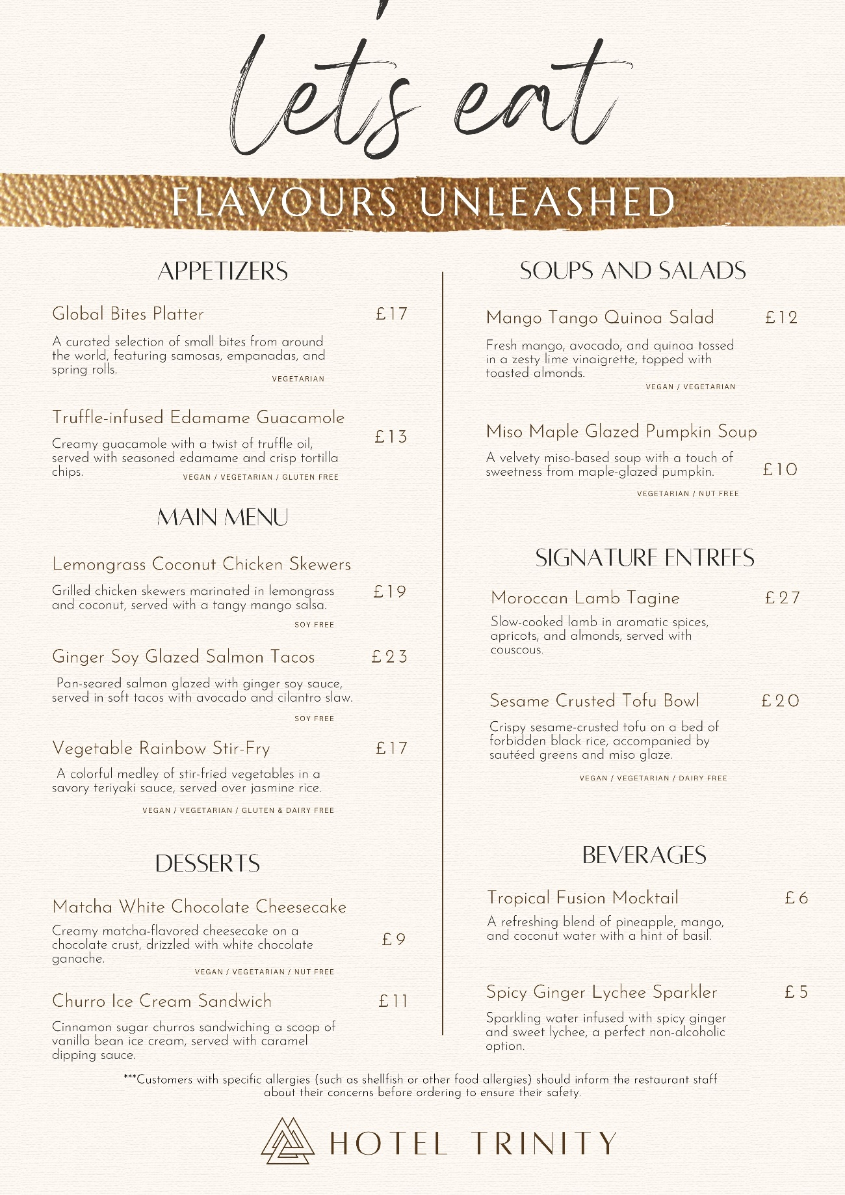

REFERENCES

- Website: www.food.gov.uk
- Modern Restaurant Management https://modernrestaurantmanagement.com/
- Website: https://www.instituteofhospitality.org/
- Website: https://www.thecaterer.com/
- Website: www.theaccessgroup.com
- Magazine: Onboard Hospitality https://www.onboardhospitality.com
- Magazine: Modern Restaurant Management https://modernrestaurantmanagement.com/
- Motarjemi, Y and Lelieveld, H (2014) Food safety management: a practical guide for the food industry. Illustrated edition. Amsterdam: Academic Press

