Marketing Fundamentals

ADIDAS

Blogging to communicate – Assessment 1

Florin Alin Cretulescu
1911820

Lecture: Riaz Bhatti

Contents
Introduction 3
Consumer behavior influences factors 4
Marketing Mix 6
Conclusion 8
Reference 9

Introduction
Adidas is a luxury accessory fashion, clothing brand with labels of treatment. The aim of this report is to share a premium product with its customers. In this article Smoothing Fluid Makeup is an essential part of Adidas components. Adidas products give the users of women today, particularly, a sexy, stunning and elegant look. The foundation of Adidas is undoubtedly one of the strongest foundations in contrast to other brands (Sugimoto, and Nagasawa, 2017).
Human needs are self-deprivation conditions. As a lady today, one of the most important maker items in everyday life has become a cornerstone. Women need a base to illustrate their attractiveness and faith by covering imperfect skin tones and blemishes like irregular skin tones. The needs of human beings are dictated by culture and personality. People buy a maquillage Adidas because it is a symbol of money, good quality or else it is a sign of luxury. Demands are people who want to purchase electricity. With a single application, Adidas's foundation often meets the desires and wishes of a woman by offering users a young and vibrant look. The foundation also has a natural look with SPF15 UV protection which last all day and attracts people to purchase this top-quality product (Sugimoto, and Nagasawa, 2017).
A luxury product in the competitive market is perceived to be a more costly product. The latest luxury is no longer having." Instead, it is the capacity to determine something, to choose something that others do not, and can't.
This report starts by describing a consumer's needs and desires for a luxury product. The segment of consumers' behavior, including culture, social, personal and psychological influences, will then be further discussed. In addition, the following section of the study addresses the form of buying-decision activity of Adidas's base. The study then continues the process of customer decision making towards the result of the base of Adidas's Vitalumiere. The following segment will then discuss the marketing mix of 4Ps approach used in the product of Adidas (Sugimoto, and Nagasawa, 2017).
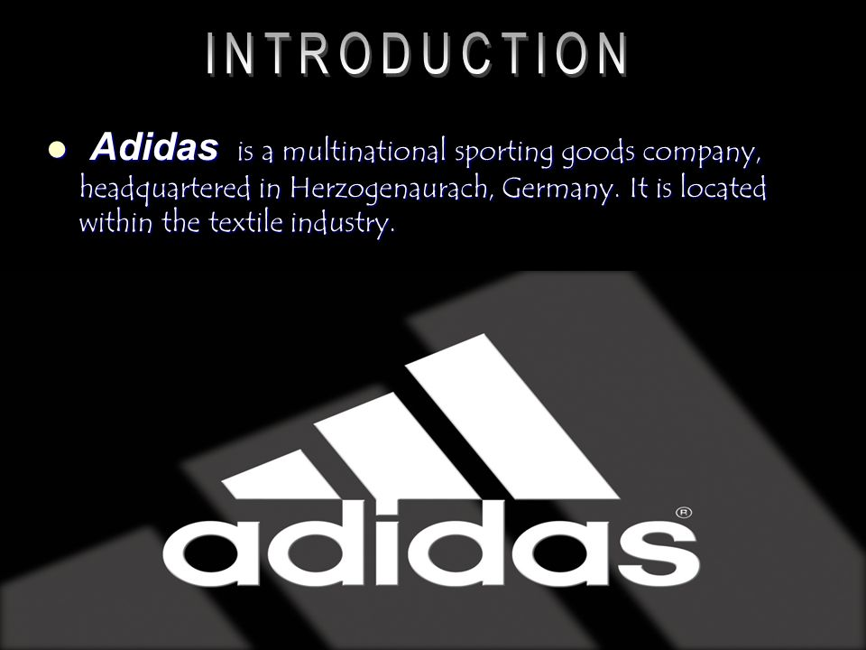

Consumer behavior influences factors
This segment will explore how cultural social, personal and psychological influences influence the actions of consumers. Cultural relations play an important role in the decision-making process, and culture has an impact on individual beliefs and lifestyles.

In a different region, the company Adidas is laying the base. | In other words, culture is built by the people's climate, faith, lifestyle, faith and different races (Verwey, 2018).


In other words, culture is built by the people's climate, faith, lifestyle, faith and different races (Verwey, 2018). The Adidas White Critical Light Reflective Whitening Compact Base, for example, only markets and sells in Asia very well. It's because many Asians believe pale and fair skin determines beauty. The way people perceive attractiveness has affected the consumer's behavior.
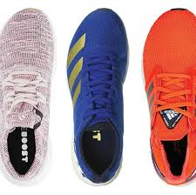
The consumer behavior of the person, as in social matters, has been affected also by friends, family members, colleagues, neighbor and various groups of individuals (Verwey, 2018). The consumer habits of individual as well as social factors are affected by friends, relatives, classmates, employers, neighbors and various groups of people. As women today, they exchange insights, knowledge and thoughts to get to know the best product. So, if you have a wonderful look with a good product, you'll start buying the product on the market because this people inspired their mate (Yrjölä, et al., 2018).
Personal considerations are typically the decision of the buyer, which depends on the age and the life cycle of the buyer, profession, economic condition and personality. In the market, various types of foundations are available for various consumer ages (Cherhabil, and Debabeche, 2016). Young ladies, for instance, need a base for oil management but mature ladies need a moisturizer base. The make-up product of Adidas is typically targeted at women whose outlook is cautious and whose economy is stronger.

Compliance with purchasing decision forms
Adidas's Vitalumiere Satin Smoothing Fluid Make-up style of purchasing decision behavior is complex. Since the customer participates heavily in the process of buying and the product varies greatly from the labels. Meanwhile the product is costly, hazardous, seldom bought and extremely automatically conveyed, the customer is a major contributor to decision-making (Cherhabil, and Debabeche, 2016).

Phase for the Decision
The report demonstrates in this segment how customers decide to purchase a premium product. The decision-making procedure contains of five steps: essential identification, evidence quest, assessment of information, procurement decision and post-customer assessment. Not all buyers can go all stages in the purchasing decision process, but some can bypass information analysis and information assessment stages, but straight into the decision-making phase (Lewis, 2020). This is particularly the case for buying everyday goods or low-cost items with little regard. This would also happen to customers who are loyal to other brand goods. However, Adidas's Luxury Product buyer Vitalumière Satin Smoothing Fluid Makeup is going through all the phases of the procurement process as it is fresh for its customers.

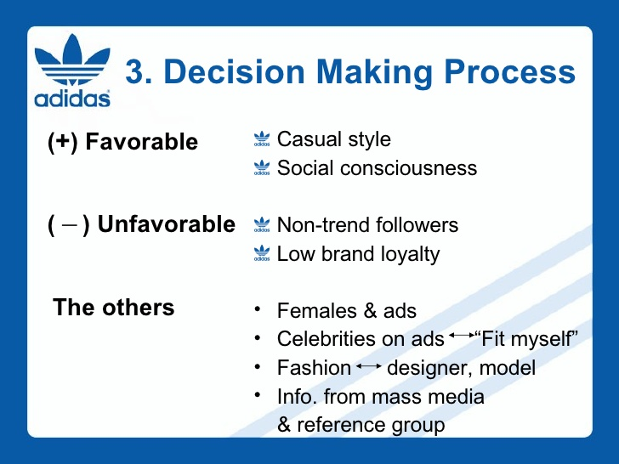
Reconnaissance Required
This is the first step of purchaser judgment, in which the purchaser realizes an issue and a need. When the product is complete, or when the user has purchased it the customer may know that a 'problem' is present, thus the customer then starts to think of replacing a new or improved product. For example, a person plans to buy a high-quality foundation to replace the basis he has bought, but he has not completely finished it because the foundation makes his skin worse and crappy. It is therefore critical that people have a better foundation (Lewis, 2020).
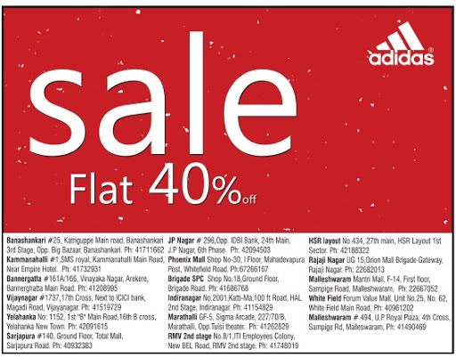

Check for Details
In this step, the consumer has to decide which goods or purchases the problem would solve and gather more information on the product. Consumers may obtain information from numerous sources including personal, industry, and public and experience sources. The most powerful sources are personal in the process of searching knowledge about an acceptable base (AMALANCEI, 2018). This is because the knowledge and opinions of members of the family, networks and contemporaries who practiced the creation are the basis. The user is receiving information from several brands that display the fluid foundation but also checks different corporate bases to assist customer reviews from internet on dry skin forms. When the user searches the details, he gathers information about the base of various brands.

Decision to buy
The customer decides in this process which brands and which goods to buy. Adidas satin fluid makeup Vitalumière Smoothing is bought on last conclusion after contrasting the items made by Shiseido, M.A.C., and Adidas from various perspectives. This was not only because of the consistency of the base, but also because of Adidas's good customer service (AMALANCEI, 2018).

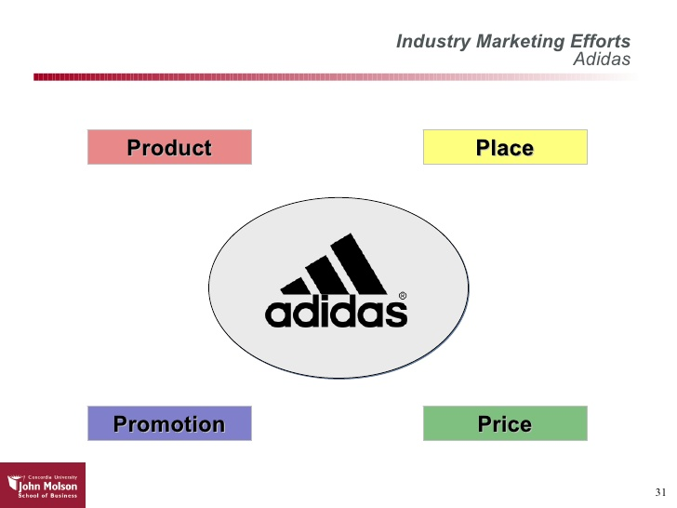
Evaluation after the purchase
In the post-buyer assessment point, customer decisions on the basis of its satisfaction or disappointment are taken after purchase. This report satisfies the buyer, since Adidas's foundation meets customer standards. The product quality is thin and easy for the consumer to apply. The foundation also provides a natural look which lasts the whole day. In addition, the bright touch of the unsolidified from Vitalumiere stretches a subtly satin texture, which lightens the face by making it glow (Schaeffer, et al., 2016).
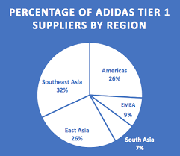

Marketing Mix
In this section you will address the 4Ps marketing mix, which includes product, price, place and promotion. The marketing mix is essential for the foundation for fluid make-up Adidas Vitalumiere Satin Smoothing. The marketing mixture has an impact on the decision making of the customer and is conducive to successful trade (Schaeffer, et al., 2016).
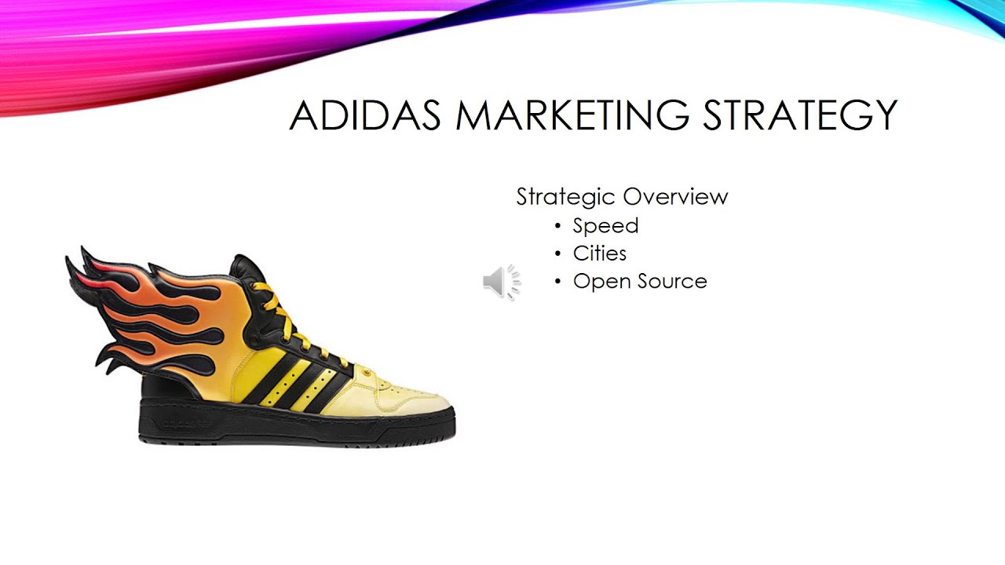
Product
Product is an individual's corporeal decent facility or idea to content their requirements and need in exchanging cash. In order to promote, price and space, a marketer considered a commodity to be the most important p. Channel's basis for satin-smoothing fluid maquillage is the product addressed in this article. The cornerstone of Adidas is to shop products that warrant a price comparison with brands and preparation, and to buy them less frequently, since they are a durable commodity (Seeney, 2017). The core product is the intangible advantage or target that the customer purchases the product. Satin fluid Makeup Adidas Vitalumiere has essential advantages in masking defects such as cuts, darks and pinches, and offers customers a lovely color and feel as this is the key feature of this product (Vos, 2016).

The second class after the core product is a functional product, which makes the ideas true to the core product. Satellite Smoothing Fluid Makeup from the Adidas is known as the final cure for the skin that is exhausted since it is thin and moisturizes to provide the best of support for the fatigued skin. Adidas's base includes even SPF 15, which is capable of protecting the skin against UV light (Hendriyani, and Chan, 2018).
Price
For the customer, the price is what must be sacrificed by the buyer to achieve the value of the attribute category in the product deal. Price shall be the value of an exchange of goods or services. The worth of the fluid make-up foundation Adidas Vitalumiere Satin Smoothing is high, costly and often represents the exclusive and high quality of the product (Latilla, et al., 2019).
Premium pricing techniques are applied to build a substantial commodity profit margin. Premium rates are applied in reality to a commodity of special and high quality, but intend to sell only limited amounts of the product of Adidas. Many women customers on the cosmetics market are prepared to pay high prices to get a better product. Nowadays customers are able to pay significantly higher sums for luxury goods. The Adidas makeup foundation's consumer segmentation is population segmentation and regional segmentation (Latilla, et al., 2019).
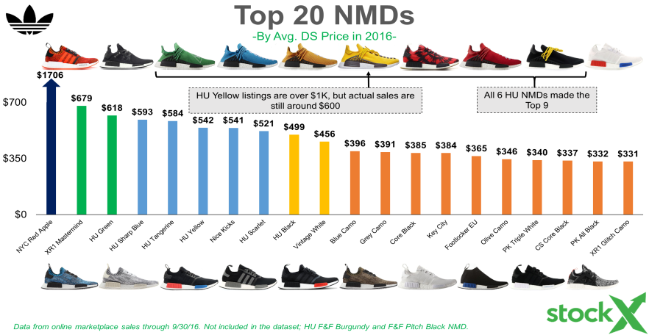
Place  The marketing network is a system that links a community of individuals or organizations through which the customer can access a product or service. The marketing channel system used by Adidas's make-up product is to address the theoretical hand, a short channel that is the route of producing/retailers and customers (Mourtzis, et al., 2019).  Adidas goods are the typical and famous distribution route for manufacturers-detailers-consumers as the retailer would buy the commodity in large quantities and then sell it to its customers. The Adidas maquillage foundation sells only in Adidas's department store, which typically has a prominent location in the city center. This approach is to distinguish the product from other rivals and preserve the exceptionality and not devalue the image of Adidas Company (Mourtzis, et al., 2019). | 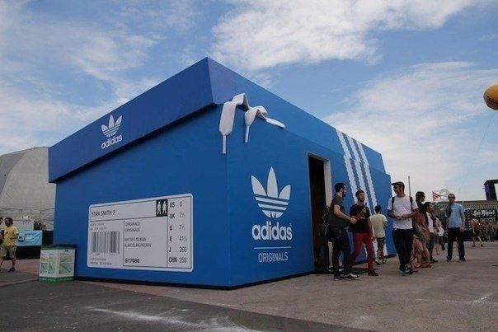  
Promotion
The company uses Promotion to connect with consumers about its product offering. Ad, sponsorship, direct marketing, public relations and personal sales are also included in the promotion mix. The following segment addresses 2 major elements of the promotional mix used in the maquillage base of the Adidas. Adidas focusses the promotional mix on the ads and personal sales (Payne, et al., 2017).
In the promotion mix of the Adidas product, advertisement plays an important role. Any paid means of introducing and promoting ideas, goods or services by a proven sponsor is advertisement. Adidas's advertisement is generally aimed at informing the market about a new Adidas product or what it is called information ads.
In the Adidas maquillage marketed, the Vitalumiere fluid base is the ultimate exhausted skin remedy (Payne, et al., 2017).

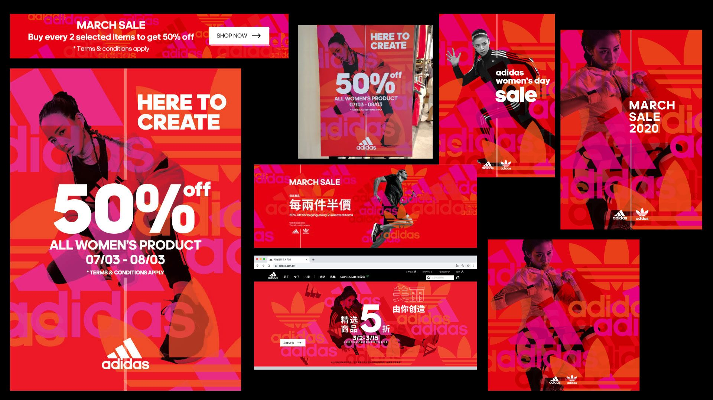

Conclusion
Finally, the customer is delighted with the formula from the fluid maker’s foundation AdidasVitalumiere Satin Smoothing. The customer is first aware of an issue in the decision-making process for the Adidas make-up foundation when the person is dissatisfied with the last product they purchased and then continues to check for another quality product to replace it and fix the problem. Consumer comportment during the product decision-making process is influenced by cultural, social, personal and psychological influences. The base for fluid makeup is assessed with other items in the knowledge assessment process by AdidasVitalumiere Satin Smoothing. The base of Adidas maquillage is acquired in the final decision, as this luxury product helps to rescue exhausted and dull skin complexion. The imperfection of the skin may be concealed as well with the use of the natural hair color such as blemish or darkness. The customer is pleased with the Adidas product and also the client after sales service.
Adidas has been popular because it well prepares marketing campaigns, including the classic product, price, location and promotion blends. Adidas has assurances that customers are able to preserve the high quality of the product by using up-to-date awareness of the safe skin. The Adidas Concept Store is restricted in Malaysia to retain the brand name but is based on the opening counter in the main department storage facility. The user claimed that Adidas's distribution channel often causes customers issues in some places. The commodity from Adidas also focuses primarily on the publicity and personal sale of the promotional combination in the marketing mix.

Reference
AMALANCEI, B.M., 2018, January. Representations of the Olfactory Concept in Advertising: A Case Study. In Argumentum: Journal the Seminar of Discursive Logic, Argumentation Theory & Rhetoric (Vol. 16, No. 1).
Cherhabil, S. and Debabeche, M., 2016.Experimental Study of Sequent Depths Ratio of Hydraulic Jump in Sloped Trapezoidal Adidas.
Hendriyani, C. and Chan, A., 2018. Understanding the New Millennial Customer Path in the Era of Omni-Channel Marketing in Indonesia. Review of Integrative Business and Economics Research, 7, pp.359-367.
Latilla, V.M., Frattini, F., Petruzzelli, A.M. and Berner, M., 2019. Knowledge management and knowledge transfer in arts and crafts organizations: evidence from an exploratory multiple case-study analysis. Journal of Knowledge Management.
Lewis, M.C., 2020. A Case Study Exploring Perspectives of Community College Experiences’ Role on Soft Skills Development of North Carolina Students Enrolled in Career and Technical Programs.
Mourtzis, D., Fotia, S., Boli, N. and Vlachou, E., 2019.Modelling and quantification of industry 4.0 manufacturing complexity based on information theory: a robotics case study. International Journal of Production Research, 57(22), pp.6908-6921.
Payne, E.M., Peltier, J.W. and Barger, V.A., 2017. Omni-channel marketing, integrated marketing communications and consumer engagement. Journal of Research in Interactive Marketing.
Schaeffer, L., de Crouy-Adidas, P., Wagner, V., Desplat, J. and Pascal, M., 2016. How to estimate exposure when studying the temperature-mortality relationship? A case study of the Paris area. International journal of biometeorology, 60(1), pp.73-83.
Seeney, R.C., 2017. The unique challenges of building permanent supportive housing for female veterans: a comparative case study (Doctoral dissertation, Massachusetts Institute of Technology).
Sugimoto, K. and Nagasawa, S.Y., 2017. Luxury branding: the case of Adidas. International Journal of Quality and Service Sciences.
Verwey, S., 2018. A case study: Adidas or Gabrielle? authenticity and iconic branding: a case study.
Vos, R., 2016. Mobile promotions as an omni-channel marketing strategy in Dutch shopping centers.
Yrjölä, M., Spence, M.T. and Saarijärvi, H., 2018. Omni-channel retailing: propositions, examples and solutions. The International Review of Retail, Distribution and Consumer Research, 28(3), pp.259-276.

