

Undergraduate assignment feedback form
(to be completed by marker)

Student Name:
Ellie Buckley
Module Code:  TRIS6009  Module title:  Exploring Muslim Societies in the Modern World | Student number:  1500323
For completion by marker:
Comments:

Marker’s signature: |  | Date:
Provisional mark:
NB. All marks are provisional until confirmed by the final examination board.
Ellie Buckley, 1500323, TRIS6009.

Case Study: Indonesia

Indonesia is a country that is located in the Pacific and Indian oceans, just off the coast of mainland Southeast Asia. It is made up of the Greater Sunda Islands of Java, Sumatra, Celebes, and the southern extent of Borneo. Along with the Lesser Sunda Islands of Bali and islands that run through the Moluccas, Timor, etc. Located in the north-western coast of Java is the capital of Indonesia, Jakarta. It is the largest country in Southeast Asia composed of 17,500 islands.
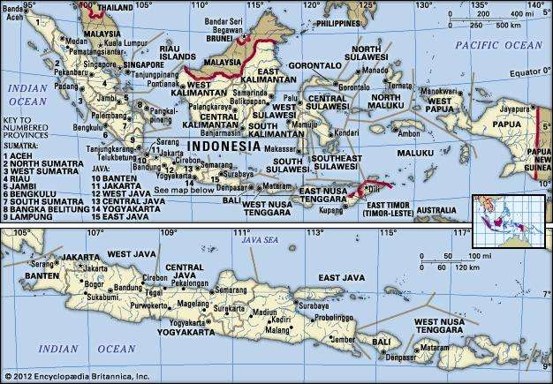

The upper map inserted above displays a wider range of view of Indonesia with the inclusion of other countries in the region. Whereas the lower map shows the islands in Indonesia, such as Bali, Sumbawa and Java in more detail at a much closer view.

2018 Key facts:
- Population: 266 million. It is the most populous country in South East Asia and the fourth most populous in the world.
- It makes up 3.5% of the total world population.
- Total land area: 1,811,570 Km2.
- Urban Population: 55.3%.
- Median age: 28.3 years.
- Life Expectancy: Males- 67 years/ Females- 71 years.
- Fertility rate: 2.42.

History:

Pre-modern Indonesia was significantly different in comparison to other countries during this time in the Arab Middle East. During the end of the seventh century, Persian and Arabian Muslim traders sailed through the Indonesian archipelago whilst on route to China, Pakistan and India. As a result, Muslim communities were established along the coast, but not yet spread widely. However, the beginning of the large conversion to the Islamic faith took place six centuries later. It was not until the fifteenth century that these Muslim settlers began entering the hinterlands and promoting the Islamic faith. It was mainly established through Wali Allah’s missionary work, who had a high association with Sufiism. As a result, the once-dominant-Hindu-Buddhist kingdoms become no more when Islam spread to the majority of interior and coastal kingdoms in the country.

Indonesia has a national motto: Bhinneka Tunggal Ika- which translated means ‘Unity in Diversity’. It is a Javanese expression adopted for the young independent republic to help with the overwhelming mission of bringing tens of millions of people across 18,000 islands to all be at peace and have a feeling of belonging. This was even more daunting because of the wide variety of major religions, ethnicities, languages and indigenous beliefs that were living closely amongst each other. According to Carool Kersten, the national motto can also apply specifically to Islam because the Muslims living in Indonesia are a part of the umma (the community of Muslims), however, they are also different to Muslims residing in other countries in terms of their historical and cultural experience.

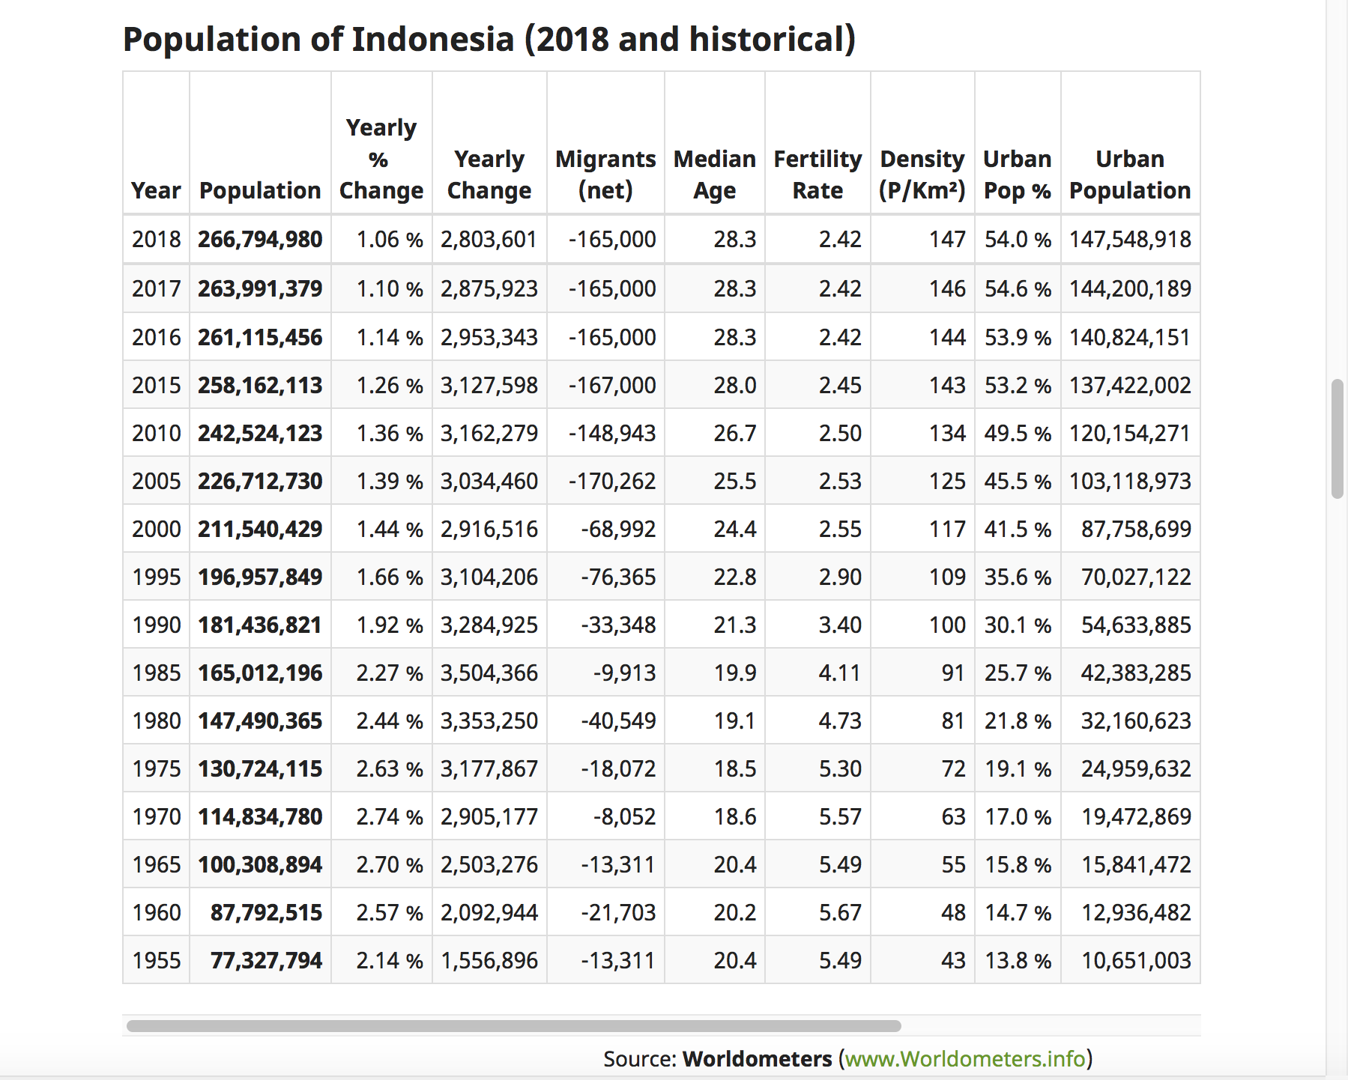
Population:
The population chart of Indonesia above shows that in 2018 it is currently at its highest population. The chart also highlights that this number has increased every five years since 1995, where it began at only 77,327,794. This conveys that in 63 years the population of Indonesia has greatly increased. However, despite the gradual increase every five years, the yearly percentage change has been getting smaller since 1975. Nevertheless, it is estimated that the population in Indonesia will continue to grow, resulting in a population of 321,550,686 in 2050. Yet the fertility rate is lower than ever before at 2.42 in 2018 compared to its highest in 1960 at 5.67. This connotes that it has dropped to less than double its amount in quite a short period of time. This also conveys that in Indonesia the population size is going up even though the fertility rate is declining.

The total population by age group is a little different to other countries in the region because the majority residing there are very young. For example, in 2016 72,205 people in Indonesia were aged 14 or under, which converts to 28% of the total population. Their findings show that each age group after this gradually gets smaller.

Urban Settlement:

Just over half of the population in Indonesia live in urban areas. Urban growth rates in Indonesia are mostly growing rapidly in cities of every population size. However, the current overall level of urbanization in the country is low compared to other countries in the same range of economic growth. The largest urban areas include Medan, Surabaya and Jakarta. Housing, potable water and public transportation availability is currently still of concern in these areas, even though they generally have better living standards than those in rural areas.

Religion and ethnicity:

Indonesia is home to a wide variety of ethnic groups and “Malay Stock” is the common umbrella term used to describe such groups. Examples being the Bataks, the Minangkabau of Sumatra and the Acehnese. Amongst them there are more than 250 mutually unintelligible languages spoken, which is one feature that distinguishes them from one another; along with religion, occupations and social structure. Despite this, in Indonesia the single national language used in education and public life is Bahasa Indonesia.

In Indonesia a wide range of religion exists too, however the largest religion in the country is Islam with an estimated 205 million Muslims living there. This can be supported by Pew Research Centre:

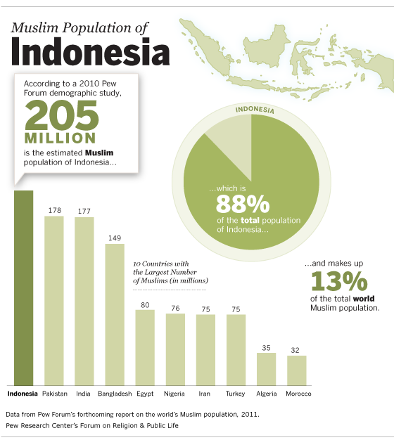
The graph highlights that the 205 million Muslims in Indonesia accounts for 88% of the total population. It also shows that this is much higher than the ten other countries with the largest number of Muslims living there, making it the country with the world’s biggest Muslim population. This can be seen because one down from Indonesia is Pakistan with a Muslim population of 178 million, which is still quite a drop. This is even lower when looking at Morocco with only 32 million, which is an extreme difference.

Despite such a large number of Muslims living in Indonesia, there is not a single Muslim community, but many. Nevertheless, the majority are followers of the Shafi’i school of law. Fasting for Ramadan is widely observed within the country, along with the daily ritual prayers and Friday congregational prayer too. Pilgrimage is also of great importance, shown through statistics from 1983-84 that highlight there were 49,946 pilgrims. This is an extremely striking number and it conveys how important it is to Muslims living in Indonesia because it implies that cost or distance issues are not a concern.

Sunni and Shia:

Within Islam there are two main sects, Sunni and Shia. Indonesia is one of the four countries in the world with the largest Sunni-majority population. The Pew Research Centre estimates that in 2010 there were 203,823,000 Sunni Muslims living in Indonesia and believes that this will continue to gradually increase. With an annual growth rate of 0.8% it is estimated that the Sunni population will rise to 237,639,000 in 2030. Compared to the other three countries with the largest Sunni population, Indonesia is estimated to have the smallest growth by 2030. This can be seen as Pakistan is expected to have the biggest annual growth at 1.8%, Egypt at 1.4% and Bangladesh at 1.2%.

Despite this, Islam has been pluralistic in terms of the practice and beliefs of some Muslims in Indonesia. This is because unique forms of religious thought have been created due to individuals being influenced by non-Muslim traditions existing within the country. This influence may have come from Hindu and animist elements strengthened by Sufism which has developed rituals that Indonesia has never experienced before. This has resulted in Muslim precepts being mixed with Hindu art, spirit beliefs, traditional medicine practises and several other things. This group is commonly referred to as abangan. A more “orthodox” division of Muslims exist in Indonesia too, known as santri. This group is less influenced by other beliefs and strictly observes rituals such as prayer and fasting. They identify as followers of a more “pure” faith. The belief that “There is no God but the God” is widely accepted within the country but the way in which the legal obligations of Islam are carried out varies greatly.

Other religions in Indonesia:

As mentioned above, Islam may be the largest religion in Indonesia, but it is not the only religion existing and practised in the country. There are followers of Christianity (mainly Protestant, independent Christian or Roman Catholic), Hinduism, smaller groups of Buddhism, primal religions and local mystical cults.

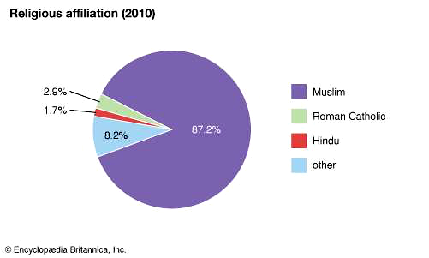
The pie chart shows religious affiliation in Indonesia created by Encyclopaedia Britannica in 2010. It conveys that aside from ‘other’, the second largest individual religion in the country is Roman Catholicism which makes up 2.9% of the population and the third largest being Hinduism making up 1.7% of the population. Displaying religious affiliation in Indonesia in a pie chart emphasises just how large the following of Islam is compared to the other religions existing there. Although it varies from region to region, there is a very high level of religious devotion from individuals within the country.

A national ideology of Pancha Sila, otherwise known as the Five Principles is the foundation of the Indonesian state. The five factors are:

- Humanitarianism;
- National unity;
- Belief in one God;
- Social justice;
- Democracy centred on people’s sovereignty.

The principle “Belief in one God” specifically does not state whether this is in Muslim terms, therefore Indonesians are given the sense that they are allowed to practice whatever religion they wish. Freedom of religion is guaranteed to every individual residing in the country because of the 1945 constitution. Due to this, the government in Indonesia observes and recognises the major holy days of Catholicism, Hinduism, Islam, Buddhism and Protestantism.

Muhammadiyyah Movement:

A number of small Islamic organisations had developed by 1912 and that year seen the development of one specific and significant group, known as the Muhammadiyyah movement. This term stands for the followers of Muhammad and was founded by Ahmad Dahlan. It was influenced from the Arab East, specifically by Salafiyyah ideas. It was primarily created as an educational and cultural organisation and did its best not to get involved with political issues. The movement wanted Indonesians knowledge on Islam to be accurate, therefore one of its aims was to remove any existing “superstitious beliefs”. It also wishes to purify Islamic belief specifically on the oneness of God and focuses on good action through charity, social work, propagation etc.

What has it established?

- Schools.
- Trained teachers.
- A wide range of activities and publications linked to social welfare.
- Education of nationalist Indonesians.
- Activities opposing radical secularism and communisms development.
- The utilization of classrooms.
- Modern clothing for students and teachers.
- Manages and owns businesses, hospitals, universities and humanitarian units that all work on environmental problems and disaster relief.

The Muhammadiyah movement later gained nationwide followings. It declares that it currently has thirty million supporters and in Indonesia it is the second largest mass organisation. It is currently operating mostly in cities and has three main branches:

- Women (Aisyiyah)
- Student (Ikatan Mahasiswa Muhammadiyah)
- Youth (Pemuda Muhammadiyah)

Religious Authority:

As for religious authority within Indonesia, an individual named K.H. Abdullah Gymnastiar (Gym) has been extremely significant, especially in relation to the media. A large part of Indonesian Muslim culture belongs to Sufism and Gym drew his inspiration from some of the Sufi dream spirituality and tales. His large audience came from the Indonesian youth and middle-aged, middle-class people. Gym was a distinctive religious authority as he discussed relationship issues under the title “managing the heart”. This covered topics such as how to create an ideal Islamic family life but also consistently incorporating everyday situations and how to deal with them in an Islamic way.

How popular was Gym?

- Thousands of people went on pilgrimages to the Islamic school he created.
- He has weekly television shows with millions of viewers every time.
- During the season of campaigning, politicians lined up for photo-ops.

The media:

In modern day Indonesia, television is the main medium used, however online media is becoming more common. This can be seen through statistics that show that the amount of internet users in Indonesia has grown from 2,000,000 in 2000 to 143,260,000 by the 31st December 2017. This is a significant rise in figures and displays that over half of the population are using the internet in Indonesia. Amongst those living in the country, Facebook is very popular and so is Twitter, with Indonesians being one of the most active users of the social media source.

Education in Indonesia:

In 2013, the length of compulsory education in Indonesia was extended from nine to twelve years, which will give the younger generation there a much better educational opportunity and prepare them for the world of work later in life. Within the country, Muslim education is offered separate to state secular education. Abd al-Samad al-Palimbani and Muhammad Arshad al-Banjari were two very significant figures in Indonesia’s development of an indigenous Islamic education system. They were prominent in the advancement of both curriculum formation and the institutions. It is estimated that there are more than 50,000 Islamic schools within Indonesia which benefit Muslims residing in the country and elsewhere because it not only educates the younger Muslim generation on religious subjects, but it also has a long-term impact on Islamic orientation and the Muslim population in the world. There are three main types of Islamic schools in the country: pesantrens, madrasahs and Sekolah Islams. Although these schools are separate from the state secular education, many of them still display aspects of educative tradition. This can be seen because many children still learn about modern, secular subjects and there are a range of activities for students.

Contemporary issues:

In modern day, there are several issues affecting the Indonesian population, one main concern being the increase in inequality. A reason for this being because the level of inequality is already quite high, therefore any increase cannot be a good sign. This inequality in Indonesia is shown through several factors, including the labour market and opportunities. For example, the life cycle of a family can be affected by where their children are born or whether the parents are well educated. Being born into such circumstances cannot be changed, however it is affecting the opportunities given to these less fortunate people. As for the working world, people who are higher skilled get paid more, in comparison to many other individuals who are in jobs that cannot increase their skills, therefore they cannot earn more money. Nevertheless, the government hope to reduce the inequality currently existing within the country and they have set targets to do so.

Women:

For many years in Indonesia, issues regarding women have been very present, even resulting in conflicts amongst the state and Muslims. As emphasised, the state and Islam have a mutual accommodation and the country caters for a wide range of beliefs and practices, however this has been close to disruption on several occasions. This being mainly because of differencing opinions on topics such as divorce, abortion and birth control. A few Muslim women’s groups have developed within the country as a result of this and they take part in challenging the government policies and trying to increase awareness.

Conclusion: the role of religion in the state:

In conclusion, Indonesian public life revolves around religious and cultural pluralism and the acceptance of it. It could be said that in Indonesia there is not an Islamic/religious state, nor is there a secular state either. It is conveyed that within the country, religion, especially Islam, does play a huge role and has a political standing, however it is not the full foundation of their society. In 1945, independence was declared in Indonesia and the two national leaders formed the Republic of Indonesia. By doing so, they avoided secluding Christians and other religions because they established a nationalist ideology not an Islamic country. Later in 1967, general Suharto was announced president and within his ruling he limited Islam’s political influence but supported the influence it had religiously and culturally. Nevertheless, ever since Indonesia gained independence specific radical Islamic parties have continuously encouraged the following of Shari’ah- Islamic law. It is obvious that many Muslims living in Indonesia would like to see the juridical system and the state have more of a base from Islam, however the country currently has no conclusion or satisfaction with how Sharia should be used. Several shari’ah rules have already been added to a range of juridical constructions and the state gets involved with several Islamic practices, such as Islamic family law, organization of pilgrimages, collecting zakat, etc. But despite these advancements, it still lacks constitutional status in Indonesia. It is clear that the country wishes to create a place of belonging for all religions and ethnicities existing there.
Bibliography:

Al-Samarrai, Samer, The World Bank, ‘Awakening Indonesia’s Golden Generation: Extending Compulsory Education from 9 to 12 years’, 9th March 2013, http://blogs.worldbank.org/education/awakening-indonesia-s-golden-generation-extending-compulsory-education-9-12-years, [accessed 25th April 2018].

Arskal, Salim, ‘Indonesia, Shari’ah in’, Oxford Islamic Studies Online, unknown date, http://www.oxfordislamicstudies.com/article/opr/t343/e0030?_hi=0&_pos=16, [accessed 26th April 2018].

BBC News, ‘Indonesia Country Profile’, 9th January 2018, http://www.bbc.co.uk/news/world-asia-pacific-14921238, [accessed 18th April 2018].

Cesari, Jocelyne and Jose Casanova (ed.), Islam, Gender and Democracy in Comparative Perspective (Oxford Scholarship Online, 2017), eBook, http://www.oxfordscholarship.com.ezproxy.uwtsd.ac.uk/view/10.1093/oso/9780198788553.001.0001/oso-9780198788553, [accessed 20th April 2018].

Encyclopaedia Britannica, ‘Religions’, unknown date, https://www.britannica.com/place/Indonesia/Religions, [accessed 17th April 2018].

Esposito, John L. (ed.), Islam in Asia: Religion, Politics, & Society (Oxford University Press: New York, 1987)

Internet World Stats, ‘Internet Usage in Asia’, https://www.internetworldstats.com/stats3.htm, [accessed 19th April 2018].

Kenney, Jeffrey T. and Ebrahim Moosa (ed.), Islam in the Modern World (Oxon: Routledge, 2014).

Kersten, Carool, A History of Islam in Indonesia: Unity in Diversity (Edinburgh University Press: Edinburgh, 2017).

McCloud, Aminah Beverly, Scott W. Hibbard and Laith Saud (ed.), An Introduction to Islam in the 21st Century (Wiley-Blackwell: Malden, 2013), eBook, http://tsd-c.worldcat.org/title/introduction-to-islam-in-the-21st-century/oclc/827235440/viewport, [accessed 20th April 2018].

Mehden, Fred R. von der, Oxford Islamic Studies Online, The Oxford Encyclopaedia of the Islamic World, unknown date, http://www.oxfordislamicstudies.com.ezproxy.uwtsd.ac.uk/article/opr/t236/e0363?_hi=2&_pos=17, [accessed 17th April 2018].

Mohamad, Goenawan Susatyo, John David Legge, Asvi Warman Adam, Thomas R. Leinbach, Oliver W. Wolters, James F. Mcdivitt, Encyclopaedia Britannica, ‘Indonesia’, last updated on the 11th of April 2018, https://www.britannica.com/place/Indonesia, [accessed 14th April 2018].

Pew Research Centre, Religion and Public Life, ‘Muslim Population of Indonesia’, 4th November 2010, http://www.pewforum.org/2010/11/04/muslim-population-of-indonesia/, [accessed 16th April 2018].

Rippin, Andrew, Muslims: Their Religious Beliefs and Practices, second edition (Routledge: London, 2001).

Susanto, Budi, Worldmark Encyclopaedia of Religious Practices, ‘Indonesia’. Ed. Thomas Riggs, Vol. 2, Gale, GVRL, 2006, p.490-496, http://go.galegroup.com/ps/retrieve.do?tabID=T003&resultListType=RESULT_LIST&searchResultsType=SingleTab&searchType=BasicSearchForm&currentPosition=1&docId=GALE%7CCX3437900136&docType=Topic+overview%2C+Country+overview&sort=RELEVANCE&contentSegment=&prodId=GVRL&contentSet=GALE%7CCX3437900136&searchId=R1&userGroupName=walamp&inPS=true, [accessed 25th April 2018].

Tan, Charlene, ‘Educative Tradition and Islamic schools in Indonesia’, unknown date, https://www.lancaster.ac.uk/jais/volume/docs/vol14/v14_03_tan_047-062.pdf, [accessed 25th April 2018].

The United Nations Educational, Scientific and Cultural Organisation, ‘Indonesia’, http://uis.unesco.org/en/country/ID, [accessed 25th April 2018].

The World Bank, ‘Indonesia’s Rising Divide’, 7th December 2015, http://www.worldbank.org/en/news/feature/2015/12/08/indonesia-rising-divide, [accessed 26ht April 2018].

Voll, John Obert, Islam: Continuity and Change in the Modern World, Second Edition (Syracuse University Press: New York, 1994).

Worldometers, ‘Countries in the world by population (2018)’, http://www.worldometers.info/world-population/population-by-country/, [accessed 14th April 2018].

Worldometers, ‘Indonesian Population’ http://www.worldometers.info/world-population/indonesia-population/, [accessed 14th April 2018]

Goenawan Susatyo Mohamad, John David Legge, Asvi Warman Adam, Thomas R. Leinbach, Oliver W. Wolters, James F. Mcdivitt, Encyclopaedia Britannica, ‘Indonesia’, last updated on the 11th of April 2018, https://www.britannica.com/place/Indonesia, [accessed 14th April 2018].
Goenawan Susatyo Mohamad, John David Legge, Asvi Warman Adam, Thomas R. Leinbach, Oliver W. Wolters, James F. Mcdivitt, Encyclopaedia Britannica, ‘Indonesia’, map, https://www.britannica.com/place/Indonesia, [accessed 14th April 2018].
Worldometers, ‘Countries in the world by population (2018)’, http://www.worldometers.info/world-population/population-by-country/, [accessed 14th April 2018].
Goenawan Susatyo Mohamad, John David Legge, Asvi Warman Adam, Thomas R. Leinbach, Oliver W. Wolters, James F. Mcdivitt, Encyclopaedia Britannica, ‘Indonesia’, https://www.britannica.com/place/Indonesia, [accessed 14th April 2018].
Worldometers, ‘Indonesian Population’ http://www.worldometers.info/world-population/indonesia-population/, [accessed 14th April 2018].
Worldometers, ‘Indonesian Population’ http://www.worldometers.info/world-population/indonesia-population/, [accessed 14th April 2018]
Worldometers, ‘Indonesian Population’ http://www.worldometers.info/world-population/indonesia-population/, [accessed 14th April 2018].
Worldometers, ‘Indonesian Population’ http://www.worldometers.info/world-population/indonesia-population/, [accessed 14th April 2018]
BBC News, ‘Indonesia Country Profile’, 9th January 2018, http://www.bbc.co.uk/news/world-asia-pacific-14921238, [accessed 18th April 2018].
Worldometers, ‘Indonesian Population’ http://www.worldometers.info/world-population/indonesia-population/, [accessed 14th April 2018]
Budi Susanto, Worldmark Encyclopaedia of Religious Practices, ‘Indonesia’. Ed. Thomas Riggs, Vol. 2, Gale, GVRL, 2006, p.490-496, http://go.galegroup.com/ps/retrieve.do?tabID=T003&resultListType=RESULT_LIST&searchResultsType=SingleTab&searchType=BasicSearchForm&currentPosition=1&docId=GALE%7CCX3437900136&docType=Topic+overview%2C+Country+overview&sort=RELEVANCE&contentSegment=&prodId=GVRL&contentSet=GALE%7CCX3437900136&searchId=R1&userGroupName=walamp&inPS=true, [accessed 25th April 2018].
Budi Susanto, Worldmark Encyclopaedia of Religious Practices, ‘Indonesia’. Ed. Thomas Riggs, Vol. 2, Gale, GVRL, 2006, p.490-496, http://go.galegroup.com/ps/retrieve.do?tabID=T003&resultListType=RESULT_LIST&searchResultsType=SingleTab&searchType=BasicSearchForm&currentPosition=1&docId=GALE%7CCX3437900136&docType=Topic+overview%2C+Country+overview&sort=RELEVANCE&contentSegment=&prodId=GVRL&contentSet=GALE%7CCX3437900136&searchId=R1&userGroupName=walamp&inPS=true, [accessed 25th April 2018].
Robert W. Hefner, ‘Islamic Law and Muslim Women in Modern Indonesia’ in Islam, Gender and Democracy in Comparative Perspective by Jocelyne Cesar and Jose Casanova (ed.), (Oxford Scholarship Online, 2017), eBook, http://www.oxfordscholarship.com.ezproxy.uwtsd.ac.uk/view/10.1093/oso/9780198788553.001.0001/oso-9780198788553, [accessed 20th April 2018].
Carool Kersten, A History of Islam in Indonesia: Unity in Diversity (Edinburgh University Press: Edinburgh, 2017), p.2.
Carool Kersten, A History of Islam in Indonesia: Unity in Diversity (Edinburgh University Press: Edinburgh, 2017), p.2.
Worldometers, ‘Indonesian Population’ http://www.worldometers.info/world-population/indonesia-population/, [accessed 14th April 2018]
Worldometers, ‘Indonesian Population’ http://www.worldometers.info/world-population/indonesia-population/, [accessed 18th April 2018]
Worldometers, ‘Indonesian Population’ http://www.worldometers.info/world-population/indonesia-population/, [accessed 14th April 2018]
The United Nations Educational, Scientific and Cultural Organisation, ‘Indonesia’, http://uis.unesco.org/en/country/ID, [accessed 25th April 2018].
Encyclopaedia Britannica, ‘Religions’, unknown date, https://www.britannica.com/place/Indonesia/Religions, [accessed 17th April 2018].
Anthony H. Johns, ‘Indonesia: Islam and Cultural Pluralism’ in Islam in Asia: Religion, Politics, & Society by John L. Esposito (ed.) (Oxford University Press: New York, 1987), p.202.
Anthony H. Johns, ‘Indonesia: Islam and Cultural Pluralism’ in Islam in Asia: Religion, Politics, & Society, p.202.
Pew Research Centre, Religion and Public Life, ‘Muslim Population of Indonesia’, 4th November 2010, http://www.pewforum.org/2010/11/04/muslim-population-of-indonesia/, [accessed 16th April 2018].
Pew Research Centre, Religion and Public Life, ‘Muslim Population of Indonesia’, 4th November 2010, http://www.pewforum.org/2010/11/04/muslim-population-of-indonesia/, [accessed 16th April 2018].
Anthony H. Johns, ‘Indonesia: Islam and Cultural Pluralism’ in Islam in Asia: Religion, Politics, & Society, p.203.
Anthony H. Johns, ‘Indonesia: Islam and Cultural Pluralism’ in Islam in Asia: Religion, Politics, & Society, p.204.
Pew Research Centre, Religion and Public Life, ‘Sunni and Shia Muslims’, 27th January 2011, http://www.pewforum.org/2011/01/27/future-of-the-global-muslim-population-sunni-and-shia/, [accessed 16th April 2018].
Fred R. von der Mehden, Oxford Islamic Studies Online, The Oxford Encyclopaedia of the Islamic World, unknown date, http://www.oxfordislamicstudies.com.ezproxy.uwtsd.ac.uk/article/opr/t236/e0363?_hi=2&_pos=17, [accessed 17th April 2018].
Fred R. von der Mehden, Oxford Islamic Studies Online, The Oxford Encyclopaedia of the Islamic World, unknown date, http://www.oxfordislamicstudies.com.ezproxy.uwtsd.ac.uk/article/opr/t236/e0363?_hi=2&_pos=17, [accessed 17th April 2018].
Fred R. von der Mehden, Oxford Islamic Studies Online, The Oxford Encyclopaedia of the Islamic World, unknown date, http://www.oxfordislamicstudies.com.ezproxy.uwtsd.ac.uk/article/opr/t236/e0363?_hi=2&_pos=17, [accessed 17th April 2018].
Anthony H. Johns, ‘Indonesia: Islam and Cultural Pluralism’ in Islam in Asia: Religion, Politics, & Society, p.203.
Anthony H. Johns, ‘Indonesia: Islam and Cultural Pluralism’ in Islam in Asia: Religion, Politics, & Society, p.202.
Encyclopaedia Britannica, ‘Religions’, unknown date, https://www.britannica.com/place/Indonesia/Religions, [accessed 17th April 2018].
Encyclopaedia Britannica, ‘Religions’, unknown date, https://www.britannica.com/place/Indonesia/Religions, [accessed 17th April 2018].
Anthony H. Johns, ‘Indonesia: Islam and Cultural Pluralism’ in Islam in Asia: Religion, Politics, & Society, p.204.
Budi Susanto, Worldmark Encylopaedia of Religious Practices, ‘Indonesia’. Ed. Thomas Riggs, Vol. 2, Gale, GVRL, 2006, p.490-496, http://go.galegroup.com/ps/retrieve.do?tabID=T003&resultListType=RESULT_LIST&searchResultsType=SingleTab&searchType=BasicSearchForm&currentPosition=1&docId=GALE%7CCX3437900136&docType=Topic+overview%2C+Country+overview&sort=RELEVANCE&contentSegment=&prodId=GVRL&contentSet=GALE%7CCX3437900136&searchId=R1&userGroupName=walamp&inPS=true, [accessed 25th April 2018].
Fred R. von der Mehden, Oxford Islamic Studies Online, The Oxford Encyclopaedia of the Islamic World, unknown date, http://www.oxfordislamicstudies.com.ezproxy.uwtsd.ac.uk/article/opr/t236/e0363?_hi=2&_pos=17, [accessed 17th April 2018].
Budi Susanto, Worldmark Encylopaedia of Religious Practices, ‘Indonesia’. Ed. Thomas Riggs, Vol. 2, Gale, GVRL, 2006, p.490-496, http://go.galegroup.com/ps/retrieve.do?tabID=T003&resultListType=RESULT_LIST&searchResultsType=SingleTab&searchType=BasicSearchForm&currentPosition=1&docId=GALE%7CCX3437900136&docType=Topic+overview%2C+Country+overview&sort=RELEVANCE&contentSegment=&prodId=GVRL&contentSet=GALE%7CCX3437900136&searchId=R1&userGroupName=walamp&inPS=true, [accessed 25th April 2018].
John Obert Voll, Islam: Continuity and Change in the Modern World, Second Edition (Syracuse University Press: New York, 1994), pp. 241.
Muhamad Ali, ‘Far from Mecca: modern Islam in Indonesia and Malaysia’ in Islam in the Modern World by Jeffrey T. Kenney and Ebrahim Moosa (ed.), (Oxon: Routledge, 2014), p.410.
John Obert Voll, Islam: Continuity and Change in the Modern World, Second Edition, pp. 241-242.
Muhamad Ali, ‘Far from Mecca: modern Islam in Indonesia and Malaysia’ in Islam in the Modern World, p.410.
John Obert Voll, Islam: Continuity and Change in the Modern World, Second Edition, p. 242.
Muhamad Ali, ‘Far from Mecca: modern Islam in Indonesia and Malaysia’ in Islam in the Modern World, p.410.
John Obert Voll, Islam: Continuity and Change in the Modern World, Second Edition, p. 242.
Carool Kersten, A History of Islam in Indonesia: Unity in Diversity (Edinburgh University Press: Edinburgh, 2017), p.111.
Muhamad Ali, ‘Far from Mecca: modern Islam in Indonesia and Malaysia’ in Islam in the Modern World, p.410.
Marcia Hermansen, ‘The emergence of media preachers: Yusuf al-Qaradawi’, in Islam in the Modern World by Jeffrey T. Kenney and Ebrahim Moosa (ed.), (Oxon: Routledge, 2014), p.312.
Internet World Stats, ‘Internet Usage in Asia’, https://www.internetworldstats.com/stats3.htm, [accessed 19th April 2018].
BBC News, ‘Indonesia Country Profile’, 9th January 2018, http://www.bbc.co.uk/news/world-asia-pacific-14921238, [accessed 18th April 2018].
Samer Al-Samarrai, The World Bank, ‘Awakening Indonesia’s Golden Generation: Extending Compulsory Education from 9 to 12 years’, 9th March 2013, http://blogs.worldbank.org/education/awakening-indonesia-s-golden-generation-extending-compulsory-education-9-12-years, [accessed 25th April 2018].
Anthony H. Johns, ‘Indonesia: Islam and Cultural Pluralism’ in Islam in Asia: Religion, Politics, & Society, p.204.
Carool Kersten, A History of Islam in Indonesia: Unity in Diversity (Edinburgh University Press: Edinburgh, 2017), p.110.
Charlene Tan, ‘Educative Tradition and Islamic schools in Indonesia’, unknown date, https://www.lancaster.ac.uk/jais/volume/docs/vol14/v14_03_tan_047-062.pdf, [accessed 25th April 2018], pp. 49-50.
Charlene Tan, ‘Educative Tradition and Islamic schools in Indonesia’, https://www.lancaster.ac.uk/jais/volume/docs/vol14/v14_03_tan_047-062.pdf, [accessed 25th April 2018], p.53.
The World Bank, ‘Indonesia’s Rising Divide’, 7th December2015, http://www.worldbank.org/en/news/feature/2015/12/08/indonesia-rising-divide, [accessed 26th April 2018].
The World Bank, ‘Indonesia’s Rising Divide’, 7th December 2015, http://www.worldbank.org/en/news/feature/2015/12/08/indonesia-rising-divide, [accessed 26ht April 2018].
Budi Susanto, Worldmark Encylopaedia of Religious Practices, ‘Indonesia’. Ed. Thomas Riggs, Vol. 2, Gale, GVRL, 2006, p.490-496, http://go.galegroup.com/ps/retrieve.do?tabID=T003&resultListType=RESULT_LIST&searchResultsType=SingleTab&searchType=BasicSearchForm&currentPosition=1&docId=GALE%7CCX3437900136&docType=Topic+overview%2C+Country+overview&sort=RELEVANCE&contentSegment=&prodId=GVRL&contentSet=GALE%7CCX3437900136&searchId=R1&userGroupName=walamp&inPS=true, [accessed 25th April 2018].
Budi Susanto, Worldmark Encylopaedia of Religious Practices, ‘Indonesia’. Ed. Thomas Riggs, Vol. 2, Gale, GVRL, 2006, p.490-496, http://go.galegroup.com/ps/retrieve.do?tabID=T003&resultListType=RESULT_LIST&searchResultsType=SingleTab&searchType=BasicSearchForm&currentPosition=1&docId=GALE%7CCX3437900136&docType=Topic+overview%2C+Country+overview&sort=RELEVANCE&contentSegment=&prodId=GVRL&contentSet=GALE%7CCX3437900136&searchId=R1&userGroupName=walamp&inPS=true, [accessed 25th April 2018].
Anthony H. Johns, ‘Indonesia: Islam and Cultural Pluralism’ in Islam in Asia: Religion, Politics, & Society, p.204.
Andrew Rippin, Muslims: Their Religious Beliefs and Practices, second edition (Routledge: London, 2001), pp.262-263.
Budi Susanto, Worldmark Encyclopaedia of Religious Practices, ‘Indonesia’. Ed. Thomas Riggs, Vol. 2, Gale, GVRL, 2006, p.490-496, http://go.galegroup.com/ps/retrieve.do?tabID=T003&resultListType=RESULT_LIST&searchResultsType=SingleTab&searchType=BasicSearchForm&currentPosition=1&docId=GALE%7CCX3437900136&docType=Topic+overview%2C+Country+overview&sort=RELEVANCE&contentSegment=&prodId=GVRL&contentSet=GALE%7CCX3437900136&searchId=R1&userGroupName=walamp&inPS=true, [accessed 25th April 2018].
Budi Susanto, Worldmark Encyclopaedia of Religious Practices, ‘Indonesia’. Ed. Thomas Riggs, Vol. 2, Gale, GVRL, 2006, p.490-496, http://go.galegroup.com/ps/retrieve.do?tabID=T003&resultListType=RESULT_LIST&searchResultsType=SingleTab&searchType=BasicSearchForm&currentPosition=1&docId=GALE%7CCX3437900136&docType=Topic+overview%2C+Country+overview&sort=RELEVANCE&contentSegment=&prodId=GVRL&contentSet=GALE%7CCX3437900136&searchId=R1&userGroupName=walamp&inPS=true, [accessed 25th April 2018].
Fred R. von der Mehden, Oxford Islamic Studies Online, The Oxford Encyclopaedia of the Islamic World, unknown date, http://www.oxfordislamicstudies.com.ezproxy.uwtsd.ac.uk/article/opr/t236/e0363?_hi=2&_pos=17, [accessed 17th April 2018].
Salim Arskal, ‘Indonesia, Shari’ah in’, Oxford Islamic Studies Online, unknown date, http://www.oxfordislamicstudies.com/article/opr/t343/e0030?_hi=0&_pos=16, [accessed 26th April 2018].

