

Programme: Master of Business Administration

Module name: Strategic Management

Module code: LCMB7003

Title: Assessment component: report – Blinkit

Lecturer’s Name: Amare Desta

Student name: Meet Piyushkumar Ahir

Student ID: 2436049

Submissions Date: 22 December, 2025

Table of Contents
Introduction 3
Section 1: Selection of Organisation and Target Market 3
The chosen organisation 3
Target Market 3
Rational for the Decision 4
Section 2: Comprehensive Strategic Analysis 4
Macro-Environmental Analysis 4
Industry/ Competitive Analysis 8
Performance Analysis 10
Insights and Strategic Implications 11
Section 3: Strategy Development and Formulation 12
Strategic Direction and Rationale 12
Strategic Model 16
Market Entry Mode 17
Competitive positioning 17
Strategic Fit and Capability Assessment 19
Strategy Implementation Components 20
Risk analysis and mitigation 22
Section 4: Performance Evaluation Framework 23
The Balanced Scorecard Framework 23
Triple Bottom Line (TBL) Integration 26
Monitoring and Mechanisms of Governance 27
Conclusion 28
References 29

Introduction
Founded in 2013, Blinkit aims to change the unorganised grocery landscape of India and help customers have healthier choices in purchasing everyday items or products online (Blinkit, 2025a). The Indian quick-commerce company has been progressing in its business operations and increasing sales nationally, providing a wide range of various products such as groceries, books, home and electrical appliances. The mentioned company is successful in becoming a leading e-commerce brand in its home country in this way.
The purpose of the report will be to provide a proper reason for choosing the e-commerce firm and its target market, along with a strategic analysis by assessing its macro and micro environmental factors. Strategic models will be applied to show the chosen firm's possibilities for expansion and progress in the new market. Also, the framework for evaluating the performance of Blinkit will be depicted here, including the theory and impact of initiatives.

Section 1: Selection of Organisation and Target Market

The chosen organisation
Blinkit is an online grocery company that has been operating in India since 2013 (Blinkit, 2025). The company provides a wide range of products and merchandise and has become popular for its quick delivery services. The mentioned businesses not only provide fresh green groceries but also involve fashion, beauty, personal care items and books. A wide product range, festive sales, and special and limited-edition offers are features of Blinkit that have made it famous and a necessity for a majority of people in India. The e-business claims to be the ‘last-minute app’ for shoppers, which is its unique selling proposition; hence, it is chosen here.

Target Market
Blinkit’s market share at present is 35% in India, followed by its different competitors Zepto and Swiggy (Bothra, 2024). The e-retailer is set to expand its business in the UK to improve global recognition and profitability. There are various competitors of Blinkit in the UK, such as ASOS, TESCO and ASDA to deal with and staying ahead of them is necessary to make a profit and create a strong brand image.

Rational for the Decision
Securing a top position in the Indian market, Blinkit has secured 50% of the market share as a quick commerce (Mukul, 2025).
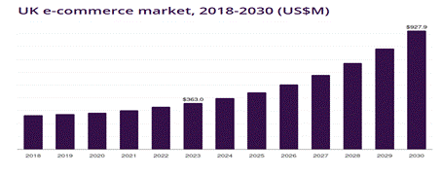
Figure 1: Market size of ecommerce in the UK
Source: (GVH, 2025)
The graph given above demonstrates the market size of e-commerce in the UK. In the UK, the commerce market is estimated to have a revenue of $927.9 million USD by 2030 (GVH, 2025). Choosing the UK market is appropriate for providing customers with quick online deliveries and various products with the help of Blinkit. The mentioned e-business focuses on sustainability by providing eco-friendly packaging.

Section 2: Comprehensive Strategic Analysis

Macro-Environmental Analysis
PESTEL analysis
Political | Positive  In 2023, the UK's political stability had a ratio of 0.51 points (The Global Economy, 2025). | Negative  The norms of VAT need to be followed by businesses in the UK (Government of UK, 2024).
Economical | Positive  The UK's GDP has grown by 1.3% in the third quarter in 2025 (Trading Economics, 2025). | Negative  The UK's inflation rate reached 3.6% in October 2025 (Clark, 2025).
Social | Positive  Consumers prefer fast delivery service, which Blinkit must maintain in the UK to meet consumer preference. | Negative  UK consumers are affected by the crisis in living and budget constraints.
Technological | Positive  UK consumers have demand for online payments options that are easy to use. | Negative  Threat of cyberattacks and AI cost infrastructure may affect retailer’s business.
Environmental | Positive  Paying attention to sustainability in packaging is necessary for UK businesses to reduce plastic waste. | Negative  Breaches of sustainability practices by retail firms increase landfill and carbon footprint.
Legal | Positive  Following legal norms and governmental regulations helps retailers to manage and retain employees. | Negative  Blinkit may face issues for not maintaining the safety and provide a safe work environment to its employees in the UK.
Table 1: PESTLE analysis
Source: (Self-developed)

Political: Blinkit needs to expand its business in the localities of the UK, and it needs to avoid political backlashes and issues by remaining ethical. All VAT-registered businesses must include VAT in the prices of all their products (Government of the UK, 2024). Blinkit needs to follow this legislation while operating in the UK.
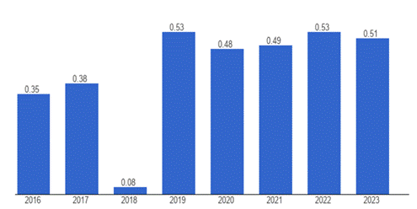
Figure 2: Political stability of the UK
Source: (The Global Economy, 2025)
The changes in the ratio of political stability indicate a decline from 2022 (0.53) to 2023 (0.51) (The Global Economy, 2025). There may be some disturbances for Blinkit in the UK if it does not follow the norms and new regulations set by the government, as per my views. However, the stability of the UK government is indicated as per the graph, which is a positive sign for Blinkit to expand there.

Economical: Blinkit needs to pay heed to the UK’s current economic position and crises before stepping into the new market.
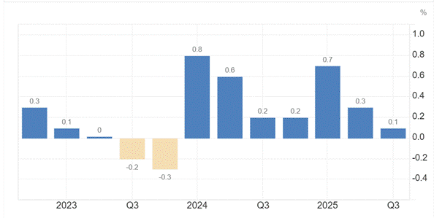
Figure 3: UK GDP
Source: (Trading Economics, 2025)
The UK’s GDP in 2025 is a little below the forecasts of 1.4% by being 1.3% (Trading Economics, 2025). In my opinion, Blinkit has a chance to tackle the UK market by understanding the sales growth of different grocery and electronic products along with other merchandise it is willing to sell in the new location.
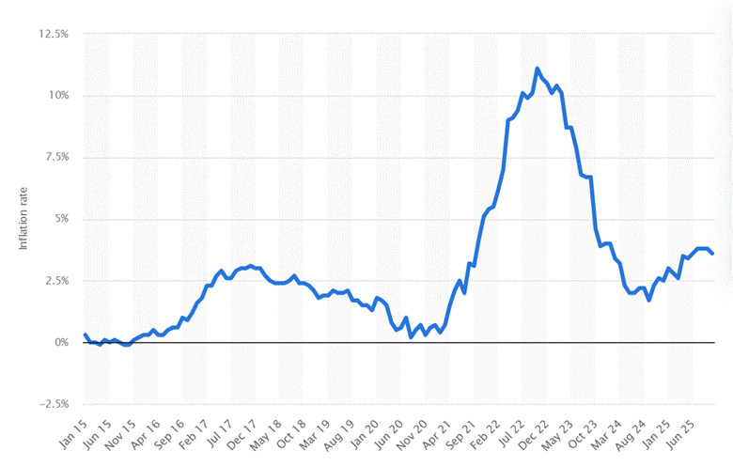
Figure 4: UK inflation rate
Source: (Clark, 2025)
The above-featured graph demonstrates the changes in inflation rates in the UK. In the month of October in 2025, the inflation rate of the UK has seen a decline (3.6%) from the ratings of 3.8% in the two previous months (Clark, 2025). The decrease in the inflation rate indicates a high chance for Blinkit to provide better offers and discounts to customers as it does in its home country.

Social: UK consumers prefer shopping from brands that remain ethical in sourcing, securing personal data, creating a bond of trust with them and using eco-friendly packaging (Hardcastle, 2024). Blinkit maintains customer relationships, taking feedback from customers for further developments.

Technological: UK customers prefer convenience in making payments; thus, the use of online payment processes is common there. Blinkit provides both offline and online payment methods, thus making it easy for customers to shop with convenience and comfort. The use of AI has changed the product recommendations for Blinkit, and it optimises its supply chains by using the Geographical Information System (GIS) (Razdan, 2021). Most of the UK consumers are comfortable using online payment methods such as Google Pay and Apple Pay (Peachey, 2025). In my opinion, Blinkit has a scope for smoothly running its business and managing inventories with the help of its various technology implementations, such as AI and GIS.

Environmental: A focus on sustainable practices is necessary for e-businesses to make proper contributions to the environment (Sun et al. 2021). UK businesses need to follow the legislation of the Environment Act 2021, originating in the House of Commons (UK Parliament, 2025). Blinkit has to maintain its eco-friendly packaging ideas in the UK to remain ethical.

Legal: UK businesses abide by the legalisations of The Health and Safety at Work Act 1974, improving occupational health for the staff members (HSE, 2024). According to my views Blinkit needs to create a more welcoming work environment while working with people in the UK and maintain communication with its staff members along with avoiding discrimination as well.

Industry/ Competitive Analysis
Porter’s five forces
Competitive rivalry (High): There are many competitors in the UK that are recognised by customers as popular e-businesses. Amazon UK is a leading e-business in the UK, eBay UK is in the second position, and ASOS UK, with 850 brands, is attracting several customers (Nicasio, 2024). According to my views, the intense market competition in the UK market could affect the profitability of Blinkit as it enters the market. All rivals have technological innovation and fast delivery options, providing similar services that customers may prefer. Amazon is a dominant player in the UK’s online space, and there are entrants such as eBay that are a threat to the e-commerce giant (Mintel, 2025).

Threat of new entrants (Low): There are already several supermarkets in the UK that people shop from, and the online retailers have secured top positions. This, in turn, reduces the chance for Blinkit to face any fear or threats from new entrants in the new market, as there are different established players, such as ASDA and Tesco, who also offer online shopping for customers, along with Amazon. Blinkit only needs to cope with these competitors, as the threats of the new entrants are low.

Bargaining power of suppliers (Low): Blinkit maintains communication and transparency with its suppliers in its home country, thus reducing the possibilities of any conflict. It is crucial for e-businesses to maintain the buyer-supplier relationships to improve business performance (Saunila et al. 2021). Blinkit needs to pay heed to this while operating in the UK and must have proper negotiations with its suppliers of goods and green groceries.

Bargaining power of buyers (High): As there are several popular e-businesses in the UK, people have the tendency to choose a better brand that offers them better products and affordable prices, hence making their bargaining power high in the UK. Argos UK’s product range includes more than 60,000 items, including partnerships with LEGO and Dyson (Nicasio, 2024). People are well content with the other big ecommerce players in the UK market, making it difficult for new companies to attract them. In my view, Blinkit may face obstacles in emerging UK customers due to these issues.

Threat of substitutes (Moderate): Customers in the UK have the tendency to switch e-businesses for the attractive offers and fast delivery services, thus posing challenges for Blinkit. Enhanced and innovative quality of product delivery increases satisfaction among consumers, impacting their online shopping experiences on a positive note (Aljohani, 2024). Blinkit promises fast delivery in India, but needs to maintain the same claims in the new market as well to attract and retain customers, along with increasing brand loyalty.

Performance Analysis
SWOT
Strengths | Weaknesses
- Blinkit’s use of advanced technology and providing healthier products online (Blinkit, 2025a),  - Fast delivery service | - Lack of dense store networks in specific rural locations,  - Intense competition with Amazon UK, ASOS and eBay UK
Opportunities | Threats
- Strong D2C and loyalty programs creating unique shopping experience,  - Convenience increasing customer engagement and revenue growth | - Limited reach threatens customer purchasing intentions,  - Price wars, competition and high customer expectation threatens profitability

Table 2: SWOT
(Source: Self-developed)
Strengths: Blinkit’s offering of great deals and leveraging of technology is effective for helping it generate more sales.
Weaknesses: Amazon’s dominance in the UK market creates issues for rival companies to operate smoothly (Mintel, 2025). Blinkit may face threats from the e-commerce giant, along with ASOS and eBay UK, as market competition increases.
Opportunities: Blinkit’s loyalty programs and direct connections with customers allow it the opportunity to increase its customer base. Vollero, Sardanelli and Siano (2023) in 2023 have found that the company generally builds a strong image through the availability of a wide range of products.
Threats: Blinkit may face threats due to increased rivalry in the UK market, which may create price wars, leading to reduced profit earning.

Insights and Strategic Implications
Effectiveness: The PESTEL analysis has provided the opportunity to explore the inflation rates and legal factors of the UK market. This provides the scope to analyse the market conditions for new businesses. The macro environment analysis has aided in finding a better scope for Blinkit to impress customers in the new market. The focus on sustainable and ethical practices is vital for online retailers to manage waste and remain ethical while operating and delivering products to consumers (Sun et al. 2021). Porter's five forces have aided in understanding different rival companies in the British market. The micro environment analysis helps Blinkit to know its competitors, suppliers and buyers’ power in the British market. According to the SWOT analysis, Blinkit’s technology application, fast delivery service, offers, and D2C connection provide it with the chance to operate in the UK market and increase customer engagement.

Limitations: The PESTEL analysis fails to provide exact market conditions of the British market regarding the changes in political stability and backlashes at present. Though the overall customer preference regarding payment options and eco-conscious behaviour is provided here, the true nature and attitude of different communities in the UK towards a new e-commerce brand remains unknown. It is crucial to know the different types of suppliers, along with maintaining service delivery and quality as an e-commerce brand (Saunila et al. 2021). Blinkit’s exact steps to cope with the intense market competition and supplier relation management have not been figured out through the analyses, which is a limitation. The insights from the SWOT analysis indicate Blinkit's chance of operating in the UK is moderate due to the threats of various competitors such as ASOS and Amazon. Changes in customer expectations may arise due to strong e-commerce competitors such as Amazon (Vollero, Sardanelli and Siano, 2023).

Section 3: Strategy Development and Formulation

Strategic Direction and Rationale
Business level strategy: According to me, the strategic expansion of the Blinkit company in the UK will be discussed through the strategic framework. Business strategy of the company indicates the competitive position of the company in the market, thus increasing shares as well as the revenues (Wheelen et al., 2018).

Marketing strategy
Effective segmentation
Demographic | ● Students (15-20)  ● Young professionals (25-30)
Geographic | ● Larger population  ● High-income zones  ● Suburban areas
Psychographic | ● Ethical consumers  ● Convenience maximisers  ● Culturally sensitive buyers
Behavioural | ● Last-minute orders  ● Tach-savvy users  ● High frequency buyers
Table 3: Segmentation theory
Source: (Self-developed)
As inferred from the above table, the demographic segmentation of the company is taking practical measures to target younger professionals and students.
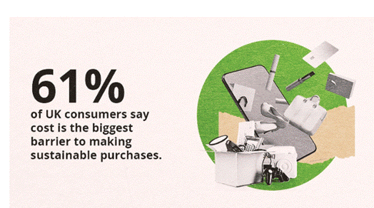
Figure 5: Growth of the sustainable products
Source: (Deloitte UK. 2025)
Research shows that ethical and sustainable buyers in the UK are on the rise (Deloitte UK 2025). Also, Blinkit might target consumers who love purchasing eco-friendly products.

Digital marketing: Social media marketing is an effective marketing strategy that coincides with the growth of digital apps among Gen Z. Social media enhances the online interactions and development of E-commerce (AlShawabkeh, Nuseir and Aljumah, 2021). Blinklit might promote the service through marketing apps on social media platforms. WhatsApp, Facebook, and Instagram might be used for creating short posts, and instant reels might contain some of the exciting offers to give the consumers extra cashback, promo codes and discounts.
There are email marketing and mobile marketing that can bring extraordinary benefits for the company. The strategic expansion will be better understood through the rate of acceptance among the users. As Gen Z are the segment that is mostly busy on social media platforms, the sentiments of Gen Z can be captured easily, so that suggestions can be made. Consumer feedback is essential to bring in some changes into the product designs and strategy verification (Burzová, 2024).

Product positioning: Product positioning is the prominent strategy to assess the market position. Ever-changing markets with the fluctuating aspirations of the consumers will be:

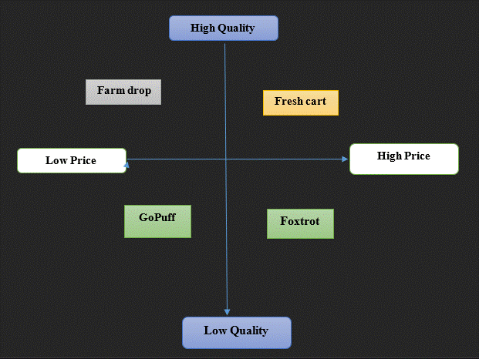
Figure 6: Positioning strategy
Source: (Self-developed)

As inferred from the above picture, Fresh cart, GoPuff, Foxtrot, and Farmdrop can be the competitors, and with these, Blinkit can continue the strategic operations, maintaining value-driven agendas.

Cooperative strategy: The scope of the organisations is strengthened through the market functionalities and cooperative contribution (Gamble, Thompson and Peteraf, 2014).
Bowman’s Clock: After reading the learning modules, I think that Bowman's clock strategy will be conducive to aligning with the organisational growth.
Position 1: Without the frills: Blinkit can offer minimal service with the cheapest essentials in the grocery. Yet, this position will not offer Blinkit a unique position with the curated products. Low values can be generated, and this can deteriorate the competitive positions as well as the market distinction of the company. As price is the strategic factor, Blinkit in the UK cannot profit from the no-frills method.
Position 2: Cost-leadership: Blinkit can take advantage of UK expansion through the strategy of cost leadership and effectiveness. Cost-leadership is the essential strategy to build values and propositions (Ali and Anwar, 2021). Premium pricing is an effective strategy in the effective utilisation of the strategic factors, and the development of the strategic implications is the key to organisational resilience.
Position 3: Hybrid: A Hybrid strategic application will be fit for Blinkit in the UK, and this might consider the integration of the differential services. Strong differentiation and high-volume growth can make the organisational purpose filled with innovation and uniqueness (Lynch, 2021).
Position 4: Standardisation and high values: Blinkit must deliver the strategies to focus on certain categories of products. High value depends upon the market segmentation and value positioning. There are bakery items that can be sold to buyers at premium prices. Differentiation itself is the strategic indicator of the heightened competitive advantage (Grant, 2021).
Position 5- Monitoring pricing: Blinkit can monitor the strategies of pricing and can create the effectual in driving business values and consistency. Effective values of the organisational principles are substantiated through value building and premium formulas (Gamble, Thompson and Peteraf, 2014).

Strategic Model
Ansoff Matrix
Ansoff strategy | Risk | Blinkit’s focus | Explanation of actions
Market penetration | Low | Boost sales through e-commerce services in the UK market, selling groceries and other items | Blinkit will use fast delivery service, exclusive offers, discounts and loyalty programs to attract UK consumers.
Product development | Moderate to high | Offer new products and services to existing UK consumers after entering the UK | Collaboration with different businesses allows us to offer various products for e-commerce businesses and attract and retain consumers (Attar et al. 2022). Blinkit will provide pharmacy products, ready-to-eat meals, and bakery items to attract UK customers.
Market development | Moderate | Use of existing products, such as its model of quick commerce in the UK | Targeting young and busy professionals will be easy for Blinkit in London, UK. Young consumers are more accustomed to using e-commerce apps and technology than elderly people (Rybaczewska and Sparks, 2022).
Diversification | High | Enter the foreign market with a new product, fast fashion clothing items to attract the UK customers | Blinkit will provide subscription offers regarding global food products to attract various communities in the UK market.

Table 4: Ansoff matrix
Source: (Self-developed)

Market Entry Mode
Joint venture: Choosing a joint venture will be appropriate for Blinkit to share responsibilities with another company in the UK. Blinkit can connect with local florists, supermarkets such as ASDA and electronic retail stores to share resources, investments and decision-making to enter the UK market. Joint ventures are effective for businesses to enter a new market by tying up with a local firm to share responsibilities, resources and have shares in profits and deal with losses equally (Camilleri et al., 2023). Sharing resources and investments along with seeking help from its partner may ease the way for the e-retailers to make a positive impression on the UK customers.

Competitive positioning
Porter’s Generic Strategies
Competitive: Generic strategies advocated by Michael Porter will be the best applicable tool in affecting organisational strategies and their implications.
Cost -leadership: Blinkit might serve the consumer of the UK through internalising low-cost and ultra-fast delivery models of service. Dark store effective optimisation can be a suitable model adopted in the urban areas such as London Zones, Manchester and Birmingham. Competitors such as Jiffy in the UK have to compete due to the high demands of the consumers and market volatility (Jiffy grocery, 2025). Blinkit has to implement a cost-effective strategy in order to create a distinctive position in the markets.
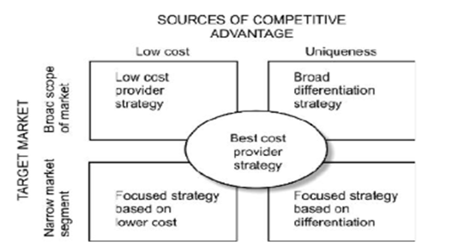
Figure 7: Porters’ generic strategies
Source: (Ali and Anwar, 2021)
Differentiation: Reliability across the UK can be a differentiator, whereas in India, it's only about speed. Brand differentiation effectiveness has its strategic advantage in influencing organisational prominence (Ali and Anwar, 2021). Personalised bundles of gifts can be offered to consumers using AI tools. Differentiation can also emerge through the focus on sustainable packaging. An electronic fleet in India can be the new point for Blinkit to consider.
Cost-focus: Blinkit might bring newness in formulating the competitive strategies, and the delivery fees might be lower during economic recession and downturn situations. Strong adoption practices can be most effective for the company to generate loyalty among consumers (Burzová, 2024). Product launch across the university areas in London might bring effective values. Essential deliveries can be maintained so that the supermarkets cannot outperform their competitive strength.
Differentiation focus: Differentiation focus in the UK can remain on the niche markets, and corporate markets can be identified as a focus to ease the market entry process. Regional expansion can be effective in tracking the patterns of demand, and this will align with the density of population.

Strategic Fit and Capability Assessment
VRIO Framework
Factors | Valuable | Rare | Inimitable | Organised
Technology infrastructure | Yes | No | No | Yes
Instant strategy of branding | Yes | No | Yes | Yes
Local partnerships | Yes | No | Yes | No
Data analytics | Yes | No | Yes | No
Eco-system integration | Yes | Yes | No | Yes
Table 5: VRIO
Source: (Self-developed)

Technology infrastructure: Dynamic pricing for tech-infrastructure must be effective for picker-rider concepts and outings. The infrastructural improvement is essential in catering to the innovative demands of the consumers. Strategic innovations in technology lead towards accelerated growth (Rêgo et al., 2022). UK infrastructural development is triggered through government sponsorship and innovations.
Instant strategy of branding: Branding strategy must be based on the micro-fulfilment efficacy and design stability. Instant everything strategy is organised and hopefully, creates the strategic implementation in essentialising the creative execution and assortments.
Local partnerships: Local partnerships will be valuable, rare and imitable to develop strategic implementation. An exclusive alliance has a strategic advantage towards enhancing profitability and organisational resilience (Lynch, 2021). As the management of vendors is strong, partnership visibility can be promoted through organisational resilience and temporary convenience.
Ecosystem integration: The concepts of ecosystem integration might be effective and valuable in order to promote the concepts of data analytics. Blinkit can easily imitate the acquisition strategies of Zomato, and this can affect the synergy process of the rivals.

Strategy Implementation Components
KPI
KPIs are the fundamental strategic indicators that can increase value to align with organisational internal operations and objective formulation.
Factors | Objective | Deadline | Evaluation
Financial KPIs | To increase Margin per delivery by 30 % at the end of 3rd quarter | Within 8 months | Blinkit will cater to a variety of online demands by measuring contribution margin and cost of acquisition.
Consumer KPIs | To acquire loyalty of the consumers by 80 % at the end of the year | By I year | Blinkit will take the error-free orders and reduce operational flaws.
Learning and growth KPIs | To enhance the learning hours for the employees by 40 %. | Within 6 months | Blinkit will analyse the effectiveness of the organisational values and productive process.
Sustainability and ethical compliance | To increase the rate of compliance by 60 % | Within 4 months | Blinkit will decrease the utilitarian rate of eye riders, and the fulfilment will be developed through digital capabilities.
Table 6: KPIs
Source: (Self-developed)

Financial KPIs: The effectiveness of the key policies is effective in driving consumer satisfaction. Monthly revenue growth will increase, and the company will develop the competitive benefits through the sustainable mechanisms that drive the organisational values. Delivery margin of the organisation will be developed further through the application of the strategic choices and value-oriented practices.
Customer KPIs: Blinkit will proceed with the acquisition of the net-promoter score, and adherence to the delivery time will be increased to affect retention in the long term. Gen Z trends in the UK are habituated to the use of the Blinkit platform.
Sustainability KPIs: demand for sustainable consumption dominates the market share of the UK. In accordance with this, Blinkit will take an effective approach to enhance the suitable values. Sustainability popularity across the UK is essential in driving business values and innovative choices (Deloitte UK, 2025). An electric fleet can be introduced that might reduce dependence on the over-consumption of energy. The company will also take the decarbonised approach that would reduce greenhouse emissions.
Internal process KPIs: Blinkit might be careful regarding stock availability and the proper maintenance of the logistics. AI in the supply chain has its efficacious measures in making distribution networks more agile (Abaku, Edunjobi and Odimarha, 2024).

Risk analysis and mitigation
Risk analysis
Inventory, supply chain and operational expenses: Blinkit may face issues in the UK in maintaining consistency of products, service and offer provision. Silva et al. 2022 have observed that managing supply chains and stocks may be affected if organisations fail to pay heed to the market conditions. Not using safety in payments and comprehensive methods may affect customers for Blinkit.
Competition and profitability: UK market competitors such as Amazon, Uber Eats and Deliveroo may create obstacles in the way of Blinkit to earn profits. Deliveroo offers a wide range of products and up to 25% off on specific items (Deliveroo, 2025).
Consumer behaviour and regulatory compliance: Managing customers may cause issues for Blinkit if it does not follow the Food Safety Act, data protection legislation (GDPR), and the employment laws. This may negatively impact customers along with employees if the mentioned retailer does not remain ethical.

Mitigation strategies
Efficiency and technology application: Applying AI for product recommendations is essential for e-commerce businesses to attract customers (Necula and Păvăloaia, 2023). Blinkit will mitigate the possible risks by using AI technology to provide personalised suggestions to customers, along with managing the stock of products. Using AI will help the company to reduce overstocking and analyse their market conditions to predict demand and keep different products for consumers to ensure satisfaction.
Adherence to regulations: UK businesses must sell safe food products and follow the norms of the Food Safety Act 1990 to avoid legal offence (SBC, 2025). Blinkit will need to maintain compliance with this law, along with ensuring fair labour practices and following the employment laws. The company will need to check for quality control and handle the delivery tactfully to satisfy customers.
Effective marketing and competitive pricing: Providing affordable prices on different products, along with offering loyalty programs, will be effective for Blinkit to attract and retain consumers in the new market. Pereira et al. in 2025 have observed that targeted deals, subscriptions and loyalty programs are essential for customers to have a unique shopping experience online. Using social networks will provide Blinkit with the chance to connect with diverse communities.

Section 4: Performance Evaluation Framework

The Balanced Scorecard Framework
Performance evaluation requires the implication of the strategic frameworks that would add to the company's growth and prepare it for future successful ventures.
Perspectives | Strategic objectives | Indicator | Strategic initiatives
Financial | ● To develop order productivity in the highly active UK market  ● To increase the repeat values of the purchase and the average values of the order | Market share  Average values of the orders | Launching of the subscription models and plans
Customer perspective | ● To enhance the factor of the net promoter score  ● To decrease complaints from the consumers. | App rating  Net sore of the promoter | Student discount  Launching various Loyalty apps
Learning and growth | ● To develop a data-driven and consumer-oriented productive culture  ● To develop the satisfaction score of the employees. | Training hours  Retention of the employees | Building eco-friendly and innovation centres in the UK.
Internal process | ● To expand collaborative partnerships and strategic alliances  ● To increase the accuracy of the fulfilment and on-demand progress. | Supply chain sustainability
Table 7: Balance scorecard
Source: (Self-developed)

Financial: The main objectives of Blinkit will be to develop the market share and attain high productivity. Average values can be enhanced in the order system, and the entire system will be innovated through the strategic initiative. Subscription plans can be improved, and this might offer benefits to the consumers.
Customer perspective: Perspectives centred on the consumers will be more effective in triggering the strategic expansion of Blinkit in the UK markets. Partnership might be exclusive, which affects the growth of the company, and FMCG brands will be the local partners of Blinkit in the UK.
Learning and growth: Continuous growth through learning is the perfect strategy to aid in the internal expansion (Banmairuroy, Kritjaroen and Homsombat, 2022). Blinkit will recruit the high-skilled employees and train the resources to be valuable, tangible assets.
Internal process: The company will have its concentration on the dark stores and resource maximisation through the operational efficiency. Singh, Jaiswal and Singh in 2023 have found that social media activities play a huge contribution towards market assessment. Scalable growth of the company will be developed through empowering the inventory and strengthening the brand performance. Blinkit will operate through the mechanisms that will add to the reliability the consumers and inventory processes are likely to bring more of the convenience and strategic responsibility towards the consumers.

Triple Bottom Line (TBL) Integration
The triple bottom line (TBL) theory stresses three different segments, such as social, environmental and economic, to measure its performance by going beyond the economic gain or profit. Blinkit has deployed some electric vehicles for product delivery to reduce carbon emissions (Dhindsa, 2025). The brand works towards a sustainable future, which indicates its focus on the traits of the TBL. TBL indicates that it is necessary for firms to focus on people, plant and profit by addressing and reducing negative social impacts and environmental footprints (Mishra and Pandey, 2025). It is vital for a firm to manage profit by reducing unnecessary spending and using its capital properly.
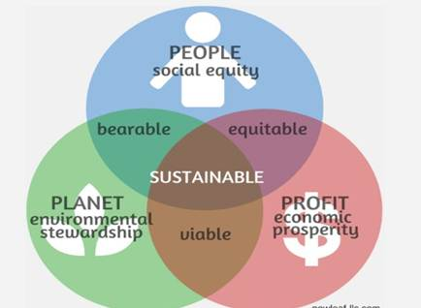
Figure 8: Triple Bottom Line
Source: (Collins, 2024)
It is crucial for firms to address the social issues along with maintaining environmental protocols (Collins, 2024). Considering the overall economic impact of the company on technology is necessary for firms. Ensuring employment, tax payments, economic well-being and value creation needs to be undertaken by businesses at present to remain ethical.

Monitoring and Mechanisms of Governance
Key monitoring areas
Technology and operations: Lack of focus on operational management results in less knowledge about technology. Blinkit uses advanced technology, but it needs to focus more on safety while operating in the UK. Providing smart payment options is necessary along with monitoring algorithms, using AI and IoT to provide better search facilities for customers (Mazhar et al. 2023). Halicka et al. in 2025 have demonstrated that consumers are attracted to the delivery of the sustainable food system. Blinkit might develop the capability to affect organisational decisions.
Regulations: Following the regulations of the Data Protection Act 2018 is necessary for businesses to safeguard their systems from unwanted sources and understand the purpose of the law to remain ethical (UK Government, 2025). Maintaining compliance with technology and regulations will be necessary for Blinkit. Maintaining sustainability in operations and monitoring waste management is also essential for the mentioned company to remain ethical in the UK. Stafford (2021) have found that consumers green wastes maintenance is the effectiveness in prioritising values and operational consistency.

Mechanism for governance:
Communication: Blinkit will need to manage compliance with internal and external stakeholders. Understanding different stakeholders and improving communication helps in maintaining collaborative relationships in the supply chains (Stoeva et al. 2024).
Robust training and legal entity: Having direct accountability with the UK legislation will allow Blinkit to reduce the risks of facing backlashes or legal issues. The firm will ensure safety in employee training, safeguard valuable and sensitive data and maintain communication with tech experts for better maintenance of operations.

Conclusion
In conclusion, Blinkit’s dominance is perceived in the Indian market, but it needs to understand the nature of the business in the British market, where it aims to expand. The Macro and micro environmental analysis factors indicate the focus on legal norms, developing and maintaining ethical sourcing, along with paying attention to eco-friendly packaging. Blinkit maintained its barn image in all these areas but needed to do the same while entering the new market. Threats from e-commerce giant Amazon seemed to affect the profit earnings for Amazon UK, along with local supermarkets that operated both offline and online. Collaborative partnerships with suppliers were necessary for Blinkit to make progress, along with using social networks to reach more customers.

References
Abaku, E.A., Edunjobi, T.E. and Odimarha, A.C. (2024). ‘Theoretical approaches to AI in supply chain optimization: Pathways to efficiency and resilience’, International Journal of Science and Technology Research Archive, 6(1), pp.092-107. DOI: https://doi.org/10.53771/ijstra.2024.6.1.0033
Ali, B.J. and Anwar, G. (2021). ‘Porter’s Generic Competitive Strategies and its influence on the Competitive Advantage’, International Journal of Advanced Engineering, Management and Science, 7(6), pp.42-51. DOI: https://doi.org/10.22161/ijaems.76.5
Aljohani, K. (2024). ‘The role of last-mile delivery quality and satisfaction in online retail experience: An empirical analysis’, Sustainability, 16(11), p.4743. DOI: https://doi.org/10.3390/su16114743
AlShawabkeh, A., Nuseir, M.T. and Aljumah, A. (2021). ‘Impacts of social media on the buying intention of the consumers in Edinburgh, UK’, International Journal of Procurement Management, 14(4), pp.470-486. Available at: https://www.researchgate.net/profile/Mohammed-Nuseir/publication/353087328_Impacts_of_social_media_on_the_buying_intention_of_the_consumers_in_Edinburgh_UK/links/6192462b3068c54fa5e9229b/Impacts-of-social-media-on-the-buying-intention-of-the-consumers-in-Edinburgh-UK.pdf
Attar, R.W., Almusharraf, A., Alfawaz, A. and Hajli, N. (2022). ‘New trends in e-commerce research: Linking social commerce and sharing commerce: A systematic literature review’, Sustainability, 14(23), p.16024. DOI: https://doi.org/10.3390/su142316024
Banmairuroy, W., Kritjaroen, T. and Homsombat, W. (2022). ‘The effect of knowledge-oriented leadership and human resource development on sustainable competitive advantage through organizational innovation's component factors: Evidence from Thailand’s new S-curve industries’, Asia Pacific Management Review, 27(3), pp.200-209. DOI: https://doi.org/10.1016/j.apmrv.2021.09.001
Blinkit (2025) Introducing brand stores. Available at: https://blinkit.com/blog/introducing-brand-stores (Accessed: 20 November 2025).
Blinkit (2025a) Blinkit | press. Available at: https://blinkit.com/press (Accessed: 27 November 2025).
Bothra, N. (2024) Zomato’s Blinkit has a great durable competitive advantage over Flipkart: Sanjeev Bikhchandani and Deepinder Goyal. Available at: https://www.forbesindia.com/article/take-one-big-story-of-the-day/zomatos-blinkit-has-a-great-durable-competitive-advantage-over-flipkart-sanjeev-bikhchandani-and-deepinder-goyal/92529/1 (Accessed: 27 November 2025).
Burzová, S. (2024) Innovations, Innovations – STUME Journals. Available at: https://stumejournals.com/innovations.html (Accessed: 27 November 2025).
Camilleri, M.A., Troise, C., Strazzullo, S. and Bresciani, S. (2023). ‘Creating shared value through open innovation approaches: Opportunities and challenges for corporate sustainability’, Business Strategy and the Environment, 32(7), pp.4485-4502. DOI: https://doi.org/10.1002/bse.3377
Clark, D. (2025) UK inflation rate 2025, Statista. Available at: https://www.statista.com/statistics/306648/inflation-rate-consumer-price-index-cpi-united-kingdom-uk/#:~:text=The%20UK%20inflation%20rate%20was,1%2C277%20pounds%20a%20year%20earlier. (Accessed: 27 November 2025).
Collins, M. (2024) Corporate responsibility in 2023: Triple bottom line sustainability, Environment+Energy Leader. Available at: https://www.environmentenergyleader.com/stories/corporate-responsibility-in-2023-triple-bottom-line-sustainability,3669 (Accessed: 27 November 2025).
Deliveroo (2025) Deliveroo. Available at: https://deliveroo.co.uk/?srsltid=AfmBOoqUYrkPd_MQmF0T7tY-kDbkF0aMAFcZO-w6hncGTKok_ccFnf8L (Accessed: 06 December 2025).
Deloitte UK (2025) The sustainable consumer, Deloitte United Kingdom. Available at: https://www.deloitte.com/uk/en/Industries/consumer/perspectives/the-sustainable-consumer.html (Accessed: 27 November 2025).
Dhindsa, A. (2021) Towards a sustainable future. Available at: https://blinkit.com/blog/towards-sustainable-future (Accessed: 27 November 2025).
Gamble, J., Thompson, A. and Peteraf, M. (2014). Essentials of strategic management 4e. McGraw Hill.
Government of UK (2024) How vat works, GOV.UK. Available at: https://www.gov.uk/how-vat-works (Accessed: 27 November 2025).
Grant, R.M. (2021). Contemporary strategy analysis. John Wiley & Sons.
GVH (2025) UK e-commerce market size & outlook, 2030, Grand View Horizon. Available at: https://www.grandviewresearch.com/horizon/outlook/e-commerce-market/uk (Accessed: 20 November 2025).
Halicka, E., Kaczorowska, J., Rejman, K. and Plichta, M. (2025). ‘Investigating the Consumer Choices of Gen Z: A Sustainable Food System Perspective’, Nutrients, 17(3), p.591. https://doi.org/10.3390/nu17030591
Hardcastle, K. (2024) Consumer awakening: One third of UK consumers want to shop ‘responsibly’, Forbes. Available at: https://www.forbes.com/sites/katehardcastle/2021/07/27/consumer-awakening-one-third-of-uk-consumers-want-to-shop-responsibly/ (Accessed: 27 November 2025).
HSE (2024) Health and Safety at Work ETC Act 1974, HSE. Available at: https://www.hse.gov.uk/legislation/hswa.htm (Accessed: 27 November 2025).
Jiffy grocery (2025) Jiffy grocery | EU-Startups. Available at: https://www.eu-startups.com/directory/jiffy-grocery/ (Accessed: 27 November 2025).
Lynch, R. (2021). Strategic management. Sage.
Mazhar, T., Irfan, H.M., Haq, I., Ullah, I., Ashraf, M., Shloul, T.A., Ghadi, Y.Y., Imran and Elkamchouchi, D.H. (2023). ‘Analysis of challenges and solutions of IoT in smart grids using AI and machine learning techniques: A review’, Electronics, 12(1), p.242. DOI: https://doi.org/10.3390/electronics12010242
Mintel (2025) UK amazon: Creating an ecosystem market report 2023: Forecast, Mintel Store. Available at: https://store.mintel.com/report/uk-amazon-creating-an-ecosystem-market-report#:~:text=%E2%80%9CAmazon%20has%20grown%20to%20be,an%20Ecosystem%20Market%20Report%202023 (Accessed: 27 November 2025).
Mishra, P. and Pandey, V.K. (2025). ‘Triple bottom line and environmental sustainability: evolution of global ESG research—a bibliometric analysis’, Environmental Sciences Europe, 37(1), p.136. DOI: https://doi.org/10.1186/s12302-025-01184-9
Mukul, P. (2025) Blinkit tops quick commerce with over 50% market share, set to gain more: Bofa, The Economic Times. Available at: https://economictimes.indiatimes.com/tech/technology/blinkit-tops-quick-commerce-with-over-50-market-share-set-to-gain-more-bofa/articleshow/124061833.cms?from=mdr (Accessed: 20 November 2025).
Necula, S.C. and Păvăloaia, V.D. (2023). ‘AI-driven recommendations: A systematic review of the state of the art in e-commerce’, Applied Sciences, 13(9), p.5531. DOI: https://doi.org/10.3390/app13095531
Nicasio, F. (2024) Top 10 ecommerce sites in the UK, Ecommerce Guide. Available at: https://ecommerceguide.com/top/top-10-ecommerce-sites-in-the-uk/ (Accessed: 27 November 2025).
Peachey, K. (2025) Half of UK adults now pay on mobile - data shows, BBC News. Available at: https://www.bbc.com/news/articles/c2ejvld0ypyo (Accessed: 27 November 2025).
Pereira, M.D.S., de Castro, B.S., Cordeiro, B.A., de Castro, B.S., Peixoto, M.G.M., da Silva, E.C.M. and Gonçalves, M.C. (2025). ‘Factors of Customer Loyalty and Retention in the Digital Environment’, Journal of Theoretical and Applied Electronic Commerce Research, 20(2), p.71. DOI: https://doi.org/10.3390/jtaer20020071
Razdan, D. (2021) Building a technology first company. Available at: https://blinkit.com/blog/building-technology-first-company (Accessed: 27 November 2025).
Rêgo, B.S., Jayantilal, S., Ferreira, J.J. and Carayannis, E.G. (2022). ‘Digital transformation and strategic management: A systematic review of the literature’, Journal of the Knowledge Economy, 13(4), pp.3195-3222. DOI: https://doi.org/10.1007/s13132-021-00853-3
Rybaczewska, M. and Sparks, L. (2022). ‘Ageing consumers and e-commerce activities’, Ageing & Society, 42(8), pp.1879-1898. DOI: https://doi.org/10.1017/S0144686X20001932
Saunila, M., Ukko, J., Nasiri, M., Rantala, T. and Sore, S. (2021). ‘Managing supplier capabilities for buyer innovation performancein e-business’, Journal of Global Operations and Strategic Sourcing, 14(3), pp.567-583. DOI: http://dx.doi.org/10.1108/JGOSS-01-2021-0007
SBC (2025) Food Safety - Food Regulations: Stafford Borough Council, Food Safety - Food Regulations | Stafford Borough Council. Available at: https://www.staffordbc.gov.uk/food-safety-food-regulations (Accessed: 06 December 2025).
Silva, P., Gonçalves, C., Antunes, N., Curado, M. and Walek, B. (2022). ‘Privacy risk assessment and privacy-preserving data monitoring’, Expert Systems with Applications, 200, p.116867. https://doi.org/10.1016/j.eswa.2022.116867
Singh, N., Jaiswal, A. and Singh, T. (2023). ‘Best time to post and review on Facebook and Instagram: analytical evidence’, South Asian Journal of Marketing, 4(2), pp.128-141. https://doi.org/10.1108/SAJM-09-2022-0059
Stafford, S. (2021) Compost: Why are more people dealing with green waste at home?, [online] BBC News. Available from: https://www.bbc.com/news/uk-england-58261972 [Accessed 11 December 2025].
Stoeva, S., Van Gompel, R., Van den Bossche, L., Rogge, E., Slavova, P., Grivins, M. and Mileiko, I. (2024). ‘Understanding collaboration in short food supply chains: a focus on collaborative relationships, interaction mechanisms and relational benefits’, Agricultural and Food Economics, 12(1), p.49. DOI: https://doi.org/10.1186/s40100-024-00344-4
Sun, M., Grondys, K., Hajiyev, N. and Zhukov, P. (2021) ‘Improving the e-commerce business model in a sustainable environment’, Sustainability, 13(22), p.12667. DOI: https://doi.org/10.3390/su132212667
The Global Economy (2025) United Kingdom political stability - data, Chart, TheGlobalEconomy.com. Available at: https://www.theglobaleconomy.com/United-Kingdom/wb_political_stability/ (Accessed: 27 November 2025).
Trading Economics (2025) United Kingdom GDP growth rate. Available at: https://tradingeconomics.com/united-kingdom/gdp-growth (Accessed: 27 November 2025).
UK Government (2025) Data protection, GOV.UK. Available at: https://www.gov.uk/data-protection (Accessed: 06 December 2025).
UK Parliament (2025) Environment act 2021 publications - parliamentary bills - UK parliament. Available at: https://bills.parliament.uk/bills/2593/publications (Accessed: 27 November 2025).
Vollero, A., Sardanelli, D. and Siano, A. (2023). ‘Exploring the role of the Amazon effect on customer expectations: An analysis of user‐generated content in consumer electronics retailing’, Journal of Consumer Behaviour, 22(5), pp.1062-1073. DOI:https://doi.org/10.1002/cb.1969
Wheelen, T. L., Hunger, J. D., Hoffman, A. N. & Bamford, C. E. (2018). Strategic Management and Business Policy: Globalization, Innovation and Sustainability. 15 ed. Harlow: Pearson Education.

