ANSWER ALL THE QUESTIONS

Question 1 [25 Marks]
- For the circuit shown in fig1, Calculate the following
- Total resistance in the circuit [6 Marks]
- Total current in the circuit. [2 Marks]
- Current across each resistor [10 Marks]
- The voltage across $R_{7}$ resistor [2 Marks]
- Power delivered by the battery [2 Marks]
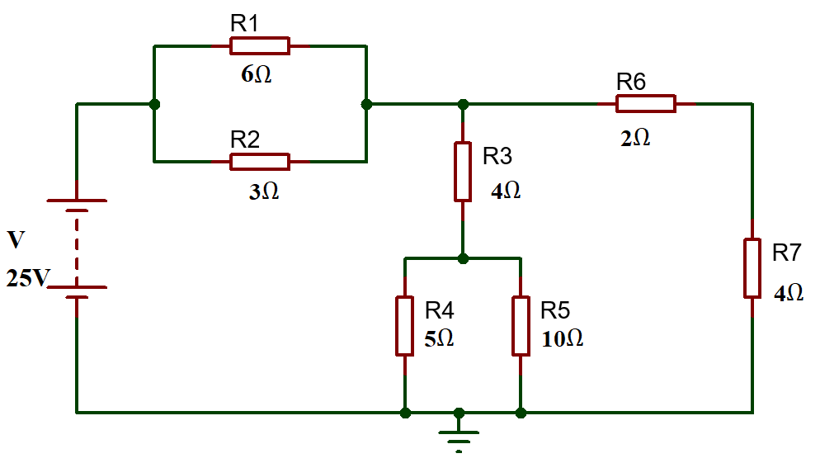
Fig: 1
- A solar yard light has a solar collector that can provide 1.0W of power for charging the 3.0V batteries. What is the maximum charging current the solar collector could supply to the fully discharged 3.0V batteries? [3 Marks]
Question 2 [25 Marks]
- Calculate the current flowing when a charge of 60C flows past a point over a period of 2 minutes. [2 Marks]
- What length of German silver wire, diameter 0.050 cm, is needed to make a 28 resistor, if the resistivity of German silver is $2.2×{10}^{-7}$ m? [5 Marks]
- Determine the current across each resistor in the circuit shown in fig.2, using mesh analysis (Kirchhoff’s Voltage Law) [14 Marks]
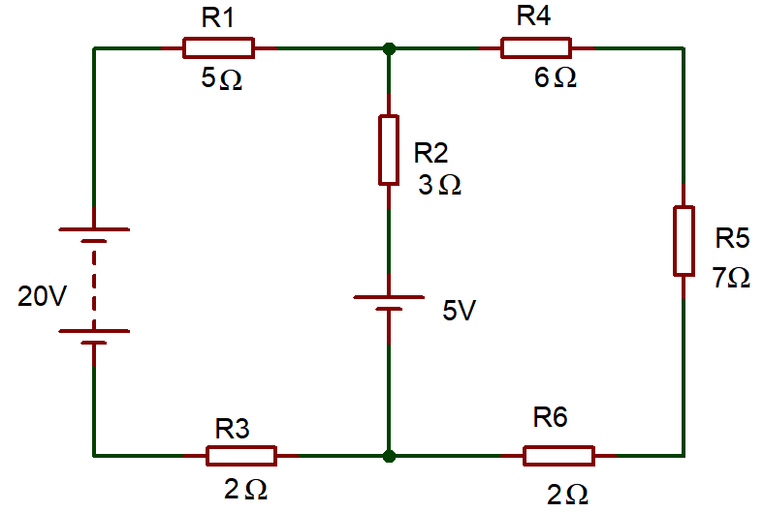
Fig.2
- A silicon diode in a circuit has a forward voltage drop of $0.7 V$ and is in series with a $1 kΩ$ resistor and a $5 V$ supply. Calculate the current through the diode. [4 Marks]
Question 3 [25 Marks]
- Differentiate Step- up Transformer and Step-Down Transformer (minimum of two differences) [4 Marks]
- Explain the following terms:
- Resistance [2 Marks]
- Reactance [2 Marks]
- Impedance [2 Marks]
- Peak inverse voltage [2 Marks]
- The alternating current is given by $i=40 sin314t A$. Determine the following
- Peak Value of current [1 Mark]
- RMS Value of Current [2 Marks]
- Frequency [2 Marks]
- Time period [1 Mark]
- An oscilloscope display shows the below voltage waveform. The oscilloscope settings are shown in the box next to the waveform.
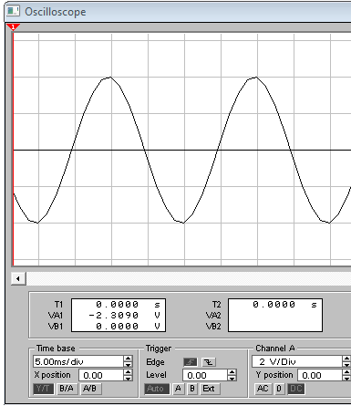
Oscilloscope settings:
2V/div
10ms/div

Fig:3
- Estimate the period of the waveform. [1 mark]
- From the estimated period, determine its frequency. [2 marks]
- Determine its peak-peak amplitude [2 marks]
- Determine the r.m.s. value of the waveform. [2 marks]
Question 4 [25 Marks]
- An RLC circuit is shown in figure 4 below. Calculate the following
- The total circuit impedance [4 Marks]
- Total current flowing in the circuit. [2 Marks]
- Determine the voltage drop across each component in the circuits. [6 Marks]
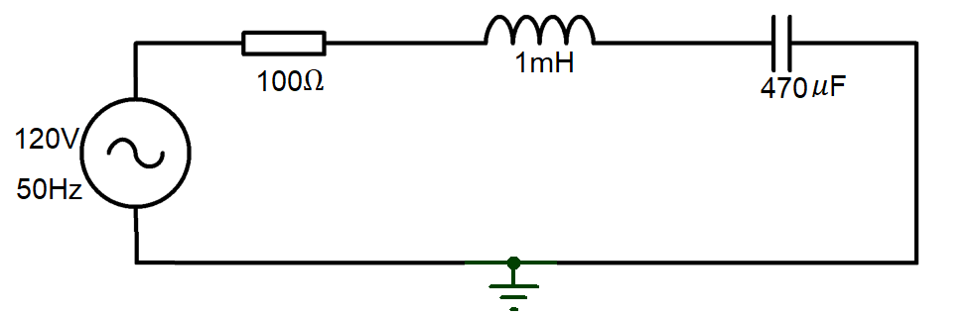
Fig: 4
- Describe the construction and working of PN Junction diode with the aid of necessary diagrams. [10 Marks]
- Determine the voltage across each resistor in the circuit shown in fig.5. [3 Marks]
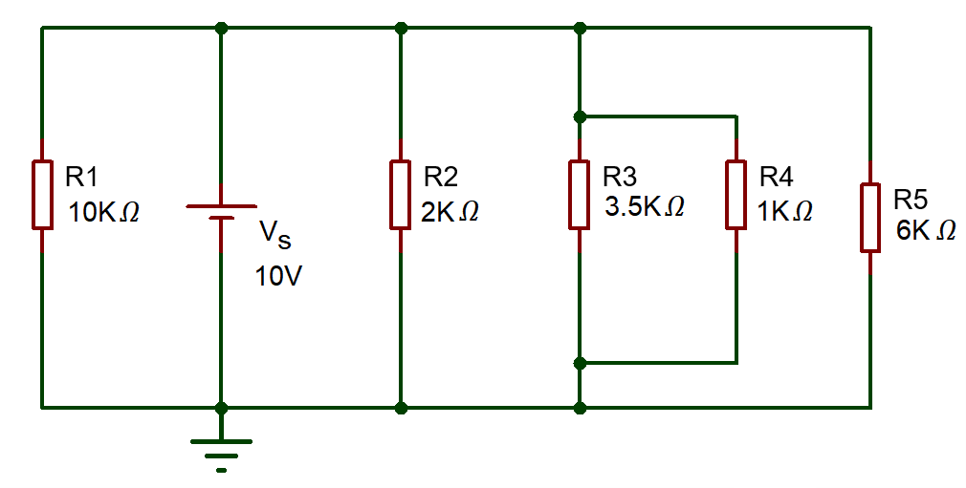
Fig.5

