

BSc (Hons) Professional Police Practice

LEVEL 5 - 40 Credits

Workbook title: Competency Based Workbook 2 (PCDA)

(SOUTH WALES POLICE, GWENT POLICE AND UWTSD)

Learner name: James seymour ______________________________

Learner’s University Registration Number:
___2245965____________________________

FACULTY OF BUSINESS AND MANAGEMENT
PUBLIC SERVICE PROGRAMME

Module title: Professional Police Practice 2 (PCDA) BMPP5000D

Workbook Guidance

Please read these notes carefully; they provide essential information.

What is the workbook for?

The purpose of this workbook is to enable learners to demonstrate and provide evidence of how they meet the learning outcomes set by the College of Policing, for the BSc programme. Essentially, you are being asked to outline your experiential learning based upon your theoretical understanding in a range of operational situations.

- Wellbeing and Resilience
- Decision-making and Discretion
- Vulnerability and Risk
- Public Protection
- Maintaining Professional Standards
- Leadership and Team-working
- Policing the roads
- Information and intelligence
- Conducting Investigations

You may wish to use the same incidents as you’ve outlined in the Occupational Competence Portfolio.

How should the workbook be presented?

Blank electronic copies can be found on Moodle of this workbook. You must submit this document electronically therefore it is important that you save your work regularly and upload the final typed version through Turnitin on Moodle.

Word count policy can be found in chapter 7 of the Academic Quality under section 7.7 (this applies to presenting work above and under the specified word count).
(https://www.uwtsd.ac.uk/media/uwtsd-website/content-assets/documents/academic-office/aqh-chapters/chapters---en/Chapter_07_Assessment_Taught_Programmes_Pages_72-79-UPDATED-05-11-2019.pdf)

Reflective practice is a core aspect for your workbooks and although there is a variety of useful resources on Moodle, there is one particular book, that is specifically based on reflective practice in policing, here is a link to one chapter from Selina Copley’s Reflective Practice for Policing Students:
https://moodle.uwtsd.ac.uk/pluginfile.php/298870/mod_resource/content/1/Reflective%20Practice%20for%20Policing%20Students%20-%20Selina%20Copley%20Chapter5.pdf

How is the workbook assessed?

Advice and support about the completion of this workbook will be provided by university staff as part of your initial training day. Your tutor constable and in-force training staff will not be involved in assessing or marking your workbook after it has been submitted.

Dates of workbook submission will be made available during the initial training day and posted on Moodle.

Once submitted your workbook will be assessed and marked independently.

Confidentiality

It is important that no individual can be identified either directly or indirectly from the information in the workbook. Therefore, you must:

- adhere to guidance in the Student Handbook about unfair practice and plagiarism.
- not identify individuals including witnesses, victims or offenders by name.
- not write information that enables any individual to be identified indirectly through the description you provide. This includes references to names, colleagues, places (including hospitals, schools, town, villages, streets) specific incidents which were high profile and could be identified due to past publicity, other professionals or any other personal information including medical or other conditions.
- take personal responsibility for adhering to confidentiality rules.
- not include any dates of any incidents or anything that specifically identifies an actual incident.

Please be aware that any content that is deemed to be inappropriate, disrespectful, or abusive will not be tolerated. Following review of any content of this nature the information will be shared with the employer of the student responsible.

Should any health and wellbeing concerns be raised because of disclosures made by the student within this workbook, the employer of the student will be informed.

NOTE

Your workbook will be submitted electronically via Turnitin on Moodle. Guidance on this is in the Student Handbook.

Remember that the workbook is YOUR responsibility you must not rely on the assessor or anyone else to pick up any confidentiality breaches as this is your work and you must accept full responsibility for confidentiality. Meeting all the confidentiality requirements is very important.

Dyslexia and other special circumstances

If you have any condition that you feel may affect your ability to deal with any part of the programme, please see the Student Handbook for further guidance. The University has a Student Services Unit that may be able to help but it is the learner’s individual responsibility to contact them.

Guidance:

- Your workbook must contain the items specified in the table below (clearly identified and in the order given);
- You should use this particular document to insert your text / answer within each section of this workbook;
- You should upload your completed document as a saved pdf file of this workbook; if this is not possible then a Worddoc file is acceptable. Do not send a scanned file from a photocopier, an apple.dot file or a Microsoft publisher file as Turnitin will not be able to assess them, despite you being able to upload them.

Contents

Workbook | Area of Professional Practice | Word count
Task 1 | Wellbeing and Resilience | 1250
Task 2 | Decision-making and Discretion  Vulnerability and Risk  Public Protection | 1750
Task 3 | Maintaining Professional Standards  Leadership and Team-working | 1750
Task 4 | Policing the roads  Information and intelligence  Conducting investigations | 1750
Task 5 | Individual Learning Plan | 1500 equivalent
 | Total | 8000
 | Bibliography

Task 1

Relevant areas of the National Policing Curriculum:
Wellbeing and Resilience

Having achieved Independent Patrol Status, reflect on the impact of organisation culture within policing on your wellbeing and resilience (organisation change, retaining personal values in a wider organisational culture).

Consider the risks of conforming to organisational culture.

Illustrate your strategies for maintaining wellbeing and resilience.

1250 words (+/- 10%: include your actual word count at the end of each section)

ANSWER:

Task 1

Policing inherently comes with risks some external in terms of health and safety both in the physical aspect and the mental wellbeing aspect. There are also real life risks that come from within organisations based upon law enforcement and this comes from organisational culture. This essay will aim to look at how organisational culture within policing impacts the resilience and welfare of police officers. In a survey conducted by mind 91% of police personnel have experiences feelings of poor mental health including having feelings of stress and low moods (MIND, 2024). This essay will also aim to look at the methods and strategies that could be used to tackle these feelings and help with mental wellbeing/resilience. South Wales police itself encourages a culture of positive and professional working practises and this equates to a number of key principles which will also be looked at in this essay.

The view of policing and the culture of policing can be separated into two facets. That being the traditional ‘bobby’ on the beat and the culture of the organisation itself. Inherently both will have an effect on how the culture within an organisation will impact on its staff (Charman, S 2017). There is a common theme amongst most organisations that the well-being of its staff are important however this does not always negate the impact of mental health on staff, particularly police officers. MIND, 2024 suggests in a survey conducted in 2019, 70% of police personnel reported personally suffering with mental health.

It could be argued that the organisation itself can not accurately reflect the personal and immediate impact of colleagues within an organisation and this is what creates two cultures within an organisation. New officers will enter what is known as response, a fast paced environment where officers will respond to an array of emergencies and then be expected to move on to the next. This dynamic results in teams of officers who will face these challenges and will have their own coping mechanisms which can be in the form of ‘dark humour’, ‘banter’ and other such like ‘coping mechanisms’. The problem with this culture amongst smaller groups withing an organisation is that this can sometimes go against the culture promoted by the organisation in large. South Wales police strives itself on being professional and in such circumstances ‘dark humour’ to deal with trauma can conflict with this.

Policing has unique challenges in comparison to other forms of employment. There are numerous occasions of traumatic incidents being faced by police officers and this would naturally have a negative impact on the wellbeing of officers. Police officers in the UK are reported or have reported to the federation for police that 97% of officers have come into contact with a serious physical assault, 99% have reported having seen the body of a person as a result of some sort of violent death, 66% reporting having seen a violent or unnatural death including suicide and 84 % having reported tending to victims of serious road traffic collisions (Police Federation. 2019).

These challenges aren’t all that dissimilar to that of other emergency services such as the ambulance service or fire service for example, however policing has the unique problem of being the organisation that is effectively the last line of defence when it comes to matters such as this. In other words there is no other organisation or service to rely on to be able to take police officers away from these incidents as they happen. These issues although serious are not enough to prevent exposing police officers to the mental risks they pose and that of the physical risks. Policing in the UK has a culture of maintaining positive relationships, being professional whilst also providing a service to deter and prosecute criminals. As a result police officers are then naturally expose themselves to the risks of physical and mental harm in the jobs they do. This aspect however is challenged by Van der Velden, G (2012) who suggests that although being a police officer is classed as a ‘high risk’ profession there were no studies or evidence to support a link between mental health problems and the profession of being a police officer. In fact it was found that there was no data or evidence to suggest mental health problems were higher among police officers than that of other professions not considered to be ‘high risk’. This is partially supported by Golembiewski, R (1992) in that he suggest that ‘burn out’ can sometimes be conflated with mental health problems and this in turn could be seen as to why there are such high number of personal responses from officers where they report matters closely related to mental health.
To tackle this problem there are a number of key coping mechanisms and strategies to be able to keep up with the demand of being a police officer whilst also maintaining or improving mental resilience. One such method involves physical activity. This inherently has benefits that bring advantages to the individual in the form of physical performance and mental well-being but also to the organisation in that officers will be better able to conduct their duties from a operational safety point of view. Peluso, M (2005) points out that physical activity has long been known to improve mental conditions such as depression and anxiety. This is through a number of theories that physical activity can introduce distraction, self-efficiency or even social interaction. Arguably the theories could be seen as individual methods of tackling mental well-being issues but there is also evidence to suggest that through physical activity this improves and increases the chemical for ‘feeling good’ named dopamine.
In conclusion, although there are arguments for and against officers being impacted my mental wellbeing there are undeniable pieces of evidence to show that trauma inherently effects peoples mental well-being be that in any occupation or walk of life. CAMH 2024 back this up by suggesting trauma can lead to mental health conditions like PTSD (post-traumatic stress disorder) if left untreated or undiagnosed. In addition to this its suggested that these trauma events are emotional responses to events that hold some sort of impact with the subject of the trauma and can become challenging later on in life. As a result of this it can be drawn that being a police officer does bring with it the challenge of managing mental well-being and this needs to be managed through appropriate coping mechanisms. It can be easy to fall into the ‘crowd’ and begin to use coping mechanisms such as ‘dark humour’ but this can go against the ideas and cultures of an organisation, particularly law enforcement but other coping mechanisms such as physical activity can be used to positively deal with these risks. Not only this but by having social interaction this can also be a tool to manage traumatic experiences. Reflecting on becoming independent as a police officer I can see the positive impact of confiding in those who experience the same or similar events instead of resorting to humour or other such coping mechanisms as this doesn’t deal with the initial trauma and instead provides distraction.

Wordcount 1190

Task 2

Relevant areas of the National Policing Curriculum:
Decision-making and Discretion, Vulnerability and Risk, Public Protection.

You must choose an incident, for example a domestic related incident, and reflect on how you made decisions in complex and unpredictable circumstances using dynamic risk assessment.

Give a brief description of the problem including social and legislative contexts and any relevant cultural, ethnicity and language issues.

Evaluate decisions made during the incident and your use (or otherwise) of the National Decision Model. Explain the rationale behind your decisions and your considerations when recording details of the incident. Consider your ethical approach to the decision. Outline the consequences of your decision making.

1750 words (+/- 10%: include your actual word count at the end of each section)

ANSWER:

In this essay I will discuss a domestic incident that I attended. Outlining the issues I faced during the incident and how I used the national decision making model as a tool to reflect on an incident I dealt with, the outcome of my decision, actions taken and the consequences of my actions. We received a call from the MET police stating they had received a call from a male in the London area. He received a call from a family member of the victim living in Bangladesh stating that the victim needs help. It was reported that she is pregnant and is being forced to have an abortion. In turn she has been threatened by her partner that if she does not have an abortion he will kill her. She is being kept in the house and has no access to money and has no control over the use of her mobile phone.
When attending the address the male answered the door who was also from Bangladesh however he was able to understand English. As soon as the female heard the police at the door she immediately rushed to the door shouting in her native language whilst pointing to her stomach. Having prior knowledge of the incident passed to me by the call handler my main aim was to safeguard the victim whilst investigating any offences committed. The National decision making model (NDM) gives the decision maker structure to rationale what they did during an incident and why. (College Of Policing, 2013). In this incident it was used by listening to and understanding the views of both persons, and seeking to recognise and respond to the physical, mental and emotional challenges and working in the public interest by taking pride and providing an excellent service to the public.

When attempting to speak to the victim it was apparent that she didn’t understand English and could only speak Bengali. Navigating a world where English is a dominant language it can be challenging for those who don't understand it. The language barrier creates a significant divide, making it difficult to access essential services, participate in conversations, This barrier can lead to feelings of isolation and frustration, as individuals struggle to express their needs, understand important information, or connect with others, They can cause misunderstandings that lead to conflict, frustration, offense, violence, hurt feelings, and wasting time, effort, money, and lives of the people. (Buarqoub, 2019).
The graph below shows the proportion of people from different cultures that speak very little English or not at all.

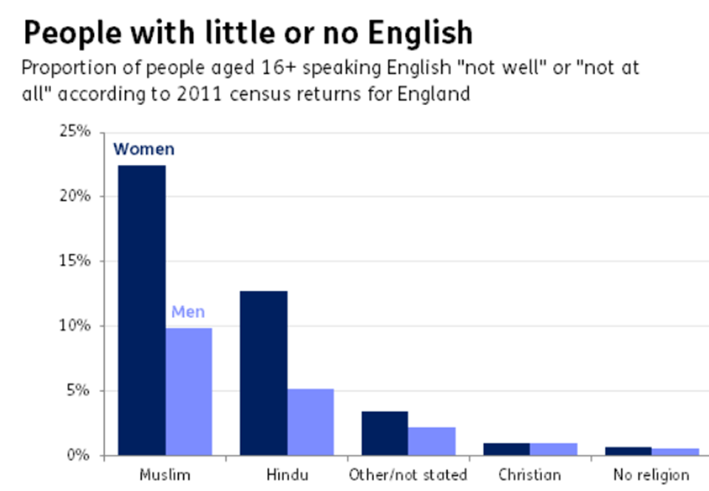

seeing the fear in the victims eyes I separated the victim from the male for safeguarding and to get an account of what has happened. Using the NDM I gathered the information and intelligence around what has happened. The only information I received until this point was the information reported to the police via a third party report. Language line were called and a Bengali interpreter was used to communicate with the victim. Language line provides interpretation and translation services, it helps bridge communication gaps between individuals who speak different languages, making services and information more accessible to non-English speakers. Language Line supports organisations within the criminal justice arena all around the UK, with professional, experienced, vetted interpreters. Our service is delivered via a team of over 10,000 interpreters fluent in more than 150 languages. (Farrow, 2024). This assisted in calming the victim whilst reducing the time spent trying to understand or be understood. I activated my BWV (body worn video) to record any evidence and record police attendance. BWV is used to provide accurate record of events as they happened, this assists in resolving disputes and provide clarity in cases where there is conflicting evidence or statements. (Williamson, 2023). Once all information was gathered from both the victim and the subject it was clear I needed to take action. The next part of the NDM is assess the threat, risk and develop a working strategy. The points that fall under this are, do I need to take action immediately. Clearly action needed to be taken immediately as the female was being kept in the address against her will. This is coercive controlling behaviour as he was keeping the victim from friends and family, taking control over aspects of her everyday life and controlling her finances.
Studies show there were 43,774 offences of coercive control recorded by the police in England and Wales (excluding Devon and Cornwall) in the year ending March 2023. This is an increase from 41,626 in the year ending March 2022, and 33,954 in the year ending March 2021 (ONS, 2023a). this is slowly decreasing however figures are still high. This is hard for the victim to report if they are deprived of their methods of communication. (Women's Aid, 2018). I needed to consider whether I needed to seek more information, how probable is the risk of harm. It’s necessary to gather as much of the information as possible so I arranged for an interpreter to attend the police station to obtain a statement from the victim. I called the reporting person to get his account of what happened. The probable risk of harm was high as the subject has threatened to kill the victim if she did not have an abortion.
The next part of the NDM is powers and policy, the subject was arrested under code G of PACE (police and criminal evidence act) due to what was disclosed to me, code G gives officers the powers to arrest a person who is involved, or suspected of being involved, in a criminal offence. (Home Office, 2022).
The next part of the NDM is options and contingencies, this is where I considered the options available to me, the amount of time available, available resources and support and what actions to take if things do not happen as anticipated. My options were to safeguard the victim by taking her to the police stations where she was safe as she did not have any friends and family in Cardiff, the only friend she had was her friend in London. This eliminated any chance of her staying at an alternative address where she could have been left in the company of friends or family. The victim has only been in the UK for five months and was being supported by her husband, when checking with immigration they confirmed she has no access to public funding, this became a problem when speaking to women’s aid and RISE as they were unable to house her due to not having a National insurance number. Women’s Aid is the national charity working to end domestic abuse against women and children. “Women’s Aid is underpinned by fundamental feminist values which for us means being anti-racist and inclusive in all that we do.” (Women’s Aid, n.d.). After speaking with immigration, women’s aid and RISE I decided to make contact with her friend in London to see if he would consider letting the victim stay with him until she could sort out a hostel or accommodation in London where she was not only safeguarded but had a friend who was able to assist her in gaining accommodation as he was from Bangladesh and could communicate with her In her language. She was very vulnerable at this point. The definition of vulnerable is “exposed to the possibility of being attacked or harmed, either physically or emotionally a person in need of special care, support, or protection because of age, disability, or risk of abuse or neglect” (www.oxfordlearnersdictionaries.com, n.d.) Vulnerability and risk are intimately connected concepts that shape our experiences and decisions. Vulnerability refers to the susceptibility to harm or loss, from various factors such as physical, emotional, or situational weaknesses. Risk, on the other hand, is the likelihood of these vulnerabilities being exposed leading to negative outcomes. I looked at all options available to us regarding transporting the victim to London. Putting the female on public transport was not an option as she did not speak English and we could not guarantee that she would arrive safely. No emergency shelters were available to house her for the night. I spoke to my inspector who suggested that if I was happy then would I take her to London myself, this was the only safe option to ensure she gets to her friend’s house safe and that she was left in the good company of her friend safe and well. As a consequence of my actions a female who was in a different country, did not speak the language, she did not have any friends or family or any access to money. She was being coercively controlled by her partner and was also being threatened for her life by her husband, she was safeguarded from the situation, she was heard by myself via an interpreter and was taken to her family under police protection where she could receive help from a familiar face. “The Crime Survey for England and Wales (CSEW) estimated 2.4 million adults aged 16 years and over experienced domestic abuse in the year ending March 2022. This is a prevalence rate of approximately 5 in 100 adults “ (ONS, 2022) This led to the arrest of her partner who was interviewed regarding the offences. Due to the religious beliefs of the subject I was considerate when assisting him in getting his belongings ready for custody. I made him aware that he may be in custody up to 24 hours, had he required anything i.e. medication etc. I was aware of and sensitive to Islamic practices and beliefs. For example, be respectful of their need to observe daily prayers or dietary restrictions, such as not eating pork or drinking alcohol. I re assured him that when he was booked in they would, ask him about his dietary requirements. I Clearly communicated the reason for the arrest and the process that will follow. Ensure that he understood his rights and the procedures involved prior to arriving in custody. I used my discretion and decided not to handcuff him due to his age and size and the fact he was fully compliant during the ordeal. It is important to treat every person with respect regardless of their ethnicity. studies show that people of race reported the threat or use of force by police when approached by police. I was also aware that I have used the Beatris box method, which is the believe that your attitude can affect the behaviour of the person you are speaking with. (Revolution Learning and Development, 2023)

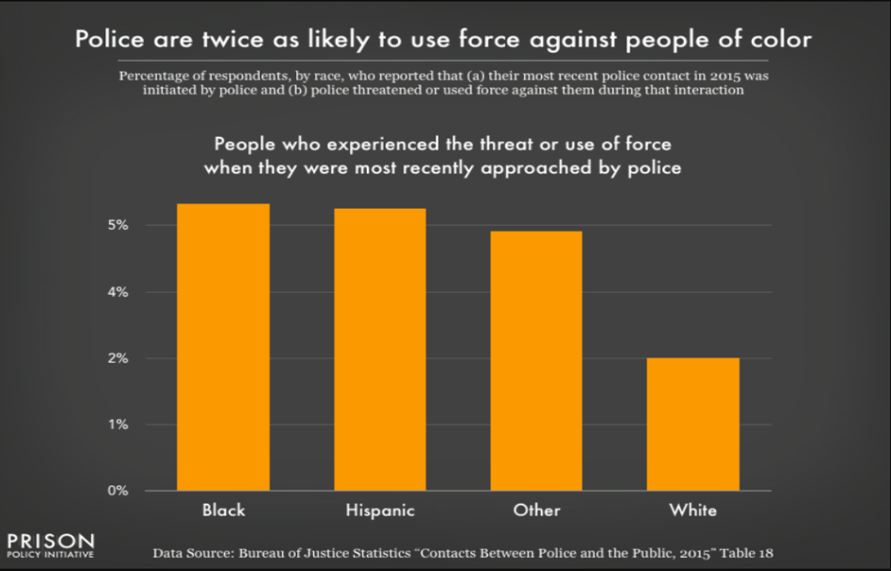

In conclusion when dealing with domestic incidents it is important to run the national decision making model, constantly re assessing when processing information that’s given about the incident. There is always a risk when it comes to domestic incidents, it’s important to understand the risk factors and most importantly safeguard the victim at all times. Domestic incidents pose a higher risk than other incidents as the victim may not want to speak out or give information as they live with their partner or have ties with each other such as children. Because of the decisions being made and safeguarding measures that are put in place it’s important that all decisions are justified and proportionate in the circumstances and a rational why this was carried out. In regards to the incident described I was happy with how things were dealt with. I explored all options with regards to safeguarding and accommodation for the victim.

word count 1912

Task 3

Relevant areas of the National Policing Curriculum:
Maintaining Professional Standards, Leadership and Team-working

Evaluate theories of team dynamics as a means of developing team cohesion (reasons why some teams cannot function, theories and models relating to team dynamics, ways to improve team cohesion).

Consider why inter-personal conflict can occur within a team and outline what strategies can be adopted to enhance individual and team performance.

Consider how team dynamics within the police service can result in failing to comply with professional standards requirements (Code of Ethics, policies, procedures, protocols or legislation).

1750 words (+/- 10%: include your actual word count at the end of each section)

ANSWER:

Team cohesion is an essential for function of any team environments such as policing. Understanding why some teams struggle to function effectively and how cohesion can be enhanced is critical. There are various theories of team dynamics that show a means of developing team cohesion. Bruce Tuckman's states ‘teams must cover five stages of development Forming, Storming, Norming, Performing, and Adjourning’. Each stage represents a section in team development in relation to challenges and behaviours. During the Forming stage, team members become acquainted, establishing ground rules. There is usually a high dependency on the leader for guidance/direction as individuals try to understand their roles in addition to the team's objectives. The Storming stage, considerably developed through conflicts arising as team members by asserting their opinions and additionally challenging authority is considered critical for growth but can be tumultuous as individuals conflict for positions within the group. The Norming stage consists of conflicts being resolved and relationships being built, as a result the team members begin to work more cohesively, by developing unity and mutual respect as a result of the 5 stages reaching a high level of performance and functioning effectively towards common goals without constant supervision. The final Adjourning stage is when the team disbands after achieving its goals. This is typically accompanied by a mix of sadness and satisfaction as members reflect on their achievements and experiences in the team. Dr. Meredith Belbin's research on team roles, provides a similar perspective on team dynamics. There are ‘nine roles that are essential for a balanced team’ however an individual can play multiple roles. The Plant, who is a creative innovator proposing new ideas; the Resource Investigator, who explores opportunities and develops contacts; the Co-ordinator, acting as a chairperson and guiding the team towards its objectives; the Shaper, who drives the team towards its goals as a means of motivation; the Monitor-Evaluator, who analyses and evaluates ideas and suggestions; the Teamwork, who ensures cohesion within the team by supporting members boosting moral; the Implementer, who turns ideas into practical actions; the Completer Finisher, who ensures thorough and timely completion of tasks; and the Specialist, who provides in-depth knowledge of key areas. Each of these roles contributes uniquely to the team's overall performance. leveraging these roles through understanding can help in forming a well-rounded team where each member's strengths is utilized effectively for the purpose of cohesion. Patrick Lencioni’s model, confirms in his book "The Five Dysfunctions of a Team," five key dysfunctions that can hinder team performance. ‘Absence of Trust, Fear of Conflict, Lack of Commitment, Avoidance of Accountability, and Inattention to Results’. The absence of trust among team members is most crucial as it prevents open and honest communication, leading to a lack of engagement and chemistry. The fear of conflict results in unresolved issues, as team members avoid healthy debates that could lead to better decisions. This can result into a lack of commitment, where team members are unclear about priorities and goals, leads to half the intended effort when there is not goal in mind. The avoidance of accountability means that team members fail to hold each other accountable undermining the standards and leading to a subpar performance. Finally, inattention to results occurs when team members focus on personal success over the collective success, this is a detriment to team cohesion as it is essential for function of any team environments such as policing because personal success focused mindset can put other members at risk creating a divided team. Understanding why some teams struggle to function effectively and how cohesion can be enhanced is critical. There are various theories of team dynamics that show a means of developing team cohesion. Team cohesion is essential for overcoming the challenges. Trust is foundational ‘where there is no trust there’s exclusion’. Trust is developed through team-building activities and exercises. Having a transparent, and consistent approach enhances behaviours and performance from all team members, particularly leaders. Trust allows team members to feel safe in expressing their ideas and concerns, open communication is also important in confidence and trust. Constructive conflict is another important strategy. Open discussions where differing opinions are valued helps prevent unresolved issues and leads to better decision-making. When team members feel comfortable voicing their disagreements and working through them, the team can arrive to more innovative and effective solutions developing cohesion. Commitment in a team involves ensuring clarity in goals and responsibilities. A clear understanding of what is expected of the team and what the team aims to achieve results to a more committed motivation to the team’s success. However, this must be reasonable within the means of the team’s abilities. Persistent accountability maintains high standards. Exercises such as reviews and feedback activities maintain accountability ensuring that individuals meet their responsibilities in a constructive manner, contributing effectively to the team's objectives. Emphasising the importance of the team success over individual success ensures that all team members are working towards the same objectives and motivated to support one another in achieving them such collective results align efforts towards common goals. Interpersonal conflict significantly impacts performance of a team and is often the initial cause of conflict. Implementing strategies that enhance both individual and team performance is essential to maintain a productive and cohesive work environment. Interpersonal conflict can arise from various matters. Misunderstandings are the most common cause for conflicts but is considered ‘an unavoidable element of communication’ unless managed. Furthermore, conflicting personalities and styles also cause friction within a team. When individuals have different approaches to tasks and problem-solving, conflicts commonly arise unless it is acknowledged and managed. In addition, unclear roles cause conflicts leading to an overlap in work furthering confusion and conflict over who is responsible for what. limited resources can create tension and causing frustrating competition among team members which is another means of conflict. Lastly, A lack of inclusivity and understanding differing values and beliefs, influenced by cultural backgrounds and personal experiences, can lead to conflicts if not addressed with sensitivity. Enhanced Performance is improved by many strategies. Effective communication is paramount through clear and open communication channels. This will prevent misunderstandings and ensure that everyone is on the same page. In addition, regular meetings and updates help keep team members informed and aligned with the team's objectives. To further enhance performance, conflict resolution training is key for team members. This allows the skills to resolve disputes preventing conflicts from disrupting the team. Roles and responsibilities must also be clear as it reduces role ambiguity, defined roles and responsibilities ensures the team knows the expectations of them and reducing the likelihood of confusion and overlap. Another critical strategy is resource management, having transparency of resources can reduce conflict and internal competition, ensuring that all team members have what is required to perform their tasks effectively. Lastly, having training in cultural competency addresses conflicts arising from differing values and beliefs, having an understanding and respect of diverse perspectives creates a more harmonious work environment which all lead to an enhanced performance. Team performance and induvial performance is enhanced through clear goals, such as ‘feedback and its high relationship to team performance’, encouraging collaboration, recognition and rewarded efforts. These promote continuous learning and development with incentives. Having goals gives direction to the team, this motivates the urge of a common objective. Furtherly, Having Feedback that is constructive helps individuals and the team improve continuously as it identifies areas for improvement and behaviours. Collaboration is key in a team and must be promoted in a collaborative environment where team members can share ideas, support each other, and solve problems collectively. Recognizing and rewarding efforts boosts morale and motivation, showing team members that their contributions are valued and appreciated. The idea of continuous learning and development opportunities keep team members engaged and skilled, ensuring they meet the evolving demands of their roles and the team's objectives. In the police service, to maintaining professional standards team dynamics are essential. This includes the application of the code of ethics, procedures, policies, protocols, and legislation. Police work demands a high level of teamwork and induvial work to strict professional standards to ensure effective and ethical practice. The police service requires professional standards with regards to a team dynamic, specifically on trust and integrity. Trust within the team ensures that members act with integrity and uphold ethical standards as the alternative risk without trust leads to greater risk of unethical behaviour and non-compliance with protocols. Additionally, having strong dynamics to hold each other accountable is fundamental. This advocates adherence to policies and procedures. The risk of poor team dynamics can result in negligence and misconduct. Failing to hold each other accountable prevents issues being dealt with promptly. Another vital requirement is clear communication for the proper implementation of policies and protocols. Failing this results in miscommunication leading to errors and breaches of professional standards, this is a vital risk to integrity. Conflict resolution skills are also essential. Being proficient in conflict resolution appeases issues before they escalate, this will maintain professional standards and a positive work environment. Having unresolved conflicts can result in a toxic environment and potential ethical violations, compromising the team's ability to uphold professional standards. In order to enhance compliance with professional standards within the police service, ethical leadership is essential. Leaders should model ethical behaviour and promote a culture of integrity and accountability as leaders set the standard for the entire team. Such influence will impact behaviours and how the team interact with one another. A good means of training and development is essential. Consistent training on policies, procedures, and the code of ethics ensures that the team are knowledgeable and compliant with professional standards. Ongoing tests in relation to education and training reinforce the importance of ethical behaviour and keeps team members updated on best practices and legal requirements. The need for clear protocols and accessible protocols helps team members understand and follow professional standards, minimising the likelihood of errors and non-compliance. A positive team culture is also critical as it encourages adherence to ethical standards and professional conduct. The feeling of value and support will have a domino impact causing the team to act with integrity and uphold professional standards. Finally, implementing regular audits and reviews helps maintain compliance with professional standards.

Wordcount 1706

Task 4
Relevant areas of the National Policing Curriculum:
Policing the roads, information and intelligence and conducting investigations.

Explain how information and intelligence can be used in the disruption of the more prevalent criminal activity (e.g. drug smuggling, human trafficking, child sexual exploitation, counterfeit goods, organised crime groups and ‘county lines’) by effective policing of the roads.

Outline how ANPR can be used as investigative resource when disrupting criminal activity.

1750 words (+/- 10%: include your actual word count at the end of each section)

ANSWER:

In this essay I will explain the importance of information and intelligence and how it can assist in disrupting criminality and more importantly lead to information on the more serious crimes such as drug smuggling, human trafficking and child sexual exploitation etc. I will explain the importance of digital equipment which is automatic number plate recognition system (ANPR). I will explain the use of police national database and the guidance that must be followed in order for the lawful permitted use of the police national database by all UK police forces.

As a police force we gather information and intelligence. Information is essentially data that has been processed, organized, or structured to have meaning and be useful. It can come in many forms, facts, instructions, knowledge, that help us understand, make decisions, or communicate. To gather this information we use the national intelligence model (NIM). The NIM is a business framework which provides structure in a police investigation in order to process information and turn it into actionable intelligence (Paige Keningale, 2020). In order to turn the information into actionable intelligence it is graded by the 3x5x2 system. This gives uniformity to the intelligence and give all staff the ability to judge the intelligence and act on it accordingly simply by using this grading system. (NAFN, 2023)

The first step in effectively gathering intelligence we must evaluate the source of the information and the reliability. This is where the 3 points of the 3x5x2 is used. Is the source of information:
- Reliable meaning that the source is believed to be both competent and the information received tends to be reliable,
- Untested meaning a source that has not previously provided information to the person receiving it.
- Not reliable meaning that there are reasonable grounds to doubt the reliability of the source.

we move onto the second part of the 3x5x2 system to find out if the information is:
- known directly to you from the source, this refers to information obtained first hand.
- known indirectly to the source, meaning that the source has not witnessed themselves however the reliability of the information can be verified by separate information that carries the information and intelligence of assessment A but the information has been corroborated by other means.
- Indirectly to the source is information that the source has been told by someone else. The source did not witness it themselves.
- Not known is where there is no means of assessing the information for example an anonymous source.
- Suspected to be false, regardless of how the source has come up with the information, there is information to believe the information provided is false.

The last part of the 3x5x2 system is the dissemination which is the handling codes and conditions which are a control mechanism for sharing information. this must always weighed against each other to consider the chances of a greater risk if the information isn’t shared.

- Lawful sharing permitted this means that before sharing the information it must be for a legitimate purpose, for example assisting others to protect life or property or prevent the commission of offences and assisting others in bringing offenders to justice.
- Lawful sharing permitted with conditions, this code permits dissemination but requires the receiving agency to observe conditions as specified.

Intelligence has played a crucial role in disrupting child sexual exploitation (CSE) and human trafficking through a variety of methods such as data analysis, surveillance and monitoring and public awareness. Human trafficking involves the recruitment of individuals for purposes such as sexual exploitation or forced labour. Victims of human trafficking can include children, adults and people from all socioeconomic backgrounds. Their primary goal is to exploit their victims for acts such as sexual services or other forms of labour or abuse by making threats or manipulating their victims by false promises of employment or a better life. Young children are being exploited by carrying out sexual acts in order to obtain goods or money. Children are usually picked due to their risk factors such as learning disabilities or come from low socioeconomic backgrounds making the more susceptible to being exploited. (NSPCC, 2019). The national crime agency states that “in the year ending December 2022, 7936 referrals were made for potential victims of exploitation that has taken place in the UK. Many of the victims work in the construction industry, agriculture, sex industry, nail bars and car washes.” (National Crime Agency, 2019)

The graph below shows that from May 2017 to April 2020 that all types of exploitation is on the rise.

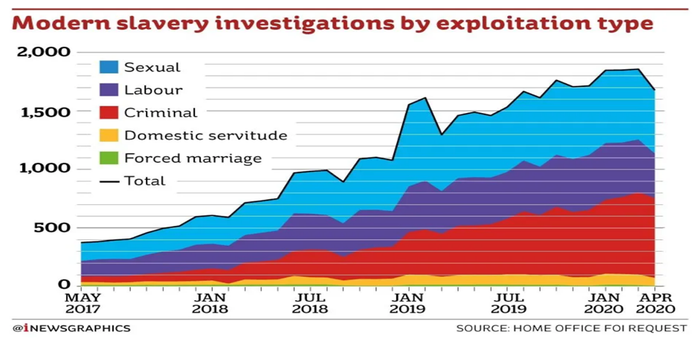

Vehicles can play a significant role in exploitation in several ways by transporting workers who are subject to exploitation. Vehicles are used to transport victims across borders or between locations making it easier for traffickers to evade authorities in order to illicit their activities. There are many ways information can be obtained in order disrupt criminality. Once of the pieces of equipment used is automatic number plate recognition cameras (ANPR). ANPR technology is used to help detect crime whilst helping deter and disrupt criminality. It provides lines of enquiry and evidence in investigating crime, it was invented in 1976 in the UK by the scientific development branch and early systems were developed for use in 1979. It was trialled in the UK on the A1 road and the Dartford tunnel crossing with the first arrest from ANPR detection of a stolen car in 1981. ANPR is a technology used to automatically read vehicle license plates using optical character recognition (OCR) on images captured by cameras. (ANPR International, 2024). Over the years ANPR has improved and has become a major asset to the police and its assistance in disrupting criminality. Cameras are usually situated at fixed locations as well as being in police vehicles meaning this software can be used mobile. ANPR works by reading the number plate of a vehicle. This information is then checked against database records of vehicle that may be of interest to us. This gives us the powers to stop a vehicle to speak the driver and where necessary make arrests. ANPR has proved to be predominant in detecting crime and locating missing persons, stolen vehicles, uninsured vehicles and assisting in detecting major crime such as exploitation. Although ANPR can be highly effective it does come with its disadvantages such as accuracy issues, weather conditions, speed and damaged or obscured license plates can affect the accuracy of recognition. The use of cloned plates on a vehicle is becoming more common as it proves difficult to track and identify vehicles involved in criminality such as theft, smuggling and other illicit activities. The roads policing unit plays an enormous role by stopping vehicles preventing all forms of criminality. The BBC revealed a 64% surge in car cloning leading to fines being cancelled over three years. It found the number of cases rose from 22,450 in 2021 to 36,794 in 2023. (Wheble, 2024). The roads policing unit plays a major part in disrupting criminals who abuse the road network for criminal gain. They assist in identifying specific routes used by county lines for drug smuggling. ANPR can produce accurate geographic location data of a vehicles movements from start to finish allowing police gather information and intelligence in order to conduct stops on vehicle when required. (College Of Policing, 2023).

The use of all the information and intelligence provided to us helps identify key areas to police. This information can be provided via statistics and intelligence from all police forces throughout the UK to identify persons and vehicles involved in high levels of criminality. The Police National Database (PND) is a national information management system that improves the ability of the Police Service to manage and share intelligence and other operational information, to prevent and detect crime and make communities safer. The PND offers a capability for the Police Service to share, access and search local information electronically, overcoming artificial geographical and jurisdictional boundaries. (Elkins, 2019).

High levels of police presence in the troubled areas can assist in the disruption of criminality and can lead to more proactive policing and stop searches which will give the public a sense of security whilst gathering more information and intelligence.
Organised crime groups are adapting their ways day by day so it is important to adapt with it. With the use of vehicles on cloned registration plates, electric bikes and scooters that do not have registration plates being commonly used for offences such as human trafficking, child sexual exploitation and the supply of drugs it is becoming a lot harder to catch these criminals in the act, however this does not mean that this cannot be achieved, it means that with the information and intelligence provided and the assistance of neighbourhood policing tracking peoples movements we can police the areas of concern and target areas. (College of Policing, 2021).

In conclusion the information and intelligence gathered plays a vital part in policing in all areas whether it be vehicles or persons involved in committing crime. It helps build a bigger picture from crimes happening in the local area to bigger crimes all over the UK such as human trafficking, sexual exploitation and county lines by sharing information with other police forces in the united kingdom.
The use of ANPR technology it helps disrupt criminality by gathering the information and intelligence and producing accurate geographic location data of a vehicles movements which helps to build a bigger picture. As outlined earlier there are some disadvantages to ANPR such as accuracy issues, weather conditions, speed and damaged or obscured license plates can affect the accuracy of recognition, however overall it plays a significant role in detecting and preventing crime. I do believe that ANPR software should be available to all response vehicles as this would increase the chances of preventing and disrupting crime when you have access to a live system. For example a vehicle that may have left the area and was suspected to be carrying drugs, ANPR would show its last known location, as it stands now response officers need to make enquiries via intel to get this information, by the time the information is relayed back to ourselves the vehicle has left the area. Seasoned criminals who are wise to the local areas know the routes that do not have ANPR cameras so plan their route around this. More ANPR cameras would have a detrimental effect on detecting crime and gathering information and intelligence. With access to such information there is always a chance information can be misused by officers and staff, this is something that will need to be monitored the same as all police data however I do believe that this will assist in the safety of the officers on the ground knowing such vehicles are in the area they are working. As always officers are governed by the code of ethics meaning “Police officers are honest, act with integrity and do not compromise or abuse their position” (www.ukpolicelawblog.com, n.d.)

Word count 1917

Task 5
Individual Learning Plan

The second learning outcome identified in the accompanying module descriptor (BMPP 5000D) asks that you create an individual learning plan to meet your identified needs through reflection upon your continuing practice. This shows confidence in your ability to manage your own learning in response to evolving circumstances in the workplace.

This task differs from the PDPs that you have completed in your previous workbooks in that this learning plan allows you to assess what level you believe you are in key knowledge, skills and experience against where you believe you (and the force) consider you should be – now and in the coming 6 to 12 months of your placement. This should then be used to target future development need.

1500 words equivalent. Please note that this is not the actual number of words used in completing the table, the count reflects the thought and research behind it.

It will count towards the overall equivalent word count of 8000 words expected from this module.

ANSWER:

Knowledge, Skills and Experience Assessment

 | REQUIRED |  |  | RATING |  |  | DEVELOPMENT NEED
KNOWLEDGE | Low  1-4 | Med  5-7 | High  8-10 | Low  1-4 | Med  5-7 | High  8-10
SKILLS | Low  1-4 | Med  5-7 | High  8-10 | Low  1-4 | Med  5-7 | High  8-10
EXPERIENCE | Low  1-4 | Med  5-7 | High  8-10 | Low  1-4 | Med  5-7 | High  8-10

Bibliography
The bibliography should only include sources referenced within the workbook using the Harvard referencing system. Information about referencing in written assignments and how to avoid plagiarism can be found on Moodle. It is important that you are aware of the importance of ensuring that the work submitted is your original work.

“» Honesty and Integrity – Honestly Different?” Www.ukpolicelawblog.com, www.ukpolicelawblog.com/honesty-and-integrity-the-same-thing/.
[Accessed: 15 Sep. 2024].

Buarqoub, I. a. S. “Language Barriers to Effective Communication.” Utopía Y Praxis Latinoamericana, vol. 24, no. Esp.6, 2019, pp. 64–77, www.redalyc.org/journal/279/27962177008/html/#:~:text=They%20can%20cause%20misunderstandings%20that.
[Accessed: 10 September .2024].

“Burnout and Mental Health among Police Officers.” Journal of Public Administration Research and Theory, Oct. 1992, https://doi.org/10.1093/oxfordjournals.jpart.a037145.
[Accessed: 10 May 2024]
CAMH. “Trauma.” CAMH, 2018, www.camh.ca/en/health-info/mental-illness-and-addiction-index/trauma.
[Accessed: 10 June 2024].

Charman, Sarah. “Organisational Culture and the Policing Organisation.” Police Socialisation, Identity and Culture, 2017, pp. 13–38, https://doi.org/10.1007/978-3-319-63070-0_2.
[Accessed: 07 June 2024]

College Of Policing. “Automatic Number Plate Recognition (ANPR).” College of Policing, 15 Feb. 2023, www.college.police.uk/app/investigation/investigative-strategies/automatic-number-plate-recognition-anpr.
[Accessed 15 September. 2024].

---. “National Decision Model.” College of Policing, College of Policing, 23 Oct. 2013, www.college.police.uk/app/national-decision-model/national-decision-model.
[Accessed 15 September. 2024].

College of Policing. “Targeting Activity.” College of Policing, 11 Jan. 2021, www.college.police.uk/guidance/neighbourhood-policing/targeting-activity.
[Accessed 15 September. 2024].

Edwards, Renee, et al. “Thats Not What I Meant: How Misunderstanding Is Related to Channel and Perspective-Taking.” ResearchGate, SAGE Publications, 4 Aug. 2016, www.researchgate.net/publication/305887589_Thats_Not_What_I_Meant_How_Misunderstanding_Is_Related_to_Channel_and_Perspective-Taking.
[Accessed: July 2024]

Elkins, Matt. “What Is the Police National Database (PND)?” Police Caution Removal Solicitors, 28 Jan. 2019, https://policecautions.uk/2019/01/28/what-is-the-police-national-database-pnd/.
[Accessed: 15 September. 2024].

Farrow, Lloyd. “LanguageLine Solutions.” Languageline.com, 2024, www.languageline.com/en-gb/blog/criminal-justice#:~:text=LanguageLine%20developed%20on%2Ddemand%20interpreting.
[Accessed: 10 September. 2024].

“Google Books.” Google.co.uk, 2020, www.google.co.uk/books/edition/The_4_Stages_of_Psychological_Safety/vpWwDwAAQBAJ?hl=en&gbpv=0.
[Accessed 15 September. 2024].

“Google Books.” Google.co.uk, 2019, www.google.co.uk/books/edition/The_Coaching_Effect/ynKODwAAQBAJ?hl=en&gbpv=0.
[Accessed 15 September. 2024].

“History of ANPR - ANPR International.” ANPR International, 5 Apr. 2024, www.anpr-international.com/history-of-anpr/#:~:text=Surprising%20to%20most%20people%2C%20the%20history%20of%20ANPR
[Accessed 15 September. 2024].
.
Home Office. “PACE Code G 2012 (Accessible).” GOV.UK, 5 Aug. 2022, www.gov.uk/government/publications/pace-code-g-2012/pace-code-g-2012-accessible.
[Accessed: 10 September.2024.]

Lencioni, Patrick. The Five Dysfunctions of ATeam a L E a D E R S H I P FA B L E. 2002.https://wtf.tw/ref/lencioni.pdf
[Accessed: 03 July 2024]

NAFN. Intelligence Management 3 X 5 X 2. 2023. https://www.local.gov.uk/sites/default/files/documents/Intelligence%20Management%20Training.pdf. [Accessed : 15 September.2024].

National Crime Agency. “Modern Slavery and Human Trafficking - National Crime Agency.” Nationalcrimeagency.gov.uk, 9 Aug. 2019, www.nationalcrimeagency.gov.uk/what-we-do/crime-threats/modern-slavery-and-human-trafficking.
[Accessed: 15 September.2024].

NSPCC. “Criminal Exploitation and Gangs.” NSPCC, NSPCC, Feb. 2019, www.nspcc.org.uk/what-is-child-abuse/types-of-abuse/gangs-criminal-exploitation/.
[Accessed: 15 September. 2024].

ONS. “Domestic Abuse Prevalence and Trends, England and Wales - Office for National Statistics.” Www.ons.gov.uk, 25 Nov. 2022, www.ons.gov.uk/peoplepopulationandcommunity/crimeandjustice/articles/domesticabuseprevalenceandtrendsenglandandwales/yearendingmarch2022.
[Accessed: 10 September.2024].

Paige Keningale. “The National Intelligence Model.” BSC Policing Network, 26 May 2020, bscpolicingnetwork.wordpress.com/2020/05/26/the-national-intelligence-model/.
[Accessed: 15 September.2024].

Patterson, Debra. “In-Depth Look: Tuckman’s Model – Five Stages of Team Development.” Ecampusontario.pressbooks.pub, vol. 1, no. 1, 1 Nov. 2022, ecampusontario.pressbooks.pub/hrstrategicprojectmanagementtheory/chapter/4-5-in-depth-look-tuckmans-model-five-stages-of-team-development/.
(Accessed: 01 July 2024)

Peluso, Marco Aurélio Monteiro, and Laura Helena Silveira Guerra de Andrade. “Physical Activity and Mental Health: The Association between Exercise and Mood.” Clinics, vol. 60, no. 1, Feb. 2005, pp. 61–70, www.sciencedirect.com/science/article/pii/S1807593222032173, https://doi.org/10.1590/s1807-59322005000100012.
(Accessed: 10 June 2024)

Revolution Learning and Development. “The Betari Box Model - Wellbeing Articles.” Www.revolutionlearning.co.uk, 2023, www.revolutionlearning.co.uk/article/the-betari-box-model/.
[ Accessed: 15 September.2024].

“Vulnerable Adjective - Definition, Pictures, Pronunciation and Usage Notes | Oxford Advanced Learner’s Dictionary at OxfordLearnersDictionaries.com.” Www.oxfordlearnersdictionaries.com, www.oxfordlearnersdictionaries.com/definition/english/vulnerable.
[Accessed:10 September.2024].

Wheble, Jim. “Thousands of London Drivers Hit by Fines from Cloned Car Plates.” BBC News, BBC News, 14 Aug. 2024, www.bbc.co.uk/news/articles/cd19pnky4x5o.
[Accessed: 15 Sep. 2024].

“Who We Are.” Womens Aid, www.womensaid.org.uk/about-us/who-we-are/.
[Accessed: 10 September 2024].

Williamson, Michelle. “What Are the Pros and Cons of Body Worn Cameras?” Radiocoms Hire, Sales & Service | Two Way Radio, Bodycams & Solutions, 31 Aug. 2023, www.radiocoms.co.uk/what-are-the-pros-and-cons-of-body-worn-cameras/#:~:text=Improved%20transparency%3A%20Body%20worn%20video.
[Accessed: 10 September 2024].

Women's Aid. “Coercive Control - Womens Aid.” Womens Aid, womens aid, 2018, www.womensaid.org.uk/information-support/what-is-domestic-abuse/coercive-control/.
[Accessed:10 September.2024].

Polfed.org, 2024, www.polfed.org/news/latest-news/2019/repeated-trauma-exposure-seriously-impacts-mental-health/#:~:text=97%25%20of%20officers%20had%20come.
[Accessed: 15 September.2024].

blue-light-scoping-survey-police.pdf (mind.org.uk) – MIND
[Accessed: 07 June 2024]

Our vision, values, purpose and ethics | South Wales Police (south-wales.police.uk) – South Wales Police Website
[Accessed 10 June 2024]

van der Velden PG, Rademaker AR, Vermetten E, et al 2012
Police officers: a high-risk group for the development of mental health disturbances? (Accessed: 10 June 2024)

