Using Reflective Practice to Improve Wellbeing
Jamie W Davies - 1302337
Continuing Professional Development (BMPF7081D)
12/01/2024

Contents
Introduction 1
The importance of capturing emotions 6
The Revisited Gibb’s Cycle 8
Further enhancing the Gibb’s Reflective Cycle 10
Conclusion 12
References 13
Appendices 15
Current annotated curriculum vitae (C.V.) 16
Current annotated job description 25
Training Needs Analysis (TNA) 35
SWOT Analysis 40
Wheel of Life 56
Reflection on a presentation 57
My ‘Attitude’ and decision making ‘Functions’ (27/09/2023) 61
Professional and Personal Development Plan 62
Insights Discovery Evaluator 69

Introduction
I have worked for Carmarthenshire County Council for over 5 years, working in the IT department. Throughout my professional career I was unfortunate to have mental health problems which harshly affected my professional wellbeing. Noticeably, during my time as a Digital Support Engineer (DSE) my anxieties became so severe that I needed to take long term sick. In this report, I will highlight the key moment during my previous job role which caused me to have these feelings. Along with the measures that took place which helped me return to work and regain some confidence.
Before attending the Continuing Professional Development (BMPF7081D) module, I never thought of reflective practice as a tool to reflect on one’s feelings. However, my study of Gibbs’ Reflective Cycle convinced me that learning from experiences through repetition can be beneficial to my professional wellbeing. More importantly, since one of the stages in the cyclical model accounts for feelings, it has made me believe that it can be used to highlight mental health concerns.
If I had been able to use these reflective practices during the experience I had working as a DSE, then it is possible that my anxieties could have been alleviated, so that I could continue working with the confidence that I had originally gained. I will use this report to detail why I believe reflective practice can be used to potentially improve my mental health, and from this contributing to my professional development.
After completing the Insights Discovery Evaluator, I identified from the report that one of my preferred methods of learning is through the consideration of reflection. Thus, by learning through this style, I should be able to understand the feelings that I have when I do face potentially stressful challenges.
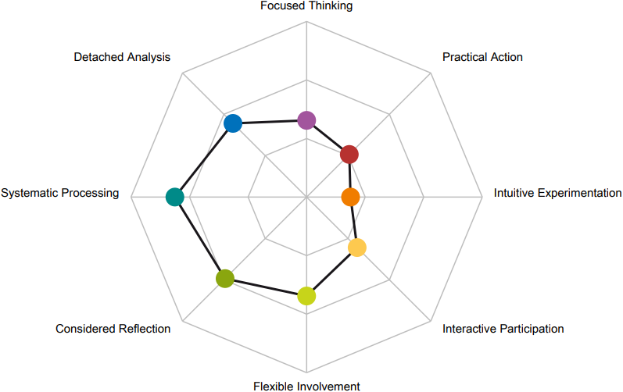
Figure 1: My preferred learning styles (Insights, 2023, p.26)
Furthermore, my preference for systematic learning will also be accounted for by using a structured and concise reflective model. In relation to my findings from the Insights Discovery Evaluator, I will refer to it in this report. This will ensure that I account for any potential blind spots in my conscious behaviours.
Not long after being successfully selected to be a DSE in 2018, my mental health deteriorated to the point where I feared going to work when assigned to 1st line support. To summarise, as a DSE, two of the duties I was responsible for included 1st line and 2nd line computer support to Council staff. When on the 1st line, I was responsible for providing support over the phones. Whilst on 2nd line, I would provide support to those that have had their calls escalated, this could also be over the phone, but additionally through email, remotely or face to face. The duty I was assigned for the week was based on a rota, but it would mean that I was on either 1st or 2nd line for the whole working week.
Being on the phones would cause me a lot of stress, primarily being that on the 1st line all calls were unexpected. This meant that it wasn’t possible to anticipate what the issue was going to be, which made it very difficult for me as someone who lacked the experience. Furthermore, I would find it stressful if I was unable to sort the client’s issue from the 1st line, since they would potentially be unable to continue working due to the reliance on a computer to effectively work.
Moreover, being someone who “…tends to avoid socialising at a superficial level” (Insights, 2023, p.6), something I have done throughout my life, and reinforced from my Insights Discovery Evaluator, meant that my stress levels were extremely high. This was evident when I was informed that I would be providing 1st line support for the entirety of that week. “Anxiety is a natural human response to stress or perceived danger” (Mental Health Foundation, 2023). As a result of this stress, my anxiety levels developed severely, and eventually led to me taking long term sick.
During my time off work due to ill health, I was given a variety of different support avenues to help me return to work. Most importantly, I went through Cognitive Behavioural Therapy (CBT) which was a major contributor to alleviating some of the anxieties that I had developed, as well as helping the way I mentally tackle potentially stressful situations.
Additionally, support from my employer was also beneficial. My line manager was very supportive and was another key contributor to helping me return to work and regain some confidence, whereby I was in constant communication with them during my time off (to ensure that I was feeling okay). Moreover, around 6 months later, before my return, I attended Occupational Health, one of the services available to Council staff. From the conversations that I had during this session meant that my return to work was made easier as it meant that I could have a phased return, but additionally it meant that I was excluded from the 1st line rota until my confidence returned.
Looking back at this experience, if I had incorporated a model of reflection which addressed these mental health problems, for example, Gibb’s Reflective Cycle (Gibbs, 1988) then this may have prevented the damaging effect my mental state had on my professional and personal wellbeing. Despite being one of the older models of reflection, Gibb’s Reflective Cycle includes feelings as one of its stages, which I believe can account for one’s mental health when carrying out reflections. Husebø, O'Regan and Nestel (2015) agreed, whereby they compared it to Kolb's (1984) Experiential Learning Theory stating that although both cycles reflect on an experience, “Gibbs adds an emotional dimension in his reflective cycle” (Husebø, O'Regan and Nestel, 2015).
With the increase in cases of those suffering from mental health issues, noticeably during the COVID-19 pandemic, I believe that including feelings in this model indicates that it can still be used to capture one’s wellbeing during an experience. Therefore, when reflecting it is more important than ever to understand your own professional wellbeing. For the most part, Gibb’s Reflective Cycle does this well and is a good starting framework to capture wellbeing. This is evident in a thesis by Pearce (2019, pp. 101-102) in which they had developed the Gibb’s Reflective Cycle and tailored it to their own wellbeing.
Gibb’s Reflective Cycle
Figure 2: Gibb's Reflective Cycle (Gibbs, 1988)
Unfortunately, with its age, I believe that there are some flaws to fully capturing wellbeing from just the use of the ‘Feelings’ stage in this reflective model. Fallin (2021) agreed, though he believed that this flaw extended to the Description stage, whereby the distinction of these stages and them being at the forefront of the cycle means that it is difficult to make connections with the other stages. From my own personal experience of workplace anxiety, it is not as simple as capturing how you felt at that time. Before going off on long term sick, I ‘bottled’ my emotions for many months prior to going sick. None of my colleagues in the office suspected that I had these anxieties because I ‘put on a brave face’ and continued to do my best despite the mental strain that it was putting on me. Therefore, I believe it is also important to capture the emotions that the reflector had before, during and after these experiences.
In general, I would consider a limitation of all reflective models, is that it is important to be in the correct frame of mind to carry out the reflection. Moreover, Ingham (2021) believed that reflecting whilst being in the right frame of mind can help us understand ourselves better. Furthermore, he believed that by doing this we are less likely to be conflicted with the same obtrusive feelings and better adapt to similar experiences.
Thus, the success of a reflection is determined by the openness of the reflector to express their feelings through the practice. Moreover, self-motivation is essential to completing the reflection. Thompson (2010) believed that the outcome of reflection is determined by the willingness of the reflector to commit to the end goal of understanding the experience. Moreover, she stated that motivation is critical and something that is often overlooked. In addition, she believed that support might be necessary to achieve the required motivation. “Motivation for learning is a complex overarching concept” (Harlen and Crick, 2002), but as someone that is motivated by “safe opportunities to develop untried or previously suppressed skills” (Insights, 2023, p.19), reflective practice motivates me because I believe that it can contribute to my professional development, by improving my mental health, which will reduce the negative impact my mind has on my working performance.

The importance of capturing emotions
To define emotions, it is important to understand that unlike feelings, emotions are involuntary responses to experiences. Extensive research carried out by Trampe, Quoidbach and Taquet (2015, p.7) presented 9 positive and 9 negative emotions that participants felt on each day of the week. Alarmingly, in terms of negative emotions, anxiety was the most common emotion participants had for everyday of the week. Feelings on the other hand are our own reaction to these initial emotions. In context of my workplace anxiety, the initial emotion of anxiety came from my fear of the unexpected. The feelings resulting from this emotion, and my response was to take long term sick to avoid having these emotions. This is considered a ‘destructive’ response because it prevented me from carrying out my work.
To truly understand my emotions, how they affect my mental state, and my reactions to those experiences, I did some research and discovered the Atlas of Emotions (Ekman and Ekman, 2023).
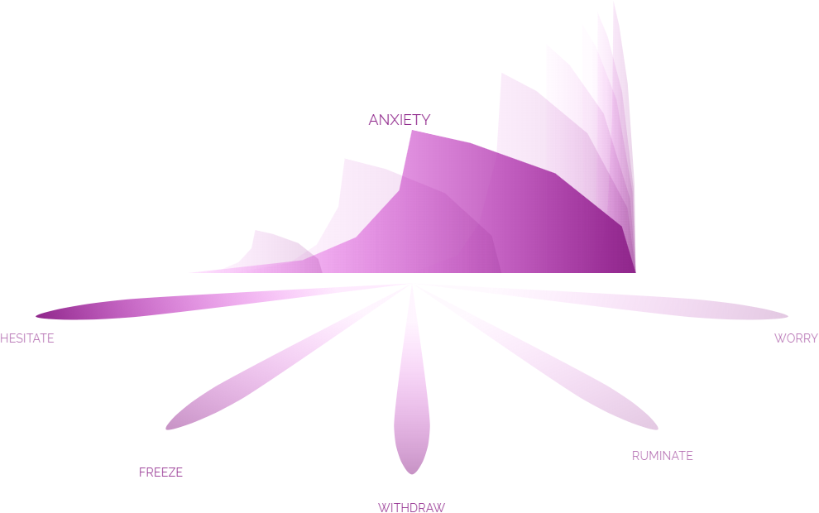
Figure 3: Potential responses to the emotion of Anxiety (Ekman and Ekman, 2023)
By having anxiety, your response to that might be to worry, but the response can depend on the circumstance. From my perspective, I can confirm that to an extent, my response to providing 1st line support when required was all the above. The most recognisable reaction for me in this circumstance would be that I would worry about it.
It’s also important for me to understand that not all responses to anxiety are necessarily a negative. Ekman and Ekman (2023) classify the responses to be ‘constructive’, ‘ambiguous’ or ‘destructive’. For example, the response to withdraw is considered ‘ambiguous’ on the Atlas of Emotions. This means, that depending on the context and outcome, withdrawing could be constructive or destructive response to the experience. In my scenario, my response to ‘withdraw’ from work to alleviate this anxiety was ‘destructive’ because it stopped me from working. Furthermore, it made my social anxiety worse as I would spend most of my time at home and not socialising with colleagues during work etc.
When carrying out reflections, I regard emotions as a fundamental aspect. Although feelings are not inherently related to emotions, the feelings that we have from these experiences come as the result of our thoughts to that emotion. Allyn (2022) backed this by stating that our emotions have a strong influence towards how we feel from an experience but more importantly it is our thoughts that shape them.
Only relying on feelings to capture the mental state of a reflector is flawed because our feelings can be affected by the emotions that we have to an experience. Noticeably, anxiety is an emotion that is likely to cause cognitive distortion. Grinspoon (2022) defined cognitive distortion as mental biases that encourage anxiety and negative thoughts to form, with the intention to make us feel bad about ourselves.
To confirm, the workplace anxiety that I suffered caused me to have cognitive distortion and paranoia when communicating with clients, which massively impacted my confidence. Moreover, because of these feelings, the impact it had on my work would extend to 2nd line support. This is because I would often avoid dealing with calls because of the cognitive distortion that I had developed from these emotions. Therefore, I believe that feelings cannot exist without the emotions that you had during those experiences.

The Revisited Gibb’s Cycle
The increased awareness of mental health, noticeably more so during the COVID-19 pandemic, have encouraged scholars to look at existing reflective models and make them more applicable to the current environment. During the COVID-19 pandemic, more than 18 million working days were lost due to mental illness, including anxiety (CIPD, 2023). This indicates the ‘destructive’ impact that emotions can have on people’s professional wellbeing. Thus, when carrying out reflective practice it is essential to correctly record one’s mental state.
Galli and New (2022) are one example of scholars looking to update these models and have recently updated the Gibb’s Reflective Cycle. The “Revisited Gibb’s Cycle” (Galli and New, 2022) adds an additional stage titled ‘Emotions’. Since emotions are an essential part of one’s mental state it is fundamental to include it in the model. The more I can record about my own mental state, the more effective the reflection will be when it comes to the action plan. This means that when I repeat the process for similarly potentially stressful experiences then I can gain insight into my wellbeing because I will be able to understand my feelings in more detail from the emotions that I have highlighted.
Revisited Gibb’s Cycle
Figure 4: Revisited Gibb's Cycle which includes Emotions (Galli and New, 2022)
It was from all the research gathered to this point that I understood that emotions and feelings are not the same thing. From my previous experience of workplace anxiety, I never thought that feelings could influence my emotions. When I was going through this experience, I always perceived the negatives of the situation, and I can understand now that it was my feelings that was causing me to respond this way. Therefore, by observing these emotions and feelings I can develop my emotional intelligence.

Further enhancing the Gibb’s Reflective Cycle
With the complications of the mind, I think that the model by Galli and New (2022), whilst effective, it is important to capture as much as I can about my state of mind before, during and after an experience. Whilst emotions can be considered the most important, being involuntary and the most intense. I believe that moods can also be integrated into the Gibb’s Reflective Cycle.
“Put simply, emotions can turn into moods, moods can affect emotions, and feelings are how we interpret our emotions” (Spencer, 2022). Since moods can have an influence on one’s feelings, I think that it is important to have an additional stage titled “Moods”. They can have a positive or negative effect on someone’s feelings, this is true from my experience.
When working as a DSE I would have ‘good days’ and ‘bad days’. The feelings that I had those days were sometimes influenced by my mood. If I was dealing with a frustrated client, I would often take it the wrong way, as a result my mood might have been angry. This mood that I had would often influence my feelings as well as how I coped emotionally. For example, this mood would make me dislike the job because I perceived that the client was frustrated with me. However, they were frustrated with the computer because it was stopping them from working.
Adapted Gibb’s Cycle
Figure 5: My adaptation of the Gibb's Reflective Cycle
Thus, I think this enhancement to the Gibb’s Reflective Cycle is a benefit to me truly understanding myself when encountering these socially difficult situations. More importantly, with my social anxiety, I think reflecting using this model could help me feel more confident when communicating with clients and colleagues, since I will be able to understand why these general feelings can also affect my emotions.

Conclusion
As someone who has gone through mental health issues and the detrimental effect it has had on my professional wellbeing by having to go off on long term sick, I believe it is essential to incorporate my own mental state into reflective practice and thus become more reflective. The use of Gibb’s Reflective Cycle can help me with this since coming from a computing background, I prefer a form of reflection that is systematic and Gibb’s Reflective Cycle does this well. More importantly Gibb’s Reflective Cycle has a stage which incorporates feelings, which is the main reason for me choosing it.
Despite being nearly 40 years old, Gibb’s Reflective Cycle still holds up considerably well, especially in healthcare and education. Moreover, documentation created by Thornalley (2023) and recently published by the NHS, encourage the use of the Gibb’s Reflective Cycle. The reason for its popularity and success is because it accounts for feelings as one of the stages of reflection, which relates well to mental health. Unfortunately, in terms of its coverage of mental health, and the complexities of the mind, the original model does not go far enough to establish someone’s state of mind from an experience. Therefore, from my perspective, not only is it important to include emotions in the cycle, but it is also important to reflect on your mood as these can also influence both feelings and emotions. Hence both have been included as stages in my reflective model.
Whilst anxiety is something that does not go away due to it being an involuntary response to potentially stressful situations, as an emotion I personally don’t believe it can be completely prevented. However, I do think that the use of reflective practice can reduce the feelings that respond to the emotions of an experience by helping me to understand why these experiences cause me to behave in that manner. Therefore, when doing potentially stressful tasks in my new role, I will reflect using my adapted Gibb’s Cycle to capture as much detail as possible about my mental state. This will conceivably improve my mental health inside and out of work, as well as my professional development.

References
Allyn, R. (2022) 'The Important Difference Between Emotions and Feelings', Psychology Today, February 23,. Available at: https://www.psychologytoday.com/gb/blog/the-pleasure-is-all-yours/202202/the-important-difference-between-emotions-and-feelings (Accessed: December 22, 2023).
CIPD (2023) Employee health and wellbeing. Available at: https://www.cipd.org/uk/views-and-insights/cipd-viewpoint/employee-health-wellbeing/ (Accessed: 21 November 2023).
Driscoll, J. (2007) Practising Clinical Supervision , in Driscoll, J. (ed.) Supported reflective
learning: the essence of
clinical supervision?. 2nd edn. London: Baillière Tindall Elsevier, pp. 27-47.
Ekman, P. and Ekman, E. (2023) The Ekmans' Atlas of Emotion. Available at: http://atlasofemotions.org/ (Accessed: December 12, 2023).
Fallin, L. (2021) 'Why I don't like Gibbs' Reflective Cycle in reflective practice', Dr Lee Fallin, October 13,. Available at: https://leefallin.co.uk/2021/10/why-i-dont-like-gibbs-reflective-cycle-in-reflective-practice/ (Accessed: Dec 22, 2023).
Galli, F. and New, C.J. (2022) 'Gibbs’ cycle review. Emotions as a part of the cycle', E-motion (Huelva, Spain), 19, pp. 92-101 Available at: https://doi.org/10.33776/remo.vi19.7224.
Gibbs, G. (1988) Learning by Doing: A guide to teaching and learning methods Oxford: Further Education Unit.
Grinspoon, P. (2022) How to recognize and tame your cognitive distortions. Available at: https://www.health.harvard.edu/blog/how-to-recognize-and-tame-your-cognitive-distortions-202205042738 (Accessed: Dec 12, 2023).
Harlen, W. and Crick, R.D. (2002) 'A systematic review of the impact of summative assessment and tests on students’ motivation for learning', Research Evidence in Education Library, 1(1), pp. 11-12.
Husebø, S.E., O'Regan, S. and Nestel, D. (2015) 'Reflective Practice and Its Role in Simulation', Clinical simulation in nursing, 11(8), pp. 368-375 Available at: https://doi.org/10.1016/j.ecns.2015.04.005.
Ingham, T. (2021) 'Frame of Mind', Toby Ingham, February 07,. Available at: https://tobyingham.com/frame-of-mind/ (Accessed: Dec 22, 2023).
Insights (2023) Insights Discovery. Scotland: Insights. Available at:(Accessed: September 25, 2023).
Kolb, D.A. (1984) Experiential Learning: Experience as the Source of Learning and Development . 1st edn. Englewood Cliffs, NJ: Prentice-Hall.
Mental Health Foundation (2023) What is anxiety? Available at: https://www.mentalhealth.org.uk/our-work/public-engagement/mental-health-awareness-week/anxiety-report/what-anxiety (Accessed: November 29, 2023).
Pearce, S.J. (2019) ‘Building Space: Developing Reflection for Wellbeing’Can a chaplain help healthcare professionals develop reflective practice for wellbeing for themselves and their team? . University of Chester.
Spencer, M. (2022) How to Tell the Difference Between Moods, Feelings, and Emotions. Available at: https://dakotafamilyservices.org/resources/blog/archive/moods-feelings-emotions/ (Accessed: Dec 12, 2023).
Thompson, M. (2010) 'Where reflection and motivation meet', Professional development in education, 36(3), pp. 393-397 Available at: https://doi.org/10.1080/19415257.2010.487323.
Thornalley, C. (2023) An Introduction to Reflective Writing Resources for Further Study. Available at: https://www.bsuh.nhs.uk/library/wp-content/uploads/sites/8/2023/01/reflective_writing_resource_list_2022-3.pdf (Accessed: December 22, 2023).
Trampe, D., Quoidbach, J. and Taquet, M. (2015) 'Emotions in Everyday Life', PloS one, 10(12), pp. 1-15 Available at: https://doi.org/10.1371/journal.pone.0145450.

Appendices
Starts on the next page.

Current annotated curriculum vitae (C.V.)
Jamie William Davies
Graduate Software Developer
 Phone 01267 235460  Mobile 07398543979  Email JWiDavies@carmarthenshire.gov.uk
Dedicated individual working in the IT industry for a local Council for over 5 years. I am an extremely diligent individual with a strong work ethic and a passion to continuously learn. I seek out opportunities to potentially grow as an individual but also seek ways in which I can use these opportunities to benefit the organisation and the local community.
In my summary, I wanted to highlight what I believe are my key qualities, noticeably highlighting that I have been working in the council for a large period. I also wanted to summarise that I use these qualities to help the company. This is so that the employer can see from the brief that I am not just highlighting the kind of person I am, but that I also consider ethics and how these qualities will help the business. The number of training sessions that I have volunteered to go on have contributed to my passion to continuously learn and one of the factors that have allowed me to grow.
To highlight, my keenness to learn about technologies, I noticed the emergence of Power Apps, a Power Platform developed by Microsoft to develop internal applications. Before the Graduate Software Developer job was posted, I was keen to develop applications. From the development days that the Council provides, I used the time to learn about Power Apps and then develop a potential solution using Power Apps to reduce the time that managers in Service Delivery use when creating the staff rota. The purpose of the app would be to allow the managers to select users and their role for that week, and when the manager submits, it would enter the relevant information into the respected calendars. This would save the managers from manually entering the data.
Another way I have been able to develop myself, is with Power BI. When asked to supply statistics about one of the projects I engaged in as a Digital Support Engineer, I thought of better ways to present the information. By learning about Power BI, I was able to analyse and create real time reports from the Excel tables. This way, managers could use the reports to see the findings in an interactive and visual environment. This was for the benefit of the organisation as it is still being used by the department to view the latest statistics for the project.

Work Experience
July 2023 – present | Graduate Software Developer – Carmarthenshire County Council  With my strong interest in programming throughout my role as a Digital Support Engineer and my career goal to achieve a Masters, it was clear that once the opportunity arose, that getting the job was the next step in my career. This is allowing me to further develop as a professional and my role in IT, where I develop systems.  -Development of internal systems using Power Apps which accessed and used by Council staff. (The Expression of Interest form that I built was the first Power App published on the intranet)  My line manager approved the use of Power Apps to develop the solution, after being impressed with a different application that I developed during my time in Service Delivery for managers to manage staff rotas. The first application that I developed early into my role was the Expression of Interest Request form, as highlighted in my C.V. The purpose of the Power App was that whenever a member of staff requests a project that needs to be done, they will need to submit a request. This helps track all the work that that is requested by Council staff and manages the workload of staff members by effectively displaying the workload in a SharePoint list.  To develop the above system and other applications, I use the computer skills that I have obtained throughout education and my career. These include university, previous experience working as a Digital Support Engineer, and my hobby of learning new programming languages in my free time. My time spent learning different languages contributed to my knowledge of Power Apps because it uses a similar programming language to those that I was learning in my own time.  Like all programming languages, Power Apps requires a similar set of skills to use it effectively. Therefore, to produce apps like the one mentioned above, I was required to use a variety of skills in addition to computer skills. These include problem-solving skills in which I needed to solve the problem described using the programming language in the most efficient way possible. For example, early on when developing the Expression of Interest Request form, I encountered an issue whereby permissions would cause issues with the form submission. By being creative and writing a piece of code that would communicate with Power Automate meant that the form could be submitted using a method that solved the problem.  When developing an application, I am required to communicate to the required stakeholders. In the app mentioned, I was required to communicate with the manager of the Digital Transformation Team. It was essential to communicate with the client to ensure that the app met the requirements that they were looking for and that ideas to further enhance the app could arise from the collaboration.  -Integrate Power Automate into Power Apps and existing systems including Teams, Outlook, and SharePoint to automate processes.  Identifying the use of Power Automate for solutions came from my developed critical thinking and my readiness to work in the most efficient ways possible. Power Automate can be used to automate repetitive and time-consuming tasks. This time can then be freed up to be used more affectively elsewhere. The Expression of Interest Request form Power App integrated with Power Automate so that whenever a new request came through, Power Automate would automatically place the entered data into a SharePoint list for review. Previously, the manager of the Digital Transformation Team would take the data from the original method that was developed in Firmstep and manually enter the data into the list. This was a time-consuming and inefficient process compared to the automated solution that I have since developed.  The integration of these systems also relates to the problem-solving skills that I have developed, since I used my initiative to use these platforms to provide a solution to the above example. Additionally, the effectiveness of these solutions, means that I will potentially use these methods to tackle problems should any similar tasks arise. This links to efficiency because it means that the code can be reused for future requirements. Moreover, I can provide higher quality services by potentially delivering solutions to clients even faster using this code.  With these integrations, I have the responsibility for ensuring that they run effectively. For example, I will be notified via email should any of the integrations fail. I will then read the errors and analyse why these issues are occurring, and then try to resolve the issue. Depending on the issue, it is important to remain calm, especially if it is a critical failure. This is so that I can remain focused and find a solution as quickly as possible, to get the app running correctly again.  -Drive and encourage the use of emerging technologies from my experiences as a Digital Support Engineer (including Power Apps, Power Automate and Power BI).  With my experiences using the above technologies and having spoken to my manager and the team manager, they are very enthusiastic about the prospect of me pushing these technologies into Carmarthenshire County Council digital environment. My enthusiasm extends from not just my work commitments, but my passion to making a change.  It is important to utilise the critical thinking skills that I strongly developed as a Digital Support Engineer. This includes being realistic, for example, if a client asks if it is possible to do something with these technologies. It is important to be honest, this includes looking at the viable options, and if it is not feasible, being truthful whilst offering potential alternatives.  -Create requested forms from council staff, which I develop using Granicus, consulting with the client accordingly.  One of the first tasks I engaged in as a Graduate Software Developer was the development of a form for Education & Children section. The stakeholders required a form for Youth Support. This form was external, meaning that members of the public needed to be able to access and submit from the form. Therefore, it was important to conduct vigorous testing to ensure that the form worked as expected before publishing.  Being one of my initial tasks as a Graduate Software Developer, it was important to ask my colleagues for support whenever the need arises. By effectively communicating any queries that arose to my colleagues, I was able to develop not just my knowledge of Granicus as a system, but also my communication skills, by communicating and working with those with which I was not familiar.  Like each project that I have been tasked with in the role so far, my project management and time management skills have needed to be utilised to achieve success. This project was done the same time as when I was developing the Power App, this meant that it was important to manage the workload and prioritise the work that was most critical. I gauged this based on several factors, including its importance, how far I was through the project and the project deadline (the projects mentioned above had no fixed deadline).  -Provide support to staff that use any of these development systems.  To achieve this, I use the skills that I acquired as a Digital Support Engineer. This includes communication skills. Similarly, to my previous role, I will need to communicate with all council staff members with different social and ethical backgrounds. Moreover, negotiations skills are also required, in which I have been required to question the client when necessary. For example, when creating a form, if the client requires any information which could be potentially confidential, then I will need to question them, asking them if the data is really required.  My critical thinking and problem-solving skills also arise whenever I must provide support to clients. For example, I was asked to provide support to a client who was having issues with a Power Automate flow. I had no awareness of the flow that they had created, nor what the problem was. Therefore, when meeting up with the client, I needed to use my initiative and quickly identify the problems and work on potential solutions to solve the issue. Moreover, also being aware that if a solution was not possible, being honest and offering alternatives. That way, I did not waste the client’s time by trying to deliver a solution that was not possible.
June 2018 – July 2023 | Digital Support Engineer – Carmarthenshire County Council  After university, I strove to work in an IT environment, preferably one where I provide IT support from all the knowledge I obtained from education and from the satisfaction in my free time fixing issues relating to my personal device. Both factors, contributed to me obtaining the job.  -Configuring and delivering of over 450 mobile phones to cleaning staff in a project I was independently involved for the IT Department for over one year. Mobile devices, as of September 2023, account for 33% of the Council’s devices used by staff.  With the mobile phone knowledge that I obtained from the earlier work conducted as a Digital Support Engineer, including the Android documentation that I produced on the intranet. In November 2021, I was asked by my manager to be involved in the above project due to a request made by the Environment Department for IT support. This final project covered much of my time in the role until moving onto my job as a Graduate Software Developer.  I had to independently work on many factors of the project. This included configuring the mobile phones, delivering the phones, and providing documentation so that the operational trainers could complete training with the staff. Additionally, being available as first line support should the operational trainers run into any issues during the training sessions. Thus, I managed a range of phases of the project to ensure that the project was able to successfully progress.  Noticeably, with the procedure of configuring the devices, I had strict deadlines to ensure that phones were configured and delivered before training sessions. In addition, devices could not be configured until I was informed of the users attending these sessions, as it was not possible to configure these devices without being assigned to a member of staff. As a result, I was often informed of users attending training sessions on short notice. This resulted in me needing to complete many phases of the project shortly before these training sessions.  From undertaking this project, I realised the importance of communication and being realistic. The deadlines, the Environment Department were giving me to configure devices were noticeably short notice. In some cases, this made it difficult to meet the deadlines of configuring and delivering the devices before the training sessions. In certain scenarios it was impossible to meet these deadlines, due to factors out of my control, e.g. mobile phones needed to be configured, but the new user accounts had not been created by Technical Delivery. This resulted in Environment needing to postpone these sessions. By being honest and communicating with the required staff who were organising these sessions, I informed them of the procedures and the timeframes that IT and I would need to complete my roles in the project. As a result, the Environment department provided me with more feasible timeframes.  My critical thinking skills were used throughout the entirety of the project, whereby I would always think of ways to come with more effective solutions to many of the problems met. This included finding more effective ways to configure the phones, including the installation of all firmware updates. This reduced potential issues that could occur during the training sessions. Moreover, when asked to supply statistics for the number of devices configured and delivered. I decided to provide an innovative solution to develop a Power BI report which is still used by the Environment department to see cleaners and highways staff with mobile phones, rather than looking at a table in Excel.  -Creation of knowledge base articles which included documentation and video guides that I put on the Self-Service portal and intranet to reduce the number of calls that came through the helpdesk.  My writing skills, that I developed throughout education and university, have been essential in my role as a Digital Support Engineer. As a result, my manager along with the team leader had requested that I create some knowledge base articles. These have been used by not just staff having IT issues, but also to provide training to staff in IT. This is so that they are aware of fixes to certain problems that they might not be aware of.  Additionally, my skills to organise means that content was never out of date. I would manage the articles and order them by a particular review date. This way, I could ensure that content was always up to date but also removed by myself if it were no longer needed.  -Upgrade over 500 school devices across Carmarthenshire to Windows 10 with a strict deadline, ensuring I updated every device before Windows 8 reached end of life (January 2020).  One of the projects that I took part in, which I worked with a colleague to complete was upgrading the school’s devices from Windows 7 to Windows 10, as Windows 7 was to reach end of life on January 14th, 2020, leading to potential security risks. It involved going into schools across Carmarthenshire, communicating with teachers and head teachers to make them aware of the change, and then ensuring that all their devices were upgraded. My diligence and commitment to improvements was clear during this project. For example, I have listened to feedback provided by Headteachers, and passed it on to other Digital Support Officers so that we can continually improve our services.  My problem-solving and critical thinking skills were also incorporated during the project. For example, I noticed an issue with AirServer after upgrading to Windows 10. This piece of software would not install on a device, after the upgrade, if the correct Windows Media Pack was not downloaded first. This media pack needed to be downloaded after every incremental update of Windows 10 until version 1903. Therefore, through my skill to innovate, I created a PowerShell script which would check if the media pack needed to be installed depending on which version of Windows 10 was running and then install the correct media pack, remotely. This would allow AirServer to successfully install and be usable once again. The Digital Support Officers used this script whenever AirServer needed to be installed through CentraStage.  -Migration of Apple devices and Microsoft Exchange email accounts to Office 365 environment, which involved scheduling appointments with staff so that I could rebuild the devices on the emerging environment.  This project was conducted in 2018-2019 and was the first major project that I engaged in during my time as a Digital Support Engineer. I and two other colleagues were responsible for migrating Apple work devices to the Office 365 environment. It was important to complete the project as soon as possible to ensure that the entirety of the organisation mobile devices were on the same environment for consistency and ease of providing support.  I had to communicate staff with diverse backgrounds and experiences using IT. Therefore, I needed to be patient and understanding. By being patient and listening, I could get a better grasp of someone’s issues and then provide them with situations to which they could relate. This meant that they could be more open and more positive about the changes that were going to be applied to their work's device.  -Supporting members of staff and troubleshooting IT related issues daily ranging, staff range from first line workers, Heads of Service and Head Teachers in schools.  Due to my role, I had to communicate with staff of all backgrounds, and additionally I often had to negotiate as well as engage and consult with these clients. For example, from 2019-2020, when going out to do work at the Schools, I engaged with Head Teachers and supplied them support by making them aware of the Hwb funding and consulted them of IT equipment and suggestions for the use of these technologies. I also have the patience and understanding when staff become overwhelmed by the implications of IT. I would effectively consult with these staff in a manner that did not demean them.  My communication and written skills, that I developed throughout education and university, have been essential in my role as a Digital Support Engineer. On a day-to-day basis, I had to communicate via a range of different methods including, through phone, email, Teams, and the helpdesk system. From the 1st line I had to answer the phone and provide support to members of staff which called the helpdesk. On the 2nd line, I had to provide support to those which had logged a call via the self-service portal or been escalated from the 1st line. The methods of communicating on 2nd line varied and included all the methods mentioned above. Moreover, I was also involved in drop-ins whereby a member of staff would arrive with the device they were having issues with, and I would need to provide support to them face to face.

Education
BSc (Hons), first, Business Information Technology, September 2013 – June 2016
University of Wales Trinity Saint David, Carmarthen
Dissertation which investigated two implications, the development of m-commerce within the retail industry with an empathises on the advantages seen by SMEs that adopt it. Secondly, how it has affected customer experiences when purchasing from a mobile device.
My degree with the course name titled Business Information Technology appealed to me because it had aspects of business and computing. Both of which I have had a strong interest in since high school. Noticeably, at Advanced Level when I received an OCR Level 3 National Certificate in ICT Distinction and an A grade in Applied Business. The course was the next step in my career in an IT discipline.
During my time in university, I completed a range of modules including but not limited to Database Management Systems, Information System Security, Web Design, Computer Systems and Data Communications, and Finance. Many of these modules have contributed to where I currently am in my career. For example, the Systems Analysis and Design module has been one of the big factors in how I am able to work as a Graduate Software Developer effectively.
In relation to the Dissertation that I completed in my final year of University, I had to complete a 9,000-word report. In this report, I needed to complete my own research, including interviews and surveys with small businesses, as well as analysing the results to draw a conclusion. Furthermore, I needed to create a poster and complete a presentation of the key findings of the research. Lastly, I completed a Reflective Journal. This enabled me to reflect on the research, including how I had developed as an individual and the shortcomings of the research.

Skills
-Computer Skills, vast range of knowledge and computer skills which I have continuously developed throughout education and as part of my roles working in the IT department.
I have gained experience not just throughout education and my work experience as mentioned in the C.V., but also as a hobby and my passion for learning new computer skills. I am currently developing a website using HTML and CSS along with the Bootstrap framework, outside working hours.
Critical Thinking, by being assigned tasks, I have often been required to work independently and use my own initiative to determine the optimal solution to these requests.
Tasks include the projects that I have been involved with as a Digital Support Engineer, as mentioned above in the C.V. Additionally, it relates to current tasks I am undertaking as a Graduate Software Developer. Noticeably, I was tasked with creating an application that would create, submit, and automate whenever a member of staff submits an expression of interest. By using my own initiative and my own personal experience with emerging technologies, I decided to develop an application using Power Apps. I then automated these processes using Power Automate. The application has now gone live, and there have since been considerations to continue using Power Apps/Automate for future developments.
-Time Management, experience of working in an environment with multiple deadlines e.g., upgrading over 500 devices within a very short period and managing daily workload including dealing with calls currently assigned to myself.
Management of my work time is essential in the IT department because it is a busy, ever-changing environment. Depending on demand, multiple tasks can arise during the same working day. As a result, I have had to prioritize and manage the workload effectively. Noticeably, in my current role, I have had multiple projects at the same time, each with different urgencies and timeframes for delivering. Creating a Power BI report as one project and developing a Power App are two currently ongoing projects.
-Collaboration, working with those within the IT department and across other departments e.g., during the mobile phone rollout project, I was required to work with the Environmental department.
If I were able to fit more content onto the two pages of my C.V., I would have also included experiences of times outside of work that I used to develop my skills. From January 2018 to May 2018, I wrote reviews for video games on a website called Bonus Stage. I was able to incorporate the writing skills that I had obtained from university and develop them professionally even further by writing in a way that would be readable to the audience that was reading the reviews. In addition, this also encompassed the fact that short deadlines had to be met to ensure that reviews were published within the required timeframe to the game's launch. This balance came from playing the game to the point a full review could be justified and written. This gave me the experience of working as a journalist, traits that I could apply in my career when I started full-time work as a Digital Support Engineer. For example, writing and publishing knowledge articles onto the Council intranet.

Professional Development & Training
October 2023 | Microsoft Webinar: The Future of Low Code and AI  Microsoft
I found an online seminar which I was authorised to watch during work time. This online seminar covered the rise of AI. It highlighted how the use of the Microsoft productivity tool, named Copilot, is helping organisations create low code, cost-effective solutions to encourage productivity and growth. The online seminar featured an interview between Global Biz Apps Lead for HSBC, Carol Soloman and EJ, a representative from HSBC UK. In this interview, HSBC UK highlighted how they are incorporating AI to enhance the value of the business.
February 2023 | Get started with Power Apps  Microsoft
The course provided a general overview of the Power Apps platform, which had further reinforced my knowledge on the emerging technology. The free course was being advertised on the Council’s intranet as one of the many courses being offered to council staff from Microsoft during that month.
July 2022 | Power BI Training  JBI International
From my own initiative to introduce Power BI reporting to the lead officer in the rollout of mobile phones to cleaning and highways staff. I developed a report which highlighted the progress of the project, in which the lead officer could report the latest statistics to their line manager and the Head of Service.
This development resulted in the Environment department funding me to go on three days of training with JBI International. Its purpose was to develop my knowledge on using Power BI and featured a range of topics which enhanced my confidence with the application. After demonstrating my report to Service Delivery, I encouraged them to use the software. As a result, the team has created reports, including Mitel phone reports and self-service reports. Additionally, I am occasionally asked for support from Service Delivery when these reports are developed.
July 2022 | Effective Project Management  The Project Hub
The Effective Project Management course was offered during a 1:1 with my line manager. I accepted the offer because I thought it would be an opportunity to further develop as an individual professionally, by reinforcing my knowledge of managing a project. This is something that I had previously acquired from a module in university called Project Management. At the end of the 4-day course, I had obtained a certificate from The Project Hub (21/07/2023) to indicate that I had completed the course.

Current annotated job description



Proffil Swydd/Job Profile

Teitl y Swydd
–

Datblygwr Meddalwedd
Graddedig

Post Title
–

Graduate Software Developer

Adran | Y Prif Weithredwr
Department | Chief Executives
Is-adran/Adain | TGCh a Pholisi Corfforaethol /  Cymwysiadau
Division/Section | ICT and Corporate Policy / Applications
Gradd/Grade | Graddedig/Graduate
Rhif y Swydd/Post Number | 032949
Paratowyd Gan/Prepared By | Ben Grice
Dyddiad/Date | Ionawr/January 2023

Prif Ddiben y Swydd
Darparu prosiectau datblygu meddalwedd yn y tîm yn unol â chais a chyfarwyddyd y Rheolwr Atebion Digidol.

Y Prif Ddyletswyddau
- Cynorthwyo i ysgrifennu côd diogel a chlir sy'n agored ac yn hawdd i eraill ei ailddefnyddio.
- Darparu cymorth cynnal a chadw a chymorth gwasanaeth i Systemau TGCh yr awdurdod, gan ymchwilio i broblemau seilwaith a'u datrys.
- Cyfathrebu a gweithio'n effeithiol gyda'r holl randdeiliaid gan gynnwys aelodau tîm, staff, a chyflenwyr i ddarparu cyngor cywir ar faterion cymorth a datblygu.
- Egluro pwrpas straeon defnyddwyr a chanolbwyntio ar anghenion defnyddwyr.
- Deall sut i weithio mewn amgylchedd agored a chydweithredol - er enghraifft, drwy weithio mewn parau.
- Gwybod y wybodaeth ddiweddaraf am dechnolegau newydd er mwyn gwneud argymhellion i wella gwasanaethau.
- Darparu gwasanaeth effeithlon trwy fod yn arloesol, yn greadigol ac yn flaengar.
- Deall diogelwch gwybodaeth er mwyn atal bygythiadau yn erbyn datrysiadau a gwasanaethau.
- Cyfrannu at y broses cynllunio busnes a bod yn ymwybodol o berfformiad gwasanaeth mewn perthynas ag amcanion a thargedau perfformiad allweddol. • Gall unrhyw ddyletswyddau eraill gael eu rhoi ichi yn unol â gwaith y Datblygwr Meddalwedd Graddedig.

Yn gyfrifol am staff/offer
Dim

Yn atebol i
Rheolwr Atebion Digidol

Meini Prawf Hanfodol
Cymwysterau, Hyfforddiant Galwedigaethol ac Aelodaethau Proffesiynol
Gradd mewn TGCh neu bwnc cysylltiedig perthnasol.
Cwblhau Gradd Meistr mewn TGCh neu ddisgyblaeth sy'n ymwneud â Rheoli fel y cytunwyd gyda'r Rheolwr Atebion Digidol.
Sgiliau sy'n Ymwneud â'r Swydd a Galluoedd
UN TÎM - Gweithio er budd y sefydliad cyfan
Hyblyg - Gallwch addasu i newidiadau yn y gwaith neu'r amgylchedd. Rydych yn hyblyg ac yn amryddawn ac yn gallu bod yn eiriolwr dros newid.
UNIONDEB - Arwain trwy esiampl
Meithrin perthynas - Rydych yn sicrhau parch ac ymddiriedaeth gyffredin yn gyflym, gan feithrin perthynas hirdymor ag eraill.
CWSMERIAID YN GYNTAF - Darparu'r hyn sy'n bwysig
Disgybledig - Rydych yn ymdrechu i sicrhau canlyniadau o safon, mae gennych ddealltwriaeth o fusnes ac rydych yn anelu at ragori ym mhopeth yr ydych yn ei wneud.
GWRANDO - Ymgysylltu a chyfathrebu
Dysgwr - Rydych yn chwilfrydig, rydych yn chwilio am wybodaeth newydd a ffyrdd newydd o ddatblygu eich hun.
CYMRYD CYFRIFOLDEB - Yn atebol
Catalydd - Rydych yn meddu ar gymhelliad cryf i gyflawni amcanion. Rydych yn hyderus o ran gweithio heb gyfarwyddyd i gyflawni pethau.
RHAGORIAETH - Arwain trawsnewid
Gwella - Gallwch ddadansoddi gwybodaeth a rhoi safbwynt newydd beth bynnag y sefyllfa neu'r cyd-destun. Rydych yn clywed barn pobl eraill ac yn gallu deall bod llawer o safbwyntiau i'w hystyried.
Gwybodaeth/Profiad
Gwybodaeth dechnegol am ieithoedd rhaglennu a chronfeydd data.
Sgiliau o ran llunio adroddiadau a chyflwyno gwybodaeth.
Meini prawf dymunol
Gwybodaeth Dechnegol am C#, ASP.Net, SQL Server, Power BI, HTML a Power Apps/ Power Automate.

Sgiliau Iaith a Chyfathrebu

Cliciwch ar y ddolen Beth yw lefel eich gallu?
Sgiliau Iaith /Cyfathrebu

Cliciwch ar y ddolen - Beth yw lefel eich gallu?
Cymraeg | Sgiliau Llafar Lefel 2 | Sgiliau Ysgrifennu Lefel 2
Saesneg | Sgiliau Llafar Lefel 4 | Sgiliau Ysgrifennu Lefel 4
Arall ()

GWIRIADAU'R GWASANAETH DATGELU A GWAHARDD (DBS)

Gall fod gwiriadau DBS yn ofynnol ar gyfer rhai swyddi lle bydd angen gweithio gyda
phlant ac oedolion agored i niwed. Mae'r canlynol yn ofynnol ar gyfer y swydd hon
Adran A – y math o ddatgeliad Dim Angen Gwiriad DBS

Adran B – y math o weithlu Ddim yn berthnasol

Y RHESWM

-

UNRHYW WYBODAETH ARALL

-

Main Purpose of Job
To deliver software development projects within the team as assigned and directed by the Digital Solutions Manager.

Software development projects currently ongoing include:

- Power BI reporting for EOI process
- Petty Cash System for Flying Start Team
- Digital Transformation for Youth Support Service
- Corporate Data Suite Dashboard

All of which have been assigned by my line manager. Reflecting upon this, I would say that the brief description is an accurate summary of the job’s main purpose.

Key responsibilities
- To assist in the writing of clean, secure code that is open and easy for others to reuse.
Existing projects, and completed projects, require me to write code. Noticeably, that code is currently written in Power Apps, and Power Automate. This is most likely to extend to other programming languages whenever required. Although at present, due to the early nature of Power Apps (testing phase) the code that I have written has not been in collaboration with other staff. This means that training would potentially need to be given for others to read the code. However, due to the current setup, if needed, the code is easily reusable in other Power Apps.
- To provide maintenance and service support for the authority’s ICT Systems, including investigation and resolution of infrastructure problems.
I have been required to provide support for two of the Authority ICT systems. For example, I am currently tasked with gaining an overview of the Petty Cash System and providing service support accordingly. I have been in communication with the team responsible for the system and have since provided support when required. This system had been previously developed by staff that no longer work in the authority, therefore I was required to quickly understand the current system and then resolve any arising problems with the system infrastructure. Furthermore, I am responsible for maintaining any systems that I work on. These currently include the Expression of Interest Request form, whereby I apply updates to the application as required.
- To communicate and work effectively with all stakeholders including team members, staff, and suppliers to provide accurate advice on support and development issues.
This point is an essential part of the role in the brief time I have been working as a Graduate Software Developer. I have been required to communicate and work effectively with others. For example, when developing the Expression of Interest Request form, I needed to communicate and work with a variety of stakeholders. The client is the one which requested the application, and I needed to communicate with them to find out the requirements of the system. These included any issues that I encountered e.g., permissions to the form, and advice/suggestions to enhance the app. Furthermore, I have also been required to communicate with team members during the project, including my manager and colleagues. For example, due to Power Apps being in the testing phase, my colleagues and I needed to do some research to see if it would allow me to carry out certain functions.
- To explain the purpose of user stories and focus on user needs.
I have not needed to explain the purpose of user stories during my time in the role. However, it does not necessarily mean that I will not need to explain them in future projects. In my current projects, the purpose of these applications had already been explained to me by the client making the requests. Although, on a day-to-day basis, I have needed to focus on the user’s needs to ensure that the applications and forms that I develop are fit for purpose and match the client’s requirements of the system.
- To understand how to work in an open and collaborative environment – for example, by pair-working.
The environment that I work in can best be described as an open and collaborative environment. When required, my colleagues are very open to collaboration. Moreover, I have already carried out the example provided, pair working. A colleague and I were responsible for developing one form each that would be used by Youth Support. During this time, we would work together and collaborate to ensure that the forms were consistent with each other.
- To keep up to date with new technologies in order to make recommendations for improved service.
Although this is something that I strive to do, it is worth highlighting that my manager and the team leader are very passionate when it comes to new technologies. They have encouraged me to continue my developments using new technologies such as Power Apps. Furthermore, they have encouraged me to make recommendations to improve services. For example, the Power App that I developed was built with the purpose of replacing an old form that was used. The recommendation to utilise the Power platform for internal applications is being considered.
- To provide an efficient service by being innovative, creative and forward thinking.
The above three skills are essential to being a software developer and can most likely be seen on any software developer job description. I have been required to have these skills to complete many of the tasks assigned to me. When developing the Power App, I needed to use the three skills to find a solution to a function that was not contained in Power Apps. By using these qualities, I came up with the idea to integrate another Power platform called Power Automate which, when used in conjunction with Power Apps, provided the solution.
- To understand information security in order to prevent threats within solutions and services.
Security is currently contributing a significant role in the organisation. As such, I have attended meetings which cover any potential security issues that could arise when developing applications in Power Apps. Additionally, addressing any concerns that Technical Delivery had with the platform.
- To contribute to the business planning process and have awareness of service performance against the objectives and key performance targets.
During my induction, I was informed of the objectives and key performance targets. These have been since reviewed during my 1:1 sessions with my manager. From these sessions and the tasks that I am assigned, I can see how I contribute to the business planning process on a day-to-day basis.
- Any other duties may be assigned in line with the post of Graduate Software Developer.
Other duties currently assigned to me include training, such as:
- Get started with ASP.NET Core MVC
- Cwrs Mynediad, Learn Welsh
Responsible for staff/equipment
None

Although I am not responsible for any staff/equipment, I am responsible for providing support to any systems that I have development. For example, if a problem arises with the Expression of Interest Request form, then I am responsible for finding a solution.
Reporting to
Digital Solutions Manager

Currently reporting to the Digital Solutions Manager, which is my line manager.

Essential Criteria
Qualifications, Vocational training and Professional Memberships
A Degree in ICT or relevant related subject.
To complete a Masters degree in an ICT or Management discipline as agreed with the Digital Solutions Manager.
Job Related Skills and Competencies
ONE TEAM - Works for the benefit of the whole organisation
Adaptable – You can adapt to variations in work or environment. You are flexible and versatile and act as an advocate for change.
INTEGRITY - Leads by example
Relationship Builder – You quickly establish mutual respect and trust, building long lasting relationships with others.
CUSTOMERS FIRST - Delivers what matters
Focussed – You strive for quality outcomes, have a business insight and aspire to achieve excellence in everything you do.
LISTENING - Engages & communicates
Learner – You are inquisitive, you seek out new information and look for new ways to develop yourself.
TAKE RESPONSIBILITY - Is accountable
Catalyst – You are self-motivated to achieve goals. You are confident using your own initiative to take actions forward.
EXCELLENCE - Leads transformational change
Improver – You can analyse information and bring a fresh perspective whatever the situation or context. You see other people’s views and can appreciate that there are many angles to consider.
Knowledge/ Experience
Technical knowledge of programming languages and databases.
Report writing and presentation skills.
Desirable Criteria
Technical Knowledge of C#, ASP.Net, SQL Server, Power BI, HTML and Power Apps/Power Automate.

Language and Communication Skills

Click on the link What level are you?

Welsh | Spoken Level 2 | Written level 2
English | Spoken Level 4 | Written level 4
Other (please State)

DISCLOSURE AND BARRING SERVICES (DBS) CHECKS

 | DBS Checks may be required for certain posts which work with children and vulnerable
 | adults. This post requires: | No DBS check required  Not Applicable
 | Section A – type of disclosure  Section B – workforce type | No DBS check required  Not Applicable

JUSTIFICATION

-

ANY OTHER INFORMATION

-

Training Needs Analysis (TNA)

SKILL | TYPICAL DESCRIPTORS | SKILL LEVEL  Low High | SPECIFIC COMMENTS
Organisation and time management | Prioritising, dealing with paperwork; interruptions; planning your day. | 1 2 3 4 | Organisation and time management skills have been developed on a day-to-day basis, managing multiple projects, and dealing with interruptions that can occur in a demanding work environment.
Decision making and problem solving | Ability to make decisions; selecting suitable solutions; analysis of appropriateness. | 1 2 3 4 | Previously working as a Digital Support Engineer, I was required to solve problems and provide suitable solutions daily. Additionally, as a Graduate Software Developer, I have needed to develop applications and analyse the appropriateness of the solution. I can be indecisive when it comes to making decisions.
Planning | Leading teams; consulting team members; task allocation; objective setting. | 1 2 3 4 | With the exemption of managing a project I engaged in whereby I was configuring and delivering mobile phones. Whilst this experience would help, I have not had any additional experience of leading a team. Additionally, although I have developed effective communication skills, my confidence is lacking.
Delegation | Matching tasks to staff; providing guidance and advice; maintaining staff motivation and focus. | 1 2 3 4 | I can develop positive relationships with staff with my calm demeanour. This connection would allow me to match tasks with staff as I would be aware with what they are comfortable in doing and thus motivate them in the correct ways. Additionally, my experience of providing training and creating training documentation, indicates that I can provide the correct guidance and advice, depending on the task.
Motivation | Applying motivational techniques; understanding individual motives; making tasks challenging; encouraging creativity; providing team support; engendering trust and openness. | 1 2 3 4 | I am a highly motivated individual, which applies this skill to others when the need arises. During University, I authored reports stating the importance of building trust between colleagues within a working environment. Understanding that colleagues will be more productive if there is trust between one and another. I have applied the theory that I learned to the working environment. As a result, I have built positive working relationships that allowed us to work as a team more efficiently. In relation to University, I met people from all aspects including social, cultural etc. I understand the importance of being open-minded to people no matter their background. This also applies to within the working environment.
Coaching | Providing guidance; listening skills; ability to draw out information; reinforcing behaviour using feedback; negotiating; planning goals and objectives. | 1 2 3 4 | Aspects of coaching have been incorporated throughout my time as a Digital Support Engineer. In providing support to clients, I have been required to listen. I have needed to obtain the required information so that I can best solve the problem. Furthermore, negotiation was also key in the role, whereby I had to offer alternative solutions. For example, I had to negotiate with Head Teachers convincing them that investing in MacBook’s was not sustainable, in terms of support, upgrading etc.
Target setting | Understanding and communicating organisational objectives; use of SMART objectives to achieve targets. | 1 2 3 4 | Whilst working in the Council, I have developed an understanding of the organisation objectives. It took me sometime to link the context of the objectives to the work that I did. However, after completing projects such as the rollout of mobile phones, I can see how I am contributing to the business aims and objectives. SMART objectives were incorporated into multiple projects I have been involved in, including the above example.
Interpersonal skills | Relating to others; building rapport and positive relationships; being sensitive to people’s needs; using influencing and persuasive skills to help others improve performance or overcome problems; listening effectively and providing feedback; being assertive; use of body language. | 1 2 3 4 | I have strong communication skills, and I have built positive relationships with my colleagues in work. I completely understand that everyone is different. Therefore, I will adapt to the situation and communicate in ways that can influence and persuade. I am also a strong listener. Assertiveness is an aspect of interpersonal skills that I could develop further. Therefore, I believe my lack of confidence may be a factor for this.
Written communications | Structure and format of letters, memos, e-mails, reports | 1 2 3 4 | With experience writing assignments, user documentation and emails to clients etc. I have a high level of written communication skills.
Oral communications | Structure and format: techniques for effective presentations; using the telephone; meetings. | 1 2 3 4 | Lack of confidence means that I often have difficulties communicating through telephone and meetings.
Academic knowledge | Understanding of theories and templates for various management practices. | 1 2 3 4 | Whilst my Business Information Technology degree covered areas of management, including project management. There is room to develop and understand management principles and theories.
IT skills | Knowledge and exposure to a variety of computer hardware and software. | 1 2 3 4 | Extensive experience working in an IT department for over 5 years. As well as all the knowledge developed in education and in my free time as a hobby.

SWOT Analysis
Introduction
SWOT analysis is a technique used to map out the Strengths, Weaknesses, Opportunities and Threats of a situation. It is often used to assess a business situation, but here you can apply it to your own career. This simple but powerful exercise will help you to build on your strengths and seize opportunities
This exercise first asks you to reflect on things you feel you have achieved both in and outside of work. From this you’ll be able to identify some of your strengths and weaknesses. To help you think about threats and opportunities, you are asked to describe areas of your work or personal life where you would like to achieve something, or make a change.
Make sure you separate internal issues from external issues: Strengths and Weaknesses are internal resources that are personal and that would not exist without you, while Opportunities and Threats are external issues in your environment that exist independent of you.

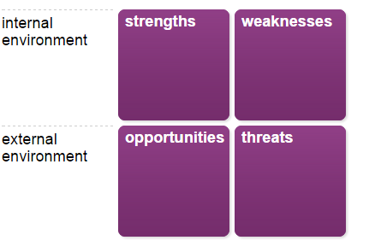

Your achievements and target areas
Before you start, spend some time thinking about your achievements over the last two to three years, or longer if that is relevant for you. Also, think about the future and what aspects of your life and work you would like to develop or change. Your notes here will help you identify your strengths and weaknesses in the stages that follow.
Your achievements
Make a note of up to three achievements where you feel you made important contributions. These could be at work or in other areas of your life.
Achievement 1
Obtaining a BSc (Hons), first, Business Information Technology is one of the most important aspects to my career success. The knowledge and experiences that I enhanced, contributed to the success of me getting a job in an IT discipline. Furthermore, it contributed to the opportunities that have arisen during my time as a Digital Support Engineer. For example, my experience of writing reports led me to creating documentation that was used by Council staff to configure mobile phones.
Achievement 2
Being involved in the upgrading of over 500 school devices from Windows 8/8.1 to Windows 10. This was one of the major projects I was involved in whilst I was a Digital Support Engineer. It was important to complete this project within the deadline as devices with these operating systems were to be no longer supported from Microsoft by January 2020. Additionally, as part of the project I was tasked with auditing all devices in each of the schools in Carmarthenshire, this related to Hwb funding and would provide schools with the IT equipment they require.
Achievement 3
More recently, in my new role as a Graduate Software Developer I was responsible for developing the Carmarthenshire County Council’s first Power App, less than three months of starting the role. It was passion and demonstration of an example Power App that I developed which influenced the manager to allow me to use Power Apps for developing applications. This application is currently being used by Council staff to submit expression of interests. I am currently in the process of developing additional applications in this environment because of the success of my first Power app.

Your target areas
Describe up to three areas of your work or personal life where you would like to achieve something, or make a change.

Target area 1
Obtain a l7 PG Dip in Professional Practise, and after that obtain a master’s qualification.
Target area 2
If feasible, transition all internal Granicus forms to Power Apps to modernise the Council’s delivery of forms and allow for greater brand consistency and further customisation.
Target area 3
Have the confidence to start driving again, which will potentially introduce opportunities in work if the need arises. For example, a client in Llanelli requires a new Power app and would like to meet face to face to scope out the project.

Stage 2 of 7
Guidance
For each achievement ask yourself:
- How did you stand out from the others?
- What skills and knowledge did you demonstrate effectively?

Your strengths

Record specific strengths which enabled you to make a contribution in each situation. You might want to ask others for feedback on what they see as your strengths. Focus on the key skills, knowledge and attitudes you demonstrated.
Your strengths
Strength 1
Obtaining a BSc (Hons), first, Business Information Technology is one of the most important aspects to my career success. My organization and motivational skills were a major factor in my success during university as they contributed to my ability to meet deadlines and complete modules to the absolute best of my ability.
Strength 2
During my time as Digital Support Engineer, I was able to manage and prioritize any workload that was given to me. Additionally, my ability to meet deadlines as evident during my degree added to this. Furthermore, the communication skills that I enhanced, which included my trustworthiness and politeness that my colleagues and clients were accustomed to, were contributors to being assigned the project. Reasoning for this included the very strict deadline to upgrade 500 devices. Additionally, continuing day to day responsibilities alongside the project, and communicating/negotiating with Headteachers and teachers at schools across Carmarthenshire to complete the project.
Strength 3
My ability to problem-solve was most likely to contribute to obtaining my new job role as a Graduate Software Developer. Moreover, my eagerness to learn and passion for emerging technologies led to me learning Power Apps. Furthermore, my communication skills allowed me to demonstrate a demo Power App that I had developed and gain my manager’s approval to use the environment to develop applications.

Stage 3 of 7
Your weaknesses
Guidance
For each aspect ask yourself:
- What did you need to do better in this situation?
- What skills and knowledge do you need to improve?
- What weaknesses did others identify in you?

Record any weaknesses you observed in yourself in each situation or elsewhere. These may be development points identified by yourself or others as part of your performance appraisal or feedback you have received.
Your weaknesses
Weakness 1
I've never truly been confident in my own abilities. As a result, I have doubted myself on many occasions. Despite achieving, a BSc (Hons), first, Business Information Technology, I still doubt myself and this can make it hard for me be open and share my ideas in scenarios that require collaboration.
Weakness 2
My lack of confidence carries over into the situation whereby I was tasked with upgrading devices in schools. This weakness made oral communication difficult because I would always doubt myself, thinking I said something incorrect. In addition, social anxiety makes it difficult for me to communicate with people I have never met. As a result, I will try to avoid situations where I need to communicate.

Weakness 3
In my ability to make decisions, I will often find it difficult to conclude if more than one option presents itself. For example, when developing the Power App, I encountered multiple solutions to the same issue. As a result, I found it difficult to make the decision as to which solution would be most appropriate. This wasted time that could be used elsewhere.

Stage 4 of 7
Your opportunities
Guidance
For each target area ask yourself:
- What changes in your organisation or working environment might create an opportunity for you in this target area?
- What new trends, services of products are emerging in your field of work which might help you achieve in this target area?
- What changes in your personal circumstances present an opportunity to achieve in this target area?

Consider the change and development 'target areas' you have selected. Record any opportunities that are emerging in your current situation which could help you achieve or make a change in these areas. Remember to think broadly across the whole of your organisation, sector and life outside work, not just your immediate job and team.

Your opportunities
Opportunity 1
Working in the Council, I have been informed that I can book 1 day per week that is dedicated to university work. Therefore, I need to ensure that I book the allocated time. This will create opportunities for more study time. Furthermore, the Council have informed me that I will be able to continue towards a master’s qualification once the course finishes. This presents me with an opportunity to obtain a master’s qualification. To achieve these targets, I need to have more confidence in myself. This is so that I can minimise any doubts I develop when completing the course.
Opportunity 2
The potential for this target to be met will depend on further success of any Power Apps that I develop. It is unrealistic to say the all the internal Granicus forms can be converted. This is because there are many of them, many of which require specific SQL databases. However, for those forms that could potentially be converted, I could use both Power Apps and Power Automate to achieve this. The emergence of these Power platforms and potential further updates to these products will enhance the potential of this opportunity. To achieve this, I will need to communicate with the team, since each form would have been developed by an individual in the team. Furthermore, I will need to utilise my problem-solving skills to come up with viable solutions. I have already made a start with this target by potentially transitioning the Procurement Exception Report Process form to Power Apps.
Opportunity 3
My confidence will be the largest contributor to achieving this target. It has around 10 years since I passed my driving test, since then I have only driven a few times as practice. Encouragement of my colleagues has helped me to start practising again. Moreover, opportunities that arise during work that I will potentially miss due to travel requirements. These could be the opportunities that encourage me to start driving again.
Stage 5 of 7
Your threats
Guidance
For each target area ask yourself:
- What changes in your organisation or working environment might prevent you from achieving in this target area?
- What new trends, services of products are emerging in your field of work which might make it more difficult to achieve in this target area?
- What changes in your personal circumstances might limit you?

Now think about barriers or constraints which might prevent you achieving in the career 'target areas' you have selected and record them.
Your threats
Threat 1
Since I am on a temporary contract for two years, there is the possibility that the Council do not extend my contract for a third year. As a result, I will not be able to obtain a master’s qualification from the course.
Threat 2
Despite its early success, there is the potential for Power Apps to not function as well as Granicus for specific forms. For example, Power Apps have not been tested for applications that have many visitors. As a result, the performance of the applications compared to Granicus forms may end being worse. This would be a large waste of development time. Moreover, the Power Platform is relatively new, depending on its success, Microsoft may decide to stop supporting the platform. Granicus forms have been used by the Council successfully for many years.
Threat 3
The threat to me gaining my confidence to drive again would come down to how I am feeling mentally. My mind is the biggest factor that has stopped me from driving again, this is due to my lack of confidence and the doubts that I have before driving.

Stage 6 of 7
Building on your strengths

Review your strengths, listed earlier. Then note down what you might do to take advantage of the opportunities and confront the threats you have identified, building on the strengths you have. You will have the chance to review your weaknesses later.

Your strategy
- How can you exploit the opportunities you have identified by building on your strengths?
- How can you confront the threats in your environment by using your strengths?
By exploiting any of the opportunities highlighted, I can build on several of my strengths. By being offered 1 day per working week to study, I can spend that time bolstering many of my skills. These include my organizational skills whereby I can manage the tasks at hand, and my ability to meet deadlines as I will have more time to complete assignments. My eagerness to learn ensures that I am fully committed to obtaining a master’s degree, should I be offered the opportunity to do so.
Furthermore, by being encouraged to continue using Power Apps and Power Automate through tasks that I have been assigned by my manager, I can continue to strengthen my problem-solving skills. This is because I can potentially develop solutions to problems using these newly emerging technologies. Moreover, opportunities arising from future updates provide by Microsoft for the Power Platform will enhance many of my strengths. For example, new functions added would encourage me to develop my problem-solving skills by enabling me to come up with different solutions using these new functions. In addition, these updates would further my eagerness to learn them. Communications that arise from my target to transition Granicus forms to Power Apps will help further develop my demonstration skills. This is because it will have me demonstrate the newly developed applications, but also my strength to negotiate these solutions.
I will utilise every strength that I have to hopefully allow the Council to keep me on after the temporary contract. However, this is a threat that is potentially out of my control. In addition, whilst Power Apps may not be suitable for specific Granicus forms, I can use my problem-solving skills to potentially utilise other means of integration. For example, by utilising Power Automate and integrations built into Power Apps, I can potentially make the applications I develop more suitable. Unfortunately, it is out of my control if Microsoft decide to stop supporting the Power Platform. However, my eagerness to learn, and my passion for discovering emerging technologies, means that I will most likely find alternative solutions before then. External factors that potentially affect my mental health are a threat to me achieving my targets. The strengths that I have developed will hopefully combat some of the feelings that I have, including, my politeness and trustworthiness during communications.

Stage 7 of 7
Minimising your weaknesses

Review your weaknesses identified earlier. Then note down what you might do to minimise their impact when choosing the opportunities and avoiding the threats you have identified.
Your strategy
- How can you ensure these opportunities are not derailed by your weaknesses?
- Which of these threats is biggest, given your weaknesses?
The opportunities highlighted in the report all have the potential to be derailed by the weaknesses that I have listed. For example, my communication with the Digital Solutions team will be difficult when developing new applications. However, since I am familiar with the small team, this will hopefully alleviate my social anxieties since I will be in communication with those with which I am familiar. Moreover, encouragement from colleagues regarding my target to start driving again will hopefully remove the lack of confidence and doubt that I give myself. Thus, this should not affect those opportunities.
If offered to continue a master’s degree after the diploma, my poor decision-making skills may result in me declining the offer. Fortunately, my strengths including motivational skills and eagerness to learn will prevent this. Regarding tasks that require travelling, my lack of confidence and the fact that these situations will be face to face will make it difficult for me to take these opportunities. However, by using my organisational skills to prepare for the task in advance and my motivational skills to encourage myself, I can hopefully combat this, should the opportunity arise.
The biggest threat to me is external factors which affect my mental health. Noticeably, my weaknesses of social anxiety, lack of confidence and communicating face to face will only insinuate how I am feeling mentally. Fortunately, the opportunities to receive encouragement from my colleagues are a key factor for making me feel better, but also alleviating the difficulty I have with oral communication.

Wheel of Life
Social Life
Health & Wellbeing
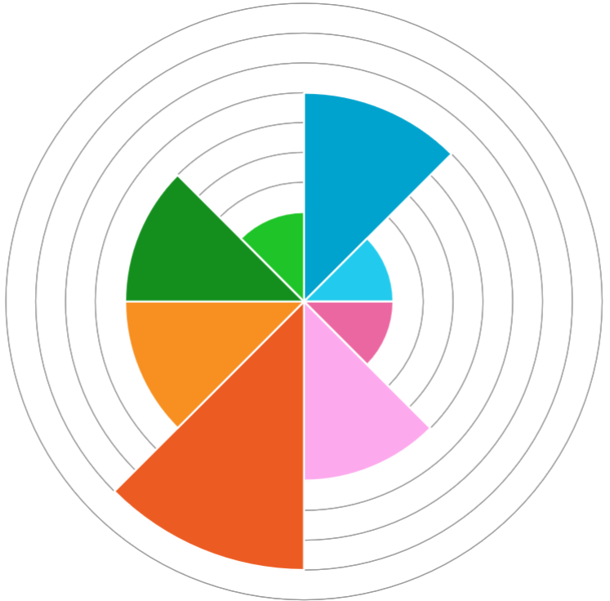
3
6
6
9
6
3
3
7
Lifestyle
Communication
Caring
Career
Confidence
Decision-making

Reflection on a presentation
Jamie W Davies
Continuing Professional Development (BMPF7081D)
08/12/2023
Description
During my Continuing Professional Development (BMPF7081D) module, I was required to complete a 10-minute presentation on a subject of my choice relating to my own professional development and experiences. The presentation was done on 06-12-2023 and including myself there were seven people present, two of which were the lecturers and the rest of us being students. Each of us took turns to present our prepared presentations and the order was decided by the lecturer whereby the first to send the presentation was to go first and so on. Since, I had sent my presentation to the lecturer first, I was given the opportunity to present first, which I did. The outcome of the presentation went better than I had expected, with positive feedback from my lecturers and colleagues. Furthermore, I managed to get through the presentation addressing all the points I wanted to get across, whilst finishing very close to 10 minutes. As a result, I was satisfied with the outcome.
Emotions
Before taking part in the presentation, I felt very anxious. Dating back to the beginning of the module, when I was first informed of the structure of the module, I felt overwhelmed. I had these emotions arise because it has been a long time since I graduated from university, which made it difficult for me to get back into the routine of completing assignments etc. Additionally, my confidence and social anxieties made me fear the completion of the module’s presentation, whereby I was doubting myself on occasions. I had these emotions leading up to the presentation, as well as during it. However, it then began to diminish shortly after the presentation whereby, I felt satisfaction, joy, happiness, and relief upon completion.
Moods
Due to my preparation for the presentation being successful, my mood on the day of the presentation was surprisingly content where I felt relatively positive despite the negative voices in my head making me feel apprehensive. Being able to present first made me grateful, since I much preferred to complete the presentation first, rather than wait and have the negative thoughts which would have made me distressed. Upon completion, my mood positively increased further in which I was able to have a sense of relief and be relaxed.
Feelings
The feelings that I had before, during and after the presentation, link to all my emotions whereby I felt many different states. Noticeably, before the presentation, I felt worried and scared. Both these feelings came from my anxieties and the negative thoughts that I would have. Moreover, unlike a homework exercise that we did prior, this presentation was being marked, which made me feel even more pressurised. The feelings of content came from when I was able to present first, as well as during the presentation, where I started feeling comfortable the longer I was presenting. After receiving applause, and positive feedback after the presentation, I felt very happy. Additionally, after completing the presentation I felt tired, most likely because of the amount of overthinking that I had done and working myself up.
Evaluation
I was able to complete the presentation at exactly 10 minutes, which was the allocated time of the presentation. Additionally, I was able to complete a presentation discussing the importance of reflective practice in relation to mental health. However, despite rehearsing, I still said filler words including ‘um’ on some occasions and additionally had some small pauses. Moreover, I did on occasions speak at a faster pace than I would have liked. My colleagues and lecturers giving me feedback contributed to the positive outcome of the presentation since they made me feel better.
Analysis
I believe that completing a presentation that was relevant to my own personal experiences was good because it allowed me to talk about, I subject that I was comfortable discussing. From going over the allocated time in the homework presentation, I felt I would do the same in this situation. However, the rehearsing that I had done for this presentation allowed me to complete it in exactly 10 minutes. Unfortunately, the negative, doubtful thoughts that I had during the presentation most likely contributed to the moments I had of pausing and saying filler words such as ‘um’. However, I do need to understand that pausing is not necessary a negative. “Most people use filler words because they’re afraid of silence. It takes confidence to use dramatic pauses.” (Gallo, 2019) Doing dramatic pauses, allows the listeners the opportunity to think on ideals that are currently being put across during these pauses. In relation to this, I also most likely spoke too fast on occasions because I was worried I wouldn’t be able to cover everything I wanted to say. The feedback provided to me was a positive outcome because it allowed me to see that I was able to present to a standard that I didn’t realise that I had. Moreover, it’s given me more confidence for future presentations.
Conclusions
I am happy with the outcome of my presentation. As a result of multiple rehearsals using the built-in coach in Microsoft PowerPoint, I was able to complete a presentation within the allocated duration. As a result, covering all the information I planned on presenting. The experience could have more positive if I was able to contain any negative thoughts for the 10-minute duration, and if I was able to remain positive despite doubting myself. I believe additional research, in terms of presenting with confidence, might have made me feel more comfortable and prevent some of the filler that I had presented.
Action Plan
When working on future presentations, I will continue to use the built-in coach in Microsoft PowerPoint due to its benefit in terms of my preparation. Before future presentations, I will watch presentations done by professionals to see how they present themselves (including TED Talks). Furthermore, I will do some further reading on presenting with confidence to ensure that I can minimise the emotions of anxiety that I develop whenever I am required to present.
References
Galli, F. and New, C.J. (2022) 'Gibbs’ cycle review. Emotions as a part of the cycle', E-motion (Huelva, Spain), 19, pp. 92-101 Available at: https://doi.org/10.33776/remo.vi19.7224.
Gallo, C. (2019) How to Look and Sound Confident During a Presentation. Available at: https://hbr.org/2019/10/how-to-look-and-sound-confident-during-a-presentation (Accessed: December 18, 2023).
Gibbs, G. (1988) Learning by Doing: A guide to teaching and learning methods Oxford: Further Education Unit.

My ‘Attitude’ and decision making ‘Functions’ (27/09/2023)
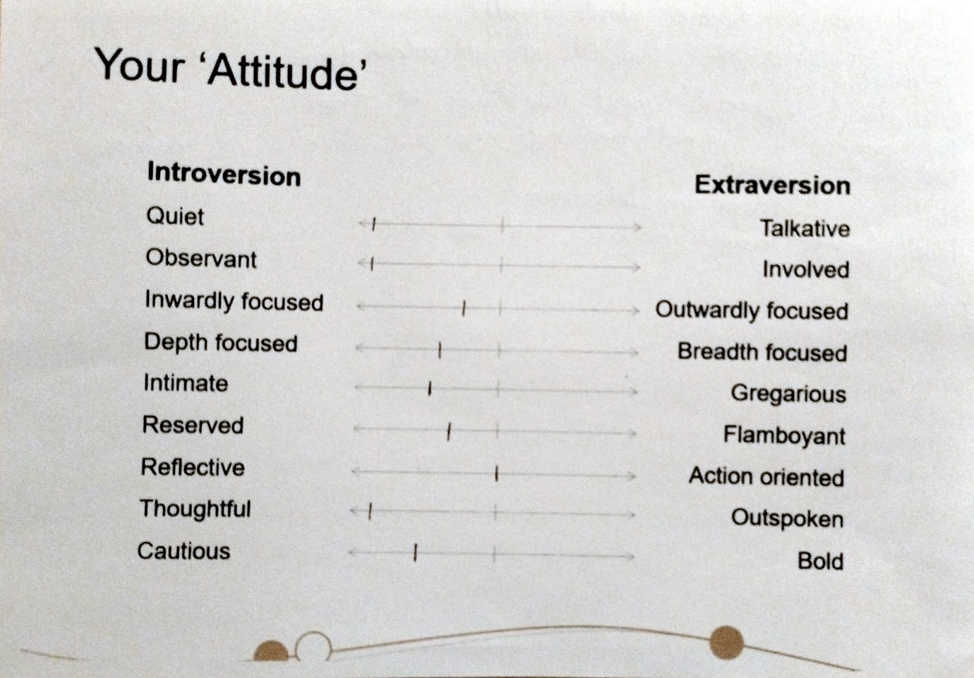
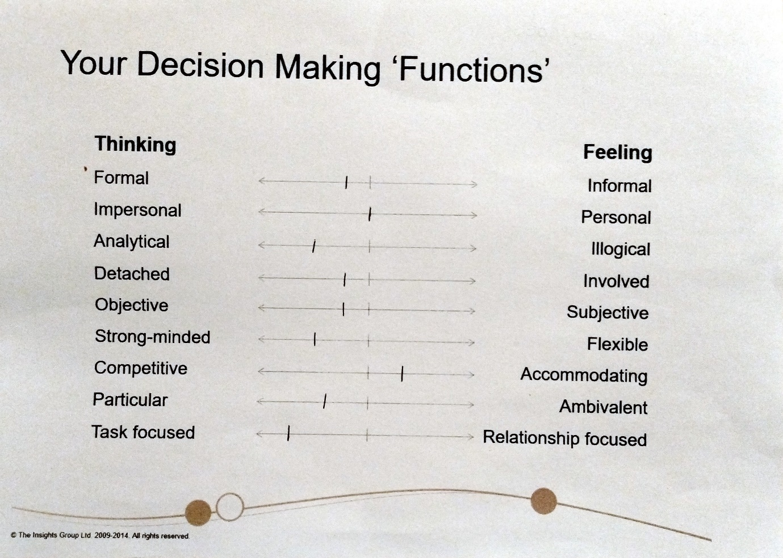

Professional and Personal Development Plan

Name: Jamie William Davies Period from:18/12/2023 Period to: 18/12/2024

Planning Professional Personal
Your aims | Professional | Personal
What would you like to achieve in the next twelve month period?  How would you like to develop yourself?  What skills will you need for the future?  Are there any particular problems you would like to solve? | In the next 12 months, I would like to continue developing Power Apps and Power Automate solutions to clients, whilst being the lead developer for these platforms.  I would like to further develop my presentation skills. It is a skill I will need to present my developed applications to clients.  Further develop reflective skills by utilizing Adapted Gibb’s cycle to address potential issues after tasks.  I currently lack programming skills, noticeably the use of C#.  I will need experience using ASP.net, the web framework used to deliver Council app solutions. | Go on at least one holiday to another country.  Regain confidence to drive again.  Make further improvements to my mental health.
Learning needs
What areas do you wish to develop in the next twelve months? | I wish to develop my C# programming skills by enabling me to write a simple program in the language.  I wish to further develop my Power Apps and Power Automate skills by continuing to develop at least three solutions.  I wish to further develop my Power Bi skills to the point that I have published a report for the team. | To continue learning Welsh, and be able to write, speak and listen to the language.  To continue learning Japanese and be able to write, speak and listen to the language.
Work skills
What technical skills do you need to improve in the next twelve months? | I need to improve my communication skills and be more comfortable when dealing with clients via these communications.  I will need to develop my presentation skills to present at least two of my developed applications to clients.  I will need to continue learning Welsh to meet the required Written and Speaking level.  Planning skills, whereby I will need to potentially lead at least one project and consult with my colleagues.
Future Learning Needs
Where would you like to be in three to five years time?  Does this change your plan? | In 3-5 year’s time, I would like to continue working for the Council, in the same team but as a Senior Software Developer.
Priorities and strategies

Which is the top priority, second, and so on? When would you like to achieve each? How might you achieve this learning (e.g. self study, course attendance)
Your priorities  (learning needs and skills development) | How will you do this? | What help and resources do you need? | When do you hope  to do this by? | When was this  accomplished?
I wish to further develop my Power Apps and Power Automate skills by continuing to develop at least three solutions. | When assigned a task, I will need to try and utilize both Power Apps and Power Automate to develop potential solutions. | Whenever I encounter an issue in these Power Platforms, I will either search the internet for a solution, or if it has not been addressed, then I will utilize the Microsoft Community forums and ask the Microsoft Community directly. | The amount of time it takes to develop a solution varies depending on the requirements. Therefore, I expect this could take up to one year. (18/12/2024)
I wish to further develop my Power Bi skills to the point that I have published a report for the team. | I will continue developing my Power Bi skills until I have produced a report that can be used by the IT department. | I will utilize the internet if I encounter any issues. More importantly, it is essential that I speak to colleagues if I am running into issues with Power Bi, since they will have a lot of experience using the platform. | I am currently in the process of developing a Power Bi report, requested by my line manager, for a list that is stored on our Teams channel. I have been making good progress on the report. (05/02/2024)
I need to improve my communication skills and be more comfortable in these situations. By dealing with at least three clients face to face. | Although most communication comes through email and Teams chats. I would like to develop my communication skills and help alleviate my social anxiety by attempting to meet with clients when possible. | If needed, I may require support for my line manager. In addition, I will need to liaise with the client to ensure that we can both meet at a time and place that is suitable for both of us. To do this, I will need to arrange meetings, and therefore will need to ensure that a meeting room is booked in advance. | Depending on the location of the client, it may not be feasible for them to meet in person. However, since more staff are now coming back into the offices, I will have more opportunities to do this. (18/05/2024)
I will need to develop my presentation skills to present at least two of my developed applications to clients. | I have been asked by my line manager, to present my newly developed Power app to those working in IT in the new year. This will help develop my presentation skills. | I will need to arrange the meeting with those that need to be involved. Furthermore, if done in person, then I will need to ensure that a suitable meeting room is available, and that I book the room in advance. | I will be required to present my latest Power app to those working in IT, sometime in January. Once, I have developed another application, I will look to do a presentation on that one also. (04/03/2024)
I wish to develop my C# programming skills by enabling me to write a simple program in the language. | I will develop my knowledge and skills of using C# mainly by following documentation online. Furthermore, support from my colleagues will also contribute to me learning the language. Additionally, I will use development days that the Council offer to complete online courses. | I will need to use tutorials and training resources that can be found on the web. Moreover, I will need direction from my colleagues when it comes to developing my first application using C#. In addition, | I hope to achieve this when I create a simple program using the language. Considering Power Apps and Power Automate are currently my priority. It could take several months to get confident using the language and write a program. (18/06/2024)
Planning skills, whereby I will need to potentially lead at least one project and consult with my colleagues. | Depending on the task assigned to me, I might not be the lead for that project. However, I may be asked by my line manager to be the lead for a task and be required to manage my colleagues. | I will most likely need support from my line manager to lead my first project. My colleagues will need to be involved, and I will potentially need to arrange meetings with them, through Microsoft Teams and face to face. | It is unknown when I will be asked by my line manager to lead a project. However, if the opportunity arises, then I will ask if I can be the lead for that project. (18/12/2024)
I will need to continue learning Welsh to meet the required Written (Level 2) and Speaking (Level 2) level. | I am currently participating in the Entry Course of Learn Welsh. By doing this, I am working towards achieving the next level of the language. | Continuing the course and doing additional learning including using Duolingo. | The course duration is 2 years. I am expected to reach this level by then. (19/09/2025)
Record of activities
Date | Activity | Duration | Development | Potential Application | Usefulness | Development Hours
The date the  activity took place | What type of development activity have  you undertaken? It may be a course or  an event or a work related task | How long did the  activity take? | Explain what you gained in one  of these terms:  • Skills: something you can now do  • Knowledge: Something you now know  • Experience: Something that reinforced  what you know or understand or  introduced you to something new | Where do you think this development  will have the most impact, and when  will you be able to use it? | On a scale of 1  very useful to 5 not  at all useful how  would you rate this development? | Claimed Cumulative
Da

Activity review
Planning | Professional | P Personal P
Review comments – achievements
What has been your greatest achievement during this review period?
What does it mean for you professionally and personally?
What did you learn from the experience?

Review comments
What have you not achieved and why?
How have your development plans changed as a result?
What new learning needs has this generated?

Activities to be carried forward
What activities would you like to carry forward into next year?
What activities need further development?

Moment of realisation
What has been this year’s ‘light bulb moment’ when you have learnt or experienced something that has helped to make sense of everything else or which was truly inspirational? It could be a phrase, a quote, or a brilliant idea.

Review date | Proposed Actual | Proposed Actual
Set a date for when you will look at your plan again and revise it. Make room for at least two reviews before the end of the plan year. | 1st 1st  2nd 2nd | 1st 1st  2nd 2nd
Cross reference
Some or most of the activities you plan may be the requirements of other bodies you belong to. Make a note here.

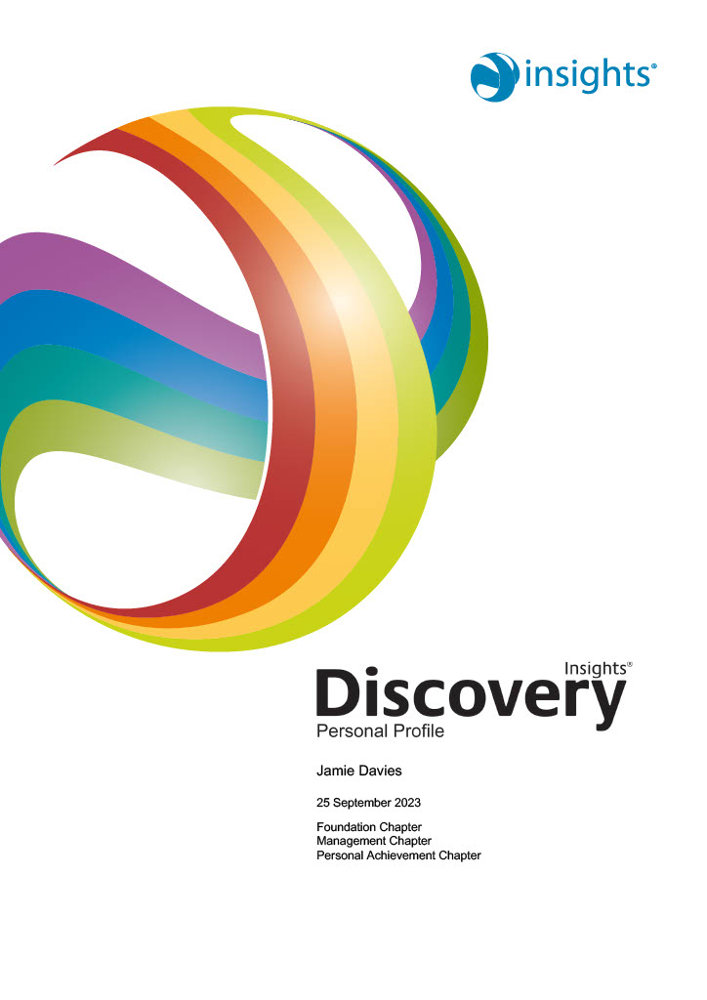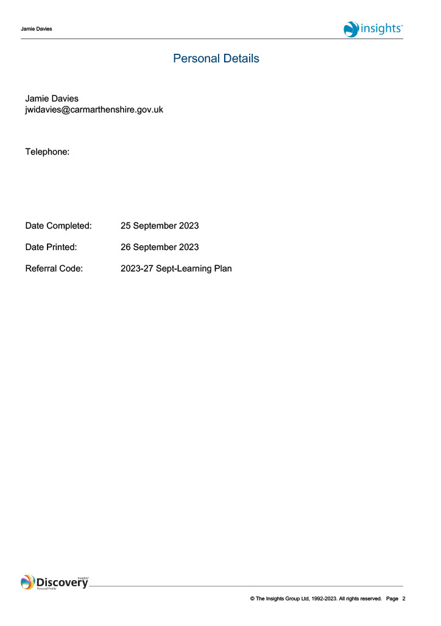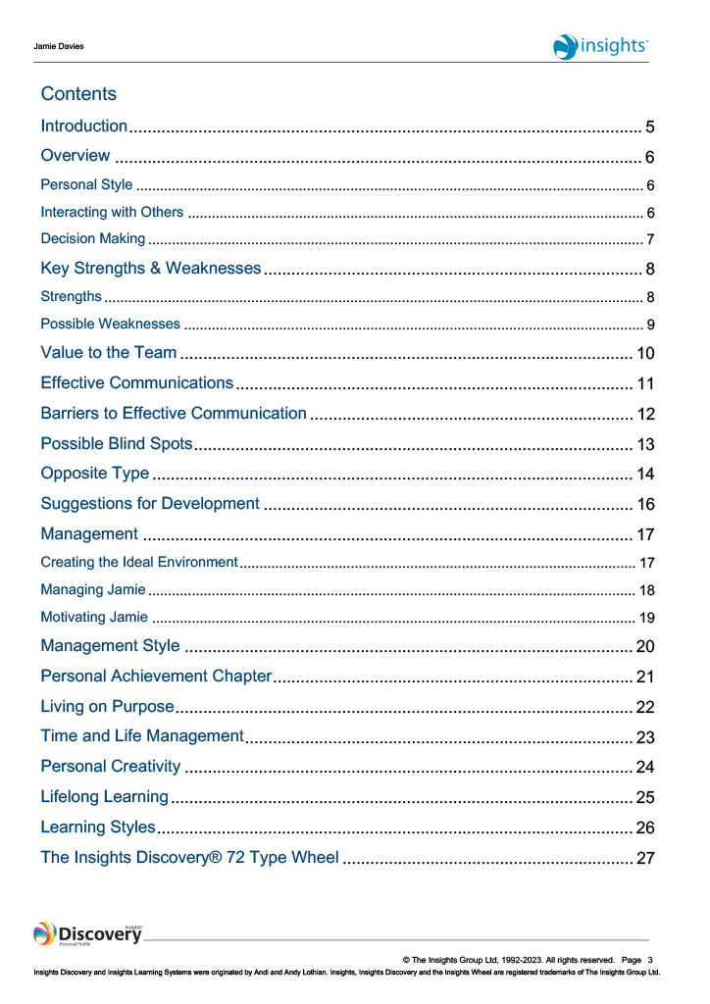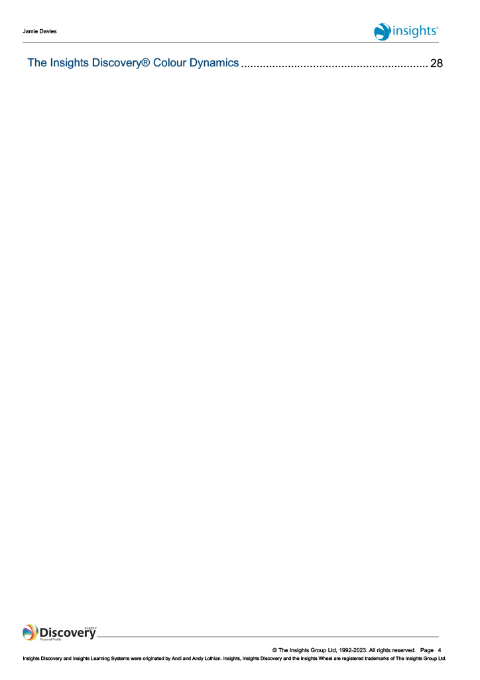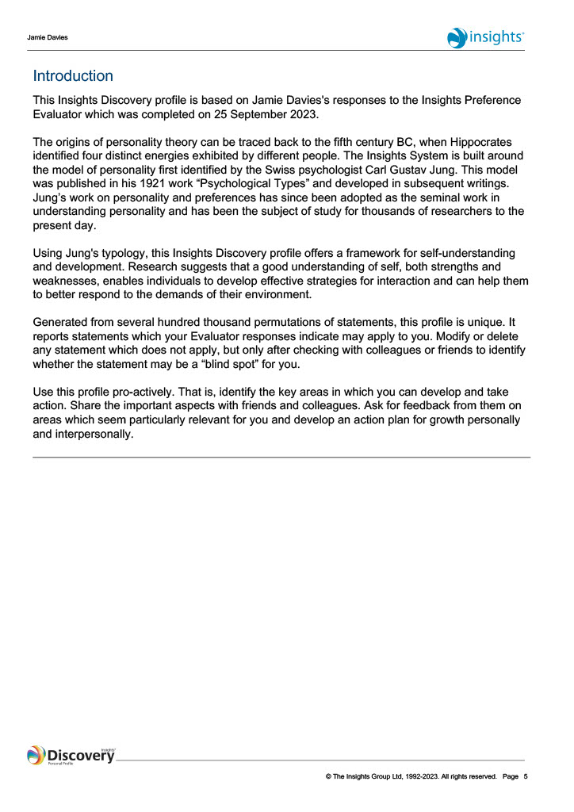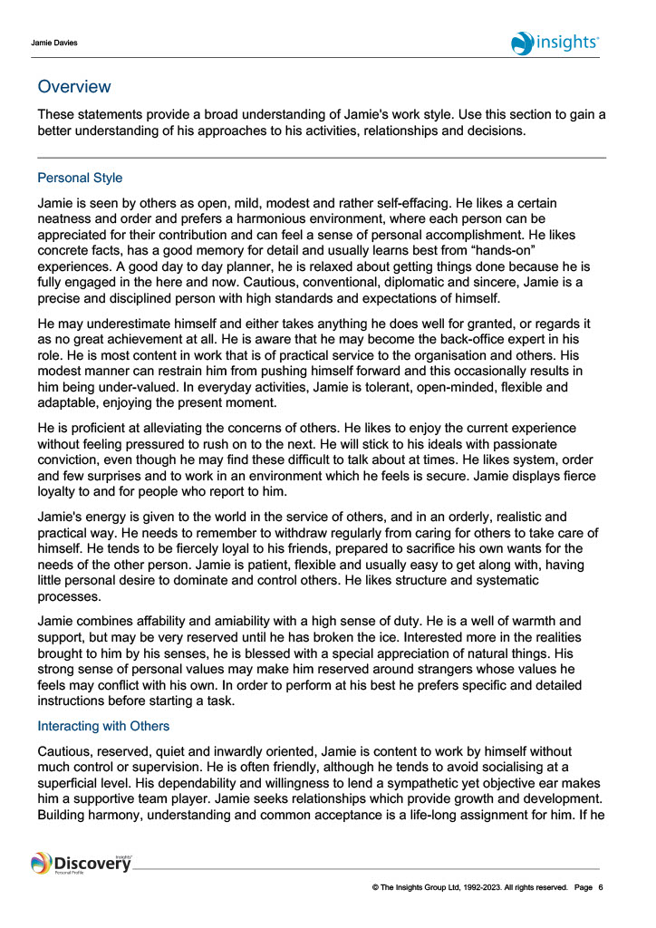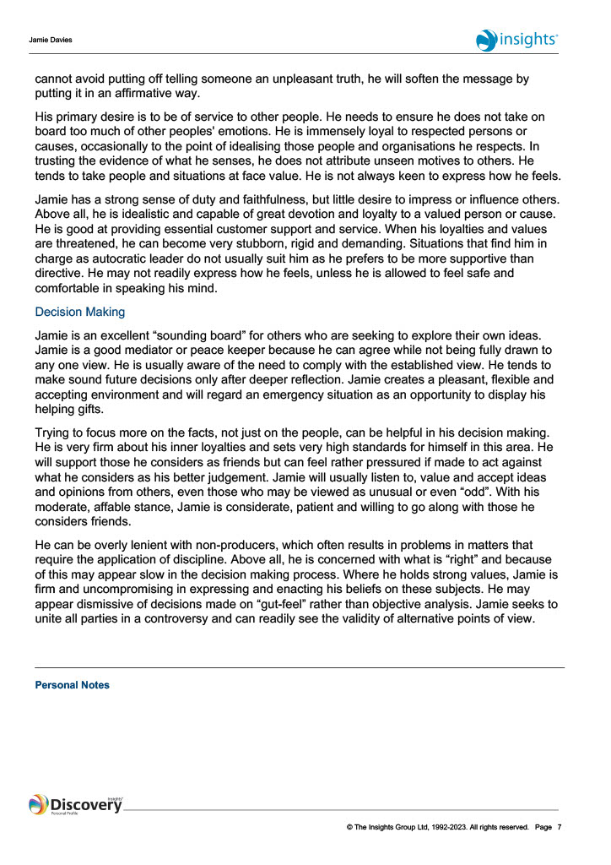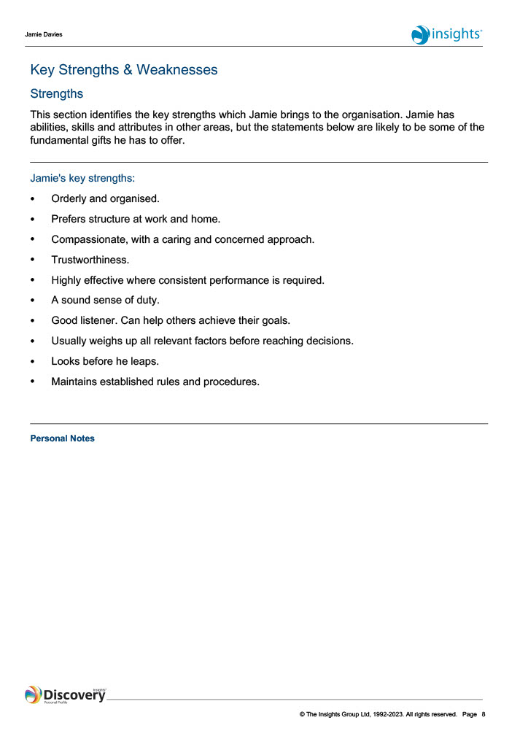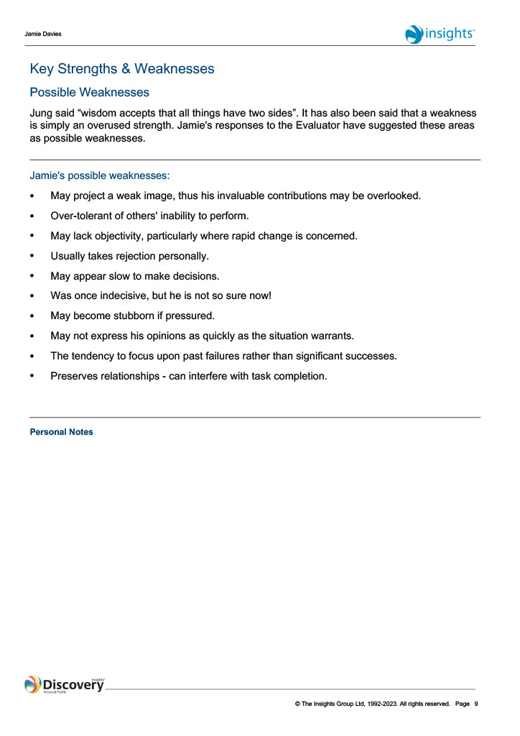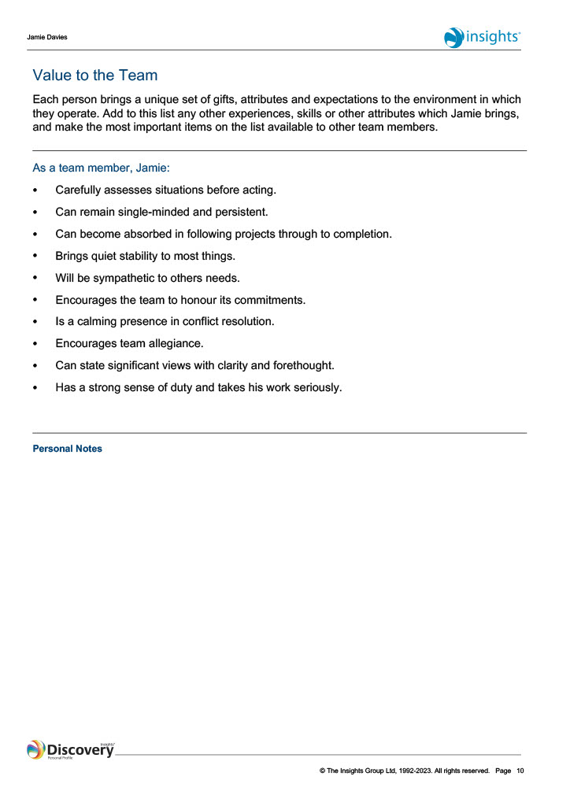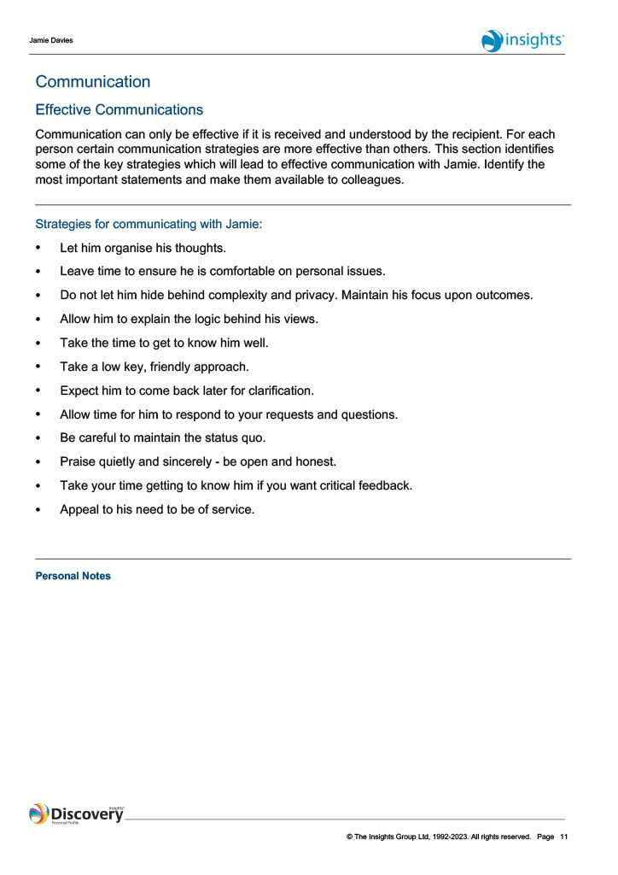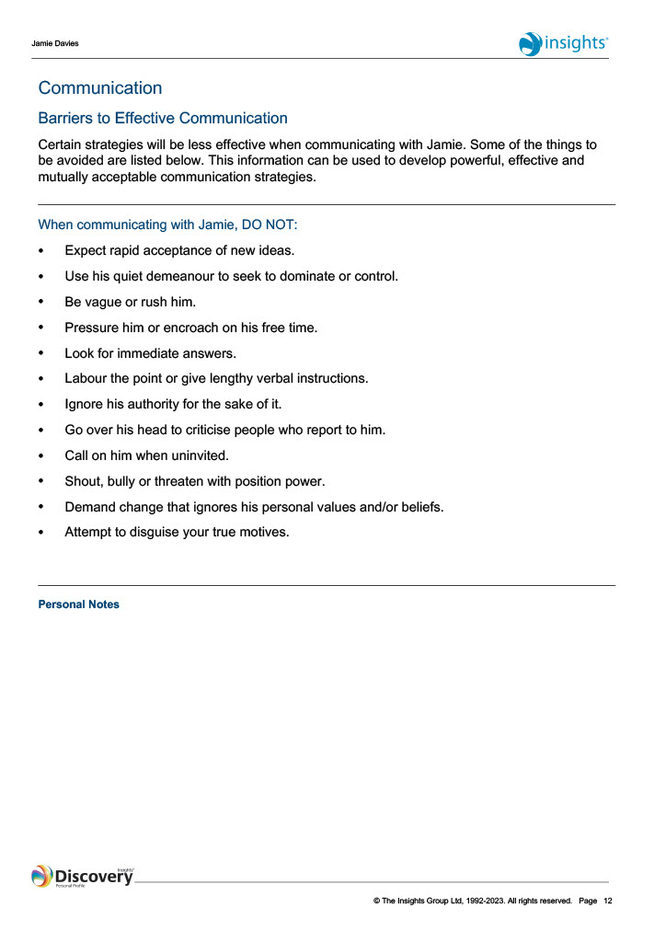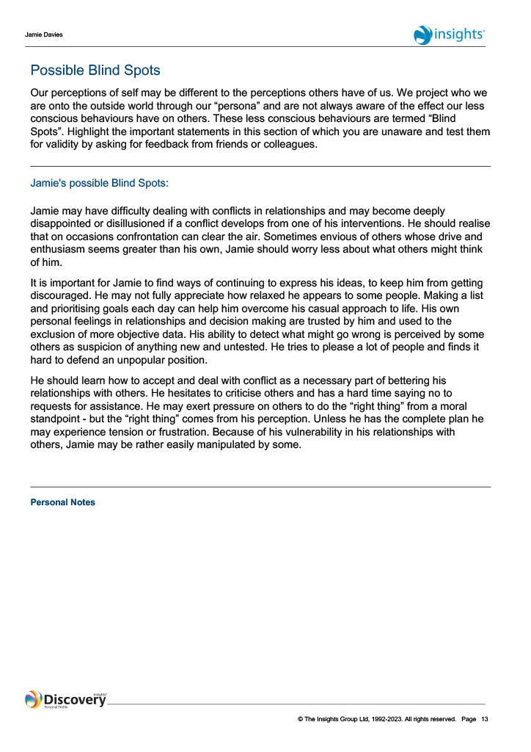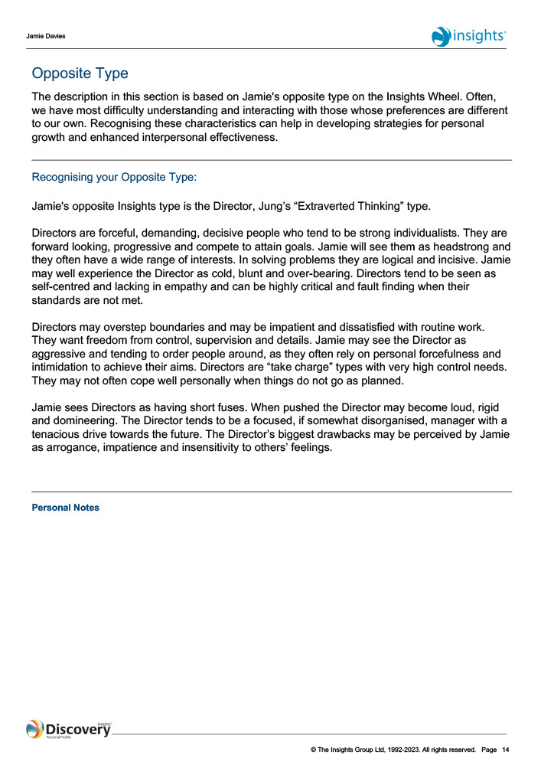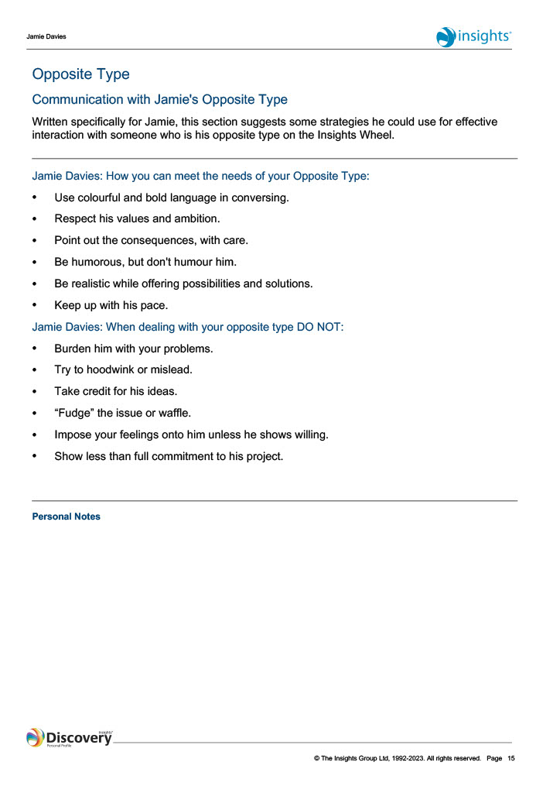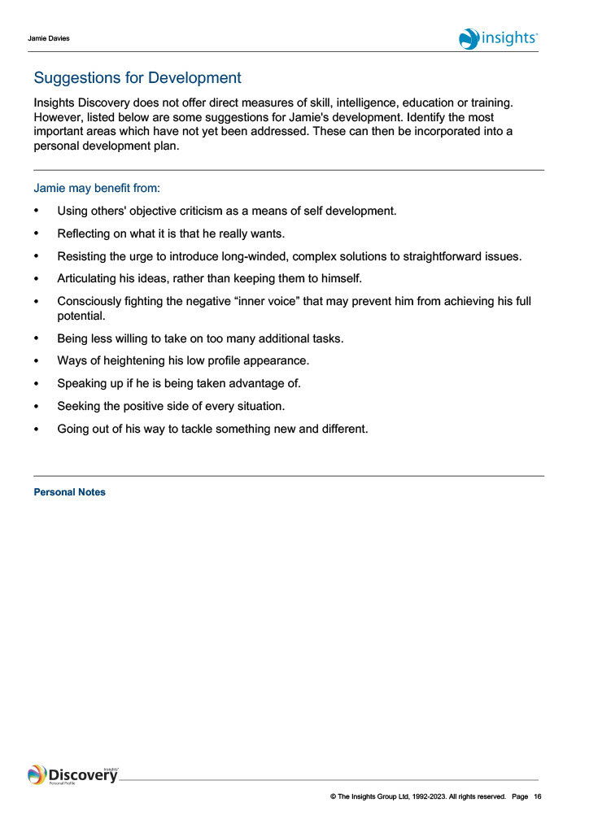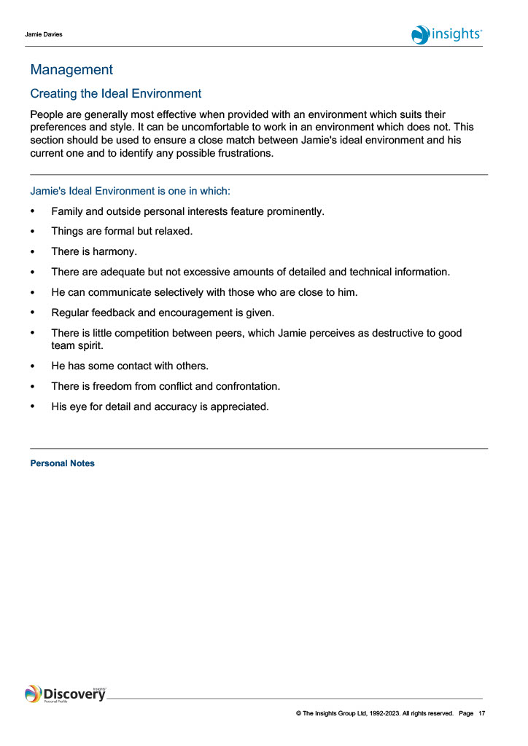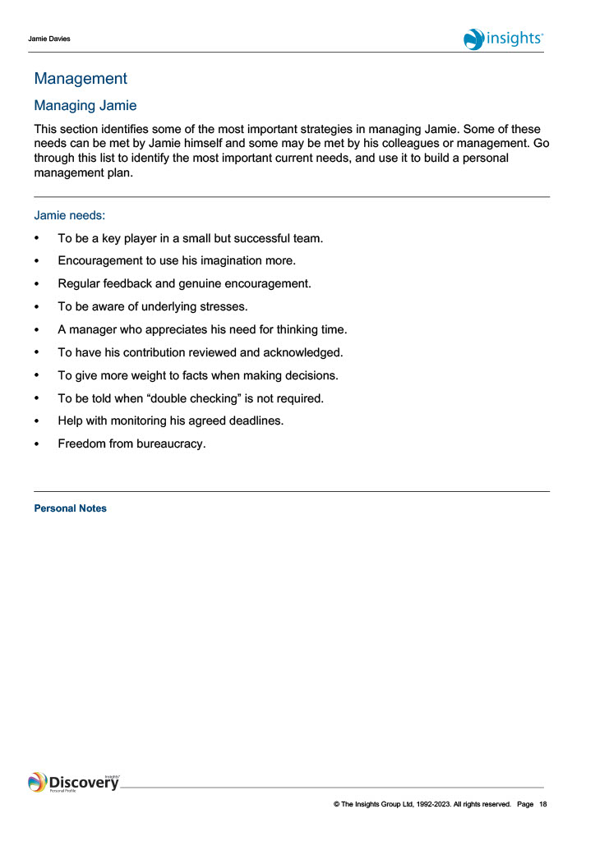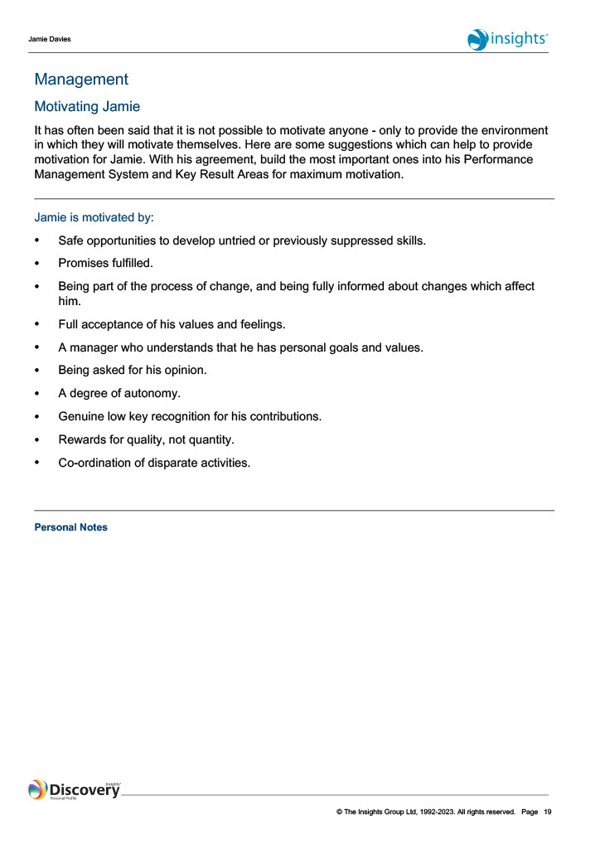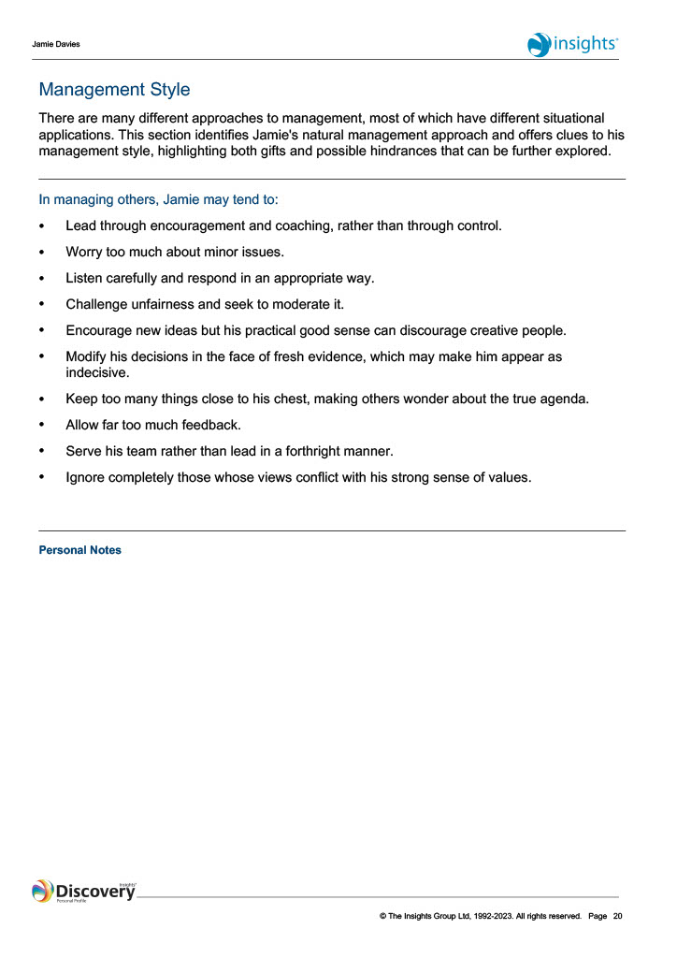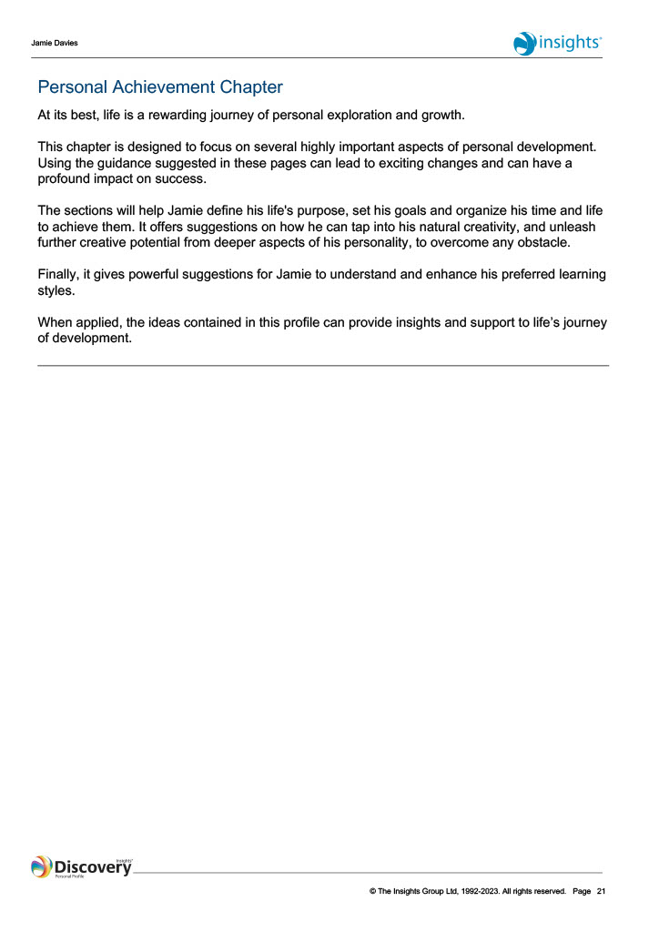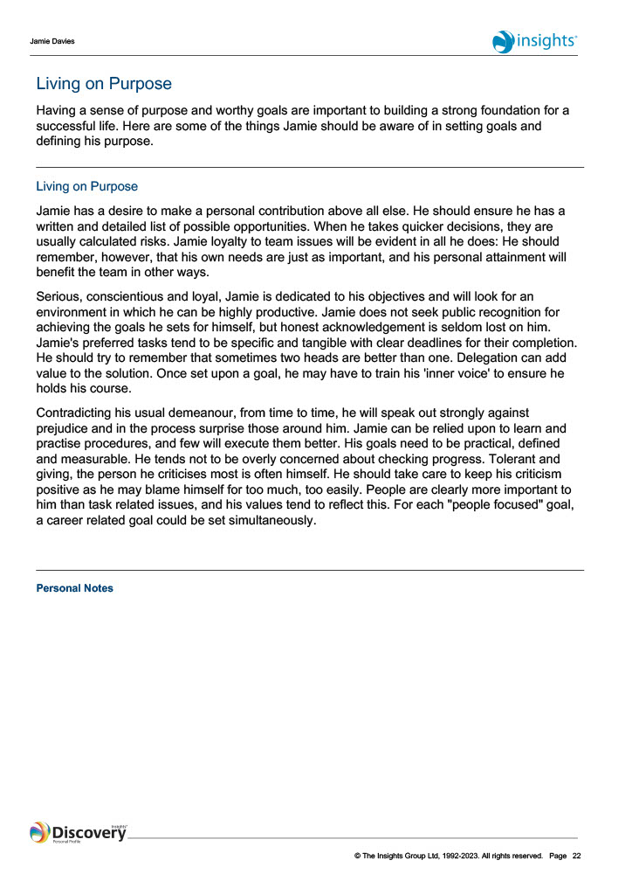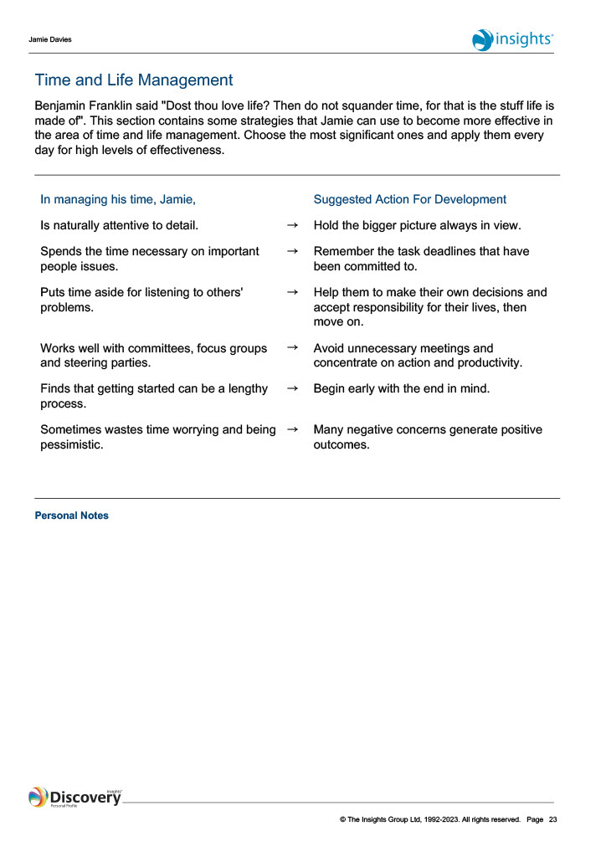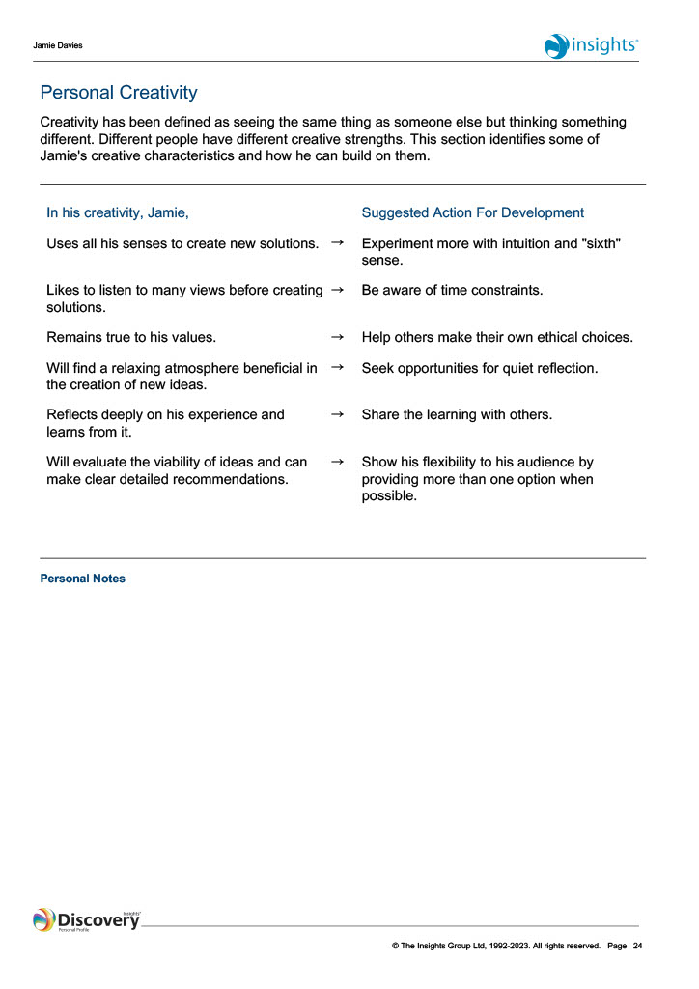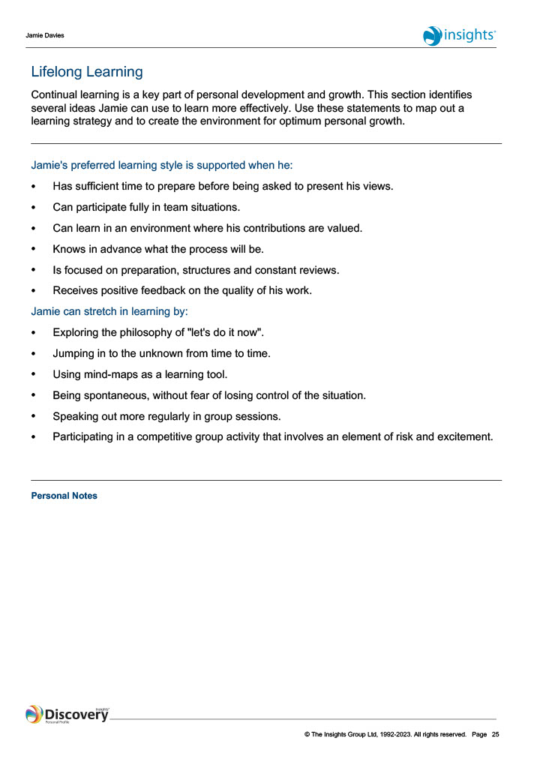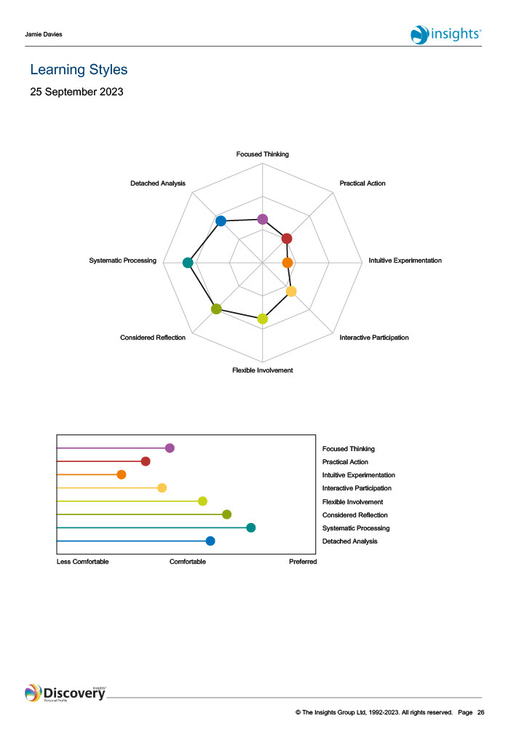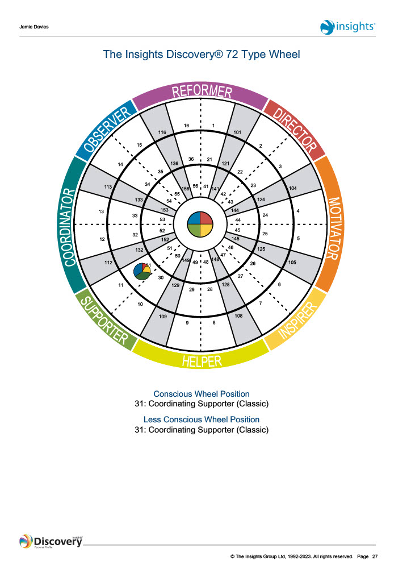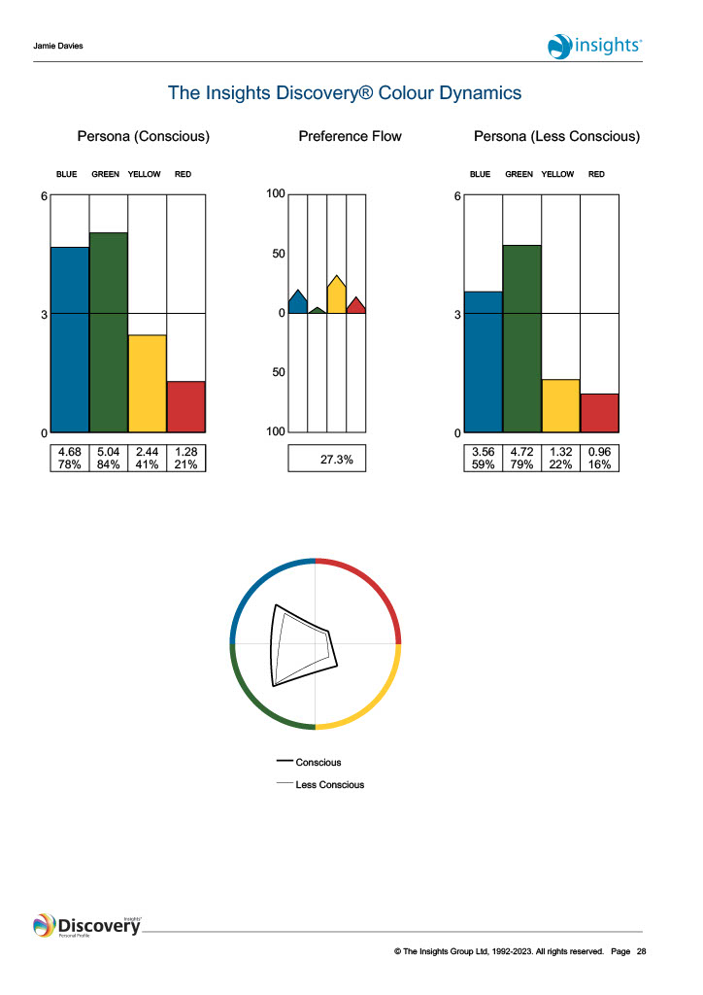

Insights Discovery Evaluator

