

Postgraduate/Distance Learning
Assignment coversheet & feedback form

THIS SHEET MUST BE THE FIRST PAGE OF THE ASSIGNMENT YOU ARE SUBMITTING (DO NOT SEND AS A SEPARATE FILE)

For completion by the student:
Student Name: Kim Harrer

Student University Email: 1814398@student.uwtsd.ac.uk
Module code: HPCA7003  Module title: History of Astrology | Student ID number: 1814398 |  |  | Educational support needs:  No
Assignment title: Did medieval astrology (1100-1400) assume that the future was negotiable or fixed?

Assignment due date: 15/12/2020
This assignment is for the 1st 2nd 3rd 4th 5th 6th module of the degree
I confirm that this is my original work and that I have adhered to the University policy on plagiarism.
Signed,
Kimberley M. Harrer
Email submission:if you are submitting this form via email, please tick this box □
(as a substitute for your signature) to confirm that you agree to the above declaration.
Assignment Mark
1st Marker’s Provisional mark
2nd Marker’s/Moderator’s provisional mark
External Examiner’s mark (if relevant)
Final Mark

NB. All marks are provisional until confirmed by the Final Examination Board.

For completion by Marker 1 :
Comments:

Marker’s signature: |  |  | Date:
For completion by Marker 2/Moderator:

Comments:

Marker’s Signature: |  | Date:
External Examiner’s comments (if relevant)

External Examiner’s Signature: |  | Date:

Did medieval astrology (1100-1400) assume that the future was negotiable or fixed?
Word Count: 2,988
Introduction
This paper will explore the relationship between free will, divine providence, and astrology in the medieval period by applying theory from St. Augustine (354-430 C. E.) and St. Thomas Aquinas (1225 – 1274 C.E.) to two separate depictions of the Wheel of Fortune. It will focus on the placement of Lady Fortune in the images and the literary context within which the images are found. Discussing this relationship through its expression in art will hopefully show that the issue of whether the future was negotiable or fixed was itself not a fixed idea. The answer was not a simple ’yes’ or ‘no’, but instead was a complex mixture of both.
Terms
For this essay, I will be using Patrick Curry’s versatile definition of ‘astrology’ as “the practice of relating the heavenly bodies to lives and events on earth”. Negotiability within the context of this essay assumes the existence of free will (also referred to as ‘chance’) and is an individual’s use of his or her own free will to modify a predetermined outcome. ‘Fate’ will here be used to mean ‘divine providence’.
St. Augustine
In Book IV of his ‘City of God’, written in 5th century C.E., St. Augustine, one of the most well-known and influential theologians in Christianity’s history, made his case against the Roman concept of the gods. He said of the goddess Fortuna, she “can be sometimes good and sometimes bad”. This duality defied Augustine’s notion of the Christian god who was only good and fully separated from bad. Fortuna could also “make men fortunate irrespective of merit” which not only eliminated free will but removed the availability of salvation. For Augustine, it was impossible that a god(dess) such as Fortuna could exist as she subjected humanity to her whim and stole the opportunity to choose the path to God. As stated by Howard Rollin Patch, St. Augustine was the first to “relate the problem of Fortuna and the element of chance to the question of fate and free will”. Patch says, “if…all is ordained by God’s providence…there is no allowance for man’s free-will….there must be the element of chance…complete divine foreordination would mean complete fatalism”. In ‘On the Free Will’ (4th century C.E.), Augustine expressed his belief that free will was a logical truth of existence, for “if man did not have free will, both punishment and reward would be unjust” – highlighting the importance of merit. While free will and divine providence coexisted for Augustine, he warned, “it is not to be believed that, because sin is committed by it…God gave free will for sin”. Man, according to Augustine, had a choice to use his free will for either good purposes or sinful. The man who chose to do good with his free will was rewarded while the man who sinned was punished and asked “why have you not used your free will for the purpose for which I gave it to you…for doing rightly?”. Augustine’s interpretation of free will as a catalyst for good or a use for evil implied that humans had some control over their individual outcomes.
Augustine applied these ideas directly to astrology in his ‘Confessions’ (4th century C.E.). Employing a literary style reminiscent of Plato’s Republic, Augustine used dialogue to convey his (and, by extension, Christianity’s) arguments against divination of any kind – astrology in particular. The story described a more personal journey with astrology in which he was a believer in the predictive power of astrology who then came to understand that it left no space for God-granted free will. The question was asked why some astrologers’ predictions came to fruition. The response was that the practice of prediction by astrologers was “a complete sham” and that “the force of chance, all-pervasive in the universe, brought this about”, acknowledging the existence of a force other than preordination. For Augustine, choice was synonymous with chance. These elements of free will and divine ordination cooperated to ensure God’s promise of human choice. To be clear, it is not that Augustine entirely disavowed astrology and its uses. In fact, he expressed hesitancy in relinquishing his belief in astrological predictions, but Augustine wanted to find “absolute proof…beyond doubt that the things people said they had predicted” were found by chance or luck rather than by reading the stars. Ultimately, his directive in this area was to find the role of free will in astrology’s predictive capacity.
St. Thomas Aquinas
St. Thomas Aquinas, a revered theologian for centuries who was made Doctor of the Universal Church in 1567, posited a more governmental and managerial approach to divine providence. in which “acts of choice and…will are controlled immediately by God…human intellectual knowledge is ordered by God through the mediation of angels”. Using astronomical analogy, Aquinas explained that much like the moon receives light from the sun and then reflects that light to earth, “lower creatures are ruled by God through the agency of higher creatures”. In this approach, God was the source of all, and his influence emanated through a hierarchy of celestial bodies that absorbed it and transmitted it to lower bodies “which are merely illuminated but do not illuminate”. Celestial bodies had an effect on human bodies but did not interfere with the human soul, which for him was an “intellectual substance”. He asserted, “an intellectual substance is superior to all bodies in the hierarchy of beings”, and concluded that “Heavenly bodies cannot directly act upon or influence” human intellect or will since they belonged to a power beyond corporeality. In this concept of free will and divine providence there was ostensibly room for both.
In terms of astrology, Aquinas held onto Augustine’s claim that using it for the purposes of divination was “unlawful”. The difference, however, between Aquinas and Augustine was Aquinas implicitly acknowledged the validity of astrology. He reconciled its divinatory power with the Christian faith by theorizing that while the planets and stars had some influence on humans through the body, humans had autonomy in how they chose to react to those influences through their will which preserved the Christian tenant of salvation.
The Wheel and Lady Fortune
Circularity and cyclicality were the structural foundation of the Medieval cosmological – and by extension, astrological – model. This model, known as the Aristotelian-Ptolemaic model, employed a system of “at least 8 concentric orbs or heavens” moving together in response to the outermost sphere – The Primus Mobile. Considered to be the sphere of divinity, the Primus Mobile was the cause of celestial motion and, by extension, the soul’s cause of movement toward divine unity. The spheres moved out of love and devotion for the divine.
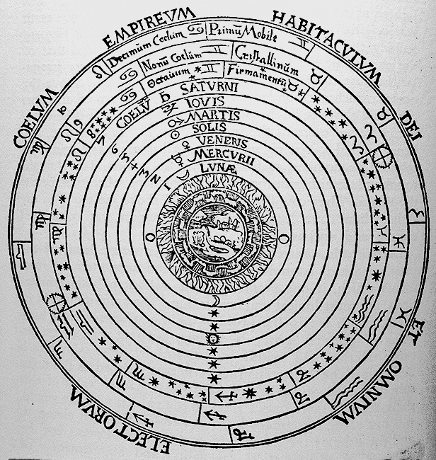
Figure 1 The cosmos according to Aristotle and Ptolemy. Earth is at the center with the Moon, Mercury, Venus, Sun, Mars, Jupiter, Saturn, the fixed stars, zodiac, and the divine realm encircling it (facultysites.vassar.edu).

In his book, ‘Planets, Stars, & Orbs’, Edward Grant explains:
Aristotle distinguished two immaterial substances associated with each celestial orb: a soul and a separate intelligence...the former is an integral part of its orb, whereas the latter is distinct from its orb…the direct cause of motion is therefore the separate intelligence, which causes the soul to love and desire it so that the soul will move its orb around and around.
Divinity inspired the soul into motion. Just as each orb in this cosmological model embodied both the corporeal and the immaterial, the former moving the latter, an individual was both corporeal and immaterial, body and spirit. The orbs were set into motion by the soul’s divine devotion, and the human soul’s impetus to move toward God was the hope and promise of reunion. As the catalyst of the soul, the body also moved toward God, but separating the two gave the body freedom to choose how to move forward toward divinity while maintaining God’s authority over the soul.
The wheel as a symbol “implies an idea of movement, and symbolizes the cycle of time…the planets’ journey around the sun…the great rhythm of the universe”. By extension, the wheel of fortune emulated the familiar structure of the cosmos – the highly organized movements of the Aristotelian-Ptolemaic spheres – as well as the vicissitudes of life through the passage of time. Frequently accompanying the wheel was the image of the goddess Fortuna, or ‘Lady Fortune’. Often Lady Fortune was depicted on “unstable footing…standing on a wheel or orb” to emphasize her “unpredictable nature”, or she was blindfolded or had two faces to show her haphazard and capricious character. The image of Lady Fortune was a testament to “what so ostentatiously asserts its presence in everyday life”, an undeniable element which posed a philosophical problem church leaders and astrologers could not ignore, “the element of chance”.
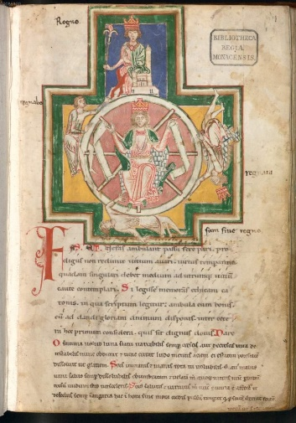
The two images below feature contemporaneous depictions of Lady Fortune. The first image is from Carmina Burana - a German manuscript of poems and songs from 1230 C.E. The second image of Lady Fortune is from Jean de Meung’s and Guillaume de Lorris’ collection (‘Recueil’) of writings published in
Figure 2: Clm 4660 Rota Fortunae, Carmina Burana, Carinthia / Styria or South Tyrol, 1230 - 1399, parchment, 25 x 17 centimeters, Bavarian State Library, Munich Germany, Image: Münchener DigitalisierungsZentrum / Digitale Bibliothek.

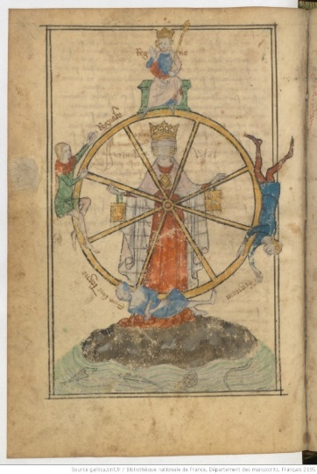
1361. Both depictions are common set-ups for Lady Fortune: she is positioned in the middle of the wheel encircled by four figures, each in a different stage of fortune’s spin, each stage with a label – ‘regno’ (I reign), ‘regnavi’ (I have reigned), ‘sum sine regno’ (I am without a kingdom), and ‘regnabo’ (I shall reign). There are also some subtle differences. In the first image, Lady Fortune is hands-free in terms of the wheel and is seated in front of it. The second image depicts Lady Fortune standing behind the wheel blindfolded - a depiction which is used to “convey the randomness of chance”- with her hands actively maintaining its spin. Lady Fortune’s engagement with the wheel’s motion is indicated by her hands – one lifting upward and one pushing downward on the spokes of the wheel. The rotation of the wheel is evident in the figures surrounding her in both images as they grip the wheel on descent, robes falling toward the ground, and climb on ascent, hands reaching for the top. The implied perpetuity of the wheel’s spin and the figures’ adherence to the wheel offer a fatalistic, choiceless view of existence. Even so, chance still occupies a central space within that order, whether it be cosmological, spiritual, or astrological.
Figure 3: Recueil, Guillaume de Lorris, BnF MS Français 2195, f.156v Paris / France, 1361, parchment, 20 x 14 centimeters, Bibliotheque Nationale de France, Paris, France, Image: BnF Gallica.

The inclusion of chance as free will within the ordered movement of the wheel reflects Aquinas’ astrological theory that while the planets have some authority in human life, ultimately choice can be used to negotiate fate. Furthermore, employing Curry’s definition of astrology as relating heavenly bodies to earthly lives, these images are not only humanized replicas of the cosmos (consistent, directed revolution occurs around a central focal point, reflecting the movement of the planets and spheres around the Earth). They are also a means by which a larger existential problem is related to the human experience. This problem being that reality unfolds in everyday life as “incessant change”. Occurrences are “’on the whole’ or ‘for the most part’” – an experience which deviates from the harmonious and steady rhythm observed in the cosmos, and an experience which deviates from the predictive claims of astrology.
These images are also a part of a larger literary context. The first image, as mentioned before, is from the Carmina Burana. This text was written by rebellious clergymen called ‘Goliards’ who prided themselves on directing “satire and cynicism…at the religious orders” writing often bawdy tales of lust and love, and corruption within the church. As the authenticity of astrology was “based almost entirely on theology”, astrological inquiry strived to answer “whether scripture condemned or supported the practice of astrology” so that, by extension, the church could have a clear stance on the subject. Throughout the text of the Carmina, the speaker laments to Lady Fortune about her fickle nature. In ‘Fortune plango vulnera (I bemoan the wounds of Fortune)’, he says “I used to sit raised up, crowned…now I fall from the peak deprived of glory” and goes on to say “far too high up sits the king…let him fear ruin!”. In this last line, the wheel’s repetitive motion and his position on the wheel allows the speaker to see into the future, to predict that the king on top will fall as he did. When applied to the image of Lady Fortune and her wheel, employing Curry’s definition of astrology, the position of the figures on the wheel become predictors of future positions or outcomes for themselves but cannot deviate from the path of the spinning wheel. They reflect the role of celestial bodies in astrology, their positions and cyclical regularity being indicators of individual outcomes. This image becomes defiant under this lens, suggesting that a future dictated by divine providence can be known using the celestial positions in astrology. This attitude aligns well with the Goliard’s disenchantment and protest of the church. The image of Lady Fortune reflects the predictive capacity of astrology which church leaders were grappling with and, in this case, connects directly to its literary context within satire.
The second image from Le Roman de le Rose, a tale which portrays Lady Fortune as intractable. When engaging in the connection between Lady fortune and aging, Barbara Thompson speaks of a scene featuring the Duenna who, feeling her descent on the wheel into old age, looks back on her life with regret, lamenting that “she should have taken advantage of her position at the time” when she was young, beautiful and wealthy. Thompson points out that the Duenna is not aware that “building up more wealth at the top of the wheel” does not guard against one’s inevitable descent to the bottom of the wheel (growing old, becoming impoverished). Indeed the story is filled with examples of Fortune having her way with humanity regardless of an individual’s choices. It is this quality of Lady Fortune, her unpredictability, her stealth – even tricking the Duenna into believing she could have done something about her own fate – which portrays an astrology of fate without free will. Regardless of one’s position on the wheel, one cannot know his or her future outcomes as the cyclical, repetitive motion of the wheel is obscured by Lady Fortune’s impulsive unpredictability.
The illuminations in their entirety could be seen as a reflection of Aquinas’ managerial cosmos. Lady Fortune turns her wheel as the Primus Mobile sets the concentric circles into motion. The many parts of the wheel contribute in succession to its momentum. The spokes forced momentum outward from the center to the exterior wheel, the wheel then thrusted human kind into the cycle of life’s incessant change. Just as god’s divine plan emanated through administrative layers of stars and planets, each passing a message in descending fashion from the divine to the earthly which could be understood through astrology, the wheel’s spin manifests an individual’s position along its perimeter in a predictable manner. Both of these images provide a view of the medieval relationship between astrology, free will, and predestination which is complex and nuanced.
Conclusion
Through examining these images with defined terms of fate, free will, and astrology, I hope to have shown that the complexities of the relationship between these ideas meant the question of negotiability or fixity of the future in the Medieval period was not a simple ‘yes’ or ‘no’ but was instead a nuanced mixture of ‘yes’ and ‘no’.

Bibliography
Primary Sources
Augustine, St., Confessions, Volume I: Books 1-8, translated by Carolyn J.-B. Hammond, Loeb Classical Library 26, Cambridge, MA: Harvard University Press (2014).
Augustine, St., ‘On the Free Will Book II’, Selections from Medieval Philosophers: Augustine to Albert the Great, translated by Richard McKeon (ed), Charles Scribner’s Sons (1929), p. 11-64.
Aquinas, Thomas, Shorter Summa, Ed. Peter Kreeft, Sophia Institute Press: Manchester, NH (1993)
Secondary Sources
Brown, Alex, ‘Turn, Turn, Turn’, History Today (Jan. 2018), p. 26-35.
Campion, Nicholas, A History of Western Astrology Volume II: The Medieval and Modern Worlds, Bloomsbury (2009).
Campion Nicholas, Astrology and Cosmology in the World’s Religions, New York University Press: New York/London (2012),
Curry, Patrick, ‘Astrology’, in Boyd, Kelly (ed.) The Encyclopaedia of Historians and Historical Writing, 2 Vols. London: Fitzroy Dearborn (1999), Vol. 1, pp 55-57.

Grant, Edward, Planets, Stars, & Orbs: The Medieval Cosmos, 1200-1687, New York: Cambridge (1996
Julien, Nadia, The Mammoth Dictionary of Symbols: Understanding the Hidden Language of Symbols, Bekeley: Peach Pit Press (1995)
Lewis, C.S. The Discarded Image. New York: Cambridge (1964).
Orff, Carl, Carmina Burana Lyrics, Schott Musik International: Mainz, Germany, classical.net (2020).
Patch, Howard Rollin, ‘The Tradition of The Goddess Fortuna in Medieval Philosophy and Literature’, Smith College Studies in Modern Language, Vol. III No. 4 (July 1922).

Thompson, Barbara, ‘The Paradoxes of Fortune in the Romance of the Rose’, Chimères, Vol. 6.1, No. 13, (1972).

Images
Figure 2 The Cosmos According to Aristotle and Ptolemy, Image: facultysites.vassar.edu.
Figure 2: Clm 4660 Rota Fortunae, Carmina Burana, Carinthia / Styria or South Tyrol, 1230 - 1399, parchment, 25 x 17 centimeters, Bavarian State Library, Munich Germany, Image: Münchener DigitalisierungsZentrum / Digitale Bibliothek.
Figure 3: Recueil, Guillaume de Lorris, BnF MS Français 2195, f.156v Paris / France, 1361, parchment, 20 x 14 centimeters, Bibliotheque Nationale de France, Paris, France, Image: BnF Gallica.

Curry, Patrick, ‘Astrology’, in Boyd, Kelly (ed.) The Encyclopaedia of Historians and Historical Writing, 2 Vols. London: Fitzroy Dearborn (1999), Vol. 1, p. 55. pp 55-7
Evans, G. R., Introduction to City of God by St. Augustine, Trans. Henry Bettenson, Penguin Classics: London (2003), p. viiii.
Augustine, City of God, trans. Henry Bettenson, Penguin Classics: London (2003), p. 157-157.
Augustine, City of God, p. 158.
Patch, Howard Rollin, ‘The Tradition of The Goddess Fortuna in Medieval Philosophy and Literature’, Smith College Studies in Modern Language, Vol. III No. 4 (July 1922), p. 182.
Patch, ‘Tradition of Goddess Fortune’, p. 182.
Augustine, St., ‘On the Free Will Book II’, Selections from Medieval Philosophers: Augustine to Albert the Great, trans Richard McKeon (ed), Charles Scribner’s Sons (1929), p. 13.
Augustine, Free Will, p 13
Augustine, Free Will, p 13
Augustine, St., Confessions, Volume I: Books 1-8, translated by Carolyn J.-B. Hammond, Loeb Classical Library 26, Cambridge, MA: Harvard University Press (2014), p. 141.
Augustine ‘Confessions’ p. 141.
Kreeft, Peter, Introduction to Shorter Summa by St. Thomas Aquinas, Ed. Peter Kreeft, Sophia Institute Press: Manchester, NH (1993), p. ix.
Aquinas, Thomas, qtd in Astronomy and Astrology in the World’s Religions, Nicholas Campion, New York University Press: New York and London (2012), p. 170.
Aquinas, Thomas, Shorter Summa, Sophia Institute Press, Manchester, NH (1993), p. 136.
Aquinas, Summa, p.137
Aquinas Summa, p.142.
Aquinas, Summa, p.142
Campion Nicholas, Astrology and Cosmology in the World’s Religions, New York University Press: New York/London (2012), p.170.
Campion Nicholas, World’s Religions, p.170
Grant, Edward, Planets, Stars, & Orbs: The Medieval Cosmos, 1200-1687, New York: Cambridge (1996) p. 315.
Grant, Edward, Planets, Stars, & Orbs, pp. 516-517.
Julien, Nadia, The Mammoth Dictionary of Symbols: Understanding the Hidden Language of Symbols, Bekeley: Peach Pit Press (1995) p. 71.
Brown, Alex, Turn Turn Turn, History Today, Vol 68 Issue 1 (Jan 2018), p. 26-27.
Patch, Fortuna in Medieval Philosophy and Literature, p. 179.
Brown, Alex, Turn, Turn, Turn, p. 26.
Brown, Alex, Turn, Turn, Turn, p. 26.
Lewis, C.S. The Discarded Image. New York: Cambridge, 1964. Print, p. 3-4
Lewis, C.S. The Discarded Image, p. 3-4
Goodrum, R. Gordon, ‘Carmina Burana: The Poetry of Wandering Scholars and Wayward Clerics’, The Choral Journal, Vol. 36, No. 2 (September 1995), p. 10.
Campion, Nicholas, A History of Western Astrology Volume II: The Medieval and Modern Worlds, Bloomsbury (2009), p. 51.
Orff, Carl, Carmina Burana Lyrics, Schott Musik International: Mainz, Germany, classical.net (2020).
Thompson, Barbara, ‘The Paradoxes of Fortune in the Romance of the Rose’, Chimères, Vol. 6.1, No. 13, (1972) p. 37.
Thompson, Barbara, ‘Paradoxes of Fortune’, p. 37

