
Industry
Consulting
Partners LLP
•
Ileana Chis
–
BENEFITS OF
TEAM
•
Mirela Lazar
-
STAGES OF THE
TEAM
•
Francela
White
-
TEAM ROLES
•
Imayinkhor
Johnbull
Osawaru
-
MANAGING CONFLICTS
•
Oproiu Luciana
-
SUCCESSFUL
TEAM DEVELOPMENT
•


Benefit of team working
Name:
Chis
Ileana
Ioana
Effective Team Working and Communication

Benefit of team working
Team working

Team
is
considered
as
group
of
people
those
who
work
together
to
meet
the
common
goal
of
the
business
unit
.

Team
members
support
each
others
and
ensure
that
workplace
efficiency
can
be
improved
.
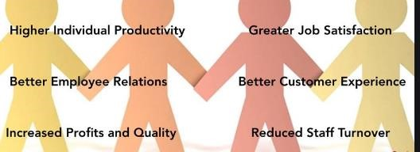
Benefits of team working

Productivity
boost

Improve
moral

Promotes
innovation

Establish
a
strong
relationship

Improves
communication
and
eliminate
conflicts
Benefit of team working
Team working is associated with many benefits, these are explained as below:
- ^{Productivity boost}: Team working is helpful for Industry Consulting
Partners to enhance productivity of employees as people work together and manage their skills adequately. That aids the business in raising productivity of the people.
- Improve moral: Employees of Industry Consulting Partners work together when they have to work in a team. That develops familiar atmosphere, and they feel recognized. This improves their moral and they perform better so that business can gain success.
- Promotes innovation: This is the benefit of team working, Leaders of Industry always ensures that each member share their innovative ideas and support in finding suitable solution of each problem. This aid the organization in gaining success and conducting operations in a unique manner (Doukanari, Ktoridou and Epaminonda, 2020)

Establish a strong relationship
:

Team working in the Industry Consulting
Partners is considered as a beneficial tool because this helps in developing
healthy relationship between leader of Industry and employees. This kind
of relationship encourages people and minimizes confusion as well.

Improves communication and eliminate conflicts
:

Team working aids
the Industry Consulting Partners in enhancing interaction with each
member and understanding their needs. This is beneficial to minimize
confusion and managing operations
smothly
.
Student name:

Stages of team DEVELOPMENT ^{Mirela Margareta}
Lazar
Student number:
1921853
- . Psychologist Bruce Tuckman (1965)
- identified 5 stages of team development:
- Forming
- The forming stage is about a group of people coming together to complete a shared goal. They may feel anxious and hesitant working with this group – especially when they aren’t familiar with each other's work style. To allow this stage to run smoothly, doing exercising that allow familiarity to develop and getting to know how each and every person works and what roles they most suit in. Assigning a correct team leader that can clearly direct and fully understand the team goals would benefit early stages of work and the success of the team. Highlighting each persons skills and background is also important as highlights weaknesses and strengths as a whole team.
- Storming
- The storming stage is where the team begins to disagree and counteract each others ideas and ways of approaching the problems, essentially all wanting to do something their own way believing it’s the best. This may be explained by the fact that the members are still getting to know each other and haven’t fully developed the perfect bond. The team feels competitive and tense and each person struggles to find their place in the group. A leader should facilitate and listen to all conversations and ease tension.
- Norming
- Norming is the stage where each member begins to see their place in the group and work more effectively with each other, leaning onto others for support in areas where they are weaker and wanting to rely on their peers. The team members begin to see each others opinions and find ways to come to a middle ground in a more sensible way that shows trust. This relationships and bond can happen consciously and unconsciously.
- Because of these bonds forming, the team leader is not as dominant over the group and everyone begins to work as one, making some progress towards the groups goal.
- Performing
- Performing is where the team peaks in successive functioning. This means that the relationships and effectiveness of the team heavily helps carry the goal to the finish. A high level of performance is shown where issues come up as its quickly and smartly resolved by all the members in a way that integrates everyone's thoughts and ideas.

Adjourning
This is where the team completes their goal. They debrief and look back to where they could have improved their skills and how they can do better individually; both as a team and per person. Alongside this, they look at the main skills that helps drive the team forward to success and aim to withhold the same skills in the future. They analyse and celebrate their success and mark the end of the project, with a new goal in mind.
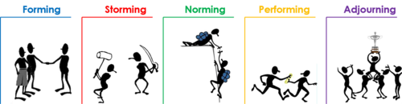
MANAGING CONFLICT IN LLP’ CONSULTATION SERVICE
Name: Imayinkhor Johnbull Osawaru Student Id:1920459

Resolving Conflict of LLP

Conflicts will arise between LLP and
clients and between managers and
employees as they are working together.
Sometimes conflict is good for
organization as team members learn and
grow from conflicts (Wade
-
Benzon
i
,
2013).
But one thing needs to bring in mind
that when adopting a resolution strategy
it must be effective for that
situation(Kindler, 2009).

Strategies for Managing Conflict in LLP
- The more positive side is the management body of LLP can apply a lot of strategies to manage dysfunctional conflicts that occurs with its clients, employees, competitors and other external parties (Lipsky, 2016)
- H. Neilsen provides some conflict reduction strategies in “ Understanding and Managing Conflict” in 1972.
- These strategies will be helpful to resolve conflicts between LLP, its employees and other parties.
(Ashby and Neilsen-Hewett, 2012)

Discussion about Strategies for Managing Conflict in LLP
➢H. Neilsen’ Conflict Management Strategies.
  1.Physical separation
  2.Use of rules and regulations
  3. Limiting inter group interaction
  4.Use of integrators
  5.Confrontation and negotiation
  6.Third-party consultation
  7.Rotation of
  members
  8.Identification of interdependent tasks.
  9. Use of intergroup training
Some strategies LLP should not Implement in Resolving problems.
1. Non action |  |  |  | 2.Administrative  Orbiting |  |  |  | 3.Due process  Non action
 | 4. Secrecy |  |  |  | 5. Character  Assassination

Successful team
development Name: Luciana-Ioana Oproiu
Student number:1914796
Name assignment: ETW Lecturer name: Magdalena

The 4 main ways to build a successful team. Wronska

- Common purpose, shared value and goals
- Development of skills
- Synergetic of harmony (agreement of working together )
- Keep the accent on the positive
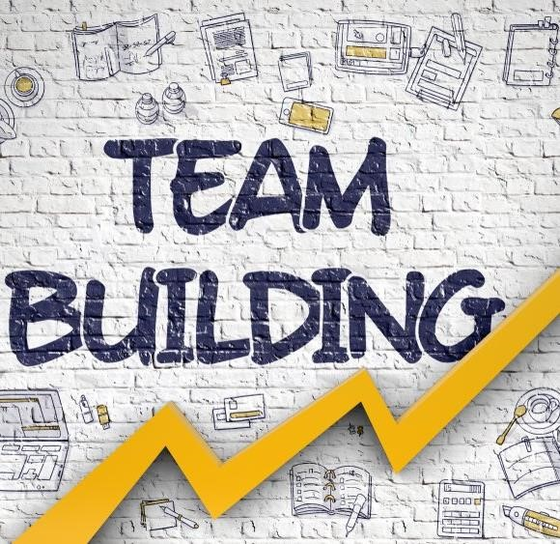
Common purpose,
shared values and goals
The team understand the purpose and goals, they use the diversity in workplace. (Susan M.
Heathfield,2019).
If the work-life is balance is the most important part to rich the goal, because of your life being balance. (Susan M. Heathfield,2019) DEVELOPMENT OF SKILLS
The skills they help to increase profits, improve performance, and for that they should grow with the company, is essential to not think they do like a job, but rather like career.(Business
Essential,2017)
Is a set of values, principals, this team use to improve their communication and keep each other accountable. The team will show how members will work together and share activities, communicate and support each other. (Molood Cecarelli,2020).
Synergetic of harmony(agreement of working together)
KEEP THE ACCENT ON THE POSITIVE
According to Rachel Jackson (2020) “promoting healthy habits you can help your staff to maintain their energy levels and reduce their stress. Office perks such as these will also make your team feel appreciated and further encourage them to do their best work”.
•Susan M. Heathfield,(2019) The balance careers. Available at: https://www.thebalancecareers.com/how-to-set-andachieve-goals-1918137 (Accessed:21 November 2020).
- .Business Essential,(2017)Importance skills development. Available at: https://www.businessessentials.co.za/2015/02/24/importance-skills-
development/#:~:text=The%20most%20important%20reasons%20for,job%2C%20but%20rather%20a%20career.&text=Gr owth%20is%20very(Accessed: 20 November 2020).
- Molood Cecarelli,(2020)Make the best team –agreement. Available at: https://shiftup.work/how-to0-make-the-best-teamagreement/#:~:text=A%20team%20agreement%20is%20a%20set%20of%20values%2C%20principles%20or,information%2 C%20and% (Accessed: 20 November 2020).
- Rachel Jackson (2020) ‘How to motivate and inspire your team to archive better results’, Rachel Jackson today [blog].21 November. Available at:www.impraise.com/blog/how-to-motivate-and-inspire-your-team-to-achieve-better-results (Accessed:21 November 2020).
- Susan M Heathfield November 2019 https://www.thebalancecareers.com/what-are-the-stages-of-team-development-1919224
- https://www.thebalancecareers.com/what-are-the-stages-of-team-development-1919224
- Deirdre Scully August tages-of-team-development-a-case-study.php
Judith Stein 2018
- https://www.teamwork.com/blog/the-5-stages-of-team-development-what-you-need-toknow/#:~:text=%20The%205%20stages%20of%20team%20development%20,it%20doesn%E2%80%99t%20come%20easily.%20In%20the...%20More% 20
- Gina Abudi May 2010
- https://www.projectsmart.co.uk/the-five-s
- https://hr.mit.edu/learning-topics/teams/articles/stages-development

References
Susan M Heathfield November 2019 https://www.thebalancecareers.com/what-are-the-stages-of-team-development-1919224
Deirdre Scully August 2018 https://www.teamwork.com/blog/the-5-stages-of-team-development-what-you-need-toknow/#:~:text=%20The%205%20stages%20of%20team%20development%20,it%20doesn%E2%80%99t%20come%20easily. %20In%20the...%20More%20
Gina Abudi May 2010 https://www.projectsmart.co.uk/the-five-stages-of-team-development-a-case-study.php
Judith Stein
https://hr.mit.edu/learning-topics/teams/articles/stages-development

References
Ashby, N. and Neilsen- Hewett, C., 2012. Approaches to conflict and conflict resolution in toddler relationships. Journal of Early Childhood Research, 10(2), pp.145-161 Kindler, H., 2009. Conflict Management. [Rochester, N.Y.]: Axzo Press.
Lipsky, D., 2016. Managing And Resolving Workplace Conflict. Emerald Group Publishing Limited.
Malloy, T., 2010. Minority Rights and Conflict: From Managing Conflict to Managing Diversity. European Yearbook of Minority Issues Online, 7(1), pp.209-223.
Thomas, K, 1992. Conflict and conflict management: Reflections and update. Journal of Organizational Behaviour,13(3).pp.265-274
Wade-Benzoni, K., 2013. Solving Want/Should Conflicts in the Workplace. Academy of Management Proceedings, 2013(1), p.10458.
.


