
- •STUDENT NAME: ANA MARIA CAPRIOARA
- • STUDENT NO:2019932
- • MODULE CODE: BMHP6009
•MODULE TITLE: LIVING WITH CARE: THE OLDER PERSON
- •LECTURER’S NAME: Laila Surani

Table of Contents
Introduction 3
Changing aging population in UK and Australia in recent years 4
Loneliness and isolation associated theories and explore along with associated concepts 6
The impact on an older person of loneliness and isolation in a care setting 8
Different laws to deal with loneliness and isolation, raise awareness, reduce loneliness among the elderly population 9
The future of the care of the elderly person and changing programs associated to the problem of loneliness among the old people:and the impact technology can have in reducing loneliness and isolation 10
Future of the care of the elderly person: 11
Recommendations 12
Conclusion 12
Reference list 14

Introduction
Health care is a necessity for any human being. This report will raise the issue of loneliness and isolation that is troubling elderly people. The purpose of this report is to understand the impact loneliness and isolation can have among elderly people. This report will include various areas that are concerning loneliness and isolation impacting elderly people. Firstly, the meaning of elderly people in the United Kingdom and in Australia will be outlined. Further, various kinds of statistics related to elderly people in the UK and Australia will be outlined. Furthermore, the theory related to loneliness will be discussed in the report. Finally, some recommendations will be outlined in this report and the intention will be to ensure greater outcomes for the care of elderly people and to reduce the impact of loneliness and isolation. In the care setting a scenario will be outlined to demonstrate the impact of loneliness and isolation in elder people that lives in care setting. Eoin Morgan who is 69 years old person in Anisha Grange Care Home will be used as an example to outline the impact.
Being An elderly person in UK
In the United Kingdom, traditionally an elderly person refers to a person who has reached the age of 65 (Ngaire Coombs, 2019). Traditionally this age has been considered the age of retiring from work in the United Kingdom. 65 years of age has been the age of retiring from work and also an individual can withdraw a state pension at this age. In the current time, the age is changing slightly. In today's professional world of the UK, it has been identified that people who are at the age of 65 are working in higher volumes. Also, these people have greater h healthier conditions and live more expectancy. Therefore, the age of an elderly persons is shifting to higher ages in the United Kingdom. People who are the age of 65 are working effectively and also have different characteristics from people who lived a century ago (Ngaire Coombs, 2019).
In Australia, people who are aged 65 and over can be addressed as elderly people. In Australia usually, the retirement age is 65 (Older Australians, health-status and functioning 2023). It is now gradually shifting from 65 to 67. In Australia also most elderly people have great health conditions. Out of 4 people, 3 people have good health. In 2021 it has been identified that 15% of people of the entire workforce of the nation belongs to the elderly age. People belonging to the elderly age have good health and immune system. In Australia, one out of 6 Australians is an old or elderly person. The participation of elderly people in the workforce is good. These elderly persons create both opportunities and pressure for the health and welfare system of the nation (Older Australians, health-status and functioning 2023)

Changing aging population in UK and Australia in recent years
Statistics of the aging population in the United Kingdom:
In 2018, in the United Kingdom, 18% of the entire population of the nation was aged. The number of people who were included in the aging population was 11.9 million. In past years the number and percentage of people have increased significantly. In 1950, the number was 5.3 million were included the age of 65 and above. Also, the percentage was 10.8% of the entire population. It can be estimated that in the middle of this century, the number of elderly people will increase to 17.7 million (Ngaire Coombs, 2019). The percentage will be 24.8% percent of the entire population. In this aging population oldest are the fastest growing in numbers. People who are above 85 years have been estimated to get increased from 1.6 million to 3.6 million from 2018 to 2050. The number will be 5% of the entire population. The balance of age in the population is also increasing in the United Kingdom. In 1950, the median age was 34 years. In 2018, the median age was 40 years. Also, it has been estimated that by the middle of this century, this median age will be increased to 43. Life expectancy is also increasing among elderly people in the United Kingdom. In 1911, the remaining life expectancy was 57 for men and 60 for men (Ngaire Coombs, 2019). In 2017, it increased to 70 for men and 72 for women (Ngaire Coombs, 2019). It is estimated that by 2066 it will increase to 75 for men and 77 for women (Ngaire Coombs, 2019). Also, positive changes in health and chronological aspect have been noticed among elderly people. In 1981 people of 65 to 85 years ago 45% people reported poor health conditions (Ngaire Coombs, 2019). In 2017, the percentage has reduced to 39%. The health conditions of elderly people have improved in the past few years (Ngaire Coombs, 2019).
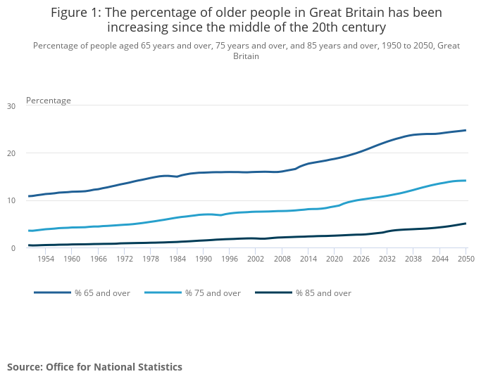
Figure: Increasing number of older people in the UK
Source: (Ngaire Coombs, 2019)
Statistics of the aging population in Australia:
In Australia, according to the statistics of the Australian Bureau of Statistics, has been identified 3 out of 4 elderly people have good health conditions (Older Australians, health-status and functioning 2023). The figure is 74% in percentage. It has been identified that 42% of these aged people have reported their health condition as excellent. 32% out of these people have reported their health condition as good. 2 men out of 5 men elderly men have addressed that their health is in good condition. 1 out of 4 older men has reported their health condition as poor. In women also the rate is very similar. The rate of disability has increased among elderly people in Australia. Previously, the percentage was 36%percent in those aged 65-69. In 2018 the percentage has increased to 85% in people who are 90 years old or higher (Older Australians, health-status and functioning 2023). I'm Australia's life expectancy has significantly improved in the last decade. Men who were at the age of 65 in 2018-20 can live up to more than 20.3 years. In women, people who were at the age of 65 in 2018-20 can live up to more than 23 years (Older Australians, health-status and functioning 2023). In Australia, the reason for death has changed over different years. Coronary heart disease was the primary reason for death for elderly people. During 2018-20 lung cancer caused 8,000 deaths in Australia. Among people aged between 75-84 coronary heart disease was the main cause of death. It caused 12,800 deaths (Older Australians, health-status and functioning 2023)
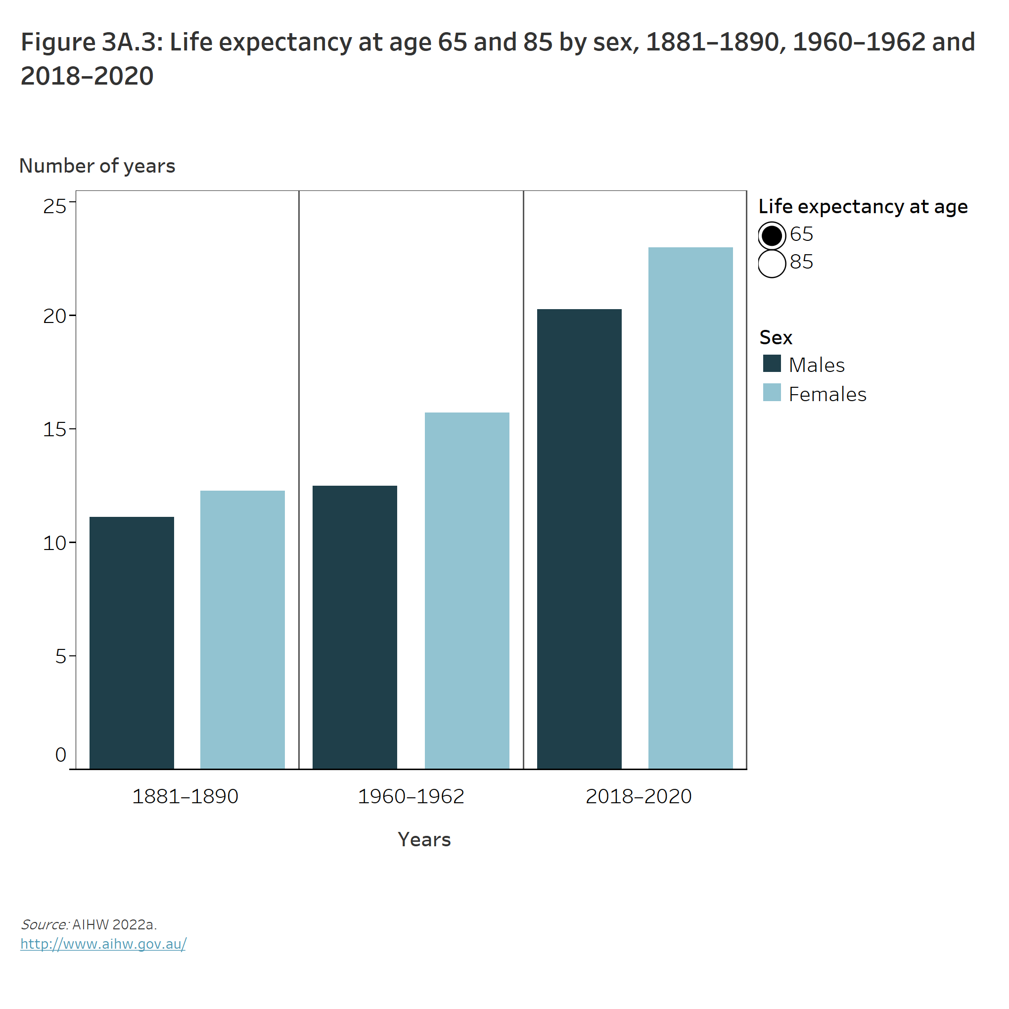
Figure: Life expectancy of elderly people in Australia
Source: (Older Australians, health-status and functioning 2023)

Loneliness and isolation associated theories and explore along with associated concepts
Robert S. Weiss is a sociologist. He has outlined the theory of loneliness. Here, the theory of loneliness will be outlined and discussed to gain further information about the theory (Pirhonen et al., 2020).
Theory of loneliness:
According to Weiss, there are six different social needs which are needed to be fulfilled. If those criteria are not fulfilled then it can lead an individual toward loneliness. Those six needs are social integration, nurturance, attachment, a sense of reliable alliance, guidance in stressful situations, and reassurance of worth.
Social integration:
A human being is always a part of the society in which the individual lives. Therefore, it is important to remain integrated with society. Society includes various kinds of people and some of them can have a great positive impact on personal life. If an individual fails to remain connected with society then loneliness can penetrate the person. If society is not a part of an individual then the individual might fail to share feelings with people and it will lead the person to automatically loneliness. As loneliness comes from remaining alone and isolated from the society (Pirhonen et al., 2020).
Nurturance:
Nurturance refers to the physical and emotional nourishment or care given to an individual. An individual always looks for care and love from other people. If nurturance has not any kind of presence in an individual's life, then it can also lead to loneliness. If an individual fails to avail emotional and physical care from others and close ones then it can lead the person to loneliness. Due to these reasons, nurturance remains part of not being a lonely person.
Attachment:
Attachment refers to the fondness, affection, or sympathy for someone or some people refers to attachment. Attachment is an absolute need to avoid loneliness. Attachment helps an individual to possess love for some people or an individual. If anyone does not have an attachment towards the individual then it can lead to loneliness as the person does not get any kind of affection or love from anyone.
Sense of reliable alliance:
Alliance refers to getting united with someone or some people. A reliable alliance refers to an alliance where both people can rely on each other without any hesitation. If an individual is not able to rely on anyone then it is clear that the person is not able to trust anyone. Lack of trust leads the individual towards loneliness as he is not able to rely on anyone or share anything with anyone then it automatically creates loneliness (Pirhonen et al., 2020).
Guidance in stressful situations:
If a person feels that there is guidance available in tough situations then it helps to remain calm and confident. If an individual is not getting any kind of guidance from anyone in tough or stressful situations then it can create frustration and that leads to loneliness. If the person gets any kind of guidance in tough situations then it will help the person to avoid loneliness and avoid frustration.
Reassurance of worth:
The Worth of a person depends on many things. Trust, love, affection, company, humanity, etc ensure the worth of an individual. If a person feels that an individual has these qualities and can be worthy then it feels very reliable and gives extra confidence. On the other hand, if an individual does not have a worthy person in life, then it leads to a lack of confidence and a lack of love in life. All these factors can lead to loneliness (Pirhonen et al., 2020).

The impact on an older person of loneliness and isolation in a care setting
The impact of loneliness and isolation on older people living in a care setting is very high. There are various kinds of impacts that loneliness and isolation can have on older people who live in a care setting. Loneliness is a very common factor in long-term care settings. Eoin Morgan is 69 years old person and he currently reside in Anisha Grange Care Home. The impact of loneliness is will be outlined by using the example of Eoin Morgan.
- Loneliness can lead to depression. Sometimes Eoin Morgan feels lonely in the healthcare setting, which can cause depression. Loneliness refers to feeling alone which do not allow us to share feelings, emotion, etc. Therefore, sometimes loneliness leads Eoin Morgan to depression. Depression refers to a state of mood disorder where the person does not feel interested or feel saddened most of the time. Lack of company for Morgan in the care setting creates that state of depression (Malcolm et al., 2019).
- Loneliness can lead an older individual to suicidal ideation. Loneliness addresses lack of company, loss of feelings, etc. Whenever these things appear in the mind of Eoin Morgan he starts feeling less valuable as no one gives attention or shows care about him. The feeling of being less valued leads Morgan towards the thought of suicidal attempts. Suicide can lead to loss of life which is a solution for the patient with depression.
- Loneliness and isolation can lead to health risks such as dementia. In the care setting of Eoin Morgan most of the people are unknown and do not act friendly with him. Therefore, Eoin Morgan feel lonely and fails to share his thoughts, emotions, feelings, etc. Therefore, lack of affection and feeling leads to health risks like dementia where he might fail to remind previous occasions.
- Loneliness and isolation of elder people in a care setting can lead to frailty. Frailty refers to the physical weakness that occurs in old age. Mental health directly impacts the state of physical health. As Eoin Morgan fail to express his feelings and thoughts, therefore it directly impacts their state of mental health. Ultimately, physical health gets impacted and issues like frailty occur (Bu et al., 2020).

Different laws to deal with loneliness and isolation, raise awareness, reduce loneliness among the elderly population
Loneliness and isolation need to be reduced. In the world reducing loneliness and isolation has become a priority. Different nations have regulated different rules to reduce loneliness and increase awareness about loneliness.
The Care Act and Loneliness were regulated in 2014 by the government of the United Kingdom (Loneliness and isolation: Guidance for local authorities and Commissioners 2023). This act is clearly an indication that the government has taken initiative to reduce loneliness and isolation in the nation. This legislation includes meeting new preventions, and meeting different support needs and care during different assessments. This legislation has included various kinds of actions that help to cure and reduce loneliness in the nation. NHS has been involved in this regulation to take different actions and preventions which are initiated to reduce isolation and loneliness in the nation (Loneliness and isolation: Guidance for local authorities and Commissioners 2023).
In Australia, the nation has created a National Strategy to Address Social Isolation and Loneliness. The motive for creating that strategy is to end loneliness in the nation collectively. Ending Loneliness Together (ELT) is the national initiative to reduce loneliness and raise awareness about loneliness and isolation (Understanding and defining loneliness and social isolation 2023). This initiative has identified gaps in society that are causing loneliness and isolation. Lack of community skills and awareness, guidelines within mental health systems and community, and absence of uniform standards have been addressed as reasons for increasing loneliness, and isolation. A national community awareness campaign, national social e-health portal, national training for health practitioners, and community care services have been initiated to reduce identified gaps in society (Understanding and defining loneliness and social isolation 2023).
The local, national, and global providers of services for the older person in line with current initiatives and policy
In the United Kingdom, both local and national provisions of services for an older person are in line with current initiatives and policies. In different cities or boroughs according to The Care Act and Loneliness. In these local cities tracking loneliness networks, including groups of high-profile charities, and different public figures formed by the government to reduce loneliness and isolation in society. At the national level, the government has involved National Health Service (NHS) to ensure the proper conduction of rules that are regulated by the government. The Care and Loneliness Act has outlined various kinds of responsibilities for the NHS which will ensure proper regulation of the act (Loneliness and isolation: Guidance for local authorities and Commissioners 2023).
In Australia, the government has initiated a strategy which is named Ending Loneliness Together (ELT). Local administrations of the nation have also participated in ensuring the success of this strategy. Different social gaps have been identified in this strategy. Lack of community and awareness skills, etc have been identified as social gaps in society. Local administrations are working according to the strategy of the national government. Creating national health awareness campaigns, etc has been addressed as one of the solutions for reducing loneliness and isolation in the nation (Understanding and defining loneliness and social isolation 2023).
At the global level, World Health Organization (WHO) has initiated various kinds of social and community training, befriending, and cognitive behavioral theory to reduce loneliness and isolation in the world. As loneliness and isolation are increasing in the world, therefore the organization has outlined various kinds of strategies and regulations. Creating an age-friendly community, improving communication technologies, etc are included in the strategies and initiatives of WHO (Social isolation and loneliness 2023).

The future of the care of the elderly person and changing programs associated to the problem of loneliness among the old people:and the impact technology can have in reducing loneliness and isolation

Future of the care of the elderly person:
The future of Eoin Morgan in Anisha Grange is very bright and fruitful. The inclusion of technology in this organization will ensure the bright future of elderly care. In Anisha Grange, various kinds of technologies will be used such as using artificial intelligence, and the inclusion of personal care robots. In Anisha Grange, artificial intelligence will be used to create and use sensors which will be extremely helpful for the organization. Use of personal care robots to ensure the care of different elderly patients will be also an emerging concept in the future of Anisha Grange (Davies et al., 2021).
The use of different high-profile charities, using different social groups will also increase in the future. Using these charities to ensure better supervising, monitoring, and treatment of loneliness and isolation.
Changing programs associated to the problem of loneliness among the old people:
Different nations such as Australia, and the United Kingdom have initiated various kinds of rules and regulations to cure loneliness and isolation. Addressed changes in these initiatives can ensure better outcomes for curing loneliness and isolation. Various kinds of identified gaps in society should be cured properly with the help of different strategies. Using different high-profile charities, raising awareness about loneliness and isolation, and promoting campaigns for reducing loneliness and isolation should be initiated (Perissinitto et al., 2019).
The impact technology can have in reducing loneliness and isolation:
The use of the latest digital communication technologies can produce a high impact in reducing loneliness and isolation. Using digital communication technologies such as virtual reality, video calls, and chatting can have a great impact on reducing the loneliness and isolation of elderly people. Elderly people can use video calls to talk and interact with different people. Virtual reality can be really helpful for entering the virtual world. All these factors can ensure a greater connection to the outside world. Also, using social media platforms can help these elderly people to reduce loneliness and isolation. Social media will help these elderly people to connect with social friends and the reduce boredom of their regular lifestyle (Ibarra et al., 2020).

Recommendations
Here, some recommendations will be made for the betterment of the care of elderly people and to reduce their loneliness and isolation.
- The use of digital technologies can help Eoin Morgan to connect with different kinds of people. Interacting with new people regularly and getting friendlier with them can help Eoin Morgan to reduce their loneliness and boredom from his life. The availability of technologies has helped people to connect with the outside world more easily. Therefore, these technologies can be used to reduce loneliness and isolation.
- Following guidelines that have been regulated by WHO and the national government. Various national governments such as the UK government and the Australian government have initiated regulations to reduce loneliness and isolation. These guidelines, training methods, and initiatives should be used and executed rightly to reduce loneliness and isolation among elderly people.
- Including more voluntary organizations and similar organizations to ensure better care of elderly people. High-profile charities and huge voluntary organizations have greater involvement and influence in society. Active participation of these organizations can ensure the better promotion of these issues and also can help people to understand the impact of these issues. It will reduce loneliness and isolation as people will understand the impact of these issues.

Conclusion
This report consists of various factors which are related to elderly care and also will be helpful enough for understanding the impact of loneliness and isolation in elder people and in their lives. Firstly, it has been identified that people above the age of 65 are addressed as old people. Further, it has been identified that in the United Kingdom, most older people have a good health condition in comparison to some years ago. Furthermore, the impact of loneliness and isolation in Eoin Morgan who lives in a care setting named Anisha Grange has been outlined here. It has been identified that loneliness and isolation can lead Mr. Morgan to depression, suicidal attempts, etc. As he is unable to express his thoughts and emotions freely, therefore it can cause problems to mental health and can result in frailty. Use of digital technologies can help Mr. Morgan to connect with new people, spend time which will be productive to reduce loneliness and isolation.

Reference list
Bu, F., Abell, J., Zaninotto, P. and Fancourt, D., 2020. A longitudinal analysis of loneliness, social isolation and falls amongst older people in England. Scientific reports, 10(1), pp.1-8.
Davies, K., Maharani, A., Chandola, T., Todd, C. and Pendleton, N., 2021. The longitudinal relationship between loneliness, social isolation, and frailty in older adults in England: a prospective analysis. The Lancet Healthy Longevity, 2(2), pp.e70-e77.
Domènech‐Abella, J., Mundó, J., Switsers, L., Van Tilburg, T., Fernández, D. and Aznar‐Lou, I., 2021. Social network size, loneliness, physical functioning and depressive symptoms among older adults: Examining reciprocal associations in four waves of the Longitudinal Aging Study Amsterdam (LASA). International journal of geriatric psychiatry, 36(10), pp.1541-1549.
Donovan, N.J. and Blazer, D., 2020. Social isolation and loneliness in older adults: review and commentary of a national academies report. The American Journal of Geriatric Psychiatry, 28(12), pp.1233-1244.
Ibarra, F., Baez, M., Cernuzzi, L. and Casati, F., 2020. A systematic review on technology-supported interventions to improve old-age social wellbeing: loneliness, social isolation, and connectedness. Journal of healthcare engineering, 2020.
Loneliness and isolation: Guidance for local authorities and Commissioners (2023) Loneliness and Isolation Policy Levers Comments. Available at: https://campaigntoendloneliness.org/guidance/policy-landscape/#:~:text=The%20Care%20Act%20and%20Loneliness,support%20needs%20identified%20during%20assessments. (Accessed: March 13, 2023).
Malcolm, M., Frost, H. and Cowie, J., 2019. Loneliness and social isolation causal association with health-related lifestyle risk in older adults: a systematic review and meta-analysis protocol. Systematic reviews, 8(1), pp.1-8.
Ngaire Coombs, A.S. (2019) Living longer: Is Age 70 the new age 65?, Living longer: is age 70 the new age 65? - Office for National Statistics. Office for National Statistics. Available at: https://www.ons.gov.uk/peoplepopulationandcommunity/birthsdeathsandmarriages/ageing/articles/livinglongerisage70thenewage65/2019-11-19#:~:text=1.-,When%20does%20older%20age%20begin%3F,could%20draw%20their%20State%20Pension. (Accessed: March 13, 2023).
Older Australians, health-status and functioning (2023) Australian Institute of Health and Welfare. Available at: https://www.aihw.gov.au/reports/older-people/older-australians/contents/health/health-status-and-functioning (Accessed: March 13, 2023).
Perissinotto, C., Holt‐Lunstad, J., Periyakoil, V.S. and Covinsky, K., 2019. A practical approach to assessing and mitigating loneliness and isolation in older adults. Journal of the American Geriatrics Society, 67(4), pp.657-662.
Philip, K.E., Polkey, M.I., Hopkinson, N.S., Steptoe, A. and Fancourt, D., 2020. Social isolation, loneliness and physical performance in older-adults: fixed effects analyses of a cohort study. Scientific reports, 10(1), p.13908.
Pirhonen, J., Tiilikainen, E., Pekkarinen, S., Lemivaara, M. and Melkas, H., 2020. Can robots tackle late-life loneliness? Scanning of future opportunities and challenges in assisted living facilities. Futures, 124, p.102640.
Social isolation and loneliness (2023) World Health Organization. World Health Organization. Available at: https://www.who.int/teams/social-determinants-of-health/demographic-change-and-healthy-ageing/social-isolation-and-loneliness#:~:text=These%20include%20social%20skills%20training,reduce%20social%20isolation%20and%20loneliness. (Accessed: March 13, 2023).
Understanding and defining loneliness and social isolation (2023) AIFS. Available at: https://aifs.gov.au/resources/resource-sheets/understanding-and-defining-loneliness-and-social-isolation (Accessed: March 13, 2023).

