
Sports Industry Research
Project Report M6X02100
Assignment 2

Christopher Gray

Is it really worth it? A Parents Perception on the Benefits of Football Excellence

Acknowledgements
I wish to acknowledge my dissertation supervisor Mr Andrew Thomas for all the support and encouragement over the last 24 months. Everything that has been taught by himself and the lecture team at the University of Wales Trinity Saint David has truly stuck with me and allowed to perform at the best of my ability in each assignment area.
I wish to thank my family for their upmost support in being able to achieve my goals of going to University and hopefully succeeding in my Sports Management Degree and I hope I have made them proud.
Further to this, I wish to thank my Fiancé Lauren, for her continued support whilst I have undertaken the foundation degree and now the honours degree. Without her help and commitment to helping me I would not have achieved anywhere as near as what I have done.
Finally, I would like to thank the Football Association of Wales for allowing me to conduct my research at the West Wales Girl’s Performance Centre. Without their permission I would not have been able to have conducted this study. I hope that the findings from my study can be effectively used by the Football Association of Wales.
Thank you to everyone mentioned in this section.

Abstract
The aim of this study was to explore the reasons which parents perceive to be benefits of football excellence in the West Wales Girls’ performance centre for attendees aged 9-14 to. The purpose of this study is to examine parent’s perceptions on the benefits of football excellence for their children at the West Wales Girl’s Performance Centre. A mixed method approach adopting both qualitative and quantitative research designs were employed in this study. Data collection methods included qualitative and quantitative questionnaires. Forty-five questionnaires were collected and analysed through data presentation techniques, to make it easier to present in graphical form and help to identify themes.
The UK Government implemented a 24-hour curfew in March 2020 due to the global outbreak of COVID-19 (coronavirus). UWTSD took steps to support students remotely with continued online supervision. However, many National Governing Bodies (NGB's), Sports Teams and Schools closed during this period which meant that data collection became more challenging. With the implementation of the Curfew, it has led to the West Wales Girls Performance Centre closing, thus affecting the way in which I had to collect my data. Therefore, leading to the collection of data through online questionnaires.
Parents indicated a range of social, physical, and emotional skills that were identified as perceived benefits for children at the performance centre. Parents believed that their children learned more in the centre partly because of the deeper understanding in one chosen sport, and parental involvement. Past research (Malina, 2001; Green, Smith & Roberts, 2005) looked at factors that caused youths to stop participating in sport or physical activity. The main aim of the study intended to further this research by exploring factors which cause young females to drop out of sport and physical activity.

Contents Page (use relevant number of pages)
Chapter 1
- Introduction Page 7-10
Chapter 2
2.0 Literature Review Page 11
2.1 Background of Football in the United Kingdom Page 11
2.1.1 Background of Woman’s Football Page 11
2.2 Participation in Sport Page 11-12
2.2.1 Current Participation Levels in Sport Page 12
2.2.2 Female Participation in Sport Page 12-13
2.2.3 Barriers of participation in Female Sport Page 13
2.2.3.1 Time and Travel Page 13
2.2.3.2 Money Page 14
2.2.3.3 Gender Page 14
2.2.4 Motivational Factors for Female Participation in Sport
Page 15
2.2.5 Motivational Factors for Female participation in Football
Page 15
2.2.6 Football Female Participation in Football Statistics
Page 15
2.2.7 Parents Perceptions on Sports Participation
Page 16
2.2.8 Parenting Experiences in Elite Youth Football Page 16-17
2.3 Current Strategies and Initiatives for Female Participation Page 17
2.3.1 This Girl Can Page 17
2.3.2 Fit Got Real Page 17
2.3.3 The Game Plan for Growth Page 17-18

2.4 Current Strategies and Initiatives for Female Participation in Wales
Page 18
2.4.1 Our Squad Page 18
2.4.2 Huddle Page 18
2.4.3 What Moves You Campaign Page 18
2.4.4 BE. Football Page 18
2.5 What is an Elite Performance Pathway? Page 18-19
2.5.1 FAW Elite Performance Pathway Page 19-20
2.6 Conclusion of Literature Review Page 20
Chapter 3
3.0 Methodology Page 21
3.1 Introduction Page 21
3.1.1 Epistemological Perspective Page 21
3.1.2 What is Knowledge? Page 21-22
3.2 Research Methodology Page 22
3.2.1 Methodology: Qualitative or Quantitative or Mixed Method Approach?
Page 22
3.3 Data Collection Techniques Page 23
3.3.1 Questionnaires Page 23
3.4 Sample Page 23
3.5 Data Analysis Techniques Page 23-24
3.6 Validity and Reliability Page 24
Chapter 4
4.0 Findings and Results Page 25-26
4.0.1 Teamwork Page 26
4.0.2 New Friendship Groups Page 26
4.0.3 Enhanced Fitness Page 26-27

4.1 Facilities and Travel Page 27-29

4.2 FAW Players Performance Pathway Page 30-31

Chapter 5
5.0 Conclusion Page 32-33
Chapter 6
6.0 Recommendations Page 34
6.1 Option of a facility closer to Swansea and Neath Port Talbot areas
Page 34
6.2 Toilet Facilities Page 34
6.3 Documentation for the WWGPC and FAW Performance Pathway
Page 35
7.0 References Page 36-55
8.0 Bibliography Page 56-57
9.0 Appendices Page 58
9.1 Questionnaire Page 58-60
9.2 Email to Andy Jones Page 61-62
9.3 Email to Kat Lovett Page 63
9.4 Response from Kat Lovett Page 64
9.5 FAW Performance Pathway Page 65
9.6 Ethics Forms Page 66-72

List of Figures or illustrations
Figure 1: Highest Percentages regarding perceived benefits of participating at the West Wales Girls Performance Centre Page 25
Figure 2: Perceived benefits of attending the West Wales Girls Performance Centre with the lowest percentages Page 27
Figure 3: Facilities at Ysgol Maes Y Gwendraeth. Page 28
Figure 4: How far do you travel roughly (One Way) Page 29
Figure 5: FAW Performance Pathway Question Result Page 30

Main body – Introduction
Chapter 1
1.0 Introduction
Research Aim
• To evaluate the rationale, perceived benefits and likely continuation for parents attending the West Wales Girls Performance Centre
Objectives
• Establish the key motivational factors that drive parents to take their children to Adult-led sporting clubs/centres.
• To identify benefits of participating in football and an excellence centre for young children
• Evaluate the outcome of responses in relation to the Football Association of Wales
Women’s and girls’ active involvement within the football environment has over the last few years been viewed as quite complex (Caudwell, 2012). Women and girls continue to be active in all aspects of the football environment such as:
• Spectating
• Managing
• Coaching
• Playing
These areas mentioned can be seen in all areas of the football pyramid in all levels of the game including:
• Grassroots
• Developmental Academies
• Competitive fixtures

• Elite Level
Participation in organised sports has become a major part of children’s and adolescents’ lives over recent years and has contributed to a variety of positive outcomes. Health benefits from physical activity and participation in organised sports have seen a range of physical, mental, and social benefits for young adolescents and children (Vella et al, 2017). The participation in organised sports programs can have an impact on the range of childhood skills that can be developed through organized sports, such as jumping, kicking, and throwing (Matvienko and Ahrabi-Fard, 2017), which are perceived benefits highlighted by parents and also can be associated with better cardiovascular fitness, both in the short-term for children and into teenage years (Barnett et al, 2008).
Little research has been carried out on the area surround parents perceptions of their children’s experiences in the sporting environment. One study that cites parents having the opportunity to voice their opinions in a research study is the work of Wiersma and Fifer (2008) who held focus group interviews to help understand parental involvement within youth sport from the perspective of parent’s. Therefore, parents described the increase in satisfaction that they gain from the increased opportunity to speak and interact with their children and, seeing their child learning, enjoying and being successful in the youth sport environment. Little is known about parents’ perceptions of their children’s experiences in youth sport programs (Na, 2015). Instead, many researchers have primarily focused on the effect parents have on their children’s levels of motivation, achievements, and competence in the sporting environment (Bois, Sarrazin, Brustad, Trouilloud, & Cury, 2005; Eccles, 1993; Fredricks & Eccles, 2004).
Researchers across the globe suggest that participating in sport and physical activity can bring a range of benefits to an individual’s mental health, physical health, and social benefits also. Some benefits of sport include improved confidence, improved relationships with friends and peers (Mulvihill, Rivers and Aggleton, 2000; World Health Organisation, 2009; Houlihan and Green, 2011). Even though there is such a range of benefits from participating in sport, participation levels are relatively low. The School Sport Survey 2018 showed that, 46% of girls took part in sport three or more times a week in comparison to 2015, where 44% of girls stated that they regularly took part in

sporting activity. When looking at the concerns about girls’ physical activity levels, the issue of girls’ low participation levels in football and other male dominated sports is a matter of interest not only to researchers but sports professionals across the world and the importance of research into the lack of participation in sport by young girls and women (Clark and Paechter, 2007). Initiatives set out by the government to tackle the issue of falling sports participation levels such as Dragon Sport and 5x60. The irregularity of physical education within the educational setting is often a barrier to participation in sport for young people (Pickup et al. 2007) which in turn made the way primary school physical education a long-term success within the 5x60 strategy. The more sport that children undertake in early life, the more that girls would want to attend football and prolong their careers in sport. Supporting this, Marsden and Weston (2007) state that ‘the quality of physical education in the early stages of life can affect a child’s motivation to participate in physical activity for the remainder of their lives.
Despite the low participation rates, the rise in participation levels in girls’ and women’s football is rather impressive. Since 2016, female football has grown by 50% with a record 8,600 women and girls now signed up to football clubs in Wales (FAW, 2020). You can see the progression of girls’ football in Wales through the progressive statistics that come directly from the Football Association of Wales. As noted, girls’ and woman’s participation levels in football here in Wales has rose each year. As of 2018, a 17% increase occurred with 6020 under 16 girls participating in football (FAW, 2018). Within two years, you can see that a further 33% increase occurred for years 2018-20 which over such a small period is an outstanding rise in participation levels.
Clear pathways of progression that enable the growth of individuals in the sporting field are recognised as being tools that are important for the sustained levels of participation within football and therefore it also helps support player development through the route from grassroots to the elite stage (UEFA, 2013b). This has been effective in Welsh football female sector of Welsh football with the introduction of the ‘Girls Player Pathway’ for Wales which indicated the clear route from grassroots football up to the national level.
Academies and centres of excellence such as the WWGPC aim to help young players maximise their potential on the football field, in education and life. The well-being of players and personal development milestones are at the heart of all academy and excellence centres (EFL Youth Development, 2018).

Main body - Literature Review (use relevant number of pages)
Chapter 2
2.0 Literature Review
2.1 Background of Football in the United Kingdom
The modern-day history of the world’s most popular sport in the World spans for more than 100 years (Boudway, 2018; SportShow, 2019; Topendsports, 2019). The game we see today all began back in 1863 in England, when association football and rugby football separated and branched off on their different courses leading to the formation of the Football Association in England – becoming the sport’s first governing body (FIFA.com, N.a).
2.1.1 Background of Woman’s Football
History of Ladies Football dates back over 100 years to the first football match in the mid 1890’s. The Football Association placed a ban on women’s football from club grounds as they claimed that football was ‘quite unsuitable for females’ which changed towards the end of the 1960s (Doble, 2015). Adding to the history of the women’s game The Women’s FA (WFA) was created in 1969 and within three years of establishment, the first Women’s FA Cup final and Women’s England internationals took place. In 1993, a Women’s football committee was set up to continue the running of the women’s game in England (The FA, N.a).
2.2 Participation in Sport
Participation in sport does not have to be exclusive to sports in an organised set-up and sporting clubs although this is often the way of ensuring continued and regular participation (Deelan, Ettema & Kamphuis, 2018). Sports participation can be defined as having been physically active during the last four weeks (Humphreys and Ruseski, 2009) however Leslie et al (2004) define sports participation as having practiced a form of sport within the last fortnight.

Increasing sports participation and physical activity is an important health objective in developed countries such as the United Kingdom (Nichelson, Hoye & Houlihan, 2011; Eime et al, 2015). Sport participation can also lead to increased levels of physical activity among children and adolescents. This is beneficial, because most youth from developed countries such as the United Kingdom are physically inactive (Janssen et al., 2005).
There is a steady growth of research that supports the concept that sport may provide children and youth with qualities such as assets, values, competencies and life skills that help them to thrive away from the sporting field (Jones, Dunn, Holt, Sullivan and Bloom, 2011).
2.2.1 Current Participation Levels in Sport
Latest figures from the Active Lives Adult Survey show 61.8% of the 16+ population in England are active with the number of people participating at 27.7 million people (Sport England, 2018). At the other end of the table, 25.7% of the adult population are inactive. This leads to an overall number of 11.5 million people (Sport England, 2018). When looking predominantly at Wales, for adults, figures show that 62% of males are more likely to participate in sport compared to females where 51% they would participate in sport. Further to this, there are more than double male members (22%) of sports clubs than the 11% of females (Sport Wales, n.a).
When looking at primary school age, participation levels for sports participation outside of school hours peaks around 68%. However, by the end of secondary school, the levels of sports participation declines significantly with only 44% of girls partaking in physical activity and 52% of boys (Sport Wales, n,a). Children and adolescents who participate in sport and physical activity accumulate more steps-per-day and are more likely to meet the physical activity guidelines than non-sporting participants (Active Healthy Kids Canada, 2009).
2.2.2 Female Participation in Sport
Women who begin sporting participation younger in life are more likely to continue being physically active as they get older (Crouter, 2007). Youle, (2017) reported that the number of females undertaking sport in Wales is lower than the participation levels of

males within the Country. However, female participation levels continue to rise to the levels at which males are currently participating at.
There are many reasons for the increase in participation by females, Coakley and Pike (2009) believe that there are five factors that are included: increased coverage across media platforms of women in sports, the fitness and health movements across the United Kingdom and the Globe, Governmental legislation and policies mandating to equality and equal rights and new opportunities.
2.2.3 Barriers of Participation in Female Sport
Aldridge, (2013) defines the term barrier as ‘something that stops or prevents an individual developing in a sport or physical activity.
Boiche, (2009) investigated potential factors for dropout rates in sport and the continuation of sport. Whereas Perry, (2011) pursued the route of identifying perceptions of motivators and barriers to undertaking physical activity.
2.2.3.1 Time and Travel
Dwyer et al., (2006) identified a lack of time as one of the main barriers to participating in sports and physical activity. Training at the West Wales Girls’ Performance centre is at 7.30pm on a weekday night. Most parents see this as quite late regarding that their children are of primary/secondary school age and as the training is on a school day, they may seek to non-attend due to this (Vu, Murrie, Gonzalez and Jobe, 2006; Robbins, Talley, Wu, and Wilbur, 2010).
Further to add to this barrier, many parents work week days and long hours, therefore the ability to travel from Swansea to Cross Hands on a weekday evening could prove hard for some parents and could lead them to not being able to take their children to the performance centre.

2.2.3.2 Money
Additionally, money can also be a barrier to young females participating in sports due to the income that their families receive. The Sociodemographic view of South Wales is that of a more working-class population with lower income jobs (Scully, 2017). Pollock,
(2019), explained that Wales is the only UK nation which has seen child poverty rise. As of 2017-18 figures show 29.3% of children were in Poverty.
Money can also be perceived as a barrier for participation, as the young children get older parents cannot afford to be paying for their children to participate in certain sports and activities, Craike et al., (2009). The West Wales Girls Performance Centre is currently £110 per annum. If you refer to figure 3 in the appendices you will see current pricings of the WWGPC kit. with the cost of kit starting at £65.00 (Total Teamwear, n.a). Studies show that financial barriers were a major factor that restricted participation in sport among children from low-income families. Furthermore, children and adolescents from low-income communities have restricted access to sport/leisure facilities (Gordon-Larsen, McMurray, & Popkin, 2000).
The ﬁndings regarding parenting perceptions by Wheeler and Green (2014) revealed that parents felt they were better able and more inclined to invest in their children in general, and their children’s sports participation in particular, because of several ‘structural’ and ‘cultural’ changes that have occurred over the past 30 years or so.
2.2.3.3 Gender
Another barrier to sporting participation is Gender. One of the biggest barriers in women’s sport today is the association of levels if activity and the perception that physical activity is ‘unfeminine’ (NI Assembly, 2010). This is apparent in the gender imbalance evident across higher levels of businesses within the sporting industry, the portrayal of female sport in the media and the formative experiences of many women in the United Kingdom.

2.2.4 Motivational Factors for Female participation in Sport
Gaston-Gayles, (2004) indicated that the opportunity to play at an elite level within sports is a key motivational motive but more prominent within the male sporting population.
It has been suggested that women who partake in sport and physical activity at elite levels feel a sense of empowerment (Robinson and Ferraro, 2004; Staurowsky et al, 2009).
2.2.5 Motivational Factors for Female participation in Football
When looking at motivational factors for female football participation, we need to underline the need for the self-determination theory. This outlines how environmental and social factors affect a persons, well-being, autonomy, mental health, self-determined behaviour, and related performance (Podlog et al, 2011).
A behaviour that is self-determined should support an individual’s experience and needs of competence, relatedness, and autonomy as well as influence motivation (Ryan and Deci, 2000).
2.2.6 Female Participation in Football statistics
Middleton, (2019) identified that a record number of girls and women are currently taking part in football thanks to the Women’s World Cup. When looking at statistical values of female participation in football in the UEFA ‘Women’s football across the national associations’ report (2017), you can see that player numbers went up by 7% from 1.270 million in 2016, to 1.365 million in 2017 in just one year.
The Football Association stated that over 2.63 million women aged 16 and over in England play football. With 23% playing either 11-a-side or small sided competitive football (BBC Sport, 2019). Figures from the Football Associations Game plan for Growth show that attendances to matches in the Women’s Super League are up by 13% and attendances have risen by over 75% in the FA Women’s Championship also (FA Gameplan for Growth, 2019).

2.2.7 Parents Perceptions on Sports Participation
Parents influence their children’s involvement in sport in several ways. In Fredricks and Eccles’ (2004) model of parental influence on children’s motivation and achievement, it is suggested that parents fulfil three crucial roles: provider, interpreter, and role model.
The importance of parents in children’s sporting participation and exercise behaviours cannot be overemphasized (Brustad, 1993). Research has indicated that parents were influential in the adoption of healthy behaviours such as involvement in physical activity in children and adolescents (Bois, Sarrazin, Brustrad, Trouilloud & Cury, 2005; Fredricks and Eccles, 2005). The examples stated from this literature imply that parental involvement is crucial to the children’s socialization process.
Furthermore, recreational benefits, social and health benefits are the top three reasons parents cite for their child’s participation in sports (Meaney et al, 1995). Additionally, Neely and Holt, (2008) highlighted that their children gained a variety of personal, physical, and social benefits such as positive perception, teamwork and co-operation skills, opportunities to make friends, increase in physical activity levels and development of fundamental movement skills.
2.2.8 Parenting experiences of Elite Youth Football
The parenting-sport literature to date has been dominated by research that has aimed at identifying “optimal” behaviours for parents in sport that enable their children to have reduced levels of anxiety, increased enjoyment and successful progression through sport (Babkes and Weiss, 1999; Weurth, Lee and Alfermann, 2004; O’Rourke, Smith, Smoll and Cumming, 2011).
The influence of contextual factors on the behaviour of parents in sport has previously been identified in past research. Such work as Dorsch, Smith and McDonough (2009) which illustrated that a parents cognition, behaviour and affect changed in response to the participation in sport by their child, through an interactive process involving the agency of the parents involved, the influence of the child and the social context (Clarke, 2014).

In one of the few studies that give parents the chance to voice their opinions in their research, Wiersma and Fifer (2008) held focus groups to understand involvement of parents in youth sport from the parent’s perspective.
2.3 Current Strategies and Initiatives for Female Participation
Strategy can be defined as a method or plan chosen to bring about a desired future, such as the achievement of goals or solutions to a problem (Business Dictionary, n.a).
Initiative can be defined as a new plan or process which aims to achieve something or solve a problem (Cambridge Dictionary, n.a).
2.3.1 This Girl Can
This girl can is a nationwide campaign aimed to get women and girls engaged and active regardless of ability, size, and shape (Sport England, n.a). Vizard, (2018), states that the This Girl Can campaign aids in the tackling of inequality and helps to leave no woman behind.
2.3.2 Fit Got Real
Fit got real is the third instalment of the ‘This Girl Can’ campaign. Launched in 2018, it builds on the successes and achievements of the ‘This Girl Can’ campaign and seeks to challenge the conventional ideas of what exercise looks like (Sport England, n.a; Moss, 2018).
2.3.3 The Game plan for Growth
The Game plan for growth strategy is set out by the Football Association with the main aims of doubling participation levels in the women and girls’ football, doubling the number of fans attending games and consistent success on the International Stage (FA Strategic Plan, 2016).
As the plan is two years into the four-year strategy, the statistics that have come from the 2019 report suggest that ladies and girl’s participation in football is increasing at a fast rate. Participation levels for players grew 9% to 2.7 million, coaches went up by

nearly a quarter (24%) to 1,691. Referees in the ladies and girls football leagues grew 13% to 1727 (FA - the Game Plane for Growth Year 2 Report, 2019).
2.4 Current Strategies and Initiatives for Female Participation in Wales
2.4.1 Our Squad
Our Squad, is an initiative set up by Sport Wales aimed at empowering, encouraging and inspiring more women and girls in Wales to get active and partake in sports and physical activity (Sport Wales, n.a; BBC News, 2017; Cook, 2018).
2.4.2 Huddle
Huddle is a new and exciting programme created by the Football Association of Wales Trust, with the aim to achieve a target of 20,000 female footballers in the country by 2024 (FAW Trust, 2019; Parkinson, 2019).
2.4.3 What Moves You Campaign
What Moves You?' is a campaign by Sport Wales. The campaign aims to get women of all ages across Wales to find their trainers and fall in love with sport. Many individual women may find sport competitive or they perceive themselves to have a lack of
confidence or ability, but this is the reason the campaign has been started by Sport Wales (Sport Wales, N.A.).
2.4.4 BE. Football
‘BE.Football’ is a new campaign launched by the Football Association of Wales to celebrate and unite all levels of the women and girls’ games in Wales. The campaign aims to challenge the perceptions of women’s sport, give confidence, and inspire the many women and girls playing football in Wales (Abergavenny Chronicle, 2019; Davies, 2019; FAW, 2019).
2.5 What is an Elite Performance Pathway?
Successful performance pathways require a range of expert coaching, leadership, and support staff, all working towards a shared common goal of identifying and confirming

the right athletes. Furthermore, the need to support those individuals to develop within an optimal sporting environment (UK Sport, N.A.).
The long-term athlete development (LTAD) model has been adopted by a variety of sporting associations and organisations worldwide in an effort to link closely training prescription with the timing and tempo of maturation in younger years (Balyi, 2002; Balyi & Hamilton, 2004).
When looking at football in the United Kingdom, it is clear to see the EPPP is the leading strategy in football. The Elite Player Performance Plan (EPPP) is a long-term strategy with the aim of developing a larger base of home-grown players and ensuring the quality of the players is of a higher standard. The plan which has been in place since 2012, promotes the empowerment of each individual player through a player-led approach (Premier League, 2019).
2.5.1 FAW Elite Performance Pathway
Clear progressive pathways that enable growth of sporting individuals are recognised as being tools that are important for the sustained participation in football and helps to support the player development through the route from grassroots football to the elite stage (UEFA, 2013b). This has been effective in Wales and predominantly in the female sector of Welsh football with the introduction of the ‘Girls Player Pathway’ for Wales which indicated the clear route from grassroots football up to the national level.
This therefore helps the Welsh Football Trust to ensure the continuation of high standard setting and enable the next generation of footballers to challenge themselves and earn the right to progress up the ladder of succession, as seen in figure 4 (WFT, 2013b). Running trials for the most talented girl footballers, born between 2003 and 2011, this ultimately allows them to make their step-up into the development pathway at a regional performance centre (FAW Trust, 2018).
The development of women’s football in Wales has grown significantly over recent years and this is demonstrated through statistical values which show around 4000 registered players since 2000 in Wales (UEFA, 2013b). The Welsh Football Trust is responsible for the identification and development of young female players across Wales (WFT, 2010).

In addition to the girls’ player pathway that has been introduced for girls from grassroots football to the elite level, the Welsh Football Trust provide a range of development centres and regional squads to assist in the nurture, development and support for talented players to progress through to the national squads at age-grade level.
2.6 Literature Conclusion
To conclude, more research needs to be undertaken to clearly identify the range of parental perspectives based around the sporting environment. More needs to be done to sustain this field of research needs to be focused on to ensure future development plans of elite sport youth set-ups. This can be done through listening to what parents perceive are benefits to their children when attending such Adult-led set ups.
Additionally, looking predominantly at the literature surrounding women’s football in Wales, it is clear to see that although participation levels in physical activity and sport are generally far lower than what it should be within Wales, the increase in participation within women’s and girls’ football contradicts this theme (McGoona, 2014). It is therefore important to understand what the Football Association in England and Wales are doing to increase the popularity of women’s football and therefore implement the successes of both football associations and apply them to a range of different sports to help increase female participation and performance levels at both grassroots and elite levels.

Main body – Methodology
Chapter 3
3.0 Methodology
3.1 Introduction
This chapter helps to outline the specific methodology adapted within this study to explore the nature of responses from parents, an aid in the understanding of the benefits of football excellence on their children who are involved in the West Wales Girls’ Performance Centre. The main intention of this study is to ascertain a key understanding of parental views and knowledge on the benefits that their children encounter whilst in a football excellence pathway.
3.1.1 Epistemological Perspective
Epistemology is a field of science that deals with the knowledge and how people acquire knowledge. It is concerned with how we as human beings gain knowledge and how we come to an answer. It is particularly concerned with the sources, nature and limitations of knowledge. Therefore, it can be defined as “a field of philosophy concerned with the limits, sources, nature and possibility of human knowledge” (Jupp, 2006).
The epistemological essentialist approach underestimates that the nature of knowledge is continuously changing over time (Barnett, 2000). Research that relies upon using the constructivist approach. To understand the benefits of football excellence it is only right to explore the minds of parents and understand the way in which they choose their answers. Epistemology therefore determines what researchers accept as the truth or as real, which then guides how we attain that knowledge” (Whaley & Krane, 2011, p. 396).
3.1.2 What is Knowledge
Knowledge is the understanding and awareness of aspects of reality. It is the clear information gained through the process of reasoning when applied to reality (Philosophy Basics, n.d).

Therefore, for this study I will use Interpretive Description (ID) methodology, which is a qualitative approach for generating grounded knowledge in applied research settings (Thorne, 2008).
3.2 Research Methodology
This research draws primarily on questionnaires with parents across four age groups at the West Wales Girls Performance Centre. The chosen participants are selected at random to complete the questionnaires and are randomly selected to undertake a focus group.
3.2.1 Methodology: Qualitative or Quantitative or Mixed Method Approach?
By mixing both qualitative and quantitative research and data, you can gain depth and breadth of understanding while offsetting the weaknesses that come with using individual approaches themselves. A mixed method research approach represents research that involves analysing, collecting, and interpreting qualitative and quantitative data in a single study (Leech and Onwuegbuzie, 2008). Further to this, Cresswell and Plano Clark (2007: 5) identify the mixed method research approach as a research design with philosophical assumptions as well as methods of inquiry. Its central premise is that the use of both forms of collecting data through qualitative and quantitative approaches combine to provide a better understanding of research problems.
By mixing both qualitative and quantitative it allows for the scope of research which allows to offset the weaknesses of using either approach alone (Blake 1989; Greene, Caracelli, and Graham, 1989; Rossman and Wilson, 1991).
Quantitative research methods are used to explain and provide description of different phenomena that occur during research (Gramatikov, Barendrecht, Laxinarayan, Verdonschot, Klaming and Zeeland, 2010, p. 47). The inclusion of a quantitative approach to this study proved beneficial as it allows for a large sample to be studied, therefore reducing generalisability bias within the study (Thomas and Nelson, 2001).

3.3 Data Collection Techniques
The use of multiple data collection techniques helps strengthen the credibility of outcomes from participants and enables different interpretations and meanings to be included in data analysis (Shanks and Bekmamedova, 2018). This is also known as triangulation (Flick, 2014).
3.3.1 Questionnaires
Jack and Clark (1998) state that questionnaires are a cost-effective research tool for use in data collection. Mcleod, (2018) identifies a questionnaire as a research instrument which consists of a series of questions for the purpose of gathering valuable information from participants. Quantitative data can be collected using questionnaires often using close-ended questions, open questions, and Likert scaling questions. Likert Scales are a five- or seven-point scale which is used to allow a person to express how much they disagree or agree with a statement (Mcleod, 2019).
The primary aim of the questionnaire is to ascertain the perceived benefits of football excellence within the West Wales Girls’ Performance Centre. The secondary aim for the questionnaire is to try to understand the reasoning behind the parent’s answers and how an epistemological approach affects the answers for each question.
Sallis and Saelens (2000) states that the reliability of a research study when using questionnaires could inevitably be hampered due to the misinterpretations of the questions asked. To prevent this, all the questions in this study are of a simple, concise nature.
3.4 Sample
The purposeful sampling criteria (Patton, 2002) were to recruit several parents of children aged 8-14 years who were involved in a range of organized youth sport programs (e.g. West Wales Girls Performance Centre). Therefore, 40 - 50 participants were recruited via the director of the West Wales Girls Performance Centre to an online questionnaire; links to the questionnaire were emailed to parents via the Survey Monkey link (https://www.surveymonkey.co.uk/r/Q7FWQ2B), and parents of attendees were able to

complete the questionnaire). The age range of respondents was from 18-100 years. Participants were required to be English speaking, and over 18 to fill in the questionnaire.
3.5 Data Analysis Techniques
The analysis of data is seen as a crucial part of any research, as it provides an overview of the collected data and aims to make sense of the collected data in order to answer the research question (Gratton and Jones, 2004).
Questionnaires are the primary source of data as they can lead to results relatively quickly through the answering of a structured set of questions. The structured questionnaire can lead to data and graphs being created with ease and ultimately lead to results being found relatively easily. Therefore, for the results to be shown effectively I will be using data presentation to help with the forecasting the future requirements and recommendations. Data Presentation enables all numerical data collected to be presented in graphical form which makes the data easier to analyse. Some of the ways which can be used are:
• Histogram
• Bar Charts
All data would be placed into graphs and through this calculation can be done easily (Weerahandi, 2003).
3.6 Validity and Reliability
Reliability and validity are concepts used to evaluate the quality of research such as mine. They therefore indicate how well a method, technique, is used in my research. Reliability is about the consistency of a measure, and validity is about the accuracy of a measure (Middleton, 2020). Validity and reliability have been considered throughout this study, with sampling, data collection techniques, and appropriate methods of measurement have been used throughout this study. It is important to consider reliability and validity when you create a research design, planning methods, and writing up results, especially in a mixed method research design (Middleton, 2020).

Main body – Findings (use relevant number of pages)
Chapter 4
4.0 Findings and Results
This section will aim to discuss all key themes that have emerged within the findings. Results from both the quantitative and qualitative part of the study will be discussed. From the data collection it is clear to see that the three most popular responses from parents regarding what they believe as perceived benefits of their child are:
List of Perceived Benefits | Percentages
- Teamwork Skills | 95.56%
- Making new friends | 88.89%
- Better Listening Skills | 80%
- Better Discipline | 80%
- Enhanced Fitness | 80%
Figure 1: Highest Percentages regarding perceived benefits of participating at the West Wales Girls Performance Centre
The results that parents have shown throughout the questionnaires run parallel to Warburton (2006); Mutrie and Faulkner (2004) who both recognised that physical activity and sports such as Football and other key sports hold a variety of mental health benefits such as an increased sense of well-being, reduction of stress levels, anxiety levels and depression, as well as improvements in a youngster’s confidence.
Additionally, Coleman et al. (2008) suggested that sports involving teams help to promote other benefits such as increased social interaction, developing communication skills and leadership skills. All points that were highlighted by Coleman et al. (2008). Are seen throughout the results sector of the questionnaires as parents have effectively highlighted what they perceive as benefits for the attendees at the West Wales Girl’s Performance Centre.

Therefore, the key areas that will be focused on around the results of the questionnaires are featured below:
4.0.1 Teamwork
When looking at these results, it is clear to see that parents perceive that teamwork is the most essential benefit that children learn whilst in a football excellence pathway. Schnell, (2017) states that teamwork is an ongoing skill set, the age of the children, as well as the type of activity all affect the benefit associated with learning teamwork. Therefore, as the participants are still at a relatively young age with the age groups ranging from Under 9’s to Under 15’s it is essential to them to develop their teamwork development as it ensures that leaders are produced within the pathway system. Therefore, it helps the participants to play as part of a team and shows them that football is not an individualist sport.
4.0.2 New Friendship Groups
Further to this, parents also highlighted that they notice that the participants gain new friendship groups from their time at the performance centre. Ultimately, this is down to the range of distances that players come to attend the centre.
Partridge, (2015) notes that the relationships that children develop during sport can lead to a range of different outcomes. For example, when children feel accepted by their peers, they report higher levels of self-esteem, more enjoyment of activities and are less likely to want to avoid participating.
4.0.3 Enhanced Fitness
The need for enhanced fitness is crucial to any sporting participant across all levels of sport within Wales. Southampton University noted in written evidence that “levels of physical activity and sedentariness among children in Wales are some of the poorest globally” (National Assembly of Wales, 2019).
For parents to identify the perceived benefit of enhanced fitness levels for participants is essential for participants to maintain a fit and healthy lifestyle. The enhanced levels of

sporting fitness can certainly ensure a prolonged career in sport and especially the FAW performance pathway.
When looking at the results, the three lowest benefits to participating at the West Wales Girls Performance centre were:

- Weight Management | 24.44%
- Speech and Language Development | 13.33%
- Increase in Academic Learning | 11.11%
Figure 2: Perceived benefits of attending the West Wales Girls Performance Centre with the lowest percentages
It is good to note that an increase in academic learning was the least selected perceived benefit from the questionnaire. However, the growing body of academic research links physical activity to improvements in academic studies and academic achievement (Jenkin, 2015).
With the growing research surrounding the positive relationship between sports participation and academic achievement, more focus needs to be placed on a student’s participation in sports. Many studies such as (Heynes, 2007; Wang & Sheikh-Khalil, 2014; Caprara et al., 2011) have been conducted suggesting that self-esteem, parental support and sporting participation all play a part in a participant’s academic achievement. However, looking at the result of this question it contradicts the studies already carried out as parents do not see this as a benefit to attending a sporting centre.
4.1 Facilities and Travel
When we look at the responses that come from the participants it is clear to see that the facilities at the centre are deemed very good/excellent when reviewing the facilities within the school sport environment at Ysgol Maes Y Gwendraeth. It is clear to see that most

parents who undertook the questionnaire really appreciate the need for good sporting facilities. FAW Trust (n.d.) state that they have set a target of creating 100 3G pitches
within Wales by 2024. The need for these facilities especially in the development of children’s football in both boy’s and girl’s youth football development pathways are essential to ensuring that Wales has their next Gareth Bale or Jess Fishlock.

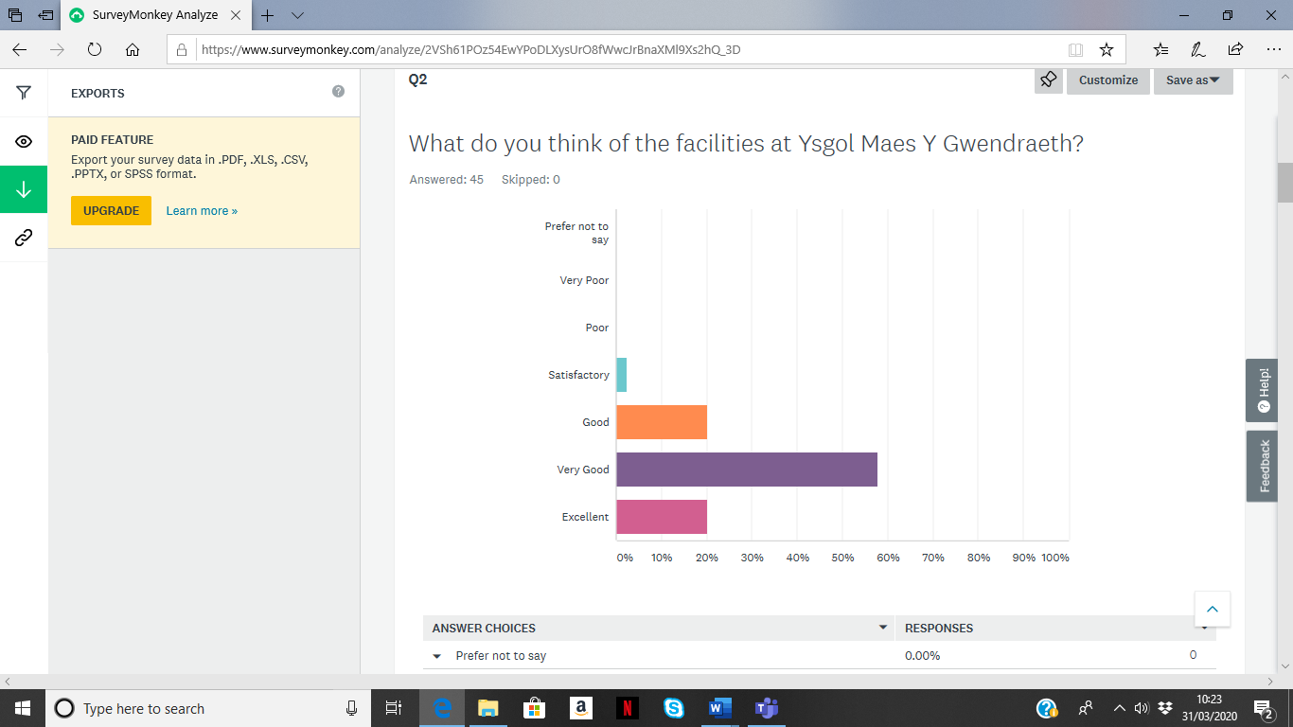Figure 3: What do you think of the faciltities at Ysgol Maes Y Gwendraeth. Survey Monkey.
The answers given by the parents who have conducted the interview correlate to that of the SPLISS Model Pillar 6 that states that training facilities are an important success factor in the process of enabling sports participants and athletes to train in a relevant and high quality sporting environment such as Ysgol Maes Y Gwendraeth and its sporting facilities. (De Bosscher, et al. 2015).
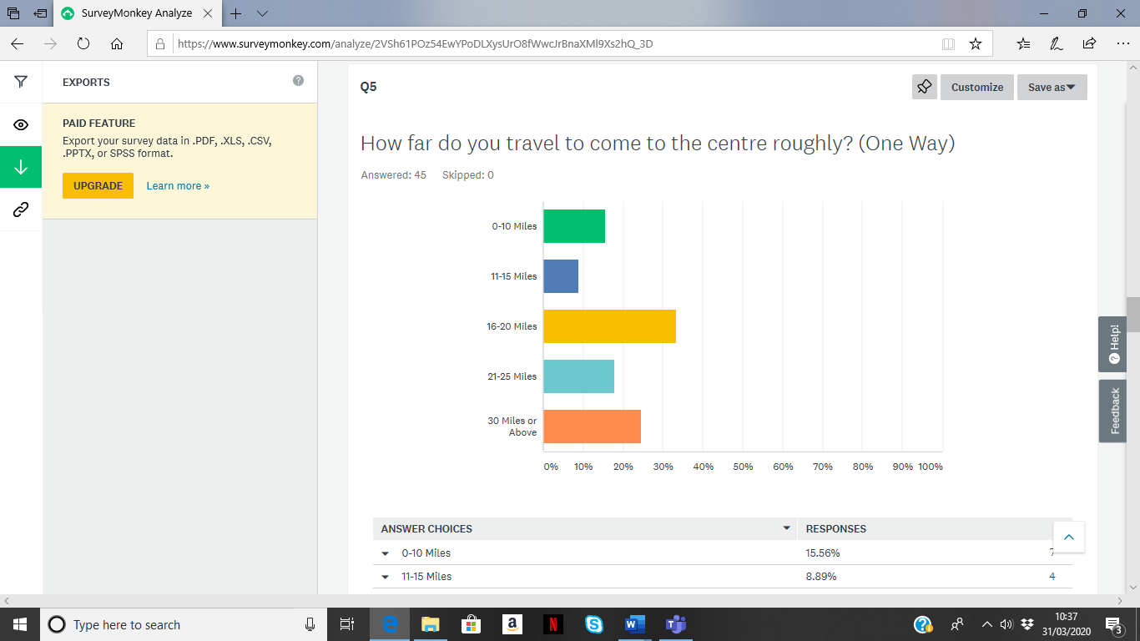Figure 4: How far do you travel to come to the centre roughly. Survey Monkey
When looking at the results of this question, it is clear to note that parents travel quite a significant distance to attend the performance centre. The graph above features the results which show the distance travelled one way. Sports such as football require a place to participate – and for many younger girls, especially in dense urban environments such as Swansea, Neath, Llanelli, means traveling to facilities through unsafe neighbourhoods in South West Wales. As the age brackets for the centre are mainly 8 to 14 years old means that they don’t have the transport essential to get to good facilities such as that of Ysgol Maes Y Gwendraeth and predominantly rely on parents to take the attendees to training.

4.2 FAW Players Performance Pathway
Having studied the answers within the question regarding the FAW players performance pathway, it is good to note that not every parent understands what happens regarding the pathway from the West Wales Girls’ Performance Centre. 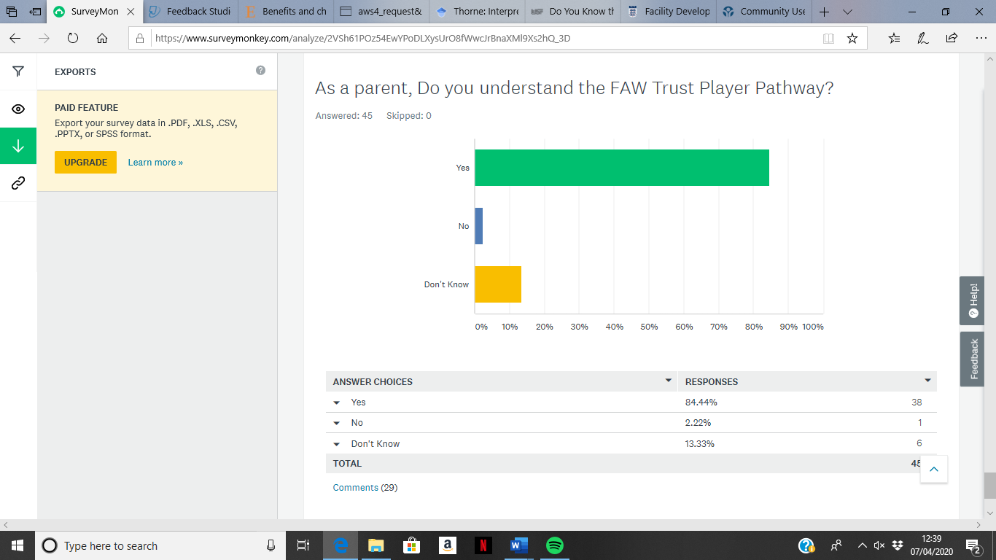
Figure 5: FAW Performance Pathway Question Result
When we look at figure 5 above you can see that:
- 84.44% of Parents understand the performance pathway
- 2.22% Have no understanding of the pathway
- 13.33% of the parents don’t know about the performance pathway
The figures that have come from the questionnaires are somewhat staggering as parents are taking their children to this performance centre and do not realise what the outcome can be for their child if they are highlighted as a talented player.
Having a target of 45 parents with the current situation surrounding Covid-19 was a good number to achieve. But with looking at the number of participants that attend the centre it is clear that more needs to be explored into the answers that have come from all 45 parents that have undertook the questionnaire, to gain an overall insight into what every

parent believes are perceived benefits for their children when attending the performance centre.
Overall, parents have highlighted key areas within this questionnaire that shows that the performance centre is somewhere that parents feel that their children can perform well and gain new experiences from exceptional coaches. From the questionnaires it is clear to see that the cost-effectiveness from a parent’s perspective is also a point to highlight. The cost for parents is very similar to the set-ups of community run clubs and therefore, having players come from all socio-demographical backgrounds allows for parents to help in the aid of sports development for their children. The benefits highlighted from this study suggest that parents were satisfied with the experiences in sport that they were ‘purchasing’ and providing for their children at the WWGPC (Frederick and Eccles, 2004). Additionally, it is good to note that parental satisfaction is an important indicator to the continued involvement in participation in a chosen sport (Brustad, 1993).

Main body – Conclusion (use relevant number of pages)

The aim of this research was to evaluate the rationale, perceived benefits and likely continuation for parents attending the West Wales Girls Performance Centre. Over the course of this research we have identified several key themes from parents and highlighted a range of benefits perceived to be positive benefits from parents for their children at the West Wales Girls’ Performance Centre. In order to achieve this, we needed to establish the key motivational factors that drive parents to take their children to Adult-led sporting clubs/centres. Identify benefits of participating in football for young children and evaluate the outcome of responses in relation to the Football Association of Wales.
To conclude, the non-competitive atmosphere that allows for children to focus on the development of their skills is key to the reasoning behind parents bringing their children to this centre. For the primary focus to be on skill development and not to be focused on winning and losing, I feel is key to the development of the young attendees at the performance centre. Therefore, the FAW has created what is known as a “mastery orientated motivational climate” as stated by Neely and Holt (2014). A mastery orientated motivational climate is an area that facilitates learning, maximum effort, and self-improvement as well as attendees viewing their mistakes on the field as part of their learning process (Weiss and Williams, 2004, p.258).
It is clear to note from the findings from the study that parents of attendees at the centre perceive very different benefits to football excellence. Researchers have agreed that children obtain a range of benefits through the participation in sports including the development of fundamental sport skills and a range of health-related benefits (Neely, 2011; Cote and Fraser-Thomas, 2007). Looking at the results from previous research studies it has led me to notice a consistency in results as parents in the current study have reported their children gain numerous physical and social benefits through their involvement in sport and physical activity. With the increasing rates of obesity here in Wales (Smith, 2018) and declining physical activity rates in Wales (Smith, 2016), there is an upmost need to increase physical activity among younger children and adolescents.

Parents throughout this study have perceived that young children gain many of the same benefits of sport as adolescents and adults. These findings add to the continuing growth of academic literature surround positive youth development through sport. Through the perceptions of the parent’s it is clear to note that coaches and parents play an important role in creating a positive sporting environment that can foster the development of the attendees. When looking at perceived benefits of the attendees, parents noted that making new friends is the benefit that had the highest answer rate. The reasoning behind this is parents have a first-hand view of their children participating at the centre and as such the answer can be perceived because of first-hand viewing when the attendee undertakes training.
Furthermore, the overall facilities and coaching received are noted by parents as being very good and exceptional and that the value for money is good with some parents highlighting that it is somewhat inexpensive to very cheap.
Additionally, to further understand how parents use the theory of epistemology when perceiving the benefits of football excellence for their children would be better understood with interviews and focus groups to determine the reasons why they thought of their chosen answers. Furthermore, for the study to gain recognition, a wider study would need to be conducted of the whole West Wales girls’ performance centre to validate the results of this study and to identify if the results of this study bring consistency with that of future studies.

Recommendations
- Option of a facility closer to Swansea and Neath Port Talbot areas
Whilst looking at the results of the questionnaires that have been undertaken it is clear too see that the distances that parents travel to bring their attendees to the West Wales Girls Performance Centre are relatively far. Having researched the areas that people come from it is clear too see that the vast number of Parents are travelling from the Neath and Swansea areas of South West Wales.
Therefore, one recommendation that the Football Association of Wales might take into consideration is the need for a facility closer to families that are travelling vast distances to the centre. Therefore, three locations that could be recommended would be that of Pontardawe Leisure Facility which has recently converted their football playing surface into a new 4G surface and Pen-yr-heol Comprehensive school which has also had a brand new 3G football pitch installed with new changing room facilities and also Bae Baglan School which has just installed brand new sporting facilities such as a 3G playing surface their also (FAW Trust, n.d.). Therefore, all three of these facilities would cater the same facilities as what Ysgol Maes Y Gwendraeth has.
Further to highlight the need for this recommendation, Sport England (n.d.) state that Many educational sites have very good sports facilities that are often underused out of normal school hours. As a result of this it reiterates the point of utilising a school such as Pen-yr-heol Comprehensive school, Bae Baglan Comprehensive because of their new sporting facilities and the distance from Neath and central Swansea areas is closer, with links to the M4 motorway.
- Toilet Facilities
Parents noted that toilet facilities are not open until the end of training sessions at Ysgol Maes Y Gwendraeth. Therefore, with the facilities mentioned both facilities have access to leisure centres (Freedom Leisure). Therefore, having access to these would mean that toilet facilities would also be provided for training sessions and for parents and participants of the West Wales Girls Performance Centre.

- Documentation for the WWGPC and FAW Performance Pathway
Parents highlighted in the questionnaire that a minor majority of the participants did not know what the FAW Players performance pathway was. As the next step up from the Performance centre is Regionals Squads, I believe that all parents should have a level of understanding to what the players performance pathway entails and also have a brief explanation regarding to what happens to players whilst at the West Wales Girls Performance Centre and their progression through to the next stages of the FAW Player performance pathway.
As we saw a minor majority of participants say that they did not understand the pathway, this could only open a further door for a future study of the whole FAW Player performance pathway and ultimately lead to future recommendations beyond the ones stated in this study.

Reference List
Abergavenny Chronicle. (2019). FA Wales launch new campaign for women and girls’ game. Abergavenny Chronicle.

Active Healthy Kids Canada. (2009). Canada’s report card on physical activity for children and youth. Available from: http://www.activehealthykids.ca/ecms.ashx/ReportCard2009/AHKC-Longform_WEB_FINAL.pdf

Aldridge, S. (2013). Barriers in Sport P5. Prezi. Available at: https://prezi.com/m/tqntlmeehpma/barriers-in-sport-p5/

Babkes, M.L., and Weiss, M.R. (1999). Parental influence on children’s cognitive and affective responses to competitive soccer participation. Paediatric Exercise Science, 11(1), pp 44-62.

Balyi I. (2002). Long-term athlete development: The system and solutions. Faster, Higher, Stronger 14: 6–9,

Balyi I, & Hamilton A. (2014). Long-Term Athlete Development: Trainability in Childhood and Adolescence. Windows of Opportunity. Optimal Trainability. Victoria, British Columbia, Canada: National Coaching Institute British Columbia and Advanced Training and Performance

Barnett, L.M., Van Beurden, E., Morgan, P.J., Brooks, L.O., and Beard, J.R. (2008). Does childhood motor skill proficiency predict adolescent fitness? Med Sci Sports Exercise. 40(12):pages 2137–2144

BBC News. (2017). Sport Wales campaign for more women to get into sport. BBC News. Available at: https://www.bbc.co.uk/news/uk-wales-40739951

BBC Sport. (2019). England’s Women’s World Cup run inspires growth in football participation. BBC Sport. Available at: www.bbc.co.uk/sport/amp/football/50300768

Blake, R. (1989). Integrating Quantitative and Qualitative Methods in Family Research. Family Systems and Health 7:411-427.

Boiche, J.C.S, and Sarazzin, P.G. (2009). Proximal and distal factors associated with dropout versus maintained participation in organised sport. Journal of Sports Science Medicine. 8: 9-16

Bois, J.E., Sarrazin, P.J., Brustad, R.J., Trouilloud, D.Q., & Cury, F. (2005). Elementary schoolchildren's perceived competence and physical activity involvement: the inﬂuence of parents' role modelling behaviours and perceptions of their child's competence. Psychology of Sport and Exercise, 6, 381-397.

Boudway, I. (2018). Soccer is the World’s Most Popular Sport and Still Growing. Bloomberg. Available at: https://www.bloomberg.com/news/articles/2018-06-12/soccer-is-the-world-s-most-popular-sport-and-still-growing

Brustad, R.J. (1993). Who will go out and play? Parental and psychological influences on children’s attraction to physical activity. Pdiatric Exercise Science, 5, 210-223.

Business Dictionary. (n.a). Meaning of strategy. Business Dictionary. Available at www.businessdictionary.com/definition/startegy.html

Cambridge Dictionary. (n.a). Meaning of initiative. Cambridge Dictionary. Available at https://www.google.co.uk/amp/s/dictionary.cambridge.org/amp/english/initiative

Caprara, G.V., Vecchione, M., Alessandri, G., Gerbino, M., and Barbaranelli, C. (2011). The contribution of personality traits and self-efficacy beliefs to academic achievement: a longitudinal study. British Journal of Educational Psychology. 81(1), 78-96.

Caudwell, J. (2012). Women’s Football in the UK. Continuing with Gender Analysis. Routledge Publishing.

Clark, S., and Paechter, C. (2007). ‘Why can't girls play football?’ Gender dynamics and the playground, Sport, Education and Society, 12:3, 261-276.

Clarke, N.J. (2014). Parenting experiences in Elite Youth Football: A Phenomenological Study. Leeds Beckett University. pp: 1-33.

Coakley, J. and Pike, E. (2009). Sports in society: issues and controversies. Maidenhead, Berkshire, McGraw-Hill Education.

Coleman, L., Cox, L. and Roker, D. (2008). Girls and Young Women’s Participation in Physical Activity: Psychological and Social Influences. Health Education Research, 23 (4), 633-647.

Cook, J. (2018). Our Squad Podcast. Bengo Media. Available at: https://www.bengomedia.com/case-study-oursquad-podcast-episodes-for-sport-wales/education-wales-1/

Côté, J., and Fraser-Thomas, J. (2007). Youth involvement in sport. In P. R. E. Crocker (Ed.), Sport and exercise psychology: A Canadian perspective (pp. 266-294). Toronto: Pearson

Craike, M J., Symons, C. and Zimmwemann, J A M. (2009). Why do young women drop out of sport and physical activity? A social ecological approach. Australian and New Zealand Association for Leisure Studies, 12(2), 148-173.

Creswell, J.W., and Plano Clark, V.L. (2007). Designing and Conducting Mixed Methods Study in Primary Care. Annals of Family Medicine 2:7-12

Crouter, S.E. (2007). Benefits of sport participation for young females. American College of Sports Medicine.

Davies, S. (2019). Campaign united all levels of women’s and girls’ football. North Wales chronicle. Available at: https://www.northwaleschronicle.co.uk/sport/17859703.campaign-unites-levels-women-39-s-girls-football/

De Bosscher, V., Shibli, S., Westerbeek, H., and van Bottenburg, M. (2015). Successful Elite Sport Policies. Meyer and Meyer Sport Ltd.

Deelen I, Ettema D, Kamphuis CBM (2018) Sports participation in sport clubs, gyms or public spaces: How users of different sports settings differ in their motivations, goals, and sports frequency. PLoS ONE 13(10): e0205198. https://doi.org/10.1371/journal.pone.0205198

Doble, A. (2015). The secret history of women's football. BBC Newsbeat. Available at: http://www.bbc.co.uk/newsbeat/article/33064421/the-secret-history-of-womens-football

Dorsch, T.E., Smith, A.L., and McDonough, M.H. (2009). Parents’ Perceptions of child-parent socialization in organised youth sport. Journal of Sport and Exercise Psychology. 31(4), pp 444-468

Dwyer, J., Allison, K., Goldenberg, E., Fein, A., Yoshida, K. and Boutilier, M. (2006). Adolescent girls perceived barriers to participation in physical activity. Adolescence, 41(161), 75-89.

Eccles, J. S. (1993). School and family effects on the ontogeny of children’s interests, self-perceptions, and activity choices. In R. Dienstbier & J. E. Jacobs (Eds.), Developmental perspectives on motivation (Vol. 40, pp. 145–208). Lincoln: University of Nebraska Press.

EFL Youth Development. (2018). CHARTER FOR ACADEMY PLAYERS AND PARENTS – EFL Youth Development Player’s and Parent’s Guide Season 2018/19. Available at https://www.efl.com/siteassets/efl-documents/201819/efl-youth-development-charter-players-and-parents-guide-2018-19--e-book4.pdf

Eime R.M., Sawyer, N., Harvey J.T., Casey, M.M., Westerbeek, H. and Payne, W.R. (2015). Integrating public health and sport management: sport participation trends 2001–2010. Sport Management Review.;18: 207–217.

Football Association. (n.a). The Game Plan for Growth - The FA’s Strategy for Women’s and Girls’ Football 2017-20. Football Association. Available at: https://www.thefa.com/-/media/cfa/staffordshirefa/files/female-football/fa-women-and-girls-strategy---gameplan-for-growth.ashx

Football Association. (2019). The Game Plan for Growth – The FA’s Strategy for Women’s and Girls’ Football 2017-20: Year 2 Review and Report. Football Association.

Football Association of Wales. (2020). Women and girls football participation in Wales hits record numbers. Available at: https://www.faw.cymru/en/news/women-and-girls-football-participation-wales-hits-record-numbers/

Football Association of Wales. (2019). FA WALES LAUNCH NEW CAMPAIGN FOR WOMEN AND GIRLS' GAME. FAW. Available at: https://www.faw.cymru/en/news/fa-wales-launch-new-campaign-women-and-girls-game/

Football Association of Wales. (2018). Girls football participation rises by 17% in Wales. Available at: https://www.fawtrust.cymru/get-inspired/news/girls-football-participation-rises-17-wales/

FAW Trust Cymru. (2019). Welcome to Huddle… Our Exciting New Programme to Grow the Girls’ Game. FAW Trust. Available at: https://www.fawtrust.cymru/get-inspired/news/welome-huddle-our-exciting-new-programme-grow-girls-game

FAW Trust. (2018). FAW Trust Girls' Performance Centre Trials. FAW Trust. Available at: https://www.fawtrust.cymru/next-generation/news/faw-trust-girls-performance-centre-trials/

FAW Trust. (n.d). 3G Artificial Pitches – Facilities. Available at: https://www.fawtrust.cymru/grassroots/facilities/3g-pitches/

Fifa.com. (N.a). History of Football – The Origins. Available at: https://www.fifa.com/about-fifa/who-we-are/the-game/

Fredricks, J.A. & Eccles, J.S. (2005). Family socialization, gender, and sport motivation and involvement. Journal of Sport & Exercise Psychology, 27, 3-31.

Fredericks, J.A., and Eccles, J.S. (2004). Parental influences on youth involvement in sports. In M.R. Weiss (Ed.) Developmental sport and exercise psychology: A lifespan perspective (pp.145-164). Morgantown, MV: Fitness Information Technology.

Gaston-Gayles, J.L. (2004). Examining academic and athletic motivation among student athletes at a division 1 university. J Coll Stud Dev. 45(1): 75-83.

Gramatikov, M., Barendrecht, M., Laxminarayan, M., Verdonschot, J.H., Klaming, L. and Zeeland, C.V. (2010). A Handbook for Measuring the Cost and Quality of Access to Justice. Portland: Maklu.

Green, K., Smith, A. and Roberts, K. (2005). Young People and Lifelong Participation in Sport and Physical Activity: A Sociological Perspective on Contemporary Physical Education Programmes in England and Wales. Leisure Studies, 24 (1), 27-42.

Gordon-Larsen, P., McMurray, R.G., and Popkin, B.M. (2000). Determinants of adolescent physical activity and inactivity patterns. Paediatrics: 105, p. E83

Gratton, C. and Jones, I. (2004). Research Methods for Sport Studies. Routledge – Taylor and Francis Group.

Greene, J., Caracelli, V., and Graham, W. (1989). Toward a Conceptual Framework for Mixed Methods Evaluation Designs. Educational Evaluation and Policy Analysis 11:255-274

Houlihan, B & Green, M (2011). Routledge handbook of sports development. Oxon: Routledge.

Humphreys, B.R. and Ruseski, J.E. (2009). The economics of participation and time spent in physical activity: Working paper 2009-09. University of Alberta, Department of Economics, Edmonton.

Jack, B., & Clarke, A. M. (1998). The purpose and use of questionnaires in research. Professional Nurse, 14(3), 176-179.

Janssen, I., Katzmarzyk, P.T., Boyce, W.F. Vereecken, C., Mulvihill, C., Roberts, C., et al. (2005). Comparison of overweight and obesity prevalence in school-aged youth from 34 countries and their relationships with physical activity and dietary patters. Obesity Reviews, 6, pp.123-132

Jenkin, M. (2015). Fit for learning: what research says about the benefits of sport. PE and School Sport. The Guardian Newspaper. Available at:

https://www.google.co.uk/amp/s/amp.theguardian.com/teacher-network/2015/sep/03/fit-for-learning-what-research-says-about-the-benefits-of-sport

Jeynes, W.H. (2007). The Relationship between Parental Involvement and Urban Secondary School Student Academic Achievement: A Meta-analysis. Urban Education 42(1), 82-110.

Jones, M.I., Dunn, J.G.H., Holt, N., Sullivan, P.J., and Bloom, G.A. (2011). Exploring the ‘5 Cs’ of positive youth development in sport. Journal of Sport Behaviour. 34(3), pp 250-267

Jupp, V. (2006). The SAGE dictionary of social research methods: SAGE Publications Ltd doi: 10.4135/9780857020116

Leslie, E., Cerin, E., Gore, C.J., St. George, A., Bauman, A., and Owen, N. (2004). Gender, age and educational-attainment differences in Australian adults’ participation in vigorous sporting and fitness activities. Journal of Physical Activity and Health. 1(4), pp 377-388

Leech, N. and Onwuegbuzie, A. (2008). A typology of mixed methods research designs. Quality and Quantity. 43(2), March, pp. 265-275

Malina, R. (2001). Adherence to Physical Activity from Childhood to Adulthood: A Perspective from Tracking Studies. Quest, 53 (1): 346-355.

Marsden, E & Weston, C. (2007). Locating quality PE in early years pedagogy. Sport, Education and Society. 12(4), p383-398.

Matvienko, O. and Ahrabi-Fard, I. (2010). The effects of a 4-week after-school program on motor skills and fitness of kindergarten and first-grade students. Am J Health Promot. 24(5): p299–303

McGoona, H. (2014). Factors that motivate females over the age of 18 to participate in football in Wales. Sport Development. Cardiff Metropolitan University.

Mcleod, S. (2019). Likert scale. Simple Psychology. Available at: https://www.simplypsychology.org/likertscale.html

Mcleod, S. (2018). Questionnaire: Definition, Examples, Design and Types. Simply Psychology. Available at: https://www.simplypsychology.org/questionnaires.html

Meaney, K.S., Dornier, L.A., Hensel, T.C. and Ludlum, K.L. (1995). Benefits parents seek from children’s sport participation. Research Quarterly for Exercise and Sport. University of Texas Tech. pg. A79

Middleton, F. (2020). Reliability vs validity: what’s the difference? Available at: https://www.scribbr.com/methodology/reliability-vs-validity/

Middleton, L. (2019). Record amount of girls and women playing football after World Cup. Metro News. Available at: https://www.metro.co.uk/2019/07/09/record-amount-girls-women-playing-football-world-cup-10136975/amp/

Moss, R. (2018). ‘Fit Got Real’ is the new campaign empowering women to exercise their way. Huffington Post. Available at: https://www.huffingtonpost.co.uk/amp/entry/fit-got-real-is-the-new-campaign-showing-no-woman-should-feel-excluded-from-exercise_uk_5bd30407e4b0a8f17ef6b989/

Mulvihill, C., Rivers, K., & Aggelton, P. (2000). Physical Activity ‘At Our Time’. London: Health Education Authority

Mutrie, N., and Faulkner, G. (2004). Physical activity: positive psychology in motion. In P.A. Linley, & S. Joseph (Eds.), Positive psychology in practice (pp. 146-164). NJ: Wiley.
National Assembly of Wales. (2019). Physical Activity of Children and Young People. Health, Social Care and Sport Committee: Report March 2019.

Neely. K.C., & Holt, N.L. (2014). Parents’ Perspectives on the Benefits of Sport Participation for Young Children. The Sport Psychologist. Vol 28(3), pp 255-268

Neely, K. (2011). Parents’ Perceptions of Positive Youth Development Through Sport. Edmonton: Canada.

Nichelson M, Hoye R, Houlihan B. (2011). Participation in Sport. International Policy Perspectives.

Norther Ireland Assembly. (2010). Barriers to Sport and Physical Activity Participation. Research Paper

O’Rourke, D.J., Smith, R.E., Smoll, F.L. and Cumming, S.P. (2011). Trait anxiety in young athletes as a function of parental pressure and motivational climate: Is parental pressure always harmful? Journal of Applied Sport Psychology, 23(4), pp 398-412.

Parkinson, D. (2019). Cardigan chosen for pilot scheme to get girls to play football. Tivyside Advertiser. Available at: https://www.tivysideadvertiser.co.uk/news/17916331.cardigan-chosen-pilot-schemeget-girls-play-football

Partridge, J. (2015). The Role of Friendships in Youth Sports. Available at: https://nays.org/blog/the-role-of-friendships-in-youth-sports/

Patton, M.Q. (2002). Qualitative research & evaluation methods. Thousand Oaks, CA: Sage

Perry, C.K., and Saelens, B.E., and Thompson, B. (2011). Intrapersonal, behavioural and environmental factors associated with meeting recommended physical activity among rural Latino youth. Paediatric exercise science. 23(4), pp 521-536

Philosophy Basics. (n.d.). The Basics of Philosophy. Available at: https://www.philosophybasics.com/branch_epistemology.html

Pickup, I., Haydn- Davies, D., & Jess, M (2007). The Importance of Primary physical education. Physical Education Matters. 2 (1), p8-11.

Podlog, L., Dimmock, J., Miller, J. (2011). A review of return to sport concerns following injury rehabilitation: practitioner strategies for enhancing recovery outcomes. Physical Therapy Sport: 12, p36-42.

Pollock, I. (2019). Child Poverty: Wales is the only UK nation to see increase. BBC News. Available at: https://www.bbc.co.uk/news/amp/uk-wales-48259327

Premier League. (2019). Elite Player Performance Plan. Available at: https://www.premierleague.com/news/58930

Robbins, L.B., Talley, H.C., Wu, T.Y., and Wilbur, J. (2010). Sixth-grade boys’ perceived benefits of and barriers to physical activity and suggestions for increasing physical activity. Journal School of Nursing. 26(1): pp 65-77

Robinson, K. and Ferraro, F.R. (2004). The relationship between types of female athletic participation and female body type. Journal of Psychology. 138(2): 115-128.

Rossman, G., and Wilson, B. (1991). Numbers and Words Revisited: Being “Shamelessly Eclectic.” Evaluation Review 9(5): 627-643.

Ryan, R.M., and Deci, E.L. (2000). Self-determination theory and the facilitation of intrinsic motivation, social development, and well-being. American Psychologist: 55 (1), 68.

Sallis, J.F. and Saelens, B.E. (2000). Assessment of Physical Activity by Self Report: Status, Limitations and Future Decisions. Research Quarterly for Exercise and Sport, 71, 1-14.

Schnell, C. (2017). The Benefit of Teaching Children Teamwork. Available at: https://howtoadult.com/benefit-teaching-children-teamwork-19822.html

Scully, R. (2017). I spent a year researching why working-class Welsh people in the Valleys voted for Brexit, and this is what I found. The Independent. Available at: https://www.independant.co.uk/voices/south-wales-valleys-brexit-vote-leave-a8021051.html%3famp

Shanks, G., and Bekmamedova, N. (2018). Case Study research in information systems. In: Williamson, K., and Johnson, G. (2018). Research Methods: Information, Systems and Contexts. 2nd Edition. Elsevier Ltd.

Smith, M. (2018). More children are obese in Wales than ever before – and here are the worst regions. Wales Online. Available at: https://www.walesonline.co.uk/news/health/rates-childhood-obesity-higher-ever-14549511

Smith, M. (2016). Children in Wales are among the least active in the world. Wales Online. Available at: https://www.walesonline.co.uk/news/health/children-wales-among-least-active-12209320

Sport England. (2018). Figures show nation's activity levels - Our new Active Lives Adult Survey figures give a snapshot of the nation's activity habits. Available at: https://www.sportengland.org/news-and-features/news/2018/march/22/figures-show-nations-activity-levels/

Sport England. (n.a). This Girl Can. Available at: https://www.sportengland.org/our-work/women/this-girl-can/

Sport England. (n.d.). Community Use Agreements. Sport England. Available at: https://www.sportengland.org/how-we-can-help/facilities-and-planning/planning-for-sport/community-use-agreements

Sportsshow. (2019). Top 10 most popular sports in the World. Sports Facts and Trivia. Available at: https://www.google.co.uk/amp/s/sportsshow.net/top-10-most-popular-sports-in-the-world/amp/

Sport Wales. (2018). School Sport Survey – State of the Nation. Available at: https://www.sport.wales/files/be75d2ef7a9f0620a5bcbd371ba9c9ce.pdf

Sport Wales. (n.a). Welsh push to get female sport moving. Sport Wales. Available at: http://sport.wales/news--events/news--events/our-news/latest-news/welsh-push-to-get-female-sport-moving.aspx

Sport Wales. (n.a). What Moves You? Campaign – About the Campaign. Sport Wales. Available at: http://sport.wales/news--events/news--events/our-campaigns/what-moves-you/about-the-campaign.aspx

Staurowsky, E.J., Desousa, M.J., Ducher, G., Gentner, N., Miller, K.E., Shakib, S., Theberge, N., and Williams, N. (2009). Her life depends on it II: Sport, Physical Activity, and the Health and Well-being of American Girls and Women. East Meadow, NY: Women’s Sport Foundation.

The FA. (N,a). The History of Women's Football in England. The Football Association. Available at: http://www.thefa.com/womens-girls-football/history

Thomas, J. and Nelson, J. (2001). Research Methods in Physical Activity: 4th Edition. USA: Human Kinetics.

Thorne, S. (2008). Interpretive Description. Left Coast Press. Walnut Creek, CA.

Top end Sports. (2019). Top 10 List of the World’s Most popular sports. Available at: https://www.topendsports.com/world/lists/popular-sport/fans.htm

Total Teamwear. (n.a). Client Shops - West Wales Girls Performance Centre. Total Teamwear. Available at: https://www.totalteamwearuk.com/client/westwalesgirlperformance/default.htm

UEFA. 2017. Registered female footballers on the rise. Women’s football across the national association 2017 report. UEFA. Available at: https://www.uefa.com/insideuefa/news/newsid=2516070.html

UEFA. (2013b). UEFA women’s development programme review. Available at: https://www.uefa,com/women/womens-football-development/programme/news/newsid=1965657.html

UK Sport. (N.a). What is a Performance Pathway? UK Sport. Available at: https://www.uksport.gov.uk/our-work/talent-id/what-is-a-performance-pathway

Vella, S.A., Swann, C., Allen, M.S., Schweickle, M.J., Magee, C.A. (2017). Bidirectional associations between sport involvement and mental health in adolescence. Med Sci Sports Exerc. 49(4): p687–694

Vizard, S. (2018). ‘This Girl Can’ tackles inequality as it vows to ‘leave no woman behind’ in new push. Marketing Week. Available at: https://www.marketingweek.com/this-girl-can-campaign

Vu, M.B., Murrie, D., Gonzalez, V., and Jobe, J.B. (2006). Listening to girls and boys talk about girls’ physical activity behaviours. Health Education and Behaviour. 33(1): pp 81-96

Watchman, T. and Spencer-Cavaliere, N. (2017). Times have changed: Parents’ Perspectives on children’s free play and sport. Psychology of Sport and Exercise. Elsevier: Vol 32, pp 102-112

Wang, M.T., and Sheikh-Khalil, S. (2014). Does parental involvement matter for student achievement and mental health in high school? Child Development 85(2), 610-625.

Warburton, D. (2006). Health Benefits of Physical Activity: The Evidence. Canadian Medical Association Journal. 146 (6), 801-809.

Weerahandi, S. (2003). Exact statistical methods for data analysis. New York: Springer

Welsh Football Trust. (2010). WFT Strategic Plan 2010 to 2014. Available at: https://www.welshfootballtrust.org.uk/WomensGrassroots.ink

Welsh Football Trust. (2013b). Grassroots. Available at https://www.welshfootballtrust.org.uk/WomensGrassroots.ink.

Weiss, M.R., and Williams, L. (2004). The why of youth sport involvement: A developmental perspective on motivational processes. In M.R. Weiss (Ed.), Developmental sport and exercise psychology: A lifespan perspective (pp. 223-268).

Whaley, D. E., & Krane, V. (2011). Now that we all agree, let us talk epistemology: a commentary on invited articles. Qualitative research in Sport, Exercise and Health, 3, 394-403. doi.org/10.1080/2159676X.2011.607186

Wheeler, S & Green, K. (2014). Parenting in relation to children’s sports participation: generational changes and potential implications. Leisure Studies, 33:3, 267-284, DOI: 10.1080/02614367.2012.707227

Wiersma, L.D., and Fifer, A.M. (2008). “The schedule has been tough but we think it’s worth it”: The joys, challenges, and recommendations of youth sport parents. Journal of Leisure Research, 40(4), pp 505-530

World Health Organisation. (2009). Unhealthy Diets and Physical Inactivity. Available: http://www.who.int/nmh/publications/fact_sheet_diet_en.pdf. Last accessed 16th October 2013

Wuerth, S., Lee, M.J., and Alfermann, D. (2004). Parental Involvement and athletes’ career in youth sport. Psychology of Sport and Exercise. 5(1), pp 21-33.

Youle, R. (2017). Not enough girls are playing sport in Wales and this is what's being done about it. Wales Online. Available at: https://www.walesonline.co.uk/news/wales-news/not-enough-girls-playing-sport-13423579

Bibliography (use relevant number of pages)
Bowling, A. (1997). Research Methods in Health. Buckingham: Open University Press.

Green, M. (2007). Olympic Glory or Grassroots Development? Sports policy priorities in Australia, Canada and the United Kingdom 1960-2006. International Journal of the history of sport. 24(7), 921-953.

Holt, N. L., Neely, K. C., Slater, L. G., Camiré, M., Côté, J., Fraser-Thomas, J., Tamminen, K. A. (2017). A grounded theory of positive youth development through sport based on results from a qualitative meta-study. International review of sport and exercise psychology, 10(1), 1–49. doi:10.1080/1750984X.2016.1180704

Jamieson, S. (2004). Likert Scales: How to use them. Medical Education, 38(12), 1217-1218.

Keegan, R., Spray, C., Harwood, C., and Lavallee, D. (2010). The motivational atmosphere in youth sport: Coach, Parent and Peer Influences on motivation in specialising sport participants. Journal of Applied Sport Psychology, 22(1), 87-105.

Likert, R. (1932). A Technique for the Measurement of Attitudes. Archives of Psychology, 140, 1-55.

Pfeiffer, K.A., Dowda, M., Dishman, R.K., Mciver, K.L., Sirard, J.R., Ward, D.S., and Pate, R.R. (2006). Sport Participation and physical activity in adolescent females across a four-year period. Journal of Adolescent Health, 39(4), 523-529.

Sirard, J.R., Pfeiffer, K.A., and Pate, R.R. (2006). Motivational factors associated with sport program participation in middle school students. Journal of Adolescent Health. 38(6), 696-703.

Sport Wales. (2010). Elite Sport Strategy 2010-16. Cardiff: Sport Wales

The Sports Council for Wales. (2010). 2008-09 Active Adults Survey. Available at http://www.sportwales.org.uk/media/331206/2008-09_active_adult_survey_-_research_findings_-_headline_results.pdf.

Scheerder J, Vos S. (2011). Social stratification in adults’ sports participation from a time-trend perspective: Results from a 40-year household study. European Journal for Sport and Society.;8: 31–44

Sport Wales. (n.a). Squad Day aims to get more Welsh women active. Available at: https://sport.wales/news--events/news--events/our-news/latest-news/squad-day-aims-to-get-more-welsh-women-active.aspx

Tan, C. and Crawford, L. (2006). Knowledge and Inquiry: An introduction to Epistemology.

Warburton, D.E.R., Nicol, C.W. and Bredin, S.S.D. (2006). Health benefits of physical activity: the evidence. Canadian Medical Association Journal. 174(6), 801-809.

Welsh Assembly Government. (2006). Climbing Higher: Next Steps. Cardiff WAG

Appendices (use relevant number of pages)
9.0 Appendices
9.1 Questionnaire



9.2 Email to Andy Jones (Head of WWGPC)

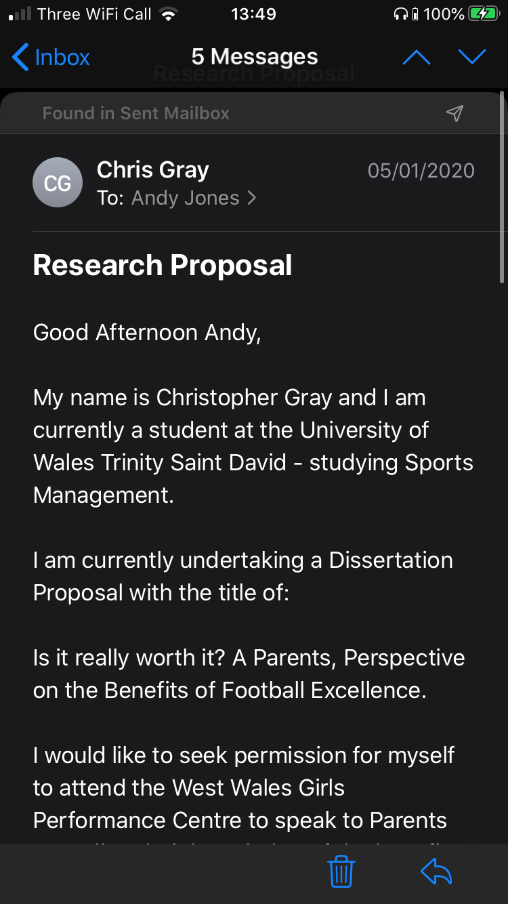

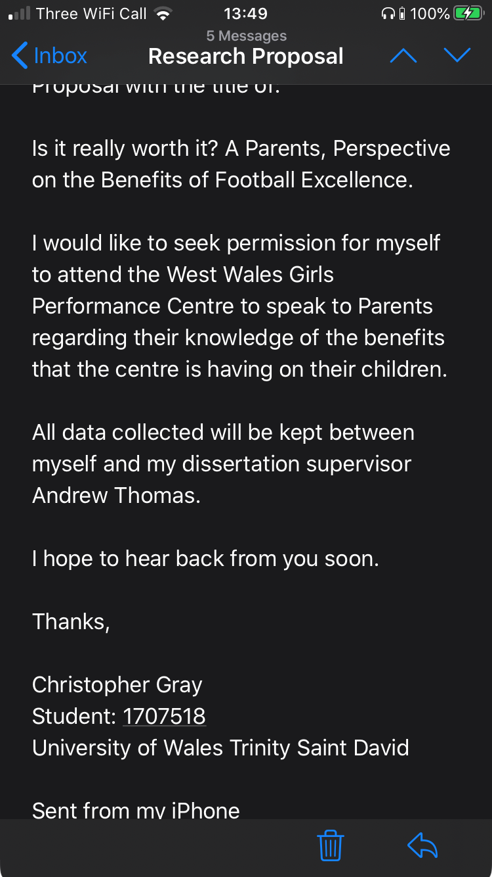

9.3 Email from Kat Lovett (FAW Employee) 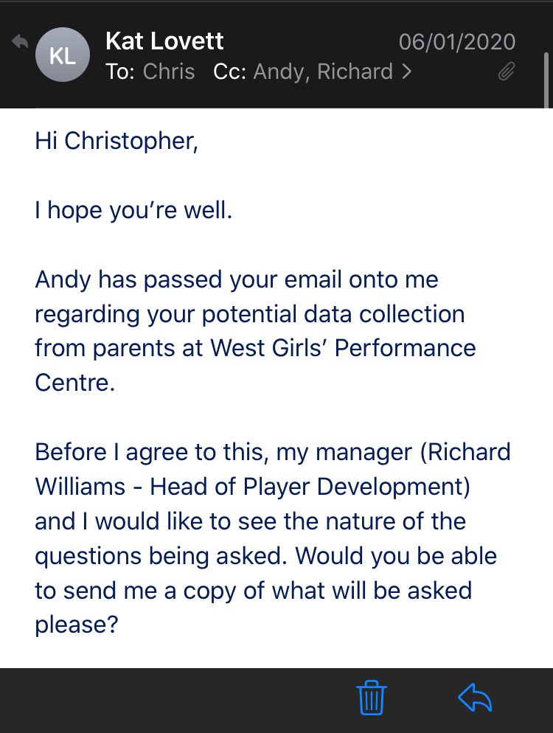

9.4 Email Response to Kat Lovett (FAW Employee)
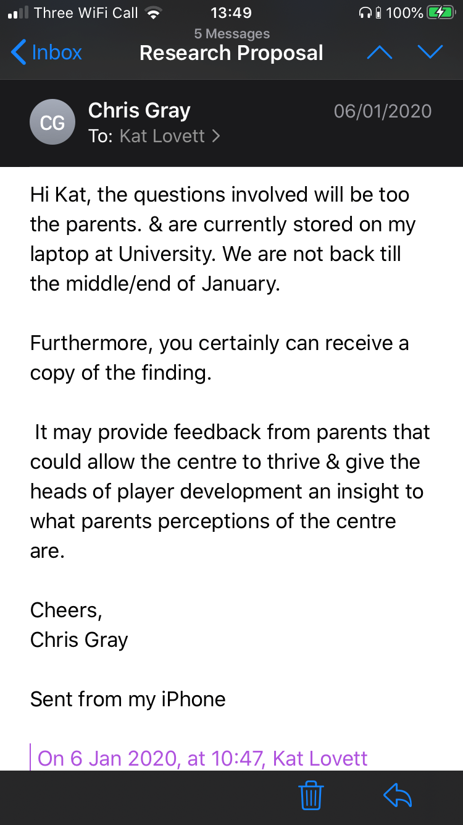

9.5 FAW Performance Pathway
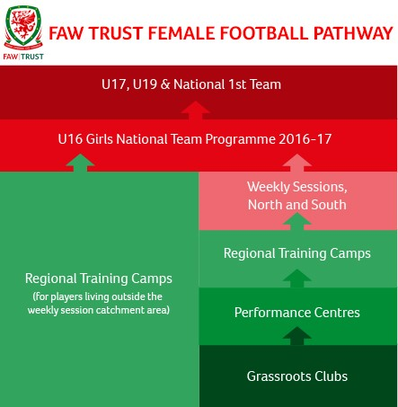

Insert Ethics Form P1 into the table below




Insert Ethics Form P2 into the table below




Insert Ethics Form P3 into the table below




Insert Ethics Form P4 into the table below



Insert Ethics Form P5 into the table below



Insert Ethics Form P6 into the table below



Insert Ethics Form P7 into the table below

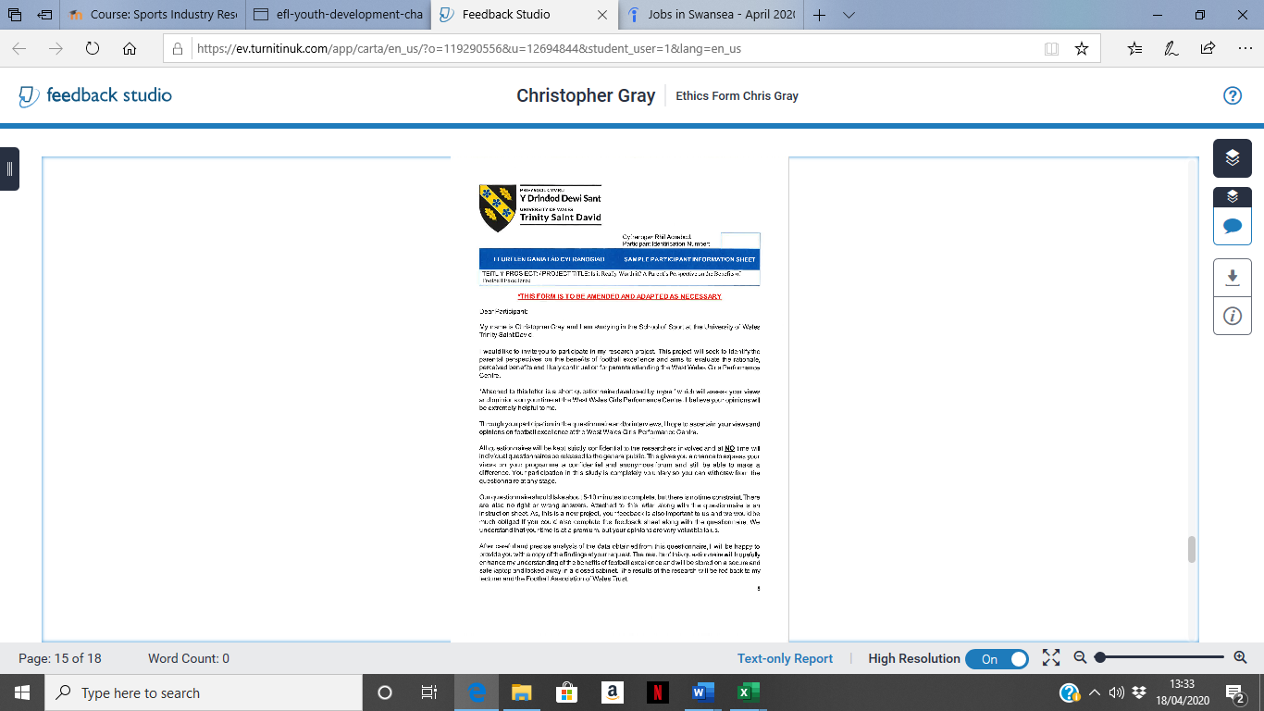

Submission Evidence

Faculty Office (1 x Paper Copy, Bind Professionally)
+
Online Turnitin Submission (prior to Deadline)



BA Sports Management Portfolio

Research Project
Report

UWTSDSport

