

Heating and Temperature Control using Wireless Sensors

by
Jordan Phillips

Supervisor: Dr Kapilan Radhakrishnan
Second Marker: Dr Carlene Campbell

Project submitted as part of the requirements for the award of BSc (Hons) Computer Networks and Cyber Security

April 2018

Declaration of Originality

I, Jordan Phillips, declare that I am the sole author of this Project; that all references cited have been consulted; that I have conducted all work of which this is a record, and that the finished work lies within the prescribed word limits.

This work has not previously been accepted as part of any other degree submission.

Signed: 

Date: 25/4/2018

FORM OF CONSENT

I, Jordan Phillips, hereby consent that my Project, submitted in candidature for the B.Sc.(Hons) Computer Networks and Cyber Security degree, if successful, may be made available for inter-library loan or photocopying (subject to the law of copyright), and that the title and abstract may be made available to outside organisations.

Signed:

Date: 25/4/2018

Abstract
Wireless Sensor Networks (WSN) have been deployed for a wide range of uses, from medical and environmental monitoring to smart home designs based on Internet of Things (IoT) technology. These networks utilise small devices called sensors, which depending on programming, monitor various environmental effects and changes, examples including temperature, humidity, light and motion sensors. This project primarily utilised temperature sensors to monitor and control ambient temperature within an area or room. Humidity and motion sensors also play smaller roles within the projects design. These devices function by transmitting data gathered from the environment to a specified server with information utilised to control various aspects within a network, or to simply relay information to any smart device or computer/laptop device. SHT15, SHT21S, Monnit and PASCO are examples of temperature and humidity sensors identified via research into various IoT and WSN fields.
A WSN was utilised to monitor the temperature and increase or decrease this ambient temperature to predetermined levels, thereby creating a network capable of temperature control. To facilitate this, a floor plan was created utilising Microsoft Visio, which was then integrated into Packet Tracer simulation software. This gave an understanding of a room layout which could be used to determine sensor device locations. Each sensor device was then connected to a central Arduino board, programmed to acquire data from these sensors, utilise it to control various devices and relay information to user devices for room temperature monitoring. The simulation demonstrated the possibility of creating a functioning WSN to monitor and react to changes within the environment. Ambient temperature monitor and control as well as motion-based lighting control were the primary simulation focus, with a greater emphasis on temperature control. As the project was proof of concept as to whether rooms or areas could be improved with use of IoT technology, the primary aim of the project was accomplished as utilising this simulation demonstrated the ability to automate room conditions using sensor devices. However, certain limitations were discovered, such as in data acquisition from Packet Tracer, with certain solutions being considered and discussed, i.e. the creation of a physical network in an area to monitor temperature changes over a given timeframe.

Table of Contents
Chapter 1 6
1.1 Introduction 6
1.2 Aims 8
1.3 Objectives 8
Chapter 2 9
2.1 Literature Review 9
2.1.1 Wireless Sensors 10
2.1.2 Internet of Things (IoT) 13
2.1.3 Security 19
2.1.4 Related Work 25
Chapter 3 27
3.1 Methodology 27
3.1.1 Philosophies 28
3.1.2 Approach 28
3.1.3 Strategies 28
3.1.4 Choices 29
3.1.5 Time Horizons 30
3.1.6 Techniques and Procedures 30
3.1.7 Risk Assessment 30
Chapter 4 31
4.1 Design 31
Chapter 5 34
5.1 Implementation and Discussion 34
5.2 Temperature Sensor Implementation 34
5.2.1 Temperature Control Implementation Utilising IoE Server 36
5.2.2 Temperature Control Implementation Utilising MCU Board 44
5.2.3 Projects Goal 50
5.3 Light Control 51
5.3.1 Implementation utilising IoT Server method 51
5.3.2 Implementation utilising MCU Board method 57
Chapter 6 60
6.1 Conclusion 60
6.2 Future Improvements 61
Chapter 7 64
7.1 Reflection 64
References 68
Appendices 77
Appendix 1: Temperature MCU JavaScript Program 77
Appendix 2: Light MCU JavaScript Program 79
Appendix 3: First Supervisor Meeting Form 80
Appendix 4: Second Supervisor Meeting Form 81
Appendix 5: Third Supervisor Meeting Form 82
Appendix 6: Fourth Supervisor Meeting Form 83
Appendix 7: Fifth Supervisor Meeting Form 84
Appendix 8: Sixth Supervisor Meeting Form 85
Appendix 9: Seventh Supervisor Meeting Form 86
Appendix 10: Eighth Supervisor Meeting Form 87
Appendix 11: Ninth, and Final, Supervisor Meeting Form 88

Table of Figures
Figure 1: WSN Logical Topology. 32
Figure 2: WSN Physical Topology. 32
Figure 3: MCU Code for Temperature Sensor 36
Figure 4: Temperature display screen 36
Figure 5: MCU IoT Server Setup 37
Figure 6: IoT Server Smart Device View. 37
Figure 7: Enabling Wireless Communication 38
Figure 8: Selecting IoT Server 38
Figure 9: Configuring Home Gateway Communication. 38
Figure 10: List of IoT Enabled Devices. 39
Figure 11: Window Control Conditions 40
Figure 12: Heating and Air Condition Control Conditions 40
Figure 13: Heating Active below 20 °C 41
Figure 14: Air Cooling Active above 25 °C 41
Figure 15: Window Control with active switch 42
Figure 16: Window Control with in-active switch 43
Figure 17: Window Switch Control via IoT Smart Device. 44
Figure 18: JavaScript code for Network setup. 44
Figure 19: JavaScript code for Network function 45
Figure 20: MCU controlled network. 46
Figure 21: Air Cooling Active 47
Figure 22: Heating Active 48
Figure 23: Window Active Function 49
Figure 24: Window In-Active Function 50
Figure 25: Enabling Wireless Communication on Light Device. 52
Figure 26: Specifying IoT Server 52
Figure 27: Specifying Wireless Communication 52
Figure 28: Packet Tracer Light Device Code for IoT Server Access 53
Figure 29: List of Devices with IoT Server Access 53
Figure 30: List of Light Control Conditions 54
Figure 31: Light Network Setup 55
Figure 32: Motion Sensor Active 55
Figure 33: Light Switch Active 56
Figure 34: Light Control via IoT Smart Device 56
Figure 35: MCU Controlled Light Network 57
Figure 36: MCU Board JavaScript Program 58
Figure 37: Motion Sensor Activated Light 59
Figure 38: Light Switch Activated Light 59
Figure 39: Gantt Chart Table 64
Figure 40: Gantt Chart Graph 65
Figure 41: Old Gantt Chart Table 66
Figure 42: Old Gantt Chart Graph 66

Chapter 1

1.1 Introduction
The purpose of this project is to utilise Wireless Sensor Network (WSN) technology to control the ambient temperature within a room. WSN’s are defined as a network of devices which can detect and gather information on changes that happen within the environment [1]. These sensors, also known as nodes, gather the information and transmit this data to a central receptor [1]. WSN’s have received significant attention and advancement thanks to the wide range of areas which they can be deployed to gather information [2] [3] [4]. Examples of such areas are industrial [5], health [6], security and environmental monitoring [4] [7]. Sensor devices typically operate using battery power, meaning as the WSN increases in size, the resources spent to set up the WSN also increases [2]. Therefore, planning becomes crucial in setting up these sensor networks, utilising only the required amount of sensor devices, placed in key, strategic positions, for maximum coverage. Once setup, these sensors require little maintenance to perform their data collection tasks, which aids in network longevity [2].

An example of WSNs are environmental monitoring [2] [7] [8]. There are two forms of environmental monitoring, one being the monitoring of environments such as landscapes [9] or underwater areas [7] [9]. WSNs deployed in this manner are known as Environmental Sensor Networks (ESNs) [7] [9]. The other environmental monitoring method, commonly utilised in “Smart Homes”, uses WSN to monitor home environmental features such as temperature, lighting and motion [10] [11]. These ESNs and WSNs are designed to acquire vast quantities of data used in environmental monitoring purposes [9]. Smart homes utilise Internet of Things (IoT) and WSN technology to control numerous devices located around a home [11] [12]. WSN technology allows for both the gathering and communication of important data between various WSN devices [11] [12]. Typical WSN devices are temperature and humidity sensors, which are used to control the ambient temperature and humidity within a specified area or room [11] [13]. These factors play key roles in multiple areas, such as healthcare of patients, human comfort level, various scientific studies and industrial applications, therefore monitoring these factors becomes increasingly important [11] [13] [14].

WSN’s operate by gathering information from their surrounding environments and relaying this information to a receiver device [11] [12] [13]. Therefore, understanding the nature of the data gathering process and what device will be the receiver for this data is imperative. It is also important to place sensor devices in areas which allow for maximum coverage, which in turn allows for more accurate and reliable data collection. As previously mentioned, IoT and WSN technology are used to control various devices within smart homes or other such locations, however, it is vital to understand how these devices communicate [11] [12]. Sensor devices are capable of communication with other WSN devices [11] [12], as well as other devices located within the IoT network.

A key factor to consider when handling and deploying WSN devices is that these devices are small and fragile, therefore can easily become damaged if mishandled or thanks to environmental threats [15]. Redundancy can play a role in preparing for device failure, however, it is not always possible to fix faulty devices, as there are numerous factors which must be considered, such as environmental hazards [15]. This issue, however, is more common when considering ESNs, rather than smart home WSNs. There are, however, other methods and factors which must be considered. Energy consumption, and therefore, cost, is a key factor to consider [2]. Continually turning heating on and off is not cost or energy effective, therefore steps must be taken to ensure energy is not being wasted [2]. Other methods which would benefit energy saving include manual control in order to adjust temperature in certain scenarios, such as the room becoming unoccupied for periods of time. This also allows for more control and the ability to adjust temperature in the event that a sensor malfunctions and needs replacing, as these devices can break [2] [15].

1.2 Aims
The aim of the project is to use wireless sensors in a WSN to monitor and control the temperature of a room.

1.3 Objectives
To achieve the aim of this project, a number of steps must be taken. The following objectives will be instrumental in the completion of the project:
- Research plays a vital role in this project, as there are numerous wireless sensors devices, data gathering methods and temperature control methods and devices. Therefore, research into the different devices will be done to determine the best value for cost and effectiveness for use within the project, as well as which type of sensors will be used. Research into how data will be gathered and controlled is also key.
- Designing the layout and area of the WSN. This is important for devices to gain maximum coverage and ensure they are in areas suitable for data collection.
- Implementation of the WSN. This will involve placing each sensor device in a predetermined location, chosen during the design phase.
- Project is a proof of concept, therefore, the simulation is run to determine if the project aim is possible.
- Analysis of the data will then be conducted. The data acquired from the WSN will then be compared to expected data discovered through research to determine if the data collected matches expected results.
Following the mentioned objectives of the project, the expected result is to be able to utilise the WSN in conjunction with IoT temperature devices, such as air conditioning and heating systems, to monitor the ambient temperature of a room. Using this data, the WSN will be able to adjust room temperature to a predetermined temperature. This temperature will be chosen based on results discovered from research.

Chapter 2

2.1 Literature Review
This report has touched briefly on various uses of WSNs, such as industrial [5], health [6], security and environmental monitoring [4] [7], as well as ESNs [7] [8] [9] and IoT Smart Home technology [11] [12]. However, for the success of this project, a more detailed analysis of various sensor technology implementations, types of sensors utilise, brand of sensors and the operation of these devices must be conducted. Research into past experiments and implementations of various WSNs will improve the authors understanding of the field of study. Through this, the author hopes to utilise information of implementation strategies, as well as types and functions of various sensors and how they function, to implement a functioning WSN which will be able to control ambient temperature within a specified room environment. The following sections will analyse various aspects of WSNs, what they are, how they function and compare various implementation methods used in other WSNs.

2.1.1 Wireless Sensors
Wireless sensors are small devices which can be used to gather information on their surrounding environment [2] [3] [4]. These devices operate via battery power [2] [16] [17]. Primary lithium batteries are often used to power these sensor devices [16]. Sensor devices are often required to be placed in one location and remain there powered by batteries for significant periods of time [17]. These time periods often reach as high as 10 years [17]. The estimated lifetime of a network can also be determined by using information from the batteries [18]. This information includes the state of charge (SOC), which is the amount of energy available within the battery [18]. However, there are a number of factors which affect the battery life of a sensor, such as node type, number of sensor types, their power consumption, sensor minimum sampling frequency, embedded data analytical capability and battery cell degradation etc. [17] [18].

Another factor of battery life expectancy is temperature [16]. Most battery manufacturers detail discharge characteristics for their battery products at both cold and hot temperatures [16]. Example of temperature affecting the battery is that cold temperature will increase internal resistance and therefore lower the capacity [16]. Heat on the other hand reduces internal resistance, meaning the battery could perform at higher temperatures for a time [16]. However, the ideal temperature conditioning for batteries is room temperature [16], which this project will be conducted in, therefore negating this potential issue.

As wireless sensors operate using battery power and typically have low installation and maintenance expenditures [19], Wireless Sensor Networks (WSNs) are extremely popular in a number of areas. Such areas include healthcare [6] [14] [20], where Zhang et al. also mentions that WSNs will see even further integrations within healthcare in the future [6]. WSN uses in healthcare have increased in certain areas like remote health monitoring, medical data access and communication with caregivers in emergencies [20]. These sensor networks provide potential solutions to inefficiencies found within healthcare industries, such as poor doctor-to-patient communications and remote monitoring [14] [20]. WSNs not only track vital signs and offer improved communication methods, but also offer improved processing and transferring of data to and from the patients’ medical records [14]. This is advantageous as typically healthcare systems concentrate on hospitals and clinics [6]. However, WSNs allow for greater home monitoring of patients utilising Internet of Things (IoT) Smart Home concepts [6] [14] [20]. These concepts will be discussed in greater detail in the following chapter.

The use of WSNs has several benefits for both doctors and patients, such as not requiring the patient to visit hospitals constantly, more mobility without being connected via cables to medical equipment and allowing doctors to remotely monitor patients, allowing real-time advice and long-term care [20]. Gogate and Bakal [20] utilised wireless sensors, attached to a patient’s body, to monitor vital parameters such as temperature, blood pressure and pulse rate and an RFID (Radio Frequency Identification) for location tracking. RFID is used in several applications such as transport, security and tracking [21]. The sensor devices can then relay the information to the Room Server for storage [20]. This server will also be connected to the hospital server, allowing doctors and other medical experts to monitor the patient’s information [20]. WSNs are typically structured in three layers:
- The sensor node layer, which is the sensor network that acquires the information to be sent to the second layer [22].
- The base station layer, which acts as a middleware, allowing communication between the sensor network and the third layer [22].
- The Sensor Network Server (SNS), which is directly connected to the internet and carries out analysis of data [22].
Another area which utilises wireless sensors is environmental monitoring [7] [8]. This area can be further separated into two different methods of environmental monitoring. One is the monitoring of various landscapes [9] and underwater areas [7] [23]. WSNs used in this manner are referred to as Environmental Sensor Networks (ESN) [7] [9] [24]. The second variation of environmental monitoring is utilised within IoT “Smart Homes” to monitor lighting, temperature, motion etc. [10] [11] [25].

ESN have emerged from WSN technology utilising a specific set of applications and technical challenges [8] [24]. Sensors deployed as part of an ESN utilise custom protocols with wider range when compared to typical WSN [24]. This means that ESNs are specifically designed to acquire large amounts of environmental data to be used in environmental monitoring purposes [22] [24]. ESNs not only monitor large areas, but typically these areas can be difficult to access and / or dangerous to humans [23] [24] [26].

Typical sensor nodes used in ESN monitor environmental variables such as temperature, light, pressure, humidity and rain [26]. Rainfall for example, is important in meteorology, hydrology, agriculture, environmental policy and weather forecasting [27], while monitoring the light levels of an area can help in determining the ecosystem of the area [26]. Ramirez et al. [26] utilised light sensors, specifically photosynthetically active radiation (PAR) and solar radiation (SR) sensors to monitor sunlight levels within the environment to monitor the areas ecosystem. Both of these environmental conditions are constantly changing, making the wireless sensors within the ESN valuable as they allow for constant monitoring of these areas.

As mentioned above, ESN are often deployed in areas with hostile environmental conditions, which can be dangerous to humans [23] [24] [26]. However, these areas can also be detrimental to the sensor devices themselves. One issue must be considered within all WSN, more so with ESN due to environmental conditions surrounding these devices, is that these devices are small and fragile, therefore are easily damaged [15].

The author has taken this information into consideration for future work utilising WSN, as such these devices will be handled with care with potential backups available. However, Kamei et al. [15] mentions that replacing these devices can be challenging under certain conditions, as they can be spread over large areas under critical conditions. Ramirez et al. [26] also noted similar concerns while conducting their experiment. As both cases are examples within an ESN environment, they are less of a concern for this project, however it is still worth noting that device failure would lead to loss of data.

Another issue is potential interference of wireless sensor communication and / or reliability of data acquired [26] [28]. Regarding the reliability of data, it can be difficult to determine thanks to limitations of sensor nodes [26]. This can be overcome within this specific project as it is possible to research expected sensor results, for example understanding the expected lux level of a standard room. The interference on the other hand is caused by shared wireless frequency of other devices [28]. Wireless sensor nodes typically operate in Industrial, Scientific and Medical (ISM) radio band at 2.4 GHz [28]. Interference is caused because this frequency is shard with Wi-Fi / Bluetooth and microwave ovens [28]. Further research into wireless frequencies will be conducted within the Internet of Things (IoT) section of this review.

2.1.2 Internet of Things (IoT)
The Internet of Things (IoT) is a network of physical devices, vehicles and other electronic items which utilise software, sensors and network connectivity in order to connect together through the internet and exchange information [29] [30]. These devices are known as “things” within IoT [29]. Over recent years, IoT has become one of the most popular and widely explored areas within IT [30]. The purpose of IoT devices is to communicate with other devices via the internet, allowing for these devices to adapt to ambient and user needs [29] [30]. Thanks to this, IoT devices do not require human-to-human or human-to-computer interaction to function [29].

Through machine-to-machine (M2M) communications, IoT is expected to impact and influence several aspects of everyday life and business applications [29]. IoT applications require an enormous number of smart devices and sensors to be connected and deployed within various facilities of everyday life [29]. Examples of IoT integration include smart-homes, smart-cities, smart power systems and agricultural monitoring environments [29]. Thanks to IoT smart-homes, it is possible to automate various functions within the user’s home, such as switching lights on and off, controlling climate systems, opening doors on arrival and many more [29].

Despite the advances within the field, IoT is still being developed and improved upon. The term IoT dates back to 1999 when Kevin Ashton put forth the idea of adding Radio-Frequency Identification (RFID) tags to various objects found in everyday life [31]. IoT effectively began with the use of RFID tags, sensors and sensor networks used for tracking various objects within an environment, such as supply chain managements [31]. People quickly discovered the potential for IoT and began designing various scenarios utilising small connected devices within what is now known as an IoT network [31].

Advancement of this field become more prominent as a result of technological improvement in hardware, i.e. sensors, actuators and RFID tags [31] [32]. This allowed for mass production of these devices, which raised the popularity and availability of these devices [31] [32]. Mosenia and Jha [32] describe the potential of services provided by these devices as “only limited by human imagination”. A side effect of the growth of IoT is that several potential threats and attacks against security or privacy of devices and individuals has increased [32]. Such issues will be detailed in the Security section.

Over the years, IoT has continued to advance and the number of devices being connected to the internet is consistently increasing [33]. It is estimated that over 50 billion devices will be connected by 2020, with more to come thereafter [33] [34]. This is made possible due to IPv6 addressing scheme, which has a number of advantages that make it ideal for continuing IoT forward [33] [34]. These advantages include:
- Global availability and interconnectivity due to the internet [34] [35].
- Scalability, possessing 2^128 IP addresses, allowing plenty of addresses for all devices connected via IoT [34].
- Self-configuration utilising Stateless Address Auto-Configuration Mechanism (SLAAC) [34].
- Mobility [34].
- Security [34] [35].

IPv6 was developed due to IPv4 running out of usable addresses [35]. IPv4 is not suitable for many new developments, including IoT, Software Defined networks (SDN) and 5th generation mobile networks (5G) [35]. Therefore, IPv6 was developed to allow for a much bigger IP address pool [35]. IPv6 also allows for the elimination of connectivity difficulties introduced by IPv4’s Network Address Translation (NAT) which allows for true end-to-end connectivity [35]. This enables true machine-to-machine (M2M) connectivity [35]. IPv6 also possesses several advantages that make it superior to IPv4, such as:
- Using multicast rather than broadcast, which saves bandwidth by enabling packets to be sent to multiple destinations at once [35].
- Simpler headers which allows for more efficient routing [35].
- Address assignment and management is simpler with IPv6 [35].
- True end-to-end connectivity [35].
- Security features such as IPSec, which provides data confidentiality, origin authentication and integrity, is a core element within IPv6 and is mandatory to ensure security between communicating devices [35] [36].
  - Confidentiality is to ensure unauthorised individuals do not gain access to information, thus encryption is required [36].
  - Integrity ensures the trustworthiness, accuracy and consistency of data, thus should not be tampered with [36].
  - Origin Authentication verifies the source of the data and ensures the legitimacy of the sender [36].

Despite IPv6 advantages, IPv4 is still integral within current networks, therefore for transition techniques such as tunnelling, translation and transport are required for a full transition between IP protocols [35].

While IPv6 development and implementation will severely aid in furthering IoT development, other aspects of IoT communications are equally important. As this papers focus is on WSNs, a number of wireless communication protocols will be examined. Wireless protocols that are widely used are ZigBee, LoRaWAN, Z-Wave, Wi-Fi and Bluetooth Low Energy [37].

ZigBee is an open standard of Low-Rate Wireless Personal Area Network (LR-WPAN) maintained by the ZigBee Alliance [37] [38] [39]. This method was designed specifically for IoT needs and is part of the IEEE 802.15.4 standard [37] [38] [39]. Data rates range from 31 kbit/s on the 868 MHz band to 250 kbit/s on the 2.4 GHz band [37] [38] [39].
ZigBee is considered one of the most popular technologies within the field of WSN [39]. This is thanks to its flexible characteristics, which enables it to be applied in lots of fields, such as automatic control and remote data acquisition [39]. There are two types of devices within ZigBee: Full-Function Device (FFD) and Reduced-Function Device (RFD) [37]. FFD supports all ZigBee operations while RFD is a simple device that can only communicate with FFDs [37]. These can be utilised in star, mesh or cluster tree topologies [37]. The four major layers utilised within ZigBee are the Physical, Media Access Control, Network and Application Layers [40]. ZigBee utilises AES algorithm in counter mode for encryption [37]. For authentication, the same algorithm is used in CBC mode [37]. The three keys used are:
- Master keys, used only for key exchange [37].
- Network keys, which are shared among devices within the network and used for encryption [37].
- Link keys, which are shared between two nodes and encrypt communications between them [37].

LoRaWAN is based on proprietary Long Range (LoRa) radio and maintained by the LoRa Alliance [37]. LoRaWAN is a newer platform for long-rage applications which first appeared in 2015 [41]. However, this protocol is still widely supported, despite being newer than other protocols [41]. This protocol possesses a distinctive adaptive data rate (ADR) mechanism for long-range applications [41]. ADR allows for optimisation of data rate, range and output power [41]. However, due to FCC’s strict output power limitations for low-power platforms, increasing communication range requires reducing the data rate [41].

The data rate is adaptive between 0.3 kbit/s to 50 kbit/s at un-licensed frequency bands [37]. As mentioned, the main advantage of this protocol is its range, which, depending on the environment, can reach 20 km [37]. LoRaWAN distinguishes three classes of end-devices [37]:
- Class A devices listen for incoming messages right after sending messages and switching to battery saving mode [37]
- Class B devices use beacon messages sent by the gateway to synchronise time windows for listening [37].
- Class C devices listen for incoming messages all the time [37].

LoRaWAN utilises AES encryption on two levels: the network level to secure transmission between devices and gateways and the application level to secure data passing to the application server [37]. Key exchange is done in two ways:
- Activation by Personalisation (ABP), which the key is stored into the device at production time and locked to a specific deployment [37].
- Over the Air Activation (OTAA), which utilises unique device keys within the handshaking process [37].

Z-Wave belongs to the Z-Wave Alliance who provides certification of the technology to ensure interoperability [37]. The full technical documentation of Z-Wave is only provided to alliance members, however, there is a public interoperability layer which has been available since 2016 [37]. Z-Wave is a wireless communication primarily used within home automation [40]. This protocol can control all major electrical devices within a home, such as turning lights on and off, air conditioning, televisions and home security [37] [40]. Z-Wave is capable of reliable transmission of short messages from a controlling unit to one or more devices within the home network with minimum noise [40].

Each device, known as nodes, must be distinguished with a network ID, or Home ID [40]. This is to distinguish nodes from neighbour Z-Wave network nodes [40]. A Node ID is also used to distinguish each node within the same Z-Wave network [40]. Z-Wave utilises mesh network configuration which allows for full coverage across all areas within a house by using intermediate nodes to find a route around home hurdles [40]. The distance between two communicating nodes can be up to 40 meters, but messages can be transferred further by hopping between nodes [37]. Maximum number of nodes messages can hop across is four [37].

Z-Wave has data rates up to 100 kbit/s and uses low-energy waves from the Industrial, Scientific and Medical (ISM) unlicensed frequency band [37]. This makes Z-Wave designed for control and sensor applications [37]. A smart home network utilising Z-Wave can have 232-appliances [37] [40]. There are two kinds of appliances within the network, known as controllers and slaves [37] [40]. Slaves receive and execute commands from the controller [37] [40].

Originally, Z-Wave communication was optionally secured using the Advanced Encryption Standards (AES) [37]. Communication keys are generated during the pairing process when data is being sent from the primary controller to the nodes [37]. This part of the communication is encrypted by a hard-coded default key [37]. However, in 2016 the Z-Wave Alliance announced Security 2 updated which became mandatory for all certified devices after April 2017 [37]. The Security 2 update increased the security of communications by making encryption mandatory and by using Elliptic-Curve Diffie-Hellman (ECDH) for key exchange processes [37].

Wi-Fi is an 802.11 wireless communication standard which allows multiple devices to connect to one network [42] [43] [44]. This standard operates over an internationally approved frequency band of 2.4GHz [42]. Compared to ZigBee, which performs better at low bandwidth communications, Wi-Fi devices are better candidates for higher bandwidth requirements [43]. However, power requirement for Wi-Fi nodes is also much higher compared to ZigBee [43]. R. Atawia and H. Gacanin [44] note that future projections show Wi-Fi will carry more than 50% of the global data traffic [44]. This will lead to networks using a large number of access points (AP) for wireless communications [44]. Currently, work on Wi-Fi deployment aims to utilise a minimal number of Aps within a network, which requires them to be placed within optimal locations manually or based on software [44].

Bluetooth Low Energy (BLE) is a standard intended for sensor networks with a focus on reduced power consumption [37]. The data rate of BLE is limited to 1 Mbit/s [37] [45]. BLE was introduced in 2010 as part of the Bluetooth 4.0 specification and is incompatible with Bluetooth Classic [37] [46]. Both Bluetooth and BLE operate on the 2.4 GHz frequency band with a different set of channels with frequency hopping [37] [45]. The technology is maintained by the Bluetooth Special Interest Group (SIG) [37] [46]. BLE was designed in order to handle a number of challenges associated with wireless sensors, such as:
- Power consumption of the wireless sensor itself [46].
- Resource limitations of memory and the calculation power of the included microcontroller [46].
- The possible wireless network structures [46].

BLE also defines a set of application-specific profiles the devices can implement [37]. Profiles are a set of services a device can provide, and each device can implement multiple profiles based on its purpose [37]. BLE previously was limited to connecting only two devices, however, in July 2017, Bluetooth SIG introduced the mesh profile which allowed many-to-many communications [37]. Encryption in BLE is optional and is arranged during the pairing process of the connected devices [37]. The most important part of securing the connection is the exchange of the AES encryption key, however, this exchange was vulnerable to eavesdropping and other attacks [37]. To alleviate this situation, BLE 4.2 improved security by using ECDH to protect the exchange against eavesdropping [37]. The security of the connection is determined by specific pairing methods, such as:
- Just Works, where the keys are automatically exchanged, and no user input is required [37]. There is no protection from attacks such as man-in-the-middle or eavesdropping without BLE 4.2 [37].
- Out of Band, where the keys are exchanged through a different channel [37]. Communication security is dependent on the security of the used channel [37].
- Passkey, where a 6-digit key is passed between devices by the user [37]. Similar to the Just Works method, the resistance to eavesdropping depends on ECDH [37].

2.1.3 Security
While discussing the various wireless communication protocols, it was noted that there are several built in security methods such as encryption [47]. Encryption is the translation of data into code and is the most common method of data security [47]. Attacks conducted against WSNs result in a loss of data confidentiality, integrity and availability [48]. These make up the CIA triad (or AIC triad) model designed to guide policies for data security [48]. The CIA triad consists of the most crucial components of data security [48].
- Data Confidentiality is essentially to ensure the privacy of data [49]. Data should not be disclosed to any unauthorised third-party, therefore measures undertaken to ensure confidentiality are designed to prevent information from reaching these unauthorised parties [49]. It is also typical for data to be separated into multiple groups according to the damage caused should this information be obtained by unauthorised groups [49]. Data encryption is the most common method of ensuring data confidentiality [47].

- Data Integrity is the consistency, accuracy and trustworthiness of data over its life cycle [49]. It ensures reliable communication and guarantees that the data arriving at the destination is the same as the source [49]. Intermediate nodes must not change the information contained within the packets [49]. Security schemes must be utilised to prevent malicious entities from corrupting the data during transmission [49]. File permissions and user access control can mitigate these risks, while backups or redundancies can be used should data become corrupted.

- Data Availability is maintaining all hardware, performing repairs as required and maintaining a correctly functioning operating system that is free of software conflicts, ensuring that data is available whenever necessary [49]. High bandwidth and steps to prevent bottlenecks are also key for data availability [48] [49]. Redundancy, failover, RAID and high-availability clusters are methods which can mitigate damage caused by hardware failure. Backups can also be created and stored offsite to prevent data loss from natural disasters [48] [49].

These components can be affected by various number of different attacks [49]. Attacks can be classified into passive and active attacks, and these can target different layers of the OSI model [49]. Passive intrusion doesn’t affect the operation of the network, but are used to eavesdrop the information, which affects data confidentiality [49]. These passive attacks are difficult to detect as they are silent and do not make their presence known [49]. Monitoring and eavesdropping are the most common forms of passive attacks [49].

Active attacks are designed to alter the message and obstruct the secure and reliable communication, affecting the data integrity and availability [49]. An active attacker can harm the network in multiple ways, such as hindering the performance by not delivering the packets to the authorised and intended destination, affecting data availability [49]. They may also attempt to mislead the destination node by introducing fake packets [49]. Active attackers can also come into possession of confidential data and misuse it for malicious ends [49]. False nodes can also be planted by the attacker, known as malicious or compromised nodes, which can alter message contents, thus affecting data integrity [49]. Wormhole, black hole and denial of service attacks are examples of active attacks [49]. A number of attacks are explained as follows:
- Jamming is an attack used to disrupt the network operations [49] [50]. This attack is aimed at the physical layer of wireless networks [49]. The attack obstructs the radio frequencies used by the network nodes, which causes disruptions within the network [49]. This is done by causing packet drops, high packet error rates, reduced throughput and long delays [51]. These attacks are done by creating interference on a certain frequency channel in the neighbourhood of certain nodes, which forces these nodes to switch to other usable channels [50]. This attack is more damaging in denser network topologies with limited bandwidth as certain nodes may be forced to switch [50]. In fixed network topologies, once the network resolves the forced conflicts, the attacker can simply repeat the attack [50]. Mitigation techniques involve retreating from the jammed area, switching to a different radio channel or using advanced communication technologies [51]. The detection of jamming attacks requires not only the detection of the radio interference, but also to distinguish the degradation caused by a jammer from those caused by network congestion or weak signals [51]. Many jamming detectors use test statistics derived from network measurements such as packet delivery ratio, packet error rate and received signal strength [51]. This is not always effective as only summary information is used, and the detection threshold is pre-set at the initial setup phase [51]. As such, improved detection delays and accuracy remain some of the unaddressed issues with jamming detection [51]. M. Cheng et al. [51] proposed a method in circumventing these issues by profiling and detecting a change of state in time series, which they note is an improvement of the existing method in time series change point detection for data with high variance [51]. They also note that this method can be utilised in many forms of jamming attacks [51].

- Tempering attacks involve the attacker physically altering a node and allowing them to manipulate the data [49]. Utilising this attack, an attacker can gain access to important information such as cryptographic keys [49]. This can lead to further information theft, including the loss of important and higher-level information [49]. This attack occurs at the physical layer of the OSI model [49]. The only possible defence against this attack is to temper proof physical packaging [49].

- Exhaustion, or continuous channel access, attack is an attack that occurs at the data link layer of the OSI model [49]. An exhaustion attack is where a malicious node injects packets into the network with the goal of depleting resources of the nodes relaying the packets [52] This prevents legitimate users from accessing the channel and sending data packets [49]. The result of this attack is that sensor devices, which are battery powered, are exhausted of power reserves as energy is being wasted on serving the uncalled intrusive packets [49] [52]. Solutions to this attack include limiting the request rate so that unnecessary requests can be discarded without wasting power [49]. A downside to this method however, is that the limit cannot be less than the conventional maximum data rate [49]. C. Balarengadurai and S. Saraswathi [52] propose a detection method utilising fuzzy logic system where a variable is a member of one or more sets, with a specified degree of membership [52]. Fuzzy logic allows the emulation of the human reasoning process within computers [52]. This allows devices to make decisions based on imperfect or vague data [52].

- Collision is when two or more nodes undergo transmissions over a similar frequency channel [49]. In this scenario collisions can occur, which has the potential to lead to small changes in the packet [49]. This leads to a mismatch when checksum is computed at the receiving end, which will require the packets to be retransmitted, which leads to energy being wasted [49]. Collision occurs at the data link layer of the OSI model [49]. While not necessarily a hostile attack, collision is an important factor to consider and to prevent these situations, error correcting codes can be used at low collision levels [49].

- Routing Information attacks happen at the network layer [49]. The focus of this attack is on the routing protocols where the information contained within is changed, which leads to packets following a different path from the intended one, thus are misdirected [49]. A MAC code being used within the message can be used to prevent these attacks [49].

- Selective Forwarding is an attack where a malicious node selectively forwards certain packets while dropping other packets [49]. This attack affects the network layer within the OSI model [49] [53]. Within a multi-hop WSN, the node transmits packets to neighbouring nodes and assumes these packets will be forwarded to their destination [53]. This attack causes a malicious node to drop the packets entirely rather than forwarding them, while other packets are forwarded to different nodes [49] [53]. Selective forwarding attacks become more dangerous if the attack controls multiple nodes within the main data flow path [53]. Redundancy plays a role in dealing with this attack [49] [53]. This is done by sending data through multiple paths [49] [53]. However, this increases energy consumption and can cause delays in transmission [53]. Khandare et al. [53] observed two other methods of selective forwarding detection. One of which was proposed by Yu and Xiao [53]. This method is known as Lightweight Security Scheme (LWSS) which involves the use of a multi-hop acknowledgement to launch alarms be obtaining responses from nodes, as malicious nodes do not transmit data [53]. This process is also known as a downstream and an upstream process [53]. However, this process shares the same downsides as the previous method, i.e. energy consumption increased and higher delays [53]. The other method was proposed by Lee et al. [53]. This method utilised “Watch Nodes” to monitor transmissions [53]. A watch node located near a malicious node can detect that packets are not being forwarded, nor does the malicious node transmit any data to neighbouring nodes [53]. As such as the watch node will then retransmit the packet through another route and the malicious node will be flagged [53].

- Black Hole attack is similar to the Selective Forwarding attack where an attacker places a malicious node which then drops packets sent through the network [49]. The attacker typically reprograms existing nodes to act as the malicious node [49]. However, unlike Selective Forwarding, Black Hole attacks drop all packets and the attacker does not allow the node to transmit any data to neighbouring nodes [49].

- Sinkhole attacks affect the network layer within the OSI model [49]. This attack works utilising a compromised node which the attacker uses to mislead network traffic [49] [54]. Due to the layout typically associated with WSNs, nodes transmit data to the base station through hop by hop patterns, which makes them especially vulnerable to this attack [54]. The sinkhole nodes utilise certain routing algorithms to make the corrupt node look attractive to other nodes [49] [54]. This leads to traffic being sent to the corrupt node, which leads to the packets being dropped or the data contained being altered, thus compromising data confidentiality and integrity [49] [54]. Ensuring each sensor device is secure is one of the more challenging issues when dealing with WSNs due to attacks like these [54]. Detection of these attacks is split into four categories [54], which are:
  - Hop Count Based Detection [54].
  - Agent Based Detection [54].
  - Cryptography Based Detection [54].
  - Sequence Number Based Detection [54].

- Wormhole is an attack directed at the network layer [49]. The attacker intercepts communication between two nodes and then replays the same communication between nodes located within a different region of the network [49] [55]. This attack gives the illusion that certain nodes are closer than they actually are [49]. The severity of this attack comes from the fact that it is difficult to detect, and it is effective against networks with high confidentiality, integrity and authentication features [55].

- Sybil attacks is where an attacker creates fabricated or stolen identities within a peer-to-peer network to function as multiple nodes [49] [56]. This type of attack effects the network layer [49]. The attacker is able to gain massive amounts of control over the network utilising this attack, resulting in reduced network performance, compromised data integrity and affecting resource utilisation [56]. Common methods of dealing with this attack are authentication and encryption protocols [49] [56].

- Hello Flood attack is when an attacker takes advantage of the Hello Packets that are utilised within networks [49] [57]. These packets are used by wireless nodes within the network to announce themselves to neighbouring nodes [57]. The attack is conducted by a laptop-class attacker, who broadcasts hello messages with a large enough transmission in order to convince genuine WSN nodes that the attack is a neighbour [57]. This attack results in loss of data availability as legitimate users are unable to access the channel [49]. The network layer is affected by this attack [49].

- Flooding attacks occur at the transport layer [49]. The attacker sends new connection requests to the nodes constantly until the resources of the node are depleted [49] [58]. This leads to legitimate requests being ignored as the channel is occupied by the attacker [49] [58]. Authentication is one method of flood attack prevention [58]. Legitimate nodes possess valid keys and sign their messages so that other nodes can authenticate the source [58]. Thus, only authorised messages are transmitted and stored [58]. This deters external flooding attackers as unauthorised data will not be processed [58]. Another method is rate limit [58]. Here nodes are limited number of messages it is allowed to generate and send in a given time frame [58]. This method, however, can also limit the networks ability to send on demand messages through the network [58].

- Denial of Service (DOS) attacks attempt to prevent genuine users from accessing data or services [49]. The destination system is overwhelmed with fallacious requests that it cannot acknowledge the genuine traffic, preventing the user’s access to resources [49]. This attack leads to inefficiencies within the network, which further degrades into performance issues and eventual shutdown of the network [49]. Within WSNs this attack will also drain energy from nodes, which drastically reduces their lifespan [49].

- Misdirection attack is a type of DOS attack that misdirects incoming packets to a node that is not the intended destination [49]. This results in loss of data which leads to shutdown of network services, higher delay and decreased throughput [49]. There are two methods of this attack:
  - Packets are delivered to a node close to the destination node [49]. This method is not as powerful or damaging as the information will still reach the destination node [49]. However, despite this there will be noticeable delay and throughput will be heavily affected [49].
  - Packets are delivered to a node far away from the destination node [49]. This method is more detrimental to the network as the information will never reach the intended destination [49]. This result is massive delay and zero throughput within the network [49].
These are security risks associated with many WSNs that must be considered [49] [55] [56] [57]. However, there are other risks involved with WSNs, such as fragile devices which could be damaged by environmental affects or by user input [15]. Another risk is that data gathered can be corrupted or unusable. Both risks require redundancy to negate, either through spare devices to replace broken devices or data backups to prevent loss of data through natural disasters or other security risks [48] [49].

2.1.4 Related Work
Several papers were useful in accumulating knowledge into various forms of sensor networks. Various aspects of these papers will be discussed and compared to information acquired throughout the literature review.
N. Barroca et al. [59] set up wireless temperature and humidity sensors within a concrete structure to monitor concrete temperature during curing and hardening phases [59]. They ran a scenario multiple times utilising SHT15 and SHT21S humidity and temperature sensors in order to determine which would be more beneficial to the environmental conditioning and how these conditions affected network performance [59]. The sensors used by Barroca et al. [59] operated using the 802.15.4 IEEE standard of Low-Rate Wireless Personal Area Networks (LR-WPANs) [59]. Previous research into IoT fields demonstrated multiple methods of wireless communications, such as ZigBee [37] [38] [39], LoRaWAN [37] [41], Z-Wave [37] [40] and Bluetooth Low Energy [37] [45] [46]. By comparing research into these communication protocols to the chosen communication protocol of the scenario it is noted that ZigBee would be the preferred choice [37] [59]. This is also noted by H. Wang et al. [39] who state that ZigBee is one of the more popular choices in the field of WSN.

In order to collect data gathered by sensor devices, Barroca et al [59] noted two methods of data collection, which are: using a microSD card to store data collected by remote agents [59] or wirelessly transmitting information in real time to a mote interface board (gateway) that is connected to a PC [59]. The network set up by them utilised a data transmitting method where it was wirelessly transmitted to an access point that could be monitored via workstations [59].

Once testing begun, Barroca et al. [59] noted performance and accuracy of each sensor at certain time zones throughout the experiment. Within the first experiment the SHT15 temperature sensor stopped functioning within a day, with the humidity sensor lasting four days [59]. The SHT21S temperature sensor had greater results for the first 16 hours of the experiment while the humidity sensor ran for a duration of 21 hours [59]. After these periods the SHT21S sensors both went off [59]. They discovered that these sensors do not resist concrete high relative humidity alkaline environments [59]. To counteract this, they shielded both SHT15 and SHT21S sensors with a filter cap which allowed for them to function unobstructed for more than two months [59]. Once their tests concluded, Barroca et al. [59] determined that for areas of high relative humidity, the SHT15 sensor was superior to the SHT21S, as readings are more accurate with longer lifespan [59]. However, the temperature sensors were both similar in effectiveness, with measured temperature similar to that of the ambient temperature of the location [59].

K. Non-Alisavath et al [60] created a network utilising Context Awareness technology. This is the ability of a program or computing device to sense or act upon the information about environmental conditions, such as location, time, user identities, lighting, temperature etc. [60]. Context Awareness can be categorised as passive or active awareness [60]. Active is where an application automatically adapts in order to discover context through changing the applications behaviour [60]. Passive causes an application to present the new or updated context to an interested user or make the context persistent for the user to retriever later [60].

K. Non-Alisavath et al [60] utilise a wide range of sensor devices such as infrared, light dependent resistor (LDR), humidity and temperature in order to monitor various changes in the environment. Their main purpose is to reduce energy expenditure by automating various procedures [60]. These sensor devices are used to control lighting within the room and to ensure room temperature and humidity are at suitable levels [60]. Their system is able to capture human movement and along with temporal data such as time and date, as well as LDR, temperature and humidity sensors to monitor the environment and adjust the brightness and darkness of the light intensity, and to ensure comfortable temperatures [60]. Their work helped improve understanding on how to implement this projects WSN to control room temperature, as many factors are similar to the projects goal.

Following this, further research into various sensor devices helped to identify suitable makes for the project. These sensors include temperature, humidity, light and motion. The following makes were identified: Monnit [61] and PASCO [62]. Both Monnit and PASCO have all sensors required for the project and are both suitable for the creation of a physical WSN to control room temperature. Another sensor which could be considered are those utilised by N. Barroca et al [59], i.e. the SHT15 and SHT21S.

Chapter 3

3.1 Methodology
Through a literature review, key aspects were discovered for the purpose of this project. The main purpose of this project is to create a WSN to control room temperature, therefore it was important to conduct research into various forms of WSNs, how they function, how each device operates and how these devices communicate. This section will be split to detail different areas of research involved in the undertaking of this project. These areas include types of data acquired, how information will be obtained, methods and strategies in completing the project and how data will be gathered for analysis and verification.

3.1.1 Philosophies
The intention is to automate and control ambient temperature within a room environment utilising wireless technology in the form of WSNs. Benefits of temperature control using this technology are that all processes will be automated, eliminating the need for human interaction. This can also lead to improved efficiency and reduced energy costs and to achieve this, research into relevant aspects of the field will be conducted. This will inform the creation of a functioning WSN and the collection of data which will subsequently be analysed to assess the effectiveness of the projects WSN. Purpose of the WSN choice is that WSN technology has been advanced over the years and offers numerous advantages. These include monitoring over the internet via IoT technology and sensor devices do not require physical cabling to the central home gateway.

3.1.2 Approach
To construct a functioning WSN for automated control of ambient room temperature, requires a more deductive approach which assesses current research in the field of wireless networks and devise an experiment to achieve the project aim. The experiment will create a WSN, based on information gathered via research, in order to achieve this goal. An experimental approach utilising simulation software was chosen due to ease of access to the software’s in question, i.e. Packet Tracer and / or NetSim. Simulations also have the benefit of cost and not requiring physical devices, which could be misplaced or damaged. This allows for the design of a larger network to achieve the projects goal. Simulations also do not require physical locations in order to setup the WSN, further reinforcing the ease of access to the required equipment and software.

3.1.3 Strategies
In order to achieve the aim of the project, a number of objectives were identified. The strategy involved falls under action research and experimentation. Research will be conducted utilising online journals found through sites such as IEEE Xplore, Science Direct etc. The research into WSN lead to the discovery of many fields in which these networks are used to great effect, examples are health [6], industrial [5], environmental [4] [7] and IoT based [29] [30]. This gave background information on the field of study which lead to greater understanding of not only the field, but into exactly how the project area fits into it. Through this research it was discovered that the project topic utilises similar concepts to the IoT Smart Homes [29] [30].

Following research, designing and implementing the WSN will be done. A simulated WSN will be created using the Packet Tracer simulation tool [63]. Packet tracer allows the creation or wired and wireless networks and supports graphical enhancements such as images and animations to display the network [63]. This work will utilise packet tracer’s environmental simulations to simulate an increase or decrease in temperature and lighting to create a WSN that adapts to these changes. Once the simulation is operational, various wireless devices should activate in order to manipulate room temperature once certain thresholds are met. Example utilising wireless air conditioning to reduce room temperature once room heat has increased past the threshold, i.e. 20-23 degrees. Packet tracer, however, does have certain limitations. These include a difficult in extracting usable data or creating actual environmental conditioning. As such it may be required to also utilise another simulation software such as NetSim, or to create a physical WSN utilising information gathered via the Literature Review.

Once the experiment has been done, data will be gathered by either physical sensor devices, should a physical experiment be conducted, or through the simulation software utilised. Examples of data acquired to determine project success would be to examine whether the simulation had the expected results. E.g. did the WSN perform as expected? Once temperature surpassed a certain threshold, did the WSNs air conditioning activate to reduce room temperature?

3.1.4 Choices
This project will adopt a mono method form of data analysis in that quantitative study will be the preferred method of analysis. In a quantitative study the data is in numerical form and is analysed using quantitative analysis techniques. Quantitative research utilises measurable data to formulate facts and discover patterns in research. For this project the main method of acquiring this data will be through systemic observation to the WSNs behaviour. Such behaviour includes the actions undertaken by the network under certain conditions, i.e. during high temperature levels, the network air conditioning is activated to reduce room temperatures. Other methods of acquiring data would be via online journals or other resources. This allows results and data acquired from the project to be compared to similar work.

3.1.5 Time Horizons
This project requires the analysis of data at certain points across a given time frame, making this project a longitudinal one. A longitudinal study occurs over many points during an extended period of time and is typically observational in nature. In the case of longitudinal studies, the data of interest is typically the same thing studied multiple times across a given time frame. In the case of this project, the data in question is the temperature and actions of the WSN to the variable temperature.

The reasoning for this choice is that the purpose of the project is to create a WSN which automates temperature control. Therefore, once the network is operational, various events should occur without the aid of human input. As such the temperature and actions of the WSN will be analysed over a given time frame to determine the effectiveness of the networks operations.

3.1.6 Techniques and Procedures
Once the simulations have been conducted, the data collected will determine the success of the projects goal. In this case, did the WSN take the appropriate action to the environmental changes of a room? The data gathered from sensor devices will be compared to expected results, i.e. did the sensor record the correct room temperature? Other data which will be considered is was the network successful in acting once temperature levels approached and surpassed certain thresholds?

3.1.7 Risk Assessment
There are certain risks involved within the projects creation. However, compared to creating a physical network, where devices could be damaged or misplaced, or problems with device location and deployment, a simulations main concern is data and software. This narrows down the main risks of the project. As software is a concern, it is advised to have a copy of the software in question, which would also be required by any who examine the work in order to have access to the simulated network. The other concern is data. This means backups of all data acquired from the project and all saved copies of the simulated project must be kept safe. Backups of all data, both from the project and of the project, must be kept always within different locations and / or within the cloud. This will ensure no work lost should one area become compromised or corrupted.

Chapter 4

4.1 Design
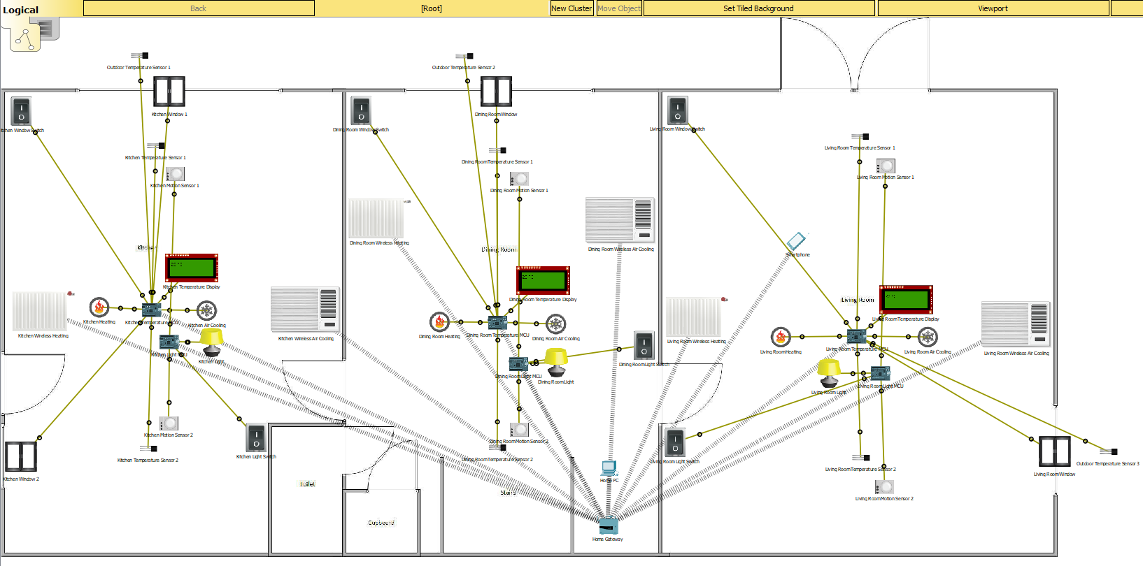
Figure 1: WSN Logical Topology.

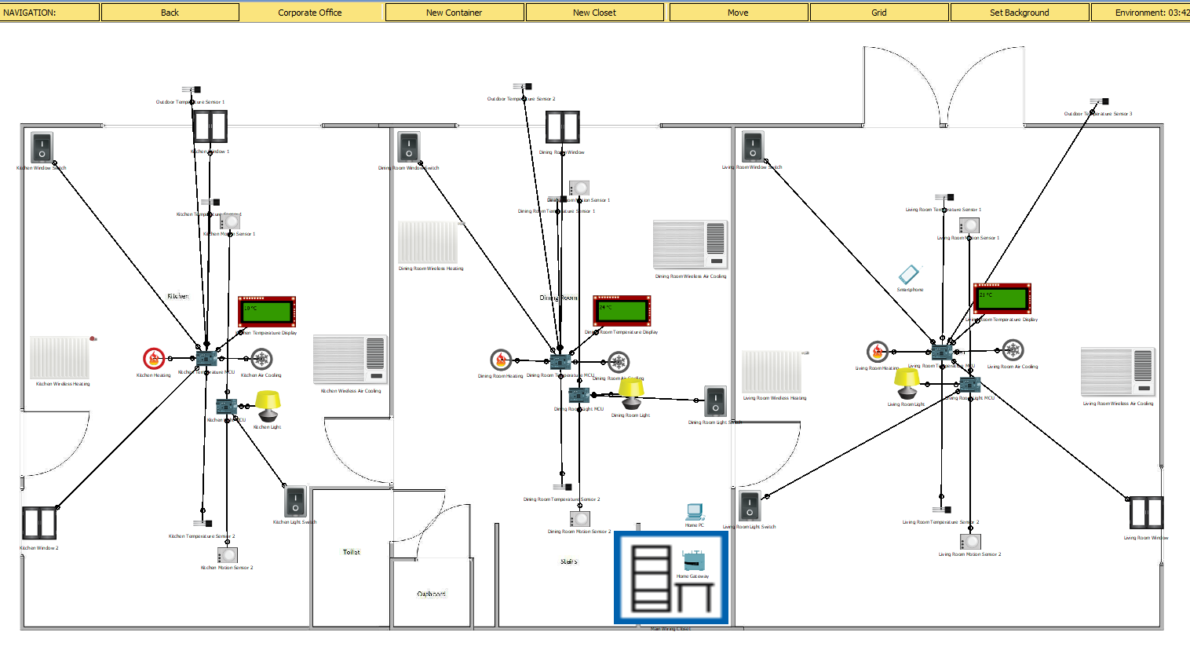
Figure 2: WSN Physical Topology.

Figures 1 and 2 depict the WSN utilised in the completion of the project. Figure 1 shows the logical topology, which includes the wireless connections, whereas figure 2 shows the physical view, which is how the network would look once physically deployed. The floor plan was created using Microsoft Visio 2016 [64], saved as a PDF which allowed it to be imported into Packet Tracer [63] using the set tiled background function. Three rooms were utilised to demonstrate the idea and concept behind the projects WSN and how each device would interact with others.

Each room utilises three temperature sensors to obtain accurate temperature readings of each room. The locations chosen were decided with this goal in mind, therefore two temperature sensors were placed on opposite ends of the room while a single temperature sensor was placed on the outside. To discover the average temperature of the room, the two temperature sensors located within the room will gather temperature data to discover the average ambient temperature within the room. The outside temperature sensor is used to acquire a rough estimate of outdoor temperature to determine quality of outside weather for various network functions. A detailed analysis will be conducted in Chapter 5. Examples of these temperature sensors in a real-world scenario would be Monnit [61] or PASCO [62]. Within the Packet Tracer simulation software, they function as simple temperature sensors utilising specific code to read temperature.

The WSN utilises a Microcontroller (MCU) board to control the temperature sensors. Each room utilises a unique MCU board to control each device to each room unique specifications. Examples of these MCU boards are made by Arduino [65]. Arduino is a computer hardware and software company who specifies in the creation of single-board microcontrollers and microcontroller kits [65] [66]. These kits function identically to the MCU board utilised in the Packet Tracer simulation. Microcontroller boards are equipped with digital and analog input/output pins which allow them to interface and control various devices, such as sensors [66]. Typically, these boards are programmed using various programming languages such as C, C++, JavaScript, etc. [66]. These devices have the capacity to create environmental monitoring systems which can monitor temperature, light, humidity etc. [66], which makes them an ideal choice for this projects purpose. Arduino is also convenient and easy to operate [66].

Other devices include two motion sensors, per room, for light control. These motion sensors, like the temperature sensors, are placed on opposite sides of the room for maximum coverage of the entire area. The purpose of these is to turn on the rooms light once movement is detected. Monnit [67] and PASCO [68] are both types of motion sensor which can be deployed within a WSN. Light control is also done utilising on/off switches which can also be accessed utilising IoT technology to allow light control via smart device.

To control ambient temperature, air conditioning, heating and smart windows were placed in each room to be utilised depending on current temperature and programmed ideal temperature. Each room currently possess one air conditioning, one heating device and one / two windows. These devices operate using IoT wireless communication standards. However, design shows a heating and cooling unit connected to each MCU. This is another method of device communication which will be discussed in chapter 5. The air conditioning and heating are also placed in a more central location to maximise the effect they have on ambient temperature of the room.

Chapter 5

5.1 Implementation and Discussion
Once the devices were placed, the next step was to configure them. The devices were placed within Packet Tracer, where a template was used to simulate change in temperature. While Packet Tracer has certain limitations, such as unable to gather accurate data over a period, it did allow for testing of certain codes and device functions under different conditions. This chapter will breakdown the function of each device, how these devices work together and how they operate to solve the issue set forth by the project. Two methods will also be discussed to achieve network functionality in this chapter: utilising IoT server for device communication and utilising MCU boards, such as Arduinos, to program and control device behaviour.

5.2 Temperature Sensor Implementation
As mentioned in the design section, there are two temperature sensors within each room and one temperature sensor located outside the room. The role of the two inner temperature sensors is to read ambient temperature within the room, send this information to the MCU, which then determines the average temperature of the room. This is done for several reasons, one being that it gives an accurate reading of room temperature. Example of this is that temperature near the window could be affected by outside sources, such as sunlight or cold air. Therefore, it is important to utilise multiple sensors, one located near the window while the second is more central. This will give a greater overview of room temperature. To accomplish this goal, the MCU is programmed to read temperature levels from both sensors, find the average temperature and then report this temperature to the IoE Server to be utilised within the network.

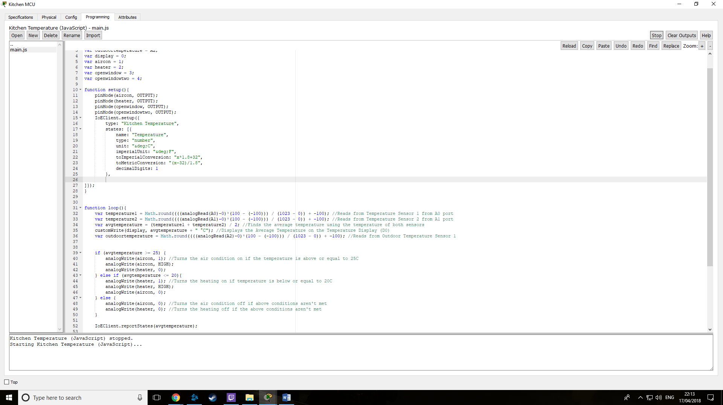
Figure 3: MCU Code for Temperature Sensor

Figure 3 depicts the code utilised by the MCU to accomplish this task. Lines 32 and 33 cause the MCU to read information acquired from specified ports, convert this data into readable temperature levels between -100 and 100 degrees and then store this information within a predetermined variable. In this case the variables are “temperature1” and “temperature2”. The reason for the conversion code is that Packet Tracer temperature sensors display data between 0 and 1023, which maps between -100 and 100 degrees. Therefore, this code translates the 0 to 1023 to data which can be understood and utilised within the network. Once data is acquired from both temperature sensors, the average temperature is calculated on line 34. This data is then stored within a separate variable then written to a display screen on line 35, which allows a user to clearly read the temperature level, demonstrated in Figure 4.

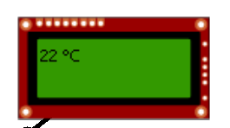
Figure 4: Temperature display screen

Line 36 shown in Figure 3 allows the MCU to read data from the outdoor temperature sensor and store this data within a variable, utilising the same code and idea as the previous temperature sensors. The data acquired by the sensors is then transmitted to an IoT server to be utilised in temperature control. This is done via line 52 where the average temperature can be viewed by IoT enabled smart devices and used by an IoT server to control smart devices. There are two methods to control device function, which will be split into two sub sections and discussed, followed by comparison of methods such as pros and cons.

5.2.1 Temperature Control Implementation Utilising IoE Server
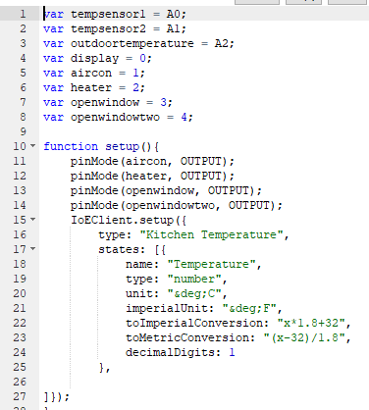
Figure 5: MCU IoT Server Setup

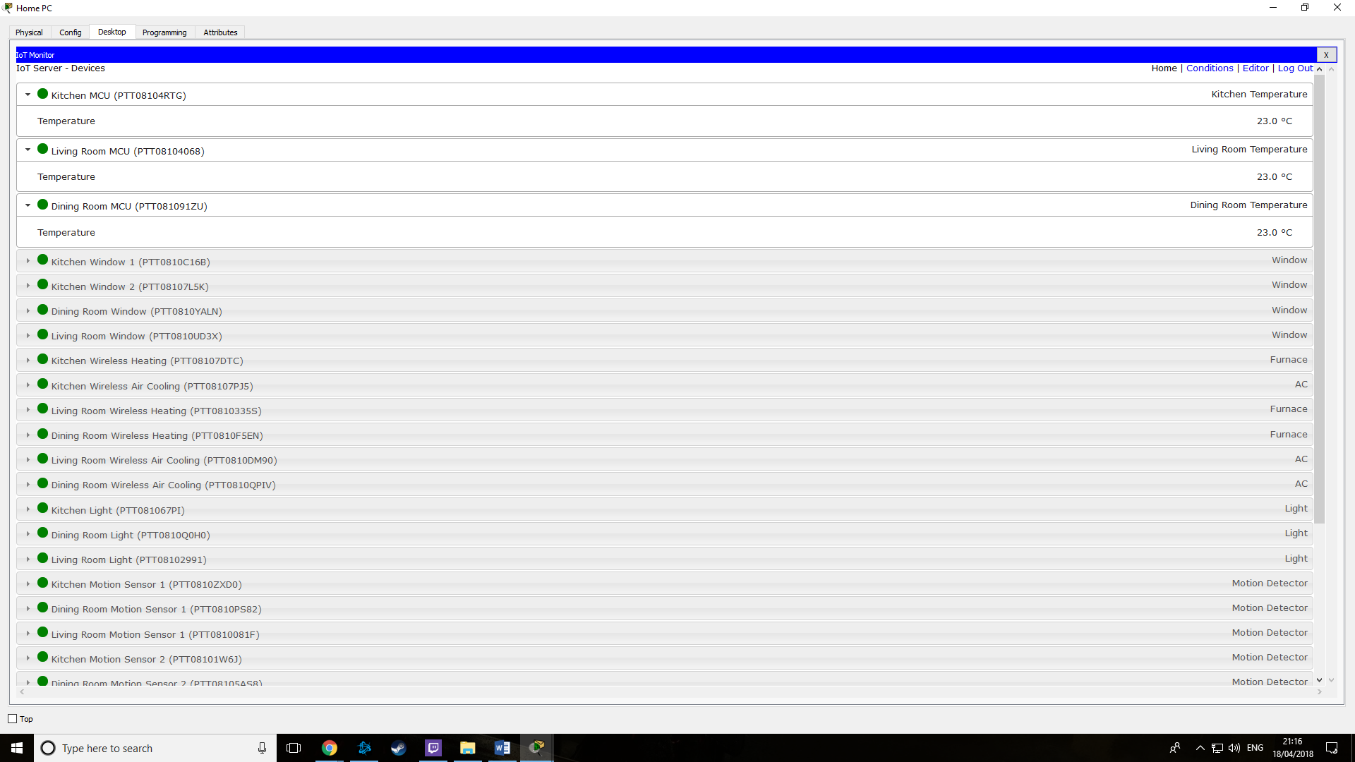
Figure 6: IoT Server Smart Device View.

The data acquired by the temperature sensors will be transmitted to the IoE server, which can be viewed by IoT devices. Figure 5 depicts the code required to allow for remote monitoring of temperature sensors. As seen on line 15 in Figure 5, the IoT Server setup is done. This is called IoEClient.setup in JavaScript for Packet Tracer functionality. Lines 15-25 depicted in Figure 5 in conjunction with line 52 of Figure 3 creates a remote view of the temperature function, viewable with IoT enabled smart devices, seen in Figure 6. This data can then be used for device control. To ensure devices are IoT compatible, they must possess a wireless communication method.

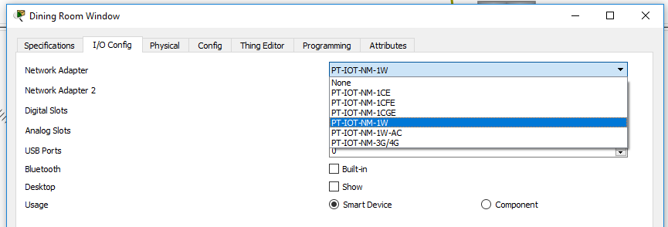
Figure 7: Enabling Wireless Communication

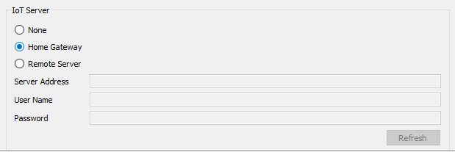
Figure 8: Selecting IoT Server


Figure 9: Configuring Home Gateway Communication.

Figure 7 shows the process of adding a wireless communication module to the device. This enables the device to wireless communicate with other devices. Figure 8 shows the selection of IoT Server, as the simulation depicts a smart home type of environment, the Home Gateway will act as the IoT Server. This will allow smart devices to relay their specified information, which can be utilised to control various devices within the network. Figure 9 shows the process of connecting the device to the Home Gateway, by specifying the Home Gateway as the SSID and enabling the WPA2-PSK security phrase associated with the Home Gateway. A list of available devices for IoT function can be seen in Figure 10.


Figure 10: List of IoT Enabled Devices.

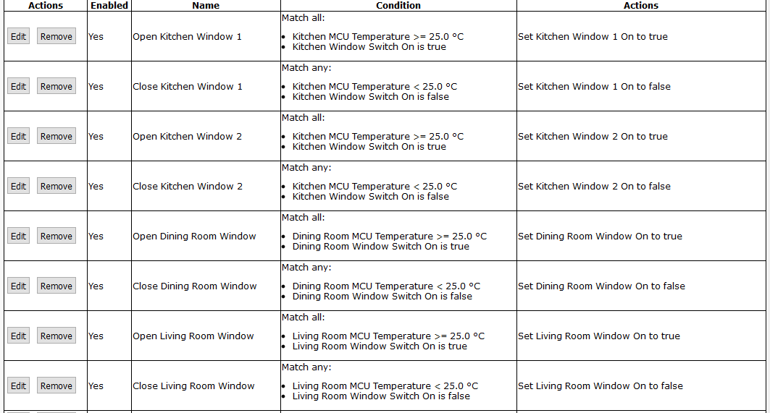
Figure 11: Window Control Conditions

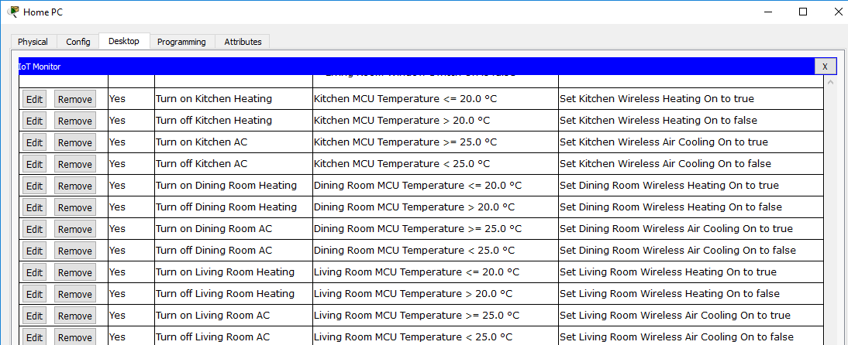
Figure 12: Heating and Air Condition Control Conditions

Figures 11 and 12 depict a list of conditions created utilising the IoT Server function within Packet Tracer to control various devices. If certain condition thresholds are met, different devices within the network will become active or de-active.
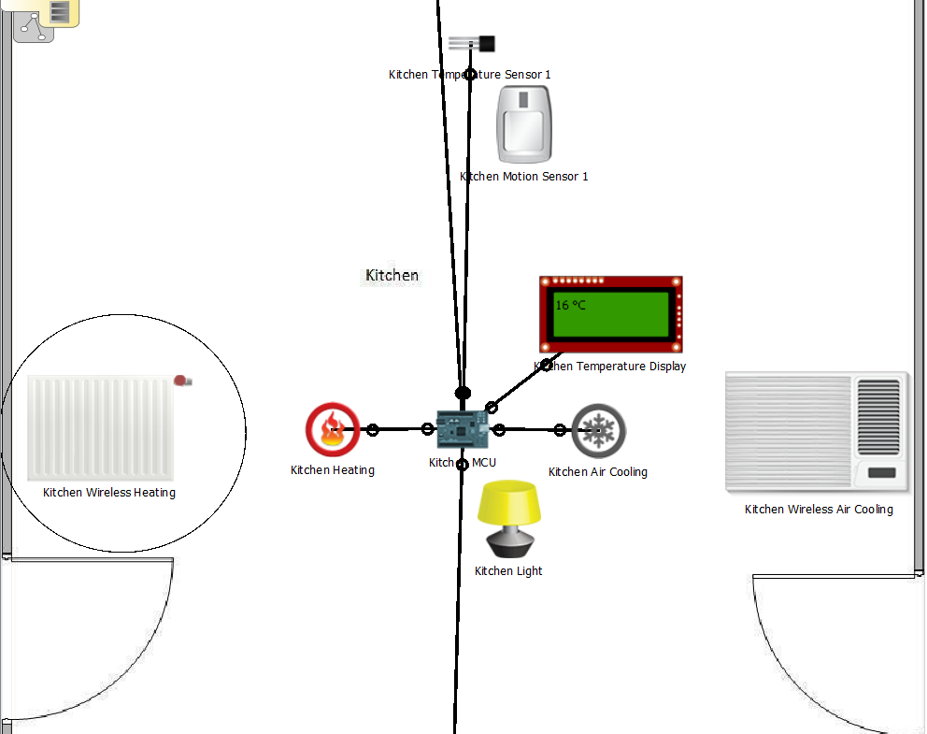
Figure 13: Heating Active below 20 °C

Figure 12 shows that under the condition that the temperature is below 20 °C, the heating device will be activated. Figure 13 demonstrates that the heating devices function as expected. The display shows a temperature level of 16 °C, which is then transmitted to the IoT Server, which sends a signal to the Wireless Heating device, encircled in Figure 13, which then activates to raise the temperature level.

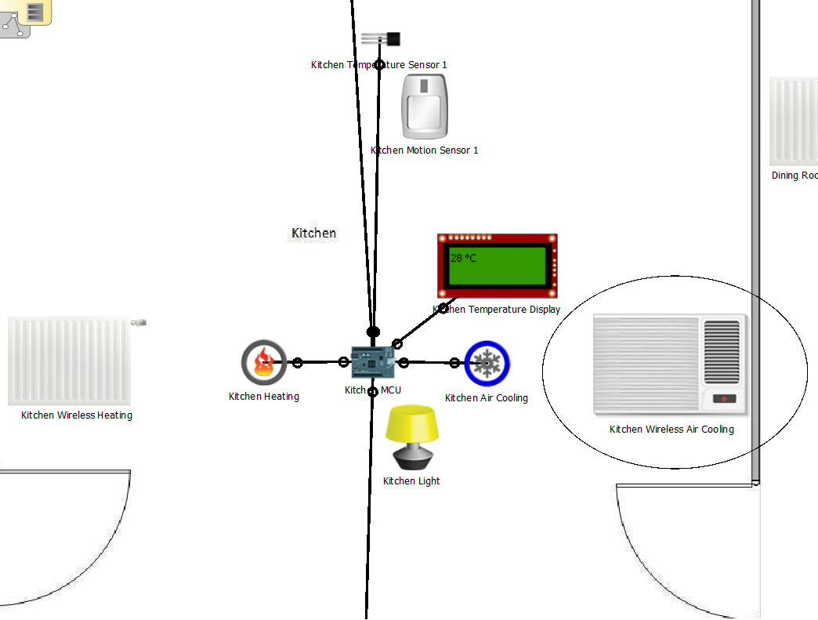
Figure 14: Air Cooling Active above 25 °C

Like heating control, once temperature surpasses 25 °C, the air cooling devices become active. Figure 12 shows the condition for this, where air cooling becomes active at or above 25 °C and deactivates once temperature come below this threshold. Figure 14 shows a temperature level of 28 °C, which is then transmitted to the IoT Server. As the temperature is above 25 °C, the air cooling devices, encircled in Figure 14, will become active. The device will remain active so long as temperature levels remain at or above 25 °C. Once temperature drops below 25 °C, the device will be inactive.

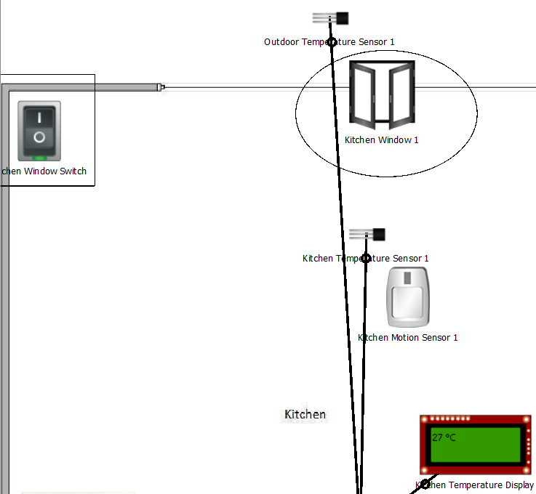
Figure 15: Window Control with active switch

Air conditioning is not the only method of cooling temperature. Other methods are as simply as opening windows to allow for air flow. This method has been incorporated into the network design. As seen in Figure 15, the design makes use of wireless IoT windows which interact with the IoT server to open and close depending on temperature level. For this method to be utilised however, the outside temperature sensor must report adequate temperature levels. This is to determine a rough estimate of outdoor weather conditions, as higher temperature typically displays better weather compared to lower temperature levels. As such, the outdoor temperature sensor is utilised to determine outdoor temperature and report this to the MCU, which then reports the temperature to the IoT Server. Should both indoor and outdoor temperature meet the conditions set, as seen in Figure 11, the window will open or close. If temperature levels are once again above 25 °C, the window will open, or if the temperature is below 25 °C, it will shut. However, one more condition is required for this to function. Each room possess a switch which activates the window functionality. This switch, marked within a square in Figure 15, must be active for the windows to open. Figure 15 shows a temperature level of 27 °C, shows the switch is active, therefore the window will open. However, Figure 16 below shows a similar set of conditions, with a temperature level of 29 °C, but with an in-active switch. This prevents the window from opening.

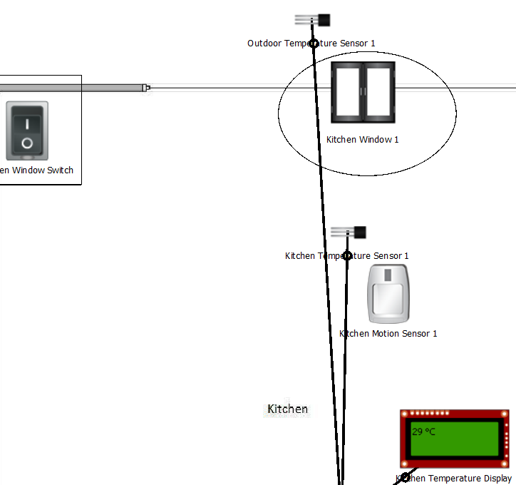
Figure 16: Window Control with in-active switch

The purpose of this feature is to deactivate the window functionality should the home owner not wish for open windows or if there are no personnel present within the home or office. This function can be controlled remotely via any IoT configured smart device, as seen in Figure 17.

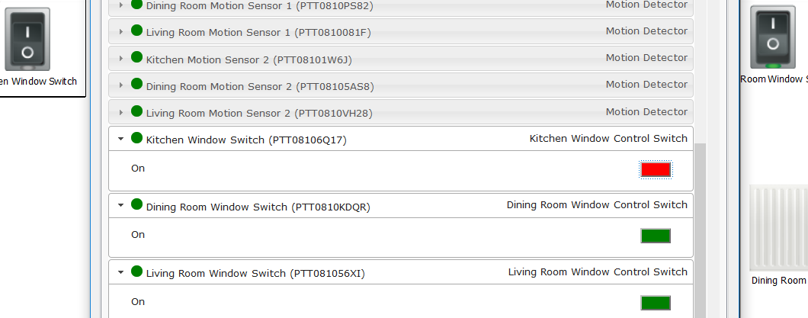
Figure 17: Window Switch Control via IoT Smart Device.

5.2.2 Temperature Control Implementation Utilising MCU Board
Another method of temperature control within a network is to utilise MCU boards, such as Arduino’s, to program various device functions. Packet Tracer also allows the simulation of Arduino board-controlled networks, which this project utilises using JavaScript programming language.

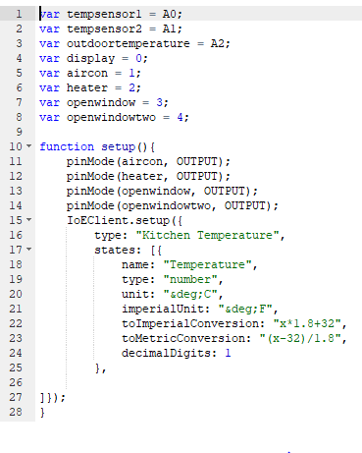
Figure 18: JavaScript code for Network setup.

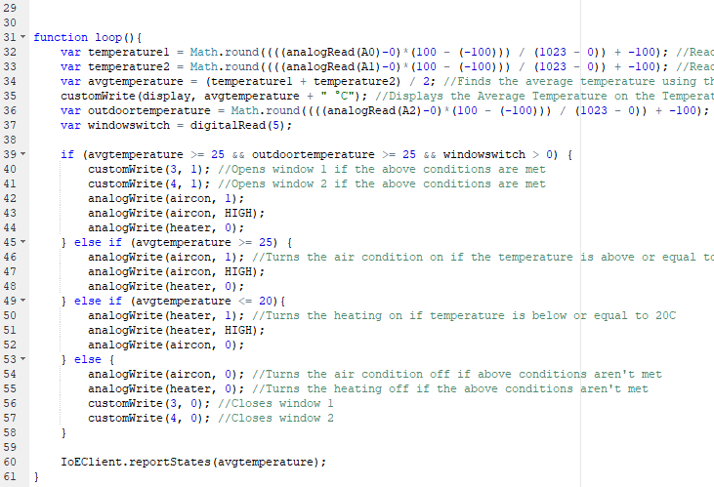
Figure 19: JavaScript code for Network function

Figures 18 and 19 depict the JavaScript code utilised within the project to control various devices. A larger view of the code within these figures can be seen within the appendices section. The function of this is like the IoT Server method, with the key difference that all device function is controlled by the MCU boards. One advantage of this method over the IoT Server method is that all process traffic does not originate from a singular location. Likewise, not all traffic is sent to a singular location. Another advantage is that devices do not require connection to an IoT server. However, the MCU itself will still require this connection if the user desires to utilise IoT concepts such as remote monitoring or remote control. While the temperature MCU board still updates the IoT Server, as seen in Figure 18 lines 15-24 and Figure 19 line 60, all device control function originates from the MCU, not the IoT Server. Figure 20 depicts the network under MCU control.

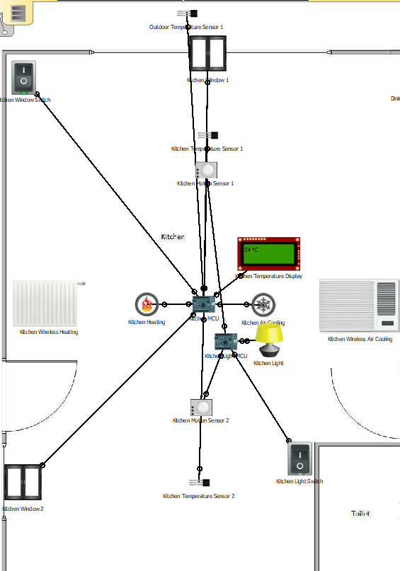
Figure 20: MCU controlled network.

The core concepts are similar to the previous method, once temperature levels reach a certain threshold, various devices become active or in-active. Looking back at Figure 19, the JavaScript code shows how the network will function. Lines 32 and 33 make the MCU read data originating from the two in door temperature sensors, connected to analog slots 0 and 1, allowing the MCU to determine average room temperature by taking the temperatures acquired from both sensors and averaging the value, done on line 34. The average temperature is then displayed on the display screen, connected to digital slot 0.

Once the room’s average temperature is calculated, various devices will become active or in-active depending on the value calculated. Lines 39 to 58 display the steps involved in determining which device becomes active. Line 45 states should the average temperature level rise above 25 °C, the air cooling function will become active, while line 49 states that should the temperature fall below 20 °C, and the heating will become active. These are done by having the MCU send a signal to digital slot 1 for air cooling, and digital slot 2 for heating. This signal, depending on the temperature conditions, will activate or de-activate the appropriate device. Line 48 prevents the heating device from operating while the air cooling is active, while line 52 states that the air cooling will not be active while the heating is active.

If the average temperature falls between 21 and 24 °C, neither the air cooling or heating devices will be activated. Lines 53 to 58 within the JavaScript code display this function.

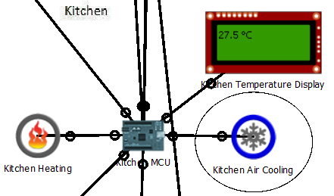
Figure 21: Air Cooling Active

Figure 21 shows that air cooling (marked by the circle) functions become active while temperature is above 25 °C. In this scenario the temperature level is 27.5 °C, therefore air cooling is activated while heating is in-active. On the other hand, Figure 22 below shows that heating functions (marked in the circle) become active once temperature falls below 20 °C.

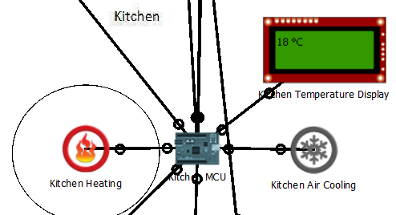
Figure 22: Heating Active

Figure 19 also depicts a scenario programmed where the kitchen windows open under certain conditions, shown in line 39. Line 36 ensures that the MCU will read temperature data gathered by the outdoor temperature sensor, connected to analog slot 2, and line 37 ensures data from the device connected to digital slot 5, in this scenario the window control switch, and is being registered. Utilising all this information, should the average indoor temperature rise above 25 °C, the outdoor temperature be above 25 °C and the window control switch is active, the MCU program will send a signal to the kitchen windows, connected to digital slots 3 and 4, to open them.

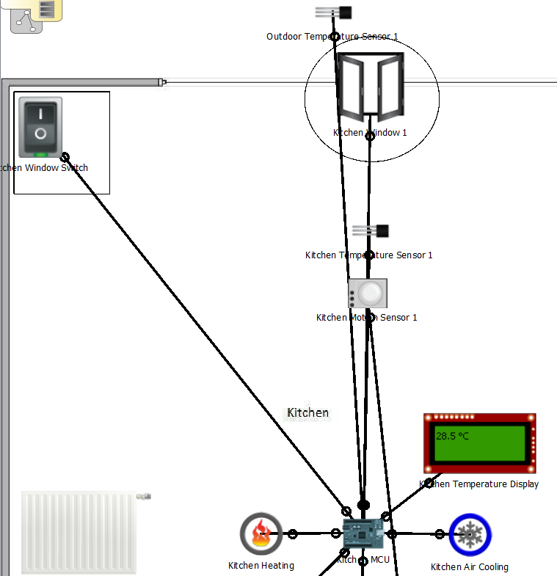
Figure 23: Window Active Function

Figure 23 shows the window open while all conditions are met. In this scenario the temperature is 28.5 °C, the outdoor temperature is above 25 °C and the window control switch, marked within the square, is active. Therefore, the window, marked in the circle, will open.

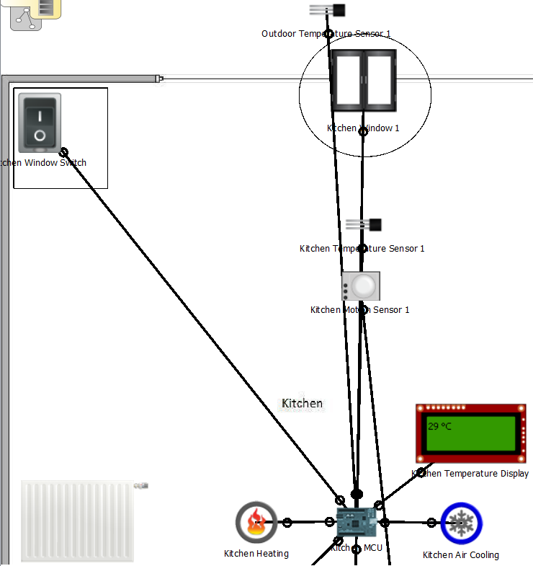
Figure 24: Window In-Active Function

Figure 24 shows the effect if one of the 3 conditions are not met. While Figure 23 showed a scenario where all 3 conditions are met, Figure 24 has one key difference. This difference is that the window control switch, marked within the square, is in-active. Therefore, the window will not open. The purpose of the window control switch is to allow for some manual control over the network. In a scenario where the home owner, or business owner, does not wish for open windows, the option is available to them.

5.2.3 Projects Goal
The goal of this project is to control heating and temperature utilising wireless sensor technology. To achieve this goal, the Packet Tracer simulation was created to test different methods of temperature control. Both methods previous discussed, that is the IoT Server control and JavaScript program, achieve this in different ways. The main difference between the two is the physical setup. While the IoT Server method focuses purely on wireless communication, which in Packet Tracer is the 2.4 GHz band under the 802.11 standard, the MCU in Packet Tracer has several wired connections but ultimately updates the temperature conditions wirelessly to an IoT Server, therefore making use of both wired and wireless communications.

The MCU’s program is instrumental in the projects creation, as it allows the network to discover a room’s average temperature and analyse this temperature and outdoor temperature. This data is then uploaded to the IoT Server, where it can be used to determine which device operates under specific conditions, i.e. air cooling while temperature is above 25 °C.

Arduino boards can be easily acquired, and with an understanding of programming languages, can be utilised in conjunction with sensors and devices to create similar networks. For the creation of an IoT Server controlled network, a server device would be required. In this scenario, a networking background is required as programming languages such as Java do not play as big a role. In a scenario where a physical network is required to achieve this projects goal, it is advised to stick with the IoT Server method, as it provides more wireless control, which is a big part of this projects goal.

5.3 Light Control
The project simulation also possesses automated light control. While this is not necessarily required to achieve the projects goal, it does help in several aspects. These include further demonstrating the advantages and usefulness of IoT / WSN technology, as well as providing a more accurate demonstrating of a WSN. By this the author means there will inevitably be many wireless devices communicating within a WSN, therefore enabling as many as possible gives a better idea of network size, scalability and resilience. As wireless devices communicate, it could generate interference within a network, therefore allowing the examination of network resilience and data reliability. Adding more devices allows for network size and scalability tests, while also allowing a better range examination, i.e. wireless signal strength at varying spots within the network. Similar to the temperature sensor implementation, there are two methods of implementing light control: IoT Server and MCU board control.

5.3.1 Implementation utilising IoT Server method
Many of the concepts in this method are similar to that used in the creation of the temperature control section. Devices must be equipped with wireless communication adapters, they must have an IoT Server specified to them and they must be configured to access the networks gateway. In this networks scenario, the Home Gateway acts as both the IoT Server and the network gateway.

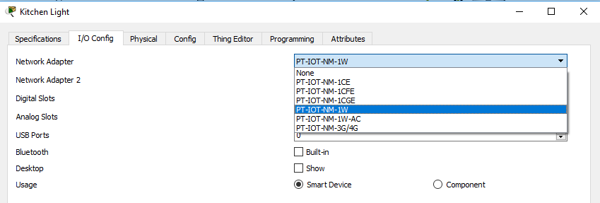
Figure 25: Enabling Wireless Communication on Light Device.

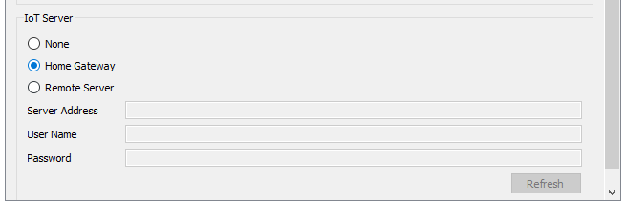
Figure 26: Specifying IoT Server

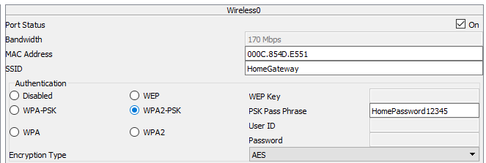
Figure 27: Specifying Wireless Communication

Figure 25 shows the process of enabling wireless communication of the device within Packet Tracer. Figure 26 shows the specification of the IoT Server, which is the Home Gateway in this projects network. Figure 27 depicts the setup of wireless access to the home gateway. The process involves specifying the Home Gateway as the SSID, enabling the WPA2-PSK pass phrase and entering the password to enable access.


Figure 28: Packet Tracer Light Device Code for IoT Server Access

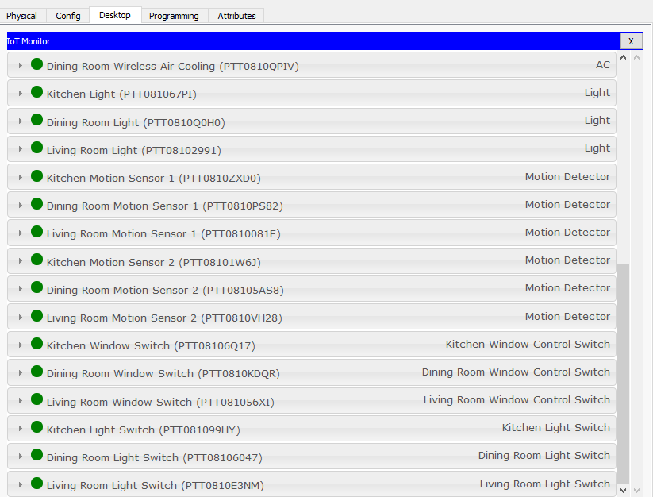
Figure 29: List of Devices with IoT Server Access

Once this process is complete, and the device has been programmed to allow for IoT Server access as seen in Figure 28, the device is ready to be controlled via the IoT Server. A list of these devices can be seen in Figure 29.

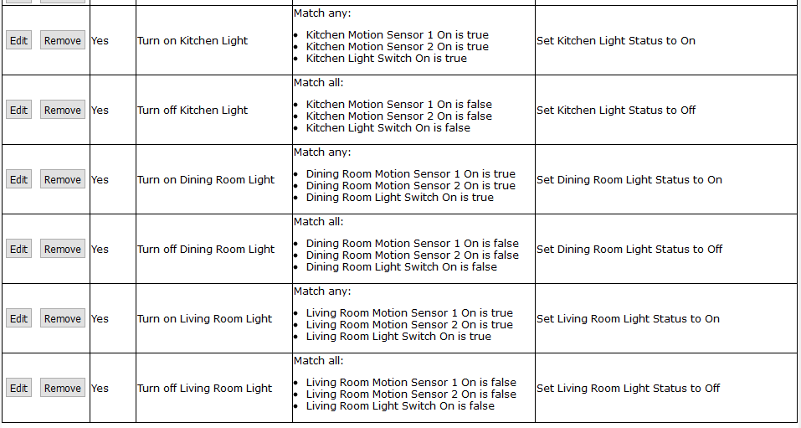
Figure 30: List of Light Control Conditions

Like the temperature control section, the light control requires a list of functions to operate, shown in Figure 30. These can be programmed into the IoT Server. Once assigned, depending on information the server receives from varying devices, different operations will be launched. The light network utilises motion sensors and light switches to determine if the light activates or not. As seen in Figure 30, there are three conditions which lead to the light activating. Only one of these is required to turn on the light, while all three conditions are required to be false for the light to be inactive.

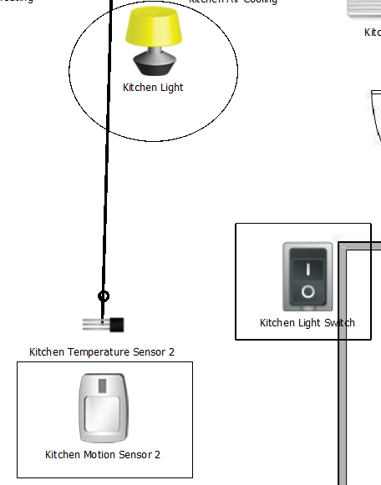
Figure 31: Light Network Setup

Figure 31 shows the projects light control network. As shown, the light (circled) is inactive while both the motion sensor and light switch are not functioning. However, if either the motion sensor or switch become active, the light will also activate, as seen in both Figures 32 and 33 below.

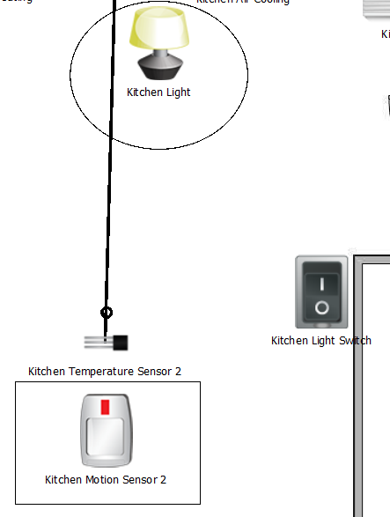
Figure 32: Motion Sensor Active

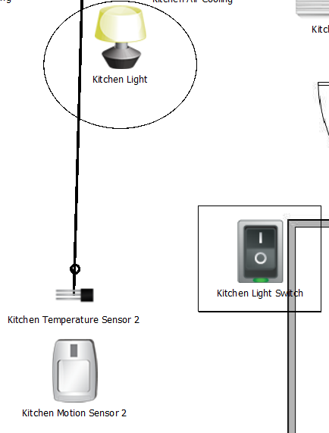
Figure 33: Light Switch Active

In the scenario presented in Figure 32, the light will activate once the motion sensor activates. Once active, the motion sensor will require 3 seconds of no movement in order to deactivate, and as a result deactivate the light. This is done by having the motion sensor relay a signal to the IoT Server, which then sends another signal to the light device to activate it. The scenario in Figure 33, however, is slightly different in that the light switch will not activate or be deactivated without human interaction. This means that the light can be manually turned on utilising the IoT device view on any smart device programmed accordingly, as seen in Figure 34, where the kitchen light was activated utilising a smart device, while the dining room light remains inactive.

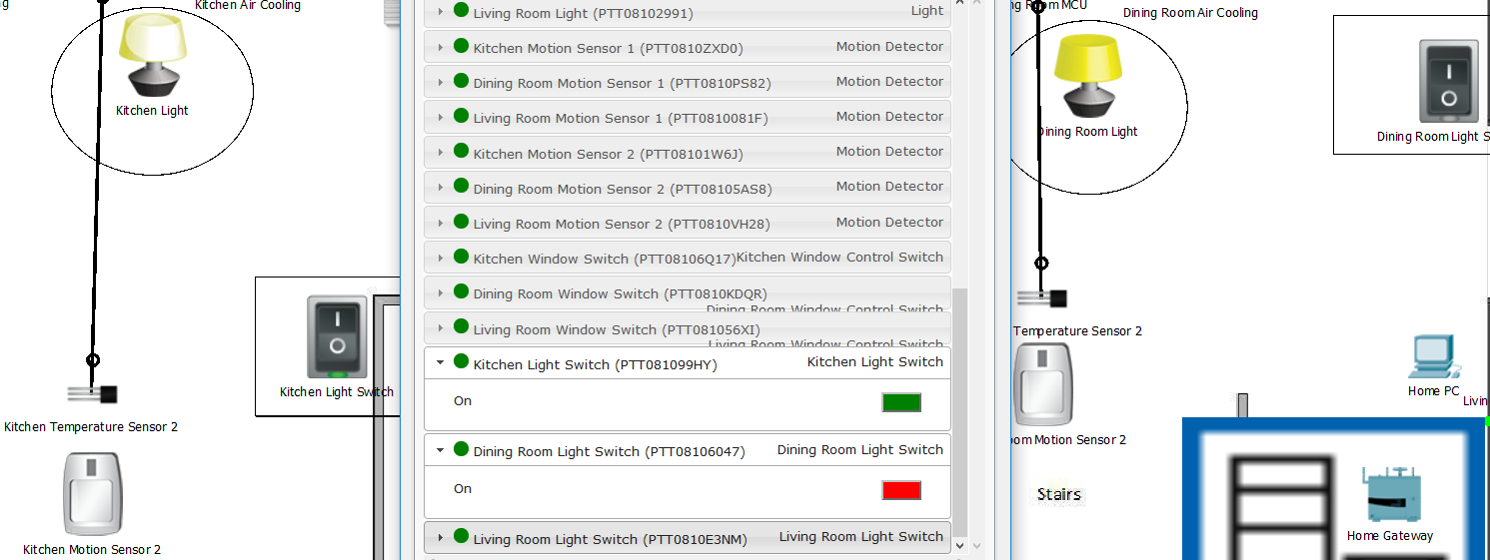
Figure 34: Light Control via IoT Smart Device

5.3.2 Implementation utilising MCU Board method
The second method is to use a MCU board, such as Arduino’s, to control room lighting. This scenario, like the temperature sensor one, requires an MCU board in each room for light function. The motion sensors send signals to the MCU, which reads the signal from the specified port, in order to make decisions on lighting control.

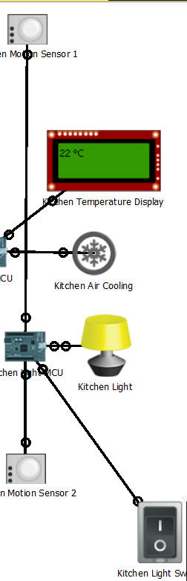
Figure 35: MCU Controlled Light Network

Figure 35 depicts the setup for the light network. Two motion sensors, a light switch and a light device are all present in each room. These devices are all connected to a central MCU board, which in turn is connected wirelessly to the IoT Server for remote monitoring.

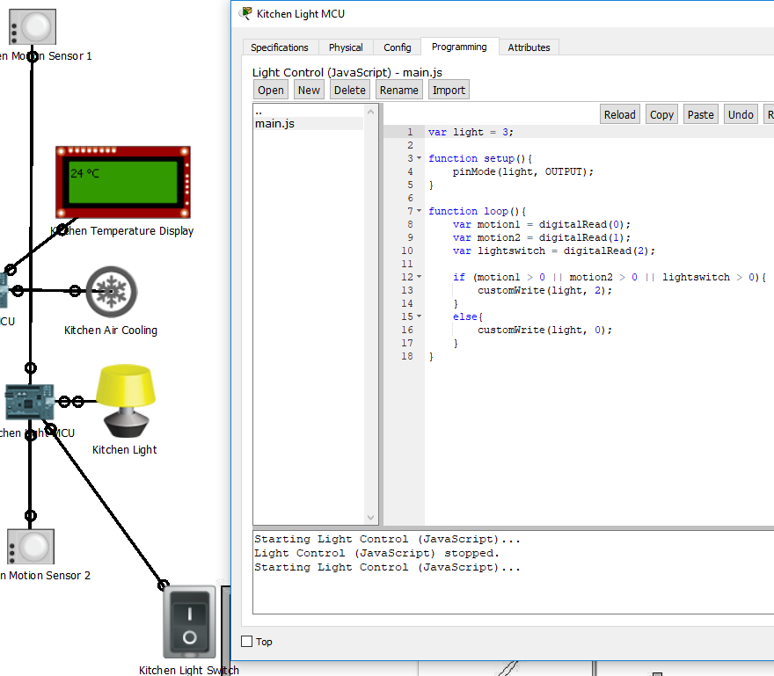
Figure 36: MCU Board JavaScript Program

Figure 36 shows the program utilised in the light control network. The program simply states the port connecting to the light device as an output port, shown on line 4, while the loop, starting on line 7, causes the MCU to read data inbound from digital ports 0, 1 and 2. This data is then stored within unique variables to be utilised in the light control process. Line 12 shows the conditions required for the light to activate. In this scenario, one of the following must be true: motion sensor 1 must detect movement, motion sensor 2 must detect movement or the light switch must be active. If any of these conditions are met, the MCU will send a signal to digital port 3, which is connected to the light device. This signal will specify that the light should become active, as one of the conditions have been met. Should no condition be met, the program will simply send a different signal to the light. This signal will instead ensure the light is inactive. Example of motion sensor detecting movement can be seen in Figure 37 while an example of the light switch function can be seen in Figure 38.

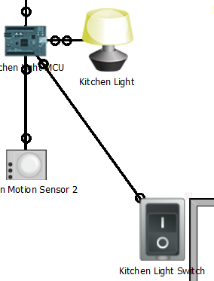
Figure 37: Motion Sensor Activated Light

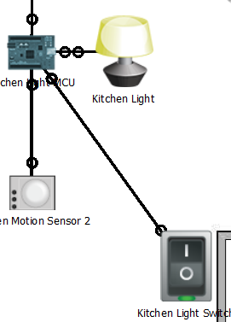
Figure 38: Light Switch Activated Light

Both the MCU and IoT Server control methods share similar advantages and disadvantages as the temperature sensor setup. Advantages of MCU include: no central convergence point, instead all program functions are handled by the MCU, while only relaying monitoring functions to the IoT Server. However, this method possesses wired methods, which contradicts the projects topic of control using WSNs. Therefore, the IoT Server method is preferred, as it controls lighting just as well as the MCU board method and is entirely wireless. However, despite this, certain aspects could prove to become an issue, such as large quantities of traffic causing signal issues. Both methods have practical implementation in a physical network. The only major difference is in which devices are used, i.e. Arduino’s for MCU board method and a Server or Home Gateway device to be configured as an IoT Server for the IoT Server control method.

Chapter 6

6.1 Conclusion
The aim of this project was to create a WSN which can analyse the ambient temperature of a room or area and use this information to control various devices connected to the network. To achieve this, several steps were taken, including research into the field of WSN and IoT, designing an appropriate network capable of performing the projects task and finally implementing said network and analysing weather the desired effects took place. From researching the fields of WSN and IoT, certain characteristics and behaviours of these types of networks were discovered. These include communication protocols, such as ZigBee, LoRaWAN, Z-Wave and BLE, types of sensors utilised within various WSNs, such as light, temperature and humidity and the makes of these sensors, such as Monnit and PASCO.

Through research, ZigBee was identified as a popular choice for several WSNs, therefore chosen as an ideal communication protocol to implement should a physical WSN be implemented. Temperature sensors makes identified were Monnit and PASCO, however, through research into related work, the SHT15 and SHT21S temperature and humidity sensors were identified, as well as certain differences such as SHT15 being superior to the SHT21S in areas of high humidity but having similar reliability when measuring the ambient temperature of an area, in that both are very accurate in their measurements. Therefore, had this project utilised a physical network, the SHT15 would more than likely have been the chosen temperature sensor.

While light sensors were initially going to be incorporated into the projects WSN, limitations identified in the implementation of the network caused this concept to be scrapped. This was because of lack of experience and technical knowledge in programming the light sensors. It was therefore marked as an area of improvement going forward, such as future attempts at the project or in a hypothetical scenario of re-doing the projects implementation.

The literature review research gave insight into the communicative process within WSNs. How these devices send signals to a central device, either a server or MCU board, such as Arduinos. The projects WSN was thus designed on this principle, where several temperature sensors are connected to a central control board. This MCU board was programmed to receive these signals from the sensor devices, which would then be used to determine which devices would be utilised, i.e. temperature above 25 °C would cause air cooling to activate. These central database servers or Arduino boards could then be accessed remotely via computer, laptop or other smart devices. Through this method it is possible to remotely view certain parameters, such as room temperature.

The WSN design implementation achieved the projects goal of controlling room temperature utilising sensor devices. Utilising Packet Tracer, the WSN was implemented and programmed to successfully monitor changes to ambient temperature created within the simulation software and react accordingly. Devices were functioning as expected under certain conditions, i.e. temperature below 20 °C cause heating to activate while temperature above 25 °C cause air cooling to activate. This proves the possibility to design and create a functioning WSN which can monitor various environmental conditions, such as temperature and light, which then can be used to control device behaviour. The project also implemented lighting control based on movement, which was detected utilising motion sensors. Lighting devices would activate in the presence of movement and become inactive without movement. The purpose of this implementation is to prove that WSN can be utilised for more than simply controlling room temperature, that they could be created for a variety of different functions.

While the simulation proved it possible for such networks to be created, the lack of a physical installation prevented the monitoring of such a network over a period. This was discussed and decided that future improvements upon the project would lead to the creation of a physical network, as it would reinforce the aim set forth by this project. Furthermore, it would lead to a higher quantity of data, even more variety, which could then be used to further reinforce the conclusion that creating WSN for tasks such as temperature control is not only possible, but can be efficient in terms of energy, cost and flexibility.

6.2 Future Improvements
Should the author repeat the project, several changes would be considered to improve upon both existing design and improving the method of acquiring data. While a number of methods of controlling temperature, and other devices, were discussed and created, more options are also available. One example would be to utilise light sensors in conjunction with the outdoor temperature sensor for more accurate measurement of outside weather. For example, the project utilised an outdoor temperature sensor to measure outside temperature to determine if windows would be opened to allow for air flow. This would lead to reduction in temperature in a cost-efficient manner. But, with a light sensor being used in conjunction with the temperature sensor, a better reading of daylight hours could be established, and as such more options would become available in the control aspect. Windows could be programmed to open only if light levels reach a specific threshold, i.e. not opening at night time hours.

The reason this method was not utilised for the project is a lack of knowledge in programming these devices within Packet Tracer. As Packet Tracer does not simulate perfect weather conditions, as it is primarily a network design soft, certain issues in configuration and programming were encountered. These include lack of knowledge in programming these sensors and in creating fluctuating light levels within Packet Tracer. For future projects in a similar field, more research and practise in programming light sensors, and more practise in JavaScript programming in general, would be beneficial and lead to a more efficient network design.

Another future improvement would be the addition of a physical network. While the Packet Tracer simulation is adequate in testing theories and programming skills to observe device behaviour, it lacks true data gathering capabilities. An example being that a WSN cannot be created and run for an extended period of time, in order to observe change in the environment, have devices react accordingly and gather data relating to the sensor devices, temperature control devices and network longevity. This has lead to the project becoming more of a proof of concept style of work, where a program is created, in this case utilising JavaScript, to control devices based on information acquired. In this aspect the project was successful, as the program ran properly and executed commands during periods where the information aligned with the conditions set, i.e. air conditioning turned on once temperature level exceeded 25 °C.

While the simulation was successful, a physical network would allow for further proof that certain aspects could be transferred to physical devices, thus improving data acquired and knowledge of the field. Furthermore, it would allow for the testing of other aspects, such as device longevity or how device A compared to device B regarding their purpose, i.e. would a Monnit Temperature Sensor [67] be superior to a PASCO Temperature Sensor [68] within a WSN? Which device had better life expectancy? Etc. Therefore, this is one aspect the author would incorporate into the project moving forward.

Chapter 7

7.1 Reflection
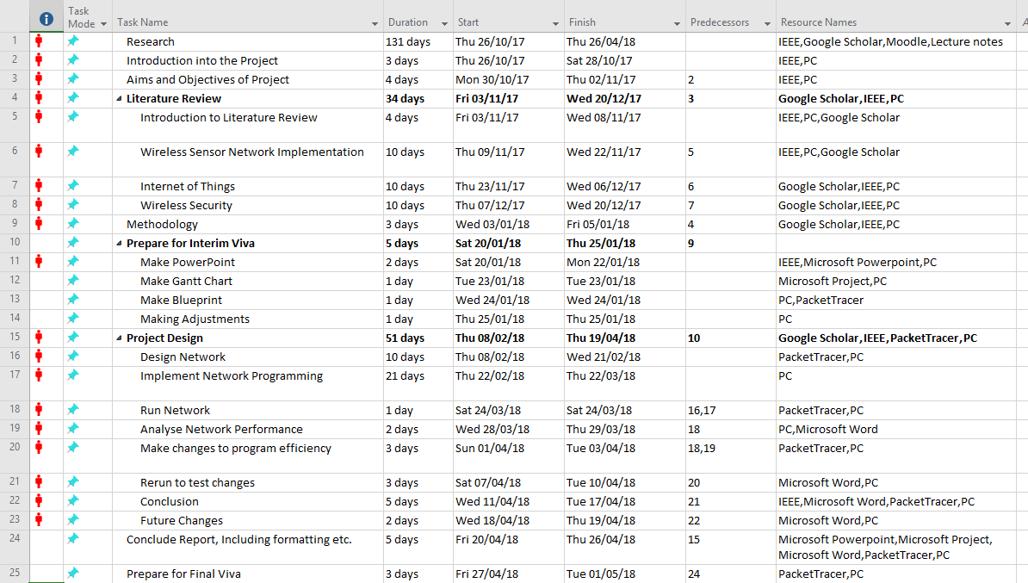
Figure 39: Gantt Chart Table
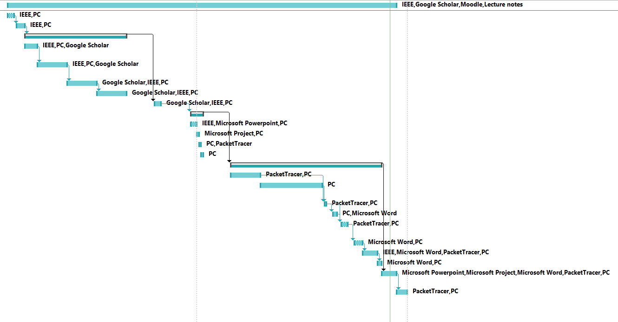
Figure 40: Gantt Chart Graph
Over the course of the project, several alterations were made to various aspects of the project plan. Figures 39 and 40 depict the final Gantt Chart used for the planning of this project. Gantt Charts are typically used to plan out time zones for various tasks within a project, therefore, keeping track of what has been done, what needs to still be done and which tasks are required before proceeding. This means that the Gantt Chart, in combination with meetings with the projects supervisor, which has been documented and can be seen in the appendices section, helped understand what was needed to be done during various moments throughout the projects lifetime. Meetings were instrumental in understanding what each section of the project would require, while the Gantt Chart kept track of time spent, or allocated, to each task over the entire project. Figures 39 and 40 show a rough estimate of the final time allocation, however, this is drastically different from what was considered during the Research Methods topics.


Figure 41: Old Gantt Chart Table


Figure 42: Old Gantt Chart Graph

As can be seen from Figures 41 and 42, when compared to Figures 39 and 40, the Gantt Chart has changed drastically. This is due to the lack of knowledge in the field of research, i.e. IoT and WSN technology and in what the project would entail in total, such as time required for various tasks as well as accounting for any life commitments or other assignments. As a greater understanding of the project was obtained, the Gantt Chart evolved from what is seen in Figures 41 and 42, to the final stage in Figures 39 and 40. Such changes include more time allocated to different tasks, alteration to the type of task and additional tasks required to complete the project aim.

Upon reflection of the end result produced by the project, it was decided that a physical network creation would have been beneficial to the project aim. While the simulation proved the projects aim to a satisfactory degree, a physical representation would have reinforced this conclusion, as well as improve other aspects. A physical network would have allowed for greater data acquisition, such as sensor device comparisons, i.e. which would perform better under certain conditions, as well as network longevity. This method would have also proven the transferability of certain skills, such as programming the Arduino boards, which would not only reinforce the project aim conclusion, but also prove that such networks could be established in a variety of areas.

One last reflection noted would be use of certain devices, such as light sensors, to more accurately control the network. Due to a lack of knowledge and time, light sensor incorporation into the project network had to be cancelled. This is due to the limited knowledge in the area of JavaScript programming, therefore, not allowing the creation and interaction with light sensors to a satisfactory level. Given more time this would be another avenue to pursue in order to improve network control. An example of light sensor incorporation would be to detect light level from outdoors to determine whether windows would open or not, as a user would likely not wish for windows to open and close during night time hours.

Another consideration was to utilise motion sensors in the temperature control network, where temperature altering devices would only function if movement was detected. This concept was scrapped as a user would prefer to pre-heat a room to satisfactory levels before anyone enters, therefore, this concept proved to be less of a priority.

References
[1] S. Chaturvedi, S. Parihar and V. Samarth, "Design of a Network for Detection of Environmental Condition Using Wireless Sensor Network Technology," 2014 International Conference on Electronic Systems, Signal Processing and Computing Technologies, Nagpur, 2014, pp. 198-203.

[2] D. Ebrahimi and C. Assi, "On the benefits of network coding to compressive data gathering in wireless sensor networks," 2015 12th Annual IEEE International Conference on Sensing, Communication, and Networking (SECON), Seattle, WA, 2015, pp. 55-63.

[3] V. Jelicic, M. Magno, D. Brunelli, V. Bilas and L. Benini, "Benefits of Wake-Up Radio in Energy-Efficient Multimodal Surveillance Wireless Sensor Network," in IEEE Sensors Journal, vol. 14, no. 9, pp. 3210-3220, Sept. 2014.

[4] P. S. Sandra, C. M. Sandeep, V. Nair, M. V. Vindhuja, S. S. Nair and M. P. Raja, "WSN based industrial parameter monitoring using smartwatch," 2017 International Conference on Circuit, Power and Computing Technologies (ICCPCT), Kollam, 2017, pp. 1-6.

[5] S. P. Gohane and G. S. Khekare, "Reconfiguration of industrial embedded system in WSN," 2015 IEEE 9th International Conference on Intelligent Systems and Control (ISCO), Coimbatore, 2015, pp. 1-5.

[6] Y. Zhang, L. Sun, H. Song and X. Cao, "Ubiquitous WSN for Healthcare: Recent Advances and Future Prospects," in IEEE Internet of Things Journal, vol. 1, no. 4, pp. 311-318, Aug. 2014.

[7] M. DArienzo, et al. "Estimation of the Energy Consumption of Mobile Sensors in WSN Environmental Monitoring Applications," 2013 27th International Conference on Advanced Information Networking and Applications Workshops, Barcelona, 2013, pp. 1588-1593.

[8] Ž. Mihajlović, et al. "Modular WSN node for environmental monitoring with energy harvesting support," 2017 Zooming Innovation in Consumer Electronics International Conference (ZINC), Novi Sad, 2017, pp. 41-44.

[9] A. Cardellicchio, et al. "An opportunistic sensor network approach to wide area environmental sensing," in 2016 IEEE Workshop on Environmental, Energy, and Structural Monitoring Systems (EESMS), 13-14 Jun. 2016, pp. 1-6.

[10] Y. Zhao and Y. z. Su, "A model of caring ability-less single via smart home WSN," in 2009 IEEE International Symposium on IT in Medicine & Education, 14-16 Aug. 2009, pp. 221-224.

[11] B. Kang, et al. "Analysis of Types and Importance of Sensors in Smart Home Services," in 2016 IEEE 18th International Conference on High Performance Computing and Communications; IEEE 14th International Conference on Smart City; IEEE 2nd International Conference on Data Science and Systems (HPCC/SmartCity/DSS), 12-14 Dec. 2016, pp.1388-1389.

[12] X. Hong, C. Yang and C. Rong, "Smart Home Security Monitor System," in 2016 15th International Symposium on Parallel and Distributed Computing (ISPDC), 8-10 Jul. 2016, pp. 247-251.

[13] J. C. Suárez Barón and M. J. Suárez Barón, "Application of SHT71 sensor to measure humidity and temperature with a WSN," in 2014 IEEE 9th IberoAmerican Congress on Sensors, 15-18 Oct. 2014, pp. 1-7.

[14] A. Alaiad and L. Zhou, "Patients' Adoption of WSN-Based Smart Home Healthcare Systems: An Integrated Model of Facilitators and Barriers," in IEEE Transactions on Professional Communication, vol. 60, pp. 4-23, 20 Jan. 2017.

[15] S. Kamei, T. Nagai and S. Fujita, "Fast and Reliable Route Maintenance Protocols for WSN with Crash and Intermittent Failures," in 2011 Second International Conference on Networking and Computing, 30 Nov-2 Dec. 2011, pp. 40-49.

[16] S. Mahalakshmi and S. Datchanamoorthy, "Prediction of wireless sensor battery life," 2015 IEEE AUTOTESTCON, National Harbor, MD, 2015, pp. 138-145.

[17] X. Lu, et al. "Reaching 10-years of battery life for industrial IoT wireless sensor networks," 2017 Symposium on VLSI Circuits, Kyoto, 2017, pp. C66-C67.

[18] V. Quintero, C. Estevez and M. Orchard, "State-of-charge estimation to improve energy conservation and extend battery life of wireless sensor network nodes," 2017 Ninth International Conference on Ubiquitous and Future Networks (ICUFN), Milan, 2017, pp. 153-158.

[19] C. Shen and S. Chen, "A Cyber-Physical Design for Indoor Temperature Monitoring Using Wireless Sensor Networks," 2017 IEEE Wireless Communications and Networking Conference (WCNC), San Francisco, CA, 2017, pp. 1-6.

[20] U. Gogate and J. W. Bakal, "Smart Healthcare Monitoring System based on Wireless Sensor Networks," 2016 International Conference on Computing, Analytics and Security Trends (CAST), Pune, 2016, pp. 594-599.

[21] M. Benamara, et al. "Array sub-loops reader antenna for HF RFID tracking," 2017 IEEE International Conference on RFID Technology & Application (RFID-TA), Warsaw, Poland, 2017, pp. 100-105.

[22] A. Cardellicchio, et al. "An opportunistic sensor network approach to wide area environmental sensing," 2016 IEEE Workshop on Environmental, Energy, and Structural Monitoring Systems (EESMS), Bari, 2016, pp. 1-6.

[23] Z. Lieping, C. Peng and P. Fei, "Design of Lijiang Water Environment Monitoring System Based on WSN," 2016 Eighth International Conference on Measuring Technology and Mechatronics Automation (ICMTMA), Macau, 2016, pp. 210-213.

[24] G. M. Bragg, et al. "868MHz 6LoWPAN with ContikiMAC for an Internet of Things environmental sensor network," 2016 SAI Computing Conference (SAI), London, 2016, pp. 1273-1277

[25] H. W. van der Westhuizen, G. P. Hancke and T. D. Ramotsoela, "Smartphone controlled WSN for a smart home," 2017 IEEE AFRICON, Cape Town, 2017, pp. 1587-1592.

[26] G. Ramirez, O. Fuentes and C. E. Tweedie, "Assessing data quality in a sensor network for environmental monitoring," 2011 Annual Meeting of the North American Fuzzy Information Processing Society, El Paso, TX, 2011, pp. 1-6.

[27] H. Messer, A. Zinevich and P. Alpert, "Environmental sensor networks using existing wireless communication systems for rainfall and wind velocity measurements," in IEEE Instrumentation & Measurement Magazine, vol. 15, no. 2, pp. 32-38, April 2012.

[28] S. Diaz, D. Mendez and R. Kraemer, "ICI — Interference characterization and identification for WSN," 2017 Wireless Telecommunications Symposium (WTS), Chicago, IL, 2017, pp. 1-7.

[29] G. A. Akpakwu, et al. "A Survey on 5G Networks for the Internet of Things: Communication Technologies and Challenges," in IEEE Access, vol. PP, no. 99, pp. 1-1.

[30] I. M. Culic and A. Radovici, "Development platform for building advanced Internet of Things systems," 2017 16th RoEduNet Conference: Networking in Education and Research (RoEduNet), Tg. Mures, Romania, 2017, pp. 1-5.

[31] K. Suri, et al. "Semantic Framework for Internet of Things-Aware Business Process Development," 2017 IEEE 26th International Conference on Enabling Technologies: Infrastructure for Collaborative Enterprises (WETICE), Poznan, 2017, pp. 214-219.

[32] A. Mosenia and N. K. Jha, "A Comprehensive Study of Security of Internet-of-Things," in IEEE Transactions on Emerging Topics in Computing, vol. 5, no. 4, pp. 586-602, Oct.-Dec. 1 2017.

[33] N. Benamar, A. Jara, L. Ladid and D. E. Ouadghiri, "Challenges of the Internet of Things: IPv6 and Network Management," 2014 Eighth International Conference on Innovative Mobile and Internet Services in Ubiquitous Computing, Birmingham, 2014, pp. 328-333.

[34] S. Ziegler, "Considerations on IPv6 scalability for the Internet of Things — towards an intergalactic Internet," 2017 Global Internet of Things Summit (GIoTS), Geneva, 2017, pp. 1-4.

[35] J. M. V. Ruiz, C. S. Cardenas and J. L. M. Tapia, "Implementation and testing of IPv6 transition mechanisms," 2017 IEEE 9th Latin-American Conference on Communications (LATINCOM), Guatemala City, Guatemala, 2017, pp. 1-6.

[36] J. L. Shah and J. Parvez, "Impact of IPSec on Real Time applications in IPv6 and 6to4 Tunneled Migration Network," 2015 International Conference on Innovations in Information, Embedded and Communication Systems (ICIIECS), Coimbatore, 2015, pp. 1-6.

[37] R. Krejčí, O. Hujňák and M. Švepeš, "Security survey of the IoT wireless protocols," 2017 25th Telecommunication Forum (TELFOR), Belgrade, Serbia, 2017, pp. 1-4.

[38] R. Iqbal and D. Saeed, "Safe railway crossing system based on Zigbee communication," 2017 Computing Conference, London, United Kingdom, 2017, pp. 1243-1246.

[39] H. Wang, L. Dong, W. Wei, W. S. Zhao, K. Xu and G. Wang, "The WSN Monitoring System for Large Outdoor Advertising Boards Based on ZigBee and MEMS Sensor," in IEEE Sensors Journal, vol. 18, no. 3, pp. 1314-1323, Feb.1, 1 2018.

[40] M. B. Yassein, W. Mardini and A. Khalil, "Smart homes automation using Z-wave protocol," 2016 International Conference on Engineering & MIS (ICEMIS), Agadir, 2016, pp. 1-6.

[41] A. Kurtoglu, J. Carletta and K. S. Lee, "Energy consumption in long-range linear wireless sensor networks using LoRaWan and ZigBee," 2017 IEEE 60th International Midwest Symposium on Circuits and Systems (MWSCAS), Boston, MA, 2017, pp. 1163-1167.

[42] N. Vikram, K. S. Harish, M. S. Nihaal, R. Umesh, A. Shetty and A. Kumar, "A Low Cost Home Automation System Using Wi-Fi Based Wireless Sensor Network Incorporating Internet of Things (IoT)," 2017 IEEE 7th International Advance Computing Conference (IACC), Hyderabad, 2017, pp. 174-178.

[43] M. Tolani, Sunny, R. K. Singh, K. Shubham and R. Kumar, "Two-Layer Optimized Railway Monitoring System Using Wi-Fi and ZigBee Interfaced Wireless Sensor Network," in IEEE Sensors Journal, vol. 17, no. 7, pp. 2241-2248, April, 1 2017.

[44] R. Atawia and H. Gacanin, "Self-Deployment of Future Indoor Wi-Fi Networks: An Artificial Intelligence Approach," GLOBECOM 2017 - 2017 IEEE Global Communications Conference, Singapore, 2017, pp. 1-6.

[45] N. Mirza and A. N. Khan, "Bluetooth Low Energy based Communication Framework for Intra Vehicle Wireless Sensor Networks," 2017 International Conference on Frontiers of Information Technology (FIT), Islamabad, Pakistan, 2017, pp. 29-34.

[46] E. Mackensen, M. Lai and T. M. Wendt, "Bluetooth Low Energy (BLE) based wireless sensors," 2012 IEEE Sensors, Taipei, 2012, pp. 1-4.

[47] R. Asif and W. J. Buchanan, "Seamless Cryptographic Key Generation via Off-the-Shelf Telecommunication Components for End-to-End Data Encryption," 2017 IEEE International Conference on Internet of Things (iThings) and IEEE Green Computing and Communications (GreenCom) and IEEE Cyber, Physical and Social Computing (CPSCom) and IEEE Smart Data (SmartData), Exeter, United Kingdom, 2017, pp. 910-916.

[48] V. Kumar, G. Oikonomou and T. Tryfonas, "Traffic forensics for IPv6-based Wireless Sensor Networks and the Internet of Things," 2016 IEEE 3rd World Forum on Internet of Things (WF-IoT), Reston, VA, 2016, pp. 633-638.

[49] K. N. SunilKumar and Shivashankar, "A review on security and privacy issues in wireless sensor networks," 2017 2nd IEEE International Conference on Recent Trends in Electronics, Information & Communication Technology (RTEICT), Bangalore, 2017, pp. 1979-1984.

[50] A. H. Anwar, G. Atia and M. Guirguis, "Dynamic game-theoretic defense approach against stealthy Jamming attacks in wireless networks," 2017 55th Annual Allerton Conference on Communication, Control, and Computing (Allerton), Monticello, IL, 2017, pp. 252-258.

[51] M. Cheng, Y. Ling and W. B. Wu, "Time Series Analysis for Jamming Attack Detection in Wireless Networks," GLOBECOM 2017 - 2017 IEEE Global Communications Conference, Singapore, 2017, pp. 1-7.

[52] C. Balarengadurai and S. Saraswathi, "Detection of exhaustion attacks over IEEE 802.15.4 MAC layer using fuzzy logic system," 2012 12th International Conference on Intelligent Systems Design and Applications (ISDA), Kochi, 2012, pp. 527-532.

[53] P. Khandare, Y. Sharma and S. R. Sakhare, "Countermeasures for selective forwarding and wormhole attack in WSN," 2017 International Conference on Inventive Systems and Control (ICISC), Coimbatore, 2017, pp. 1-7.

[54] A. Mathew and J. S. Terence, "A survey on various detection techniques of sinkhole attacks in WSN," 2017 International Conference on Communication and Signal Processing (ICCSP), CHENNAI, India, 2017, pp. 1115-1119.

[55] R. Verma, R. Sharma and U. Singh, "New approach through detection and prevention of wormhole attack in MANET," 2017 International conference of Electronics, Communication and Aerospace Technology (ICECA), Coimbatore, 2017, pp. 526-531.

[56] A. Rajan, J. Jithish and S. Sankaran, "Sybil attack in IOT: Modelling and defenses," 2017 International Conference on Advances in Computing, Communications and Informatics (ICACCI), Udupi, 2017, pp. 2323-2327.

[57] K. Saghar, D. Kendall and A. Bouridane, "RAEED: A solution for hello flood attack," 2015 12th International Bhurban Conference on Applied Sciences and Technology (IBCAST), Islamabad, 2015, pp. 248-253.

[58] T. N. D. Pham, C. K. Yeo, N. Yanai and T. Fujiwara, "Detecting Flooding Attack and Accommodating Burst Traffic in Delay-Tolerant Networks," in IEEE Transactions on Vehicular Technology, vol. 67, no. 1, pp. 795-808, Jan. 2018.

[59] N. Barroca, L. M. Borges, F. J. Velez, F. Monteiro, M. Górski, J. Castro-Gomes, "Wireless sensor networks for temperature and humidity monitoring within concrete structures, Construction and Building Materials," Vol. 40, Mar. 2013, pp. 1156-1166.

[60] K. Non-Alisavath, S. Kanthavong, K. Luangxaysana and X. Louangvilay, "Context-awareness application to control multiple sensors for monitoring smart environment," 2017 14th International Conference on Electrical Engineering/Electronics, Computer, Telecommunications and Information Technology (ECTI-CON), Phuket, 2017, pp. 920-923.

[61] Monnit Wireless Temperature Sensor, https://wireless-sensors.co.uk/wireless-temperature-sensor, Date Accessed Mar. 10, 2018.

[62] PASCO Wireless Temperature Sensor, https://www.pasco.com/prodCatalog/PS/PS-3201_wireless-temperature-sensor/index.cfm, Date Accessed Mar. 10, 2018.

[63] M. Vijayalakshmi, P. Desai and M. M. Raikar, "Packet Tracer Simulation Tool as Pedagogy to Enhance Learning of Computer Network Concepts," 2016 IEEE 4th International Conference on MOOCs, Innovation and Technology in Education (MITE), Madurai, 2016, pp. 71-76.

[64] Microsoft Visio 2016, Work Visually https://products.office.com/en-gb/visio/flowchart-software?tab=tabs-1, Date Accessed Apr. 16, 2018.

[65] Arduino Microcontroller Kits, https://www.arduino.cc/, Date Accessed Apr. 16, 2018.

[66] H. Zhang, G. Li and Y. Li, "A Home Environment Monitoring Design on Arduino," 2018 International Conference on Intelligent Transportation, Big Data & Smart City (ICITBS), Xiamen, China, 2018, pp. 53-56.

[67] Monnit Wireless Motion Sensor, https://www.monnit.com/Product/MNS-9-W1-MS-IR, Date Accessed Apr. 16, 2018.

[68] PASCO Wireless Motion Sensor, https://www.pasco.com/prodCatalog/PS/PS-2103_pasport-motion-sensor/index.cfm, Date Accessed Apr. 16, 2018.

Appendices

Appendix 1: Temperature MCU JavaScript Program

var tempsensor1 = A0;
var tempsensor2 = A1;
var outdoortemperature = A2;
var display = 0;
var aircon = 1;
var heater = 2;
var openwindow = 3;
var openwindowtwo = 4;

function setup(){
pinMode(aircon, OUTPUT);
pinMode(heater, OUTPUT);
pinMode(openwindow, OUTPUT);
pinMode(openwindowtwo, OUTPUT);
IoEClient.setup({
type: "Kitchen Temperature",
states: [{
name: "Temperature",
type: "number",
unit: "&deg;C",
imperialUnit: "&deg;F",
toImperialConversion: "x*1.8+32",
toMetricConversion: "(x-32)/1.8",
decimalDigits: 1
},

]});
}

function loop(){
var temperature1 = Math.round((((analogRead(A0)-0)*(100 - (-100))) / (1023 - 0)) + -100);
var temperature2 = Math.round((((analogRead(A1)-0)*(100 - (-100))) / (1023 - 0)) + -100);
var avgtemperature = (temperature1 + temperature2) / 2;
customWrite(display, avgtemperature + " °C");
var outdoortemperature = Math.round((((analogRead(A2)-0)*(100 - (-100))) / (1023 - 0)) + -100);
var windowswitch = digitalRead(5);

if (avgtemperature >= 25 && outdoortemperature >= 25 && windowswitch > 0) {
customWrite(3, 1);
customWrite(4, 1);
analogWrite(aircon, 1);
analogWrite(aircon, HIGH);
analogWrite(heater, 0);
} else if (avgtemperature >= 25) {
analogWrite(aircon, 1);
analogWrite(aircon, HIGH);
analogWrite(heater, 0);
} else if (avgtemperature <= 20) {
analogWrite(heater, 1);
analogWrite(heater, HIGH);
analogWrite(aircon, 0);
} else {
analogWrite(aircon, 0);
analogWrite(heater, 0);
customWrite(3, 0);
customWrite(4, 0);
}

IoEClient.reportStates(avgtemperature);
}

Appendix 2: Light MCU JavaScript Program

var light = 3;

function setup(){
pinMode(light, OUTPUT);
}

function loop(){
var motion1 = digitalRead(0);
var motion2 = digitalRead(1);
var lightswitch = digitalRead(2);

if (motion1 > 0 || motion2 > 0 || lightswitch > 0) {
customWrite(light, 2);
}
else {
customWrite(light, 0);
}

}

Appendix 3: First Supervisor Meeting Form


Appendix 4: Second Supervisor Meeting Form


Appendix 5: Third Supervisor Meeting Form


Appendix 6: Fourth Supervisor Meeting Form


Appendix 7: Fifth Supervisor Meeting Form


Appendix 8: Sixth Supervisor Meeting Form


Appendix 9: Seventh Supervisor Meeting Form


Appendix 10: Eighth Supervisor Meeting Form


Appendix 11: Ninth, and Final, Supervisor Meeting Form


