  Component One- Key Skills Requirement When Working In the Housekeeping Team | Student No: | 2206723
 | Module Title: | Operating Hotel Facilities
 | Module Code: | BMIH4006
 | Lecturer: | Kathryn Flynn

Introduction
The housekeeping team ensure the maintenance, cleanliness as well as aesthetic appeal of the public areas and rooms. There are a number of skills required to be working in a job of housekeeping effectively. This learning log will discuss the important key skills required to be working in a housekeeping team and how the housekeeping job is related to the hospitality industry (Cottrell, 2019).

Team Work
I believe effective teamwork in a housekeeping department brings forth the strength of every individual in a group setting. It helps in completing a task and navigating a stressful workday in an effective manner (Quick, 2020). Moreover, through teamwork individual skills and capabilities are also constantly improved which helps a person working as a housekeeper in the long run (Leiter and Bakker, 2010).
I worked in the housekeeping team at The Clermont Hotel. One day I was appointed as an attendant for beverages and food for guests and we suddenly faced an increase in the number of guests. Limited staff was available as it was off-season but through effective team working every staff member worked more than they were expected to. I took charge of food preparation due to my previous experience. I also served the guest whenever needed. All of the staff actively took part in finalising payment, taking orders, greeting and seating the guests through which we were able to manage the situation effectively.

Conflict Management

Conflict management is another skill which I consider important for an individual to have while working in a housekeeping team. Conflicts might occur between a housekeeping staff and a customer or even between the housekeeping team members (Jung and Yoon, 2018). When I was newly appointed to the housekeeping team, the supervisor that I was working under kept on assigning me tasks I was not supposed to do, hence increasing my workload. I did not say anything for a few weeks but this led to an increase in the work pressure and affected my productivity due to which some guests also complained about the quality of my work. I tried telling my supervisor how this situation is affecting my productivity but he did not listen to me. I decided to take the matter to the head of the housekeeping department who called a meeting immediately to address the issue. He set clear guidelines on what I was supposed to do and advised my supervisor not to increase my workload. This timely management of the situation leads to an increase in my productivity.

Organisation
I believe organisation skills are mandatory for a housekeeping job. No one can be a good housekeeper without this key skill. The organisation skill of one housekeeper affects the productivity of the other housekeeper or a whole team. Housekeepers are assigned a number of tasks daily which they have to keep track of in an organised manner otherwise they can miss a task assigned to them. Moreover, a housekeeper must keep all the supplies and equipment organised. Keeping equipment organised is highly essential if a housekeeper is working in a team (Batinić, 2015). While working as a housekeeper, I used to write down my daily task. Moreover, I had a habit of double-checking my housekeeping cart for the right equipment. My organisation skills helped me immensely in my housekeeping career.

Time Management Skill
Time management skills are highly essential in my point of view as housekeeping staff are assigned a number of tasks which they are expected to complete in a limited time frame. Sometimes the tasks of housekeeping staff are interrelated which requires every individual to complete their task on time otherwise it can create a snowballing effect and can affect the productivity of the whole team (Grissom et al., 2015). I used to manage time efficiently between each task while working in the housekeeping team by planning ahead. I had a practice of assigning realistic time frames to each task. Moreover, I also used to prioritise the daily work assigned to me. I mostly gave first priority to the tasks that were related to the task of my team member. These practices allowed me to perform efficiently and increased my productivity as a housekeeper as well.

How housekeeping is important in the Hospitality Industry
The role of housekeeping staff cannot be ignored in the hospitality industry as this industry cannot function without this department. Studies have shown that around 97% of guests book accommodation in a hotel after looking at its cleanliness. An effective housekeeping team maintains the positive image of businesses in the hospitality industry. Therefore, it is highly crucial for organisations to hire competent housekeeping staff with essential key skills (Mullins and Dossor, 2013).

Conclusion
To conclude, for effectively working in a housekeeping team, multiple skills are required in which some of the skills include team working, time management, conflict management and organisation. These key skills will lead to effective working in a housekeeping team. Moreover, housekeeping staff is really important in the hospitality industry as they play a major role in generating profit and retaining customers in this industry.

Word Count | 750

Component Two- Practical Task

Problem | Why did it happen? | What are you going to do? | How will you prevent this from happening in the future? | What measures would you introduce to improve team effectiveness?
A room in a hotel was not properly cleaned on the arrival of the guest. | A guest complained about the improper cleanliness of the room when they arrived. On investigation, a number of reasons were found which leads to the room not being cleaned properly before the arrival of the guest. | As a team leader, I will first conduct the proper investigation to look into the matter. I will apologise to the guest for the inconvenience caused by the housekeeping and cleaning staff or try to explain the situation to them if the problem is not from the side of the housekeeping staff. | I will support and assist the manager in assigning tasks to the room attendants and housekeeping staff in order to make sure that a reasonable amount of tasks with appropriate time frames are allotted to each staff member so that they can carry out their duties effectively and properly. This will increase the productivity of the staff. | As a team leader, I will assign the task to each housekeeping staff according to their strength so that everyone can perform their task and duties effectively as a result improving the overall team effectiveness.
The guest reported that the bed was not properly made and that there were even hair on the bed and on the pillows. | The guest arrived a little earlier than the time they mentioned at the time of booking. | I will then assign a different room for the time being and assist and supervise the housekeeping staff in properly cleaning and maintaining the hotel room for the guest. | I will also assist the manager of the housekeeping staff in checking the hotel guest rooms daily and make sure that the cleanliness standard of the hotel rooms is maintained and taken care of. | The duties and responsibilities will be assigned to each member at the start of the day and there will be a checklist provided to them to make sure that every task is carried out by them and that no task is left unattended.
Moreover, guests also mentioned that the washbasin in the washroom was not cleaned properly. | The last guest that was staying in that room did not check out of the hotel room on time which gave little time for the staff to clean the room properly and thoroughly. | I will personally check and look over the hotel room after it is cleaned by the cleaning employees. | I will help in conducting the orientation of the housekeeping staff members as well as their reinforcement training to make sure they perform their duties and task efficiently. | I will provide feedback to the housekeeping team on the quality of their work from time to time and offer solutions in case they are facing any issues and if there is any concern regarding the work which will improve the individual's performance.
There were things left in the closet by the previous guest that the housekeeping staff forgot to collect. | The cleaning staff was not allotted a realistic time frame to complete their tasks and duties and clean and maintain the hotel room and late check-out further reduced that time. | If there is a different room available, then I will offer that room as compensation to the guest otherwise I will request the guest to wait while the room is being cleaned. In case other rooms are not available I will offer some 10-50% off on the charges depending on the severity of the problem. | I will also allow and encourage the housekeeping and cleaning staff to put forward their concern so that no one is assigned an unfair amount of work or task within an unreasonable time frame to increase their productivity and motivation. There will also be a procedure to complaint against the higher staff anonymously but proper investigation will be done regarding these complaints. | As the job nature of housekeeping workers is really hectic sometimes, I will implement Pomodoro Technique to improve the overall productivity of the team. Under this rule, the housekeeper workers would be allowed to take a 5 to 7-minute break after doing continuous work for 30 to 60 minutes.

Component Three- Presentation
Hotel Housekeeping
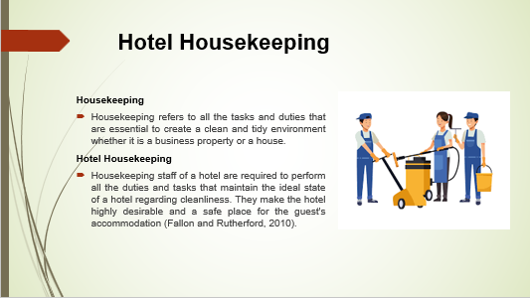
Training Notes:
Housekeeping refers to all the tasks and duties that are essential to create a clean and tidy environment whether it is a business property or a house. Housekeeping staff of a hotel are required to perform all the duties and tasks that maintain the ideal state of a hotel regarding cleanliness. They make the hotel highly desirable and a safe place for the guest's accommodation (Fallon and Rutherford, 2010). Though it does not seem like it housekeeping department contributes highly to the overall profit and revenue of a business as cleanliness and tidiness create the first impression of a hotel on a guest (Raghubalan and Raghubalan, 2016).
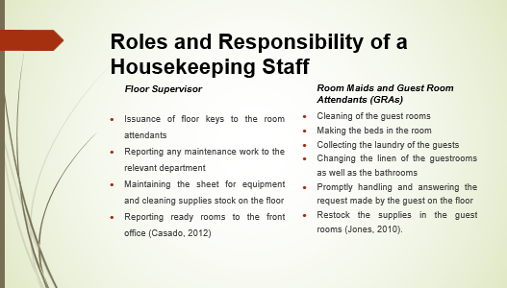
Training Notes:
Roles and Responsibility of a Housekeeping Staff
Roles and responsibilities of the housekeeping staff include:
Floor Supervisor
- Issuance of floor keys to the room attendants
- Reporting any maintenance work to the relevant department
- Maintaining the sheet for equipment and cleaning supplies stock on the floor
- Reporting ready rooms to the front office (Casado, 2012)
Room Maids and Guest Room Attendants (GRAs)
- Cleaning of the guest rooms
- Making the beds in the room
- Collecting the laundry of the guests
- Changing the linen of the guestrooms as well as the bathrooms
- Promptly handling and answering the request made by the guest on the floor
- Restock the supplies in the guest rooms (Jones, 2010).
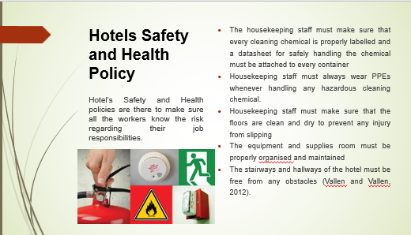
Hotels Safety and Health Policy
Hotel’s Safety and Health policies are there to make sure all the workers know the risk regarding their job responsibilities. Health and Safety policies give employees an idea of how they can protect themselves and others in case of any emergency and potential hazards at a workplace (Badri et al., 2018). The health and safety procedures for the housekeeping staff of the hotel are as follows:
- The housekeeping staff must make sure that every cleaning chemical is properly labelled and a datasheet for safely handling the chemical must be attached to every container
- Housekeeping staff must always wear PPEs whenever handling any hazardous cleaning chemical.
- Housekeeping staff must make sure that the floors are clean and dry to prevent any injury from slipping
- The equipment and supplies room must be properly organised and maintained
The stairways and hallways of the hotel must be free from any obstacles (Vallen and Vallen, 2012).
The 5S Model for the Housekeeping Staff
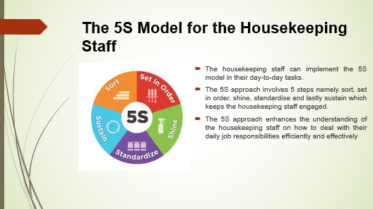
Training Notes:
The housekeeping staff can implement the 5S model in their day-to-day tasks. The 5S approach involves 5 steps namely sort, set in order, shine, standardise and lastly sustain which keeps the housekeeping staff engaged. The 5S approach enhances the understanding of the housekeeping staff on how to deal with their daily job responsibilities efficiently and effectively (Morey, 2020). Through this approach, the workers can make sure that the quality standards of the hotels are taken care of and that they are properly following the health and safety policies of the hotel (Sharma et al., 2019).
Learning Outcome
- Understanding of the 5S approach in the housekeeping staff’s day-to-day tasks.
- Importance of the 5S approach in meeting the standards of the hotel
- Understanding that the 5S approach helps in adhering to the health and safety procedures of the hotel
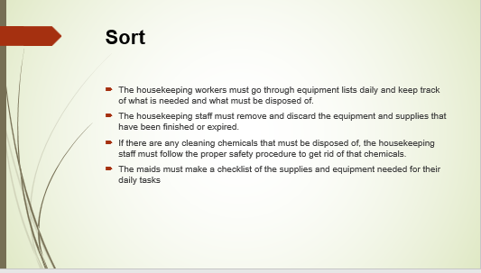
Training Notes:
The first step of the 5S approach is sorting. The housekeeping workers must go through equipment lists daily and keep track of what is needed and what must be disposed of. The housekeeping staff must remove and discard the equipment and supplies that have been finished or expired. If there are any cleaning chemicals that must be disposed of, the housekeeping staff must follow the proper safety procedure to get rid of that chemicals. The maids must make a checklist of the supplies and equipment needed for their daily tasks (Agrahari et al., 2015).
Learning Outcome
- Develop an understanding of the first step in the 5S approach for the daily tasks of housekeeping employees
- What steps and measures to take in order to effectively implement the sorting step of the 5S approach
Employees Assessment
- The floor supervisor will check the equipment and supplies room from time to time to make sure that all the supplies are organised and that the unnecessary items are disposed of properly
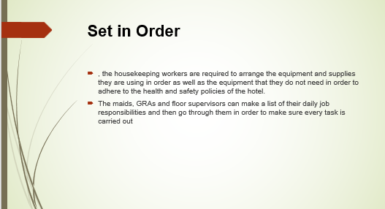
Training Notes:
Set in order
The second step in the 5S approach is straightening or setting in order. In this step, the housekeeping workers are required to arrange the equipment and supplies they are using in order as well as the equipment that they do not need in order to adhere to the health and safety policies of the hotel. The maids, GRAs and floor supervisors can make a list of their daily job responsibilities and then go through them in order to make sure every task is carried out (Shaikh, 2015).
Learning Outcome
- The workers and housekeeping employees are supposed to develop an understanding of the step Set in order in the 5S approach
- Understand their role in carrying out the Straighten step in the 5S approach and how to effectively manage their daily work through this step
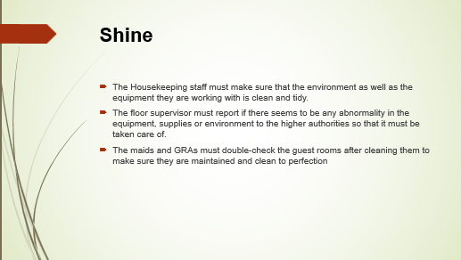
Training Notes:
Shine
After organising their stuff and prioritising their daily task, the housekeeper’s staff are supposed to carry out their job responsibility. They must make sure that the environment as well as the equipment they are working with is clean and tidy. The floor supervisor must report if there seems to be any abnormality in the equipment, supplies or environment to the higher authorities so that it must be taken care of. The maids and GRAs must double-check the guest rooms after cleaning them to make sure they are maintained and clean to perfection (Gupta, 2022).
Learning Outcome
- Developing the understanding of the step Shine in the 5S approach
- Understanding how housekeeping employees can implement this step in their daily job responsibilities
Employees Assessment
- The guests will be given a rating sheet to rate the cleanliness of the room they stayed in as well as a rating sheet for the overall cleanliness of the hotel
- The guest will also be given a feedback form to write down any other concern related to the cleanliness of the hotel which then will be checked thoroughly
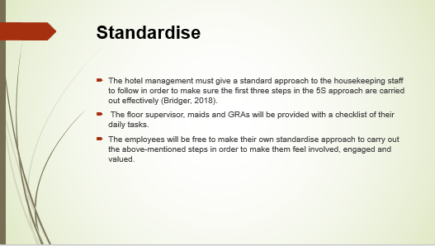
Training Notes:
Standardise
The hotel management must give a standard approach to the housekeeping staff to follow in order to make sure the first three steps in the 5S approach are carried out effectively (Bridger, 2018). The floor supervisor, maids and GRAs will be provided with a checklist of their daily tasks. The employees will be free to make their own standardise approach to carry out the above-mentioned steps in order to make them feel involved, engaged and valued. This will also help in increasing the productivity of the housekeeping employees but they must make sure they are adhering to the hotel's standards and are carrying out all the tasks according to the first 3S's in the 5S approach (Rauch et al., 2016).
Learning Outcome
- Developing an understanding of the step standardise in the 5S approach
- Understanding how standardisation can be implemented in their daily task and responsibilities
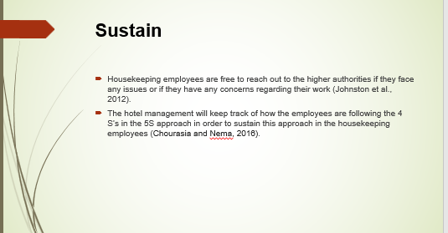
Training Notes:
Sustain
If the first 4 steps in the 5S approach are carried out by the housekeeping workers efficiently then the step Sustain become easy. Housekeeping employees are free to reach out to the higher authorities if they face any issues or if they have any concerns regarding their work (Johnston et al., 2012). The hotel management will keep track of how the employees are following the 4 S’s in the 5S approach in order to sustain this approach in the housekeeping employees (Chourasia and Nema, 2016).
Learning Outcome
- Understanding the last step in the 5S approach i.e. Sustain
- Developing the knowledge of their role in carrying out the sustain step in the 5S model
Employees Assessment
- Employees’ performance as well as whether the housekeeping staff is following the 5S approach will be evaluated through an evaluation form
- The floor supervisor will also be given an evaluation form to daily assess the performance of the housekeeping staff
- The manager will assess the performance of the employees the anytime without prior informing the housekeeping staff
- A team meeting will be conducted in which the employees will be notified of where they are lacking and will be given advice by the supervisor and the manager
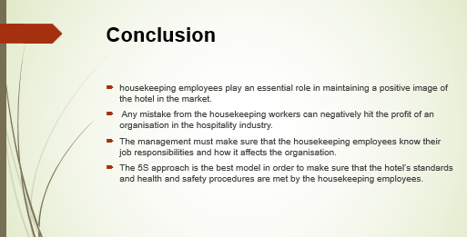
Training Notes:
Conclusion
To conclude, housekeeping employees play an essential role in maintaining a positive image of the hotel in the market. Any mistake from the housekeeping workers can negatively hit the profit of an organisation in the hospitality industry. The management must make sure that the housekeeping employees know their job responsibilities and how it affects the organisation. Moreover, the 5S approach is the best model in order to make sure that the hotel’s standards and health and safety procedures are met by the housekeeping employees.
Learning Outcome
- Understand the importance of the training presentation given to the housekeeping employees
- Develop a sense of responsibility regarding their role in the hospitality industry

References
Agrahari, R.S., Dangle, P.A. and Chandratre, K.V., 2015. Implementation of 5S methodology in the small scale industry: a case study. International Journal of Scientific & Technology Research, 4(4), pp.180-187.
Badri, A., Boudreau-Trudel, B. and Souissi, A.S., 2018. Occupational health and safety in the industry 4.0 era: A cause for major concern?. Safety science, 109, pp.403-411.
Batinić, I., 2015. Organization of business in hotel housekeeping. Journal of Process Management and New Technologies, 3(1), pp.51-54.
Bridger, E. (2018) Employee engagement: a practical introduction. 2nd ed. HR Fundamentals. London: CIPD and Kogan Page.
Casado, M. (2012) Housekeeping Management. London: Wiley.
Chourasia, R. and Nema, A., 2016. Review on Implementation of 5S methodology in the Services Sector. International Research Journal of Engineering and Technology, 3(4), pp.1245-1249.
Cottrell, S. (2019) The Study Skills Handbook. 5th ed. London: Red Globe Press.
Fallon, M. & Rutherford, D. (2010) Hotel Management and Operations. London: Pearson.
Grissom, J.A., Loeb, S. and Mitani, H., 2015. Principal time management skills: Explaining patterns in principals’ time use, job stress, and perceived effectiveness. Journal of Educational Administration.
Gupta, K., 2022. A review on implementation of 5S for workplace management. Journal of applied research on industrial engineering, 9(3), pp.323-330.
Hargreaves, E.A., Hayr, K.T., Jenkins, M., Perry, T. and Peddie, M., 2020. Interrupting sedentary time in the workplace using regular short activity breaks: Practicality from an employee perspective. Journal of Occupational and Environmental Medicine, 62(4), pp.317-324.
Johnston, R., Clark, G. & Shulver, M. (2012) Service Operations Management. London: Pearson.
Jones, T. (2010) Professional Management of Housekeeping Operations. London: Wiley.
Jung, H.S. and Yoon, H.H., 2018. Improving frontline service employees' innovative behavior using conflict management in the hospitality industry: The mediating role of engagement. Tourism Management, 69, pp.498-507.
Leiter, M. P. and Bakker, A. B. (2010) Work Engagement : A Handbook of Essential Theory and Research. Hove [England]: Psychology Press.
Mohanty, A. and Mohanty, S., 2018. The impact of communication and group dynamics on teamwork effectiveness: The case of service sector organisations. Academy of Strategic Management Journal, 17(4), pp.1-14.
Morey, J., 2020. 5S Method and its Implementation in Company. International Research Journal of Engineering and Technology, 7(2), pp.892-895.
Mullins, L. and Dossor, P. (2013) Hospitality Management and Organisational Behaviour. 5th ed. Harlow: Pearson.
Ogbeide, G.C.A., Böser, S., Harrinton, R.J. and Ottenbacher, M.C., 2017. Complaint management in hospitality organizations: The role of empowerment and other service recovery attributes impacting loyalty and satisfaction. Tourism and Hospitality Research, 17(2), pp.204-216.
Quick, L. (2020) Managing Events. Real Challenges, Real Outcomes. London: SAGE Publications Ltd
Raghubalan, G. and Raghubalan, S. (2016) Hotel Housekeeping - Operations And Management. 3rd ed. India: Oxford University Press.
Randhawa, J.S. and Ahuja, I.S., 2017. 5S–a quality improvement tool for sustainable performance: literature review and directions. International Journal of Quality & Reliability Management, 34(3), pp.334-361.
Rauch, E., Damian, A., Holzner, P. and Matt, D.T., 2016. Lean Hospitality-Application of Lean Management methods in the hotel sector. Procedia CIRP, 41, pp.614-619.
Shaikh, S., 2015. Review of 5S technique.
Sharma, N., Chaudhary, N. and Singh, V. (2019) Management Techniques For Employee Engagement In Contemporary Organizations. Hershey, Pennsylvania: IGI Global.
Sucher, W. and Cheung, C., 2015. The relationship between hotel employees’ cross-cultural competency and team performance in multi-national hotel companies. International Journal of Hospitality Management, 49, pp.93-104.
Vallen, G. & Vallen, J. (2012) Managing Hotel Operations. London: Pearson.

