TITLE: PORTFOLIO OF WORK
STUDENT NAME: BAFFOUR GYIMAH
STUDENT NUMBER:2128410
MODULE CODE: BSW4005
LECTURERS’ NAME: DR KINGSLEY OMEIHE
TASK 3 – REFLECTIVE PORTFOLIO

Abstract
In this module I talked about the benefit I gained in this module by accessing my self-awareness and also able to identify by strength and weakness that I have overcame by studying this module and was able to work in teams and was able to write a good cv for a job position and again was able to learn how to undertake a successful and also on how to work in groups which really built my confidence in learning on how to undertake an interview for my career development

Table of Contents
Introduction 2
Assess of my own skills and competencies using the analytical tools 2
Reflect on the learning style theories which have learned in this module and explain how has this impacted in my workplace 3
Reflective model to assess the concepts I have learned from this module 5
Conclusion 7
References 9

Introduction
Reflective portfolio development is mainly collection of evidence with critical reflective analysis that helps to demonstrate personal and professional development. It is a set of writing that summarises one's own insights and develops experience over identifying one's own position on current skills and future requirements (Gibbs, 1998). In this study, I have developed critical reflective analysis along with secondary evidence that has helped in the evaluation of my current position. Along with this reflective report it will identify the learning theories and different style of learning and this report will also identify how I have benefited from the course it would help me to determine my growth for future needs in my both personal and professional development. In this section I will use the following analytical tools which is known SWOT analysis and personal development plan.

Assessing of my own skills and competencies using the analytical tools
SWOT analysis is a analytical tools that is used to evaluate the strength and weakness and opportunities and threats of a business of an individuals to undertake a project within an organisation. (GURL 2017). In assessing my performance during this module, the following table was drawn.

Strength is an ability to perform well in an organisation, through this module, I was able to strengthen my capabilities within my organisation. for example, I remember at my workplace where there was conflict between two parties, apparently manager s were not able to solve it so I used my strength as good communicator to settle that issue

On the hand opportunity are the openings and chances that one can adapt when you identify the opening chances when you know your strength, I have acquired many opportunities by undertaking this module I have been exploit to many chances by networking with people from other organisation.

SWOT Analysis
Strengths | Weaknesses
- I have patience and determination towards my job role and responsibility.  - I make my co-workers happy with my good interpersonal relationship skills.  - I have developed my experience to be flexible and open to change as per customer requirements. | - Communication and collaboration skills are my weak zones.  - I have a lack of time management skills.  - I wasn’t knowing how to write a good cv and a cover letter for specific job interview.  - Was lacking a presentation skill and how to work in groups.
- Opportunities | - Threats
- Based on my higher patience and determination level, I would be a calm and quality service provider in clearing services in a stressful situation.  - My knowledge and experience in co-workers’ interpersonal relationship skills will help me to provide outstanding peaceful place of working. | - Lack of time management would significantly reduce my professional achievement and would further hamper my management skills.  - Ineffective collaboration and communication competencies with teammates would seriously reduce my work culture management skills and would limit my working efficiency.
Table 1: SWOT Analysis
(Source: Created by Author)
In this module I was able to draw my personal development plan which is the process of establishing aims and objectives of what you want to achieve or where want to go in a long term or short term in your career and identifying current the skills, knowledge and competence needed to achieve your future goals (CMI Report, 2022).
Through this module I was able to understand the cyclical process of personal development plan which has helped me to access my current understanding of my future direction and how to come over it. The following checklist was drawn to establish my understanding of my personal development plan.
Figure 1. CMI Personal Development Cycle

Source: Adapted from CMI (2022).
Through this module I was able to understand the cyclical process of personal development plan which has helped me to access my current understanding of my future direction and how to come over it. The following checklist was drawn to establish my understanding of my personal development plan.
Furthermore, to achieve my aim in this module all I need attend all my lectures and doing all my assignment and passing all the necessary exercises. Through the module can undertake the required progression that I will have to undertake the required job that will need the use of my degree certificate
On the other hand, through this module, I can record the purpose of my establishment.

Nevertheless, after recording the outcome, I have I can review and evaluate my success of the purpose that I have obtain. The following table shows how my personal development plan was generated through this module

Table 2: Personal Development Plan.

Objective | Time | Activities | Success criteria | Resource
Short term | 6 months  2 weeks  1 week | - To be a good team player.  - To learn how to present  - To learn how to access my online library | To start mingling myself with colleagues  Start practising power point slides.  Start attending seminars | Watching you tube videos.  Watching online videos  Asking the IT team to assist me
Long term | 1 year | - To get degree by the end of the course | - To start attending classes | To attend my classes and do my assignment

Table 2: Personal Development Plan
(Source: Created by Author)

Reflect on the learning style theories which have learned in this module and explain how this has impacted in my workplace.
Learning style can be explained as a preferred way of thinking and understanding information.
Through this module can identify different learning style which has helped me to understand this module namely Kolb’s learning style, honey and Mumford, and Neil and Fleming
Kolbs learning style.

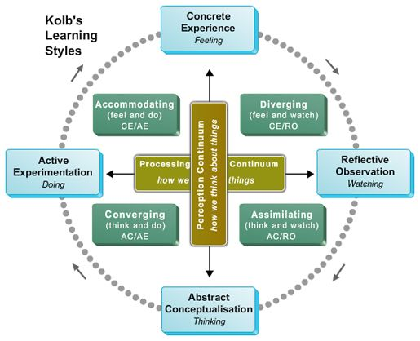

From this module am able to identify that there are many ways people can learn and understand individual ability like feeling, watching and thinking and doing what they have learnt through the mains of understanding their ability to understand.
.
Secondly, I will talk about honey and Mumford which has helps me to understand and has given me the insight through this module which talks about activist, reflector, theorist, and pragmatist and in this concept it shows how people study different perspectives with an opportunity to plan ahead and pay detail to the meaning of things.

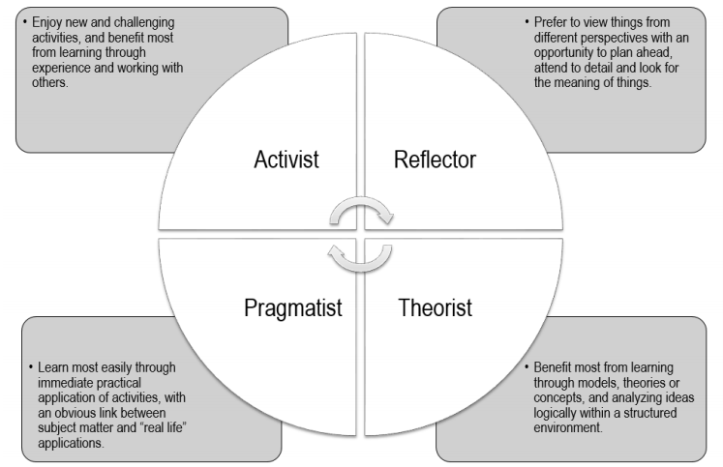

In this section I was able to understand the learning style where people tend to be fast talkers but they are fast to understand this concept which has been very helpful to me
Neil and fleming learning style.
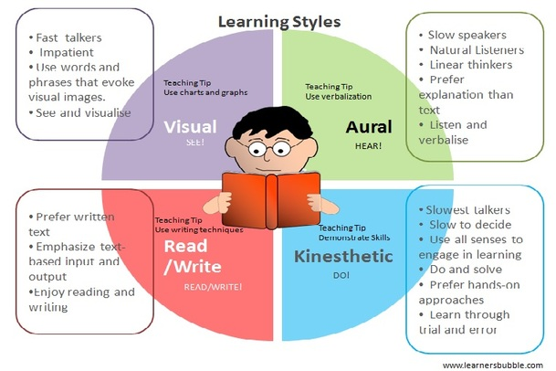

Through the study of this module, I can identify my learning style to be honey and Mumford which I did enjoyed a new challenging activity and benefited from the learning through groups. Also, I gain experience working in teams.
Also this module I was able toto view things from different perspective whiles working in teams or groups.Again through this module I was able to learn through model and theories and concepts and analysing logical Ideas through the structured environment
Furthermore, I was able to learn most through immediate practical application of activities through real life and personal application.

Impacts of theories in workplaces
Honey and Mumford’ learning (1998) theory has helped me to develop the idea and objective of self-awareness. Along with this, it significantly taught me to be self-focused and other-focused. According to Shin et al. (2023), people would focus attention on the self and external environment based on ideas and objectives of honey and Mumford' learning theory. I have access to self-awareness through this theory which has ensured my capability enhancement in gaining and developing information and ideas for effective self-awareness in responsible and sustainable professional achievement. On other hand, Objective Factor Theory of Recruitment has been developed that is effective to make me clear about both personal and professional purpose fulfilment. As mentioned by Emmanuel (2021), Objective Factor Theory has assessed the importance of tangible benefits in jobs that keep higher employment motivation and satisfaction in job roles. Based on this theory, I become aware of the importance of employee benefits in workplaces that make me clear about the purpose of recruitment and that would reflect on my professional development in the workplace.

Reflective model to assess the concepts I have learned from this module.
Gibbs’ Reflective Cycle
Gibbs Reflective Cycle is an effective reflective model that has provided a good way to develop experience. As identified by Adeani et al. (2020), cyclical model of reflection is Gibbs' Reflective Cycle which leads to exploring experience of individuals through six stages description, feelings, evaluation, analysis, and conclusion and action plan. All such stages are effective to examine experience and allow developing a plan for developing repeated experience for future perspectives.
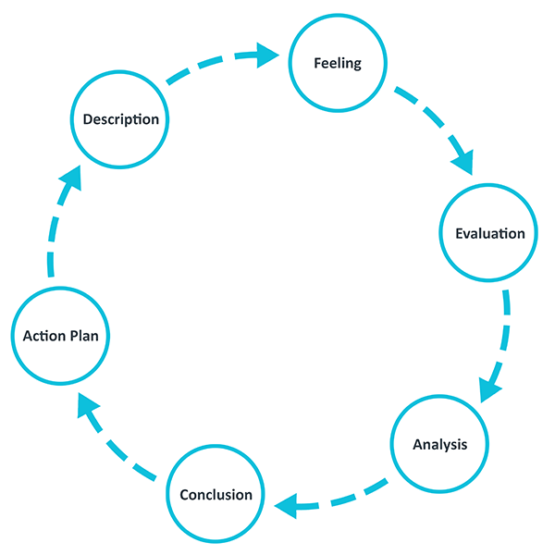
Figure 1: Gibbs’ Reflective Cycle
(Source: Influenced by Adeani et al. 2020)

Description
In this module, gaining of knowledge, participation in interview and own skill analysis has been dealt. Case study-based knowledge has been conducted in this model which has helped to gain more data and information related to my career success. According to Rashid et al. (2019), case study analysis is a suitable way to get information and develop understanding of learning facts to real-world situations. It is important in situation-based learning and developing competencies to handle a complex or uncertain situation. On other hand, Thunberg and Arnell (2022) participation in an interview developed experience, confidence and obtained greater employment of learners. I have gained confidence and have identified my current position on needed skills and competencies through participating in the interview process. In reflective writing, I become able to critically identify my strengths and weak zones in my learning and experience that help in developing my professional skill achievement. Alajmi (2019) commented that reflective portfolio serves as a demonstration of course attainment and analyses current position of leader towards desired goal and advanced skill achievement. I have also developed my analytical power to access my future needs and requirements to make me fit in customer-centric clearing service.

Feelings
I felt that this module has helped me a lot to develop my competencies and skills towards successful management and my both personal and professional skill attainment. I also feel that my journey through this module activity has helped my abilities and powers along with pointing my future needs and requirements in skill. This has helped me a lot to make me perfectly fit in procession of window clearing and effective driveway clearing service. These module activities have used case study analysis, interview process and reflective portfolio to identify my current base in knowledge and understanding. As well as it helps to develop my competencies in the future in field of my career.

Evaluation
It was good in this module that I have preceded with an effective pathway that has critically developed my skills and competencies in clearing service professionals. I have learned the effectiveness of user-centric responsibility management based on my case study analysis and stressed my capabilities to handle a critical situation. However, I have access to limited discussion opportunities to keep me on right track all time. I have also been unable to take my skill and experience review from my tutor or classmates in successfully developing a reflective portfolio. Hence, these module activities are effective enough to deal with my career effectiveness by providing me a proper understanding of aims and objectives of my job role and help me to be a more user-centric professional.

Analysis
I have gained knowledge effectively throughout this module journey and reflect greatly on my analytical skill and development. As identified by Phadermrod et al. (2019), case study is important in analytical skill as well as knowledge development. a goal with higher competitiveness (Alsina et al. 2019). Based on this activity, I would be able to engage my competencies in personal effectiveness and professional skill development with higher cleaning employability.
. On other hand, I have developed my confidence and role of professionalism through the interview process while a reflective portfolio explores my further skill improvement requirements. From the above analysis, it has been identified that I need effective communication and time management competencies to make me fit in a clearing profession.

Action plan

Skills | Actions to be taken | Timeframe | Outcome
Complex situation handling skill | Identification of risk, then discussing with engaged people and decision making to effective crisis management with being always positive.  Having undertaking training . | 5-24 months | Good team player
Effective communication skills | Active listening skill and formulation of response with critical understanding of others would be effective to proceed with a collaborative job role execution.  Having training and gaining a certificate | 3-12 months | Good communicator
Time management competency | Determination to priorities and effective planning and monitoring would be effective to keep me engaged in job role and responsibility that would reflect on my deadline management. | 4-36 months | Good timekeeper
Table 3: Action Plan
(Source: Created by Author)

Conclusion
I have developed my determination and ability to provide customer-centric service which would reflect fulfilling my company competences . honey and Mumford’ learning theory has been evaluated to develop self-awareness of individuals to enhance capacity in their own experience. Additionally, Objective Factor Theory of Recruitment has been discussed that has critically evaluated the importance of recruitments to fulfil the development purpose of individuals in both personal and professional aspects. Reflective model analysis has identified my experience from this module to make me fit in my profession. Hence, it can be concluded that I must enhance my skill and capabilities with proper understanding of my professional aim and principles to enhance my career achievements. I would keep myself more professional in my workplace along with achieving a great professional achievement framework from this module experience.

References
Adeani, I.S., Febriani, R.B. and Syafryadin, S., (2020). Using Gibbs’reflective Cycle in Making Reflections of Literary Analysis. Indonesian EFL Journal, 6(2), pp.139-148.
Alajmi, M.M., (2019). The impact of E-portfolio use on the development of professional standards and life skills of students: A case study. Entrepreneurship and sustainability issues, 6(4), p.1714.
Alsina, Á., Ayllón, S. and Colomer, J., (2019). Validating the Narrative Reflection Assessment Rubric (NARRA) for reflective narratives in higher education. Assessment & Evaluation in Higher Education, 44(1), pp.155-168.
Chiat, L.C. and Panatik, S.A., (2019). Perceptions of employee turnover intention by Herzberg’s motivation-hygiene theory: A systematic literature review. Journal of Research in Psychology, 1(2), pp.10-15.
Emmanuel, O.O., (2021). The dynamics of work environment and its impact on organizational objectives. Annals of Human Resource Management Research, 1(2), pp.145-158.
Ghoffar, H., (2019). Analysis of Self-Consciousness Based on the Multi-theory Perspective. JOMSIGN: Journal of Multicultural Studies in Guidance and Counseling, 3(1), pp.15-26.
Phadermrod, B., Crowder, R.M. and Wills, G.B., (2019). Importance-performance analysis based SWOT analysis. International journal of information management, 44, pp.194-203.
Rashid, Y., Rashid, A., Warraich, M.A., Sabir, S.S. and Waseem, A., (2019). Case study method: A step-by-step guide for business researchers. International journal of qualitative methods, 18, p.1609406919862424
Thunberg, S. and Arnell, L., (2022). Pioneering the use of technologies in qualitative research–A research review of the use of digital interviews. International Journal of Social Research Methodology, 25(6), pp.757-768.
Yılmaz, H.A., (2022). Self-Awareness and Self-Consciousness: A Review from a Social Psychology Perspective. PsikiyatrideGüncelYaklaşımlar, 14(4), pp.437-445.

