
LCHS7003 MSC PUBLIC HEALTH AND SOCIAL CARE IN PRACTICE

NAME: MD. AL ZAKARIA
UNIVERSITY OF WALES TRINITY SAINT DAVID (LONDON CAMPUS)
STUDENT ID: 2511048

ASSIGNMENT TITLE: COMPONENT 1 INFORMATION BOOKLET OF LONG-TERM CONDITION MANAGEMENT
TOPIC: MENTAL HEALTH

WORD COUNT: 3056

Table of Contents

1. Introduction
  - Definition of mental health as a long-term condition
  - Prevalence/ burden of mental health as per worldwide and UK statistics
  - Risk factors/ aetiology of mental health
2. Main body
  - Impact of mental health focusing on physical, psychological and social implications

  - Suitable treatments in the UK
  - Theoretical perspectives for improved outcomes for mental health patients
  - Implementation of local and national political agendas
  - Recommendations for improvement considering person-centered care
3. Conclusion
- References

1. Introduction
Title: Understanding mental health to live a better life
Management of long-term conditions in healthcare is important for improving the quality of life of individuals affected by it through offering coordinated care. Long-term condition management in healthcare helps to ensure better outcomes by empowering patients through providing integrated care (Huebner and Flessa, 2022). The purpose of this assignment is to develop an information booklet of mental health as a long-term condition for managing its prevalence for worldwide and UK adult people. The information booklet further examines physical, social and psychological implications of mental health challenges on people by outlining evidence-based treatments by NHS UK. Theories and models for improving patient outcomes will be also used here to promote developmental initiatives for managing mental health.

1.1 Definition of mental health as a long-term condition
Long-term mental health conditions are defined as psychological or emotional disorders which consistently impact an individual’s feelings, thoughts, thoughts and behaviour, with duration of months to years. A mental disorder is defined as clinically significant disturbance to cognition, emotional regulation or behaviour of each person (WHO 2025). It is usually associated with distress or impairment of important functional areas of an individual. Long-term psychological disorders such as bipolar disorder, schizophrenia, chronic anxiety disorders, and depression have varying intensity, course and time course, but virtually all require continuing support treatment and management. Mental health problems may have temporary effects or long-lasting effects or there may be more than one mental health disorder present at the same time (Mayo Clinic, 2025). Depending upon the intervention, including medication therapy, social support, psychological intervention, and lifestyle changes, it is possible for many people with long-term conditions to lead productive and meaningful lives with stability. This includes substantial emphasis on long-term health, well-being, effective recovery, and well-established resilience.

1.2 Prevalence/ burden of mental health as per worldwide and UK statistics
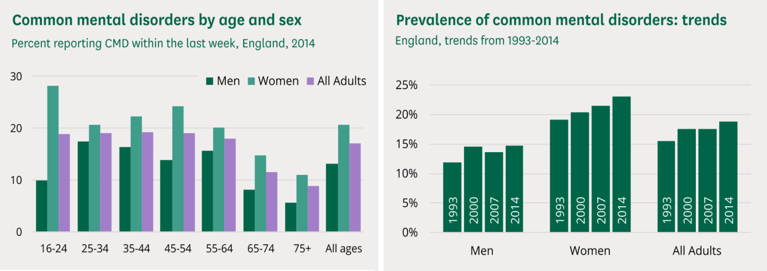
More than 1 billion people live with mental health problems and diseases such as anxiety and depression result in staggering human and economic costs (WHO 2025). Although many countries have improved their mental health policies and programmes, there is increasing need for investment and action on a worldwide scale to implement services to protect and promote people’s mental health. Mental illnesses such as anxiety and depression are very common in all the countries and communities of the world, and in both sexes of all ages and incomes (WHO 2025). It is also the second most prevalent cause of long term disability which results in people not enjoying a healthy life.

Figure 1: Common Mental Disorders in UK
(Source: Baker and Kirk-Wade, 2024)
This disability causes increased costs of health care to the individuals and families suffering them while it causes enormous social and economic losses on a worldwide basis. The 2014 results of the Mental Health and Wellbeing Survey in England showed that 1 in 6 persons aged 16+ reported symptoms of a common mental disorder such as anxiety or depression in the last week (Baker and Kirk-Wade, 2024). Women were more likely than men to suffer from a common mental disorder; with a rise in the prevalence since 1993. 2% of respondents stated that they had suffered from bipolar disorder, while 0.7% had experienced psychotic disorder during the past year (Baker and Kirk-Wade, 2024). Furthermore, 4.4% of respondents screened positively for post traumatic stress disorder and just over 5% of respondents stated that they had had suicidal thoughts in the past year.

1.3 Risk factors/ aetiology of mental health
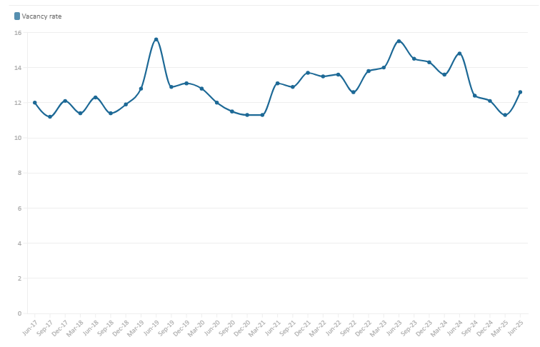
In the UK, the aetiology and risk factors of mental health problems are understood as complex interactions between biological, psychological and social factors. Biological factors include genetic predisposition, family history of mental disorder, neurochemical disturbance and long-term physical health problems like cardiovascular diseases. Psychological factors include exposure to trauma, an adverse childhood experience, bereavement, chronic stress, nor low self-worth. Campanile et al. (2022) opined that epigenetic factors like DNA methylation and stress are among major risk factors driving distinct psychiatric conditions. The social determinants, which predominate in the UK, include poverty, unemployment, insecure housing, discrimination, social isolation, exposure to violence and/or abuse. Additionally, environmental pressures from academic demands, work stress and ill health from a cost of living crisis further compound mental health difficulties (Campbell et al. 2025; NHS, 2023; MHF, 2025). Certain groups such as migrants, ethnic minorities and LGBTQ+ may face additional stresses resulting from stigma, cultural dislocation or inadequate access to service provision.

Figure 2: Mental Health Staff Vacancy in UK
(Source: BMA 2025)
Substance misuse such as alcohol and drugs on either hand is a cause and effect of poor mental health. Inequalities of access to mental health services in the UK and the long waiting times and varying availability of community support can aggravate these conditions (Lowther-Payne et al. 2023; Rethink Mental Illness, 2025). On the whole, the aetiology of mental health problems represents multifactorial interactions between biological vulnerability, experience and the broader social and economic conditions in which the subjects of these disorders find themselves. According to Bourmistrova et al. (2022), the cost of poor mental health, before the COVID-19 pandemic, was £105 billion per annum in economic and social results, in England. After 18 months from the first reporting of cases, the direct impact of COVID-19 upon mental health, has only just begun to manifest it. Moreover, the mental health service is not keeping pace with, either, the present population need or the anticipated increase in needs of the service. The overall NHS England vacancy factor for doctors, in NHS mental health services, is high, with 12.6% vacancies FTE presently (BMA 2025). This is even lower in NHS mental health nursing, with a vacancy factor of 10.2% on average throughout England which is compounded by inadequate funding.

2. Main body

2.1 Impact of mental health focusing on physical, psychological and social implications
- Physical implications
Mental health as a long-term condition has psychological impact on individuals by increasing stress levels that can lead to increased risks of hypertension due to cardiovascular disease. As stated by Thomson et al., (2022) poor mental health can result in dysregulation of stress functions in the body that can create a risk of hypertension. Apart from this, mental illness can impact lifestyles of adults by reducing motivation to engage in physical activity that can also worsen dietary plans resulting in increased fat in the body.
Sleep disturbance is another physical implication of mental illness among adults as it can lead to insomnia that can result in declined immunity power (Palagini et al., 2022). Mental illness on a long-term basis mainly affects adults by increasing the possibility of insomnia due to sleep disorders. For example, it is observed that 10 to 30% of adults face insomnia due to poor mental illness that can also reach 50 to 60% sometimes based on the condition (Pradhan and Saikia, 2024). Thus, mental health showcases wide-spread physical implications for adults that requires proper medication process to reduce consequences.
- Psychological implications
Mental health showcases a long-term physical implication for adults as it can affect individuals by lowering self-esteem that can further result in increased hopelessness. Merino et al., (2024) denoted that low self-esteem is observed as a direct physical impact of mental illness leading to increased loss of identity. On the other hand, mental illness among adults can also reduce emotional stability by increasing persistent anxiety that can lower capacity to cope up with mood fluctuations. Cognitive impairment is another key physical consequence of mental illness that can create difficulties for adults to concentrate (Morozova et al., 2022). Beside this, social stigma can also discourage individual adults in seeking treatment for mental health conditions that can enhance emotional strain. The psychological implication of mental health can also negatively affect families by increasing emotional and role strain due to hopelessness. Therefore, it is necessary to focus on reducing psychological implication of mental health to enhance mental strengths of adult patients.
- Social implications on individuals and families
The long-term mental health condition shows social impacts on individual adults by increasing social isolation as loss of confidence can influence withdrawal from any social circle. Brandt et al., (2022) denoted that social isolation is a key negative consequence of mental illness resulting in increased mental distress. Moreover, it can also negatively affect employment as difficulty to maintain mental health can reduce confidence in work that can reduce overall productivity. Mental health can also reduce quality of life for adults by disrupting leisure time and relationships due to forgetfulness. Hachuła et al., (2023) mentioned that long-term illness might affect individuals by discriminating in a healthcare setting by offering inadequate treatment. In this context, a long-term plan by NHS UK can benefit UK adults to enhance mental conditions for boosting quality of life by strengthening social connections.
Social implication can also negatively affect families of affected people through imposing financial pressure as treatment costs for mental health illness is high in the UK. Supporting this, the total costs for mental health illness in the UK is around £70 to 100 billion per year that is equivalent to 4.5% of GDP (Mental Health Foundation, 2024). It is clear that financial burden is a key negative impact on families, however social withdrawal is another issue due to lack of understanding. Hence, a mental health illness patient needs an excellent family dynamic to get emotional support that can help in developing mental stability.

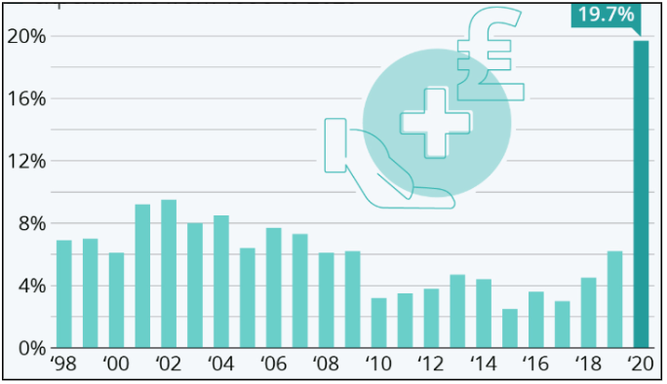
2.2 Suitable treatments in the UK
The UK government focuses on increasing spending on healthcare to manage financial stability for poor economic people to prevent mental illness and live a healthy life. The UK government has increased its healthcare spending by 19.7% to manage prevalence of chronic diseases that costs £269 billion based on its GDP growth (Martin, 2021). The UK government puts emphasis on increasing care excellence for managing mental health illness among adults by increasing its healthcare expenditure. Interpersonal therapy is a common treatment used in the UK to manage depression among patients by focusing on moods and relationship-building. Similarly, cognitive behavioural therapy (CBT) is also effective for understanding changes in thinking and behaviour among adults for boosting mental health. NHS’s ICSs also helps to offer specialist theories to patients having mental illness by emphasising on offering peer support (NHS, 2025). Therefore, focusing on CBT, ICSs and IPT can be key treatments of mental health illness for offering better mental conditions to adults in the UK.

Figure 3: UK healthcare expenditure
(Source: Martin, 2021)

2.3 Theoretical perspectives for improved outcomes for mental health patients
- NHS and social care model
Based on the theoretical perspective on managing mental health among adults, the NHS social care model (SCM) can be used to enhance positive outcomes for affected patients. Durand et al., (2025) narrated that the social care model outlines ways for providing adequate care to people with long-term conditions based on key needs. Moreover, this SCM model can help expert patients to develop self-management for mentally challenged patients and guide healthcare specialists to support adults in managing complexity. The application of SCM can further guide healthcare workers to work collaboratively for increasing mental stability of diagnosed patients in the UK. Jefferies et al., (2024) mentioned that strong public support, dedicated workforce and central leadership are key strengths of using social care models. Infrastructure, delivery systems and better outcomes are key factors related to this model that helps to empower patients in making better decisions. However, prior to applying this model, the UK government needs to focus on weaknesses including fragmentation; underfunding and poor integration to manage positive health outcomes for mentally challenged patients.
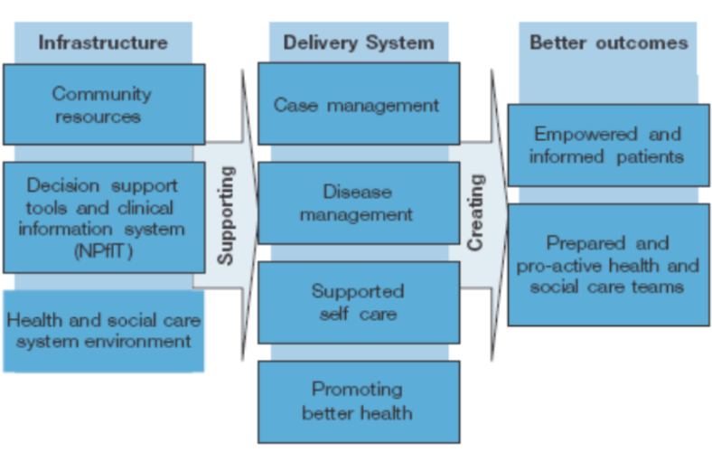
Figure 4: NHS social care model
(Source: Week 3 Lecture note, Slide 60)
- Chronic care model
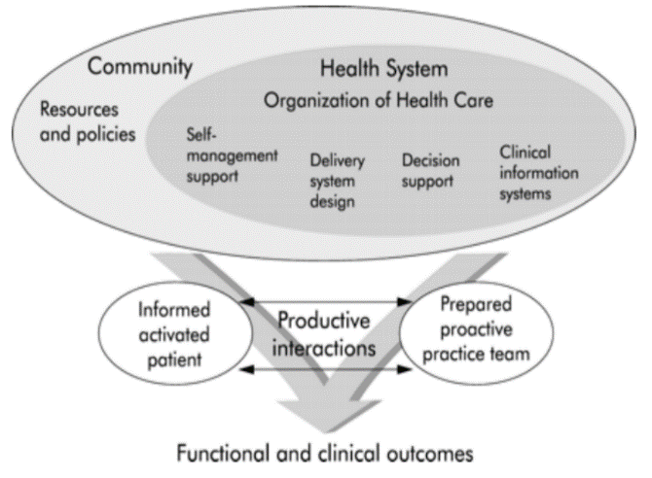
The CC model plays a notable role in enhancing clinical outcomes for offering a quality life to mentally challenged patients by focusing on reducing implications of cardiovascular disease. Al‐Qahtani (2024) mentioned that the CC model was developed by Edward Wagner at MacColl Institute for supporting healthcare innovation to improve chronic disease. The CC model provides self-management support, decision support and clinical information to improve healthcare services for adults with mental health issues. This CC model is used by healthcare professionals globally to manage chronic diseases by offering decision support to healthcare professionals (Simmons et al., 2024). It also can help to develop a proactive team for informing active mentally retarded patients to improve health conditions by developing healthcare management through making informed decisions. Therefore, the CC model can help to foster productive interactions between mentally challenged patients and nurses to gain positive outcomes through faster recovery.

Figure 5: Chronic care model
(Source: Week 3 Lecture note, Slide 70)

2.4 Implementation of local and national political agendas
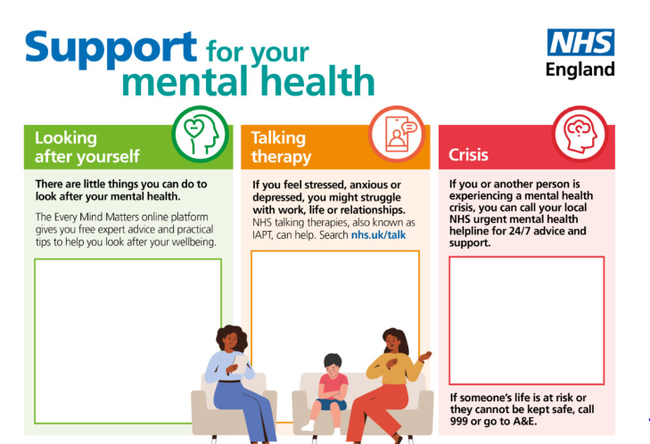
Implementation of social care agendas based on local and national level is important for improving developmental initiatives on mental health for offering a better life.
- National political health agendas
The NHS's integrated care systems (ICSs) can be a significant social care agenda that showcases a key focus on increasing access to healthcare interventions, developing integrated mental wellness paths. NHS’s ICSs provides a collaborative effort to bring local health and providers of social care together for improving mental health (NHS, 2025). Yet again, inadequate access to healthcare and poor ability to address social determinants are key limitations to manage mental illness among adults. The use of Health and Social Care Act 2012 can be significant for offering integrated services to ensure continuity of care for patients (Legislation, 2025). UK’s Clinical Commissioning Groups (CCGs) is also an important agenda involved with improving care regarding mental health issues like depression and anxiety by offering specialist services. Hence, efforts from national healthcare agendas can be significant for developing healthcare initiatives for preventing mental health issues like depression and anxiety among adults.

Figure 6: NHS’s mental health prevention programme
(Source: NHS, 2025)
- Local health and social care agendas
Local governments show a high influence on prevention of mental health issues by doing nutrition programmes, offering integrated care systems (ICSs) and healthy living centers to address root causes. NHS offers ICSc to develop joined-up plans for offering developmental initiatives on preventing chronic diseases in the UK (NHS, 2025). Moreover, digital transformation through NHS apps, virtual clinics and remote monitoring can be also significant for strengthening equality in health services for preventing mental deteriorations. For example, NHS’s intervention plans and a support of £1 billion has driven scope for about 370,000 adults to have greater control and choice over their care annually (NHS, 2024). Apart from this, development of virtual clinics by the NHS also helps to maintain equality in healthcare access that guides adults to get adequate care for managing mental health. Therefore, mental health management showcases a less intersection with social care, however offering personalised care can be significant for offering self-management support to patients.
Enhancement of self-management support through education | Emphasising on person-centered care in mental health management | End-of-life (EoL) care with advance care planning
- Professional development training  - Feedback mechanism  - Engagement of community health workers | - Co-create care plans  - Regular review  - Adaptation of care plans | - Open communication with patients  - Mental stability  - Focus on patients comfort

2.5 Recommendations for improvement considering person-centered care
Table 1: Recommendations
(Source: Self-developed)
- Self-management
The NHS UK is recommended to provide self-management support to increase education levels of healthcare professionals as it would help to build self-efficacy of patients. Koontalay et al., (2024) denoted that self-management support is important for increasing mental health outcomes by increasing confidence and reducing costs of diagnosis. In this context, motivational interviewing of patients can help healthcare professionals to better understand mental health status for making key medication decisions. The use of telehealth and guided support groups can be also significant for offering self-management support that can increase collaboration between patients and families (Sharma et al., 2024). Hence, self-management support can be a crucial element for providing emotional support to mentally retarded patients for improved empowerment and quality of life
- Person-centered care
Healthcare professionals are suggested to utilise a person-centered care approach as it can help in coordinating care by involving mentally unstable patients into their own care plan. Watson et al., (2024) mentioned that a person-centered care helps healthcare professionals to improve overall well-being of patients by supporting interdependence. It can also provide individualised support for supporting collaboration and respecting values for patients in order to stay informed about medication. Supporting this, NHS UK emphasises person-centered care for mentally challenged patients by underpinning existing mental health, learning disabilities, end-of-life care, and dementia core skills framework (NHS, 2024). Therefore, focus on person-centered care can be significant for reducing risky behaviours, boosting self-efficacy, and enhancing empowerment among mentally challenged patients.
- End-of-life care
The EoL initiative plays a notable role in offering medication based on preferences of patients to enhance progress and emphasising psychological suffering like depression and anxiety. As mentioned by Aker et al., (2024), the EoL approach provides practical support to healthcare professionals for managing symptoms and modifying care to enhance quality of life. Offering practical support to patients can help in complication prevention by developing advance care plans, improving medication processes and stressing spiritual well-being. For example, the UK government provided £2.3 billion for mental health development in 2019 and it engaged 2 million appointments in 2023 to 2024 (BMA, 2025). Therefore, the EoL initiative can work as a key success factor for handling mental health by providing psychological support and increasing patient engagement.

3. Conclusion
It can be concluded that prevention of mental instability is an important aspect for developing health outcomes of adults by offering adequate access to healthcare services. Mental deterioration shows a high relevance among adults due to its detrimental effects by increasing mortality rate due to inadequate healthcare infrastructure and stigma. In this context, the NHS's integrated care systems (ICSs) can work as a significant initiative to foster positive signs in developing mental health of adults by increasing prevention accuracy.
As per recommendations, focus on self-management, person-centered care and end-of-life practice can be significant for managing mental wellness among adults. The use of CC model and NHS SCM model can be significant for preventing mental deterioration by making key decisions on increasing awareness among adults to focus on measurable improvement. Therefore, the information booklet on preventing mental conditions among adults can positively contribute to reduction in long-term implications to ensure continuity of care.

References
Aker, N., Griffiths, S., Kupeli, N., Frost, R., Nair, P., Walters, K., Melo, L.J. and Davies, N. (2024) ‘Experiences and access of palliative and end of life care for older people from minority ethnic groups: a scoping review’. BMC Palliative Care, 23(1), p.228. Available at: https://doi.org/10.1186/s12904-024-01555-8
Al‐Qahtani, A.A. (2024) ‘Improving outcomes of mellitus patients in primary care with Chronic Care Model: A narrative review’. Journal of General and Family Medicine, 25(4), pp.171-178. Available at: https://doi.org/10.1002/jgf2.659
Baker, C. and Kirk-Wade, E. (2024). Mental health statistics: prevalence, services and funding in England. Available at: https://commonslibrary.parliament.uk/research-briefings/sn06988/ (Accessed: 1 November 2025).
BMA (2025). Mental health pressures in England. Available at: https://www.bma.org.uk/advice-and-support/nhs-delivery-and-workforce/pressures/mental-health-pressures-data-analysis (Accessed: 1 November 2025).
Bourmistrova, N.W., Solomon, T., Braude, P., Strawbridge, R. and Carter, B., (2022). ‘Long-term effects of COVID-19 on mental health: A systematic review’. Journal of affective disorders, 299, pp.118-125. https://doi.org/10.1016/j.jad.2021.11.031
Brandt, L., Liu, S., Heim, C. and Heinz, A. (2022) ‘The effects of social isolation stress and discrimination on mental health’. Translational psychiatry, 12(1), p.398. Available at: https://doi.org/10.1038/s41398-022-02178-4
Campanile, G., Fanelli, G., Fabbri, C., Serretti, A., Mendlewicz, J., Bhugra, D., Moussaoui, D. and Craig, T.J., (2022). ‘Epigenetics and aetiology of mental illness’. Oxford textbook of social psychiatry, pp.41-48. https://books.google.com/books?hl=en&lr=&id=jlt9EAAAQBAJ&oi=fnd&pg=PA41&dq=aetiology+of+mental+health&ots=Fo4dFlQAPT&sig=rWSSUxufu_BPodwbqr5-UuJDc2g
Campbell, F., Blank, L., Cantrell, A., Baxter, S., Blackmore, C., Dixon, J. and Goyder, E., (2022). ‘Factors that influence mental health of university and college students in the UK: A rapid review’. BMC Public Health, 22, 1778 (2022). https://doi.org/10.1186/s12889-022-13943-x
Durand, M.A., Wistow, G., Al Haboubi, M., Douglas, N., Erens, B., Hoomans, T., Manacorda, T., Miller, R., Pacho, A., Rehackova, L. and Smith, J. (2025) ‘Evaluating the role of community-based multi-disciplinary teams in integrated health and social care in England: overview of findings from the Pioneer evaluation and their implications for health and social care integration’. Journal of Health Services Research & Policy, 30(1_suppl), pp.69-81. Available at: https://doi.org/10.1177/13558196251349398
Hachuła, M., Kosowski, M., Zielańska, K., Basiak, M. and Okopień, B. (2023) ‘The impact of various methods of obesity treatment on the quality of life and mental health—a narrative review’. International journal of environmental research and public health, 20(3), p.2122. Available at: https://doi.org/10.3390/ijerph20032122
Huebner, C. and Flessa, S. (2022) ‘Strategic management in healthcare: a call for long-term and systems-thinking in an uncertain system’. International journal of environmental research and public health, 19(14), p.8617. Available at: https://doi.org/10.3390/ijerph19148617
Jefferies, D., Wellings, D., Morris, J., Dayan, M. and Lobont, C. (2024) ‘Public satisfaction with the NHS and social care in 2023’. Results from the British Social Attitudes Survey. London: The King’s Fund and Nuffield Trust. Available at: https://www.nuffieldtrust.org.uk/sites/default/files/2024-03/BSA%20Survey%202023_FINAL.pdf
Koontalay, A., Botti, M. and Hutchinson, A. (2024) ‘Narrative synthesis of the effectiveness and characteristics of heart failure disease self‐management support programmes’. ESC heart failure, 11(3), pp.1329-1340. Available at: https://doi.org/10.1002/ehf2.14701
Legislation (2025) Health and Social Care Act 2012. Available at: https://www.legislation.gov.uk/id/ukpga/2012/7 (Accessed: 7 November 2025).
Lowther-Payne, H.J., Ushakova, A., Beckwith, A., Liberty, C., Edge, R. and Lobban, F., (2023). ‘Understanding inequalities in access to adult mental health services in the UK: a systematic mapping review’. BMC health services research, 23(1), p.1042. https://doi.org/10.1186/s12913-023-10030-8
Martin, A. (2021) UK healthcare expenditure spiked in 2020. Available at: https://www.statista.com/chart/24994/uk-health-expenditure-annual-growth/?srsltid=AfmBOoptXA6Mtxbf9vJMLoEgBZZHRvdWYTvRF6-nSruj2KLNgxwwooaU (Accessed: 7 November 2025).
Mayo Clinic (2025). Mental Illness. Available at: https://www.mayoclinic.org/diseases-conditions/mental-illness/symptoms-causes/syc-20374968 (Accessed: 1 November 2025).
Mental Health Foundation (2024) The cost of diagnosed mental health conditions: statistics. Available at: https://www.mentalhealth.org.uk/explore-mental-health/statistics/cost-diagnosed-mental-health-conditions-statistics (Accessed: 7 November 2025).
Merino, M., Tornero-Aguilera, J.F., Rubio-Zarapuz, A., Villanueva-Tobaldo, C.V., Martín-Rodríguez, A. and Clemente-Suárez, V.J. (2024) ‘Body perceptions and psychological well-being: a review of the impact of social media and physical measurements on self-esteem and mental health with a focus on body image satisfaction and its relationship with cultural and gender factors’. In Healthcare (Vol. 12, No. 14, p. 1396). MDPI. Available at: https://doi.org/10.3390/healthcare12141396
MHF (2025). Cost-of-living and mental health. Available at: https://www.mentalhealth.org.uk/explore-mental-health/cost-of-living (Accessed: 1 November 2025).
Morozova, A., Zorkina, Y., Abramova, O., Pavlova, O., Pavlov, K., Soloveva, K., Volkova, M., Alekseeva, P., Andryshchenko, A., Kostyuk, G. and Gurina, O. (2022) ‘Neurobiological highlights of cognitive impairment in psychiatric disorders’. International Journal of Molecular Sciences, 23(3), p.1217. Available at: https://doi.org/10.3390/ijms23031217
NHS (2023). Work-related stress. Available at: https://www.nhs.uk/every-mind-matters/lifes-challenges/work-related-stress/ (Accessed: 1 November 2025).
NHS (2024) Community mental health services. Available at: https://www.england.nhs.uk/mental-health/adults/cmhs/ (Accessed: 7 November 2025).
NHS (2024) Person-centred care. Available at: https://www.hee.nhs.uk/our-work/person-centred-care (Accessed: 7 November 2025).
NHS (2025) Integrated care in action – mental health. Available at: https://www.england.nhs.uk/integratedcare/resources/case-studies/integrated-care-in-action-mental-health/ (Accessed: 7 November 2025).
NHS (2025) NHS mental health. Available at: https://www.england.nhs.uk/long-read/going-further-for-winter-mental-health-supporting-resources/ (Accessed: 7 November 2025).
NHS (2025) What are integrated care systems? Available at: https://www.england.nhs.uk/integratedcare/what-is-integrated-care/ (Accessed: 7 November 2025).
Palagini, L., Hertenstein, E., Riemann, D. and Nissen, C. (2022.) ‘Sleep, insomnia and mental health’. Journal of sleep research, 31(4), p.e13628. Available at: https://doi.org/10.1111/jsr.13628
Pradhan, M.R. and Saikia, D. (2024) ‘Prevalence and predictors of insomnia and its treatment-seeking among older adults in India’. Journal of Activity, Sedentary and Sleep Behaviors, 3(1), p.6. Available at: https://link.springer.com/content/pdf/10.1186/s44167-024-00044-w.pdf
Rethink Mental Illness (2025). New analysis of NHS data on mental health waiting times. Available at: https://www.rethink.org/news-and-stories/media-centre/2025/02/new-analysis-of-nhs-data-on-mental-health-waiting-times (Accessed: 1 November 2025).
Sharma, V., Feldman, M. and Sharma, R. (2024) ‘Telehealth technologies in self-management and education’. Journal of science and technology, 18(1), pp.148-158. Available at: https://doi.org/10.1177/19322968221093078
Simmons, C., Pot, M., Lorenz-Dant, K. and Leichsenring, K. (2024) ‘Disentangling the impact of alternative payment models and associated service delivery models on quality of chronic care: A scoping review’. Health policy, 143, p.105034. Available at: https://doi.org/10.1016/j.healthpol.2024.105034
Thomson, R.M., Igelström, E., Purba, A.K., Shimonovich, M., Thomson, H., McCartney, G., Reeves, A., Leyland, A., Pearce, A. and Katikireddi, S.V. (2022) ‘How do income changes impact on mental health and wellbeing for working-age adults? A systematic review and meta-analysis’. The Lancet Public Health, 7(6), pp.e515-e528. Available at: https://www.thelancet.com/pdfs/journals/lanpub/PIIS2468-2667(22)00058-5.pdf
Watson, B.N., Estenson, L., Eden, A.R., Gerstein, M.T., Carney, M.T., Dotson, V.M., Milnes, T. and Bierman, A.S. (2024) ‘Person-centered care planning for people living with or at risk for multiple chronic conditions’. JAMA Network Open, 7(10), pp.e2439851-e2439851. Available at: https://jamanetwork.com/journals/jamanetworkopen/articlepdf/2824977/watson_2024_oi_241147_1728488519.14304.pdf
WHO (2025). Mental disorders. Available at: https://www.who.int/news-room/fact-sheets/detail/mental-disorders (Accessed: 1 November 2025).
WHO (2025). Over a billion people living with mental health conditions – services require urgent scale-up. Available at: https://www.who.int/news/item/02-09-2025-over-a-billion-people-living-with-mental-health-conditions-services-require-urgent-scale-up (Accessed: 1 November 2025).

