Logos and symbols:
The role of “visual language” in contemporary digital culture

Zaneta Williams
P142964
BA (Hons) Graphic Design
Supervisor: Mark Cocks
Word count: 5349

Introduction
As a graphic designer, I have always been interested in codes and symbols. Looking at pictograms, I think it is the ultimate efficiency to be able to express a word, phrase or concept without even using a single word. Jerome Haldemann (2014) stated that “a pictogram is a symbol that conveys meaning through its resemblance to a physical object”. There are hundreds of examples in our everyday life, yet most people don't realise what they are and how they are affecting them.
This dissertation is an investigation of how symbols, specifically pictograms, are used to convey information in place of words so that their meaning may be understood by anyone, regardless of how familiar or unfamiliar they may be with the local language and customs. I intend to outline some of my favourites: their origin, their evolution and how they have affected the course of graphic design as a discipline.
The following chapters will examine the origin of the pictogram, its first uses in social graphics, its development and its widespread use in the contemporary era. This text will discuss the importance of using pictograms and symbols in place of words and whether it can be said that these symbols form a “visual language”.
Chapter one will explore how the pictogram evolved; it will review the creation of the Isotype (International System Of TYpographic Picture Education) and how the two are linked. A pictogram is a symbol that represents a place, action or object, and the Isotype created in the 1920s was the start of pictograms' use in social graphics. I will analyse the effect of the Isotype, and how it has influenced the evolution of graphic communication. For example, Isotype as a system changed the way data is often represented; it gave a new way to depict quantitative information.
Additionally, chapter one will examine the part that the Olympic Games have played in the timeline of the pictogram: how the pictogram became a useful tool in wayfinding signage and overcoming language barriers. By this I mean that the Olympics are an important international event, where thousands of athletes and tourists travel to the hosting city for weeks at a time.
At such an event, finding one’s way around in unfamiliar territory and often in a country which speaks a different language, can prove an immensely difficult task, not to mention stressful. It is, therefore, imperative that there be signs in place for visitors to find their way around, but these signs must be comprehensible by all who would read them. As such, using words, which are inherently bound to one specific language, would not fulfil this purpose. A visual language comprising pictograms and colour coding was devised.
Following this, chapter two will address the development of the pictogram into its current usage in contemporary society. Within this discussion, I will consider the impact of this usage on social behaviours and understandings. For instance, I will examine the system of graphics produced to modify violent behaviour within hospitals.
The National Health Service (NHS) found that violent incidents in Accident and Emergency departments were costing a great deal of money to the service each year, and discovered that part of the reason for this was patients’ lack of understanding of the system; that is, patients did not understand why, for example, they were having to wait so long to be seen.
Realising that a lack of communication was exacerbating an already stressful environment, a brief to design a system of graphics that addressed this problem was released. PearsonLloyd, a company founded in 1997 by Tom Lloyd and Luke Pearson, responded with a series of information boards that explain the process from the patient’s entry to their departure after diagnosis and, if necessary, treatment.
Through the case studies outlined above, I will examine the concept of visual language: its origin, components and purpose. Within this discussion I will investigate where such a language fits into the contemporary digital culture.

Chapter 1
The focus of this chapter is the creation and first usage of the pictogram; it will explore the origin of the Isotype in 1920s Austria, how the creation of Isotype was a significant turning point in graphic communication, and how it has influenced graphic design to this day.
Additionally, I will review the work of Otl Aicher and his team, who designed the entire system of graphics for the 1972 Olympic Games held in Munich. While this was not the first instance of pictograms being used in graphic design or even in the designs for the Olympics, Aicher's work influenced the move towards the use of pictograms in wayfinding signage across the world.
Isotypes
Isotype, or the International System Of TYpographic Picture Education, revolutionised the use of pictograms in data representation. “The word is based on Greek roots and may be translated 'always using the same types'.” (Neurath, n.d.: 102) It was originally called the Vienna Method of Pictoral Statistics.
It was created by Otto Neurath, Marie Reidemeister and Gerd Arntz in Vienna, Austria during the 1920s. Neurath was the founder, Reidemeister was a 'transformer' whose job was to liaise between the data collectors and the artists, and Arntz was the graphic artist who designed the icons themselves.
Neurath (1882-1945), was a philosopher and economist from Vienna. In 1925 he initiated the Social and Economic Museum of Vienna, which was created “to educate the general public about post-war housing by creating displays of social information”. (Stock-Allen, 2012) Neurath had always been interested in hieroglyphics and their influence can be seen in his work, using pictures and symbols to portray meaning instead of words.
Reidemeister (1898-1986) was from North Germany; she met Neurath at the museum of estate housing in 1924 where some of his charts were on display. According to a text written by Reidemeister in 1980 and translated by Robin Kinross:
Otto saw how impressed I was, and asked me if I could perhaps design things of this kind…he asked, 'if I started a museum where such charts are designed, would you be willing to join in?' To which I replied, without qualifications: 'yes', and I meant it. (Reidemeister)
Reidemeister and Neurath were married in later years; Reidemeister's work is generally credited with her married name, but for the purposes of avoiding confusion, this text will refer to her by her maiden name.
Around 1920, the world was still feeling the aftermath of World War I. It was the largest and fiercest war the world had ever experienced, with casualties in the tens of millions. Many people agreed that another such conflict should never occur, and that understanding each other properly was imperative; among other factors, a misunderstanding had been at the heart of why World War I began. This common feeling resulted in efforts to create a universal language in order to avoid further conflict. However, “Neurath believed it was words that led to these misunderstandings in the first place. His interest in hieroglyphics led him to develop a system to help people understand social and economic facts with a minimum of words.” (Lewallen, 2008)
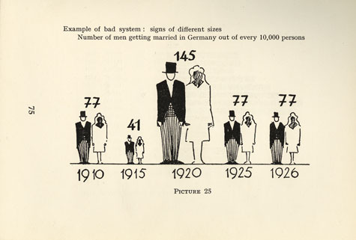
Figure 1: Men Getting Married in Germany in a Year: A Bad System. Neurath, 1936: 75

Information and data were already starting to be displayed in picture formats, however, the pictograms used were not standardised and were used at different sizes to depict varying amounts.
The issue with this method was that it was unknown what the scale was – was the data represented by the height of the item, its width or its volume? This was the reason that Otto Neurath opted instead to use a system of repeating symbols of the same size. Each symbol occurrence represented a defined quantity. Using this approach made it significantly easier for the viewer to understand the data.
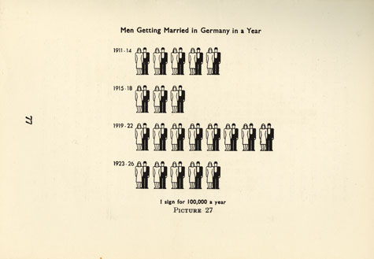
Figure 2: Men Getting Married in Germany in a Year. Neurath, 1936: 77

As Cheryl Buckley noted, “Isotypes attempted to provide a universal graphic design vocabulary that was particularly effective at representing quantitative information.” (2007: 105)
Nancy Stock-Allen (2012) wrote that “Neurath was deeply convinced that his 'world language without words' would not only enhance education but facilitate international understanding.” From this, it is clear that Neurath understood the implications of the creation of a visual language. He realised that it could be adapted and used in more situations than just for depicting and visualising data.
1972 Munich Olympics
As previously discussed, the Isotype had a profound effect on the evolution of graphic communication. It influenced the move towards representing key information with icons that explained their meaning without need for accompanying words. These icons, or pictograms, were not widely used until the 1960s, when British Rail changed their graphic design to a standard system. Margaret Calvert and Jock Kinneir created a new typeface, called Railway, specifically for this redesign. Additionally, a set of pictograms were produced, which included what is thought to be the first usage of the cut-out silhouetted man and woman to represent the location of the lavatories.
Around the same time, pictograms were brought to the world stage in the form of the Tokyo 1964 Olympics. The designers, Masaru Katzumie and Yoshiro Yamashita, created a set of pictograms that stood for each sport, as well as a set that would help visitors in wayfinding and information services. This was the first time that the stick figure was used internationally.
The Olympic Games are the epicentre of mass tourism; at each instance of the Games the host city is inundated with visitors from every country and culture. Tourists must be guided in an unfamiliar place with many events being held in multiple stadiums. Therefore, a language which can be understood by all attendees is required. The Olympic Studies Centre (2017) stated that “pictograms do not belong to a particular language or form of writing, and therefore function as a universal language.”
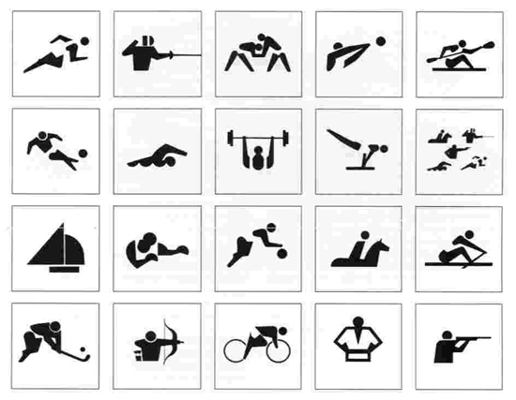
Figure 3: Tokyo Olympics. Katzumie and Yamashita, 1964

Michael Bierut (2004) stated: “pictograms have a long history, with figures like proto-information architect Otto Neurath playing major roles.”
Bierut went on to write that pictograms “came into wide use in Tokyo in 1964, with symbols for individual sports developed by Masaru Katzumie and Yoshiro Yamashita.”
The pictograms that Katzumie and Yamashita produced can be seen above; by using simple, single colour shapes and negative space, the pictures can be easily and swiftly recognised. It is this uncomplicated characteristic that both sets the designs apart from regular illustrations and associates them with the simple style of the Isotype that Arntz created.
Maryam Mokhtar (2014) stated that “Tokyo ’64 revolutionised the role of design in communicating messages to both an international and linguistically diverse group of elite athletes and a global audience.” The design team not only worked to create symbols, or pictograms, to depict each sport, but to help guide tourists around the stadiums.
Recognising the need for a basal, common understanding that could cut across languages and cultural barriers at such an international event, Tokyo ’64’s Olympic design team, led by design critic Masaru Katzumie alongside graphic designer [Yoshiro Yamashita], did away with the use of words, opting instead for pictograms. This was the first time ever that graphics were being systematically used. (Mokhtar, 2014)
Mokhtar’s assessment of the way pictograms replaced words to form a visual language is in keeping with my premise that visual language transcends regular language barriers and evokes international understanding.
Following the success of the Tokyo designs, Otl Aicher and his team designed a series of pictograms to help visitors of the games navigate the stadium and events of the Olympics hosted in Munich in 1972. These pictograms were accompanied by a colour system and grid structures. Together these elements formed a system of information that was implemented across all the Olympic stadiums, in printed handbooks, on posters and more.
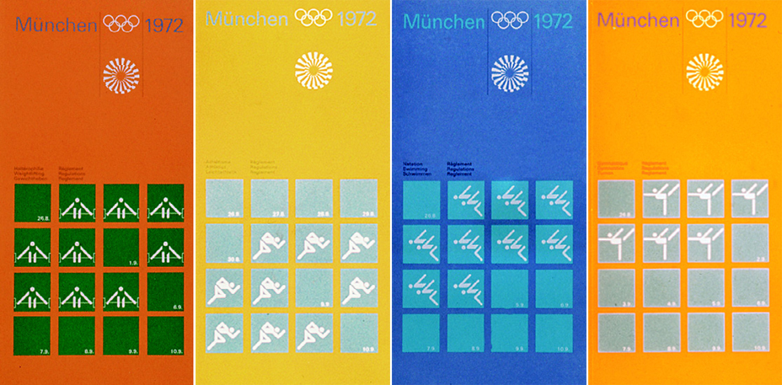
Figure 4: Munich Olympics. Aicher, 1972

The pastel blues, greens and silvers of the colour scheme were intended to reflect the palette of the Alps, but the colours were also used to signify which stadiums events were held at, the department a staff member worked for, and more. Additionally, the palette was carefully chosen to avoid using any red or black, as Germany was trying to rebuild its image after the distressing Nazi occupation in World War II. The 1972 Games were the first time Germany had hosted the Olympics since the war, and it was perfect opportunity to present Germany as a healed and forgiven nation.
The colours were used to identify allocated themes such as media, technical services, celebrity hospitality and public functions and each had a different colour so visitors could differentiate the themes around the stadium and village. Uniforms were colour-coordinated to represent these themes; the Olympic staff could be identified as working for a particular department by the colour they were wearing. (The History of Graphic Design, n.d.)
In this way, the pictograms only formed a small part of a much larger system. They were not the first instance of pictograms used in the design of the Olympic Games, nor were Aicher's designs the first which implemented a system of wayfinding, as the Tokyo Olympics eight years earlier had also done this. However, Aicher's designs utilised a strict grid structure encompassing 45 degree angles and consistent line widths that standardised the appearance of each icon, making them more recognisable both individually and as a set. “Otl Aicher, design director for the Munich 1972 games, developed a set of pictograms of such breathtaking elegance and clarity that they would never be topped.” (Bierut, 2004)
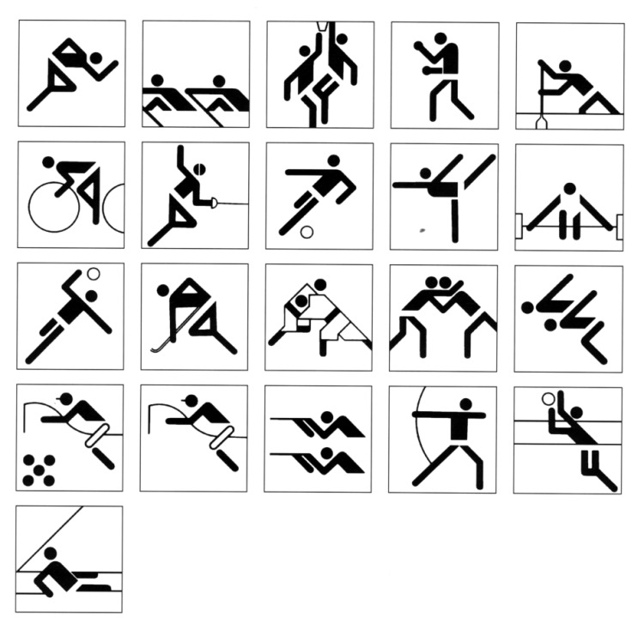
Figure 5: Munich Olympics. Aicher, 1972

Aicher's designs were the first that transformed pictograms, which had now been around for a few years and were gaining popularity in graphic communication.
These designs were directly influential on the DOT pictograms, developed in 1974 by the United States Department of Transportation, which applied the same principles to standard public signage such as those for toilets and telephones. (The History of Graphic Design, n.d.)
In this way, Aicher's work paved the way for widespread usage of pictograms as signage. His designs are clear and elegant; they are visible from a distance and they are easily recognisable.
Summary
After World War I, many people felt that they needed to communicate more effectively to avoid another conflict. Neurath and his team developed a system of pictograms that served as a visual language to aid in understanding and to transcend language barriers. This system, which was eventually titled Isotype, had significant influence in the course of graphic communication. The idea of using pictures instead of words was something that transformed how graphic design was used in social formats, particularly in scenarios where many people from different cultures came together at the same time.
This influence can be clearly seen in the work of Otl Aicher and his team, who designed the Munich Olympics graphics. These, in turn, had a further influence in graphic design that built upon Neurath's Isotype legacy.

Chapter 2
The focus of this chapter is the use of pictograms in public spaces and wayfinding signage in more recent years, examining the evolution of this use and how it has impacted everyday contemporary life.
Firstly, this chapter will discuss how such a simple symbol has come to be universally accepted as a sign for public toilets; how the symbol represents the act of relieving oneself without actually showing this or even alluding to it in the symbol, and how it has come to be used worldwide.
Additionally, this chapter will investigate a more specialised use of pictograms: the system of graphics implemented in NHS Accident and Emergency (A&E) departments. It will examine how the designs utilise our familiarity with the cut-out style pictogram man and pair it with clear, concise typography and diagrams to aid patients in their A&E experience.
British road signs
Neurath suggested “that Isotype pictograms could be used 'in ships, railroads, hotels, indicating everything of general interest: Boat, Lavatory, Gentlemen, Ladies, Water, Cloakroom, Luggage'”. (Burke et al, 2014) Looking at contemporary signage and information systems, he was not only right in that Isotype pictograms could be used in this way, but that they were in fact actually implemented.
It is not known exactly when the very first use of the silhouetted man and woman symbols were used in depicting public toilet location, but according to Jonathan Glancey, “one of the best early examples of intuitive global signs for public lavatories was that created for British Rail in the mid-1960s” (2014). British Rail's new corporate identity was created by Design Research Unit in association with Margaret Calvert and Jock Kinneir.
Kinneir (1917-1994) studied engraving at the Chelsea School of Art in the 1930s and eventually went on to teach part time there. In between, he worked at the Central Office of Information as an exhibition designer and at Design Research Unit. Calvert was born in South Africa in 1936 and moved to England as a teenager. She also studied at the Chelsea School of Art, specialising in illustration.
In the 1950s, plans to build a motorway to address the overwhelming numbers of cars on the roads emerged. However, road signs all over Britain used varying colours, typefaces and symbols. It was deemed too dangerous to continue using this system, or lack thereof, when the first motorway would have drivers travelling at speeds of over seventy miles per hour. A government committee was formed to “review the signing needed for British motorways” (Design Museum, 2015) and Colin Anderson, chairman of the P&O Orient Line shipping company, became the chairman. Anderson had worked with Kinneir before when he commissioned Kinneir to redesign the baggage labelling system, and asked him to design the new signs for Britain's roads.
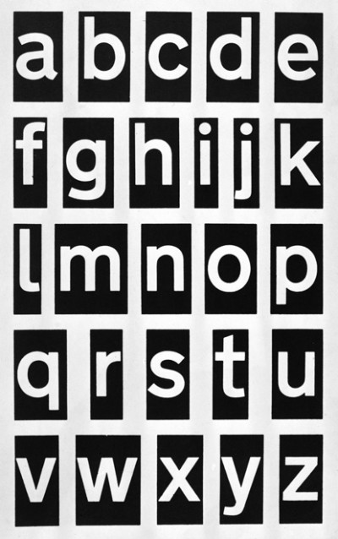
Figure 6: Transport original artwork, lower case letters, tiling system. Calvert & Kinneir, 1957-64
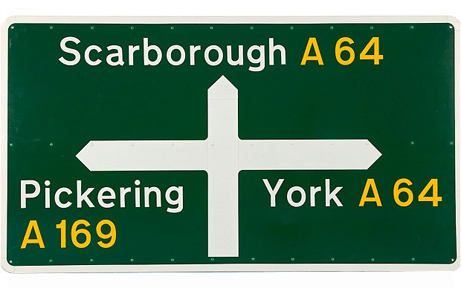
Figure 7: Road sign. Calvert & Kinneir, 1958-1964

“The first public appearance of the new signs took place in 1958 on the first motorway-standard road – the Preston by-pass in Lancashire (now part of the M6) – and the system was approved.” (Design Museum, 2015)
Calvert and Kinneir's designs, still in use today almost fifty years after their creation, are a testament to the requirement of effective graphic design in contemporary society. Without a standard system of graphics for the road signs across the country, navigating would be much harder. Without the simplified map depicting the layout of the road ahead, understanding junctions – a key element to negotiating them safely – would be almost impossible.
The designs seen above that Calvert and Kinneir established were, in essence, just examples of what they created: they did not simply make a new typeface and slap it on a few signs of different coloured backgrounds, but they constructed a system which consists of rules and guidelines. By doing this, they created a way for new signs to be made at any time that would follow the same style and format as all the other signs already in place. This system is a testament to how much work goes in to creating a recognisable, efficient structure that fulfils its purpose of wholly improving both navigation experience and the safety of road users.
Toilet signs
Another example of a need for graphic design is the signs for public toilets. Having accessible toilets is such a basic human right that it is imperative they are clearly marked. It is important that when in a busy area, foreign or unfamiliar territory, one can rely upon being able to recognise the sign for the public restrooms. In the words of Jonathan Glancey, “a universal need has needed universal signage” (2014).
In the mid-1960s, British Rail became one of the first railways to implement a standard design style for all signs in their trains, stations, and restrooms. This was around the same time that mass tourism and an increasingly globalized economy were making universal signs more important than ever. (Debczak, 2015)
Due to the vast increase in tourism and travel, signs that could be understood by anyone, regardless of what language they spoke, were essential. They had to communicate their meaning clearly and concisely to anyone reading them, otherwise they were not fulfilling their purpose.
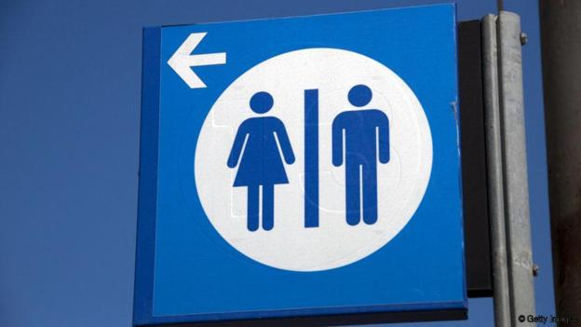
Figure 8: Toilet sign. Anon., n.d.

Burke et al stated that “from about 1928, male and female were always signified through differences in the form of the pictograms” (2014), rather than through colour as they had been beforehand. In this way, although not used to represent the location of public toilets until British Rail's re-brand in the 1960s, the silhouetted gingerbread man style of the man and woman were already a common pictogram to many people. As public restrooms were divided into Ladies and Gentlemen, it was not a large step to begin using the cut-out man and woman as the sign for them.
An archetype is a typical example of a person or object. In this case, the silhouetted stick man and woman are archetypes of the human form. They represent the outer appearance of a person without focusing on the details that make each person different from another. As such, the shape is recognisable from a distance or at a glance without difficulty. This is thought to be the principal reason that the toilet signs as seen above are still used over fifty years after their first appearance in British Rail's re-brand of the 1960s; wherever you are, you want to be able to look up and see the sign for the toilets quickly and easily, not have to read lots of text or scan for the sign amongst many other symbols.
Glancey (2014) wrote that “such archetypal imagery also informs the design of a plethora of signs found, for example, in international airports and major railway stations… They are understood intuitively. No words need accompany them.” He went on to state that if, in fact, the pictograms did need words present with them, there would be mass confusion on their meaning. Therefore, the icon would not be fulfilling its job of informing and assisting the viewer.
In general, the symbols seen above are most widely used to represent the lavatories. However, many artists and designers have created versions that play on the archetypal imagery or disregard it completely in favour of something more cryptic. These 'corrupted' versions of the lavatory symbol can be amusing and charming, however, they can also be confusing if care is not taken to ensure that the symbols can be understood at a glance.
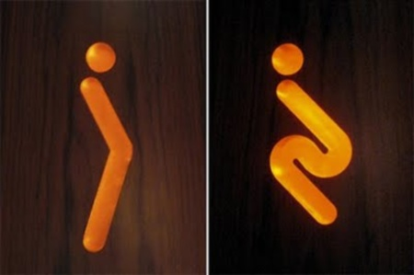
Figure 9: Alternate toilet sign. Anon, n.d.

An example of an alternative toilet sign, seen above, plays upon the human element of the call of nature by representing the body shapes that men and women adopt in the lavatory. In this way, these symbols are fairly unreserved in comparison to the regular versions; it could be said that only a few years ago these might have been deemed explicit and inappropriate, but in contemporary society they are seen as amusing.
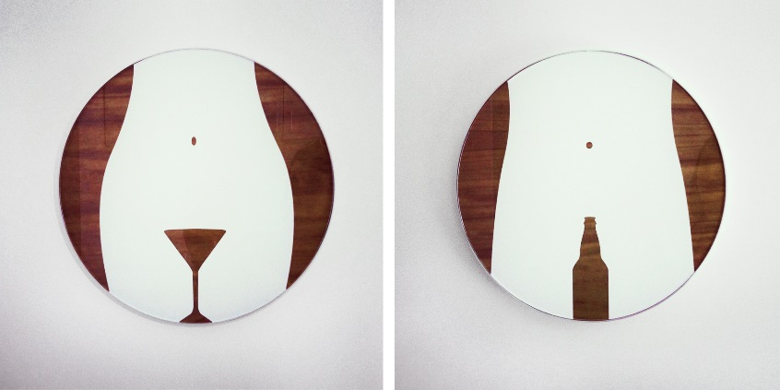
Figure 10: Alternate toilet sign. Liquid Agency, n.d.

Additionally, the signs seen above are a more extreme example of explicit signage in that they depict the sexual organs of men and women using a Martini glass and a beer bottle. In this way, these signs are remarkable clever, yet they could be seen as explicit and offensive.

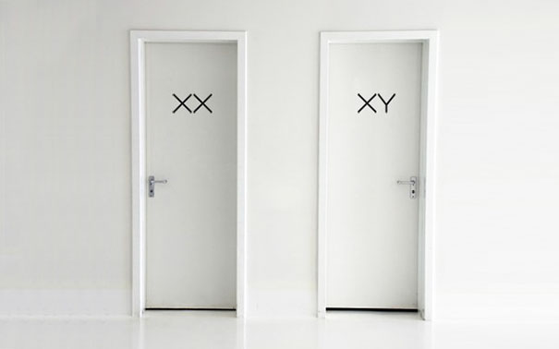
Figure 11: Alternate toilet sign. Anon, n.d.

Above is a more conservative approach to the alternative toilet sign. It still uses the biological differences in men and women, but it does so in a much more scientific, innocent way. The only issue with this is that it is dependent on the English language and an understanding of the chromosomes that determine gender. Due to these factors, these signs may be appropriate in a research or laboratory environment, but they may well cause confusion if they were implemented in public places such as restaurants or airports.
These examples of alternative toilet signs serve as a reminder of how easy to understand the regular signs are. The usual toilet signs cannot be deemed inappropriate in the way that some of the above examples can. Equally, many of the corrupted versions of toilet signs are not as legible from a distance or at a glance.
One of the main qualities about the regular toilet signs is that they are not just visible but easily recognisable from a large distance, but another characteristic which increases their success as a symbol is that they are able to be recognised at a glance. This feature is especially important as the signs for public toilets must often be seen in busy periods and when in transit, without the time to stop and study a sign to decipher its meaning. As a result, the toilet signs that are used in train stations, airports and almost every public place are distinctive and coherent.
“A Better A&E”
In 2012, the Department of Health Design Council issued an open brief aimed at reducing violence against their Accident & Emergency (A&E) department staff in National Health Service (NHS) hospitals. The National Audit Office stated that “violence and aggression towards hospital staff costs the NHS at least £69 million a year in staff absence, loss of productivity and additional security.” (A Better A&E, 2012)
Design company PearsonLloyd, founded by Tom Lloyd and Luke Pearson, discovered that the main root of the issue was that patients felt they were not being kept informed. As laymen, they did not understand hospital protocol and were anxious about why they were having to wait so long to be seen. As a result of this, Pearson Lloyd's response to the brief was a system of pictograms and information boards that guide the patient through their A&E experience by explaining the stages from admission to exit.


Figure 12: A Better A&E: Process Map. PearsonLloyd, 2012

The system of graphics included signs which were placed in strategic locations such as waiting areas and between departments. The illustration above depicts an information board that simplifies the timeline of the patient’s journey into terms and visual paths that the patient can understand, without needing to learn any medical knowledge.
It is easy to recognise the influence of Neurath in this work; the stick man has been used to aid understanding of the charts and information boards. PearsonLloyd’s use of this archetypal figure, which is seen throughout train stations, hotels and airports in our everyday life, means that the designs are intuitive and simple.
At first, this solution was experimentally implemented in just two A&E departments with two similar hospitals studied without the graphics as a control. As seen below, a system was devised where a whiteboard was placed in the department and tallies were made to record the number of incidents experienced, divided into day and night, and men and women.
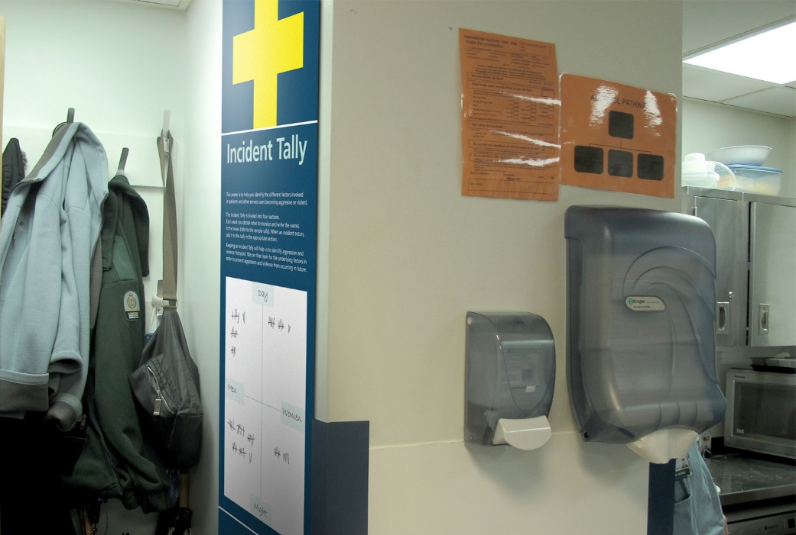
Figure 13: A Better A&E: Incident Tally. PearsonLloyd, 2012

After a year of its application, all recorded violent incidents had fallen by 50% (A Better A&E, 2012). This is just one example of how graphic design is more than just art; it is indeed a useful, needed element; most people who visit A&E will not know anything about this design project or its purpose. But they will read the information, see the pictograms, and live its success without even realising.
Summary
Visual language plays an important role in contemporary society in that it forms a universal language; that is to say, symbols can be used to express meaning without relying on the words of a particular spoken language. Instead, symbols can be, and are, used to replace words.
The examples above outline a brief timeline of the evolution of the pictogram and the most prominent cases that can be found in contemporary society.
For instance, the work of designer Otl Aicher for the Munich Olympics helped to shape the pictograms that are used in wayfinding signage across the globe. Without his influence we might have pictograms still, but it could be said that his work influenced the clarity of the designs by his use of consistent line weights and contrasting 45 degree angles.
Secondly, wayfinding signage across British roads was vastly improved when Margaret Calvert and Jock Kinneir agreed to design a new system of graphics for the British road signs. Their work in creating a system of rules accompanied by two new typefaces is still in use on the roads across the United Kingdom over fifty years after their conception.
Additionally, the pictogram used as the logo for public toilets is often unaccompanied by words but instead stands alone in symbolising the location for the lavatories. It is universally recognised as having this meaning and can be found in hotels, airports, train stations and many more places across multiple countries and continents.
It was first implemented by British Rail in the sixties when mass tourism was vastly increasing and since then has not particularly changed. There are many alternate versions of it, but the symbol itself has not been improved upon since its first usage. It has had such a profound effect on graphic communication that many designers have warped it to produce versions that are less obvious, more artist and sometimes even cryptic.

Conclusion
Pictograms are a graphic representation of an action, location or object. They are often used in instances where their meaning must be understood by people of any language or culture.
Graphic design is an inherent part of our everyday lives, yet most people do not realise or recognise it. Of course, we all see the icons and signs that shape our decisions – if we want to go to the bathroom we must choose to move towards it; the signage helps us choose which way to go in order to fulfil this goal. However, many people take it for granted that these signs had to be researched, designed and implemented to consider our use for them, so that they might be exactly suited to their purpose, whether it be wayfinding signage, information graphics or otherwise. Fundamentally, graphic design for wayfinding works best when you do not realise it is there, yet you use it anyway.
Spoken and written languages can only be understood by those who have learned it. Therefore, in circumstances where many people of different languages and cultures come together, a common language must be established in order to avoid confusion and miscommunication. In this way, symbols transcend the usual language barriers and allow people who speak different languages to be able to understand what is being communicated through imagery.
The example of the toilet sign is perhaps the most obvious form of this visual language, as it has been implemented across the globe; equally, it has been used for so long that children are being brought up to recognise it for its meaning without having to be taught.
Furthermore, there is a traceable influence in the history of pictograms. By this I mean that each of the examples given in this dissertation have influenced, or been influenced by, one another. The work of Neurath and his team in the 1920s began the move towards using a visual language and using pictograms to represent information or concepts. Following this, Aicher’s iconic designs for the Munich Olympics in 1972 were instrumental in globalising pictograms used in wayfinding signage and as symbols to represent actions or items.
Additionally, visual language goes beyond representing words and concepts; it also has real effects on human behaviour. For instance, the system of graphics that PearsonLloyd designed for the Accident and Emergency departments in NHS hospitals caused a fifty per cent decrease in reported violent incidents against the staff after a trial period of just one year. This, in turn, has saved the NHS money in staff absence, stress and more.
Graphic design is not just an art; it has many real-world applications and it affects our lives in ways that most people are not even aware of. As a discipline, graphic design plays an important, essential role in contemporary culture. It alters our behaviour, as seen in the effects of the Better A&E designs by PearsonLloyd; it helps us navigate safely and efficiently, as seen in the works of Calvert and Kinneir where their designs were implemented to help citizens drive safely.

Reference List
Books
Burke, C., Kindel, E. and Walker, S., 2014. Isotype: Design and Contexts. London: Hyphen Press.
Neurath, O., 2010. From Hieroglyphics to Isotype: A Visual Autobiography. London: Hyphen Press.
Reidemeister, M., 1980. The Transformer: Principles of Making Isotype Charts. Translated from German by Kinross, R.,2008. London: Hyphen Press.
Online Sources
A Better A&E, 2012. A Better A&E. [online] Available at <http://www.abetteraande.com> [Accessed 7 November 2017]
Bierut, M., 2004. The Graphic Design Olympics. [online] Design Observer. Available at <http://designobserver.com/feature/the-graphic-design-olympics/2517> [Accessed 21 November 2017]
Buckley, C., 2007. Designing Modern Britain. [e-book] Reaktion Books. Available at <https://books.google.co.uk/books?id=ws2YJ7EYOQYC&pg=PA105&dq=graphic+design+isotypes&hl=en&sa=X&redir_esc=y#v=onepage&q=graphic%20design%20isotypes&f=false> [Accessed 24 October 2017]
Debczak, M., 2015. How Bathroom Stick-Figures Became Universal Symbols. [online] Mental Floss. Available at <http://mentalfloss.com/article/71997/how-bathroom-stick-figures-became-universal-symbols> [Accessed 17 November 2017]
Design Museum, 2015. Jock Kinneir & Margaret Calvert. [online] British Road Sign Project. Available at <http://www.britishroadsignproject.co.uk/jock-kinneir-margaret-calvert> [Accessed 30 November 2017]
Eco, U., 1976. A Theory of Semiotics. [e-book] Indiana University Press. Available at <https://books.google.co.uk/books?id=BoXO4ItsuaMC&printsec=frontcover&dq=umberto+eco+theory+of+semiotics&hl=en&sa=X&ved=0ahUKEwje4NL9-eXWAhWCWRoKHWTiB4EQ6AEIKDAA#v=onepage&q=semiotics&f=false> [Accessed 10 October 2017]
Glancey, J., 2014. The Genius Behind Stick Figure Toilet Signs. [online] BBC. Available at <http://www.bbc.com/future/story/20140911-the-genius-of-toilet-signs> [Accessed 30 November 2017]
Haldemann, J., 2014. A Brief History of Pictograms and Ideograms. [online] Saffron Interactive. Available at <http://saffroninteractive.com/a-brief-history-of-pictograms-and-ideograms> [Accessed 7 November 2017]
Lewallen, E., 2008. A History of the Stick Figure. [video online] Available at <https://www.youtube.com/watch?v=D0-IcL7nBAE> [Accessed 23 November 2017]
Mokhtar, M. 2014. Graphic Design and the '64 Tokyo Olympics – Just Look! [online] Looking for Tokyo. Available at <https://lookingfortokyo.wordpress.com/2014/09/29/graphic-design-and-the-64-tokyo-olympics-just-look> [Accessed 19 November 2017]
Olympic Studies Centre, 2017. The Sports Pictograms of the Olympic Summer Games from Tokyo 1964 to Rio 2016. [pdf] Available at <https://stillmed.olympic.org/media/Document%20Library/OlympicOrg/Factsheets-Reference-Documents/Games/Pictograms/Reference-document-The-Sports-Pictograms-of-the-OG-from-Tokyo-1964-to-Rio-2016.pdf> [Accessed 21 November 2017]
Stock-Allen, N., 2012. ISOTYPE: International System of Typographic Picture Education: “Words Divide, Pictures Unite” [online] Design History. Available at <http://www.designhistory.org/Symbols_pages/isotype.html> [Accessed 24 October 2017]
The History of Graphic Design, n.d. Otl Aicher. [online] Available at <http://www.historygraphicdesign.com/the-age-of-information/the-international-typographic-style/172-otl-aicher> [Accessed 7 November 2017]

Bibliography
Books

Online Sources
American Institute of Graphic Arts, n.d. Symbol Signs. [online] Available at <https://www.aiga.org/symbol-signs> [Accessed 25 November 2017]
Honeywill, Paul, 1999. Visual Language for the World Wide Web. [e-book] Intellect Books. Available at <https://books.google.co.uk/books?id=vQte_0H7Oh0C&printsec=frontcover&dq=visual+language+hieroglyph&hl=en&sa=X&ved=0ahUKEwjK0rzO-eXWAhXDBBoKHaT1D7IQ6AEIKDAA#v=onepage&q=visual%20language%20hieroglyph&f=false> [Accessed 10 October 2017]
Icon Utopia, 2016. The History of the Olympic Games Icons. [online] Available at <http://iconutopia.com/the-history-of-the-olympic-games-icons> [Accessed 21 November 2017]
Isotype Revisited, n.d. Available at <http://isotyperevisited.org/2012/08/introduction.html> [Accessed 22 November 2017]
Kleon, A., 2008. Gerd Arntz and the Woodcut Origins of the Stick Figure. [online] Available at <https://austinkleon.com/2008/02/12/gerd-arntz-and-the-woodcut-origins-of-the-stick-figure> [Accessed 23 November 2017]
Macnab, M., 2008. Decoding Design. [e-book] HOW Books. Available at <https://books.google.co.uk/books?id=v0iH_3bFgnQC&printsec=frontcover&dq=symbols+in+graphic+design&hl=en&sa=X&ved=0ahUKEwjB0vfh6qbVAhUkB8AKHXAVB4sQ6AEIOzAE#v=onepage&q=symbols%20in%20graphic%20design&f=false> [Accessed 8 October 2017]
Media Made Great, n.d. Olympic Pictograms: Design Through History. Available at <https://mediamadegreat.com/olympic-pictograms> [Accessed 23 November 2017]
Neurath, O., 1936. International Picture Language. [e-book] Available at <http://imaginarymuseum.org/MHV/PZImhv/NeurathPictureLanguage.html> [Accessed 24 October 2017]
PearsonLloyd, 2012. A Better A&E. [online] Available at <http://pearsonlloyd.com/a-better-aande/> [Accessed 7 November 2017]
Pratt, n.d. US Department of Transportation Symbol Signs (1974). Available at <https://www.pratt.edu/the-work/gallery/u.s.-department-of-transportation-symbol-signs-1974> [Accessed 25 November 2017]
Rand, P., n.d. Thoughts on Design. [e-book] Chronicle Books. Available at <https://books.google.co.uk/books?id=UAZpAwAAQBAJ&printsec=frontcover&dq=symbols+in+graphic+design&hl=en&sa=X&ved=0ahUKEwjB0vfh6qbVAhUkB8AKHXAVB4sQ6AEIRzAG#v=onepage&q&f=false> [Accessed 8 October 2017]
Rich, S., 2012. The History of the Olympic Pictograms: How Designers Hurdled the Language Barrier. [online] Smithsonian. Available at <https://www.smithsonianmag.com/arts-culture/the-history-of-the-olympic-pictograms-how-designers-hurdled-the-language-barrier-4661102> [Accessed 21 November 2017]

List of Illustrations
Figure 14: Neurath, O., 1936. Men Getting Married in Germany in a Year: A Bad System. [printed illustration] International Picture Language. Available at <http://isotyperevisited.org/intro01c_IPL_p75.jpg> [Accessed 25 November 2017]
Figure 2: Neurath, O., 1936. Men Getting Married in Germany in a Year. [printed illustration] International Picture Language. Available at <http://isotyperevisited.org/intro01b_IPL_p77.jpg> [Accessed 25 November 2017]
Figure 3: Katzumie, M. and Yamashita, Y., 1964. Tokyo Olympics. [image online] <http://public.media.smithsonianmag.com/legacy_blog/tokyo1964.jpg> [Accessed 5 December 2017]
Figure 4: Aicher, O., 1972. Munich Olympics. [image online] Available at <http://olympic-museum.de/pictograms/1972/1972-olympic-games-pictograms.jpg> [Accessed 25 November 2017]
Figure 5: Aicher, O., 1972. Munich Olympics. [image online] Available at <http://www.phaidon.com/resource/otl-aicher-110-page-1-image-0008.jpg> [Accessed 25 November 2017]
Figure 6: Calvert, M. and Kinneir, J., 1957-64. Transport original artwork, lower case letters, tiling system. [image online] Available at <http://www.britishroadsignproject.co.uk/wp-content/uploads/2015/08/Transport_Alphabet_2-e1440519165673.jpg> [Accessed 30 November 2017]
Figure 7: Calvert, M. and Kinneir, J., 1958-1964. Road sign. [image online]
Figure 8: Anon., n.d. Toilet sign. [image online] Available at <http://www.bbc.com/future/story/20140911-the-genius-of-toilet-signs> [Accessed 30 November 2017]
Figure 9: Alternate toilet sign. Anon, n.d. Available at <https://middleclassfury.com/2013/03/03/obscure-toilet-signs> [Accessed 5 December 2017]
Figure 10: Alternate toilet sign. Liquid Agency, n.d. Available at <https://i.pinimg.com/736x/d1/bf/3f/d1bf3fe68c230c19efa8666165416aff--restroom-signs-bathroom-signs.jpg> [Accessed 5 December 2017]
Figure 11: Alternate toilet sign. Anon, n.d. Available at <http://thetango.net/wp-content/uploads/2016/09/TheTango-BathroomSigns-0919201662.jpg> [Accessed 5 December 2017]
Figure 12: PearsonLloyd, 2012. A Better A&E: Process Map. [image online] Available at <http://www.abetteraande.com> [Accessed 2 December 2017]
Figure 13: PearsonLloyd, 2012. A Better A&E: Incident Tally. [image online] Available at <http://www.abetteraande.com> [Accessed 12 December 2017]

